
Assignment oNE: rEPORT
Valentina Somnik: 2020147

June 1, 2022
University of Wales Trinity Saint David

Table of Contents
Executive Summary 1
1. Introduction 3
2. Financial Analysis 4
3. Financial Analysis Trends 5
a. Horizontal ratios for 2019 and 2020 analysis of the financial information included within the financial statements. 5
b. Outline the importance of using ratio analysis for decision making 6
c. Limitation of ratio analysis, including why an understanding of ratios and their fluctuations is essential for hotel management in analysing the information seen in their financial statements. 8
Bibliography 10

Introduction
The following report is willing to investigate the horizontal analysis of the given company based on the financial statements that are generated from the company. Further, the limitations of financial ratios are going to be provided in the second section of the report. All the information is going to be provided from valid resources.

Financial Analysis
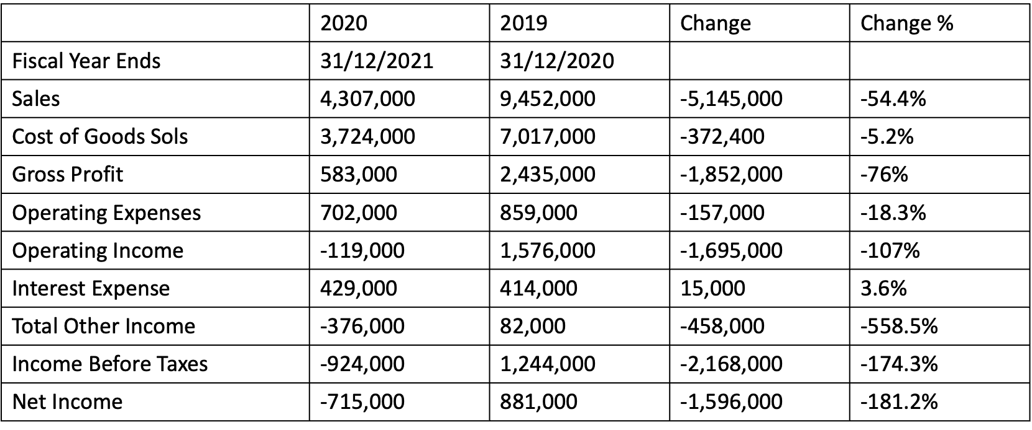

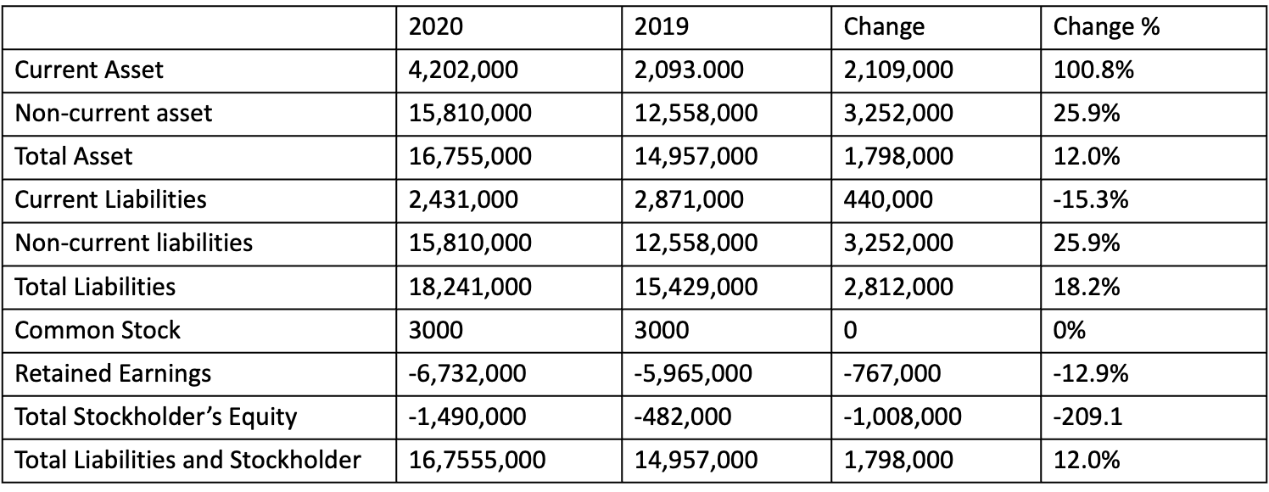

Financial Analysis Trends

Horizontal ratios for 2019 and 2020 analysis of the financial information included within the financial statements.
Even investigation of budget summaries includes correlation of a monetary proportion, a benchmark, or a detail over various bookkeeping periods. This strategy for investigation is otherwise called pattern examination. Flat examination permits the evaluation of relative changes in various things after some time. It likewise shows the way of behaving of incomes, costs, and other details of budget reports throughout the process of everything working out (Akdeniz, 2010).
Bookkeeping periods can be at least two than two periods. Bookkeeping period can be a month, a quarter or a year. It will rely upon the examiner's attentiveness while picking a proper number of bookkeeping periods. During the speculation evaluation, the quantity of bookkeeping time frames for investigation depends on the time skyline viable.
Even examination of fiscal summaries can be performed on any of the thing in the pay articulation, accounting report and explanation of incomes. For instance, this examination can be performed on incomes, cost of deals, costs, resources, money, value and liabilities. It can likewise be performed on proportions, for example, profit per share (EPS), cost acquiring proportion, profit payout, and other comparative proportion.
Even examination can be acted in one of the accompanying two unique strategies for example outright examination or rate correlation.
Outright Comparison:
One approach to performing even investigation is looking at the outright money measures of certain things throughout the timeframe. For instance, cash close by toward the finish of a bookkeeping period can measure up to other bookkeeping periods. This technique is useful in recognizing the things which are changing the most (Leach, 2010).
Considering the results that have been generated in the financial statements of the given hotel, the first thing to mention is that the sales has decreased comparing from 2019 to 2020, this is demonstrating that the company has not managed to keep the number of the sales up and the same time it does also demonstrate that the company has been affected by the coronavirus as during this time the hotel could have not offer services.

Speaking about the common stock, for example, there has been a change of 0% as in both years there has been an amount of 3000. The aspect that has increased in the non-current liabilities as well as the total-liabilities, these are important components that should be known.

Rate Comparison:
In the second technique for even examination, rate contrasts in specific things are looked at throughout some undefined time frame. The outright cash sums are changed over into the rates with the end goal of examination. For instance, an adjustment of money from $5k to $5,5k will be accounted for as 10% increment in real money. It can likewise be accounted for as every available ounce of effort, and that implies that the money is every available ounce of effort of the money toward the finish of past bookkeeping period. This strategy is helpful while contrasting execution of two organizations of various scale and size.

- Outline the importance of using ratio analysis for decision making.
Proportion examination is significant for the organization to break down its monetary position, liquidity, productivity, risk, dissolvability, proficiency, tasks viability, and appropriate usage of assets which additionally shows the pattern or correlation of monetary outcomes that can be useful for decision making for venture by investors of the organization.
Proportion Analysis is a strategy to comprehend the liquidity position, effectiveness of tasks, productivity position, and dissolvability of a business association. A quantitative method utilizes an association's budget summaries, for example, the pay proclamation and the monetary record. The proportions and their examination assist us with measuring the monetary exhibition of an association over various revealing periods. It is especially significant for partners like the financial backers, providers, and loan bosses as it fills in as an estimation device of the organization's presentation in quantitative terms. With proportions, it becomes more straightforward to think about the exhibition of the organization over the different detailing periods. Besides, it becomes simpler to contrast an organization's exhibition and different organizations in similar industry with the assistance of proportions. Allow us now to figure out the significance of proportion examination exhaustively.
There is a huge volume of bookkeeping information in any association. Proportions are a method for summing up the monetary place of an organization. The clients of these reports don't need to more than once go through the intricate fiscal summaries. They can compute the proportions, investigate them, and make the expected move. They will give adequate data on the association's general proficiency and monetary position.
Proportions like profit from resources, return on value, and so on, assist clients comprehend the viability with which an organization procures a profit from its resources. The gross edge proportion enlightens us regarding the organization's capacity to create returns on deals. The working edge gives an outline of the organization's functional proficiency. Other proficiency proportions, like record receivables turnover proportion, stock turnover proportion, and so forth, additionally let us know how proficient the functioning of the organization is (Risk, 2014).
Throughout the long term, analysts have constantly settled the utility of monetary proportions in researching different parts of professional benefit, dissolvability, and effectiveness. It gives patterns inside associations by dissecting monetary proclamations over an enormous number of monetary years (FYs). This is incredibly helpful to grasp the bearing of development of an association and recognize any patterns that influence execution. This sort of pattern investigation is unimaginable with the information of a solitary monetary year. Proportion examination is likewise essential to benchmark one's presentation in contrast with industry contenders, recognize holes, survey upper hands, qualities, shortcomings, valuable open doors, and dangers. This data can be involved by chiefs to advance the association's situation in the business. Proportion examination is likewise an instrument to perceive how proficiently an association is utilizing its resources and liabilities and whether the monetary assets are finished or underutilized. To help chiefs in their dynamic cycle, a few classifications of proportions are utilized. In the first place, the liquidity remainders like current proportion, fast proportion, and money proportion, measure the capacity of an association to meet its ongoing liabilities with the utilization of current resources.

Limitation of ratio analysis, including why an understanding of ratios and their fluctuations is essential for hotel management in analysing the information seen in their financial statements.

The absolute most significant constraints of proportion investigation include:
Authentic Information: Information utilized in the examination depends on genuine previous outcomes that are delivered by the organization. Subsequently, proportion investigation measurements don't be guaranteed to address future organization execution.
Inflationary impacts: Financial proclamations are delivered intermittently and, thusly, there are time contrasts between each delivery. If expansion has in the middle between periods, genuine costs are not reflected in the fiscal summaries. In this way, the numbers across various periods are not practically identical until they are adapted to expansion.
Changes in bookkeeping arrangements: If the organization has changed its bookkeeping approaches and systems, this may fundamentally influence monetary revealing. For this situation, the key monetary measurements used in proportion examination are adjusted, and the monetary outcomes recorded after the change are not tantamount to the outcomes recorded before the change. It depends on the expert to be in the know regarding changes to bookkeeping strategies. Changes made are by and large found in the notes to the budget summaries segment.
Functional changes: An organization may essentially change its functional design, anything from their store network system to the item that they are selling. At the point when critical functional changes happen, the correlation of monetary measurements when the functional change might prompt deluding decisions about the organization's exhibition and future possibilities. P o I u r f d e r t g f d c v b g f d w e r t g f d s x c v f d s P o I u r f d e r t g f d c v b g f d w e r t g f d s x c v f d s P o I u r f d e r t g f d c v b g f d w e r t g f d s x c v f d s P o I u r f d e r t g f d c v b g f d w e r t g f d s x c v f d s P o I u r f d e r t g f d c v b g f d w e r t g f d s x c v f d s P o I u r f d e r t g f d c v b g f d w e r t g f d s x c Occasional impacts: An expert ought to know about occasional elements that might bring about impediments of proportion examination. The powerlessness to change the proportion examination to the irregularity impacts might prompt bogus understandings of the outcomes from the investigation (Tracy, 2012).
Control of fiscal summaries: Ratio examination depends on data that is accounted for by the organization in its budget reports. This data might be controlled by the organization's administration to report an improved outcome than its genuine exhibition. Thus, proportion examination may not precisely mirror the real essence of the business, as the deception of data isn't recognized by straightforward investigation. It is vital that an expert knows about these potential controls and consistently complete broad expected level of effort prior to arriving at any resolutions. P o I u r f d e r t g f d c v b g f d w e r t g f d s x c v f d s P o I u r f d e r t g f d c v b g f d w e r t g f d s x c v f d s P o I u r f d e r t g f d c v b g f d w e r t g f d s x c v f d s P o I u r f d e r t g f d c v b g f d w e r t
Considering everything that has been mentioned above, it is important to mention that hotels are using the financial ratios to investigate if their plans are working effectively or not. There are ratios that are put in comparison with other financial rations that have been calculated in the past and in this way the hotel can easily consider if the profits, returns, and so on are increasing. P o I u r f d e r t g f d c v b g f d w e r t g f d s x c v f d s P o I u r f d e r t g f d c v b g f d w e r t g f d s x c v f d s P o I u r f d e r t g f d c v b g f d w e r t g f d s x c v f d s P o I u r f d e r t g f d c v b g f d w e r t g f d s x c v f d s P o I u r f d e r t g f d c v b g f d w e r t g f d s x c v f d s P o I u r f d e r t g f d c v b g f d w e r t g f d s x c v f d s

Bibliography
Akdeniz, C. (2020) Financial Statement Analysis Explained. 1st Edition. Taylor and Francis

Leach, R. (2010) Ratios made simple: a beginner’s guide to the key financial ratios, 1st Edition. Harriman House

Tracy, A. (2012) Ratio analysis fundamentals. 1st Edition. RatioAnalysis.net.

Rist, M. (2014) Financial ratios for executives: how to assess company strength. 1st Edition Apress Publishing

