

Assessment 1 – Reading Task Template
PART 1: Upload your photo of your A3 in-class notes here:
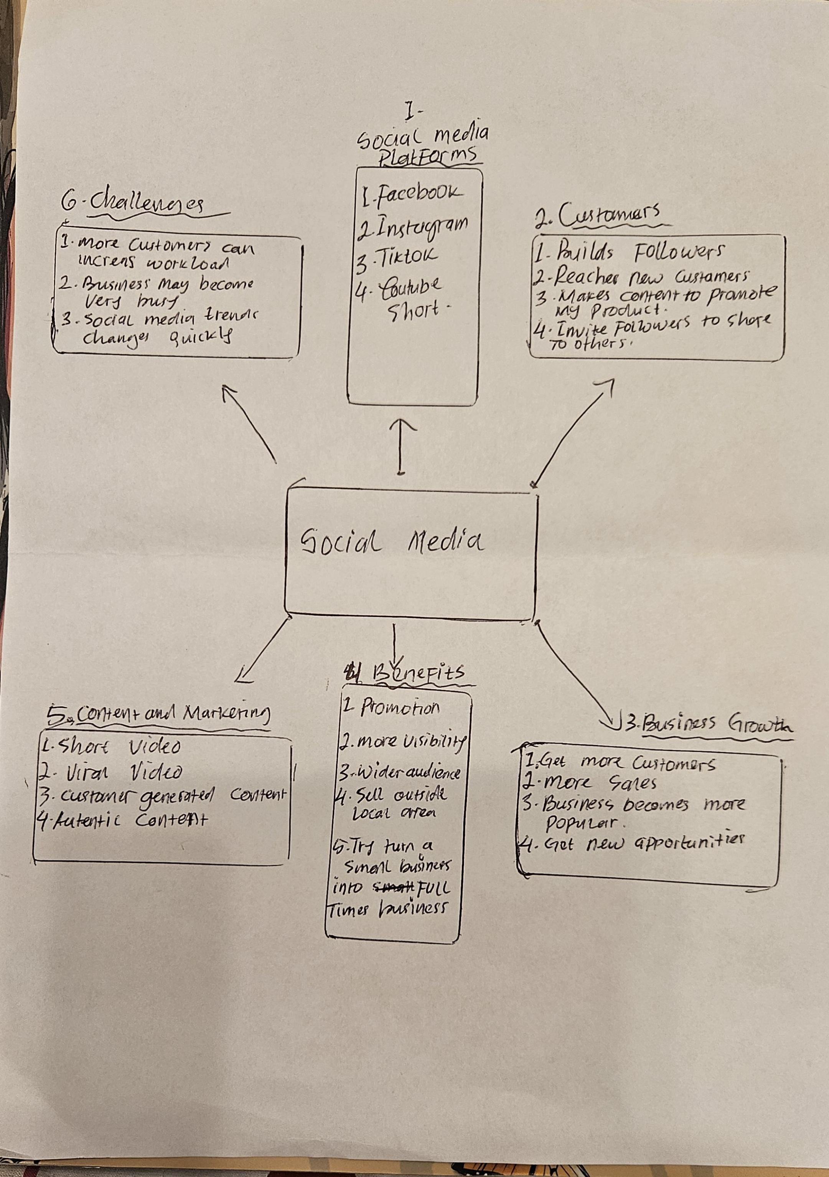

PART 2:
- Answer every question below in 1-3 full sentences.
- Use your own words. Do not use generative AI to answer these questions.
- Include a specific detail from the text when asked.
REMINDER
- The main idea is the overall message of the whole text.
- A key point helps to explain the main idea.
- A specific detail or example from the text shows that the key point is true.

- What is the main idea of the whole text?
Social media can help businesses become more successful by reaching new customers and increasing sales.

- What is one key point that supports the main idea, and which specific example from the text shows this?
Viral social media content can attract customers from far away.
Example customers travelled three hours to visit Honeywood Sandwich Shop because they wanted to try its chicken burger.

- What is a different key point that supports the main idea, and which specific example from the text shows this?
Social media can help businesses reach a much wider audience and grow beyond their local area.
Example, Lindy Loo’s Boutique moved her clothing business fully online and now sells to customers across the UK and even Australia.

- Which part of the text do you think is most important, and why?
“People buy from people “I Think this is important because businesses can use social media to build a relationship with customers, not just advertise their products.

Reflection:
- What did you find difficult in this task (including in-class components), and why was it difficult?
It difficult to identify the main idea and choose the most important information from a long text. There were many examples so sometimes I was not sure which information I should include.

- What helped you with this difficulty, and how did it help you?
The mind map and discussing the text in class helped me organise the information into different sections, such as customers, marketing and business growth

