
Skills for the Workplace
Module Assignment Submission
Student Name: | Howard Lewis
Student Number: | 2011712
Module No: | BMSK4002
Module Title: | Effective Team Working and Communication  Part 2

Statement of Confirmation of Authenticity
By the act of making this submission, the student declares that this is the work of the student named above. The work has not, in whole or in part, been knowingly presented elsewhere for assessment, or where assessment has been built on a previous assessment, this has been identified. Where materials have been used from other sources it has been properly acknowledged. If this statement is untrue, the student acknowledges that an assessment offence has been committed.
Attention is drawn to the plagiarism and unfair practice policies of both the University and of ILM.

Table of Contents
Part 2 Communication 3
1.0 3
Communication Cycle 3
- 4
Communication in the workplace 5
2.0 6
Assessing Own Communication Skills 6
Gap Analysis 6
PDP 7
References 8
Appendix A 8
Skills You Need Communication Quiz 9
Mind Tools Communication Quiz 10

Part 2 Communication

1.0

Communication Cycle
There are a few communication styles from different recognised theorists for the different learning styles. Amongst looking closely, I personally noticed that all come to the same conclusion but is explained in a way for us an individual to learn what is the best one for us to use, for ourselves and our teams to communicate. Here are a few examples of some theories by different people for the same methods and outcomes.
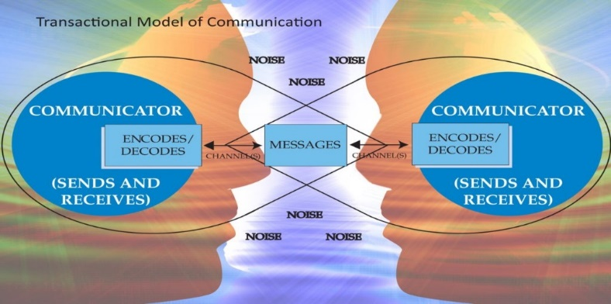
Transactional model of communication
(4 years ago)
Image from: -
http://ugcnetpaper1.com/important-key-notes-communication/

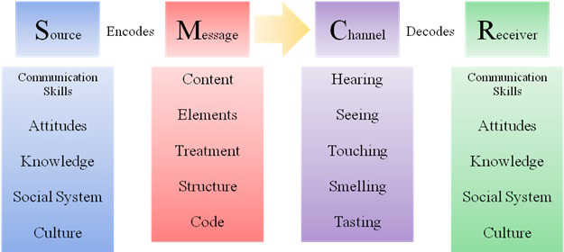

Berlo’s communication model
(1 year ago)
Image on Pinterest.
https://jayaseelansr.blogspot.com/2017/07/david-berlos-model-of-communication.html

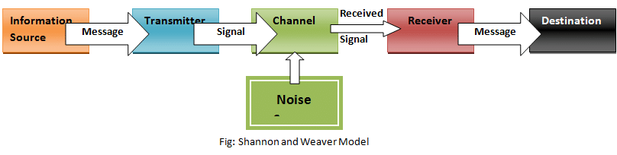
Shannon and Weaver’s theory of communication. (4 years ago).
https://thebusinesscommunication.com/types-of-communication-model/

Above is Shannon Weavers model on communication but in her way of thinking and putting into place for herself to process, she logically thought and calculated it with maths. Hence why she called it the mathematical model and she released the theory model itself in (1949).

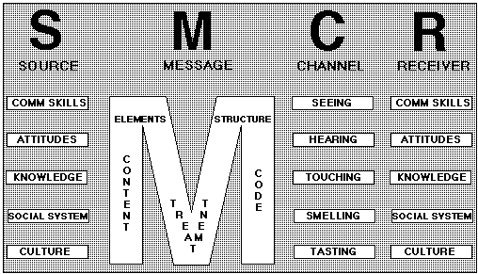
Pictured on the left is: -
Berlo’s model of communication.
Picture was placed online seven years ago on or before: - (August 2011)
http://www.managementstudyguide.com/berlo-model-of-communication.htm

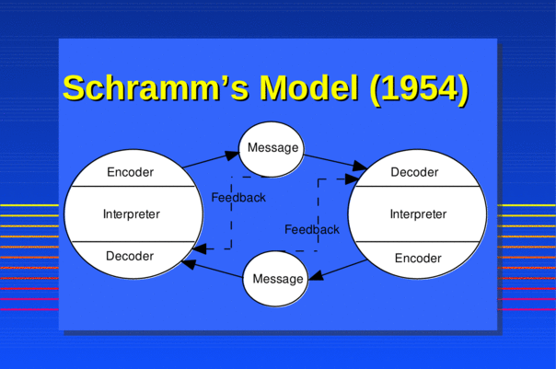
Pictured on the left is: -
Schramm’s model of communication.
Image first appeared online on or before the: - (22nd November 2018)

https://vdocuments.mx/schramm-model-of-communicationppt.html
Berlo on the other hand had another approach towards his communication model by using all of our five senses to come into factor.

-
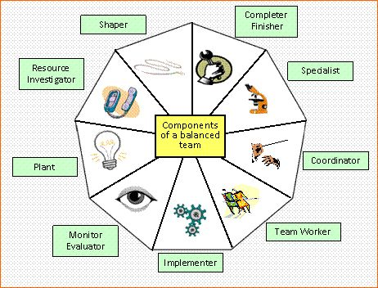
Pictured on the left is: -

Meredith Belbin’s model of communication
(Image on Pinterest 2018)
Image first appeared on or before: -
https://www.pinterest.com/jobellets/belbin/

All these processes are ways or models of showing how we not only send and receive calls, emails, texts etc. But the best part of looking closer to them is they are explained in ways different people can adapt them into comprehending them, decoding, and encoding through the channels first before it hits its destination.
Firstly, let me start with a name we are all now familiar with: - Meredith Belbin.
Belbin has been established for decades due to his highly effective nine team goals, targets, or achievements if you like but has managed to describe how every person within the team all have their places and roles in going forward to achieve said tasks and goals this is a contributing factor due to having communication involved in there, but In this day in age, we are still affiliating these nine roles as now we can see they are all part of a bigger plan, e.g., “we are all the cogs in a watch! without each of us doing the mechanical timing and piecing together for the final decision”. DEFINITIVE ANSWER! (in this/my example is the time)”.
Belbin also explains his communication models to use with every part of every day, and why they are essential to a team, without the nine key steps including communication he describes, being used during or delegating to a new or an already established team you are less likely to succeed. (communication)

Secondly, I would like to explain about Bruce Tuckman who as I mentioned earlier collaborated his original four steps (forming, storming, norming and performing) into five during a conference seminar he was speaking at. Bruce collaborated with a Dr Mary Anne Jensen who at the time was herself studying at Rutgers university in (1977) to add a fifth step called adjourning to his team building roles. This is a prime example as to communicating at its best as if somebody already established can still speak, relate, and take in what others suggested hence how they decided to add the fifth step. That shows how communication is works and is key.

Belbin, Covey Tuckman, and many more did their theories worked alone, then some big theorists moved on and also collaborated with doctorates such as Mary Anne Jensen along with so many more to super succeed. they are all established theorists that have written and published books for ways of effecting ourselves or our team and when that happens you should be able to have a successful running business with good communication.

Schramm’s model (1954) of communication is based on the same basis as the rest by the way of sending and receiving of mail or calls. Whilst they both worked on encoding and decoding messages are differently interoperated in this model.
“Shannon and Weavers theory is the theory you are more than likely to come across first but again same theory same outcome, “The Shannon and Weaver model provides framework to be able to analyse how the messages are sent and received. This model though shows how to use the best ability to explain how the messages can be misinterpreted whilst during its process whilst on its way whilst sending”.
Shannon Weaver Model Of Communication – 7 Key Concepts
By Chris Drew, PhD / September 29, 2019
The Berlo model way of communication as pictured on the beginning of the assignment is more of the senses side i.e., hand signals/movement sight, hearing, smell etc.
To have good communication skills in the workplace is important so we are able to delegate and direct if leadership is your hands, but we are not always able to just say it or shout it, so it is a good way to start communicating through hand signals, spot issues with facial expressions etc.

Communication in the workplace

The Berlo model way of communication is my favourite of the communication models, it seems that I am myself able to relate to this role more as an individual as I have been a manager and have had to follow the communication barriers quite often with customers and clients. To communicate as I said in this manor is more of the senses side i.e., hand signals or movement with sight, hearing, smell etc.
To have good communication skills in the workplace is important so we are able to delegate and direct if leadership is your hands e.g., the team should feel they can come to you at any point if there is a possible problem, through trust we can establish trust now to run an effective team. To establish the line of communication to which you can all agree on you will need to build up the trust of your fellow teammates and of those you choose to work with or a customer. In my personal experience where I have worked on building sites, in attics, places only enough room for one but needs help as you cannot manoeuvre with a tool bag, so I have had to use alternative methods such as hand movements or signals, even a simple nod of the head with my eyes towards an item or tool I was in need of. So, all forms of communication can be different but not always convenient to mouth what you need to say.
Communication is key in a team working environment, As Stephen Covey said within his 7 habits of highly effective people.
So quite simply: -
“Without the communication skill, the team will just simply not be able to reach said goals or tasks”.
Or simply as another example Baseball, as the pitcher is looking to line up what throw he should put out the umpire or backstop is always hand signalling showing a signal what might be his strong side or even the weak areas of the batsman.

2.0

Assessing Own Communication Skills

For me, the Berlo model is by far the best way of communication i.e., hand signals and movements, sight, hearing, smells etc.
This to my line of work was essential to have as a good communication skills in the workplace. Not to say I have not used any other of the models in the past as they all systematically do the same but just in different ways possibly but as I said I relate more to the Berlo’s model as I was formally a business owner for six years and was a heating engineer, so it wasn’t always convenient to mouth the words to my apprentice or workers, I relied on signals and hand movements so much as whilst I am working on a construction site it is constantly busy and noisy, so I would always try to establish a method and a signal for a tools, materials or even just to simply hold or tighten the other end whilst I solder weld up towards that area ready for me. While I was hiring my team, I would always ask them to have their phone on vibrate as even if it was busy and they are using a power tool that stops them from hearing it at least they would be able to feel it vibrate and can contact or come to me depending whether I phoned them or messaged them as we established a phone call is a need and a message is when they become available, this can prove to be difficult too at times it is not always convenient to have someone that is capable on the ready as we cannt be in two places at once. Communication is the key in any form of business so we all eventually ending up using the model best suited to the individual at that precise time a lot, but a lot of times it can be misconstrued and come across different to the person you have tried or contacted as their general attitude or non-comprehension of the message can cause an issue. This is the part where all the models shown have all come into play when we have all messaged or phoned someone and have had distortion on the line or punctuation in the wrong place can make a nice message into an angry sounding one.
Sometimes this method cannot always be used as eye contact is required for most other signals and say now it is again loud on site and now, I am at a disadvantage to using my usual method so now I would have to use another method to relay or delegate my instructions so I would need to refer to another model of communication.

Gap Analysis

PDP
Objectives | Tasks | Success Criteria | Time Frame | Resources
List your Goals | What do you need to do to achieve these goals? | How will you identify your success? | When do they need to be done by? | Who or what do you need to help you?
Keep on going and hopefully complete my assignments on time and even more pass them | Keep on going and try not to get deflated if things do not go according to plan as quick as I would like | Keep checking on my results from my assignments and study better in the areas that are suggested for me too. | I would preferably like the done within the 5-year plan I have made but in a date.  (20.02.2026) | Here I am not lacking anything this one is all on me and how I approach it.
I am taking studies to help with the parts of my business I was failing on.  (paperwork) | Carry on with my studies and hopefully it will work out as I need it too | Continue to stay organised. Ensuring I hit my targets and deadlines on time. | I am looking to have this successfully completed by  (02.02.2026) | I have all the help from Moodle, the university Hwb, and we have a class group if we need to ask anything.
Keep to the course and ask for as much assistance I can get until I am where I need to be | I am again using my university course to better myself and also my partner is in admin so she helps whenever she can too. | Hopefully, my results from assignments will show me I am becoming more successful. Also, I write everything down so I can keep track on aspects I need to prioritise. | I can see me taking a while as I believe in paper still but at the moment, I am on track with my 5 – year plan.  (02.02.2026) | I need to focus so it is more on me to attack this one, but I do have help from my tutor and friends. Also, I have access to whatever I am in need of so far.

References

Quote by Howard Lewis (myself)
29/05/2021
“we are all the cogs in a watch! without each of us doing the mechanical timing and piecing together for the final decision”. DEFINITIVE ANSWER!

Shannon Weaver Model Of Communication – 7 Key Concepts
By Chris Drew, PhD / September 29,
[online] Available at: schramm model of communication.ppt - [PPT Powerpoint] (vdocuments.mx)
“The Shannon and Weaver model provides framework to be able to analyse how the messages are sent and received. This model though shows how to use the best ability to explain how the messages can be misinterpreted whilst during its process whilst on its way whilst sending”.

7 Steps to highly effective people (book)
By Stephen Covey
[online] Available at: https://www.change-management-coach.com/stephen-covey.html
“Without the communication skill, the team will just simply not be able to reach said goals or tasks”.

Blenkinsop, P. (2010) The Communication Cycle. [online] Available at: http://manyana-education.blogspot.com/2010/10/communication-cycle.html Accessed: 30.05.21
MindTools (2019) How good are your communication skills? [online] Available at: https://www.mindtools.com/pages/article/newCS_99.htm Accessed: 30.05.21
Shannon, C. and Weaver, W. (1949) The Mathematical Theory of Communication. Urbana: University of Illinois Press.
Skills You Need (2019) Interpersonal Skills Self-Assessment. [online] Available at: https://www.skillsyouneed.com/ls/index.php/343479 Accessed: 30.05.21

Appendix A

- Transactional model of communication
- (4 years ago)
- Image from: -
- http://ugcnetpaper1.com/important-key-notes-communication

- Berlo’s communication model
- (1 year ago)
- Image on Pinterest.
- https://jayaseelansr.blogspot.com/2017/07/david-berlos-model-of-communication.html

- Shannon and Weaver’s theory of communication.

- (4 years ago)
- Image from: -
- https://thebusinesscommunication.com/types-of-communication-model/

- Schramm’s model of communication.
- Image first appeared online on or before the: -
- (22nd November 2018)
- https://vdocuments.mx/schramm-model-of-communicationppt.html

- Meredith Belbin’s model of communication.
- (Image on Pinterest (2018)
- https://www.pinterest.com/jobellets/belbin/
- Image first appeared on or before: -
- (7th March 2012)

Skills You Need Communication Quiz

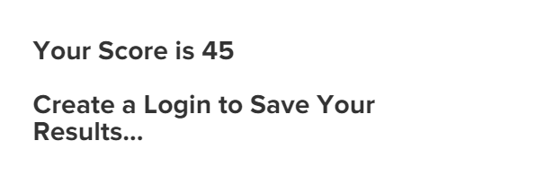

Mind Tools Communication Quiz


