Ellis Jones

1708692

Construction Materials

Through your own research, select two existing buildings from around the world, one of Concrete Frame, one of Steel Frame and report on their original design planning, construction and potential impact in sustainability at the site of the build.

Contents

Introduction – Page 1

Case Study (Steel Frame) Al Bahar Towers, Dubai – Pages 2-6

Case Study 2 (Concrete Frame) 432 Park Avenue, New York – Pages 7-12

Comparison & Conclusion – Pages 13-14

Bibliography – Page 15

Introduction

In this essay I will be studying comparing a number of different factors which differentiate concrete frame buildings from their steel frame counterpart. I will be discussing their design, sustainability, climatic resistance, durability and also their ease of production and further adaptation. The two buildings investigated in this essay are one of steel frame, the Al Bahar Towers in Dubai and also one of concrete frame, 432 Park Avenue, New York. This essay will consist of a case study for each method of construction, followed by a comparison between the two.

Al Bahar Towers, Dubai

- Its durability and climatic resistance, given the environmental conditions it is exposed to at the site.

The Al Bahar Towers are two identical towers located in Abu Dhabi. Construction of the towers was officially completed in 2012. Both towers have many unique characteristics which are beneficial in terms of the surrounding climatic conditions.
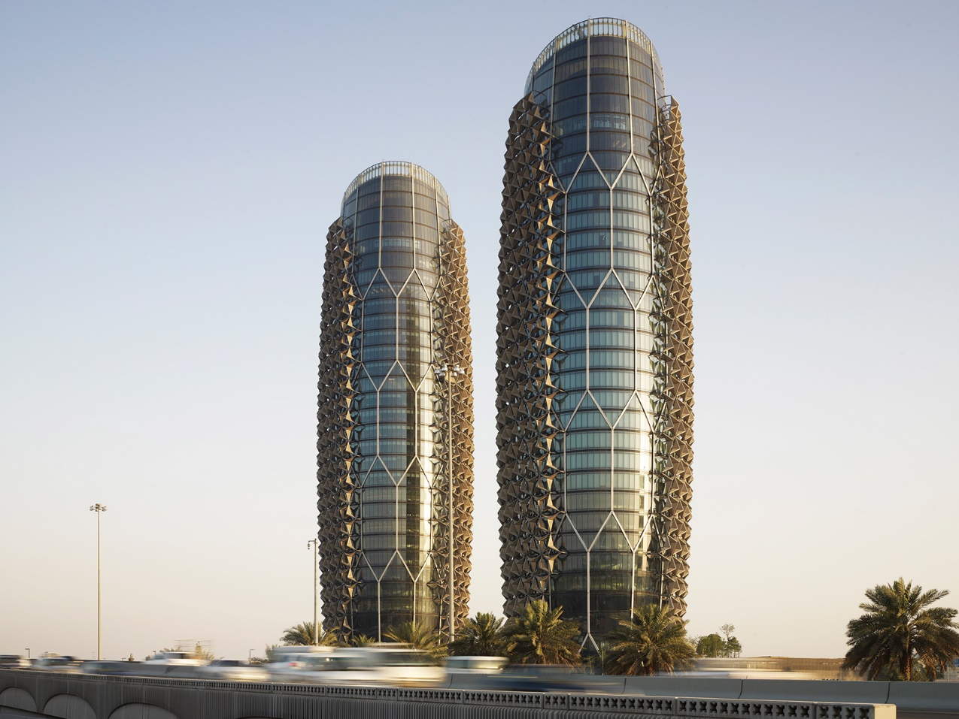

Abu Dhabi is renowned for its high temperatures and low levels of rainfall. It was therefore essential that systems were implicated into the buildings to adapt to their surrounding desert environment. Given its desert environment, one aim of the developer would have been to reduce solar gain as this would mean less air conditioning required. One of these systems implicated into the building can be easily seen on the external skin of the two towers, the “mashrabiya” style façade.

“Each of the two towers comprises over a thousand individual shading devices that are controlled through the buildings management system, creating an intelligent façade with each unit consisting of stretched PTFE (polytetrafluoroethylene) panels. The dynamic façade has been conceived as a contemporary interpretation of the traditional Islamic mashrabiya with umbrella like components opening and closing in response to the suns path” (Al-Kodmany, K, 2017)

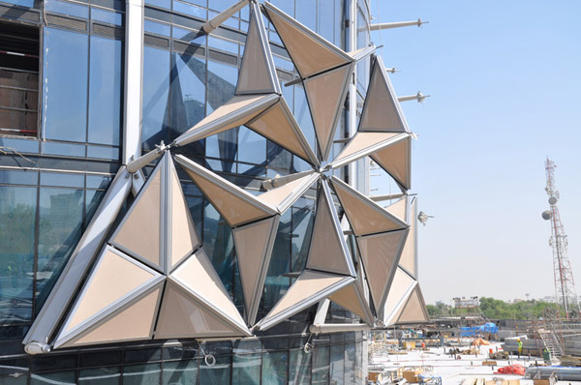

(https://freshome.com/2012/12/24/intelligent-shading-system-showcased-by-abu-dhabis-al-bahar-towers/ Date Accessed 20/11/18)

Further sustainability is achieved through the positioning of solar panels. Due to their positioning, south facing, they’re exposed to optimum levels of sunlight. Dubai experiences many hours of sunlight and so the towers generate a large amount of renewable energy.
Other environmental conditions that would have been taken into consideration when building the Al Bahar Towers are high humidity levels, corrosion (due to its marine environment) and also high wind speeds.
“all main-fixed supporting components like cantilever arms, Y- structure arms, and brackets connecting the system back to the main structure are made of duplex stainless steel, due to its high strength and corrosion resistance”
(Karanouh, A & Kerber, E, 2015)
Unless treated adequately through specialist anti-corrosion coating, the integrity of steel can decrease significantly if exposed to oxygen and water. Although the levels of rainfall are low in Dubai, the towers are situated in a marine environment. The designers would have had to take this into consideration at design stage and ensure that all steel delivered to site had been adequately treated.

Further treatment would have to be made to ensure fire proofing of the steel. Although steel is not a combustible material, there is potential that a fire could start internally and cause the steel to fail.

The two main categories of fire proofing consist of thermal and absorptive. Thermal fire protection typically consists of the installation of specialist insulation and also the application of specialist intumescent paint. This paint is applied to the steel to keep its temperature below melting point for longer, lengthening the time the building can hold its stability. Specialist cement and vermicilite coatings can also be used.

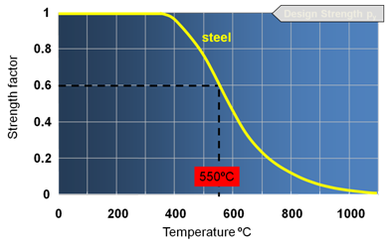

(https://www.steelconstruction.info/Fire_damage_assessment_of_hot_rolled_structural_steelwork Date Accessed 8.12.18)

The above diagram displays the typical stages of steel failure. At around 400 degrees celcius, the steel starts to become flexible. At 550 degrees celcius, the integrity of the steel is now in rapid decline until at around 1300 degrees celcius where it will then melt. This displays how vital it is to protect steel against fire.

- The likely impact of the frame materials original production process to the environment.

The fabric of the building consists of a steel frame, steel floors and a concrete core. One benefit of using a pre-fabricated steel frame for such large developments is that it is produced in a controlled environment. This means that it’s manufactured in a factory with high levels of quality control, leading to a smaller likelihood of any defects and also less wastage as the measurements of these materials will be more accurate.

Further wastage reduction was achieved through the use of BIM as this helped prevent any clashes or incorrect construction, leading to less remedial works.
“An average of 10% waste is common for regular buildings reaching up to 30% waste for bespoke buildings. The Design Team of the Al-Bahr was able to bring the level of waste down to 3% to 5% on this ambitious and complex project”
(Karanouh, A & Kerber, E, 2015)

One negative of the pre-fabrication process however is that it is often much more expensive to manufacture and it is not cheap to transport. The manufacturing process also has a detrimental effect on the enivironment in that the components that make up steel are being mined from the ground (iron ore, coke, limestone) and also they are omitting high levels of CO2 in the process.

“Iron and steel production is one of the major sources of anthropogenic CO₂emissions. In the EU, the sector is responsible for 4.7% of the total emissions, which amounts to a total of 182 million tonnes of CO₂”

(Morfeldt, J, Nifs, W, Silveira, S. (2014)

However, it could be argued that the initial mining and production of steel is less detrimental than it first seems, as steel frames are almost 100% re-usable and do not lose their quality once they’ve been recycled. This means that upon its demolition one day, the waste accumulated from the towers will be kept to a minimum as a lof of the metal will go back into construction.

- The frames ease of assembly and the potential ease of its adaptation to different building shape and use within the life cycle of the building.

Steel is renowned for its high strength and it’s light weight. “ Steel is a good material for building because it combines high strength with low volume and weight, making it cost effective to transport. Steel components can be pre-fabricated very precisely”
(De Gruyter, w, 2012)

As mentioned earlier, the steel is produced in a quality controlled factory environment. This significantally decreases the construction time on site with each piece being delivered in what is known as “just in time” deliveries. It is then down to the site team to assemble each piece of the frame as they get delivered and so the team constructing the Al Bahar towers would have been able to assemble its frame with ease through installing bolts and welding. More benefits from pre-fabricated components are faster construction time, leading to less chance of charges from LAD’s and also less chance of the environment having an effect on materials such as plasterboards getting wet or metal rusting.

The ease of assembly is also relevant in terms of future adaptation. Steel frames are much more adaptable than that of a concrete frame and colunmns can be cut, adjusted and new steel welded into place to alter a buildings design or extend the size of a building.

“if requirements change in the future, steel frames are easier to alter than the concrete alternative”

(Cox, A, Ireland, P, Townsend, M, 2006)

This also lengthens the life span of the building as it will be easier for future remedial works, whereas this isn’t possible with a concrete frame as removing sections without extensive temporary works will have negative effects on the integrity of the building, possibly leading to collapse.

Due to its large span, steel enables designers to have large open plan rooms without the need for columns.

Throughout the towers there are extensive electrical works such as the solar panels, the state of the art façade and many other systems incorporated into the building. A steel frame is beneficial for the distribution of these services as cables and other materials can be run through the steel frame with ease due to the shape of castellated beams.

It should also be noted that as the assembly of a steel frame is easy, it is also easy to dismantle. This is beneficial in that it is easier to retain components for re use and it’s safer and easier to demolish than its concrete counterpart.

432 Park Avenue, New York

- Its durability and climatic resistance, given the environmental conditions it is exposed to at the site.

One major environmental condition that should be taken into consideration when building skyscrapers is the wind. 432 Park Avenue is situated in central Manhattan, an island in New York which experiences high winds. The higher the building, the more prone it is to high winds and at 1,397 feet, 432 Park Avenue certainly falls into this category. Any building with a height to width ratio above 7:1 is considered slender in structural terms. 432 Park Avenue has a ratio of 15:1, deeming the building extremely slender. This could have left the building prone to what is known as “vortex shredding”, where high winds have an adverse effect on a building, causing it to sway and sustain damage.

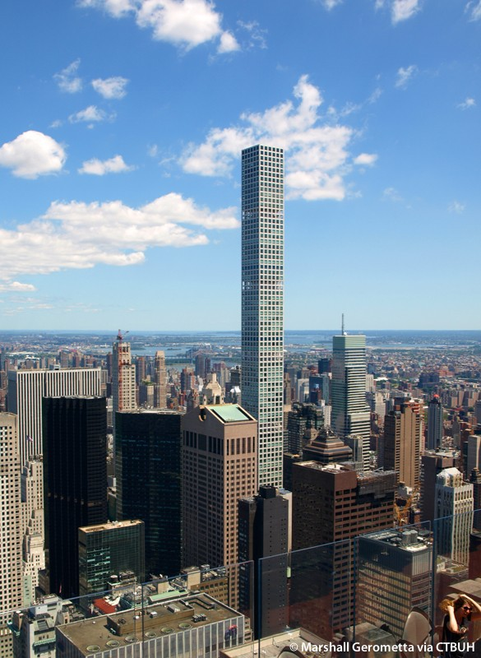

(http://www.skyscrapercenter.com/building/432-park-avenue/13227 Date Accessed 6.1.19)
Modern day skyscrapers such as the Burj Khalifa can rely on large, Y shaped foundations to provide a solid base. However, due to the “postage stamp” size site, situated in the middle of a densely populated Manhattan street, the designers of 432 Park Avenue had to adopt different methods to provide a stable structure. One major preventative measure that was put in place to counter the high wind speeds were to introduce certain voids in the building, as explained in the book “Best Tall Buildings” where the author stated:

“It’s slenderness ratio (dictated by the demands of the site) required inventive concepts to reach structural stability and provide adequate levels of comfort to all occupants. This is achieved through a number of means. Although the tower appears simply as a vertically extended rectangular form, there are actually several two-story void levels that help provide stability against lateral forces. These voids allow air to pass through the building, increasing the lateral stability on the tower and mitigating the “vortex shredding” phenomenon that develops with 90 degree corners” (Wood, A & Henry, S 2016).

These voids occur every twelve floors and consist of two open floors with no windows, allowing wind to pass through them. These void floors containin mechanical services which are often stored in basement or loft spaces of high rise buildings. Instead, the loft of 432 Park Avenue contains another system to prevent movement with the wind. Due to it’s height, it could feel very uncomfortable for those in the highest apartments during high winds. Mass dampers have been installed to prevent this movement. These are essentially concrete weights that counter act the movement of the building during high wind speeds.

The digram below displays the positioning of these void floors and also shows the outriggers installed. These are essentially structural beams that connect walls and exterior columns to stiffen a structure.

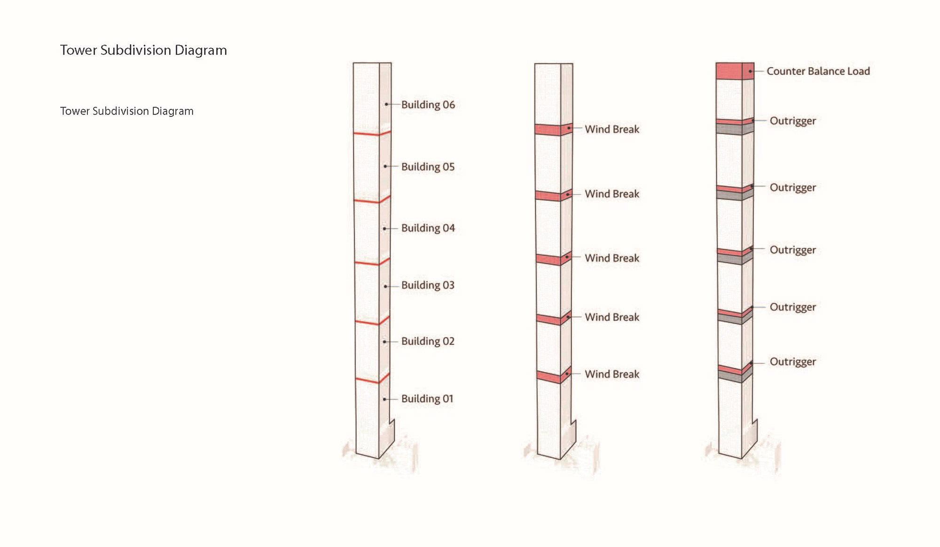

(https://www.theplan.it/eng/webzine/international-architecture/en-432-park-avenue Date Accessed 8.12.18)

The buildings walls are of re-inforced concrete to provide the structure with more tensile strength as naturally, concrete is strong in compression but not in tension.

“Concrete is very strong in compression but relatively weak in tension. To overcome this deficiency when concrete is used as a structural building material, and to combat early shrinkage and control subsequent diurnal thermal expansion and contraction, reinforcement (historically iron and later steel) is included in areas where tension occurs to create reinforced concrete”
(Macdonald, 2008)

Due to this, it is vital that the steel reinforcement within the structure are protected from the elements as this could seriously compromise the structural integrity of the building.

- The likely impact of the frame materials original production process to the environment

Like steel, concrete production has a significantly negative effect on the environment.

“Concrete production has several negative impacts on the environment, such as the emission of CO2 and other greenhouse gases and the use of non-renewable natural resources like natural stone and water”

(De Brito, J, Saikia, N, 2012)

Carbon dioxide emissions are so high during production due to the burning of coal. Coal is used as the reducing agent in blast furnaces and so it is a vital part of the production process.

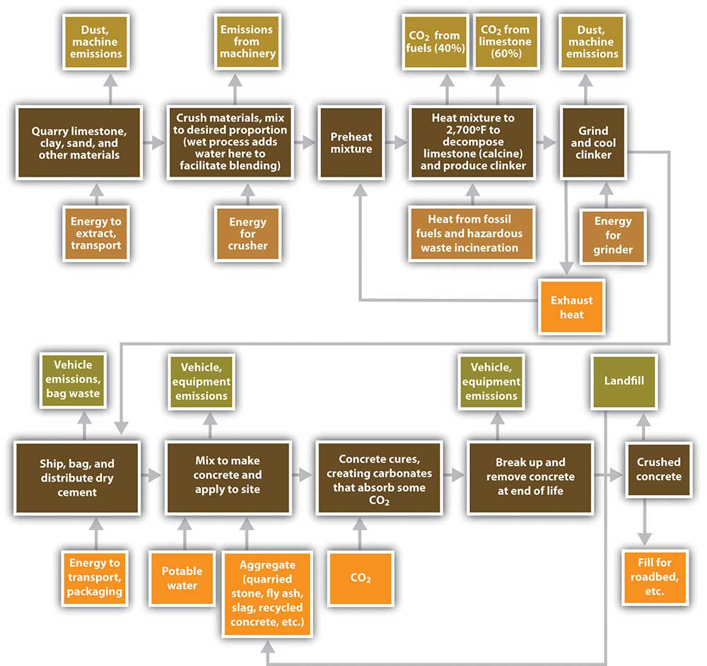

http://www.greenspec.co.uk/building-design/environmental-impacts-of-concrete/ Date Accessed 10.12.18)
The diagram above displays the concrete production process and the different ways in which it affects the environment. One part of this process which has a major effect on the environment is the burning of fossil fuels which leads to the emission of carbon dioxide. Other detrimental side effects of the process are dust, heat and noise pollution, particularly during transportation. Also, the quarrying of aggregates and other materials needed for the production process result in the degradation of landscapes, the loss of agricultural land and can have a negative impact visually on rural areas.

- The frames ease of assembly and the potential ease of its adaptation to different building shape and use within the life cycle of the building

Concrete frame buildings aren’t typically known for their ease of assembly. However, due to a state of the art specialist “Table Lifting System”, the contractors were able to complete the building in just 20 months with a much smaller work force than would typically be required. The system, provided by ‘Doka’, used hydraulic systems to slowly raise itself up the building floor by floor, hoisting materials up the tower, meaning that cranes were not as essential as they would so often be on a building site. This was vital as due to the “postage stamp” nature of the site, a crane would not have been a viable option.

Although concrete frame buildings are not as adaptable as their steel frame counterpart, it is still possible to make adaptations. It would be more difficult to adapt a concrete frame as it is heavy and would require cutting into sections. Due to its weight, it’s likely that temporary structural support will need to be in place and it should be taken into account that the foundations of the building may need to be adapted to account for the extra weight.

Conclusion

Upon studying each case study, there are a number of different beneficial factors for each method of construction.

One stand out advantage of concrete frame that is accepted across the construction industry is it’s fire resistance qualities in comparison to that of steel. A concrete frame building better maintains its integrity in a fire in comparison to steel. When exposed to extreme heat steel frames buckle under too much heat as displayed in the tragic event of 9/11.

“The greatest disadvantage of steel construction in comparison with concrete is the extra work to provide adequate fire resistance”
(De Gruyter, W, 2012)

A designer could also be swayed by a concrete frames natural thermal gain and sound proofing qualities. This could save a lot of time and money as although there would still be need for insulating and boarding, it would be less extensive than that of a steel frame build.

Another attractive element of a concrete build is its rigidity and its natural strength. Also, this naturally high compressive strength can be combined with steel reinforcement in order to improve its tensile strength.

It can be poured in situ, making it arguably more workable than a steel frame.

However, whilst there are many positives to concrete, many contractors will prefer the steel alternative. It’s main positives, pre-fabrication and fast installation mean that contractors are less likely to face late fees and less complications due to high quality control in a factory environment.

Steel is also highly suitable for contractors working to a tight schedule as it is light and easier to assemble. Alternatively, with concrete, although some components can be pre-fabricated, should the contractors opt to produce the frame in situ, they must wait until the concrete has set and reached a certain level of solidity.

“The essence of forming any concrete element is to pour the viscous mix into a mould – the formwork – that defines its external profile, and to leave this in place until the concrete has hardened sufficiently for the formwork to be safely removed. This may be done at the required location of the element, when the work is described as ‘in situ’ concrete”
(Macdonald, 2003)

In conclusion, I believe that both methods of construction certainly have their pros and cons. However, it is of my opinion that steel frame construction possesses higher qualities than its concrete counterpart, particularly due to its ease of assembly and the speed in which it can be erected. From a conctractors point of view, its speed of assembly is highly attractive as this decreases the likelihood of overdue projects, resulting in a lower risk of sustaining late fees.

This is supported in the text of “Architecture and Construction in Steel where the author concludes that - “What emerges clearly is the greater speed of steel construction. At the narrowest definition of cost, a steel frame is likely to be more expensive to buy and build than a concrete one. Extend the definition to include the foundations, and the cost difference is smaller”
(Blanc, A, McEvoy, M, Plank, R, 2003)

The savings on foundations are due to the fact that concrete structures are typically heavier than steel and so more extensive support is required from the foundations, should concrete be the material of choice.

“Extend the definition of cost, however, to include the cost of the time taken to complete the building – the contractor’s overheads, the interest on the money to finance the project – and then also to include the benefits fo earlier completion, either in rental income or earlier use of new facilities, the economic advantages of steel construction can be very real”
(Blanc, A, et al 2003)

Bibliography

Books

Al-Kodmany,K (2017). Understanding Tall Buildings. .: Taylor & Francis. 108-109.

Karanouh, A & Kerber, E, (2015). Innovations in dynamic architecture The Al-Bahr Towers Design and delivery of complex facades. .: IOS Press. 200-201.

De Gruyter, W (2012). Prefabricated Systems: The Principles of Construction. 70-71.

Cox, A, Ireland, P, Towsend, M, (2006). Managing in Construction Supply Chains and Markets: Reactive and Proactive Options for Improving Performance and Relationship Menagement. : 84.

Wood,A & Henry,S (2016). Best Tall Buildings: CTBUH Awards: A Global Overview of 2016 Skyscrapers:The Images Publishing Group. 29-30.

MacDonald, S (2003). Concrete Building Pathology. London: Blackwell. 5.

De Brito, J, Saikia, N, (2012). Recycled Aggregate in Concrete: Use of Industrial, Construction and Demolition Waste. .: Springer Science. 4.

Blanc, A, McEvoy, M, Plank, R, (2003). Architecture and Construction in Steel. .: Taylor & Francis. 137-139.

Journals

Morfeldt, J, Nifs, W, Silveira, S. (2014). The impact of climate targets on future steel production - an analysis based on a global energy system model. Journal of Cleaner Production. 103 (.), 469.

Websites (Charts and Photos)

http://www.asiagreenbuildings.com/8288/uae-al-bahar-towers-moving-closer-truly-sustainable-construction/

https://freshome.com/2012/12/24/intelligent-shading-system-showcased-by-abu-dhabis-al-bahar-towers/

