University of Wales Trinity Saint David
School of Engineering
Motorsport Engineering BEng

Kinetic Energy Recovery
Alternative Propulsion Systems (ACHA5010)

Priveshnan Soemani Segaran
2204879
November 2023

Contents
1. Introduction 3
2. Selected Vehicle 4
3. Worldwide Harmonised Light Vehicle Test Procedure (WLTP) 6
4. Spreadsheets 8
5. Largest Possible KERS 13
6. Suitable KER system 14
7. Kinetic Energy Recovered 16
8. Kinetic Energy Recovery System 17
References 19

1. Introduction
A Kinetic Energy Recovery System (KERS) is a technology used in various vehicles, particularly in the realm of motorsports and hybrid vehicles, to recover and store the kinetic energy that is typically lost during braking. KERS are mechanisms used to store kinetic energy for later use. It functions by transforming the kinetic energy that would have been wasted as heat in the event that the vehicle had not been equipped with a recovery system into electrical energy that may be stored in a flywheel, supercapacitor, or battery. (EnergyEducation, 2023). The primary purpose of KERS is to improve overall energy efficiency and fuel economy. The capacity of KERS to store kinetic energy during braking or deceleration is fundamental to the system. Regenerative braking systems, which transform the vehicle's kinetic energy into electrical energy, help to facilitate this process. In contrast to conventional braking systems, which release this energy as heat, KERS makes sure that it is captured and used again. There are two primary types of KERS which are electrical and mechanical. Electrical systems are prevalent in hybrid road vehicles, where an electric motor/generator is employed to convert and store kinetic energy. In contrast, mechanical systems use a flywheel to achieve the same purpose. The choice between these types often depends on the specific requirements and design considerations of the vehicle. (Sarkar, 2016). The captured electrical energy is then directed to a storage system, typically a high-capacity battery or a flywheel. This stage is critical for preserving the harnessed energy efficiently until it is needed for propulsion. In electric KERS (e-KERS) systems, the electrical energy is stored in batteries, while mechanical KERS systems utilize a rotating flywheel for storage. The stored energy is released from the storage system when the vehicle needs an extra burst of power, for example when accelerating or navigating an uphill terrain. This is driving an electric motor in e-KERS systems and releasing stored energy from the spinning flywheel in mechanical KERS systems. This feature not only improves efficiency but also makes driving more environmentally friendly and fuel-efficient. KERS overcomes the inefficiencies in conventional braking systems by collecting and recycling energy that would otherwise be wasted. As a result, energy efficiency has significantly increased overall, improving fuel economy, and having a less negative environmental impact. Because of this characteristic, KERS has become very popular in the racing industry, where small efficiency increases can result in a competitive advantage.

2. Selected Vehicle
The vehicle that has been selected for this assignment is the BMW 330e G20. The BMW 330e's engine is a turbocharged petrol, 2 litre, double overhead camshaft 4 cylinder with 4 valves per cylinder. This unit produces 181 bhp (184 PS/135 kW) of power at 5000-6500 rpm, and maximum torque of 300 N·m (221 lb·ft/30.6 kgm) at 1350-4000 rpm. This car has a curb mass of 1845 – 1905 kg and a test mass of 2265 – 2355 kg. The car has a drag coefficient of 0.25 with a frontal area of 2.23m^2. The rolling resistance of this car is measured at 0.013.

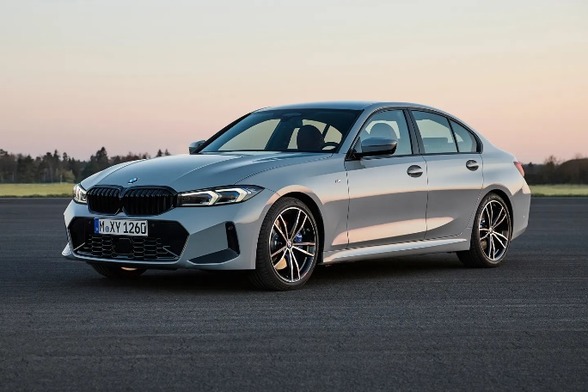
Figure 1: BMW G20 330e (PistonHead, 2022)

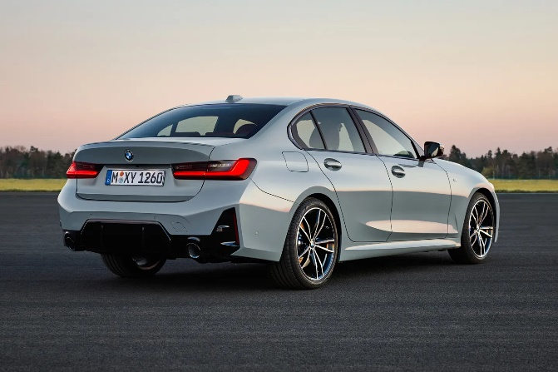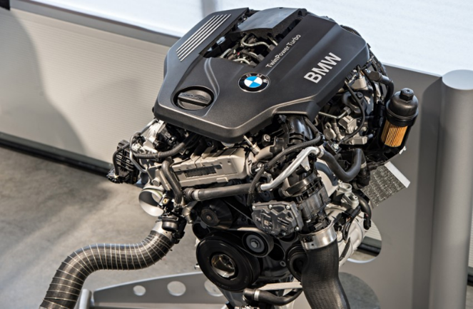
Figure 2: BMW G20 330e (PistonHead, 2022) Figure 3: BMW G20 330e Engine (Paultan, 2014)

Coast Down Test
The quest for improved fuel efficiency and performance in the automotive industry has driven the development of advanced testing methodologies to scrutinize various factors influencing a vehicle's behaviour. Among these methods, the coast-down test stands out as a pivotal procedure designed to evaluate rolling resistance and aerodynamic drag. To begin the coast down test the vehicle must be in optimal working condition, and tire pressures should align with manufacturer specifications. Extraneous items that could interfere with test results are removed. The primary objective is to measure the resistance forces acting on the vehicle during coasting conditions specifically, rolling resistance and aerodynamic drag. The methodology of the test begins with the acceleration phase, where the vehicle is driven to a predetermined speed, typically ranging from 70 to 80 miles per hour or 110 to 130 kilometres per hour. This phase serves to achieve a stable speed from which the coast-down test can commence. Upon reaching the desired speed, the driver disengages the engine and shifts the transmission into neutral. The vehicle is allowed to coast freely, subject only to external forces like rolling resistance and aerodynamic drag. This phase captures the vehicle's natural deceleration, providing crucial data for analysis. The heart of the coast-down test lies in the analysis of collected data. Rolling resistance, influenced by factors like tire characteristics and vehicle weight, is unveiled through the examination of deceleration rates. Simultaneously, aerodynamic drag, intricately tied to the vehicle's shape and frontal area, is scrutinized. By quantifying these forces, engineers gain invaluable insights into the overall efficiency and performance of the vehicle. To ensure the reliability and consistency of results, coast-down tests are often repeated multiple times. Averaging results from repeated tests enhances the robustness of the data obtained. (Intertek, 2015).

3. Worldwide Harmonised Light Vehicle Test Procedure (WLTP)
WLTP stands for Worldwide Harmonised Light Vehicle Test Procedure. It is a global standard for measuring the fuel consumption and emissions of vehicles. The WLTP is designed to provide more accurate and realistic data on a vehicle's fuel consumption and emissions compared to the previous testing procedure, the New European Driving Cycle (NEDC). The WLTP was introduced to address the shortcomings of the NEDC, which was criticized for being outdated and not reflecting real-world driving conditions. The WLTP uses a more dynamic and representative driving cycle, including a wider range of speeds, acceleration, and deceleration, as well as more realistic ambient temperatures. This results in more accurate and reliable data on a vehicle's fuel consumption and emissions. The adoption of WLTP is part of efforts to ensure that consumers have more reliable information about the environmental performance of vehicles and to encourage the development and adoption of more fuel-efficient and environmentally friendly technologies in the automotive industry. (Dale, 2021).
There are several classes of the WLTP being:
Class 1 - low power vehicles with PWr <= 22;
Class 2 - vehicles with 22 < PWr <= 34;
Class 3a - high-power vehicles with PWr > 34 and Vmax < 120 Km/h
Class 3b – high-power vehicles with PWr > 34 and Vmax ≥ 120 Km/h
The BMW 330e falls under class 3b.

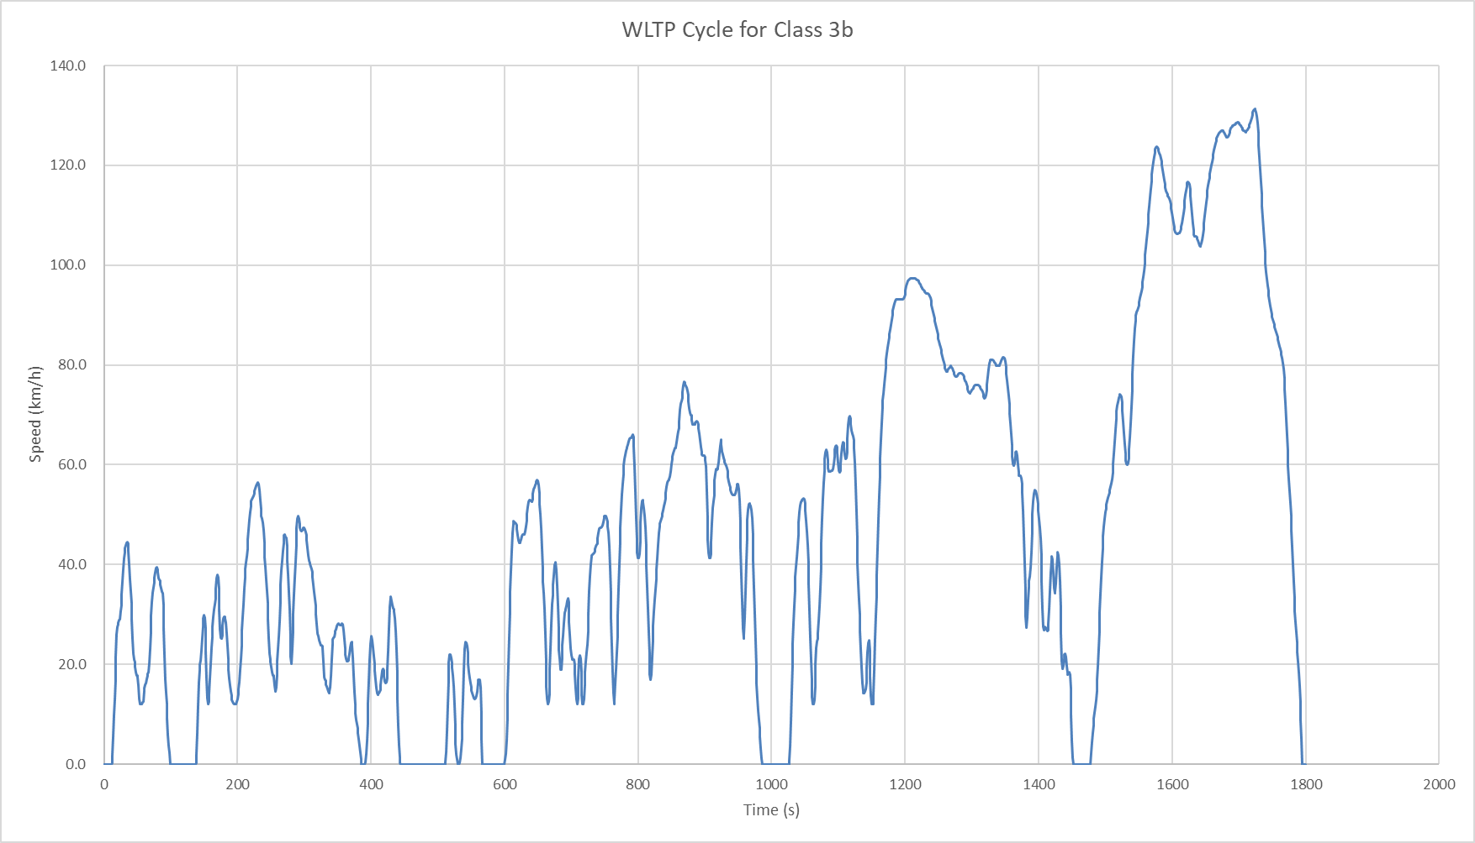
Figure 4: WLTP cycle for vehicles in class 3b

4. Spreadsheets

Graphs of Acceleration Resistance
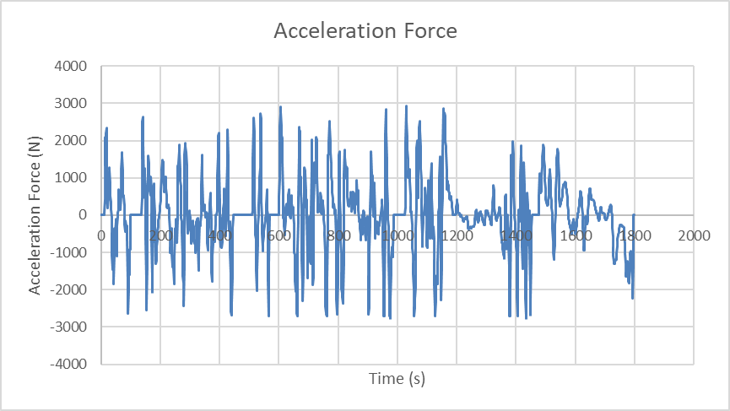
Figure 5: Acceleration Resistance Graph

Graph of Aerodynamic Resistance
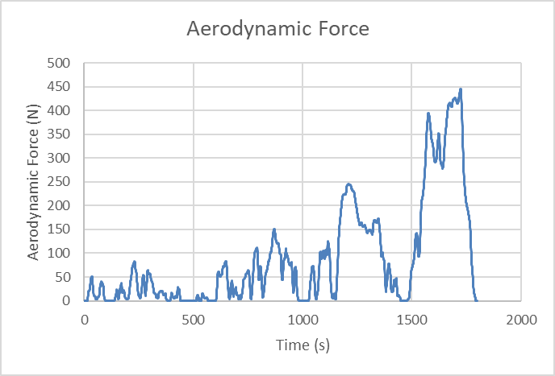
Figure 6: Aerodynamic Resistance Graph

Graph of Rolling Resistance
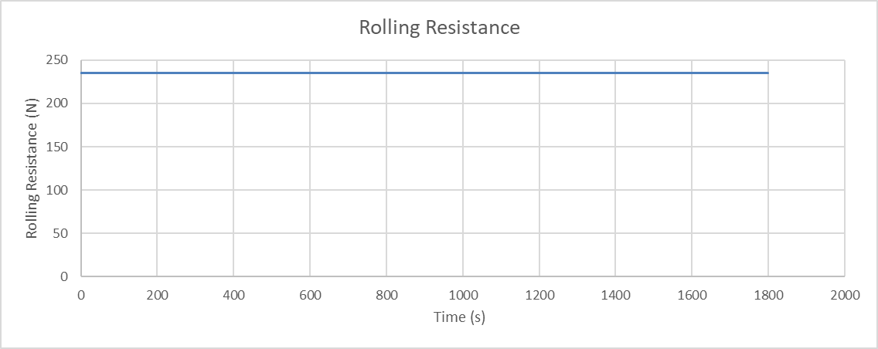
Figure 7: Rolling Resistance Graph

Graph of Total Resistance
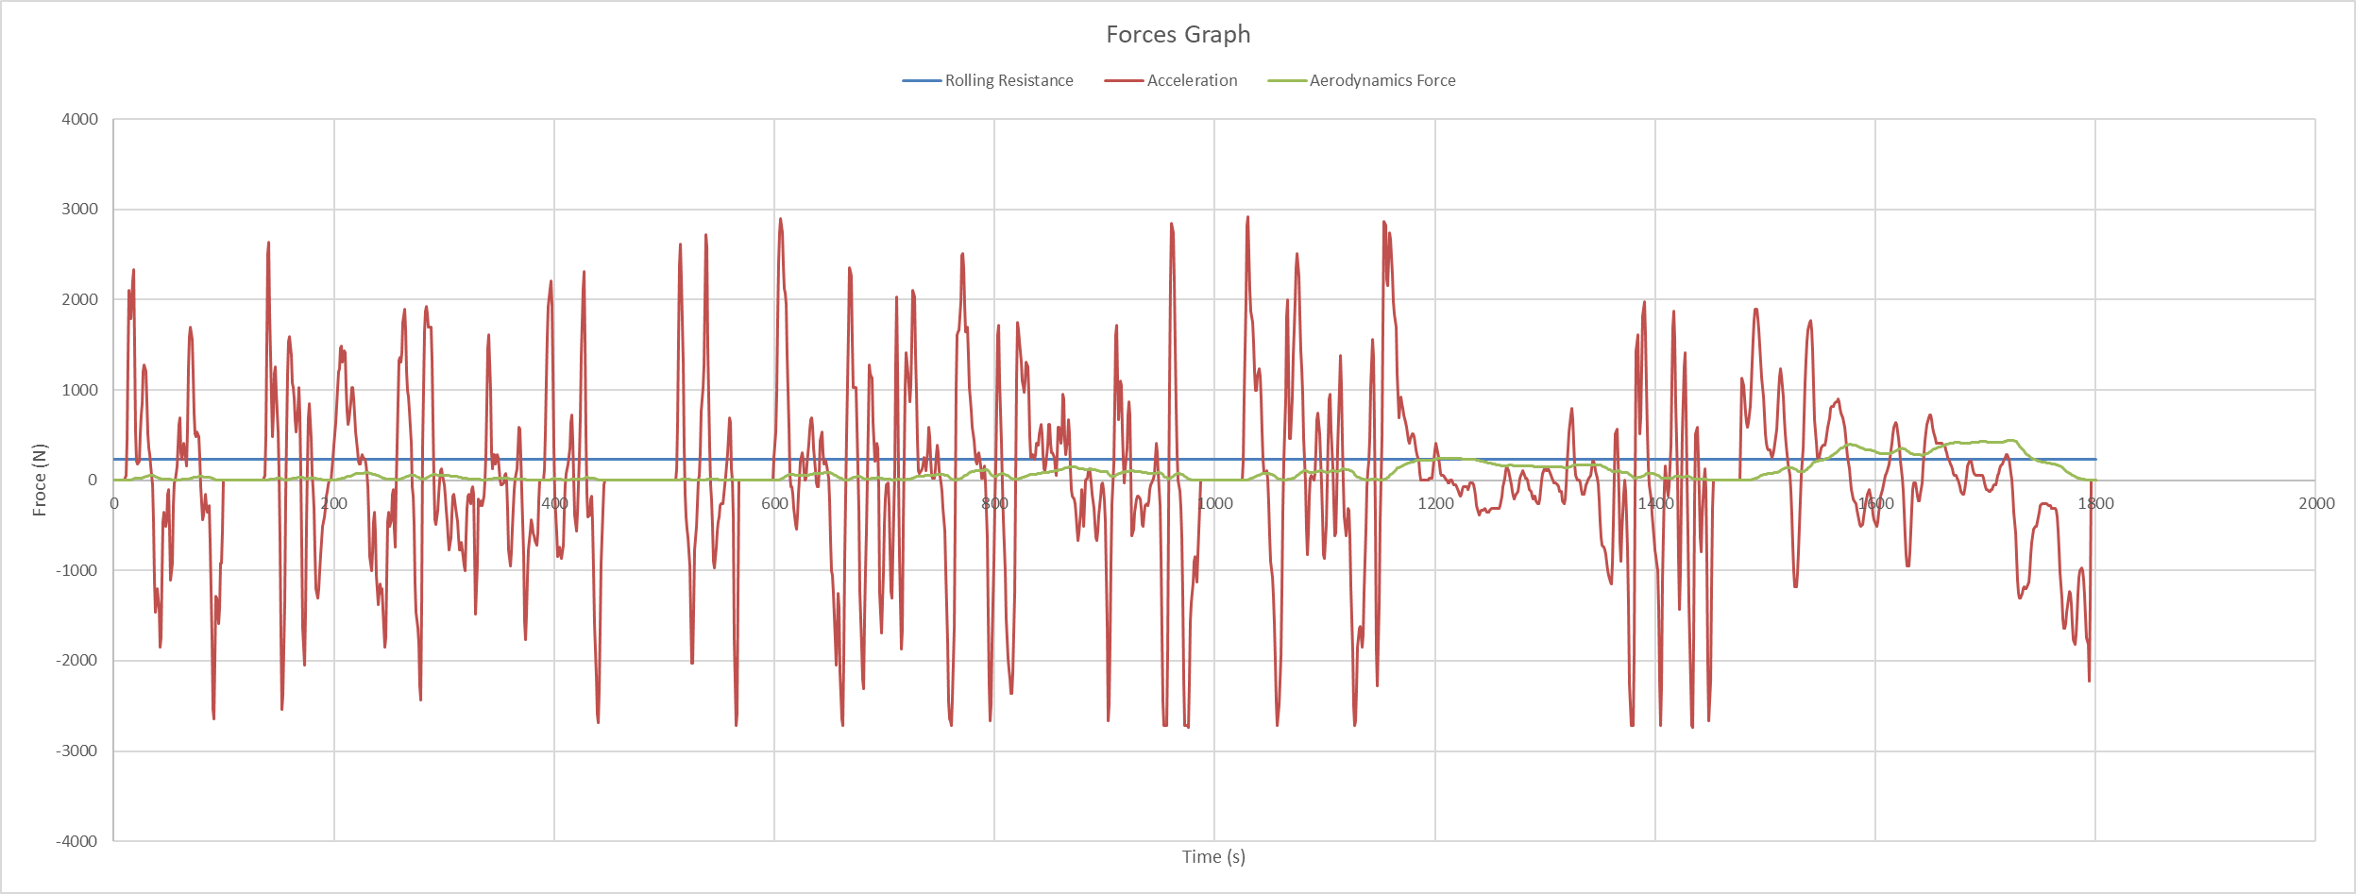
Figure 8: Total Resistance to Motion Graph

Graphs of Cumulative Tractive and Braking Energy
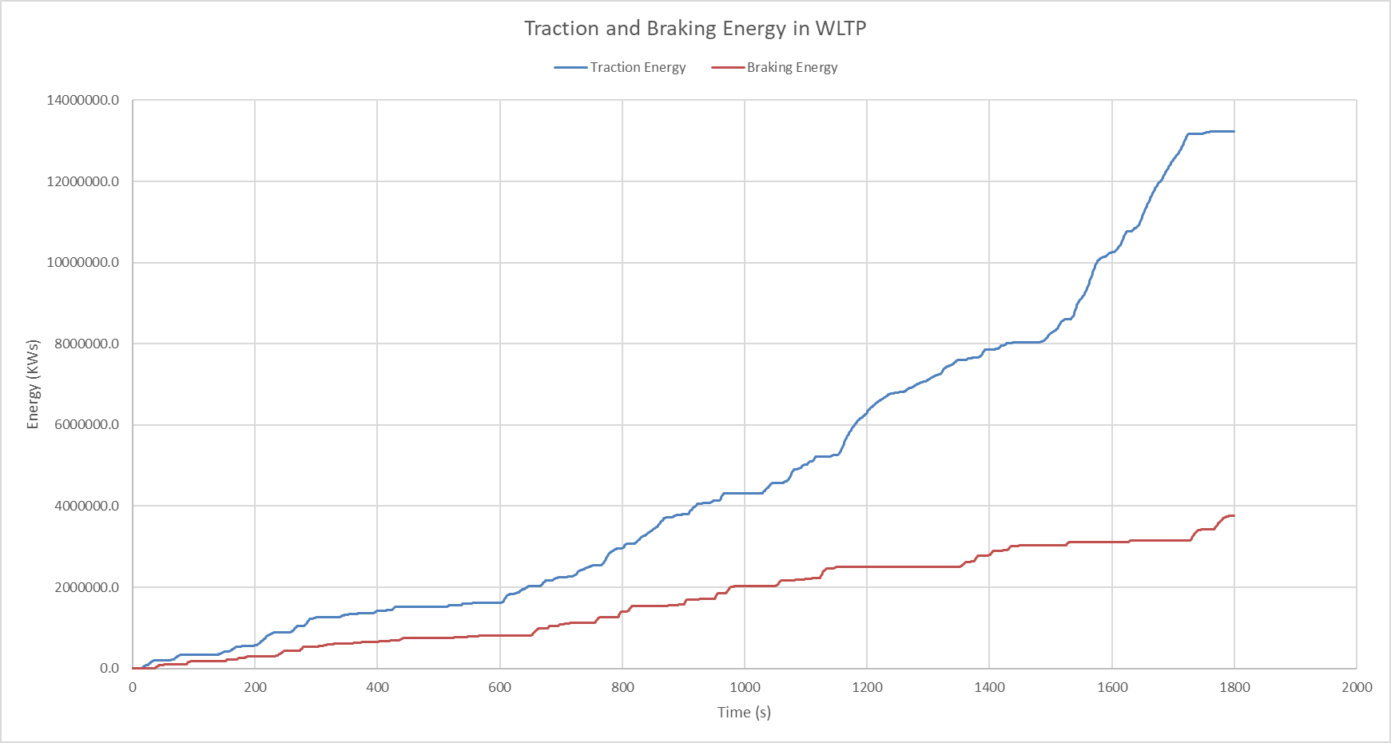
Figure 9: Graphs of Cumulative Tractive and Braking Energy

5. Largest Possible KERS
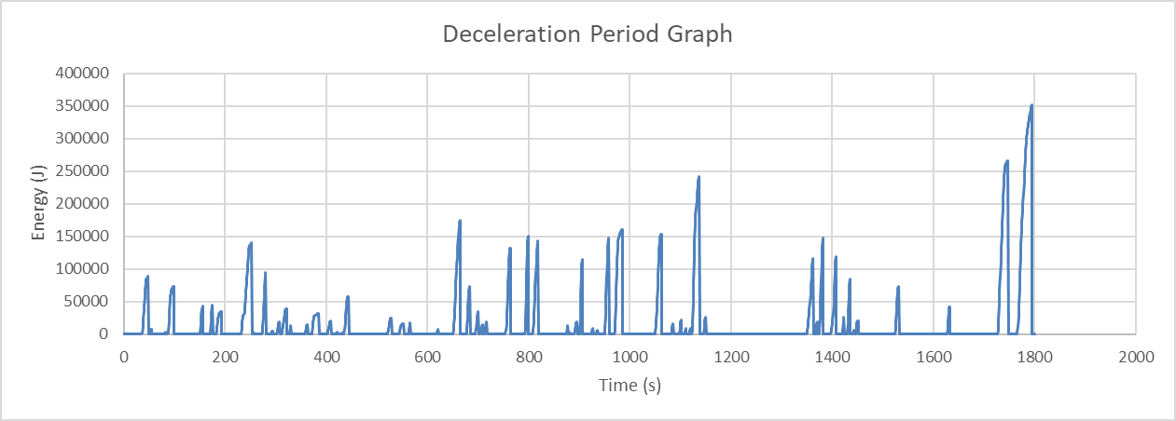
Figure 10: Deceleration Period Graph
Referring to figure 10, the largest value on the graph is 350000 joules which is a very unrealistic value. This is because it is unlikely that the vehicle is coming to a full stationary stop from 130kmh. Instead, the value that is more plausible is the one marked between 1000 to 1200 seconds valued at 2377591.102 joules. Where the vehicle is most likely coming to a stationary position from 40kmh.

6. Suitable KER system
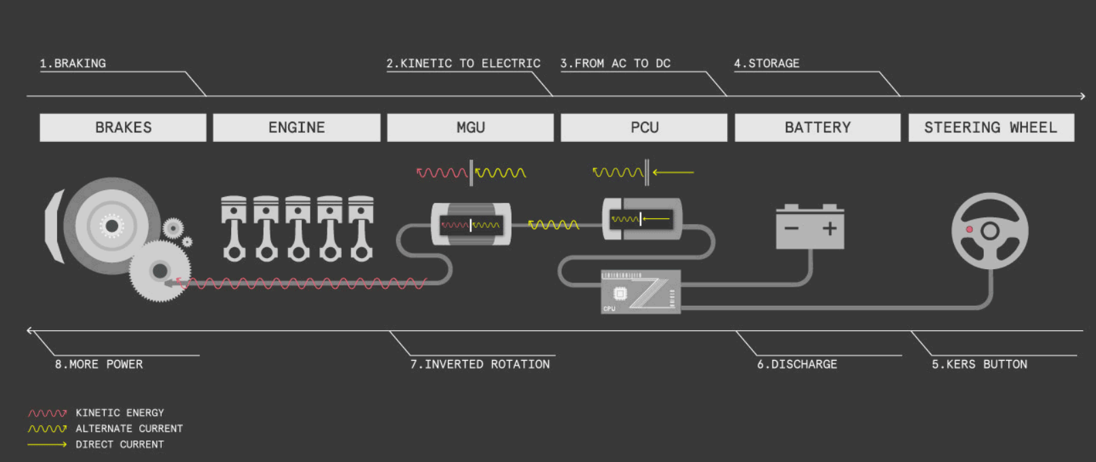
Figure 11: Basic KERS Process (EnergyEducation, 2023)
The amount of energy that is being used by the BMW 330e is 2377591.102 joules. The energy first goes through the gears. According to research, gears tend to have an efficiency of 98%. These gears are connected to an MGU-K (motor generated unit – kinetic). The efficiency of the MGU-K is valued at 92.5% for this system. The MGU-K converts kinetic energy to alternative current which will be stored later. The energy then goes through the PSU (power supply unit) / PCU (power control unit), where it is converted from AC to DC. The PSU/PCU tend to have an efficiency value of 89% to 95%. From this system we will assume 90% efficiency. The battery then receives the converted DC energy and stores it. The battery has an efficiency of 90% to 95%. For this system the battery is assumed to be at 90% efficiency. However, the battery must be doubled in size to ensure that the depletion does not have detrimental impact on the batteries output. The battery must have the ability to store 350858.45 joules. (EnergyEducation, 2023)
A battery that can be selected is a 12V 9Ah battery. An example of this is a Duracell Original DR9-12 Valve Regulated Lead Battery-12V | 9Ah - Replaces PW91210 | CP1290 | Ultra-max NP9-12 | E300. (DuracellDirect, 2023). After the energy reaches the battery, the process goes in reverse because the energy is charged and discharged in the same way (ReddyK, 2018). This means the output and input efficiency values are the same.

The physical dimensions of the 12V 9Ah batteries are (L x W x H) ~5.94 x 2.56 x 3.70 inches (~151 x 65 x 94 mm). (BatteryEquivalents, 2023)
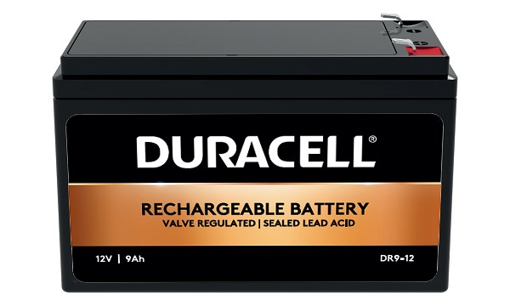
Figure 12: 12V 9AH Battery (DuracellDirect, 2023)

The pursuit of sustainable and efficient energy solutions has become paramount in the face of environmental challenges and the increasing demand for cleaner technologies. Kinetic Energy Recovery Systems (KERS) plays a pivotal role in this endeavour, and among the variety of options available, batteries emerge as the superior choice. One of the key reasons why batteries stand out as the best KERS is their high efficiency in converting kinetic energy into stored electrical energy. Traditional mechanical KERS, such as flywheels, suffer from energy losses due to friction and mechanical constraints. However, batteries demonstrate remarkable efficiency in capturing and storing kinetic energy, to ensure minimal losses during the conversion process. Batteries are the best option because of their adaptability. Batteries are versatile and adaptable to a wide range of industries and technology because they may be easily incorporated into a multitude of systems and applications. Batteries provide an adaptable and very scalable method of kinetic energy recovery, whether they are used in renewable energy systems, industrial machinery, or electric car applications. The environmental impact of energy recovery systems is a critical consideration in the quest for sustainable technologies. Batteries, particularly those based on advanced technologies like lithium-ion, contribute significantly to reducing the carbon footprint of various applications. By efficiently recovering and storing kinetic energy, batteries promote the use of cleaner energy sources and decrease reliance on fossil fuels. In the context of electric vehicles, batteries enable regenerative braking, converting the kinetic energy during braking into electrical energy that can be reused for acceleration. This not only enhances the vehicle's energy efficiency but also reduces the overall energy consumption and emissions associated with transportation. (ReddyK, 2018)

7. Kinetic Energy Recovered
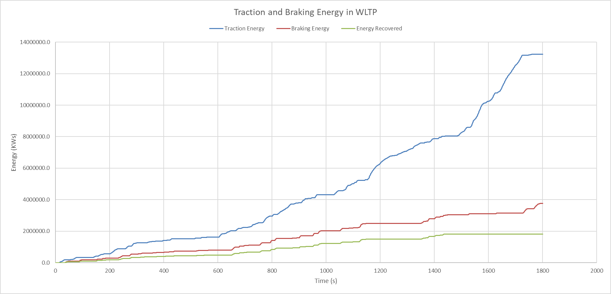
Figure 13: Kinetic Energy Recovered that is returned to the wheel road contact.

8. Kinetic Energy Recovery System

How it Operates
The fundamental principle underlying KERS is the capture of kinetic energy generated during braking. Traditionally, there will be lost of heat through friction in conventional braking systems, this surplus energy becomes a valuable resource in a vehicle equipped with KERS. The first step in the process involves a motor-generator unit, strategically positioned in the vehicle's drivetrain. Critical to the efficiency of KERS is a sophisticated control system that monitors a variety of parameters such as vehicle speed, braking force, and the state of charge of the energy storage system. This control system orchestrates the entire process, determining optimal times for energy harvesting and release. It ensures seamless integration with the vehicle's internal combustion engine, a vital aspect for achieving synergistic performance (Ahmed T. Hamada, 2022). The stored energy in the KERS is not merely a passive reservoir, it is a dynamic source ready to be deployed when needed. When the driving demands additional power for acceleration, the control system activates the KERS. The stored energy is then released from the energy storage system and channelled to an electric motor connected to the drivetrain. This supplementary power augments the internal combustion engine, providing an immediate boost in torque and acceleration. The integration of KERS into the overall powertrain of the vehicle is a harmonious combination of traditional and advanced technologies. The electric boost seamlessly complements the internal combustion engine, resulting in a synchronized power delivery. The continuous monitoring and optimization performed by the control system ensure that the KERS operates at peak efficiency, contributing to overall fuel efficiency and reduced environmental impact. (EnergyEducation, 2023)

Assumptions
A set of common assumptions is often made to facilitate mathematical modelling and simplify the complexities associated with real-world dynamics. At the core of KERS analysis lies the bedrock principle of conservation of energy. This first assumption asserts that the total energy within the system, encompassing both kinetic and potential energy, remains constant unless acted upon by an external force. This assumption provides a fundamental framework for understanding the energy flows within the system. Acknowledging the non-ideal nature of physical systems, engineers often assume a certain level of efficiency for KERS (Melito, 2022). This efficiency accounts for losses due to a variety of factors such as friction, air resistance, and other forms of dissipation. While these assumptions streamline calculations, they underestimate the values needed for real-world testing and optimization to enhance actual system performance. Simplifying assumptions regarding the mass and inertia of KERS components are prevalent in mathematical models. While these assumptions help in simplifying equations, they may not hold true value in all practical scenarios, especially when considering the complicated and dynamic nature of real-world applications. In the search of analytical tractability, idealized components are often assumed, ranging from frictionless bearings to perfect energy storage devices with no additional loses. Such idealizations facilitate the development of mathematical models but necessitate a cautious approach when translating theoretical predictions into practical applications. (wdbgroup, 2020)

Variations between ICE and Friction Brake Vehicles
One of the most obvious distinctions lies in the feel of regenerative braking itself. Unlike the abrupt and often jerky deceleration associated with traditional friction brakes, regenerative braking offers a more nuanced and controlled experience. This is owed to the system's ability to harness kinetic energy during deceleration, converting it into electrical energy to recharge the vehicle's battery. The result is a smoother, more harmonious deceleration process that resonates with drivers seeking a refined and responsive driving experience. The dynamic driving experience of electric vehicles is further shaped by the seamless integration of coasting and regeneration. Lift-off from the accelerator initiates a coasting effect, while regenerative braking engages when the driver intends to slow down or come to a stop. This harmonious dance between kinetic energy and deceleration mechanisms provides a unique and engaging driving experience, setting EVs apart from their traditional counterparts. Electric vehicles typically use a system that blends regenerative and friction braking for more effective stopping power. This transition may feel different compared to traditional vehicles that rely solely on friction brakes. Regenerative braking systems can offer more precise control, especially at low speeds. This can be beneficial for parking and navigating in tight spaces. (Han, 2022)

References
Ahmed T. Hamada, 2022. An overview of regenerative braking systems. [Online]
Available at: https://www.sciencedirect.com/topics/engineering/kinetic-energy-recovery-system
[Accessed 12 January 2024].
BatteryEquivalents, 2023. 12V 9Ah Battery: Sealed Lead Acid Batteries vs. Lithium Batteries. [Online]
Available at: https://www.batteryequivalents.com/12v-9ah-battery-sealed-lead-acid-batteries-vs-lithium-batteries.html
[Accessed 11 January 2024].
Dale, N., 2021. What is WLTP and what does it mean? WLTP Explained. [Online]
Available at: https://www.evanshalshaw.com/blog/what-is-wltp/
[Accessed 27 December 2023].
DuracellDirect, 2023. Duracell 12V 9Ah VRLA Battery. [Online]
Available at: https://www.duracelldirect.co.uk/pno/dr9-12.html
[Accessed 11 January 2024].
EnergyEducation, 2023. Kinetic energy recovery system. [Online]
Available at: https://energyeducation.ca/encyclopedia/Kinetic_energy_recovery_system
[Accessed 25 December 2023].
Han, J., 2022. EV Braking Requires a Different Approach. [Online]
Available at: https://nrsbrakes.com/blogs/blog/ev-braking-requires-a-different-approach
[Accessed 11 January 2024].
Intertek, 2015. Test Specification – Coastdown Testing. [Online]
Available at: chrome-extension://efaidnbmnnnibpcajpcglclefindmkaj/https://avt.inl.gov/sites/default/files/pdf/reports/IntertekTestSpecCoastdownTesting.pdf
[Accessed 26 December 2023].
Melito, S., 2022. ICE Vehicles vs. Electric Vehicles. [Online]
Available at: https://www.elastoproxy.com/ice-vehicles-vs-electric-vehicles/
[Accessed 12 January 2024].
Paultan, 2014. BMW’s new B48 2.0 litre four-cylinder TwinPower Turbo engine to produce up to 255 hp and 400 Nm. [Online]
Available at: https://paultan.org/2014/02/25/bmws-new-2-0-litre-twinpower-turbo-engine-255hp-400nm/
[Accessed 26 December 2023].
PistonHead, 2022. BMW unveils G20 3 Series facelift. [Online]
Available at: https://www.pistonheads.com/news/ph-germancars/bmw-unveils-g20-3-series-facelift/45693
[Accessed 26 December 2023].
ReddyK, J., 2018. Regenerative braking. [Online]
Available at: https://www.sciencedirect.com/topics/engineering/kinetic-energy-recovery-system
[Accessed 11 January 2024].
Sarkar, A., 2016. Kinetic Energy Recovery Systems in Formula 1. [Online]
Available at: http://large.stanford.edu/courses/2015/ph240/sarkar1/
[Accessed 25 December 2023].
wdbgroup, 2020. Energy Recovery Systems (ERS). [Online]
Available at: https://wdbgroup.co.uk/blog/energy-recovery-systems/
[Accessed 11 January 2024].

