  A report on Sainsbury’s and the effect that the global COVID pandemic had on the organisation. |   Thomas Shanks (2006042)

Introduction & Executive Summary.
This study focuses on J Sainsbury Plc (Sainsbury’s), a UK-based supermarket which has experienced changes because of the COVID-19 pandemic (Xiao et al., 2021). Sainsbury’s is the second largest supermarket in the United Kingdom and faces competition from supermarkets such as Tesco plc (Bentham 2018). According to Guo and Wang (2019), Sainsbury’s falls under the retail sector since it sells glaciers, general merchandise and clothing items. The COVID-19 pandemic made most businesses adopt cutting-edge technology to sell their products to customers (Whalley and Curwen, 2023). Social distance measures also restricted individuals from purchasing products from physical shops because of fear of virus infection (Rossetti et al., 2022). Therefore, this made most businesses, such as Sainsbury’s, use online selling means to reach customers. For instance, Sainsbury’s embraced pay&Go technology to allow customers to scan the products and make payments without being in contact with the sellers to prevent infection of covid 19 disease (Subramanian et al., 2020). Guo and Wang (2019) indicate that Embracing technology led to an increase in Sainsbury’s revenue to $31,491 in 2023 compared to annual revenue of $29,007 in 2020.
According to Rajabi and Bolhari (2015), change is inevitable in any business organisation because of external and internal forces such as pandemics, high competition, changes in the preferences of the customers and government policies. Therefore, the proposed change in Sainsbury’s is to implement more advanced cutting-edge technology, such as using robots to deliver products to the customer and implementing virtual and augmented technology to promote online shopping of customers from different parts of the country (Worth, 2021). Also, advancements in technology will meet the competition from more advanced supermarkets such as Tesco, which utilises the latest technology to serve a wide range of customers, as stated by Alexander (2020). However, Mani and Chouk (2018) argue that the proposed change can encounter resistance from the existing management. Therefore, Wrigley (2018) states that change management models are significant in enhancing change in the organisation because they consist of systematic procedures to change the practices in the organization. Therefore, this paper will discuss change management models that influence the adoption of new practices in the organisation and evaluate the significance of the changes in Sainsbury’s.
Impacts of Technology Changes in Sainsbury’s
According to Xiao et al. (2021), introducing new technology in Sainsbury's supermarket, such as the installation of self-service checkouts, has improved the customers' experience because the customers serve themselves, saving time. Garg (2019) revealed that installing self-service checkouts has enabled Sainsbury's to serve over 22 million customers within a week. Also, the latest technology (Mobile Scan & Go) has enabled customers to scan items using Android or iPhone rather than unloading their trolleys or bags (Wilk, 2019). This has promoted efficiency in serving the customers and reduced the high workload of offloading the trolleys (Wilk, 2019). Mobile Scan & Go was implemented during COVID-19 to enhance social distancing (Alo et al., 2021). This method has been adopted today because it allows the organisation to operate efficiently.
Mani and Chouk (2018) revealed that the challenges encountered by Sainsbury's in implementing the new technology included inadequate knowledge among customers about how to adapt to the new changes. For instance, some customers lack the technology to install the scanning app on their phones. Also, it was revealed that some workers prefer using the old methods of selling rather than advanced technology (Cuevas, 2018). Hoyer et al. (2020) indicate that it is a significant organization to receive feedback from the customers about the newly implemented technology to avoid negative changes that affect the customer's experiences, which may reduce the customers' trust towards the services and products provided by the company. Hence, the change management model is significant in making organisations adapt to the implemented changes and evaluate the impact of changes on the experience of customers and workers (Errida and Lotfi, 2021).

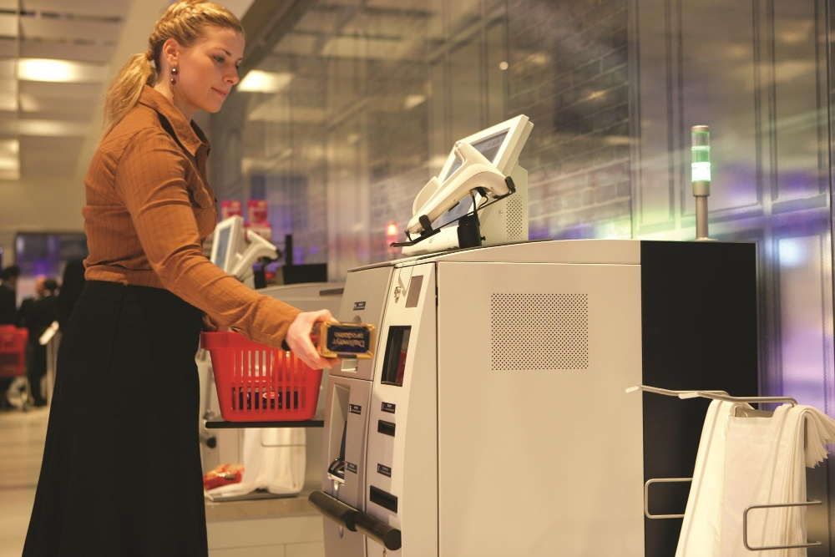
Figure 1
Image source (Xiao et al., 2021).
Figure 1 below shows self-service checkouts, which were implemented in Sainsbury’s to enhance efficiency in provision by allowing the customers to scan their goods.
Change management models
Lewin’s change model
Lewin's change model consists of three steps: freezing, change and refreezing, which makes the organisation adopt newly implemented practices (Burnes, 2020). Sainsbury's utilising this model will help to implement cutting-edge technology, specifically robots and virtual and augmented reality, to promote efficiency in operation (Bernardino and Tan, 2022).
Freezing is the first step, which includes creating awareness among the workers and the customers about the importance of implementing advanced technology in the organisation (ELLIS, 2023). This will make stakeholders of Sainsbury's embrace these changes because they will understand the benefits of cutting-edge technology. Burnes (2020) indicates that at the freezing stage, the organisation may face resistance from the workers and customers because they are used to the old practices. Thus, the change agent should be consistent in reminding individuals why the organisation needs to adopt new technology (Jami Pour and Hosseinzadeh, 2021).
The second step is implementing the proposed technology, such as making Sainsbury's use robots to deliver products and services to the customers (Burnes, 2020). This stage involves collecting data to improve the operation of the implemented system. At this point, stakeholders will implement the proposed technology and assess its benefits to the organisation (Hussain et al., 2018). However, Crosby (2020) states that change tends to be sensitive at this point of implementation because if the implemented system does not benefit the organisation, it may experience criticism and resistance from the stakeholders.
According to ELLIS (2023), the third stage of Lewin's change model is refreezing, in which the change agent ensures that the implemented technology is incorporated into the daily operation of the business to ensure the stakeholders forget about the old practices. At this stage, the change agent conducts regular meetings with organisation workers to ensure they utilise the newly implemented system.
Cummings et al. (2016) criticise Lewin's change model, saying that it requires a lot of resources and time to change the practices of the organisation. Regular follow-ups are required to ensure stakeholders understand and implement the change in their daily practices (Cummings et al., 2016). Additionally, implementing cutting-edge technology requires training employees on utilising the new system, which is costly and time-consuming (Allioui and Mourdi, 2023). However, Cummings et al. (2016) state despite the limitation of Lewin's change, it is effective because it is easy to follow three steps to implement changes. Hence, using this model will enable Sainsbury's to deliver products effectively using robots and allow its customers to scan the products from its online store without needing to visit its physical shop (Hussain et al. 2018).
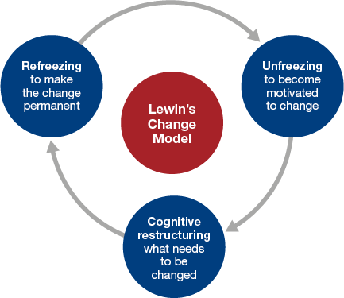
Figure 2
Image source: (Hussain et al. 2018).
Figure 2 above shows Lewin’s change model, which leads to a change in the operation of Sainsbury’s.
Kotter’s 8-step model
Kotter's 8-step model consists of eight systematic steps to change the practices in the organisation (Laig and Abocejo, 2021). Kotter's model is effective because it helps the organisation successfully change its practices and assess how the implemented practices impact its performance (Kang et al., 2022). For instance, cutting-edge technology in Sainsbury's will also be assessed to understand how the implemented system has increased sales and enhanced customer satisfaction. Kotter’s customers create urgency to make stakeholders of Sainsbury's understand the importance of bringing change in the organization (Ong and Walker, 2022). Sarkis et al. (2010) indicate that creating awareness among stakeholders makes them develop a positive attitude toward the proposed cutting-edge technology, making it easy to influence them to adopt the new practices. Some stakeholders do not understand the significance of technology in the daily operation of the business; therefore, making them aware will make them accept the use of technology (Lin and Chen 2012).
The second step is forming a powerful coalition with stakeholders to convince them that introducing robots and virtual and augmented reality will improve the organisation's performance (Laig and Abocejo, 2021). This step is essential because it helps individuals learn more about the proposed technology, according to Kang et al. (2022). The third step is to create a vision ensuring cutting-edge focus is on achieving the specific objectives (Sibanda et al., 2023). The fourth step is to communicate the vision to make the stakeholders reflect on how the cutting-edge will change the operation of Sainsbury's customers (Laig and Abocejo, 2021). Communicating the vision will help Sainsbury’s to achieve specific goals, such as increasing sales. The fifth step is to identify and remove the barriers that can hinder the implementation of cutting-edge technology in the organisation (Schweiger et al., 2018). The sixth step is to create a short win, such as using robots to deliver the products to the customer (Laig and Abocejo, 2021. Nadim and Singh (2019) argue that the short success of the implemented practice promotes trust among the stakeholders, making them embrace changes. For instance, timely delivery of Sainsbury's products to customers using robot Sainsbury's trusts cutting-edge technology. The seventh step is to build every operation on the implemented cutting-edge technology (Kang et al., 2022). For instance, Sainsbury's should ensure that every operation in Sainsbury' is based on the implemented cutting-edge technology (Munson, 2019). The last step is to incorporate cutting-edge technology to be in the organisation's daily routine.
Trawick and Carraher (2023) state that the advantage of Kotter's model is that it promotes the organisation's long-term success by empowering stakeholders to focus on its sustainable growth. However, Lagi and Abocejo (2021) reveal that Kotter's change model involves following the 8 steps, which can be time-consuming to implement change in the organization.
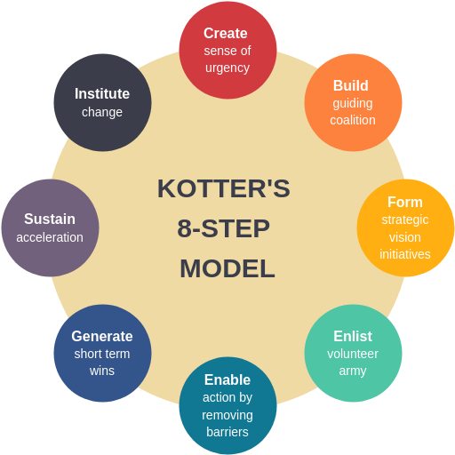
Figure 3
Image sources: (Laig and Abocejo, 2021)
Figure 3 above shows eight steps of Kotter’s 8-step model.
PDSA Cycle
PDSA Cycle is a four-stage model that helps the organisation implement change in its operation (Ente and Ukpe, 2022). This model can help the organisation to solve the problem impacting it because it enhances planning, implementing the change, studying the effectiveness of the change and taking robust action to improve the implemented change (Brau et al. 2019).
The first step of the PDSA cycle is to plan how to solve the problem impacting Sainsbury's and predict the possible outcomes (Moses, 2021. For instance, it is crucial to plan how to meet changes in the customers' preferences in the market (Ente and Ukpe, 2022). Advancements in technology have made individuals prefer online shopping to physical shopping. Also, during COVID-19, most people work online rather than physically in the workplace, making them choose to order shop items online (Aryani et al., 2021). Hence, the businesses that embraced e-commerce had an advantage over those that relied on physical selling strategies (Costa and Castro, 2021). This shows that planning to implement effective strategies to improve sales and meet the high competition in the market will help Sainsbury's propose effective cutting technology such as virtual and augmented reality (Smith and Zook, 2024).
The second step is to implement the proposed cutting-edge technology and collect data on how it impacts the organisation's operation (Allioui and Mourdi, 2023). At this step, Sainsbury's will develop online stores to enable customers to view and scan various items they are interested in (Sun et al., 2022). Also, Sainsbury's will purchase various robots to deliver groceries and clothing to customers. Allioui and Mourdi (2023) state that this step is crucial because it determines the perception of the stakeholders toward the implemented technology. The success of the technology motivates individuals to utilise the implemented technology in the technology (Ritz et al., 2019).
The third step is the study, which involves analyzing the collected data and evaluating the results to assess the impact of cutting-edge technology on the organization (Ente and Ukpe, 2022). Also, in the studying step, the key learnings, such as the challenges and benefits of using robots in virtual reality, will be outlined to perfect the use of technology (Brau et al. 2019).
The last step is taking action based on the outcome observed about the impact of cutting-edge technology. The last step determines whether to adopt robots and virtual reality in the operation of the business (Allioui and Mourdi, 2023). However, Smyth-Renshaw (2018) criticises the PDSA cycle in that it does not provide detailed information on how to solve the complex problem of an organisation. For instance, a detailed description is needed to identify how the installation of the equipment, the training of the workers, and the sources of funds are required to understand the organisation better. The model cannot also show the external factors, such as government policies, that can hinder the successful implementation of technology (Smyth-Renshaw, 2018).
While using these three change models, it is important for an organisation to assess the completion and significance of the implemented changes (Stouten et al., 2018). The ways to identify completion in implementing the new system include a high frequency of utilising the new system of operation and a positive attitude of the employees and customers towards the implemented system (Kasim et al., 2018). Some organisations use the newly implemented system for a short period and then return to the old operation (Langenwalter, 2020). According to Brown et al. (2018), organizations must abandon the old practices to promote new and advanced operations. For instance, the change argent of Sainsbury's should ensure that implemented cutting-edge technology (robots and virtual and regimented reality) are utilised for the long term.
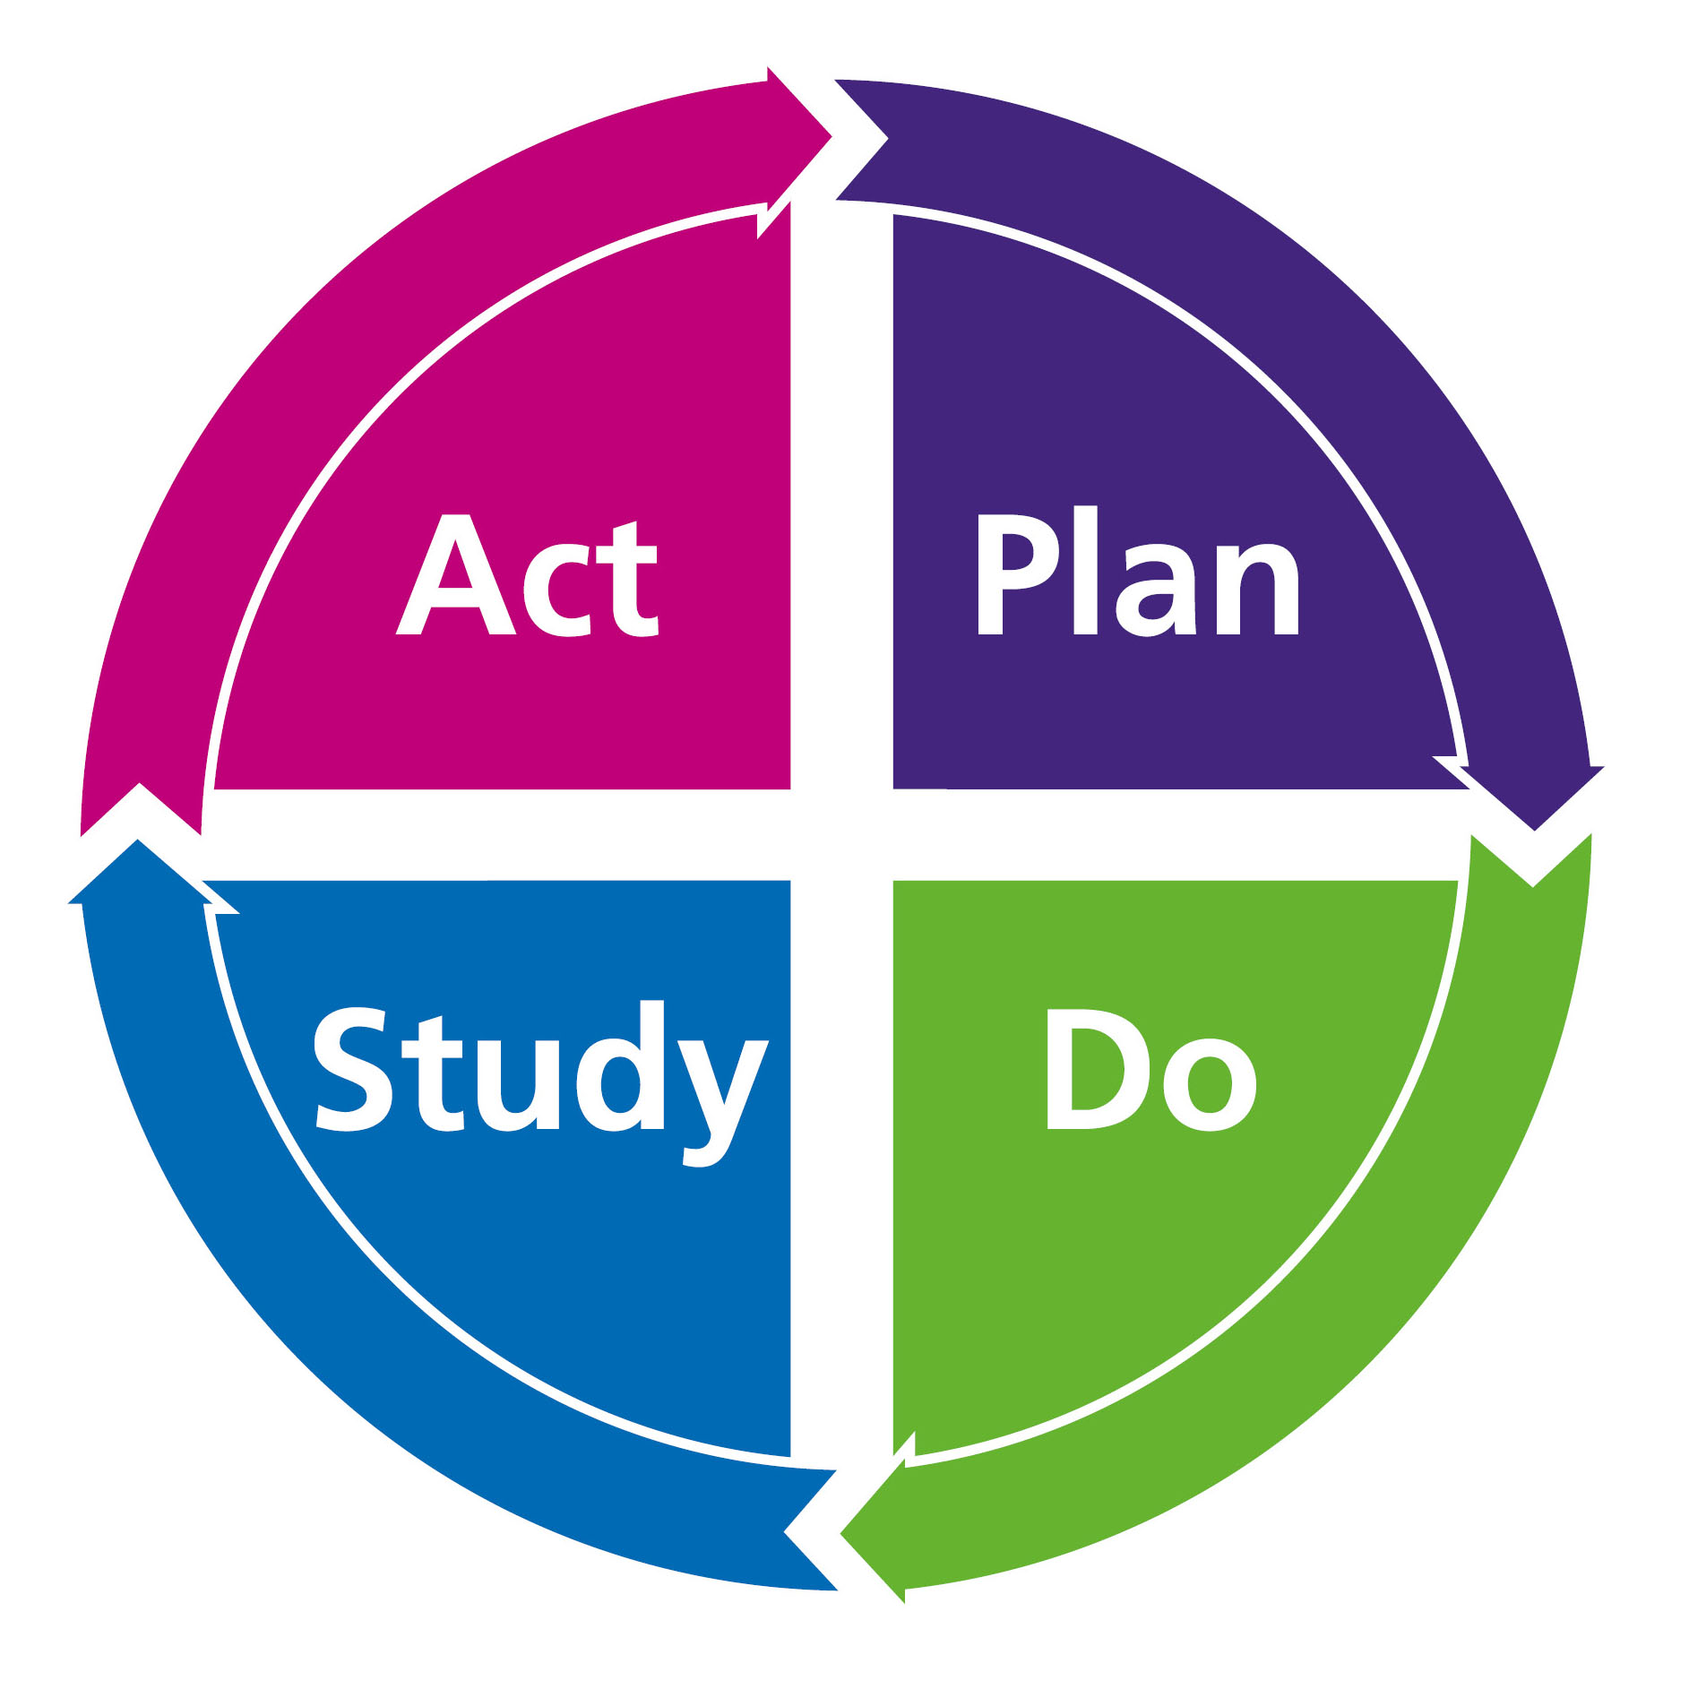
Figure 4
Image source: (Brau et al. 2019).
Figure 4 above shows four steps of the PDSA cycle that are significant to implement change in Sainsbury’s
Significance of changes in the organisation
Based on the observed changes in Sainsbury’s, change is significant because it helps the organisation cope with external business drivers, such as the global pandemic (Li et al., 2021). For instance, Xiao et al. (2021) reveal that the global pandemic led to a decline in the sales of Sainsbury. Also, the introduction of Mobile Scan & Go increased sales because individuals could maintain social distance while paying for the items. Sainsbury's sellers had to operate online more than physically during covid 19 (Sainsbury’s, 2024). Online selling strategies are effective because the customers can communicate easily with the sellers using the company's website (Piranda et al., 2022). Selling products online also saves time because customers can scan the products using online platforms (Vulkan, 2020). Therefore, changes in technology are crucial because they promote the satisfaction of the customers and also increase the sales of the business (Hallencreutz and Parmler, 2021). Online stores encourage self-services where customers can scan and pay for the items using the QR code (Aguzman et al., 2020). This indicates that change benefits the organisation by increasing revenue (Hallencreutz and Parmler, 2021).
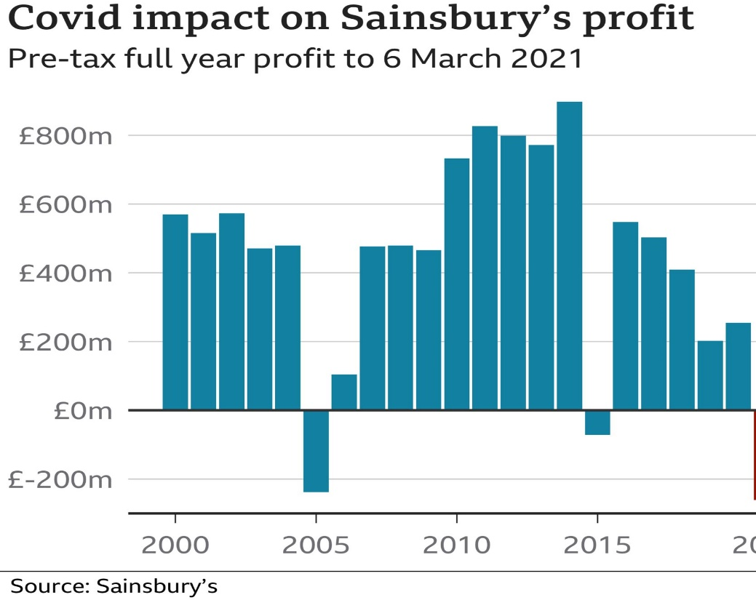
Figure 5
Image sources (Sainsbury’s, 2024)
Figure 5 above shows a decline in the profit of Sainsbury's in 2019 because of the COVID-19 pandemic. However, implementing the Mobile Scan & Go led to a rise in profit in 2020 (Jocevski et al. 2020). The organisation that adopted more sophisticated technologies, such as virtual reality, had a competitive advantage over Sainsbury's, which indicates that the organisations should adopt changes that meet the competition in the market (Mkansi et al. 2021). Shokouhyar et al. (2020) state that technology and other factors, such as the quality of the products and services, can influence the organisation's sales. Therefore, promoting high-quality products while advancing technology is crucial to cover a wide range of customers (Grewal et al., 2020). According to Tidd and Bessant (2020), change in the organisation encourages innovation because it will allow the management team to research the available strategies to run the business effectively. For instance, the COVID-19 pandemic made most of the businesses in the UK advance online selling strategies (Kumar et al., 2020).
Moreover, the organisation should retain the implemented change in its daily operation to promote sustainable growth (Bryson, 2018). For instance, Sainsbury's has retained Mobile Scan & Go technology in its operation since the outbreak of the global pandemic. According to Neumeyer et al. (2020), training workers and customers to utilise the implemented technology is crucial because individuals have inadequate technological knowledge and experience, making the implemented system ineffective. For example, some customers are not able to install Mobile Scan & Go apps.
Despite the advantages of changes in the organisation, its limitations in Sainsbury's include a high cost to make a change (Guo and Wang 2019). For instance, cutting-edge technology, such as robots and developing a company's website is very costly (Ameen et al., 2021). Also, training the workers to adapt to the new system of operation consumes a lot of time and money. However, the implementation of cutting-edge technology has more advantages than limitations because it increases sales and reduces the cost of operation because it promotes self-service (Gurley, 2021).
Conclusion
In conclusion, the change in Sainsbury’s supermarket was driven by the COVID-19 pandemic, which reduced sales because of the lockdown. Implementing pay&Go technology promoted self-services among the customers, leading to increased sales. Sainsbury’s competitors, such as Tesco plc, use more advanced technology, such as visual reality, to operate the business. Therefore, the proposed changes are implementing cutting-edge technology in Sainsbury’s, specifically robots and virtual reality, to cope with changes in customers’ preferences and the high competition in the market. Implementing proposed cutting-edge technology can encounter resistance from customers and employees because of inadequate technological knowledge and experience. Change management models such as Lewin’s change model, Kotter’s 8-step model, and PDSA Cycle effectively implement change in an organisation because they consist of systematic procedures that guide and instil change. The limitation of these change models is that they require a lot of resources and time to implement the new system in the organisation.
Recommendations.
Based on the findings of this study, it is recommended that effective cutting-edge technology be implemented in Sainsbury’s to gain a competitive advantage in the market (Mkansi and Nsakanda, 2021). The organisation should train its employees to utilise newly implemented technology to achieve this. It is also recommended that frequent meetings be held with the management team to convince them to accept the change in operation (Lauer, 2020). Creating awareness among customers using social media about implementing cutting-edge technology is recommended.

References
Aguzman, G., Pangaribuan, C.H. and Sasongko, A.H., (2020). Self-Service Checkouts: The Role of Service Innovation in Indonesian Convenience Stores. Psychology and Education Journal, 57(9), pp.81-87.
Alexander, I.N., (2020). The influence of technological innovations on organization's competitive advantage: Case study on Irish food retail company (Tesco) (Doctoral dissertation, Dublin, National College of Ireland).
Allioui, H. and Mourdi, Y., (2023). Unleashing the potential of AI: Investigating cutting-edge technologies that are transforming businesses. International Journal of Computer Engineering and Data Science (IJCEDS), 3(2), pp.1-12.
Alo, U.R., Nkwo, F.O., Nweke, H.F., Achi, I.I. and Okemiri, H.A., (2021). Non-pharmaceutical interventions against COVID-19 pandemic: Review of contact tracing and social distancing technologies, protocols, apps, security and open research directions. Sensors, 22(1), p.280.
Ameen, N., Hosany, S. and Tarhini, A., (2021). Consumer interaction with cutting-edge technologies: Implications for future research. Computers in Human Behavior, 120, p.106761.
Aryani, D.N., Nair, R.K., Hoo, D.X.Y., Hung, D.K.M., Lim, D.H.R., Chew, W.P. and Desai, A., (2021). A study on consumer behaviour: Transition from traditional shopping to online shopping during the Covid-19 pandemic. International Journal of Applied Business and International Management (IJABIM), 6(2), pp.81-95.
Bentham, J., (2018). Business and Economics in the News–Sainsbury's and Asda-the decade's mega-merger. Teaching Business & Economics, 22(3), pp.11-12.
Bernardino, M.J.D. and Tan, E.B., (2022). Utilization of the Unfreeze, Change, and Freeze Model to Enhance the Organizational Culture in Public Schools.
Brau, R.I., Gardner, J.W., Webb, G.S. and McDonald, J.K., (2019). Teaching plan‐do‐study‐act (PDSA) in a supply chain context: A paper football in‐class activity. Decision Sciences Journal of Innovative Education, 17(1), pp.6-32.
Brown, S., Bessant, J. and Jia, F., (2018). Strategic operations management. Routledge.
Bryson, J.M., (2018). Strategic planning for public and nonprofit organizations: A guide to strengthening and sustaining organizational achievement. John Wiley & Sons.
Burnes, B., (2020). The origins of Lewin’s three-step model of change. The Journal of Applied Behavioral Science, 56(1), pp.32-59.
Costa, J. and Castro, R., (2021). SMEs must go online—E-commerce as an escape hatch for resilience and survivability. Journal of Theoretical and Applied Electronic Commerce Research, 16(7), pp.3043-3062.
Crosby, G., (2020). Planned change: Why Kurt Lewin's social science is still best practice for business results, change management, and human progress. Productivity Press.
Cuevas, J.M., (2018). The transformation of professional selling: Implications for leading the modern sales organization. Industrial Marketing Management, 69, pp.198-208.
Cummings, S., Bridgman, T. and Brown, K.G., (2016). Unfreezing change as three steps: Rethinking Kurt Lewin’s legacy for change management. Human relations, 69(1), pp.33-60.
Cummings, S., Bridgman, T. and Brown, K.G., 2016. Unfreezing change as three steps: Rethinking Kurt Lewin’s legacy for change management. Human relations, 69(1), pp.33-60.
ELLIS, P., (2023). Managing change--the Lewin model 3: refreeze. Wounds UK, 19(4).
Ente, C. and Ukpe, M., (2022). Quality Management. In Essentials for Quality and Safety Improvement in Health Care: A Resource for Developing Countries (pp. 137-165). Cham: Springer International Publishing.
Errida, A. and Lotfi, B., (2021). The determinants of organizational change management success: Literature review and case study. International Journal of Engineering Business Management, 13, p.18479790211016273.
Garg, A.K., (2019). Self-Checkout Systems for Grocery Stores in Dublin! A Customers’ perspective (Doctoral dissertation, Master’s Thesis, Technological University Dublin).
Grewal, D., Hulland, J., Kopalle, P.K. and Karahanna, E., (2020). The future of technology and marketing: A multidisciplinary perspective. Journal of the Academy of Marketing Science, 48, pp.1-8.
Guo, L. and Wang, Z., (2019). Ratio analysis of J Sainsbury plc financial performance between 2015 and 2018 in comparison with Tesco and Morrisons. American Journal of Industrial and Business Management, 9(2), pp.325-341.
Gurley, R.C., (2021). Strategies for Implementing Self-service Technologies in Supermarket Retail Operations (Doctoral dissertation, Walden University).
Hallencreutz, J. and Parmler, J., (2021). Important drivers for customer satisfaction–from product focus to image and service quality. Total quality management & business excellence, 32(5-6), pp.501-510.
Hoyer, W.D., Kroschke, M., Schmitt, B., Kraume, K. and Shankar, V., (2020). Transforming the customer experience through new technologies. Journal of interactive marketing, 51(1), pp.57-71.
Hussain, S.T., Lei, S., Akram, T., Haider, M.J., Hussain, S.H. and Ali, M., (2018). Kurt Lewin's change model: A critical review of the role of leadership and employee involvement in organizational change. Journal of innovation & knowledge, 3(3), pp.123-127.
Jami Pour, M. and Hosseinzadeh, M., (2021). An integrated framework of change management for social CRM implementation. Information Systems and e-Business Management, 19(1), pp.43-75.
Jocevski, M., Ghezzi, A. and Arvidsson, N., (2020). Exploring the growth challenge of mobile payment platforms: A business model perspective. Electronic Commerce Research and Applications, 40, p.100908.
Kang, S.P., Chen, Y., Svihla, V., Gallup, A., Ferris, K. and Datye, A.K., (2022). Guiding change in higher education: An emergent, iterative application of Kotter’s change model. Studies in Higher Education, 47(2), pp.270-289.
Kasim, T., Haracic, M. and Haracic, M., (2018). The improvement of business efficiency through business process management. Economic Review: Journal of Economics and Business, 16(1), pp.31-43.
Kumar, A., Gawande, A. and Brar, V., (2020). Marketing tactics in times of Covid-19. Vidyabharati International Interdisciplinary Research Journal, 11(2), pp.263-266.
Laig, R.B.D. and Abocejo, F.T., (2021). Change management process in a mining company: Kotter’s 8-step change model. Journal of Management, Economics, and Industrial Organization, 5(3), pp.31-50.
Langenwalter, G.A., (2020). Enterprise resources planning and beyond: integrating your entire organization. CRC Press.
Lauer, T., (2020). Change management: fundamentals and success factors. Springer Nature.
Li, J.Y., Sun, R., Tao, W. and Lee, Y., (2021). Employee coping with organizational change in the face of a pandemic: The role of transparent internal communication. Public relations review, 47(1), p.101984.
Lin, A. and Chen, N.C., (2012). Cloud computing as an innovation: Percepetion, attitude, and adoption. International journal of information management, 32(6), pp.533-540.
Mani, Z. and Chouk, I., (2018). Consumer resistance to innovation in services: challenges and barriers in the internet of things era. Journal of Product Innovation Management, 35(5), pp.780-807.
Mkansi, M. and Nsakanda, A.L., (2021). Leveraging the physical network of stores in e-grocery order fulfilment for sustainable competitive advantage. Research in Transportation Economics, 87, p.100786.
Moses, B., (2021). Emulating Plan, Do, Study, Act (PDSA). Enhancing Performance: A Best Practices Guide for Innovations in Community Colleges, 131.
Munson, J.E., (2019). The Digital Transformation of the UK’s Grocery Market (Doctoral dissertation, University of Southampton).
Nadim, A. and Singh, P., (2019). Leading change for success: embracing resistance. European Business Review, 31(4), pp.512-523.
Neumeyer, X., Santos, S.C. and Morris, M.H., (2020). Overcoming barriers to technology adoption when fostering entrepreneurship among the poor: The role of technology and digital literacy. IEEE Transactions on Engineering Management, 68(6), pp.1605-1618.
Ong, S.Y. and Walker, A., (2022). Using Kotter's 8 steps of change to tackle over‐fasting of children attending day surgery. Pediatric Anesthesia, 32(11), pp.1238-1245.
Piranda, D.R., Sinaga, D.Z. and Putri, E.E., (2022). Online marketing strategy in Facebook marketplace as a digital marketing tool. Journal of Humanities, Social Sciences and Business, 1(3), pp.1-8.
Rajabi, M. and Bolhari, A., (2015). Business Transformations: Inevitable Changes of the Era. In Optimization of Supply Chain Management in Contemporary Organizations (pp. 61-86). IGI Global..
Ritz, W., Wolf, M. and McQuitty, S., (2019). Digital marketing adoption and success for small businesses: The application of the do-it-yourself and technology acceptance models. Journal of Research in interactive Marketing, 13(2), pp.179-203.
Rossetti, T., Yoon, S.Y. and Daziano, R.A., (2022). Social distancing and store choice in times of a pandemic. Journal of Retailing and Consumer Services, 65, p.102860.
Sainsbury's (2024). Sainsbury’s. [Online] Sainsburys.co.uk. Available at: https://www.sainsburys.co.uk/.
Sarkis, J., Gonzalez-Torre, P. and Adenso-Diaz, B., (2010). Stakeholder pressure and the adoption of environmental practices: The mediating effect of training. Journal of operations Management, 28(2), pp.163-176.
Schweiger, S., Stouten, H. and Bleijenbergh, I.L., (2018). A system dynamics model of resistance to organizational change: The role of participatory strategies. Systems Research and Behavioral Science, 35(6), pp.658-674.
Shokouhyar, S., Shokoohyar, S. and Safari, S., (2020). Research on the influence of after-sales service quality factors on customer satisfaction. Journal of Retailing and Consumer Services, 56, p.102139.
Sibanda, M., Moyo, E., Dzinamarira, T. and Murewanhema, G., (2023). Application of Kotter’s 8-steps model to reduce maternal mortality due to third delay in sub-Saharan Africa. International Journal of UK Nursing Sciences, p.100651.
Smith, P.R. and Zook, Z., (2024). Marketing communications: Integrating online and offline, customer engagement and digital technologies. Kogan Page Publishers.
Smyth-Renshaw, J., (2018). A 4-Stage Fact Framework for Solving Product Quality Problems. The University of Liverpool (United Kingdom).
Stouten, J., Rousseau, D.M. and De Cremer, D., (2018). Successful organizational change: Integrating the management practice and scholarly literatures. Academy of Management Annals, 12(2), pp.752-788.
Subramanian, N., Chaudhuri, A. and Kayıkcı, Y., (2020). Blockchain and supply chain logistics: Evolutionary case studies. Springer Nature.
Sun, Y., Jiang, S., Jia, W. and Wang, Y., (2022). Blockchain as a cutting-edge technology impacting business: A systematic literature review perspective. Telecommunications Policy, 46(10), p.102443.
Tidd, J. and Bessant, J.R., (2020). Managing innovation: integrating technological, market and organizational change. John Wiley & Sons.
Trawick, S. and Carraher, T., (2023). Contextualising Kotter’s 8-step model to a sustainable digital transformation: A qualitative study from the perspective of organisational change.
Vulkan, N., (2020). The economics of e-commerce: a strategic guide to understanding and designing the online marketplace.
Whalley, J. and Curwen, P., (2023). How COVID-19 accelerated the restructuring of UK Retail. In Beyond the Pandemic? Exploring the Impact of COVID-19 on Telecommunications and the Internet (pp. 135-151). Emerald Publishing Limited.
Wilk, G., (2019). SCO technology in grocery retailing: a structured analysis of current SCO systems from a customer and retailer perspective (Doctoral dissertation).
Worth, T.E., (2021). Implications of express delivery business modelling in the last mile industry. Sheffield Hallam University (United Kingdom).
Wrigley, N., (2018). How British retailers have shaped food choice. In The Nation's Diet (pp. 112-128). Routledge.
Xiao, B., Chen, Q. and Yu, Z., (2021, April). Research on the Investment Value of Sainsbury’s. In 2021 6th International Conference on Social Sciences and Economic Development (ICSSED 2021) (pp. 108-115). Atlantis Press.

