PLANNING FOR MARKETING DRIVERS OF CHANGE
(IN-PERSON GROUP PRESENTATION)
Module: Managing Marketing Change
Module code: BMMB7026
Lecturer: Gwyneth Jones

Title: Planning for Marketing Drivers of Change
Word Count: 1959

Contents
Introduction 5
Company Overview 6
Defining the Issue – Climate Change & Sustainability 7
Why this is a Marketing Issue 8
Sustainability Challenges at Amazon 9
Internal Marketing Challenges 10
External Marketing Challenges 11
PESTLE analysis -Environmental Focus 12
SWOT Analysis – Sustainability Lens 13
Impact on the Marketing Mix – Product & Price 14
Impact on Marketing Mix – Place & Promotion 15
Impact on Marketing Mix – People, Process & Physical Evidence 16
Consumer Behaviour Shifts 17
Need for Change Management 18
Lewin’s Change Model Application 19
Evaluation – Strengths of Business Response 20
Evaluation – Weaknesses of Business Response 21
Recommendations– Strategic Marketing Actions 22
Recommendations – Cultural and Operational Change 23
Conclusion 24
References 25




Introduction
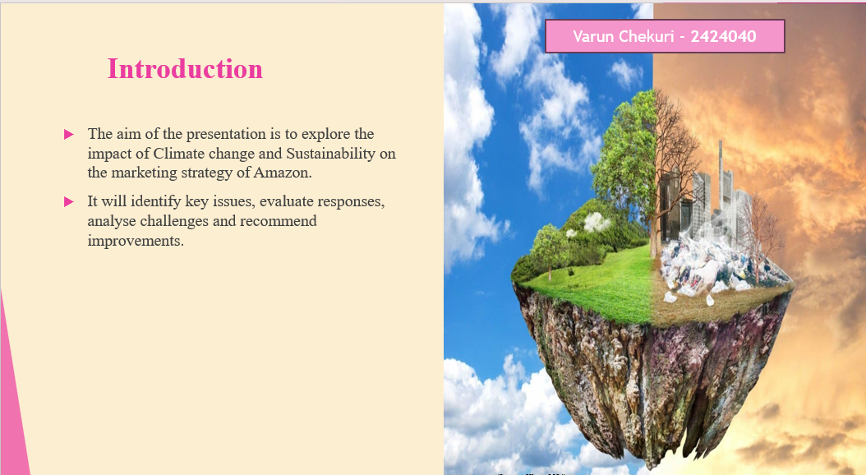
The presentation will shed light on the topic of Climate change and sustainability and its impact on the marketing strategies of the global company, Amazon. The presentation will begin by identifying the core issues facing the company including challenges it brings to the marketing efforts of Amazon. In addition, the report will critically evaluate the approach to change of the company to finally produce suitable recommendations for future improvements.

Company Overview
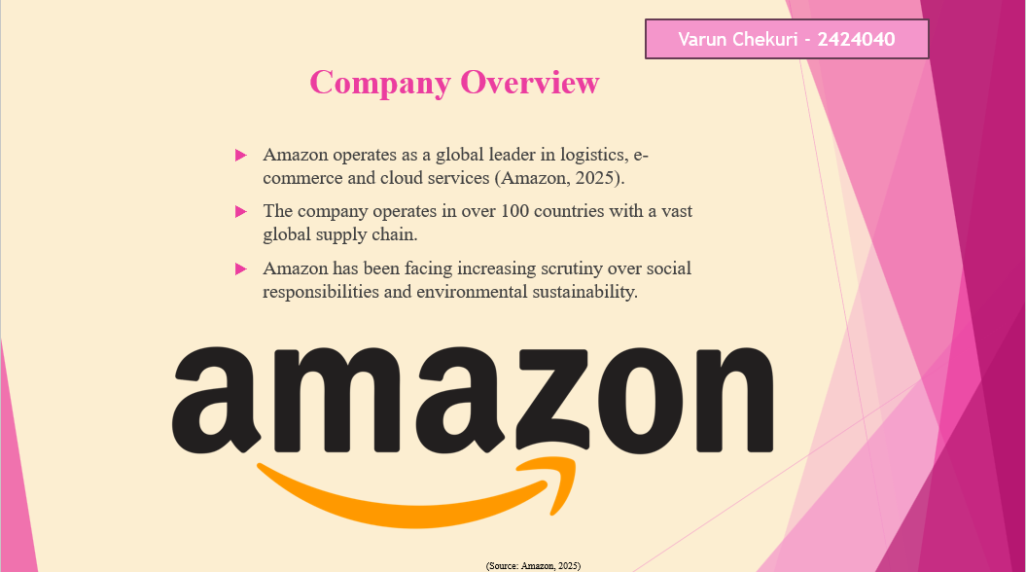
The multinational tech-oriented company Amazon is popular for dominating the cloud computing and e-commerce industry through AWS. The worst operations of the company span globally, influencing millions of businesses and customers. However, with technical upgradation and due to its scale and size, Amazon has been facing growing pressure from customers and other stakeholders to adapt socially and environmentally responsible practices aligning with ESG goals.

Defining the Issue – Climate Change & Sustainability
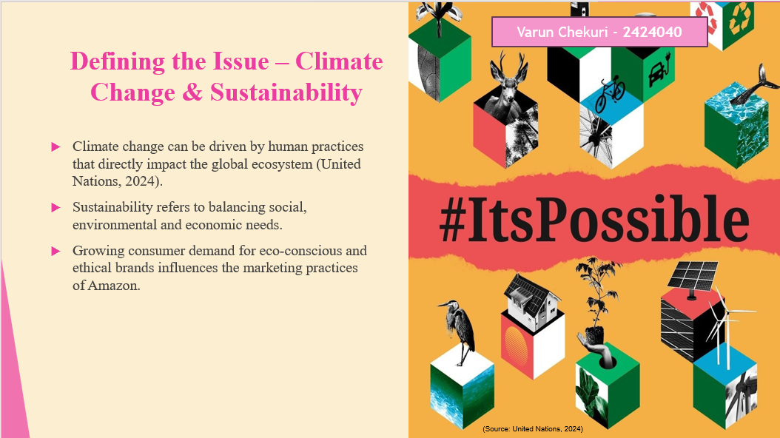
The process of climate change involves long-term changes in environmental factors caused mainly due to carbon emissions. Sustainability can be defined as meeting the needs of people demanding environmentally friendly products or services without harming future generations. Climate change and sustainability issues now heavily shape the marketing management practices of companies like Amazon. Customers demand for brands that demonstrate eco-friendly and ethical practices. It is important for Amazon to align with sustainability efforts and to meet these expectations to stay competitive and relevant.

Why this is a Marketing Issue
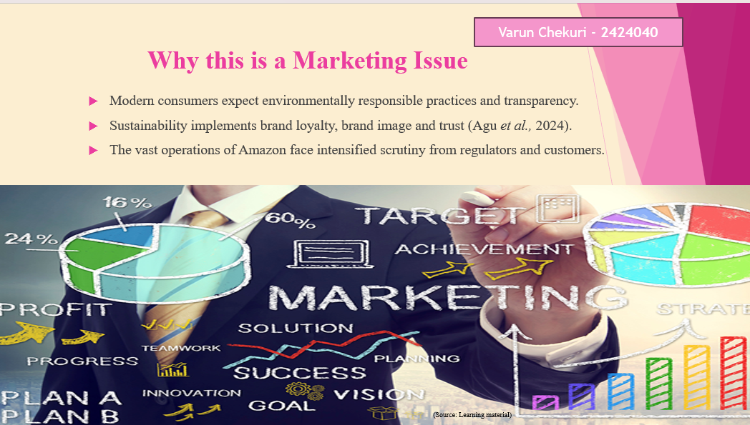
Sustainability becomes crucial in marketing where consumers actively demand brands that value environmental responsibilities and transparent practices. The brand reputation of Amazon depends on the ways in which it responds to market expectations. Reflecting on the Global prisons of the company, any delay or misstep associated with environmental sustainability and concerns may cause public criticism, making sustainability a critical marketing challenge for the company.

Sustainability Challenges at Amazon
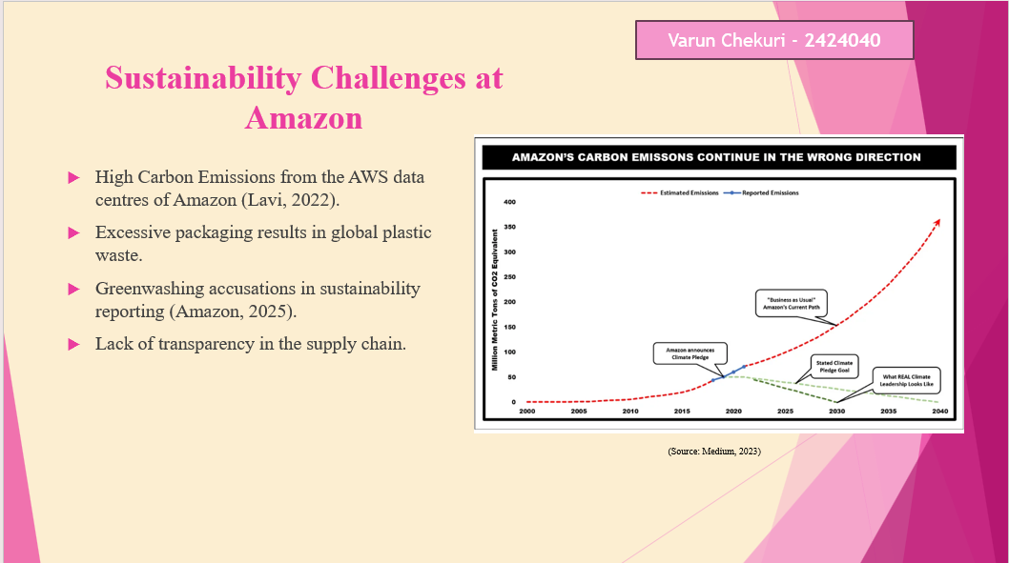
Amazon has been facing significant challenges associated with environmental sustainability due to energy-intensive cloud computing services and logistics networks. Despite renewable energy initiatives, the overall carbon footprint of the company remains a significant concern as critics argue about the net-zero promise from Amazon that may be more about maintaining a strong brand image rather than making substantial results. Amazon is criticized for its lack of transparency in the supply chain and due to its complex nature, that directly impacts the environment. The company is further criticized for alleged greenwashing and excessive packaging. These issues undermine consumer loyalty and trust creating pressure on the business to match its marketing practices with strong environmental actions.

Internal Marketing Challenges
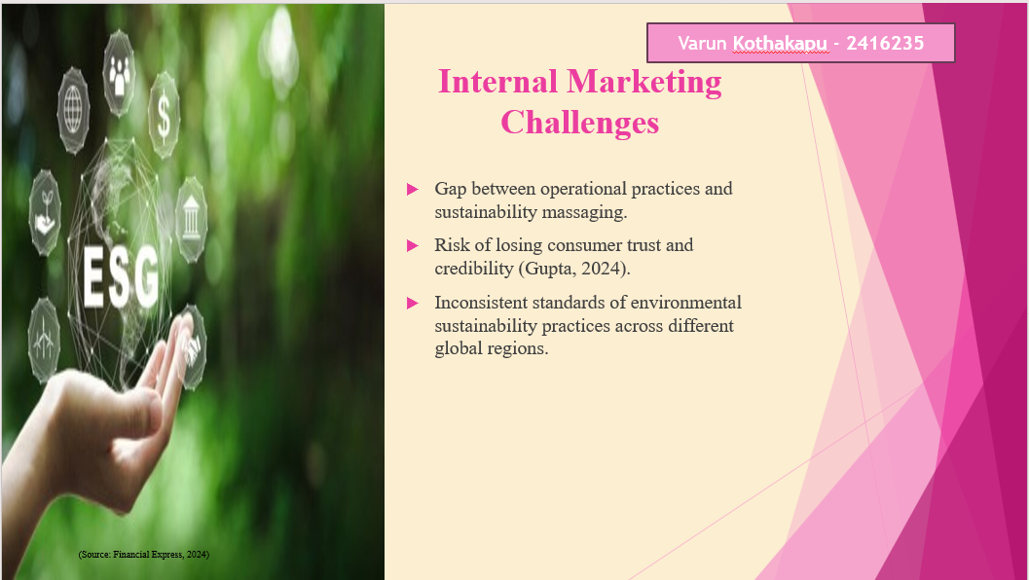
Amazon is criticized for different factors and sustainability concerns where climate change is one of the crucial factors. The marketing efforts of the company promote bold sustainability efforts but these do not align with business efforts or practices with on-ground factors leading to profitability issues. Customers of Amazon may consider this as greenwashing which results in misleading information and trust issues. In addition, the implementation of proper sustainable marketing strategies due to differences in regional factors including infrastructure, regulations and customer expectations directly impacts the brand image of Amazon.

External Marketing Challenges
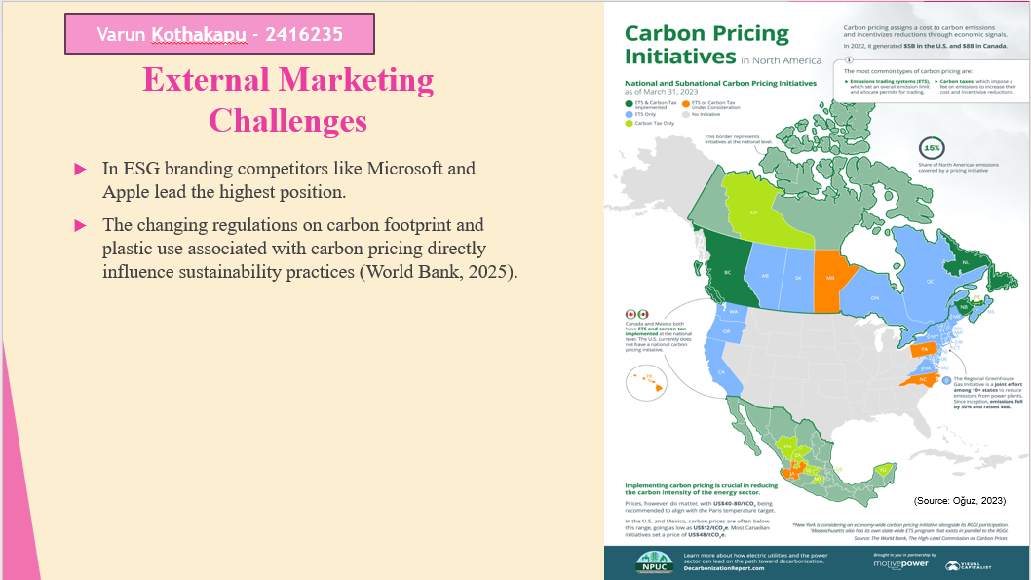
In ESG branding competitors like Microsoft and Apple lead the highest position of Amazon in the global market. Media and watchdogs influence public reactions and accountability impacting brand image and sustainability efforts.

PESTLE analysis -Environmental Focus
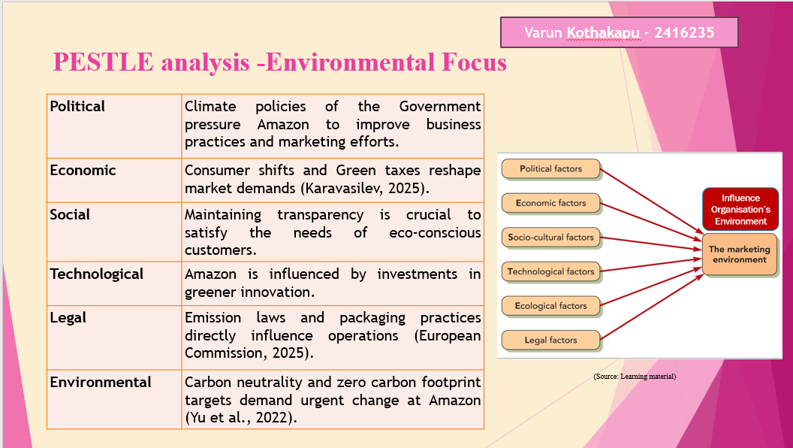
Climate change issues directly impact the external environment of Amazon. Political commitments associated with sustainability goals, UN SDGs and other policies force alignment with marketing efforts to promote awareness of customers. Economically the changes in demands and green taxes directly influence change at Amazon. In addition, the Eco-aware customers demand loyalty and transparency. The technical investment of Amazon must ensure alignment with environmentally friendly practices to limit carbon footprint. However, growing consumer demands for eco-friendly practices and evolving climate policies pose serious challenges impacting business compliance and the image of Amazon.

SWOT Analysis – Sustainability Lens
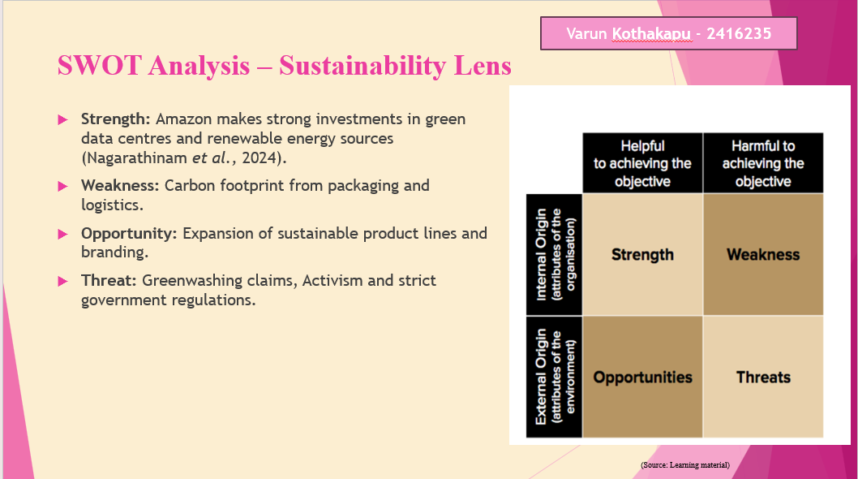
The business strength of Amazon lies in its ability to invest in sustainability efforts and practices like eco-friendly packaging and renewable energy to eliminate climate issues. However, the company still faces measure challenges including over-packaging and carbon footprint from Data centres. Consumer expectations and changes in policies and regulatory practices create a huge threat to business. Yet, the opportunities associated with sustainable Innovation and green marketing initiatives allow the company to become a more responsible brand.

Impact on the Marketing Mix – Product & Price
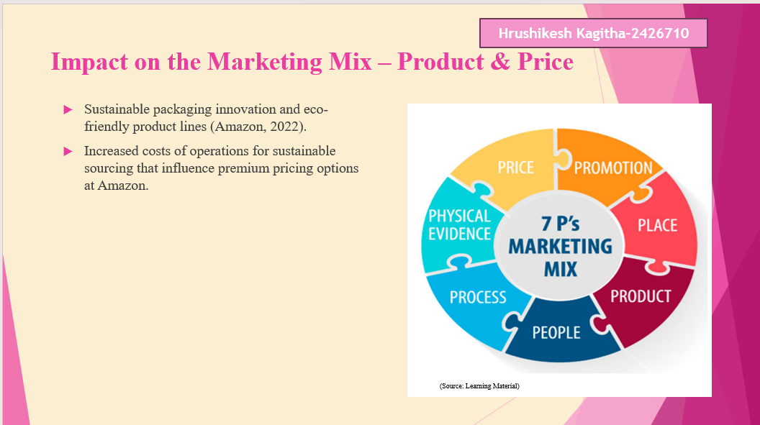
The usefulness of adopting eco-friendly product lines and packaging by Amazon including recyclable packaging systems, green products and climate pledge-certified items benefits meeting customer satisfaction. These measures benefit from increasing the cost of productions which might be reflected in the higher prices of products at Amazon. However, the pricing aligns with eco-conscious consumers who are willing to pay more for green products enhancing environmental credibility and perceived brand value.

Impact on Marketing Mix – Place & Promotion
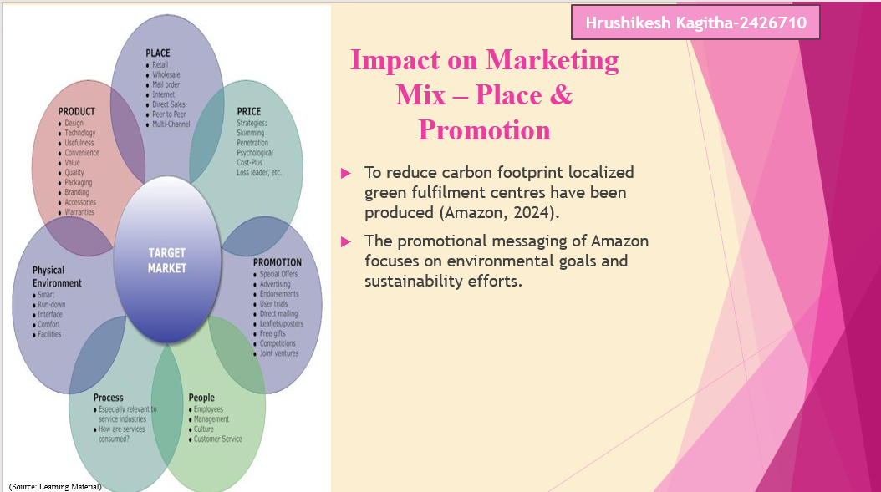
Amazon is improving the distribution process by introducing fulfillment centres closer to customers to eliminate the carbon footprint. Considering promotional practices the company utilizes digital platforms to highlight sustainability efforts and climate pledges. Green messaging is crucial and appealing to the customers who are eco-conscious will reinforce the brand image of Amazon as an environmentally responsible brand.

Impact on Marketing Mix – People, Process & Physical Evidence
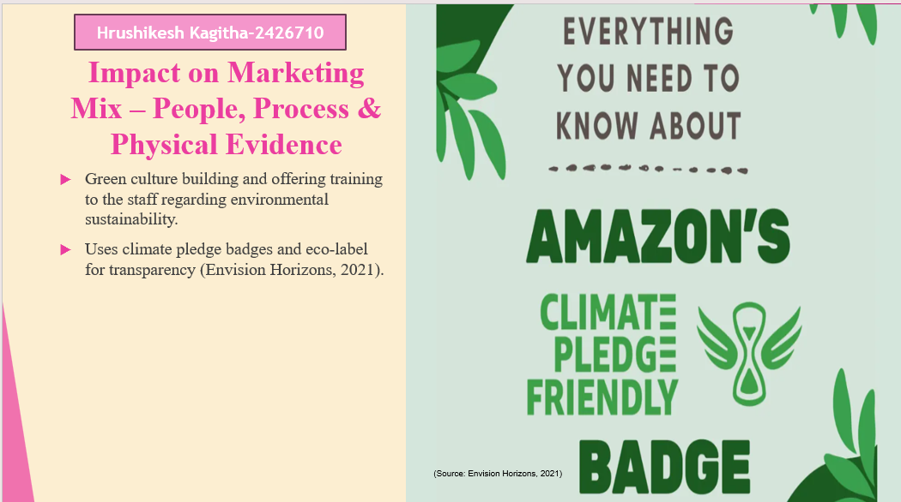
Amazon invests in employee training and education regarding sustainable practices that encourage Innovation and internal advocacy. Operationally, the company integrates eco-friendly processes such as waste reduction and electric delivery systems. Physical evidence includes green indicators with certifications and badges on pages of products that helps customers trust on Amazon aligning with environmental commitments of the brand.

Consumer Behaviour Shifts
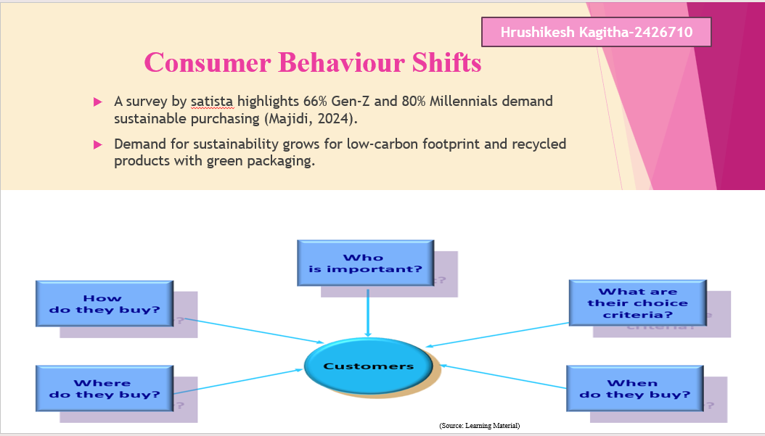
Understanding changes in consumer behaviour is crucial for businesses to improve service offerings. A survey from Statista shed light on sustainability drive that shows 66% of Gen Z and 80% of Millennials prioritize green purchasing decisions. Modern customers demand eco-friendly products as it is evidenced with increasing demand for sustainable packaging. The shift influenced Amazon to reshape its offerings and strategies of marketing management towards eco-friendly consumption.

Need for Change Management
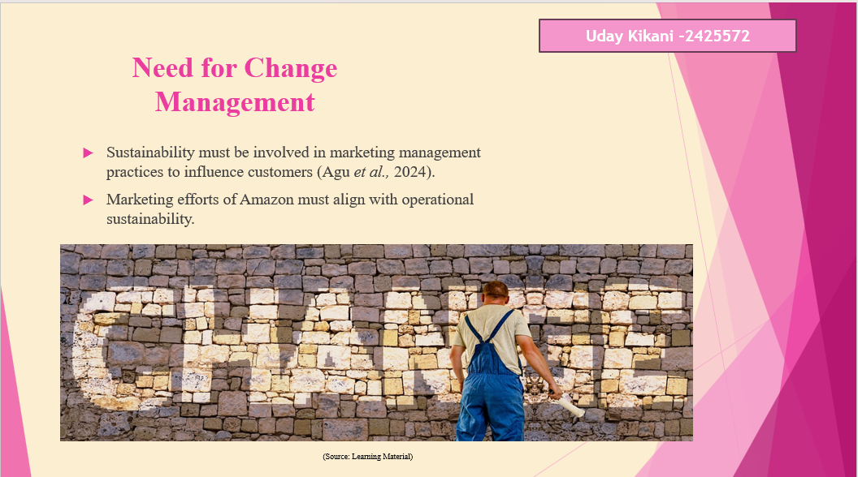
Reflecting on climate change issues and sustainability practices, Amazon must adopt an effective change management process aligning with operational practices and internal factors with its green branding. It is important to maintain genuine transformation to eliminate marketing risk that can be recognised as greenwashing. Operating in competitive market, sustainability required to be aligned across supply chain management and marketing practices to maintain consumer loyalty and trust.

Lewin’s Change Model Application
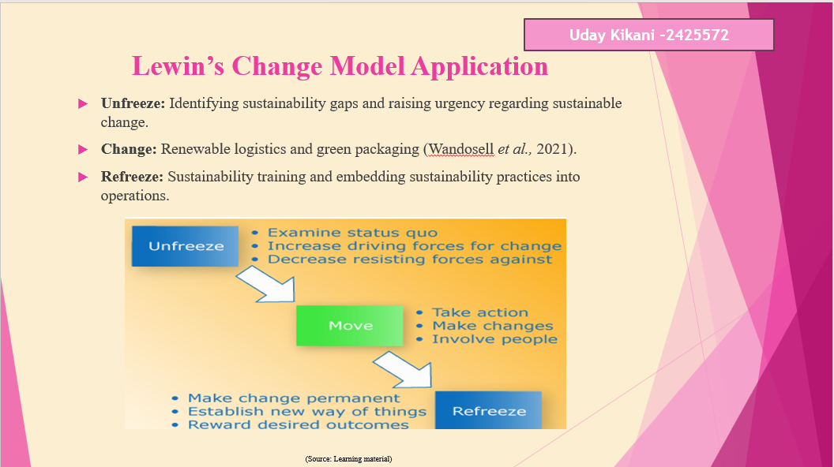
In the Unfreeze stage of change management Amazon must focus on reshaping old habits highlighting environmental challenges. During the Change phase business managers and leaders should implement sustainable practices and involve people through sustainability training. Finally in the Refreeze stage, it is important to make change permanent ensuring sustainability practices become a part of long-term culture at Amazon.

Evaluation – Strengths of Business Response
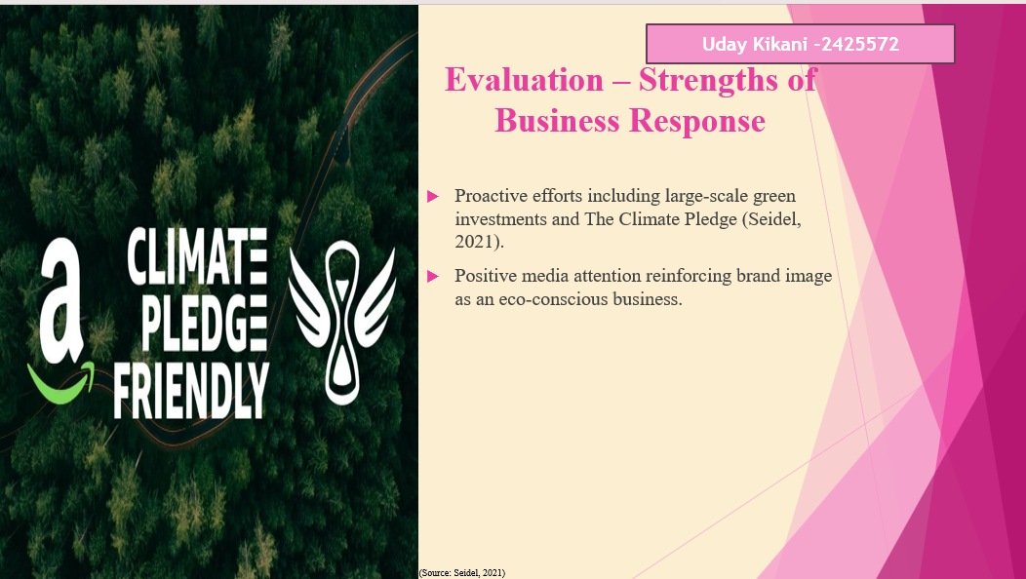
Amazon has taken strong initiative with The Climate Pledge, committing to reach net-zero emissions by 2040. Massive investments in sustainable infrastructure and renewable energy will boost credibility. Media recognition aligns with strong initiatives of Amazon towards sustainable innovation.

Evaluation – Weaknesses of Business Response
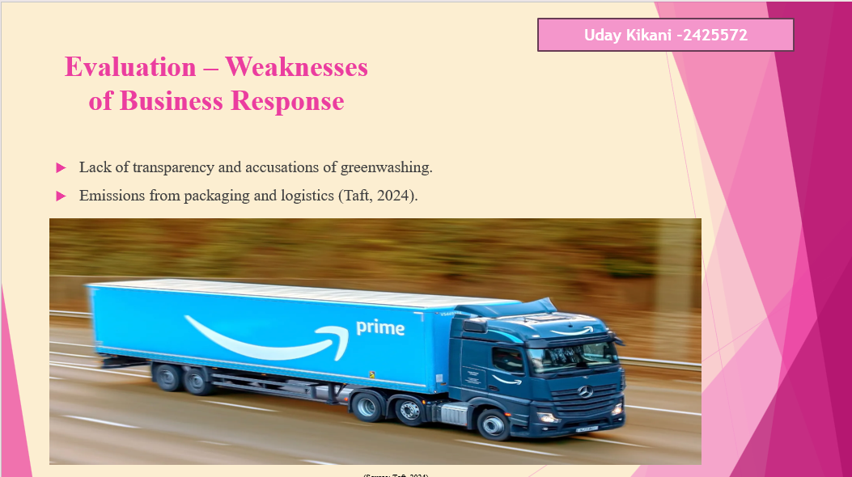
Despite green initiatives of Amazon, the company faces criticism due to over-promising on sustainability and lack of transparency. Carbon emissions and packaging waste from the waste logistic network at Amazon continue as a challenge affecting its credibility.

Recommendations– Strategic Marketing Actions
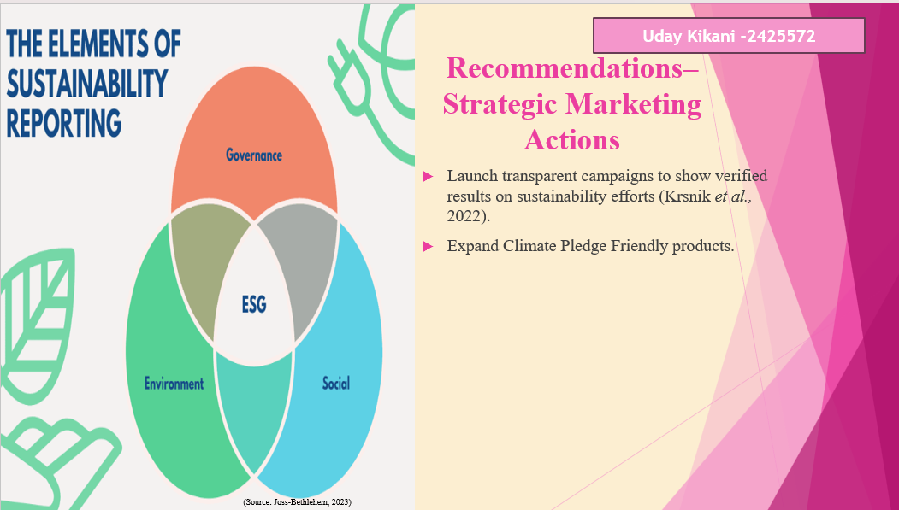
It is suggested to improve business credibility through promotion in verified sustainability efforts. Expanding the eco-friendly product line of Amazon at competitive pricing will attract environmentally conscious consumers.

Recommendations – Cultural and Operational Change
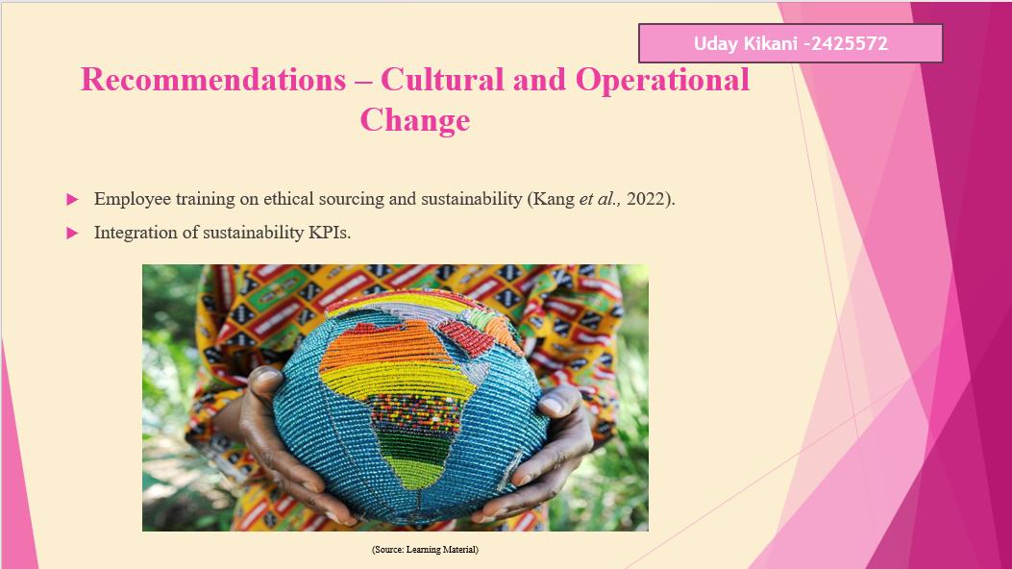
Cultural change at Amazon will start from share to responsibility and employee training. Implication of sustainability KPIs will allow ensuring alignment with sustainability goals and operations management.

Conclusion
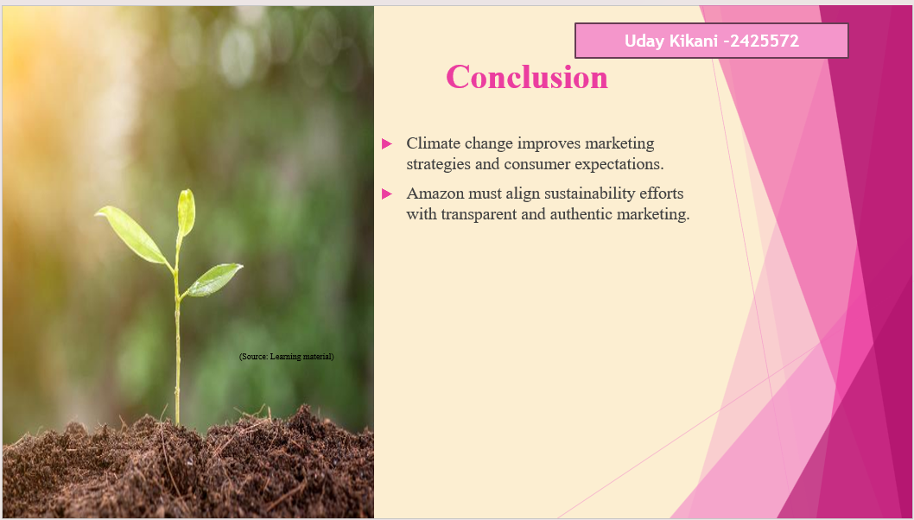
In conclusion, climate change is not just a prominent and badminton issue but directly impacts marketing practices of companies like Amazon. To generate long-term success the company needs to integrate sustainability policies and maintain transparency in messaging and operations.

References
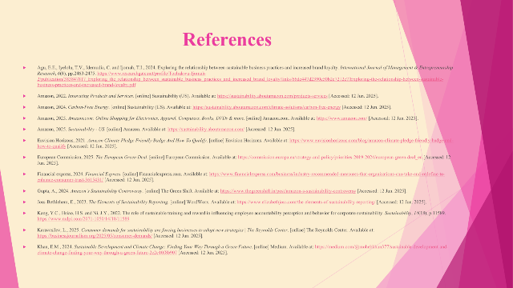
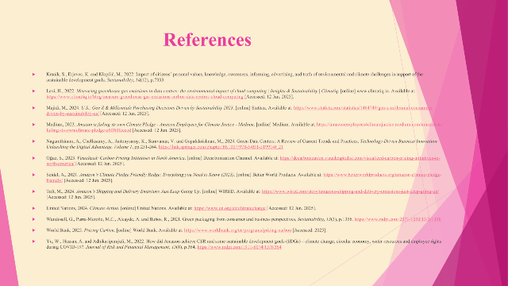
Agu, E.E., Iyelolu, T.V., Idemudia, C. and Ijomah, T.I., 2024. Exploring the relationship between sustainable business practices and increased brand loyalty. International Journal of Management & Entrepreneurship Research, 6(8), pp.2463-2475. https://www.researchgate.net/profile/Tochukwu-Ijomah-2/publication/383847817_Exploring_the_relationship_between_sustainable_business_practices_and_increased_brand_loyalty/links/66dc447d2390e50b2c7212e7/Exploring-the-relationship-between-sustainable-business-practices-and-increased-brand-loyalty.pdf
Amazon, 2022. Innovating Products and Services. [online] Sustainability (US). Available at: https://sustainability.aboutamazon.com/products-services [Accessed: 12 Jun. 2025].
Amazon, 2024. Carbon-Free Energy. [online] Sustainability (US). Available at: https://sustainability.aboutamazon.com/climate-solutions/carbon-free-energy [Accessed: 12 Jun. 2025].
Amazon, 2025. Amazon.com: Online Shopping for Electronics, Apparel, Computers, Books, DVDs & more. [online] Amazon.com. Available at: https://www.amazon.com/ [Accessed: 12 Jun. 2025].
Amazon, 2025. Sustainability - US. [online] Amazon. Available at: https://sustainability.aboutamazon.com/ [Accessed: 12 Jun. 2025].
Envision Horizons, 2021. Amazon Climate Pledge Friendly Badge And How To Qualify. [online] Envision Horizons. Available at: https://www.envisionhorizons.com/blog/amazon-climate-pledge-friendly-badge-and-how-to-qualify [Accessed: 12 Jun. 2025].
European Commission, 2025. The European Green Deal. [online] European Commission. Available at: https://commission.europa.eu/strategy-and-policy/priorities-2019-2024/european-green-deal_en [Accessed: 12 Jun. 2025].
Financial express, 2024. Financial Express. [online] Financialexpress.com. Available at: https://www.financialexpress.com/business/industry-recommended-measures-that-organisations-can-take-and-redefine-to-enhance-consumer-trust-3615431/ [Accessed: 12 Jun. 2025].
Gupta, A., 2024. Amazon’s Sustainability Controversy. [online] The Green Shift. Available at: https://www.thegreenshift.in/post/amazon-s-sustainability-controversy [Accessed: 12 Jun. 2025].
Joss-Bethlehem, E., 2023. The Elements of Sustainability Reporting. [online] WordWorx. Available at: https://www.elizabethjoss.com/the-elements-of-sustainability-reporting/ [Accessed: 12 Jun. 2025].
Kang, Y.C., Hsiao, H.S. and Ni, J.Y., 2022. The role of sustainable training and reward in influencing employee accountability perception and behavior for corporate sustainability. Sustainability, 14(18), p.11589. https://www.mdpi.com/2071-1050/14/18/11589
Karavasilev, L., 2025. Consumer demands for sustainability are forcing businesses to adopt new strategies | The Reynolds Center. [online] The Reynolds Center. Available at: https://businessjournalism.org/2025/05/consumer-demands/ [Accessed: 12 Jun. 2025].
Khan, E.M., 2024. Sustainable Development and Climate Change: Finding Your Way Through a Green Future. [online] Medium. Available at: https://medium.com/@mohebkhan377/sustainable-development-and-climate-change-finding-your-way-through-a-green-future-2c2e10f8b907 [Accessed: 12 Jun. 2025].
Krsnik, S., Erjavec, K. and Klopčič, M., 2022. Impact of citizens’ personal values, knowledge, awareness, informing, advertising, and truth of environmental and climate challenges in support of the sustainable development goals. Sustainability, 14(12), p.7333.
Lavi, H., 2022. Measuring greenhouse gas emissions in data centres: the environmental impact of cloud computing | Insights & Sustainability | Climatiq. [online] www.climatiq.io. Available at: https://www.climatiq.io/blog/measure-greenhouse-gas-emissions-carbon-data-centres-cloud-computing [Accessed: 12 Jun. 2025].
Majidi, M., 2024. U.S.: Gen Z & Millennials Purchasing Decisions Driven by Sustainability 2023. [online] Statista. Available at: https://www.statista.com/statistics/1464749/gen-z-millennial-consumers-driven-by-sustainability-us/ [Accessed: 12 Jun. 2025].
Medium, 2023. Amazon is failing its own Climate Pledge - Amazon Employees for Climate Justice - Medium. [online] Medium. Available at: https://amazonemployees4climatejustice.medium.com/amazon-is-failing-its-own-climate-pledge-c6ff60fceccd [Accessed: 12 Jun. 2025].
Nagarathinam, A., Chellasamy, A., Antonysamy, K., Saravanan, V. and Gopalakrishnan, M., 2024. Green Data Centers: A Review of Current Trends and Practices. Technology-Driven Business Innovation: Unleashing the Digital Advantage, Volume 1, pp.251-264. https://link.springer.com/chapter/10.1007/978-3-031-51997-0_21
Oğuz, S., 2023. Visualized: Carbon Pricing Initiatives in North America. [online] Decarbonization Channel. Available at: https://decarbonization.visualcapitalist.com/visualized-carbon-pricing-initiatives-in-north-america/ [Accessed: 12 Jun. 2025].
Seidel, A., 2021. Amazon’s Climate Pledge Friendly Badge: Everything you Need to Know (2023). [online] Better World Products. Available at: https://www.betterworldproducts.org/amazon-climate-pledge-friendly/ [Accessed: 12 Jun. 2025].
Taft, M., 2024. Amazon’s Shipping and Delivery Emissions Just Keep Going Up. [online] WIRED. Available at: https://www.wired.com/story/amazons-shipping-and-delivery-emissions-just-keep-going-up/ [Accessed: 12 Jun. 2025].
United Nations, 2024. Climate Action. [online] United Nations. Available at: https://www.un.org/en/climatechange [Accessed: 12 Jun. 2025].
Wandosell, G., Parra-Meroño, M.C., Alcayde, A. and Baños, R., 2021. Green packaging from consumer and business perspectives. Sustainability, 13(3), p.1356. https://www.mdpi.com/2071-1050/13/3/1356
World Bank, 2025. Pricing Carbon. [online] World Bank. Available at: https://www.worldbank.org/en/programs/pricing-carbon [Accessed: 2025].
Yu, W., Hassan, A. and Adhikariparajuli, M., 2022. How did Amazon achieve CSR and some sustainable development goals (SDGs)—climate change, circular economy, water resources and employee rights during COVID-19?. Journal of Risk and Financial Management, 15(8), p.364. https://www.mdpi.com/1911-8074/15/8/364


