Name | Student Number | Date | Lecturer’s Name | Your score
Sadia Nadeem | 2434168 | 30.06.2025 | daniel | To be filled by the marker  ___/40
You will have 90 minutes to complete this assessment. It is divided into three sections: note-taking, paraphrasing and writing a paragraph.
---------------------------------------------------------------------------------------------------------------------
1. Take diagrammatic notes from the passage below using the space provided:

The university experience is not just about subject knowledge, but also about developing skills that will equip you for your future life. For starters, it's impossible to graduate without a range of people skills under your belt. You'll meet new people from different backgrounds. You'll also interact with lecturers, tutors and university staff almost daily. Another life lesson that university teaches you is taking responsibility for yourself, your own schedule and learning. A lot of university study is self-directed - it's up to you to plan and organise your work, juggle multiple projects and manage deadlines – you will need to develop self-motivation if you want to succeed. Let’s not forget learning how to overcome obstacles; whether academic, work-related or personal, you'll face your fair share of hurdles as a student, but you will develop resourcefulness and resilience in the process. If you were a bit unorganised before you went to university, you won't be by the time you leave. To successfully navigate student life you'll need to handle a variety of study, work, social and personal commitments and the only way to do this is with organisation and time management. Finally, university provides plenty of opportunities to work on and boost your confidence: you'll work in groups, deliver presentations, complete assessments and maybe even become a class representative.
Adapted from: https://www.prospects.ac.uk/applying-for-university/university-life/7-life-skills-youll-learn-at-university

Space for your notes (max 12 marks):
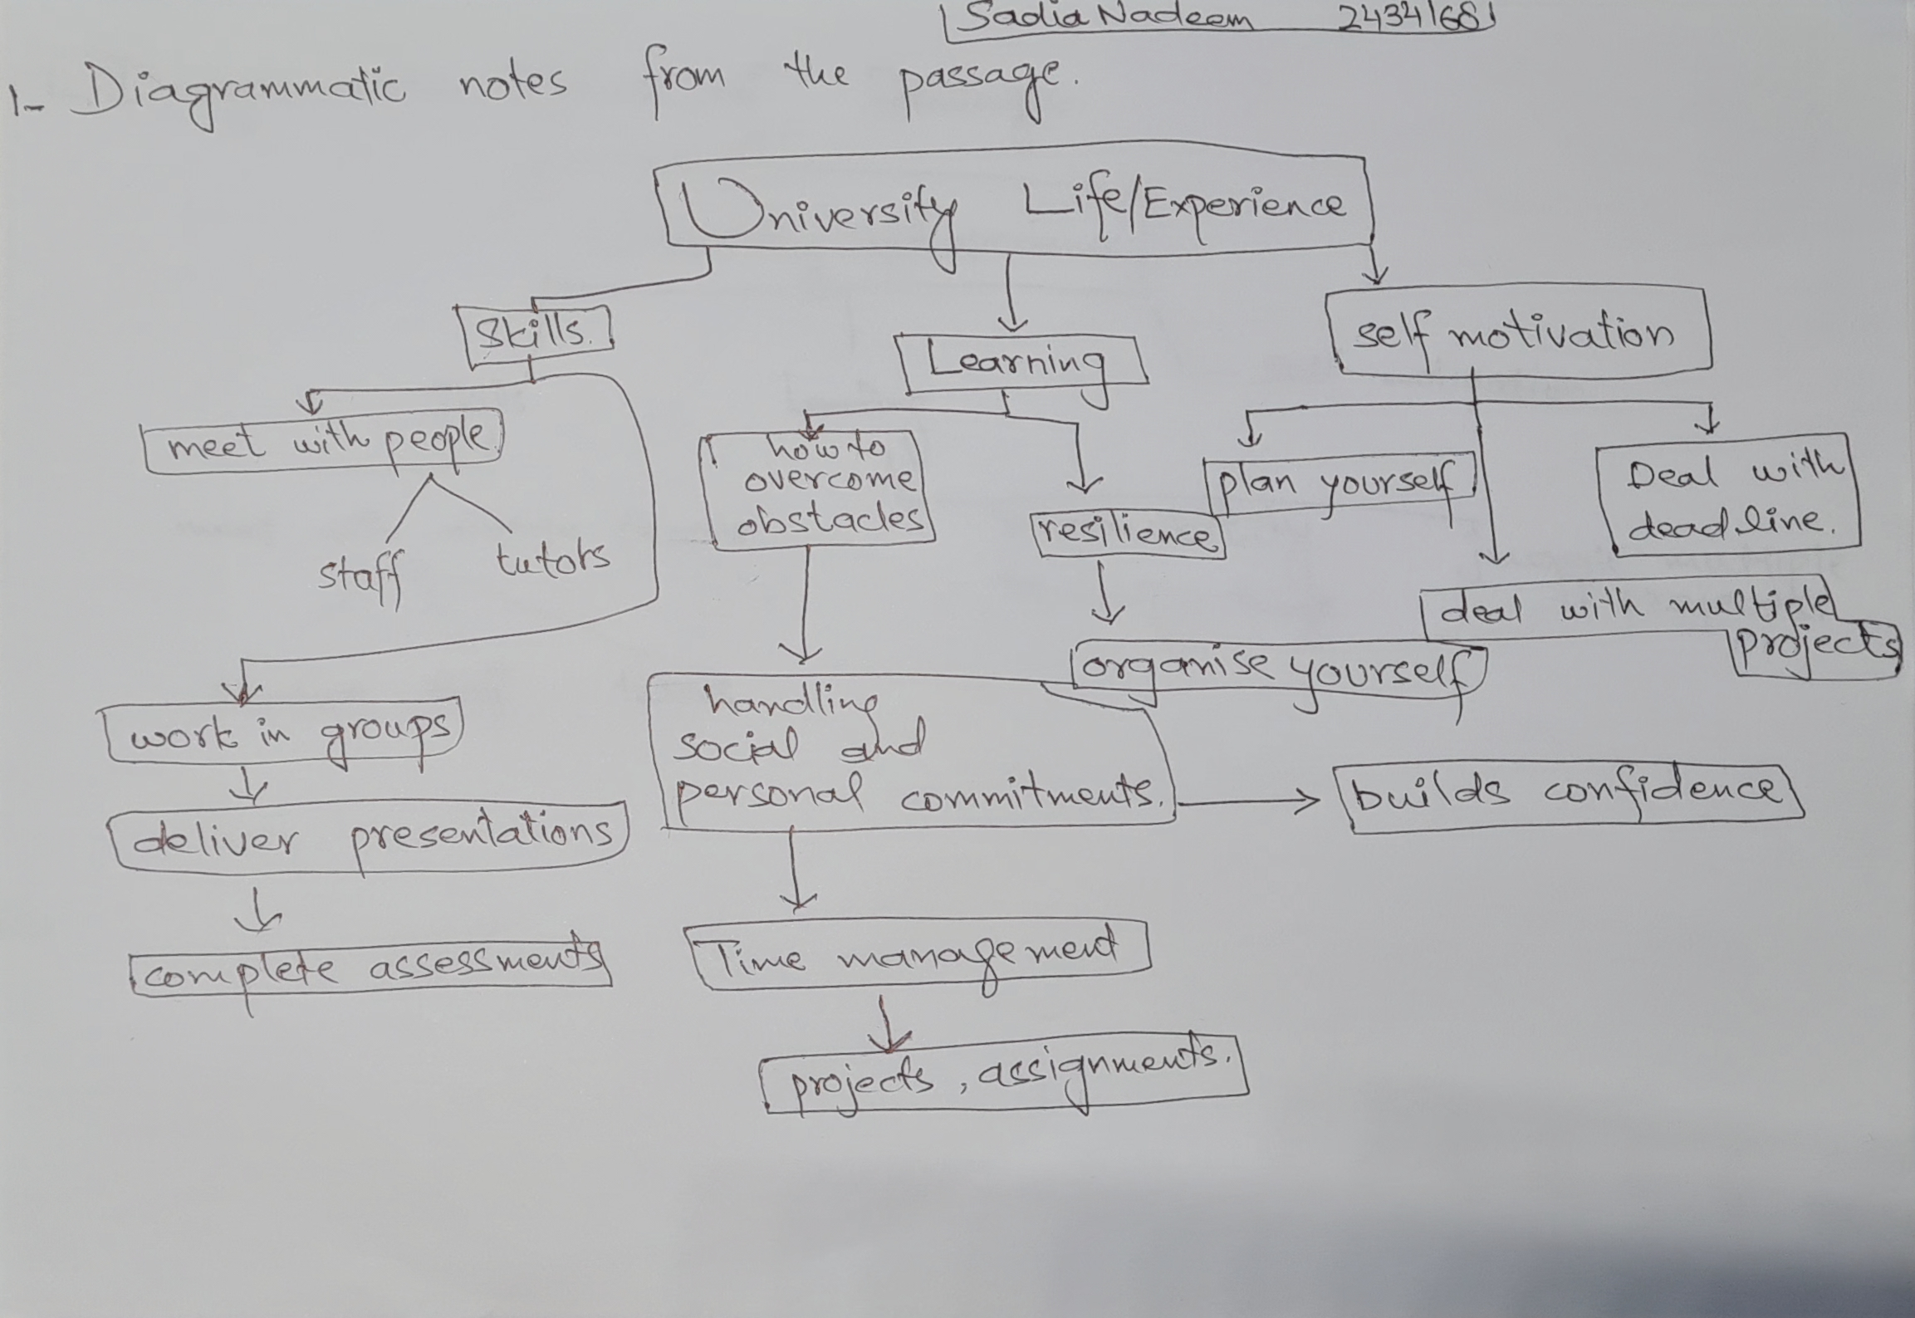

2. Paraphrase the following sentences (max 3 marks for each, max 12 marks in total):

a) To successfully navigate student life you will need to handle a variety commitments.
If u want to succeed in student life you will have to manage different kinds of activities and tasks efficiently.

b) You will need to develop self-motivation if you want to succeed at university.
You will have to encourage yourself to do the tasks if you want to get success in university.

c) Many students find it challenging to manage stress during assessment periods.
In the university life its very difficult to deal with the depression . A lots of students face depression and anxiety during assessment time.

d) Frequent reading can help you become a more effective communicator.

If you want to become a more efficient talker or speaker then you must make a habit of time to time reading.

3. Write a well-structured paragraph (8 sentences) on the following topic:

Effective time management techniques for university students

Your paragraph must be written in full sentences (no bullet points) and in an academic style.

(max 16 marks in total)

Time management is a very important technique for the university students to manage and control the academic activities and personal life. If a student follows some strategies like to-do the list ,smart goals,4D strategy, then it will be easy to organise things. Using Pomodoro technique will also help him to do the tasks effectively. Another thing is to divide the bigger tasks into smaller will also help to manage the tasks. It reduces the stress level during assessment period and he can manage the university life more smoothly. Another time management skill is to distract yourself from the things that divert your attention (like mobile notifications)turn them off while doing some work. Managing deadline is also very important to self organising in a better way. Reviewing and adjustment of your tasks also help you to manage your time. If a university student follows these techniques he can enjoy the university life and personal life as well .

