Demonization of the Egyptian Gods

Introduction

Gods, Protectors and creators of life and protectors of the afterlife.

Since the beginning of time people have worshiped and followed gods through religion. It has brought people together, built amazing societies and caused war. For generations people have defended what they believe in and worshiped their own gods.
Religion is a mandatory subject in many schools across the globe. We are taught the religion of others, we are encouraged to respect it. So why are some gods demonized for entertainment in the media industry?
The Egyptian gods are the most noticeable of being victim to demonization within the media. This is likely in part due to the lack of understanding ancient Egyptian religion. This is not due to naivety but could be credited to the lack of general knowledge regarding ancient Egyptian religion. The history of Egypt is fragmented and there are also conflicting findings and ancient texts.
“Understanding ancient Egyptian thought on creation, or indeed reconstructing Egyptian myth overall, is like trying to piece together a jigsaw puzzle when the majority of the pieces are missing and someone has thrown away the box.”
Garry J. Shaw, 2014, The Egyptian Myths, page 17.
Within ancient Egyptian religion, one god above the rest has been subject to demonization in modern media. Anubis, the Egyptian god of the dead. Before understanding his misrepresentation in this way, we must first know his true origins along with his purpose and roles in ancient Egyptian religion. We should start by looking at his original design and depiction.
I will be focusing on Anubis first and for the majority of this investigation as he has been most subject to reinterpretations within modern media. I will also look into other gods as they appear in the movies or games alongside Anubis. The focus on Anubis is also due to the limitation of the size of this document as there are many Egyptians gods, too much gods to cover them all in this document.

The design of Anubis
Anubis is depicted as a canine sometimes in the form of a human with a canine head or as a dark black furred canine. Although it is still debated in which animal Anubis has the form of, its widely believed to be a jackal.
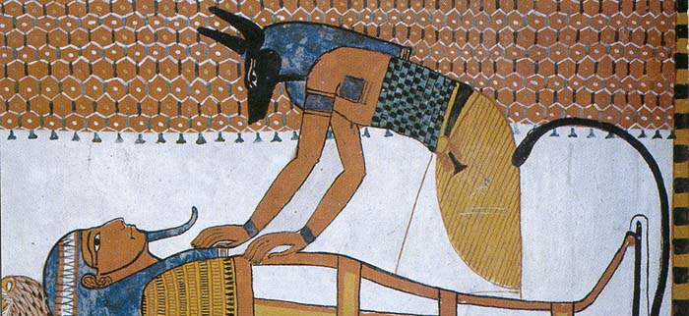
Image source: http://www.ancient-egypt-online.com/anubis.html accessed on: 19/11/2017
Anubis was depicted with black fur. This colour represented “both rebirth and the decolourisation of the corpse after embalming” (Gryglewski 2002 p.145)
This colour could be one of the reasons Anubis has come be represented wrongly as in movies and games we are led to believe that light (white) is good and dark (black) is bad. This could be due to as children we fear the dark as it is the unknown.
We associate different colours with different meanings, green is good (or go) and red is bad (or stop). Without even know when we see a colour we have an idea of the traits the bearer has. In the Star Wars movies, we see the most obvious uses of this colour theory. (Star Wars, Directed by George Lucas, Mat 1997>)
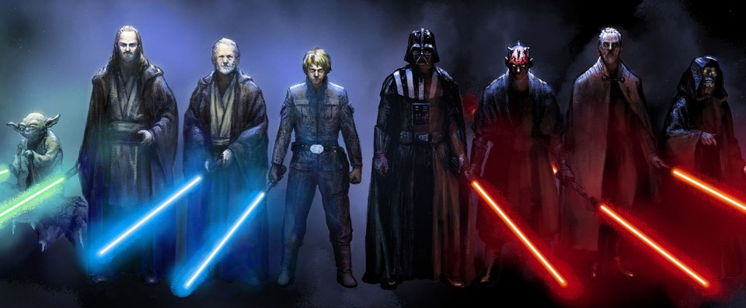
Image source: https://www.stylecracker.com/blog/a-dummies-guide-to-star-wars/ Accessed on 10/12/17
If I was to ask you “who is good and who is bad?” in the previous image, the answer would be obvious. We have blues, greens and greys on the left and reds and blacks on the right. You can see from just this image that these two sides are not the same. Red is associated with blood and violence, it can cause our brain to make more resonate decisions. In Game Theorists video, Red vs Blue, The SECRET Color Strategy, he speaks about how we preserve colours (red and blue in particular). Red is associated with blood and violence, it brings out the instincts in us to think fast or fear something bearing that colour. Blue on the other hand makes us think of the sea, the sky and other natural calm things. We are more at ease with the colour. During his video he found evidence that a team wearing red was more likely to win a sport like boxing due to the red team being more aggressive and the opposite team being instinctively afraid of the red team, so red is associated as bad and blue as calm and good.
With Star Wars this idea of darker colours and red being bad and lighter colours being good is actually in the names of the side themselves, “the dark side” being the side of villains and the “light side” being the heroes.
So, in movies today darker colours are linked to villains or un-trustable characters or places in which you should not explore. While in ancient Egypt it was linked with birth, rebirth and the afterlife. This along with the title “God of the Dead” is likely what started the modern demonized version of the god Anubis.
Anubis has been theorised as being a jackal, although this is contested with others saying he is another canine such as the Golden Wolf (desert wolf). For now, I have chosen to follow the belief of him being a jackal. Although most points I cover will be applicable to most canines.
When asked to think of a wild animal, expectably when thinking of a predator. One of the first things to come to mind would be their teeth and claws.
Image source: http://jasonconnell.co/goodness/ Accessed on: 29/11/2017
Human instinct like animal instinct notices the danger first. A wild canine will be seen as a risk, a threat and something no sane person would approach. These animals especially when untamed. This brings me to a quote from Terence DuQuesne,
“The Egyptian jackal is a beautiful, elegant and often misrepresented animal”
Terence DuQuesne, 2005, The Jackal Divinities of Egypt (Part 1), page 17, XIX.
This misrepresentation of the jackal Terence speaks about could also be linked to how Anubis is also misrepresented as the animal he has the form of also has this problem.

Anubis’s Roles In Ancient Egyptian Religion

Anubis has many roles throughout Egyptian religion (this could be due to the conflicting finding and differed beliefs in lower and upper Egypt). Anubis is the god associated with mummification and the afterlife. According to ancientegypt.co.uk, jackals would often be seen in cemeteries, this could be why the ancient Egyptians believed Anubis would watch over the dead. This is likely where he got the title of “Protector of Tombs”. He was mostly known as the god of death due to his involvement of the weighing of the hearts.
It could be argued due to the age and scattered origins of these gods, it can be debatable to witch gods were good and which were to be feared. A clear example of a god to be feared would be Apep, the Egyptian god of chaos, also known as Apophis.
“Apophis, a monstrous snake, 120 cubits (about 63m or 206ft) long, who represented disorder.”
Garry J. Shaw, 2015, The Egyptian Myths, page 37.
Anubis however was not a mischievous god like Apep. According to Richard H. Wilkinson in his book The Complete Gods and Goddesses of Ancient Egypt 2003 (page 187), Anubis was the most important funerary god. Originally, he was seen as to be only concerned with the death of the Pharaoh, but his role later extended to accompany all of the dead. Despite all his roles and purposes in ancient Egyptian religion the title most people know him by is the “God of Death”.

The Design and Depictions of Egyptian gods in modern media

Assassin’s Creed Origins (Assassin’s Creed Origins, 2017, published by Ubisoft)

The Egyptian gods have been depicted in movies and many video games over that past couple of years. One of the most recent appearances of the gods is from a video game called “Assassin’s Creed Origins”, published 27th October 2017. The game takes place in Egypt during the Ptolemaic period (BCE). In this game you play as Bayek, an Egyptian character. For the majority of this game the gods are represented as they truly were in temples and shrines across the games map and within the games story. The game however features an event called the “Trails of the Gods”, during this in game event players are put up against the gods themselves. During the time of writing this the trails has featured 3 gods. The gods Anubis, Sobek and Sekhmet have been included. All these gods had very different roles and depictions in ancient Egypt. These trails when beat would provide the player with a piece of gear designed after the first god to appear, Anubis. I will look at these weapons after looking at the gods used in this event.

Sobek
First, I will look at Sobek and Sekhmet before looking into Anubis and the gear based on him. I will also be looking at what the publishers (Ubisoft) themselves have said about the gods in the trails.
Sobek, “Lord of the waters”, “God of the Nile” (According to ancientegyptonline.co.uk assessed on 10/12/17) and also the “Gods of Crocodiles. Also, as said on ancientegyptonline.co.uk, Sobek was the first god to be mentioned in pyramid texts as was wildly worshiped until the Roman period. He was also known to bring fertility to the earth. Richard H. Wilkinson mentions in his book (The Complete Gods and Goddesses of Ancient Egypt, p218, 2003) the name Sobek simply means “crocodile”, due to this form he was also associated with strength and power.
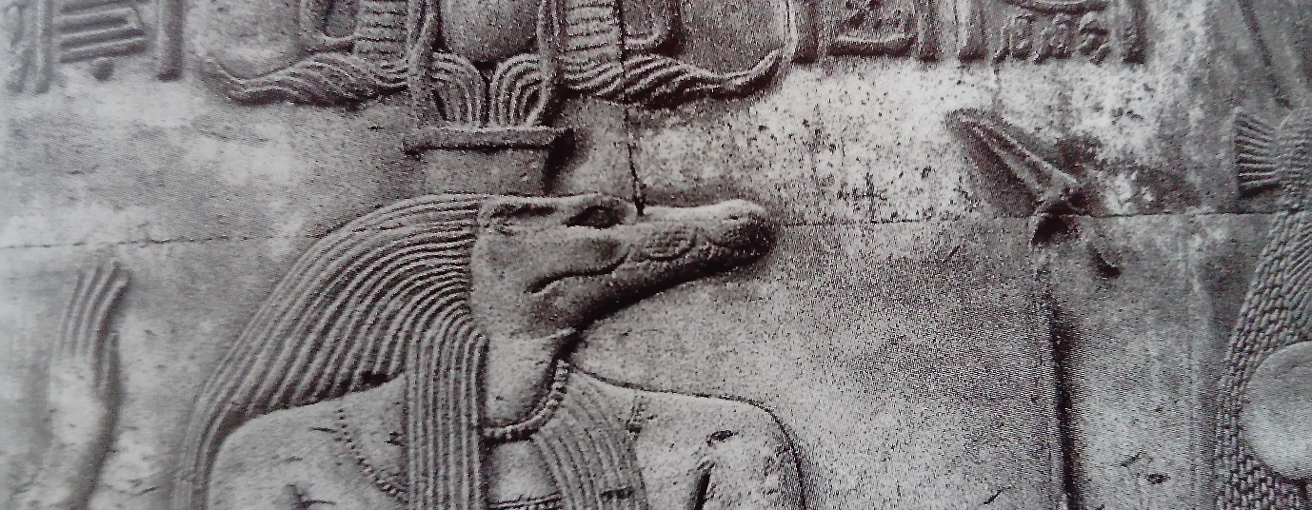
Image source: Richard H. Wilkinson, The Complete Gods and Goddesses of Ancient Egypt, p219, 2003.

In Assassin’s Creed Origins “Trails of the Gods”, he is put against the player as an enemy. Many of his Attacks towards the player reference his strength with him able to create a shockwave like attack but striking the ground around him. Leading up the this Sobek trail going live for the public, Ubisoft realised a short teaser for the event. On assassinscreed.ubisoft.com (Accessed on 06/12/17) they wrote that Sobek “embodied one of the fiercest predators known to Ancient Egypt”. They also note that the Nile crocodile was known for its “size and strength”. During the post they also refer to the title “Lord of the waters” but they refer to it as “fearsome”. Due to the fertility he provided to the land and also his strength along with his animal form he was a god to be feared but also respected and worshiped. Ubisoft also go onto say that there were crocodiles bred and kept in temples in honour of Sobek, “According to ancient sources”. I was able to validate this in Richard H. Wilkinson’s book The Complete Gods and Goddesses of Ancient Egypt as he says, “His temples were usually provided with pools containing sacred crocodiles which were mummified when they died” (page 220).
This information suggesting this was all done in honour of Sobek and had temples dedicated to him shows the ancient Egyptians had a huge about of respect for this god. Even though he was to be feared, he was mostly and widely respected and worshiped.
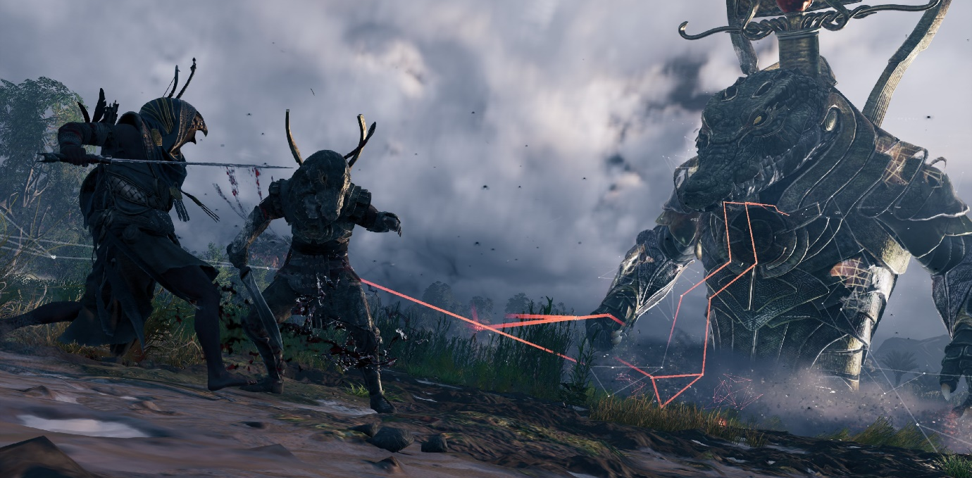
Image source: Assassins Creed Origins, Ubisoft, 2017, captured on PS4 Pro Photo Mode.

With Sobek being portrayed as an enemy within the game, especially with the playable character being Egyptian is an inaccurate depiction.

Sekhmet
Sekhmet (sister of Bastet), was the goddess to follow Sobek in the “Trails of the Gods” event. In ancient Egypt she is depicted with a head and form of a lioness. According to ancientegyptonline.co.uk “Her name is derived from the Egyptian work Sekhem (which means power or might)”. She was a Warrior goddess as well as the god of healing. She was strongly associated with power and violence, this was likely due to her animal form being a lioness. She was also associated with fire, this is due to Sekhmet being one of the daughters of Ra who was god of the sun. Ra gave her the title “Right Eye of Ra”. She was created to act as “Ra’s instrument of vengeance” (www.angelfire.com/mb/manifestnow/sekhmet.html accessed on 07/12/17) and she would bring retribution on whoever dared to oppose Ra.
“It was said that her breath created the desert” www.crystalinks.com/sekhmet.html accessed on 10/12/17) This shows the god was also associated with creation, not just violence.
Although this goddess was healing, she was mostly known for her more violent attributes.
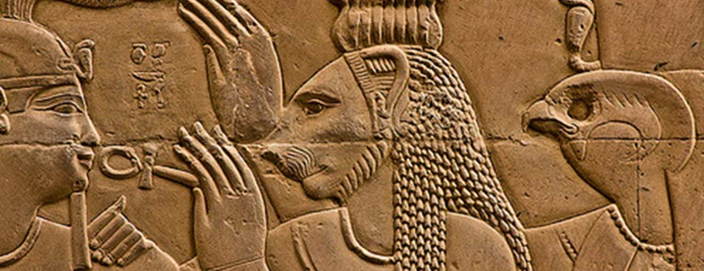
Image source: http://www.ancient-origins.net/news-history-archaeology/numerous-statues-sekhmet-lioness-goddess-war-unearthed-egypt-007183 Accessed on 10/12/17)
In the game the playable character Bayek refers to Sekhmet as the “Goddess of slaughter” when he finds an old temple berried in the sand dedicated to the goddess. Ubisoft (on their website) assassinscreed.ubisoft.com claims she has a “great capacity for violence when displeased”, this is correct as being the “Right Eye of Ra” she slaughtered those who opposed him. The Egyptians would go though “great lengths” appease the goddess as the punishments for wronging her or Ra were dire. Ubisoft also mentions the titles of “healing and fertility”, but they do not expand on these titles, likely due to them indicating she would not be an enemy to the player.
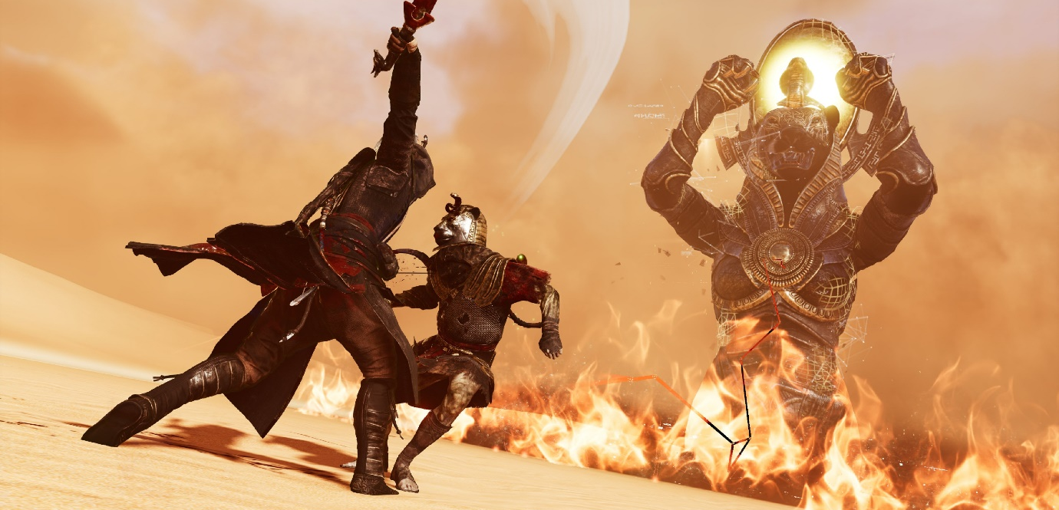
Image source: Assassins Creed Origins, Ubisoft, 2017, captured on PS4 Pro Photo Mode.
Due to her more violent attributes, it was not far fetched for her to be depicted in this event as a boss battle (in game enemy). As she had a positive side you would have to argue you are just defending yourself against her aggressive and violent side. The goddess in the game is designed with the solar disc above her head (like she was depicted on walls in ancient Egypt). She uses powers focused on fire, this is relating to her origin, being the daughter of Ra (the god of the sun). This god is depicted accurately in terms of her design and powers linking directly to the source. The location this event takes place in is also true to the origins of Sekhmet as it takes place in the desert which it is believed she created.

Anubis
The first god to appear in the “Trails of the Gods” was Anubis, the god of the dead. Even though Anubis was the first to be featured I decided to cover the other 2 gods first due to Ubisoft having very little to say about Anubis on their website. The only information they gave on Anubis was his title, “God of the Dead” and his form being a jackal (assassinscreed.ubisoft.com Accessed on 06/12/17). The lack of information Ubisoft posted about Anubis suggests they had nothing to sell him as a foe for the game so simply said nothing other than his title.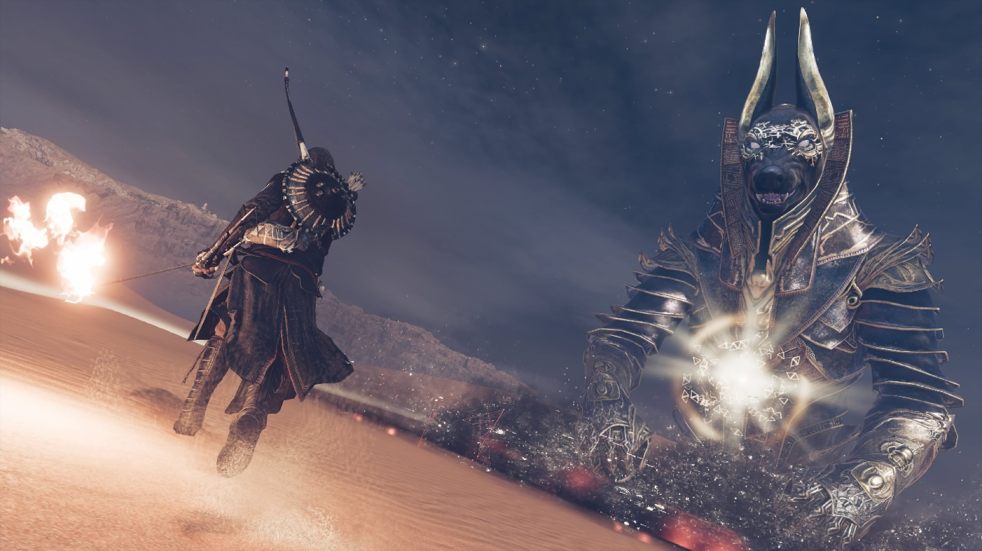
Image source: Assassins Creed Origins, Ubisoft, 2017, captured on PS4 Pro Photo Mode.
These trails are referred to as a “glitch in the Animus” (Technology in the game used to view the memories of ancestors thought DNA). So, these missions are written as glitches and there for can ignore reality for the purpose of making an entertaining video game. Like both the other gods to appear so far in the trails he enters with an enraged roar before attacking the player. During the battle he is able to summon hyenas to fight for him, this is likely due to Anubis’s form being a canine, but it does not stand true to the type of canine he is (a jackal). As this is a video game, production cost should also be considered. This event was realised to the public for free, the hyena mesh already exists in the game files, so it was likely just a cheaper and easier option to use the hyena instead of creating a jackal model. He also summons zombies (mummified) who wear a helmet following the design of Anubis’s form. Anubis does not have the power to give life, but he was the protector of tombs and also the god of the dead, so you could argue that the ones he protects, also protect him. Due to this being a game and the publishes referring to the event as a “glitch in the Animus” they are able to bend the sources a little with still following the depictions of the gods from ancient Egypt.
Although these trials provide the player with a unique piece of gear as a reward for being able to beat the trails. One piece of gear is rewarded for the completion of each boss (god) defeated. The gear given are all themed after Anubis in design, naming and weapon perks. These items also have deceptions referring to Anubis as well.
At the time of writing there have been 3 gods featured in the trails, this means 3 items. A sword, shield and a sceptre are the current available items. These items are giving to the player to keep, meaning these are not tied to the “glitch” Ubisoft has used to descript the missions themselves.
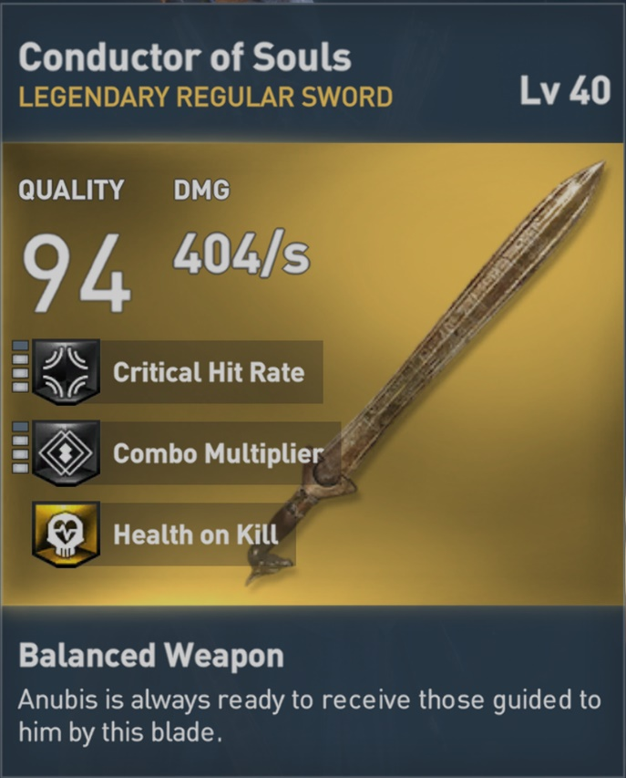
The first weapon given to the player is the sword called the “Conductor of Souls”, this name lily refers to Anubis being seen as the guider of souls (into the afterlife). As he was present during the weighing of the scales and would guide the dead to the afterlife. The swords perk (bonus ability) though provides the player with extra health in game when the sword is used to kill. The description also reads, “Anubis is always ready to receive those guided to him by this blade”. This suggests that Anubis wants souls and also desires them enough to reward the player when they provide him with them. Anubis in ancient Egyptian mythology does not want or hunger for souls, but there is another god who follows these traits, I will be talking about this god later.
Image (to right and below) source: Assassins Creed Origins, Ubisoft, 2017, captured on PS4 Pro.
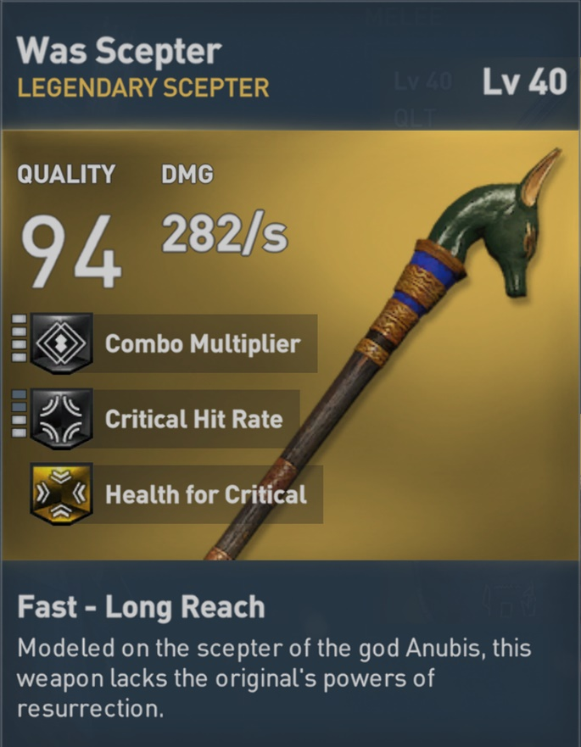
The next weapon is a sceptre, and is provided for beating Sobek (lord of the waters). The name of this item is the “Was Scepter”. This refers to the Was Sceptre which appears in many images of the gods and Pharos of ancient Egypt. It was a symbol of divine power.
“The Was Sceptre was believed to be a fetish, an object that was believed to embody magical powers, used to create a bond between the mortal world and the underworld”
Source: landofpyramids.org accessed on 10/12/17
The items description reads “Modelled on the sceptre of the god Anubis, this weapon lacks the original’s powers of resurrection”.
Anubis is often depicted holding a sceptre, however I was unable to find any evidence of the powers including “resurrection”, or at least not while held by Anubis. This weapon also provides the player with health on a critical hit. This does suggest Anubis wanting people to be killed and sent to him, however due to the “Was sceptre” having divine powers, this perk can be credited to this.
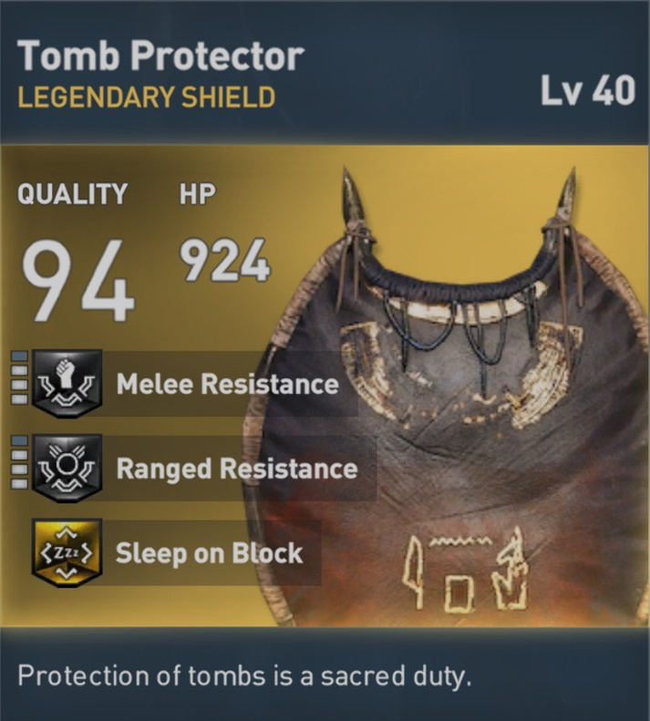
The final item (to the date of writing) was a shield. This piece of gear is called the “Tomb Protector”, the names links to Anubis being the “Protector of Tombs” and is the most accurate reward given in the “Trails of the Gods” in relation to his roles and titles. The description reads “Protection of the tombs is a sacred duty”. Anubis was linked to protecting tombs likely due to jackals being commonly seen around tombs. The Shields perk causes the attacker to sleep if blocked using it. This can be a link to death being seen as the eternal rest.
The shield also feathers Anubis name in Egyptian hieroglyphs at the base of the shield.
Image (to right) source: Assassins Creed Origins, Ubisoft, 2017, captured on PS4 Pro.

So overall in Assassin’s Creed Origins the gods are portrayed fairly accurate in the main game but have some floors in the “Trails of the Gods” event portraying these gods as the antagonist.

The Mummy Returns (The Mummy Returns, 2001, directed by Stephen Sommers)
The Mummy Returns (2001) directed by Stephen Sommers features Anubis. At the start of the movie the antagonist comes closes to death. As he was dying he calls to Anubis and offers a deal, he offered his soul in exchange for his life. Anubis accepts this deal and spares his life (in exchange for his soul). Anubis however does not have this power or the desire for souls, he simply oversees the weighing of the scales and watches over the dead. There are gods linked to resurrection in ancient Egyptian religion however Anubis does not have this power. As for the offer of the antagonist’s soul, there is a god interested in souls and is also said to live in the Duat (realm of the dead). Apep, a giant snake like god with the title “Eater of Souls”. Apep was the reason the dead needed defending. Anubis being “The Protector of Tombs” and Apep, “The Eater of Souls”, these gods were polar opposites, so why has Anubis been giving a trite from his enemy? This could just be down to naivety and lack of research into the gods. Anubis is the “God of Death”, his colour is dark and has the form of a predator, he could easily be seen as a villain (an easy choice for the director). To someone without any education of these gods, they would assume him to be an antagonist.
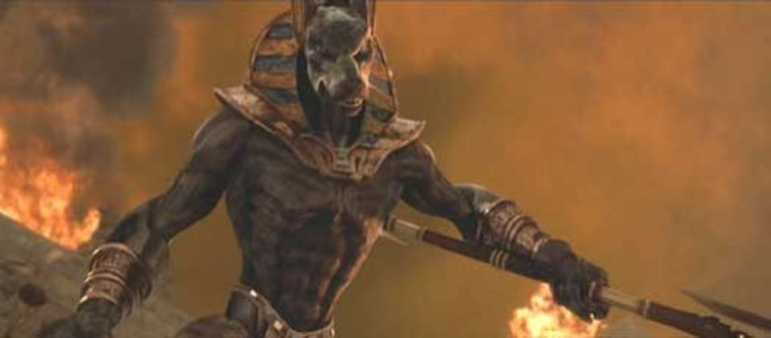
Image from The Mummy Returns, 2001, directed by Stephen Sommers
During this deal Anubis made with the antagonist, he provides him with an army referred to as the “army of Anubis”, this army is in his image. The design is true to the key features of the depictions of Anubis back in accent Egypt however his fur covers his full body (normally was depicted with a human body). This army was provided for the antagonist to conquer the world. After seeing this I was confused as I’ve not read or heard any mention of Anubis having an army or being interested in the conquering of the world. No matter where I looked I could not find anything to support this. However during reading the book The Jackal Divinities of Egypt (part 1) by Terence DuQuesne, I found a name witch kept popping up, “Upwawet” (also known as Wepwawet). This name led me to something far more interesting than Anubis having an army, Anubis was not the only canine god and also has a lookalike god.
Upwawet is another canine god, he has the form of a wolf, but it drawn the same as Anubis when in anthropomorphic form. This god shared the appearance of Anubis however Upwawet was pale (grey or white) furred unlike Anubis’s black fur. This god had many titles of interest, including “God of War and Victory”, and also “Opener of the ways”. With the war and victory title, this god could have been seen as possessing the power to provide an army like in the movie. Also, the title “opener of the ways”, this title I believe was given to him due to the translation of his name. According to Pat Remler in the book Egyptian Mythology A to Z (Pat Remler, Egyptian Mythology A to Z: A Young Readers Companion, Facts on File Inc., 2000. p. 170) Wepwawet’s name means “opener of the ways”. Due to his connection & association with war, he was seen as being linked to death. This along with his title “opener of the ways” he was seen as one who could open the ways between the living world and the Duat. So Upwawet/Wepewawet was a god with association to an army (thought his “War” title), a passion for conquering (due to his “victory” title) and also could be seen as having the power to open passageway for the dead and the living (due to his “opener of the ways” title). This god has 3 out of 4 of the traits and powers of Anubis in The Mummy Returns movie.
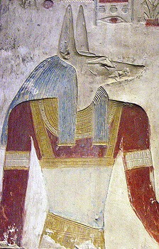
Image source: https://cowofgold.wikispaces.com/Wepwawet accessed on: 4th Dec 2017
I showed this image of Upwawet to others with one simple question, “Who is this?”. Everyone I asked gave the same answer as the last, “Anubis”. Many depictions of this god are not coloured so could easily be seen as Anubis. However, with this image they saw Anubis’s black fur to have faded as this is clearly an old image, but why would the colour black have faded with time and not the skin tones used?
Could it have been possible that when researching Anubis for the film, they accidently researched the wrong god? Researching Upwawet in the place of Anubis would have provided them with the thoughts of him having this sort of power in the movie.

The Pyramid (The Pyramid, 2014, directed by Grégory Levasseur)
A more resent movie to feature Anubis and references to the Egyptian gods comes if the form of a horror movie in 2014, The Pyramid was published. This movie contained multiple references to the gods. As the characters are digging up the pyramid, they complain about all the dogs barking at them, this is a nod to Anubis as he is canine and is “Protector of tombs”, these “dogs” are protecting the pyramid (which is a tomb) from the discovers. During one scene we follow some archaeologists though a narrow hall lined with Sekhmet heads caved into the walls. A trap is triggered which starts to fill the room with sand, this sand pours from Sekhmet’s mouth. This is clearly a link to her creating the desert sands with her breath I mentioned earlier. Anubis also weighs the heart to see if it’s pure, they also speak of Osiris as Anubis’s father (or creator) and how he was killed (by Seth) leaving Anubis to help embalm the god. With these examples and other references, they make to other gods it shows that a lot of research and planning has gone into the movie. However. The films plot revolves around Anubis soul being corrupted, preventing him from joining his father in the afterlife. Anubis starts to sacrifice humans to try find a pure heart (pure soul). This leads to the pyramid being created to keep him inside trapped as said in the film, “this pyramid became a prison, closed by the Egyptians to get rid of their own god”.
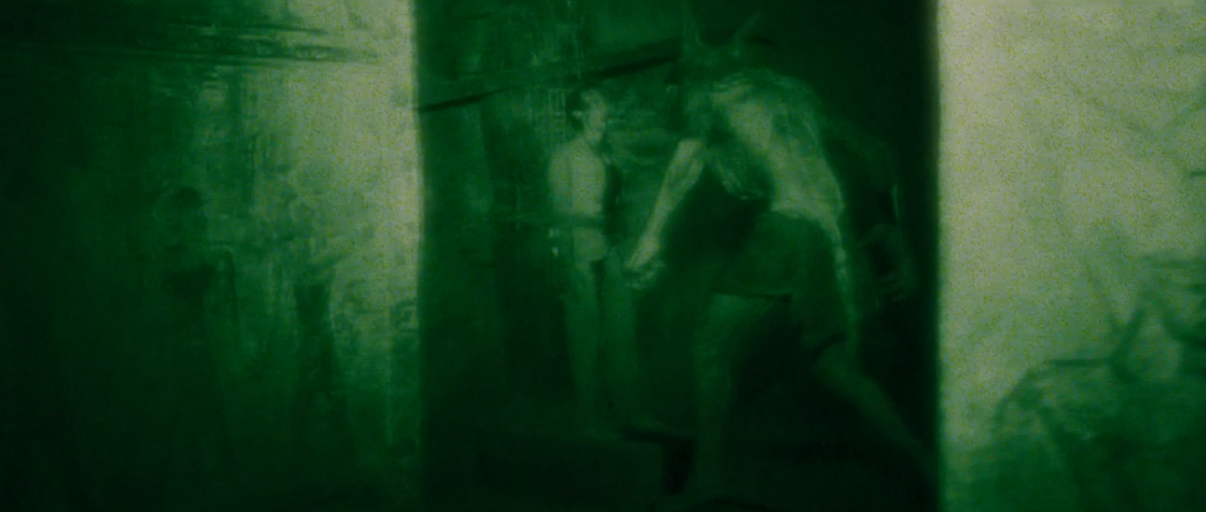
Image from The Pyramid, 2001, directed by Grégory Levasseur
His design in the movies appears to not follow any depictions from ancient Egypt. He is less humanoid and far closer to the design of a werewolf. This design is far from the origin of Anubis. When depicted in ancient Egypt in human form, he has the head of a black jackal and a human body (no fur on body) and in some cases with a long black tail (normally without). The design of him in this case is likely to make the character more scary or powerful as this is a horror film.
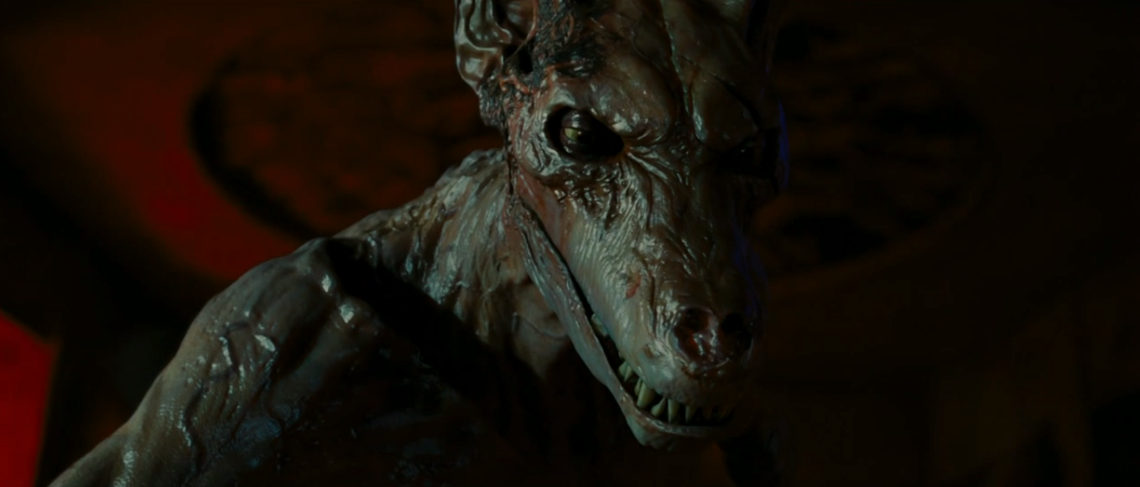
Image from The Pyramid, 2001, directed by Grégory Levasseur
His colour is also not true to his depictions from ancient Egypt. Anubis in the movie is not black furred like his origin or most other recreations, instead he is closer to the colour of Upwawet (the pale or grey coloured canine god). Due to his role in the movie of weighing the hearts and them speaking of Anubis’s father it is highly unlikely they researched the wrong god here. His colour in the movie could be down to how long he has been trapped in the dark without any sunlight also his design looks like his has been skinned or is rotting in the pyramid.
The characteristics of Anubis also have holes, the weighing of hearts he did do, but in the movie after the heart was found not worthy he consumed the heart (ate). During the movie Nora (a character) says “It’s Anubis, half man, half jackal, he ate the hearts of those he found to be impure”. This line and action pf Anubis is defiantly wrong as he never did this, he only weighted the heart for judgement. At the scales in the underworld Anubis used there was another deity who would wait at the scales for an impure heart to be weighted. Ammut would consume the hearts that were not pure.
“Her name meant ‘female devourer’ or more fully ‘female devourer of the dead’. In this role, as an underworld deity, she was also called ‘great of death’ and ‘eater of hearts’ and were supposedly the destroyer of those who had led wicked lives and who were not to be granted access into the afterlife”.
Richard H. Wilkinson, The Complete Gods and Goddesses of Ancient Egypt, 2003, page 218.
This gods role has been combined with Anubis’s, this could be done out of confusion as both these deities oversaw the weighing of the hearts at the scales. It may also have been done to make Anubis appear scarier, but it did not add to the story and Anubis only consumed a heart once giving the impression is was put in as they believed it to be an accurate depiction of the god.

Gods of Egypt (Gods of Egypt, 2016, directed by Alex Proyas)
The movie Gods of Egypt features many Egyptian gods following many myths from ancient times such as Set killing his brother (Osiris). Horus would then seek revenge on Set (exactly like the Egyptian myth). While Set rules (in the movie) he creates the rule of people having to buy their way into the afterlife with gold. The scales in the Duat are still overseen by Anubis but other gods are absent from the scales. The hearts are also not weight at the scales as they should be, instead offered gold is weighed to see if the person is eligible for the afterlife. This is more in line with “Lady Judgement” from Greek mythology who could be confused with Anubis weighing the heart as Greeks wrote about the gods and there were some cross overs between Greek and Egyptian mythology. One example in the film is the blood of the gods. During the movie, when Osiris is killed by Set, he has golden blood. This was a trait for Greek mythology and gods, Egyptian god’s blood is never described indicating their blood was red, like most other life on earth. If the blood was confused with Greek mythology, then is possible the scales were to.
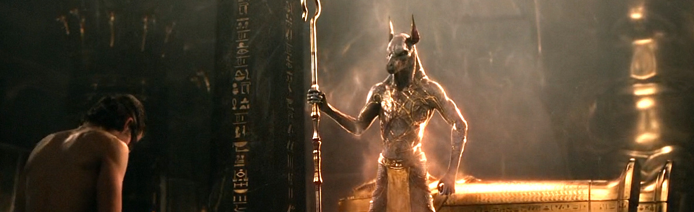
Image source: Gods of Egypt, 2016, directed by Alex Proyas

For the most part the myths from ancient Egypt are correctly depicted as well as the design of Anubis (other gods may be depicted wrongly but I have chosen to focus on the main gods in this movie). Anubis is designed following how he was drawn back in Egypt and also has no tale like his most common depictions. His design of being thin (as if he does not eat) is likely due to his title “God of the Dead” and the designers wanting to link him to his role in the Duat.
Ancient Egyptian Religion Now Public Domain

Ancient Egyptian religion started to fade with the spread of other popular religions, this means that the Egyptian myths can be interpreted in media as the developer or director pleases without the risk of masses being offended by what they show and do with the gods. In some cases, this had led to some directors becoming naive in the amount of research they do before writing their script, with some gods being confused with others. Due to this free picking of the gods and myths, gods have been combined into one such as Anubis and Upwawet or Ammut. Gods have become demonized and used as characters without the amount of appropriate research conducted.
With no one left to defend the Egyptian gods, they will continue to be used and written as the director/developer’s choosing, rather than being depieced truly to their origin. They have become a way for media to cheat their way out of needing to develop a back story and just refer loosely to Egyptian mythology.
Due to Ubisoft using their popular and well-known game series Assassin’s Creed known for its exploration into history to create Assassin’s Creed Origins which takes place in Egypt and focuses on Egyptian gods and mythology as well as depicting it accurately (with the exception the “Trails of the Gods” event), we may start to see the gods being represented correctly and not vilified in future media productions and shown as the ancient Egyptians worshiped them.

Bibliography

Book
SHAW, G.
The Egyptian Myths
(Shaw, 2014)
Shaw, G. (2014). The Egyptian Myths. Thames & Hudson, pp.17-37.

Book
DUQUESNE, T.
The Jackal Divinities of Egypt: From the Archaic period to Dynasty X
In-text: (DuQuesne, 2005)
DuQuesne, T. (2005). The Jackal Divinities of Egypt: From the Archaic period to Dynasty X. p.17.

Book
WILKINSON, R. H.
The Complete Gods and goddesses of Ancient Egypt
In-text: (Wilkinson, 2003)
Wilkinson, R. (2003). The Complete Gods and goddesses of Ancient Egypt. pp.187-220.

Online video
THE GAME THEORISTS
(The Game Theorists, 2015 YouTube)
The Game Theorists (2015).
Available at: https://www.youtube.com/watch?v=X31K6jammH0 [Accessed 8 Dec. 2017].

DVD
SOMMERS, S.
The Mummy Returns
(The Mummy Returns, 2001)
The Mummy Returns. (2001). [film] Directed by S. Sommers. universal studios.

DVD
LEVASSEUR, G.
The Pyramid
(The Pyramid, 2014)
The Pyramid. (2014). [DVD] Directed by G. Levasseur. 20th Century Fox.

DVD
PROYAS, A.
Gods of Egypt
(Gods of Egypt, 2016)
Gods of Egypt. (2016). [DVD] Directed by A. Proyas. Summit Entertainment.

Book
REMLER, P.
Egyptian Mythology, A to Z
In-text: (Remler, 2010)
Remler, P. (2010). Egyptian Mythology, A to Z. p.170.

Software
ASSASSIN'S CREED ORIGINS
(Assassin's Creed Origins, 2017)
Assassin's Creed Origins. (2017). Ubisoft.

Website
Ancientegypt.co.uk
In-text: (Ancientegypt.co.uk, 2017)
Ancientegypt.co.uk. (2017). Introduction. [online] Available at: http://ancientegypt.co.uk [Accessed 8 Dec. 2017].

Website
ANCIENT EGYPT ONLINE
In-text: (Ancientegyptonline.co.uk, 2017)
Ancientegyptonline.co.uk. (2017). Ancient Egypt Online. [online] Available at: http://ancientegyptonline.co.uk [Accessed 10 Dec. 2017].

Website
ASSASSIN'S CREED ORIGIN - UBISOFT
In-text: (Assassinscreed.ubisoft.com, 2017)
Assassinscreed.ubisoft.com. (2017). Assassin's Creed Origins - Available now on PS4, Xbox One, PC | Ubisoft. [online] Available at: http://assassinscreed.ubisoft.com [Accessed 6 Dec. 2017].

Website
CITE A WEBSITE - CITE THIS FOR ME
In-text: (Angelfire.com, 2017)
Angelfire.com. (2017). Cite a Website - Cite This For Me. [online] Available at: http://www.angelfire.com/mb/manifestnow/sekhmet.html [Accessed 7 Dec. 2017].

Website
SEKHMET - CRYSTAINKS
In-text: (Crystalinks.com, 2017)
Crystalinks.com. (2017). Sekhmet - Crystainks. [online] Available at: http://www.crystalinks.com/sekhmet.html [Accessed 10 Dec. 2017].

GRYGLEWSKI, R. W.
Medical and religious aspects of mummification in ancient Egypt
In-text: (Gryglewski, 2002)
Gryglewski, R. (2002). Medical and religious aspects of mummification in ancient Egypt. p.145.

