

Programme Name: Master of Business Administration
Module Code: LCMB7003
Module Title: Strategic Management
Module Lecturer: Andry Rakotovololona

ASSESSMENT: INDIVIDUAL REPORT ON NEXT PLC’S EXPANSION STRATEGY TO THE VIETNAMESE MARKETPLACE

Student Code: 2423984
Student Name: Himanshu Panchal
Word Count: 5267

Executive Summary
The current report presents a detailed proposal of the international expansion strategy of Next plc, a top-ranking UK-based retailer, which deals with clothing, home, and omnichannel retailing activities. The focus is to come up with an evidence-based entry strategy in Next to expand to Vietnam, a fast-developing Southeast Asian economy that has an increasing interest in brand fashion and online shopping. It is intended to analyse the external business environment, analyse the situation on the market, and present an appropriate entry strategy with support for sustainable and measurable results.
Multi-framework methodological approach was used in order to guarantee analytical rigour. PESTEL analysis showed the political stability, good GDP growth and digitisation revolution of Vietnam as significant opportunities and threats, like cultural adjustment and regulation compliance. Five Forces Porter revealed that there was high rivalry among competitors and buyer power that required differentiation by creating a brand position and convenient multichannel.
According to these insights, the Matrix designed by Ansoff found Market Development as the most adequate strategic direction. The type of entry mode suggested would be a progressive hybrid model, that is to start with an e-commerce launch to capture the Vietnamese online retail market, estimated at $24.9 billion in 2024, and then open flagship stores in the major cities through joint ventures or franchising to adapt to local circumstances. The Balanced Scorecard (BSC) model was implemented to measure performance in a financial, customer, internal process, and learning perspective, including ROI, CSAT, local sourcing ratio, and employees’ training hours KPIs.
The findings conclude that the expansion of Next’s business in Vietnam has a strong long-term prospect. The strategic agility, localisation, and sustainability integration will mean the difference between success and failure as the Next plc will improve its level of competitiveness in the world, as well as become part of the changing retail and employment environment in Vietnam.
TABLE OF CONTENTS
Introduction 4
Section 1: Selection of Organisation and Target Market 4
1.1 Overview of the Company 4
1.2 Rationale for the Selection of the Organisation 5
1.3 Overview of the Target Market 6
1.4 Rationale for Selection of the Target Market 8
Section 2: Comprehensive Strategic Analysis 8
2.1 PESTEL Analysis of Vietnam 8
2.2 Porter’s Five Forces - Vietnamese Apparel Industry 11
2.3 Porter’s Diamond Model - National Competitive Advantage 14
Section 3: Strategy Development and Formulation 15
3.1 Application of Ansoff’s Matrix 15
3.2 Selection of Market Entry Strategy 16
3.3 Competitive Positioning and Generic Strategy 17
3.4 Implementation Plan 18
3.5 Risk Register 20
3.6 CSR and Sustainability Integration 21
3.7 Expected Outcomes 22
Section 4: Performance Evaluation Framework 22
4.1 Financial Perspective 23
4.2 Customer Perspective 24
4.3 Internal Business Processes Perspective 24
4.4 Learning and Growth Perspective 24
4.5 Monitoring and Review 25
Conclusion 25
References 26

Introduction
The purpose of this report is to prepare an evidence-based international expansion strategy of Next plc, and specifically the entry of the company into the Vietnamese market. In the contemporary globalised and digitally fined market, retailers should still be dynamic in order to grasp new market prospects. The report critically uses the PESTEL, Porter’s Five Forces and Porter’s Diamond Model to analyse the macroeconomic, competitive and structural factors in Vietnam. It then uses the Matrix put forward by Ansoff to determine the most appropriate way of growth and mode of entry, before a Balanced Scorecard structure is used to measure the strategic performance. On the whole, the report combines theory and real insight to make a consistent and sustainable expansion plan for Next plc in Vietnam.

Section 1: Selection of Organisation and Target Market

1.1 Overview of the Company
Next plc is a UK-based multinational retailer. Next is a company that was established in 1864 (under the name J Hepworth and Son) and is based in Enderby, Leicestershire, UK (NEXT, 2025). The company is based on the public limited company structure, and is listed on the London Stock Exchange, being a member of the FTSE 100 (London Stock Exchange, 2024). The existing global scope of the company is based on the scene of the UK domestic market.
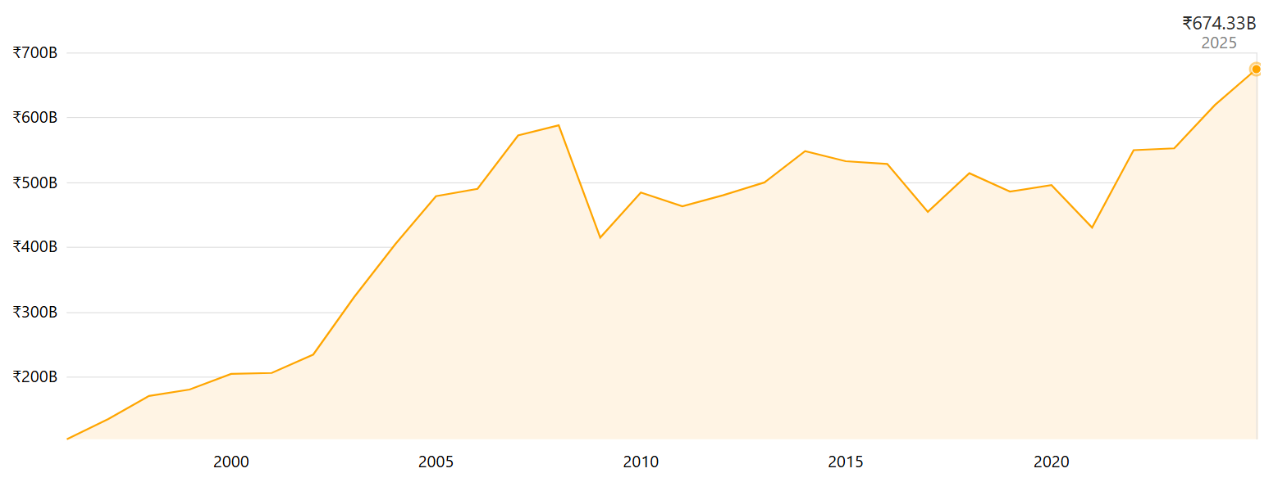
Figure 1: NEXT Plc Revenue
(Source: Companiesmarketcap, 2025)
Meanwhile, it also caters to customers across Europe, the Middle East, as well as some parts of Asia through global outlets as well as online platforms. As an illustration, nearly 80% of the revenues come from the UK, and approximately 10-11% from Europe and 4-5% from the Middle East/Asia regions (MarketScreener, 2025). At Next plc, there are three large streams of products in the business model: fashion apparel (men, women and children), footwear and accessories, home-ware and furniture and service parts including credit, distribution/logistics support of third-party brands (Stock Analysis, 2025). The company integrates the use of physical retail shops, a catalogue and online (e-commerce) operations, and international store outlets that are franchised. Revenues came over to £674 billion in 2025 as well, and there are about 32,931 employees around the world (Companiesmarketcap, 2025; Tip Ranks, 2025). Next plc also enjoys a competitive advantage in that brand equity in the UK, a high level of consumer familiarity and developed logistics (omnichannel) capability (as a result of which the company can deliver goods within a short period of time and returns (Statista, 2025). It has a large global sourcing network of suppliers, both locally sourced in the UK and globally, and the company has been more focused on sustainability initiatives.

1.2 Rationale for the Selection of the Organisation
The rationale for the selection of Next plc in this international expansion analysis stems from the fact that the company has shown the desire and ability to expand out of its UK stronghold. To begin with, Next Plc has documented that its foreign business has grown by a large margin. According to its annual report, it asserted that its international outlets have grown their sales in the last decade by 350% and it is an indication that the company understands how it can use its infrastructure in the foreign markets (Next, 2025). Second, Next Plc has a varied and differentiated business platform, its own brand and a platform that hosts third-party brands, which is more scalable and digitally strong (Group and Neavwby, 2025). This model is specifically applicable in entering new markets that have good digital and omnichannel opportunities. Third, the domestic UK market is at its maturity stage; the company recognises that the opportunities to enlarge the customer base, trading area and product range are not as high as they were in the UK (Next, 2023). Therefore, the business case to venture into a growing emerging market is timely and necessary.
In summary, the proven international expansion ambition of Next Plc, along with its scalable business model, and the domestic market saturation makes it an attractive strategic option for global expansion.

1.3 Overview of the Target Market
Vietnam is a dynamic economic environment with strong growth, buying power and continuous urbanisation. Its actual GDP per capita increased from under $700 in 1986 to almost $4,500 in 2023 (World Bank, 2025). The economy increased to about 7.1% in 2024, and the government has estimated an 8% growth by 2025 (Levison, 2025). The level of urban population is approximately 37.55% in 2022 (around 37.4 million residents) and is expected to increase to over 50% by 2039 (Open Development, 2024). The size of the retail market is also increasing; the Vietnam retail market is projected to be at $162.87 billion in the year 2025, and it will increase to $209.19 billion in the year 2030 (Mordor Intelligence, 2025). By 2026, the proportion of the middle-class population is projected to go all the way to 26% (compared to 13% in 2023), which will bring tens of millions of new buyers (Sharma, 2024). The Vietnam clothing market is accelerating well. By 2024, the e-commerce sector of the fashion industry will be approximately $4.27 billion, with an annual growth rate of about 20-25% (ECDB, 2017). By the end of 2024, E-commerce sales in the apparel value sale had reached an approximate of 27.5% (Thumrongchote, 2025). Moreover, branded fashion is getting more popular and foreign brands like Zara, H&M and Uniqlo have already entered Vietnam and grabbed the transition of moving to branded clothes. The cultural and social setting in Vietnam is favouring this market momentum.
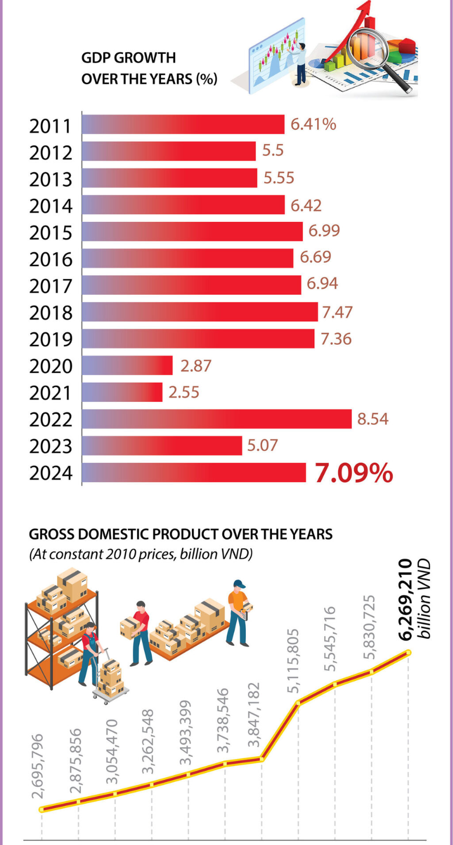
Figure 2: Vietnam Market Economy Growth
(Source: Vietnam Law Magazine, 2024)
Moreover, there is a strong youth market and growing recognition of fashion behaviour as consumers embrace digital behaviour, shopping on the move and a global tendency. The young adults in urban centres such as Ho Chi Minh City and Hanoi have a great enthusiasm for branded and trend-based clothing. Foreign investment and entry into the retail sector are becoming more and more favourable. It only has 18+ free-trade agreements (FTA), such as the EU-Vietnam Free Trade Agreement (EVFTA), which will eliminate about 99% of the tariffs in the long run (Vietnam Briefing, 2024). FTA-partner countries are in the process of phasing out Retail investment laws, including the Economic Needs Test (ENT) (Vietnam Briefing, 2024). The competition market is harsh but free. There are global retail fast-fashion and style brands like Zara, H&M and Uniqlo, and local domestic-based fashion retailers compete with vibrant e-commerce platforms in urban cities as well as the secondary cities (Resources, 2017). Risk factors are still present: currency fluctuations, regional logistical complexity, cultural localisation of its products and its high BRIC competition is an issue.

1.4 Rationale for Selection of the Target Market
The rationale for selecting Vietnam as the target market in the international expansion of Next plc is that it fits well with its mid-range fashion positioning and omnichannel advantages. The economy of Vietnam has been expanding by 7.1% in 2024 and is expected to continue to be among the fastest-growing economies in Asia with the support of a quickly developing middle class that is projected to grow up to 26% of the population by the year 2026 (Vu and Nguyen, 2025; Vietnam Briefing, 2024). This results in increasingly high demand for branded apparel with low prices, which is an area where Next can succeed. Furthermore, the high-growth fashion e-commerce market in Vietnam, with a projected market worth of $4.27 billion in 2024, will be beneficial to Next due to its well-developed online and logistics support (ECDB, 2017). The EU-Vietnam Free Trade Agreement (EVFTA) also lowers the import tariffs, giving the benefit of cost to the UK-based retailers (Vietnam Briefing, 2024). Having established acceptance of foreign brands as Zara, H&M, and Uniqlo, Vietnam will be an open consumer market to the modern British fashion that Next offers. Thus, Vietnam is enhanced with high development prospects, digital maturity, and advantages in trade that can be directly linked to the global expansion goals of Next plc.

Section 2: Comprehensive Strategic Analysis

2.1 PESTEL Analysis of Vietnam
Political
Vietnam has been fruitful with stable political stability under the one-party rule, which encourages the sustaining of economic policy and large-scale investment in infrastructure, which can attract foreign retailers. The nation has concluded significant trade agreements like the EU-Vietnam Free Trade Agreement (EVFTA), which eliminated about 65% of EU tariffs on EU product entry into force (European Commission, 2020). It is also seeking to remove more than 90% of the tariff lines in the span of seven years, and it is built into ASEAN pacts of trade pacts that can support regional supply chains (Latiff and Azhar, 2025). The recent CPTPP/CPTPP-like reforms have also eased certain foreign capital control measures in the retail sector, such as the Economic Needs Tests intended to qualify participating FTAs, which have gradually been removed, allowing foreign investors to expand their stores in Malaysia. These are the policy moves which reduce the entry barriers and decrease the costs of tariffs where the enterprises are the European ones importing to Vietnam. Generally, the political and trade environment is characterised by a good entry opportunity.
Economic
In this section, the macroeconomic performance and consumer purchasing power of Vietnam are summarised. The 2024 GDP growth has been impressive at roughly 7.1% in Vietnam and is projected to continue steadily at around 6.5-6.8% in the year 2025, which supports the growth in household demand (World Bank, 2025). Exim and FDI are still strong, FDI inflow is increasing (recorded FDI $25.3 billion in recent times), and official inflation has been kept within reasonable bounds (CPI 2024, 2025 close to low single digit, 3-4%) to facilitate real income gains (Vietnam Briefing, 2024). Retail and e-commerce are growing at a high pace: estimates suggest the tens of billions USD of e-commerce in Vietnam their total and digital retailing adoption is increasing (Vietnam Briefing, 2024). These macro trends imply an increase in purchasing power and consumer spending ability. On the whole, the favourable macroeconomics and increasing retail demand are an opportunity for the retailers.
Social
This section outlines the demographic and social consumer profile of Vietnam, as far as the apparel demand is concerned. The population of Vietnam is young and urbanising, with an almost 79% penetration of the internet in 2024 (approximately 78 million internet users in 2024) (Nguyen et al., 2025). Moreover, it is estimated that the expanding middle-class population of the country will hit approximately 26% by 2026, as compared to the 13% in 2023 (Vietnam Briefing, 2024). These changes contribute to the demand for branded and aspirational consumer products.
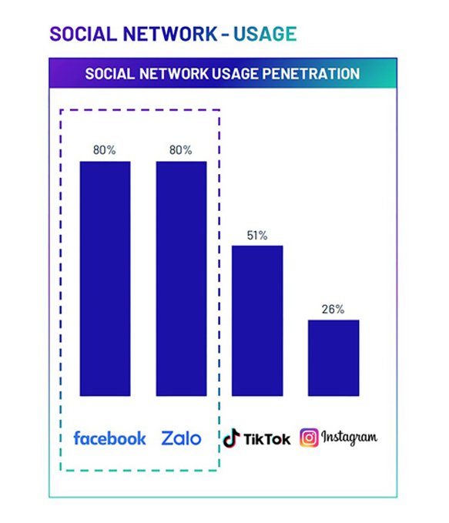
Figure 3: Vietnam Internet Penetration Rate
(Source: RMIT, 2023)
Urban centres like Ho Chi Minh City and Hanoi concentrate on the fashion-conscious young people who adhere to style indications across the world and mobile shopping habits; fashion trends and social media have a serious influence on the buying decision. These social forces form a large audience of digitally-aware consumers who are seeking international brands and trend-following clothing. In sum, there is a great opportunity to grow the brand due to the demographics and trends of online socialisation.
Technological
The digital infrastructure in Vietnam is an enabler for to fast development of e-commerce. The penetration rate of the internet reaches 79%, and huge social-media audiences and purchases, which are mobile-first (Nguyen et al., 2025). Digital payment methods and mobile wallets (Momo, ZaloPay) have grown significantly, with mobile platforms recording tens of millions of registered users and large volumes of transactions, allowing an effortless application of the Internet to make payments online and fulfil payments in cash. There is an increase in logistics networks, both in major urban areas and in increasing delivery capacity, and last-mile delivery varies between major urban areas and other markets (Roig and Palau, 2020). High level of mobile usage, payment systems, and an evolving logistics environment provide a favourable technological ground for an entrant into the omnichannel.
Environmental
The Vietnamese consumers and regulators are increasingly becoming environmentally conscious; worldwide investigations of the apparel producing companies are becoming more visible on the waste of textiles, consumption of water and factory emissions in the giant garment industry in Vietnam. Vietnam has posted the plans of climate and green development, and global consumers are requesting supplier sustainability reports and certificates more and more frequently (Công, 2023). Meanwhile, the clothing manufacturing hub in Vietnam poses certain environmental threats (waste, emissions), and the benefits of retailers who can show their effective sourcing, circularity, and supplier criteria (Vietnam Briefing, 2024). Thus, sustainability requirements are a possible operational expense and a possibility to differentiate through sustainable sourcing and the use of the circular program.
Legal
The legislation concerning commerce, labour and intellectual property in Vietnam has been empowered in the past few years in a bid to match the commitments of the FTA and enhance better protection of the trademarks and commercial rights, but still needs to take a closer local enforcement. Workplace safety and minimum-wage systems, labour laws are province-specific and have to be followed when opening stores or local operations (Acharya, 2024). Administrative procedures can still be involved in retail licensing and registration, but several ENT/foreign-ownership tests have been eased for qualifying FTA members. The unpredictability in enforcing regulations and the lack of predictability of regulation enforcement require compliance and local legal counsel in order to enter the market. In general, the legal developments soften some of the barriers and present an opportunity, though they carry compliance risks that should be mitigated.

2.2 Porter’s Five Forces - Vietnamese Apparel Industry
Threat of New Entrants
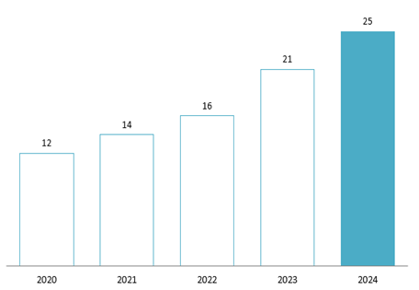
Figure 4: Vietnamese E-commerce Market Value
(Source: B&Company, 2025)
The threat of new entrants is based on the ease with which new players can join the apparel industry in Vietnam and compete with the existing players. The fast growth of e-commerce in Vietnam, estimated to reach approximately $24-27 billion in total e-commerce value and mobile shopping taking the largest part of this amount, approximately 70%, in 2024-25, can reduce barriers to physical-store entry, and digital-first brands may be launched fast (PCMI, 2024). Meanwhile, the traditional international fast-fashion competitors, as well as local incumbents, have considerable brand and real-estate advantages within big cities, which implies heavy marketing and investment in the store to compete offline. With this combination of low cost of entry digitally and low store/brand investment, the total effect is evaluated as Moderate.
Bargaining Power of Suppliers
Supplier power determines the bargaining power of textile and garment suppliers with retailers in Vietnam. The textile and garment industry in Vietnam is massive and export-based, with textile/ apparel export turnover in the tens of billions (estimates vary widely at $37bn-71 billion in recent years), suggesting plenty of supplier capacity and variety of inputs to apparel purchasers (Ken Research, 2024). The intensity of nearby production and nearshoring patterns provides a retailer with bargaining strength on the subject of expenditures and lead-times, but the lead-time strain of high-quality or custom sourcing may increase the supplier power within fragmented domains. As a result, the net impact is Moderate.
Bargaining Power of Buyers
The buyer power looks at the capacity of the consumer in terms of demanding low prices, superior service or a change of brands. The Vietnamese consumers are extremely digital and price-conscious: internet penetration is approximately 79% ( 78 million users), social/mobile commerce is a serious expected influence on buying, and a rapidly developing middle-income population is interested in branded products but price-checks across numerous sources (Nguyen et al., 2025). Buyer power is High because stores like omnichannel retail, discount platforms, and resale channels are offering more options to switch and more bargaining power because of increased buyer power.
Threat of Substitutes
Substitute products will bear in mind that alternatives to branded retail, that is, tailoring, second-hand clothes and imports exist. The second-hand sector is growing at a precipitous rate (analysts estimate it to grow within the double-digit range and at least multi-billion-dollar market opportunities), and custom tailoring and informal attire channels are still favoured by price-sensitive customers, as well as premium localised designs (6Wresearch, 2022). The impact of substitutes is Moderate in that they do not kill the demand, but cool off the market for full-priced branded apparel.
Competitive Rivalry
Competitive rivalry evaluates the level of competition between the already existing apparel stores and platforms present in Vietnam. Large international brands have already tested and developed in Vietnam, such as Uniqlo with dozens of stores in the country or the entry/expansion of Zara and H&M, and the competition between prices and convenience is stiff, growing local cultures and brands (Thumrongchote, 2025). The density of stores in Ho Chi Minh City and Hanoi, as well as aggressive sales campaigns in e-commerce, generates a long-term pressure on margins and nearly constant promotion; therefore, the competition is High.

2.3 Porter’s Diamond Model - National Competitive Advantage
Diamond Element | Key Evidence & Metrics
Factor Conditions | - Skilled labour, low-cost manufacturing; textile & apparel exports projected $44 billion in 2024 (Vietnam Briefing, 2024)
Demand Conditions | - Domestic demand for branded/apparel is rising; retail apparel value growth is positive in 2024 (Euromonitor, 2023)
Related & Supporting Industries | - Strong textile-manufacturing base, logistics hubs in HCM & Nam Dinh regions (Vietnam Briefing, 2024)
Firm Strategy, Structure & Rivalry | - A mix of global and domestic players is competing; Vietnam climbed to the 3rd largest global apparel exporter in 2025 (Vietnam News, 2025)
Government Role | - Investment incentives, FTAs like EVFTA, boosting trade access (Admin Vinatex, 2024)
Chance Events | - Global “China +1” sourcing shift favours Vietnam; raw-material import reliance is still a risk (Vietnam News, 2025)
Table 1: Porter’s Diamond Model
(Source: Author)
The Diamond analysis indicates that Vietnam has strong structural benefits, i.e. low-cost labour force, a large manufacturing ecosystem is large, the local consumer market that is increasing and a trade policy that is supportive of an apparel retailer. Nevertheless, it does not forecast as well the performance of a particular internal aspect, such as local brand recognition, in-store experience, or adaptation to the supply chain. Furthermore, integration of omnichannel is those aspects which are firm-specific and are not reflected here. This model has been instrumental in evaluating the environment, but not a guarantee of strategic accomplishment at the firm level.

Section 3: Strategy Development and Formulation

3.1 Application of Ansoff’s Matrix
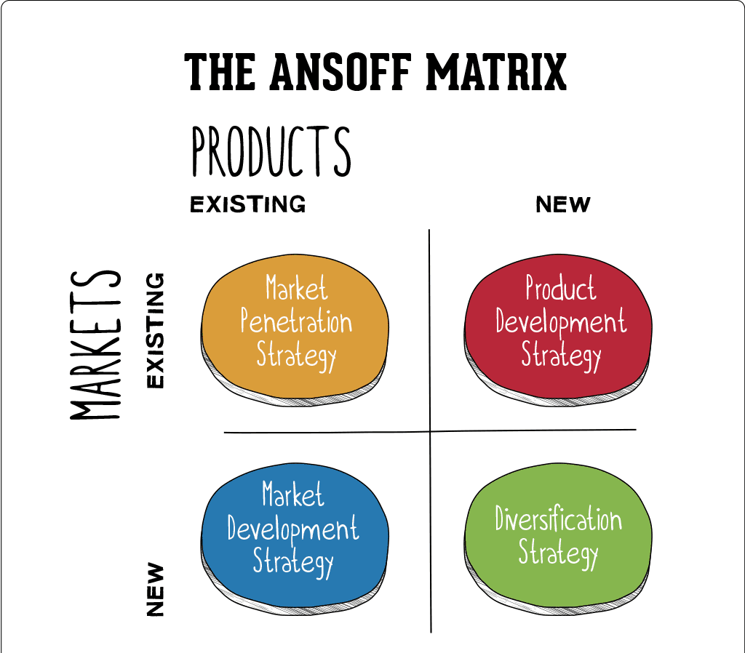
Figure 5: Concept of Ansoff Matrix
(Source: Hanlon, 2021)
Market Penetration | Product Development
The approach will be aimed at raising market share in the already established markets like the UK and EU by offering loyalty programmes, optimising the online channels and promoting price-cutting offers. Although there is a potential for further engagement through the Digital Next platform of Next plc, known as NEXT online, such mature markets are extremely saturated and would, therefore, restrict the growth (The Next Platform, 2025). This entry mode includes domestic e-commerce improvements and retail collaborations, which incorporates a low strategic risk but has minuscule returns because of limited demand that remains unexploited, and the local competition is high. | Next can launch new product lines like sustainable or region-specific fashion collections, to serve its existing consumers in Europe and the Middle East. The in-house design teams and supplier network structures are in line with the rising eco-conscious tastes (Lin, Chang and Mi, 2017). In the entry mode, it will have internal innovation and partnership with ethical suppliers. However, there is a moderate risk which arises because of the instability of consumer trends, the cost of R&D and uncertainty surrounding fashion cycles in the current markets.
Market Development | Diversification
The section focuses on presenting the already developed Next product lines, such as apparel and homeware, to a new international market. Having a joint venture or a franchise with a regional chain store (AEON Vietnam) is a way of overcoming regulatory and cultural risks and gaining market familiarity (Puck et al., 2016). Initial investment and localisation expenses are high; however, the moderate level of risks is compensated by the increasing middle-class and youth fashion-conscious market in Vietnam. | The diversification strategy would be to introduce new lifestyle or tech-inspired fashion products to unexplored Asian markets through direct investment. Though it could become transformative, it is also insanely risky as it will require market and product innovation (Gómez-Prado et al., 2022). This may happen via wholly owned subsidiaries or acquisition of a regional fashion tech company, but due to an absence of brand recognition and excessive establishment expenses, the option is strategically unwise, especially at this stage.

Table 2: Application of Ansoff Matrix of Next Plc’s Expansion Strategy
(Source: Author)

3.2 Selection of Market Entry Strategy
The proposed entry mode method is a Staged Hybrid Approach, comprising e-commerce Entry, with Joint Venture Retail Expansion. It is a Market Development quadrant of the Ansoff Matrix of Next plc because it entails launching existing product lines (apparel and homeware) into a new geographical market (Vietnam). The suggested hybrid solution is comprised of an online-focused e-commerce debut with the main goal of using the rapidly growing digital retailing environment in Vietnam. In the case of Vietnam, its e-commerce market is about $24.9 billion dollars in 2024 and is expected to increase at a CAGR of 26.2% through 2033 (IMARC Group, 2025). This is a cheap, digital penetration, which enables Next to have a great opportunity to explore the market with minimum physical efforts, get consumer feedback and create brand awareness in a short period of time.
Once a brand presence has been established using online channels, the next step involves using flagship stores in major urban centres like Ho Chi Minh City and Hanoi using a local joint venture or franchisee. This is to fit the foreign retail regulation nuances, cultural adaptation and operation localisation, which is less risky than a single wholly-owned subsidiary. It is also important to note that the hybrid mode offers a balance between reduced initial capital base, faster market testing, scalability and brand building which has coincided with the positive e-commerce growth in Vietnam and the high rate at which the middle-class is expanding.

3.3 Competitive Positioning and Generic Strategy
Strategic Element | Objective | Implementation in Vietnam | Expected Advantage
Generic Strategy | Adopt a Differentiation focus | Offer high-quality, British-designed apparel and homeware with sustainable materials | Builds brand distinction amid fast-fashion competitors
Product & Design | Localise product relevance | Tropical-friendly fabrics, modest fits, inclusive sizing; promote sustainable textiles (organic cotton, recycled polyester) | Aligns with the Vietnamese climate and eco-aware youth
Pricing | Mid-premium affordability | Positioned between H&M and Zara; average urban disposable income US$350-400/month | Captures aspirational middle-class consumers
Distribution | Omnichannel expansion | Launch e-commerce via Shopee, Tiki, and own site - then flagship stores in HCMC & Hanoi (hybrid model) | Rapid brand access with scalable growth
Branding & Promotion | Build a modern British image | Campaigns on TikTok/Facebook; sustainability storytelling; local influencer tie-ups | Enhances awareness and brand trust
Strategic Goal | Achieve sustainable market share growth | Integrate quality, design, and digital convenience | Long-term competitiveness and loyalty

Table 3: Competitive Positioning of Next Plc
(Source: Author)

3.4 Implementation Plan
Phase | Timeline | Key Milestones / Activities | Resources Required | Responsible Stakeholders
Phase 1: Market Preparation | Year 1 (Q1–Q4) | - Conduct detailed market research and a feasibility study  - Register business entity and secure regulatory approvals  - Develop a Vietnam-specific e-commerce platform and logistics framework  - Initiate digital marketing (social media, influencer partnerships) | £3–4 million (setup and marketing budget), Market analysts, Legal advisors, IT & e-commerce team | Global Strategy Division, Digital Commerce Unit
Phase 2: Market Entry | Year 2 (Q1–Q4) | - Launch e-commerce operations nationally  - Establish a joint venture/franchise agreement  - Open flagship stores in Ho Chi Minh City and Hanoi  - Recruit and train the local workforce | £6–8 million (retail setup, staff training, local partnerships) | Regional Operations Manager, HR & Retail Expansion Team
Phase 3: Consolidation & Growth | Years 3–5 | - Expand product lines (homeware, kids wear)  - Extend retail presence to Da Nang and Can Tho  - Strengthen local supplier partnerships and distribution  - Launch sustainability initiatives (green packaging, recycling program) | £10–12 million (capital investment and operations), Sustainability team, Logistics partners | Country Director, Supply Chain & Marketing Teams

Table 4: Implementation Plan
(Source: Author)

3.5 Risk Register
Risk Description | Likelihood (1–5) | Probability (1–5) | Impact (L×P) | Mitigation Strategy
Regulatory delays or licensing issues | 3 | 4 | 12 | Partner with local legal advisors and government liaison teams.
Cultural misalignment in product preferences | 4 | 3 | 12 | Conduct consumer insight studies and tailor collections regionally.
Supply chain disruption or import delays | 3 | 5 | 15 | Develop dual sourcing with local textile suppliers.
Currency fluctuations are affecting pricing | 2 | 4 | 8 | Hedge against forex volatility; price in VND.
Competitive pressure from global brands | 4 | 4 | 16 | Emphasise differentiation through design and sustainability.

Table 5: Risk Register
(Source: Author)

3.6 CSR and Sustainability Integration
This section helps in understanding the CSR and Sustainability integration aspects of Next Plc with the help of Carroll’s CSR model.
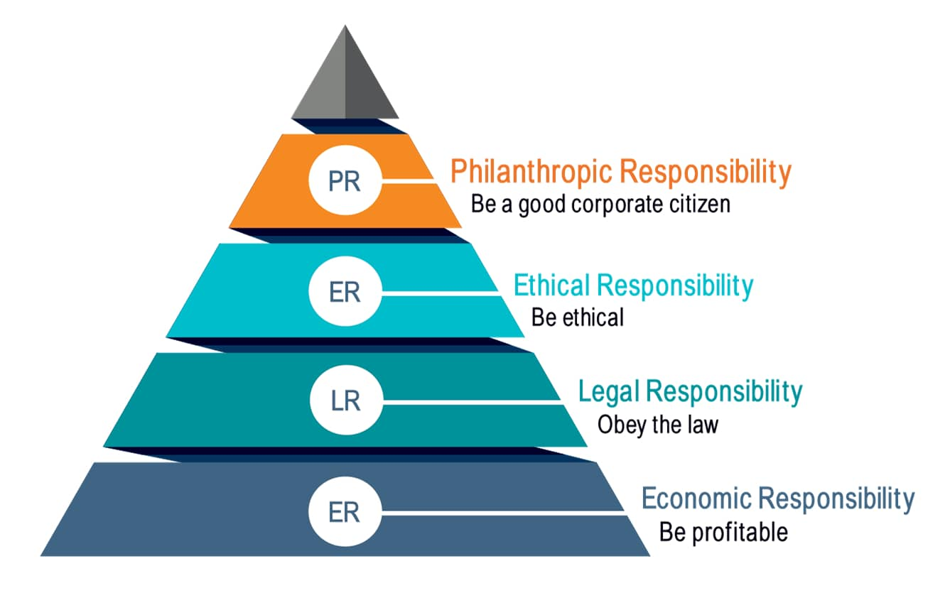
Figure 6: Carroll’s CSR Pyramid
(Source: The CSR Journal, 2024)
Next plc meets its economic obligation because it functions profitably and at the same time, engages in long-term sustainability through its 47% Scope 1&2 emissions decrease, as well as 95% of the waste diversion into landfill (Fibre2Fashion, 2023). Next complies with international principles within its legal scope, ethical sourcing and human rights. The 2024/25 report notes that it works with 11 factories to address the risks of modern slavery, six of them in Vietnam (MarketScreener, 2025). Next goes beyond compliance to be ethical, the company focuses on sustainable materials (65% of major raw materials are responsibly sourced) and pursues circular business, including the resale and repair programs (MarketScreener, 2025). At the philanthropic level, Next contributes and nurtures community activities and NGO associations; in Vietnam, its global engagements may by virtue of association, workforce development and recycling programmes, serve as community partners. When developing these four layers of model of Carroll, Next will not only make its CSR approach an adjunct, but it will be embedded in its core strategy of expanding into Vietnam.

3.7 Expected Outcomes
The expansion proposed in Vietnam is likely to provide multifaceted strategic results to Next plc. It will also enhance the regional presence of the company in the Southeast Asia region in the medium term to help it diversify its revenue base beyond the old markets in the UK and European regions. The brand will experience increased brand visibility and consumer access to medical through the hybrid model of entry will involve the use of e-commerce and flagship stores that will lead to a sustained increase in sales. In addition, when combined with CSR activities and responsible sourcing, Next will gain greater brand equity around the world as an affordable retailer. Finally, the growth will make Next a competitive, ethically-oriented fashion brand that will help to develop sustainable retail operations in Asia.

Section 4: Performance Evaluation Framework
This section outlines the utilisation of the Balanced Scorecard (BSC) model to analyse and track strategic performance on various aspects of operations of the organisation. Balanced Scorecard (BSC) is a strategic management tool created by Kaplan and Norton in 1992 to bridge the gap between the vision and strategy of an organisation and a system of measurable goals (Madsen, 2025). It combines both financial and non-financial measures to give a holistic picture of performance, not necessarily those presented through conventional accounting measures. BSC aims to ensure that the business operations are in alignment with the strategic objective, enhance an effective communication process among various departments and review organisational performance in relation to predefined targets.
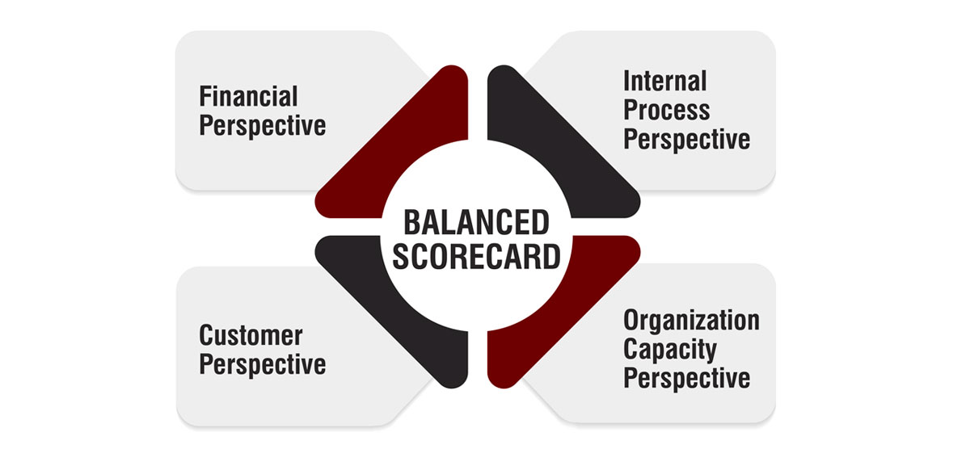
Figure 7: Concept of Balanced Scorecard
(Source: The Strategy Institute, 2024)
The Balanced Scorecard is a systematic tool for Next plc in its expansion to Vietnam. This will assist in the review of the performance of strategic choices according to four major lenses, such as the Financial, Customer, Internal Processes, and Learning and Growth (Madsen, 2025). This will make sure that the operational efficiency, as well as long-term sustainability, will be evaluated and allow making data-driven corrections during the market entry stage and the growth stages. Below is the application of Balanced Scorecard on Next Plc.

4.1 Financial Perspective
The Balanced Scorecard financial view is aimed at evaluating the profitability, investment returns and cost effectiveness of Next plc in the Vietnamese market. Among the Key Performance Indicators, there are the rate of revenue increase through Vietnam operations, market share performance in three years, ROI and the cost-to-revenue ratio. The targets of success measures aim at 15% growth in revenue over the first year and upholding a ROI of over 10% after the second year, alongside a 10-12% decrement in the cost of logistics and sourcing based on local relationships. These financial metrics are a cumulative reflection of the financial viability and sustainability of exposure to investment, and as such, strategic decisions will add to long-term profitability and operational soundness in a competitive retailing environment.

4.2 Customer Perspective
The customer view will be an assessment of the brand acceptance, customer satisfaction, as well as customer loyalty to Next plc in the dynamic retailer environment in Vietnam. The Customer Satisfaction Score (CSAT), Net Promoter Score (NPS), and online customer acquisition and repeat purchase rate are considered to be the Key Performance Indicators. The success measures will target the achievement of CSAT >= 80%, NPS >= 50 and 30% repeat purchases after two years. These measures mean that Next is doing well in learning about local consumer needs, providing customised value-formulas and establishing long-lasting relationships, which in the end will promote brand trust and increase the market share within the competitive fashion retail industry.

4.3 Internal Business Processes Perspective
The internal business processes lens evaluates the efficiency of the operations and supply chain integration, and ethical sourcing by Next plc in Vietnam. The KPIs comprise the supply chain lead time, delivery accuracy, among local suppliers that meet CSR requirements, and quality assurance ratings. The targeted results are to attain a 98% on-time delivery percentage and 40% local sourcing in a span of three years. These figures strengthen the excellence of processes, minimise operational bottlenecks and ensure that all business operations are aligned to the global CSR and sustainability undertakings by Next in the new market.

4.4 Learning and Growth Perspective
The Learning and Growth approach takes into consideration the establishment of employee competence, innovation and the culture that is geared towards sustenance to facilitate long-term growth. The main KPIs are the completion of the training, staff retention, and cross-cultural innovation programs. A 90% sustainability training first-time success and 85% retention is equivalent to a stronger human capital and this makes the Next plc develop a flexible and skilful as well as an ethically compatible labour force that is vital in sustainable internationalisation.

4.5 Monitoring and Review
Monitoring Tool | Frequency | Purpose | Responsible Unit
Quarterly Performance Review | Quarterly | Track KPIs and financial targets | Regional Management Team
Stakeholder Dashboard | Monthly | Provide real-time visibility of key performance metrics | Strategy & Analytics Department
Annual Sustainability Report | Annually | Assess CSR progress and environmental performance | CSR & Compliance Division
Executive Review Meeting | Bi-annually | Evaluate strategic alignment and corrective actions | Senior Leadership Team

Conclusion
This report assessed the strategic expansion of Next plc into Vietnam, where it has seen the country experience a tremendous economic growth and an emerging retail market. Based on PESTEL as well as Porter’s Five Forces and the Diamond Model, Vietnam was considered as one of the potential and competitive markets requiring differentiation and cultural flexibility. The Market Development plan that is proposed (a blend of e-commerce and flagship stores) allows for scaling the growth with minimum risk. With the help of the Balanced Scorecard framework, the monitoring of performance will be conducted in the financial, customer, process, and learning perspectives. Long-term growth globally is determined by strategic responsiveness, local responsiveness and sustainable practices that ultimately lead to success.

References
6Wresearch (2022) Vietnam Secondhand Apparel Market (2024-2030) | Trends, Outlook & Forecast, www.6wresearch.com. Available at: https://www.6wresearch.com/industry-report/vietnam-secondhand-apparel-market.
Acharya, M. (2024) Minimum Wages Act 1948: Rules and Applicability, cleartax. ClearTax. Available at: https://cleartax.in/s/minimum-wages-act.
Admin Vinatex (2024) Vietnam’s Textile Industry to Achieve $44 Billion Export Target - Vinatex, Vinatex. Available at: https://vinatex.com/vietnams-textile-industry-to-achieve-44-billion-export-target (Accessed: 13 November 2025).
B&Company (2025) Summary of Vietnam EC Market in 2024 and Prospect for the Future - B-Company, B-Company. Available at: https://b-company.jp/summary-of-vietnam-ec-market-in-2024-and-prospect-for-the-future/.
Carroll, A.B. (2016) ‘Carroll’s Pyramid of CSR: Taking Another Look’, International Journal of Corporate Social Responsibility, 1(3), pp. 1–8. Available at: https://doi.org/10.1186/s40991-016-0004-6.
Companiesmarketcap (2025) Next plc (NXT.L) - Revenue, Companiesmarketcap.com. Available at: https://companiesmarketcap.com/inr/next-plc/revenue/#google_vignette (Accessed: 13 November 2025).
Công (2023) Vietnam’s environmental industry poised to drive green transition. Available at: https://en.mae.gov.vn/vietnams-environmental-industry-poised-to-drive-green-transition-9005.htm.
Delteil, B. et al. (2021) ‘The new faces of the Vietnamese consumer’, McKinsey & Company. Available at: https://www.mckinsey.com/featured-insights/future-of-asia/the-new-faces-of-the-vietnamese-consumer.
ECDB (2017) eCommerce Data & Analytics Based on Billions of Transactions, Ecdb.com. Available at: https://ecdb.com/resources/sample-data/market/vn/fashion.
Euromonitor (2023) Apparel and footwear in vietnam | market research report | euromonitor, www.euromonitor.com. Available at: https://www.euromonitor.com/apparel-and-footwear-in-vietnam/report.
European Commission (2020) EU-Vietnam Free Trade Agreement, trade.ec.europa.eu. Available at: https://trade.ec.europa.eu/access-to-markets/en/content/eu-vietnam-free-trade-agreement.
Fibre2Fashion (2023) UK’s Next Plc reduces carbon emissions by 47% towards 2030 target, www.fibre2fashion.com. Available at: https://www.fibre2fashion.com/news/textile-news/uk-s-next-plc-reduces-carbon-emissions-by-47-towards-2030-target-287424-newsdetails.htm.
Gómez-Prado, R. et al. (2022) ‘Product Innovation, Market Intelligence and Pricing Capability as a Competitive Advantage in the International Performance of Startups: Case of Peru’, Sustainability, 14(17), p. 10703. Available at: https://doi.org/10.3390/su141710703.
Group, N.W. and Newby, E. (2025) How NEXT Made £1 Billion: The UK Retail Success Story Everyone’s Talking About, Nigelwright.com. Available at: https://www.nigelwright.com/middleeast-africa/how-next-made-1-billion-the-uk-retail-success-story-everyone-is-talking-about (Accessed: 13 November 2025).
Hanlon, A. (2021) The Ansoff Model, Smart Insights. Smart Insights. Available at: https://www.smartinsights.com/marketing-planning/create-a-marketing-plan/ansoff-model/.
IMARC Group (2025) Vietnam E-Commerce Market Size, Share, Trends 2024-2032, www.imarcgroup.com. Available at: https://www.imarcgroup.com/vietnam-e-commerce-market.
Ken Research (2024) Vietnam Textile Market, Kenresearch.com. Available at: https://www.kenresearch.com/industry-reports/vietnam-textile-market.
Latiff, R. and Azhar, D. (2025) ‘China and ASEAN, hit by US tariffs, sign upgraded free trade pact’, Reuters, 28 October. Available at: https://www.reuters.com/world/asia-pacific/china-asean-sign-upgraded-free-trade-pact-2025-10-28/.
Levison, E. (2025) In The Hubbis Hot Seat: Investment Strategies for the Evolving Philippine Wealth Market, Hubbis.com. Available at: https://hubbis.com/article/vietnam-asia-s-next-tiger-economy-vinacapital-s-perspective.
Lin, C.-T., Chang, Y.-H. and Mi, C. (2017) ‘Develop Eco-Friendly Enterprise: Aligning Enablers with Strategy’, Sustainability, 9(4), p. 570. Available at: https://doi.org/10.3390/su9040570.
London Stock Exchange (2024) Table - FTSE 100 FTSE constituents | London Stock Exchange, www.londonstockexchange.com. Available at: https://www.londonstockexchange.com/indices/ftse-100/constituents/table.
Madsen, D.O. (2025) ‘Balanced Scorecard: History, Implementation, and Impact’, Encyclopedia, 5(1), p. 39. Available at: https://doi.org/10.3390/encyclopedia5010039.
MarketScreener (2025) NEXT PLC, MarketScreener. Available at: https://www.marketscreener.com/quote/stock/NEXT-PLC-9590100/company-governance (Accessed: 13 November 2025).
Mordor Intelligence (2025) Vietnam Retail Sector | Opportunities and Forecast to 2024, Mordor Intelligence. Available at: https://www.mordorintelligence.com/industry-reports/retail-industry-in-vietnam.
NEXT (2025) Our History, Nextplc.co.uk. Next Plc. Available at: https://www.nextplc.co.uk/about-next/our-history.
Next (2023) ANNUAL REPORT & ACCOUNTS. Available at: https://www.annualreports.com/HostedData/AnnualReportArchive/n/LSE_NXT_2022.pdf.
Next (2025) A N N U A L R E P O R T & A C C O U N T S . Available at: https://data.fca.org.uk/artefacts/NSM/Portal/NI-000117376/NI-000117376.pdf.
Nguyen, T.T. et al. (2025) ‘Patterns of social media use in Vietnamese youths: status and associations with psychological well-being’, BMC Public Health, 25(1). Available at: https://doi.org/10.1186/s12889-025-22337-8.
Open Development (2024) Urbanization in Vietnam - Open Development Vietnam, Open Development Vietnam - Sharing information about Vietnam and its development with the world. Available at: https://vietnam.opendevelopmentmekong.net/topics/urbanization-in-vietnam.
PCMI (2024) Vietnam E-Commerce Market Data 2024-2027, Payments and Commerce Market Intelligence - Global payments market research and insights. Available at: https://paymentscmi.com/insights/vietnam-ecommerce-market-data.
Puck, J. et al. (2016) ‘Ownership mode, cultural distance, and the extent of parent firms’ strategic control over subsidiaries in the PRC’, Asia Pacific Journal of Management, 33(4), pp. 1075–1105. Available at: https://doi.org/10.1007/s10490-016-9471-2.
Resources, A. (2017) Local fashion retailers get jittery as Zara, H&M enter Vietnam | Retail News Vietnam, Apparel Resources. Available at: https://apparelresources.com/business-news/retail/local-fashion-retailers-get-jittery-as-zara-hm-enter-vietnam (Accessed: 13 November 2025).
RMIT (2023) Unveiling the popularity of chat and social networks in Vietnam, www.rmit.edu.vn. Available at: https://www.rmit.edu.vn/news/all-news/2023/sep/unveiling-the-popularity-of-chat-and-social-networks-in-vietnam.
Roig, M.V. and Palau, E.J.A. (2020) ‘The Impact of E-Commerce-Related Last-Mile Logistics on Cities: A Systematic Literature Review’, Sustainability, 12(16), p. 6492. Available at: https://doi.org/10.3390/su12166492.
Sharma, A. (2024) Vietnam’s Middle Class: Size, Consumer Trends, & Business Opportunities, Vietnam Briefing News. Available at: https://www.vietnam-briefing.com/news/understanding-vietnams-middle-class-size-spending-patterns-and-opportunities-for-businesses.html.
Statista (2025) Topic: Next plc, Statista. Available at: https://www.statista.com/topics/11004/next-plc.
Stock Analysis (2025) NEXT plc, StockAnalysis. Available at: https://stockanalysis.com/quote/fra/NXG/company (Accessed: 13 November 2025).
The CSR Journal (2024) Carroll’s Pyramid: Understanding the Four Levels of CSR - The CSR Journal, The CSR Journal. Available at: https://thecsrjournal.in/understanding-the-four-levels-of-csr-2/.
The Next Platform (2025) The Next Platform - The Next Platform, www.nextplatform.com. Available at: https://www.nextplatform.com/.
The Strategy Institute (2024) A Comprehensive Guide to Implementing the Balanced Scorecard Framework, www.thestrategyinstitute.org. Available at: https://www.thestrategyinstitute.org/insights/a-comprehensive-guide-to-implementing-the-balanced-scorecard-framework.
Thumrongchote, K. (2025) Vietnam’s fashion sector: Key trends driving the apparel market, Global Angle. Available at: https://global-angle.com/vietnam-fashion-sector (Accessed: 13 November 2025).
Tip Ranks (2025) Next plc Corporation (GB:NXT) Revenue - TipRanks.com, TipRanks | Know who to trust. Available at: https://www.tipranks.com/stocks/gb:nxt/revenue (Accessed: 13 November 2025).
Vietnam Briefing (2024) Vietnam Guide - Vietnam’s International Free Trade Agreements | Doing Business in Vietnam, Vietnam Briefing. Available at: https://www.vietnam-briefing.com/doing-business-guide/vietnam/why-vietnam/vietnam-s-international-free-trade-and-tax-agreements.
Vietnam Law Magazine (2024) Vietnam’s GDP in 2024 up 7.09 percent, vietnamlawmagazine.vn. Available at: https://vietnamlawmagazine.vn/vietnams-gdp-in-2024-up-709-percent-73324.html.
Vietnam News (2025) Việt Nam’s garment industry rebounds, but challenges loom, vietnamnews.vn. Available at: https://vietnamnews.vn/economy/1729038/viet-nam-s-garment-industry-rebounds-but-challenges-loom.html.
Vu, K. and Nguyen, P. (2025) ‘Vietnam’s 2024 GDP growth accelerates to 7.09%, driven by strong exports’, Reuters, 6 January. Available at: https://www.reuters.com/markets/asia/vietnam-2024-gdp-growth-quickens-709-2025-01-06/.
World Bank (2025) Vietnam Overview, World Bank. Available at: https://www.worldbank.org/en/country/vietnam/overview.

