

Postgraduate/Distance Learning
Assignment coversheet & feedback form

THIS SHEET MUST BE THE FIRST PAGE OF THE ASSIGNMENT YOU ARE SUBMITTING (DO NOT SEND AS A SEPARATE FILE)

For completion by the student:
Student Name: Bridget Thomas

Student University Email: 2301429@student.uwtsd.ac.uk
Module code: HPCA 7016  Module title: Researching Contemporary Cosmologies | Student ID number:  2301429 |  |  | Educational support needs:  Yes
Assignment title: Research Project in Contemporary Cosmology, Project 3, Living with the Sky (Daily Life)

Assignment due date: 7 August 2022
This assignment is for the 1st 2nd 3rd 4th 5th 6th module of the degree
I confirm that this is my original work and that I have adhered to the University policy on plagiarism.
Signed ……………………………………………………………
Email submission:if you are submitting this form via email, please tick this box X
(as a substitute for your signature) to confirm that you agree to the above declaration.
Assignment Mark
1st Marker’s Provisional mark
2nd Marker’s/Moderator’s provisional mark
External Examiner’s mark (if relevant)
Final Mark

NB. All marks are provisional until confirmed by the Final Examination Board.

For completion by Marker 1 :
Comments:

Marker’s signature: |  |  | Date:
For completion by Marker 2/Moderator:

Comments:

Marker’s Signature: |  | Date:
External Examiner’s comments (if relevant)

External Examiner’s Signature: |  | Date:

Research Project in Contemporary Cosmology 5463 Words

Introduction
In its broadest definition astrology rests on the Greek idea of cosmos, a ‘beautiful order’ which is whole and alive, and of which humans and their world are a part. By this broadest definition, the second premise of astrology is the idea that humans can find meaning from their specific view of cosmos, that it can speak to them. This exercise was developed to assess whether, without encouragement or training, people experience the view of cosmos from West Wales in a way that supports these assertions.
This essay documents research conducted in West Wales in April and May 2022 using mixed methods to investigate three facets of contemporary cosmology in a population of non-specialist sky-watchers. It is a phenomenological investigation of personal perceptions of the solar system and the stars beyond. Three methods of data gathering were employed in overlapping phases to investigate perceptions of immediate, subjective experience. To find out what people can see when they look at the sky, how they understand what they see, and how they feel about what they see, here and now.

Background to the Research
Andrew Yang's ‘Conversations with the Milky Way’ explored inner perceptions and outer experience of the milky way by talking to parts of it, specifically people. If people are to make meaning from their skies, they need to be able to see them. At a time when up to fifty percent of the Global population may never see the Milky Way, the Dark-Skies movement lobbies to protect and expand areas where the skies are dark by reducing excess light and atmospheric pollution. Ada Blair's Sark in the Dark, an investigation into dark skies and well-being is a key text for the present work which utilised her interview script and coding framework to add a small sample to the corpus of data she hoped would support claims of a dark skies positive affect on human well-being. A commitment to the well-being of future generations is Wales has proportionately the largest percentage of the darkest skies in Europe. Lampeter at a latitude of 53° N in Ceredigion, has dark skies.
The sample group invited to participate in this project are members of a walking group that have been walking together for eight years. The group was formed in response to the Ceredigion Council, ‘Walking for Wellbeing’ public health initiative. Kenotic Walking is term devised to describe the sense of flow experienced by long-distance hikers or pilgrims as they become part of the symphony of the trail. The poet Leslie Scalapino’s ‘walking person who has sky flowing-by’ is not moving across an inert landscape, they are in motion and the sky flows by them. This implies a ‘cosmic’ perception, everything is part of a greater whole and all of it is in motion. The research participant group were chosen because evidence of their agency in participating with their environment, community, and their own well-being is established and suggestive of the possibility that they would be as curious about and engaged with the night sky.

Methodology
The first phase of the investigation was participant enquiry. This facilitated an understanding of the culture of the walking groups and was documented in a research diary and field notes. A questionnaire provided a quantitative measure of exactly what people see when they look at the night sky; and interviews elicited phenomenological, thick descriptionin the participants own words. An informal group of ‘friends who walk’ were chosen as the core sample group. The group began walking together in 2014 as part of a Ceredigion County Council initiative to encourage walking for wellbeing. The members regularly become what the poet Leslie Scalapino describes as a ‘walking person who has sky flowing-by’,they are familiar with the sky and comfortable in it as they move across the land. The researcher’s participation in the regular group walks facilitated an appreciation of the social and cultural context of the sample group and the researchers’ relationship to them; and initiated a process of inductive reasoning.

The second phase of data-gathering utilized an online questionnaire to conduct a quantitative survey of walking habits, naked eye observations and spiritual affiliation. The questionnaire was designed to quantitatively gauge the frequency of participants engagement with the sky, their awareness of celestial objects and their cycles, and whether this awareness influenced behaviour. There was space for people to register qualitative responses if they wished. The questionnaire was divided into three sections. The first section asks about walking habits, to establish the significance of a regular practice of flowing through the sky in the life-worlds of the participants. The next section asks about observations, these questions were inspired by the artist Andrew Yang’s 2016 project ‘Conversations with the Milky Way’, and Ada Blair’s question “Do you recognise any constellations, planets etc.?” was expanded to ask participants if they can identify any constellations or planets and how often they might do this. The final part of this section asks about responses to lunar and solar phenomena.
A question is included about the practice of ‘planting by the moon’. This frequently reported example of lunar-lore adopted by twenty-first century permaculture gardeners reflects the survival of ancient traditions. Two questions about seasonal signifiers ask participants to list three observations they might make that they would associate with spring, and three observations they would interpret as signs of winter. The final part of the questionnaire expanded Ada Blair’s question ‘Do you consider yourself a spiritual/religious person?’with the addition of two questions that asked about religious affiliation in early life and at the present time, taken from Liz Greene’s investigation onto ‘Mystical Experiences Among Astrologers’. Religious calendars are based on celestial cycles and familiarity with a faith-based calendar might influence the way a person perceives the passage of time, or rather the units by which the passage of time is measured, the cycles of the sun and the moon. Finally, the questionnaire invited respondents to participate in an interview. Those who accepted the invitation, were asked to supply an email address. The questionnaire and all responses were securely stored on Google Forms. Participation required internet access and a link to the questionnaire. To limit the amount of personal data collected and protected the identity of participants, this link was provided to members of the group by a ‘gatekeeper’who was known to them all. Completed questionnaires were numbered and the only personal data collected was the email addresses of potential interviewees.
The volunteers were sent an invitation to schedule a thirty-minute interview, and a Participant Interview Release Form. Interviews were scheduled according to participant availability. This third phase was designed as a qualitative investigation of the experience of the sky. To facilitate thick description the interviews were conducted outdoors, either in person or on zoom and followed Ada Blair’s script of open questions with two omissions previously included on the questionnaire. All interviews were fully transcribed and coded before analysis.

Ethics
The project was designed and implemented in accordance with the guidance set out in the UWTSD Research Ethics and Integrity Code of Practice, UWTSD Research Data Management Policy and the BERA Ethical guidelines (2018). Method specific ethical considerations were applied to each stage of the project which were approved by the module tutors before any data collection began.

Results and Discussion

The researcher participated in the weekly group walks on several occasions. This afforded the opportunity to outline the research, explore its relevance to the interests of the group, answer queries about it and make clear the voluntary nature of participation. A researcher can never be taken out of their research, and cultural differences between their discipline and the participant group can obstruct or colour the research design and obscure the findings. Barbara Prost described participant enquiry as a method that recognises this and helps the researcher negotiate the space between the two cultures.Field notes and a research diary were useful in considering the relationship of the researcher to both the research and the participant group, and informed the design of the questionnaire, to make it compatible with the culture of the group and more accessible to them. In this way the second and third stages of the project became a truly collaborative effort. We all contemplated the limits of our awareness of our dark(ish) sky and the personal significance it holds.

Basic Data
Four participant responses to the questionnaire were removed from the sample before analysis because they did not agree to the use of their data by ticking the box on the form.
This reduced the sample size to 12 participants. Five participants agreed to be interviewed but one provided no email address to contact them, and one had to cancel. Three interviews were conducted.

Questionnaires
The voluntary nature of participation was emphasised at every stage of the research and not all respondents answered all the questions. The dataset is thus incomplete, but the comments are helpful, and the omissions are interesting too.

Section One - Walking Habits
The aim of this section of the questionnaire was to establish the walking habits of the research participants. With one exception all participants reported walking outside with other people for more than half an hour at least once a week. Half the sample reported that they did this more than once a week. The next question asked about solitary walks of the same minimum duration. One participant chose not to answer this question and one commented that they didn’t consider their daily walk into town ‘walking’ and relied on the group activity once a week ‘to get them out there’. One person said they walked more than once a month but less than once a week. The other five participants all reported that they walked every day for at least half an hour. The final question was about walking particular routes on specific dates or times of year. Two participants did not answer this question, five responded that they did do this, one commenting ‘I like to walk past lambs in spring’ and another ‘I like to walk in woodlands in spring and winter’. Five responded that they didn’t have any preference. However, the following response demonstrates that there can be a difference between what people do and what they think about what they do.

Do you have particular routes that you prefer to walk at particular times of year or on specific dates?

Not really. We are blessed to live in a rural environment. Every season is beautiful from the point of view of nature. It is more pleasant to walk in the warm and dry. Spring is glorious as new life abounds. Bluebell Wood has become a bit of a tradition with Thursday Night Walkers, it marks a move from winter street walking to summer off-road walking. I try to encourage family to go to Parc Cefn Onn for the rhododendrons.

The initial non-committal statement is followed by a description of two favoured springtime walking routes. The first is associated with a seasonal change that liberates the walking group from winter practices, the other an annual family occasion. Rafaela Giavagnoli has explored the distinction between habit and ritual and summarizes that habit is individual, and ritual is social. Roy Rappaport writes that context specific recurring rites constitute one of six different forms of ritual. As these activities involve a group and are specific to the time of year, they can be considered examples of seasonal rituals. These spring walks unite communities of walkers or family members in observation and celebration of the secondary effects of solar phenomena.

All the participants were regular walkers. For a significant proportion of the sample group walking is a daily habit independent of their membership of the group. For others it is a social activity. Half of respondents indicated no preference for particular routes on particular dates. The evidence of their comments suggests otherwise, and an enthusiasm for spring walks in woodlands is observable across the sample. The responses to the first section of the questionnaire established that at least half of the respondents to the questionnaire walk for at least the recommended duration and frequency to benefit from positive effect to well-being. The sample group were chosen because their existing participatory relationships with their local environment, their own well-being and other walkers suggested the likelihood of similar engagement with the sky.

Section Two - Observations
The second section of the questionnaire asks about naked-eye observations of the sky. Two people reported sighting the Milky Way, identifying constellations, and locating Polaris more frequently than twice a month and five people reported making these observations less than twice a month. Only one respondent reported never having seen the Milky Way. However, 5 people reported that they could never identify constellations or Polaris.

I had anticipated respondents using the space for comments to list the constellations they can identify. No-one did. One person commented that they have an app on their phone to help with identification of constellations. Other comments revealed that respondents felt that they didn’t know what they were looking at.

My lack of seeing these things is not because they are not there - but 'cos I don’t know what I am looking for.

I am ignorant concerning locations in the sky.

This perceived gap in knowledge may be at the root of why three respondents did not answer the question about seeing the Milky Way. I did not include a ‘don’t know’ option but one person made the comment

Not sure what the Milky Way is. I see stars. Mostly in the winter as the sky is dark before I go to bed.

No-one expressed concern at their lack of knowledge, rather an enthusiasm for what they did know and curiosity about what they didn’t. Three people responded that they could not identify the presence of planets in the night sky. Four people reported noticing and tracking the position of planets more than twice a month and four reported making the same observations less than twice a month. This reveals a general awareness of the differences in appearance between planets and stars. However, the comments again revealed a gap in the astronomical understanding of some participants that may have skewed the accuracy of this section of the questionnaire.

If the moon is a planet, I notice the different places it seems to be.

Especially the moon, with respect to the tides.

Even from the pages of the dry quantitative investigation of the questionnaire, the moon emerges as an object of mystery and fascination. The next section of the questionnaire focussed on lunar-observations. Ten people responded that they noticed moon phase. Of these, eight reported noticing it more frequently than twice a month and two reported observing the phase of the moon more frequently than twice a year. These habits of observation did not necessarily tally with knowledge of cultural conventions of the perception of the moon, be they scientific or folkloric. Five people responded that they did not know where to expect to see a new moon. The other six responses were equally split between seeing a new moon near the western horizon after sunset and near the eastern horizon before dawn. Even though sightings of the moon were one of the most frequently reported observations, only three people could correctly identify when and where the first sliver of a new moon appears. One respondent commented

Never really think about it as its path changes.

This person is aware that the moon does follow a path across the sky, and that the path varies with time. They are content to accept this apparent irregularity and have not pursued a more detailed understanding of the moon’s cycles. People who knew the new moon appeared low in the western sky after sunset were not necessarily familiar with the practice of planting by the moon. Six respondents expressed that they did not know which phase of the moon was considered beneficial for planting.
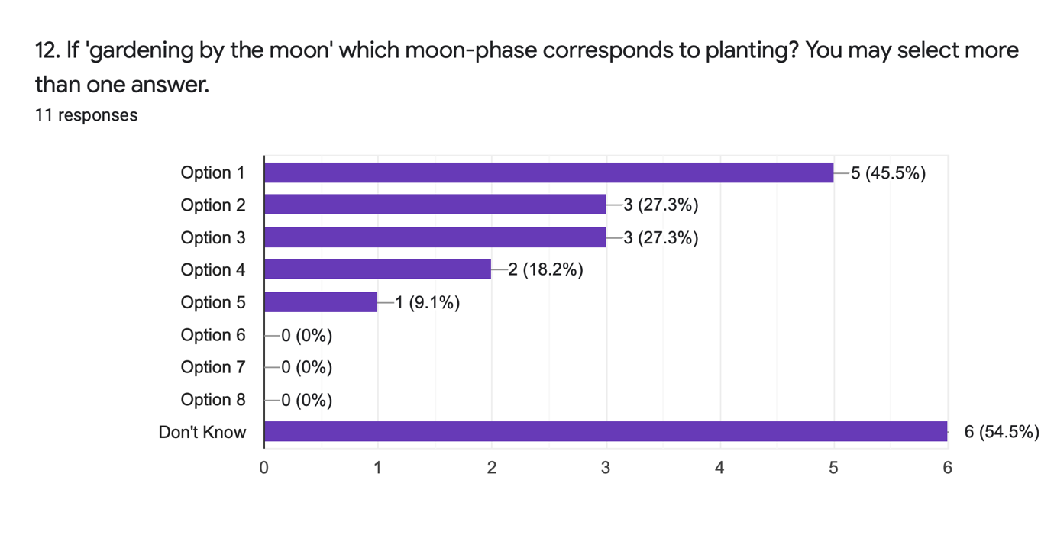
Figure 1 Table generated by Google Forms to show responses to question 12 on the Cosmology Questionnaire.

The chart in figure 1 shows the distribution of opinions about when to plant in sympathy with the moon’s cycle of waxing and waning. Option 1 corresponds to the new moon and was the most popular choice, all participants who expressed an opinion chose this option. Some people selected more than one option. The selection of option four which represents the full-moon, accords with Columella’s mid-first century CE advice for planting beans. Pliny considered the dark of the moon (Option 8), to be the most opportune time for planting vetch and fodder crops. The timing of agricultural practices according to the phase of the moon is described in Classical sources including Pliny and Vergil. Regarding these sources and their Greek antecedent Democritus, Daryn Lehoux writes ’The instructions concerning the beneficial lunar phases are based on perceived sympathies between the phase of the moon and the state of things on Earth.’ These traditions demonstrate the survival of the third century BC Stoic concept of sumpatheia, described by Bernadette Brady as ‘a web of connectivity which binds all to everything.’It is one of the principles that underpins astrology by providing the rationale for events in the sky relating to events on the earth. This question prompted almost half the participants to express the opinion, not only that events in the sky relate to events on earth but also what events might correspond to the phase of the moon.
The final part of this section of the questionnaire was about observation of solar phenomena. Ten participants responded to questions about witnessing sunrise, sunset, and natural phenomena caused by the seasonal movement of the earth in relation to the sun. Seven people reported witnessing sunrise more than once a month, and three of them see it more than once a week. One person commented ‘Depends on time of year’ and other comments concurred that it was a winter seasonal practice.

Always up around 6.30am so only see the sun rise regularly in the winter these days. I do love seeing it rise and have had some magical moments over the years.

Every day in winter - when it is dark when we get up. Never in the summer. Sunrise at Kanyakumari - South India is a pilgrimage event. The morning we went - hundreds of people present but cloud so no visible sunrise. I think also as a Girl Guide in Cardiff we were taken on a dawn hike but don’t recall seeing the sun then, either.

These responses demonstrate appreciation of the experience of witnessing sunrise and acknowledgement that at the latitude of Lampeter, 53°N, the time at which it occurs varies by several hours across the year. The second comment draws attention to the transcultural significance of sunrise. Pilgrims in South India and Girl Guides in Cardiff moving themselves to participate with others in observance of it. In each case it is the cultural practice that is remembered, the sun rises every day, but it is not always visible. The participants reported witnessing sunset more frequently than sunrise. Ten people reported witnessing sunset more than once a month and four of them
answered that they witness sunset every day. The comments reflect a similar seasonal variation to the frequency of these observations as those made about the stars and the moon; ‘Frequently in winter’ wrote one respondent. Between early November and early February at this latitude sunset and sunrise are less than nine-hours apart and the short days of winter make witnessing these events more likely. Other comments reflect a contemplative mood associated with sunset.

The west is a peaceful direction at sunset, I look that way.

In contrast to the mood of sunset, many of the responses to the next question about signs of spring were descriptions of dynamism. Nine of eleven responses referred in general to new growth of plants and trees ‘Certain plants waking up’; there were also nine responses relating to birds. These included the general ‘increased bird activity’ to more specific types of activity such as nesting or singing. Two people mentioned swallows and one ‘the song of the lark’. Two people listed ‘lambs’ as signs of spring. Six respondents named specific flowers as signs of spring and five of them mentioned daffodils. The question asked for three observations, but some responses listed more. Six responses referred to the increased hours of daylight that stimulate dramatic changes in growth rates and activity levels. One person listed ‘the position of the Plough’ as a sign that spring had arrived. The Plough is an asterism that forms part of the circumpolar constellation Ursa Major, the great bear. At a latitude of 53°N it is always visible in the night sky, however the portion of its circuit round the pole that occurs during the hours of darkness is determined by the position of the earth relative to the sun. In spring at dusk (figure 2) the Plough emerges above the North-north-eastern horizon and arcs toward the zenith. Beginning its descent toward the North-north-western horizon the seven bright stars fade from sight an hour before sunrise whilst still high in the sky.
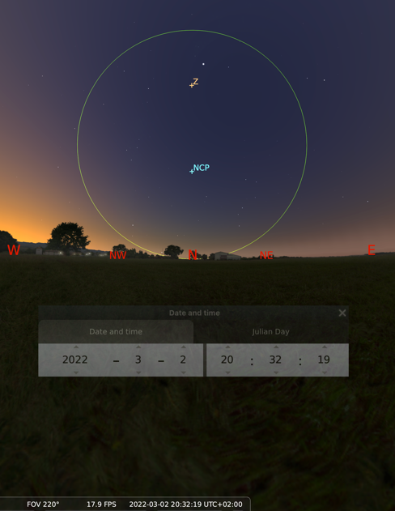
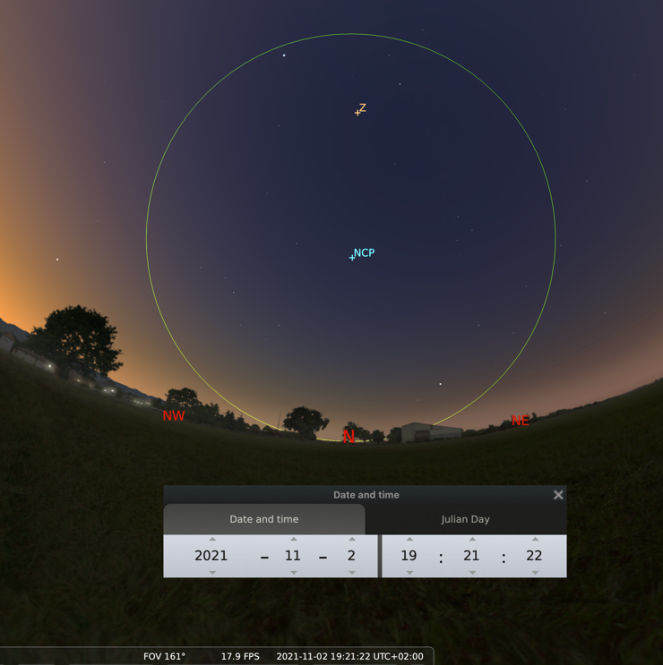
In winter (figure 3) the Plough emerges at dusk above the North-north-eastern horizon and travels low across the sky below the northern celestial pole. It begins its ascent toward the zenith but fades from at about 7 a.m. before ever reaching it.
Figure 3, The Plough at Dusk in Winter, Image generated with Stellarium Planetarium
The signifiers of winter were the subject of the next question. Descriptors focussed on the consequences of the increased distance of the northern hemisphere from the sun after the September Equinox.

It feels as if nature has gone to sleep

One person commented that they noticed a change in the position of the Plough and the moon rising higher in the sky. The majority of responses to this question described the primary effects of the suns position in relation to the earth; the lower temperatures and the reduction in daylight hours. Ten of the comments referred to shorter days, darkness or the long shadows that accompany the days when the sun stays low in the sky all day. Six responses related to cold and frost, one person listed ‘cool calmness’ and another a change in their mood. No-one responded to the questions about signs of spring or winter with a date on a calendar.

Section Three -Spirituality
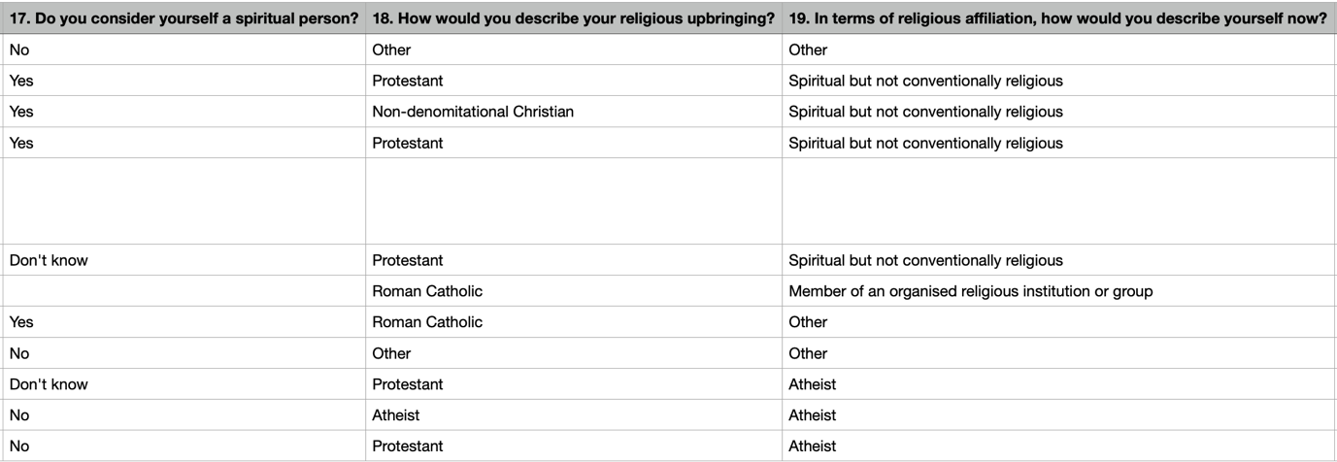
The final section of the questionnaire enquired about spirituality. These questions were included to inform any data that suggested the creation of personal calendars. The data up to this point demonstrated seasonal variation but not the specificity to necessitate comparison with religious calendars. The responses to these questions are shown in the excerpt from the Cosmology Questionnaire Results Table in figure 4.
Figure 4, Responses to Questions about Spirituality

The responses pose more questions than they answer, and this reflects an oversight in the questionnaire design. No space was provided to specify what ‘other’ referred to. Question 18 listed of twelve religions and two respondents selected ‘other’. Question 19 suffered the same deficiency. Two people did not respond to question 17, and two people responded that they didn’t know if they were spiritual, but no-one described their current religious affiliation (question 19) as agnostic. The results do indicate a shift away from the major Christian denominations over time.

Interviews
Concurring with the findings of Blair’s 2014 study, all the interviewees expressed sentiments of Noctcaelador, the term derived by William Kelly to denote intense attachment to the night-sky. Several participants commented that when I introduced the research, they didn’t think they had any ‘sky stories’, but the specificity of the questionnaire had prompted recollections, and they were excited to share the stories of their own experience. The interviews were conducted outside, under the sky, exposed to the cosmos.
Figure 4 is a photograph taken at the location of interview two, where the sun shone on shimmering birch leaves.

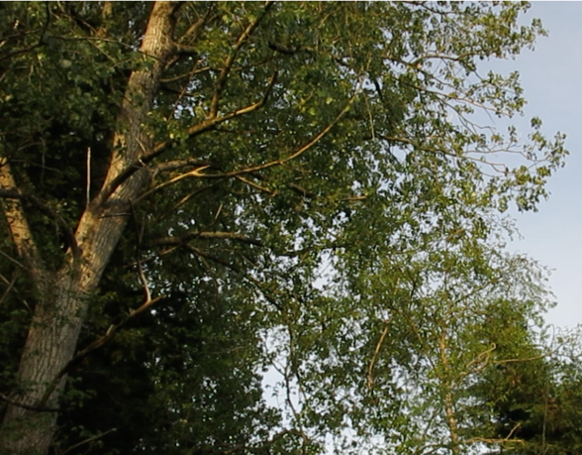
Figure 4, Evening sun on Birch, Bridget Thomas 2022
Blair identified seven themes that emerged from her interviews. These themes were used to code the transcripts of three interviews. The first theme she addressed was ‘Meaning and Significance: the human desire to connect with the night sky.’ Two of my three interviewees talked about their habit of checking the sky.

How often do you notice the night sky?

Every night! (Laughs)…I’ve got a lovely view out of my bedroom window, its hills and forests, and I can see the sky changing colour, and then I can see the stars, and then I actually open the window so that I can stick my head out. (more laughing).

Most evenings. I’m not the most patient person when it comes to cloud in the evening…I often pop out for a look and if it’s cloudy, I tut…I do look forward to just popping out even if it’s only for a couple of minutes. It’s something that I want to do in the evening ‘n er I want to feel that feeling or those feelings...but yeah, I genuinely do love it…

All the interviewees who participated in this project talked about discussing phenomena such as the appearance of the moon, or the sunrise with friends and family. Blairs second theme is ‘Community: observing the sky with others as a means of building and maintaining family/community connection.’ My interviewees described calling family members outside to share the view, chatting about the sunrise with people in town and phoning family members to compare views of the setting sun. In response to the question What is the most powerful experience you have had when looking at the night sky? One interviewee had this to say about observing the moon from a veranda in India many years ago,

…one night I saw the moon and realised that it was the same moon that my family saw in Wales. … the fact that it stayed with me means it’s a kind of uniting force. That’s all I could really say about that. It made me feel connected with them. Connected because it was a long physical distance, but I did feel connected with them.

Participants reported that they felt a sense of connection to others when observing the sky even if the phenomena are not witnessed with other people. To date there are no star-gazing events or observatories in the immediate area and no astronomy club or similar that might organise the sorts of community events that Blair describes occurring on Sark. Nevertheless people reported a sense of connection to others engendered by the night sky.

Blair asserts that her research provides oral testimony in support of the claims made by organisations promoting dark skies that dark skies enhance human well-being. The next of her themes is ‘Well-being: Experiencing positive feelings through observing the night sky.’ These 2022 interviews add support to that body of evidence.

I’m calmed and em…em…humbled by it. Even though I only spend a couple of minutes a day (looking at the night sky) I think I do I think, I genuinely believe I reach a calmness that I would find difficult to attain otherwise. I find it simpler to only think about the sky for a moment…without the chatter. Erm, erm, yeah, similar to when I’m in water actually, similar to that state.

the benefits are…it takes stress out of the equation…it slows everything down in my mind…yeah, peace, calm, happiness.

The similarity between these two responses is striking. Both were provided in response to the question, What feelings come up for you when you look at the night sky? When I asked Interviewee Two the same question they laughed

…I would have said none, except I should be honest and say the first thing that came into my head!

The interviewee then demonstrated the next theme identified by Blair, nostalgia. This was not Blair’s nostalgia for childhood memories of the night sky but for warm evenings on holiday in Tenerife…

…and he and I used to walk down to the coast in the evening after work and chat to the night sky…what was the question? I went right off on one…(laughing)
What feelings come up for you when you look at the night sky?
Ah so I suppose Romance. Yes. Yes.

This answer is a reminder that significance, feelings, and meaning are all words that are subjectively defined. This stage of the research was designed to elicit a sense of the emic significance of taking notice of the sky; in full awareness that this is unique to the individual. When the same themes present themselves repeatedly it is tempting to generalise and helpful for organising the findings. However, this type of qualitative enquiry must attempt to allow the data to speak for itself, attending to all the stories not just the ones that fit a favoured theoretical narrative, or the worldview of the researcher.
The fifth theme to emerge from Ada Blair’s data was ‘fear and fearlessness of the dark.’ When I asked the question How do you feel about being out at night in the dark in Lampeter or elsewhere? All the interviewees asserted that they felt more alert but not afraid and stressed that they might feel different somewhere else. This consensus is consistent with that expressed by research participants on Sark in 2014. Blair discusses the diminution of her own fear of the dark over the course of her research as she became acclimatised to the dark sky.
None of my interviewees or the people who completed questionnaires made any comments in relation the Blair’s sixth theme ‘The dark sky movement and astronomical tourism’. They expressed gratitude for their dark sky and awareness that they had access to something not every-one does. One interviewee related this personal sky story

Two friends came up to visit me from London. I knew they had arrived I’d seen their car go past. They just didn’t appear because they had basically got out of the car and were just stood there, they were completely gobsmacked by the stars. Yes. We’re lucky, were seriously lucky.

All the interviewees had experience of visitors who had arrived and then needed to be fetched into to the house because the stars had waylaid them.

People who visit say “wow! your sky, you get more stars than us.” I do genuinely feel for them you know because I know what they’re getting…maybe the odd glimpse of the sun and maybe the north star. That really gets me when people go “Wow! Your sky.”

This participant had lived in a large city for many years and was speaking from experience. In cities an excess of artificial light bounces off every particle and every drop of water vapour in the atmosphere to obscure the view.
The sample group was selected because their weekly gatherings bring them into contact with the landscape and the skyscape as they walk through them. Familiarity with the local landscape is a natural consequence of their behaviour. In my research diary, I made a note that in conversation the walkers expressed a sense of location specific skies. They referred to house or street or village skies as if they were individual separate entities. The distinction they were making was an assessment of the quality of the atmosphere in those locations, the cleanness of the air, the levels of light pollution and the relationship between the land and the sky.

I think mine is the nicest…I think I’d like to at least pretend that I know my sky, from my house and that it is nicer than anywhere else.

This comment reflects an attachment to the view of the sky from ‘home’ that was a sentiment frequently expressed by the admittedly small sample group. In conversation, and in response to the questionnaire participants contemplating the experience of looking at the night sky were often prompted to express gratitude for being in the right place at the right time, here and now.

CONCLUSION
My initial query about behaviour in response to observations solar and lunar natural calendars was partially satisfied by participants reports of seasonal visits to favoured natural environments. Observation of primary and secondary solar phenomena does impact participants sense of time and influences their behaviour. People love their dark skies but frequently don’t know what they are looking at. The moon is perceived by participants as unpredictable and mysterious and holds great fascination. These West Wales walkers experience an emergent cosmos. It is at once perceived as familiar and constant, and shifting and changing. The facts of scientific description are known about, but often poorly registered; considered interesting but distant from immediate subjective experience. My research sample is small, but I believe the results contribute to an understanding of contemporary uses of the sky.

If we consider ourselves a necessary component of a resilient ecosystem, then a better understanding of the nature and significance of our own relationships to the sky can only enhance our capacity to create a culture which supports the wellbeing of future generations.

Bibliography

Bell, Judith, Waters Stephen, Doing Your Research Project: A Guide for First-time Researchers, 7th edition, 2018 (London, New York: Open University Press, 1987).

Blair, Ada, Sark in the Dark: Wellbeing and Community on the Dark Sky Island of Sark, (United Kingdom: Sofia Centre Press, 2016).

Brady, Bernadette, Cosmos Chaosmos and Astrology, (Lampeter; Sofia Centre Press, 2014).

Campion, Nick, Cosmology and Astrology in the World’s Religions, (New York, London: New York University Press, 2012).

Gergen, Kenneth J. ‘The Social Constructionist Movement’, American Psychologist, (American Psychological Association, 1985), Vol 40, No.3, p.267. Available at: <DOI: 10.1037/0003-066X.40.3.266> [Accessed 20/3/22]

Greene, Liz, ‘Mystical Experiences Among Astrologers’ Culture and Cosmos, Vol.13, no. 2, Fall 2009, pp.31-32.

Giovagnoli, Rafaela ‘From Habits to Rituals: Rituals as Social Habits’ Open Information Science 2, no. 1 (2018): 181-188. Here p. Available at: <https://doi.org/10.1515/opis-2018-0014> [Accessed 21/4/22]

Hennink, Monique, Hutter, Inge, Bailey, Ajay Qualitative Research Methods, (London, California, New Delhi, Singapore: SAGE, 2011).

Husserl, Edmund; Carr,David trans. ‘The Crisis of the European Sciences and Transcendental Phenomenology: An introduction to Phenomenology’ (Evanston: Northwestern University Press, 1970), p.39.

Kelly, William E. ‘Development of an Instrument to Measure Noctcaelador: Psychological Attachment to the Night Sky College Student Journal 38.1 (2004). pp.100-102. Available at: <https://search-ebscohost-com.ezproxy.uwtsd.ac.uk/login.aspx?direct=true&db=aph&AN=12844798&site=ehost-live> [Accessed 28/5/2022]

Lehoux, Daryn Rosario, ‘Parapegmata, or, Astrology Weather and Calendars in the Ancient World…’ Unpublished Phd. Thesis, (University of Toronto, 2000).

Malighetti, Roberto, ‘The Work and Legacy of Clifford Geertz: An Essay on the Interpretive Turn in Anthropology’, in Bérose – Encyclopédie Internationale des Histoires de l’anthropology, (Paris: Università degli Studi di Milano-Biocca, 2020).

Marselle, Melissa R., Irvine, Katherine N. and Weber, Sara L. ‘Walking for Well-being: Are Group Walks in Certain Types of Environments Better for Well-Being than Group Walks in Urban Environments?’ International Journal of Environmental Research and Public Health, (2013), 10, pp.5603-5628. Available at: <https://doi:10.3390/ijerph10115603> [Accessed 21/4/2022]

Nordgren, Tyler, ‘At Night’s End’, in Darrelyn Gunzburg, Ed. The Imagined Sky: Cultural Perspectives, (Sheffield: Equinox, 2016).

Probst, Barbara, ‘Both/and: Researcher as Participant in Qualitative Inquiry’, Qualitative Research Journal, Vol.16, Issue 2 (2016), pp.149–58. Available at: <DOI:10.1108/QRJ-06-2015-0038> [Accessed 28/5/2022].

Rappaport, Roy A., and Roy Rapaport. ‘Obvious Aspects Of Ritual.’ Cambridge Anthropology 2, no. 1 (1974), pp.3–69. Available at: <http://www.jstor.org/stable/23816434.> [Accessed 20/4/2022]

Redick, Kip, ‘Pilgrimage Pedagogy and Wilderness Journeys.’ In Pilgrimage as Spiritual Practice: A Handbook for Teachers, Wayfarers, and Guides, edited by Jeffrey Bloechl and André Brouillette, pp. 201–20. (1517 Media, 2022). Available at: <https://doi.org/10.2307/j.ctv29sfx9c.15> [Accessed 1/8/2022].

Scalapino, Leslie, New Time, (UK: Wesleyan University Press, 1999).

ONLINE SOURCES

Brecon Beacons National Park Website. Available at:<https://www.breconbeacons.org> [Accessed 20/5/22].

Cambrian Mountains Dark Skies, Mynyddoedd Cambrian Mountains website, (2022). Available at: <https://www.thecambrianmountains.co.uk> [Accessed 29/5/2022]

Discovery in the Dark: Wales, Website. Available at: <https://discoveryinthedark.wales> [Accessed20/5/22].

Go Stargazing, Blog Available at <https://www.gostargazing.co.uk> [Accessed 29/5/2022]

Google Forms. Available at: <https://www.docs.google.com>

International Dark-Sky Association Website. Available at: <https://www.darksky.org> [Accessed 20/5/22].

Litmus Press Website. Available at: <https://www.litmuspress.org> [Accessed 20/3/2022]

Stellarium 0.22.1, Virtual Planetarium Software.

West Wales Walking for Wellbeing <www.https://Ceredigion.gov.uk> [Accessed 30/6/2022].

Yang, Andrew, ‘Interviews with the Milky Way’, (2016), available at: <https://www. andrewyang.net>; ‘Kinshape’ in Kinship: Belonging in a World of Relations, Vol. 1 - Planet. (United States: Center for Humans and Nature, 2021). Available at: <https://www.humansandnature.org> [Accessed 28/5/2022]

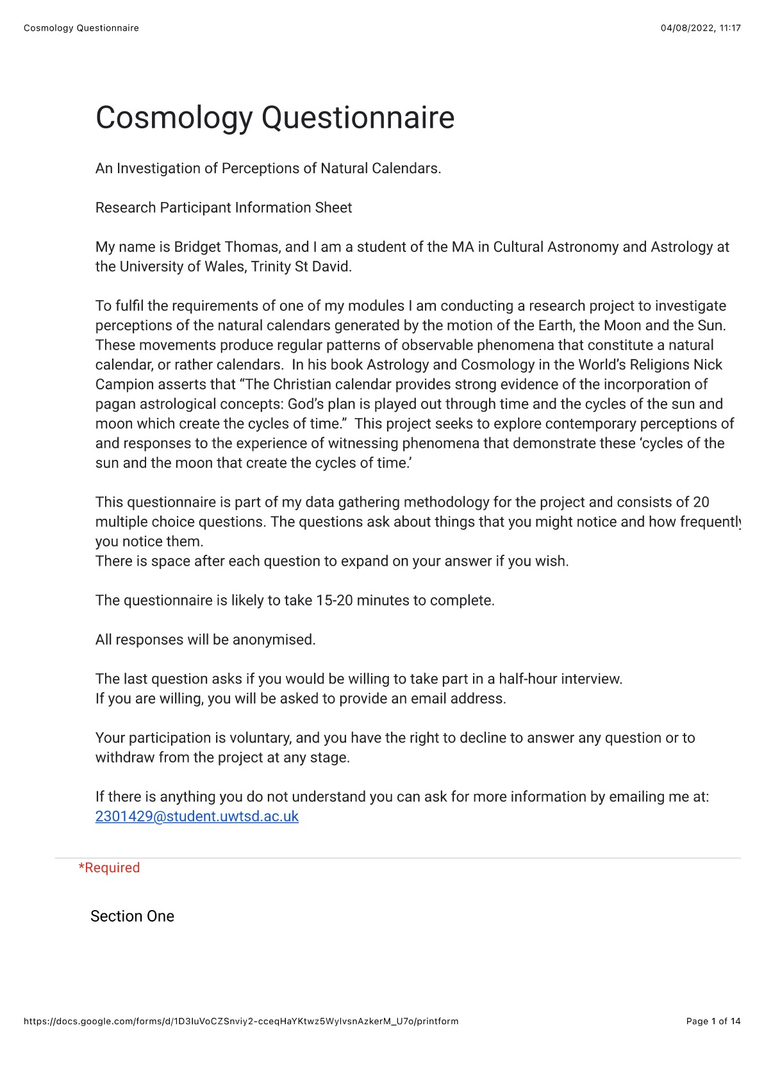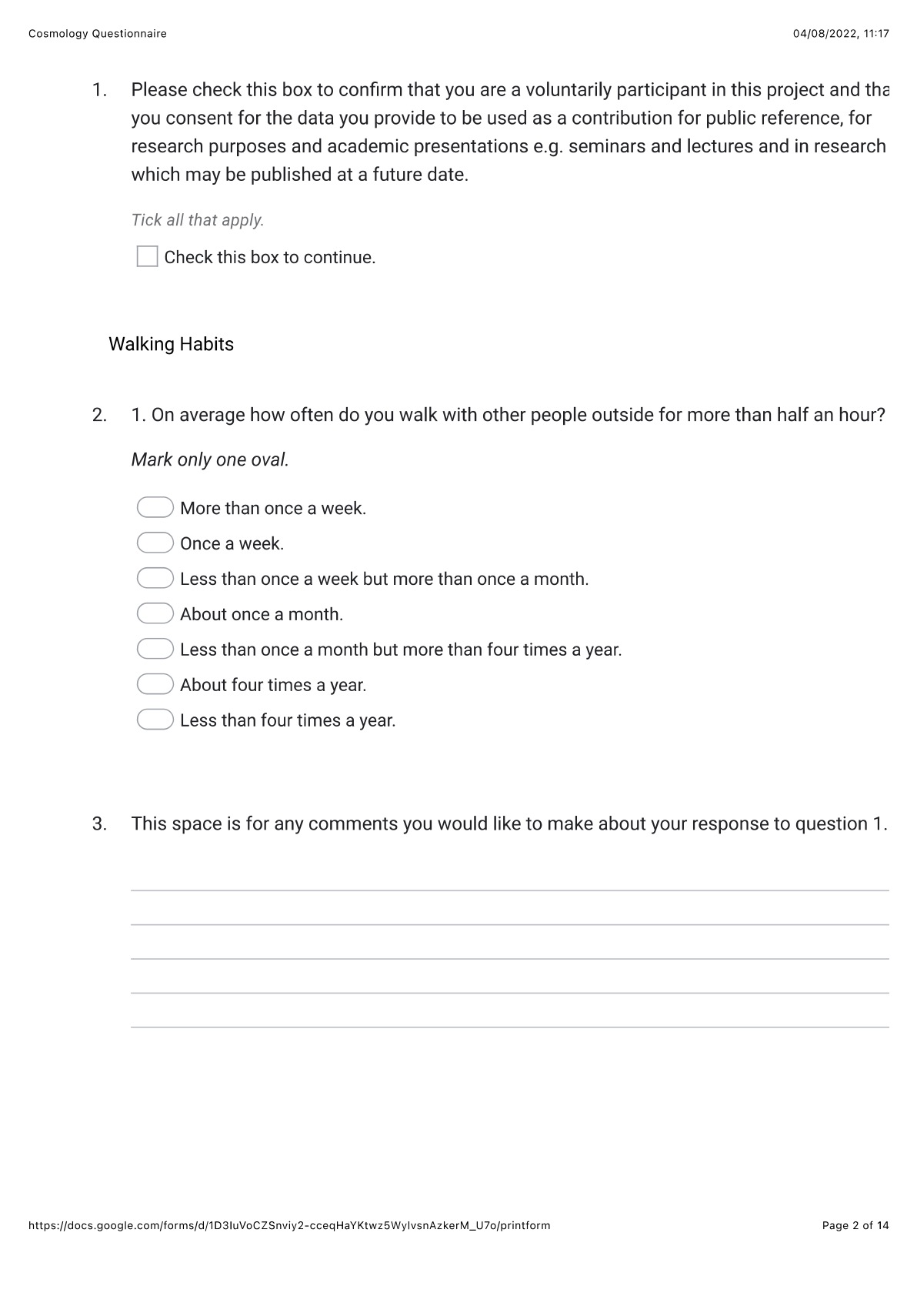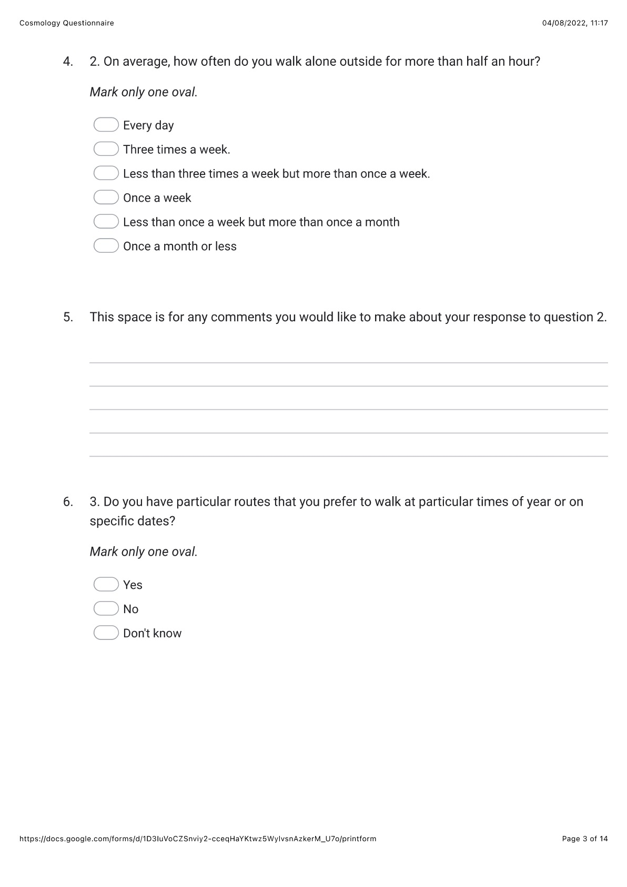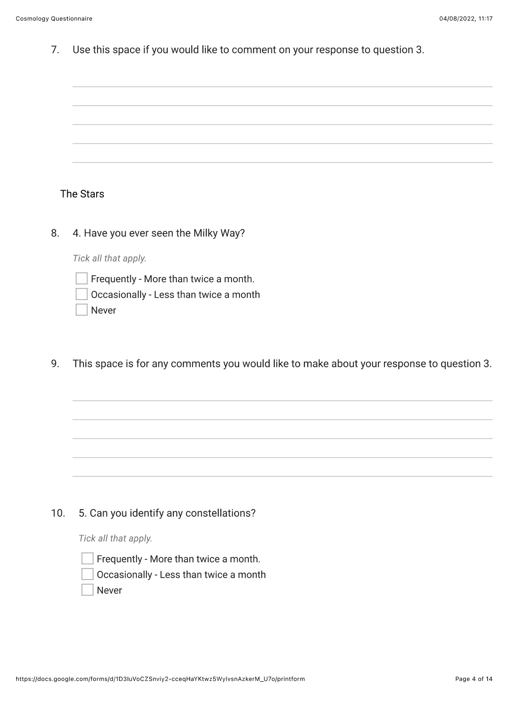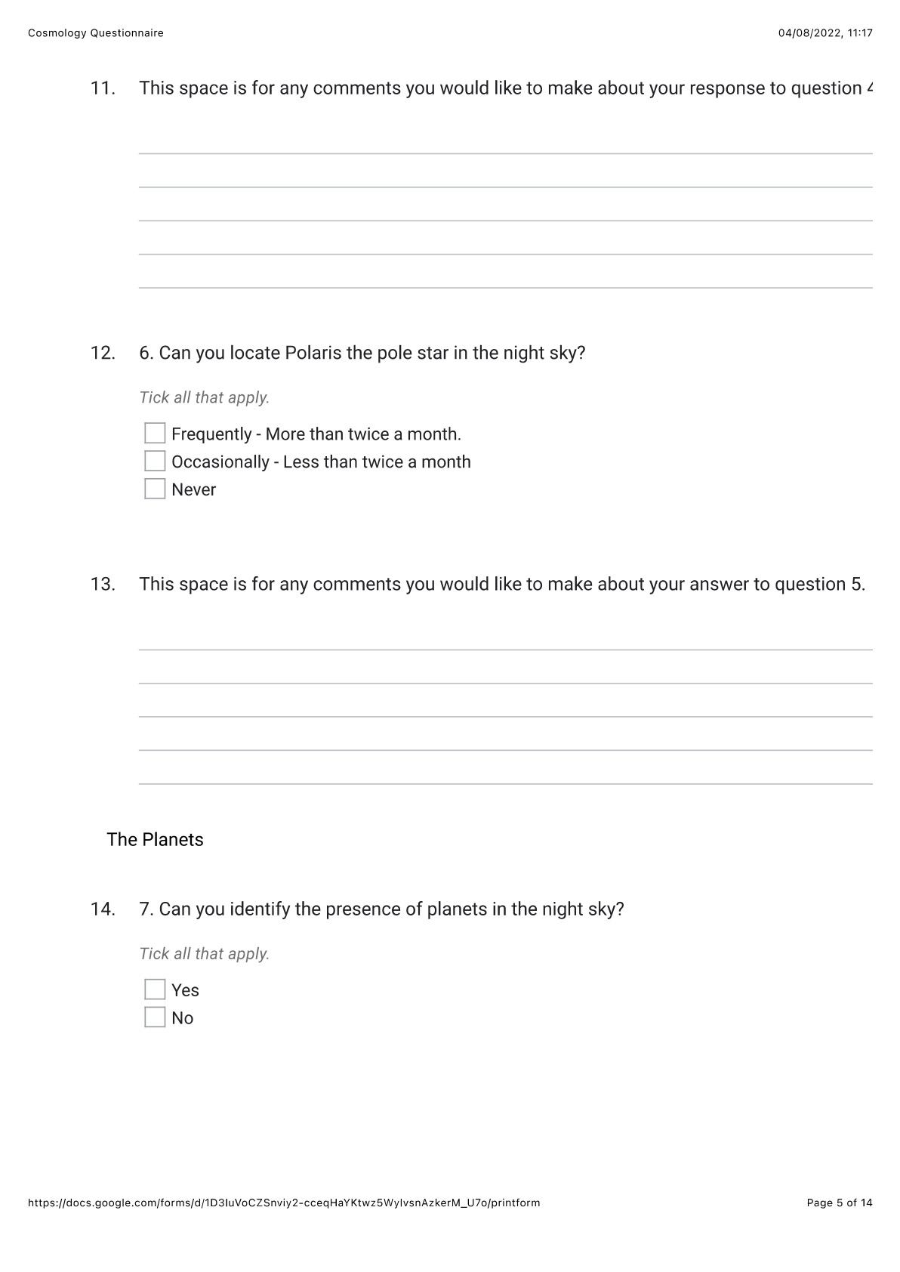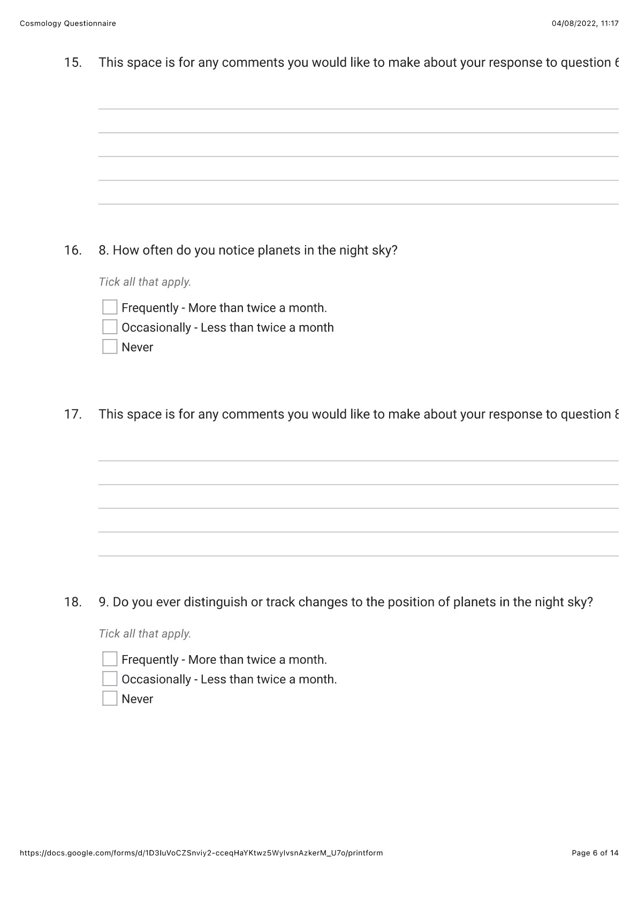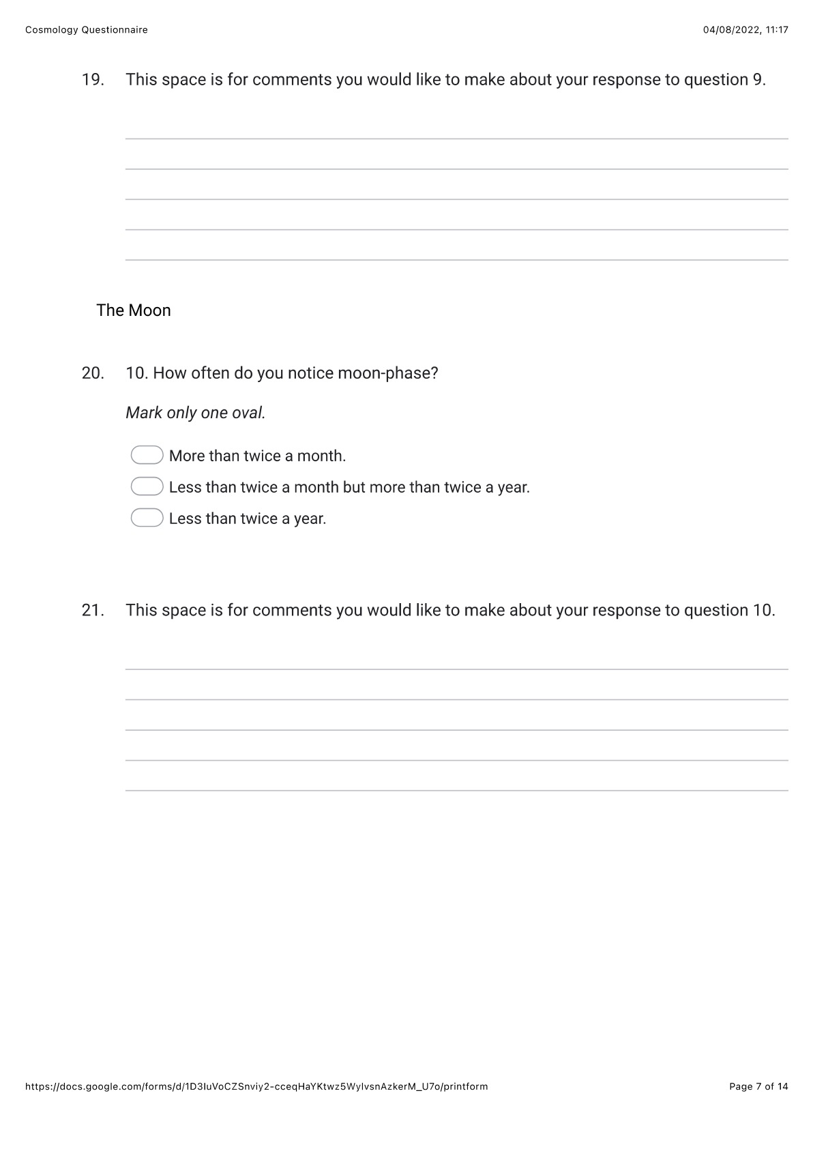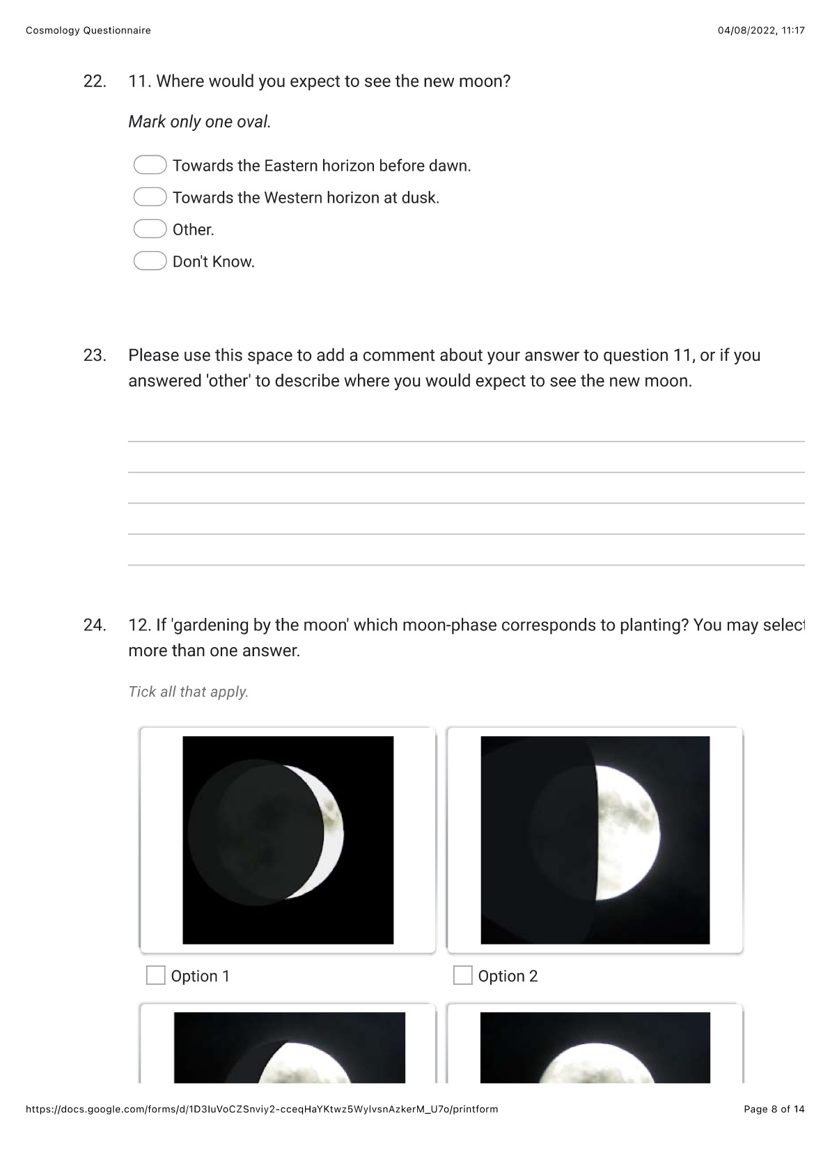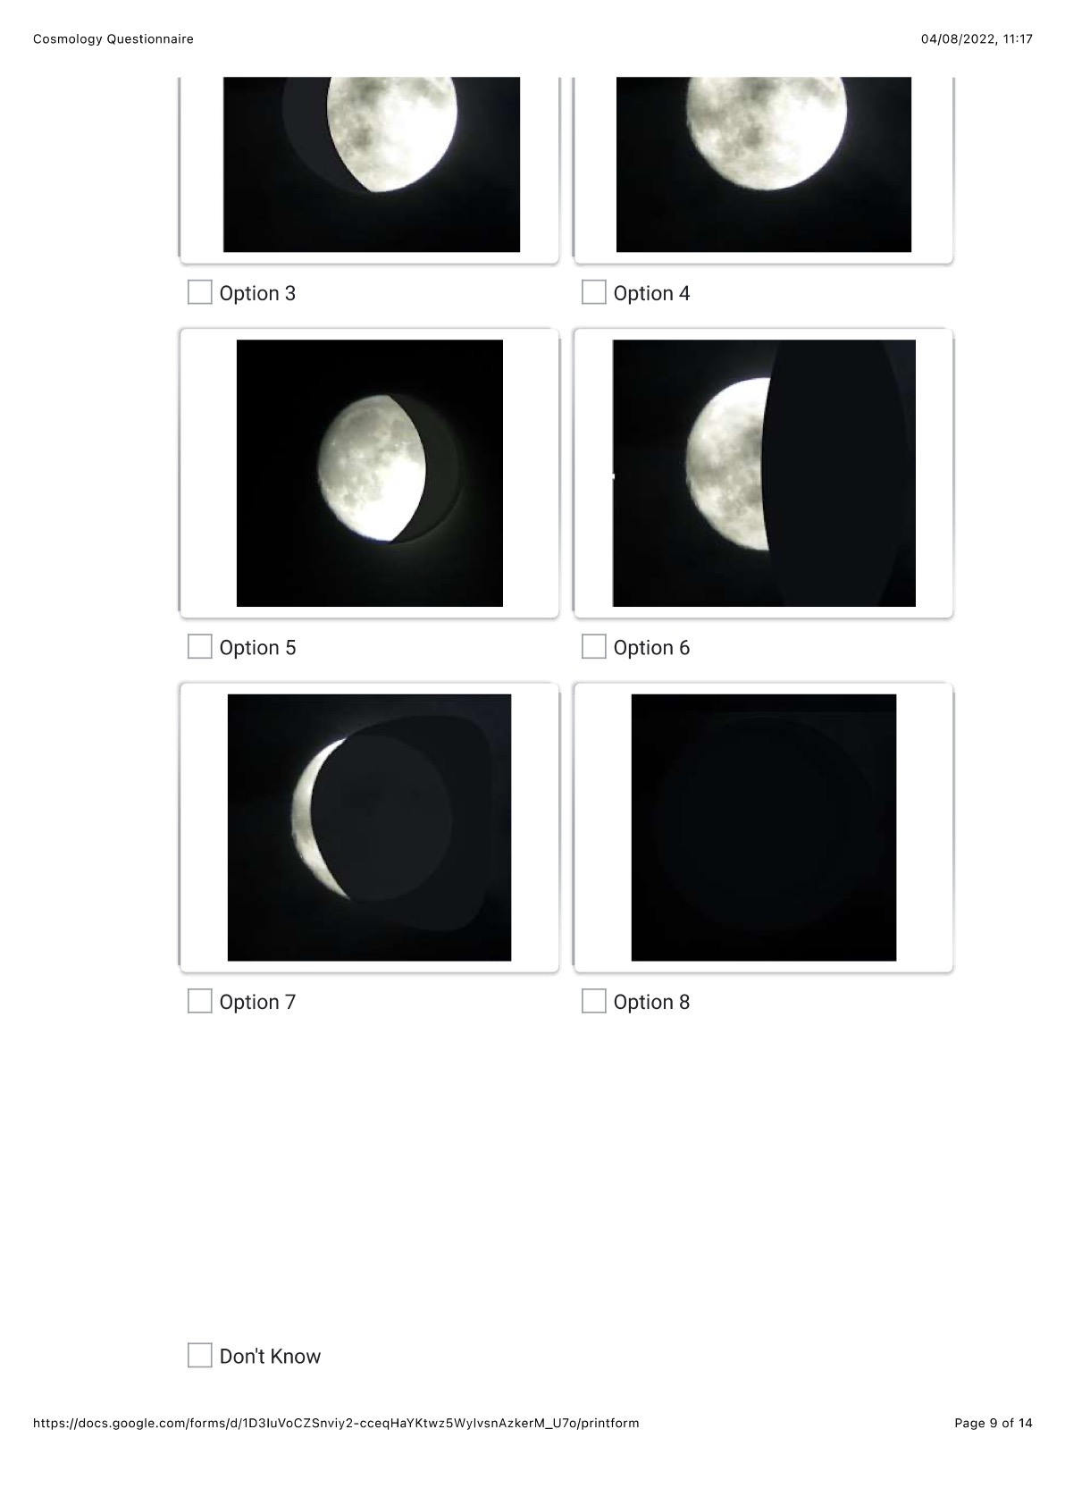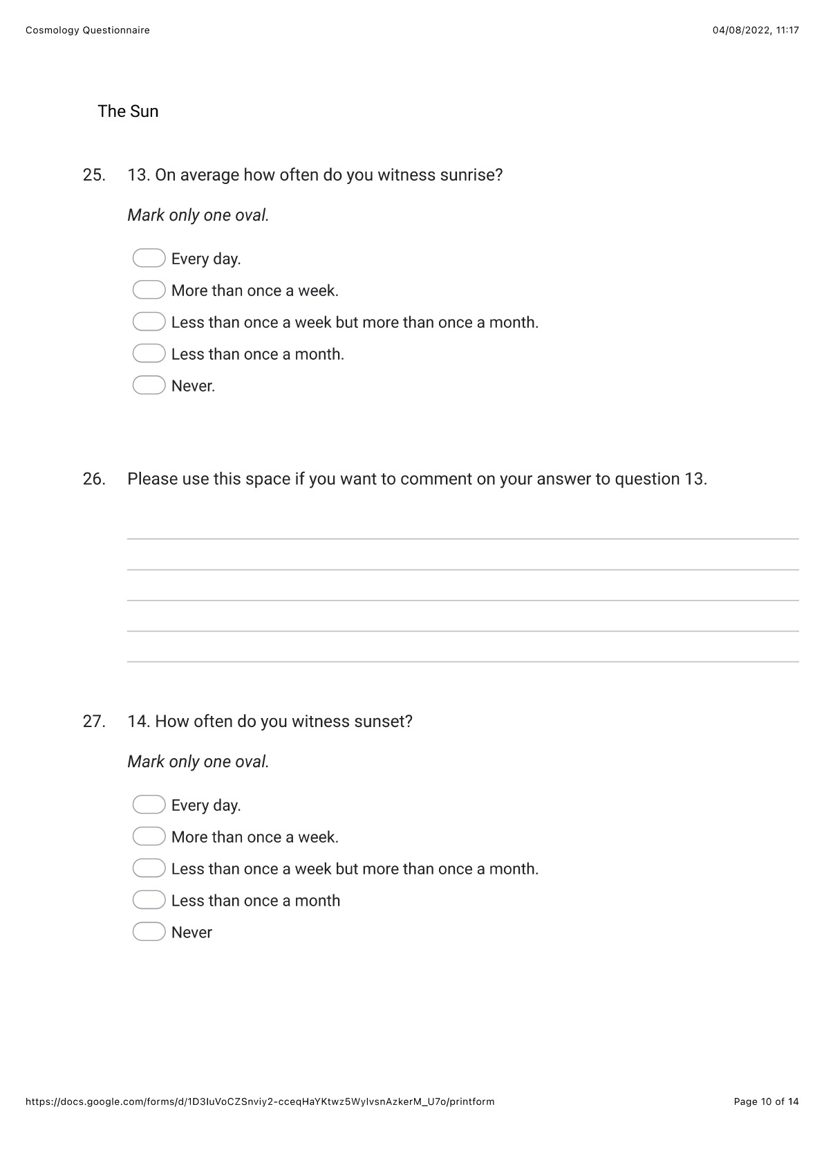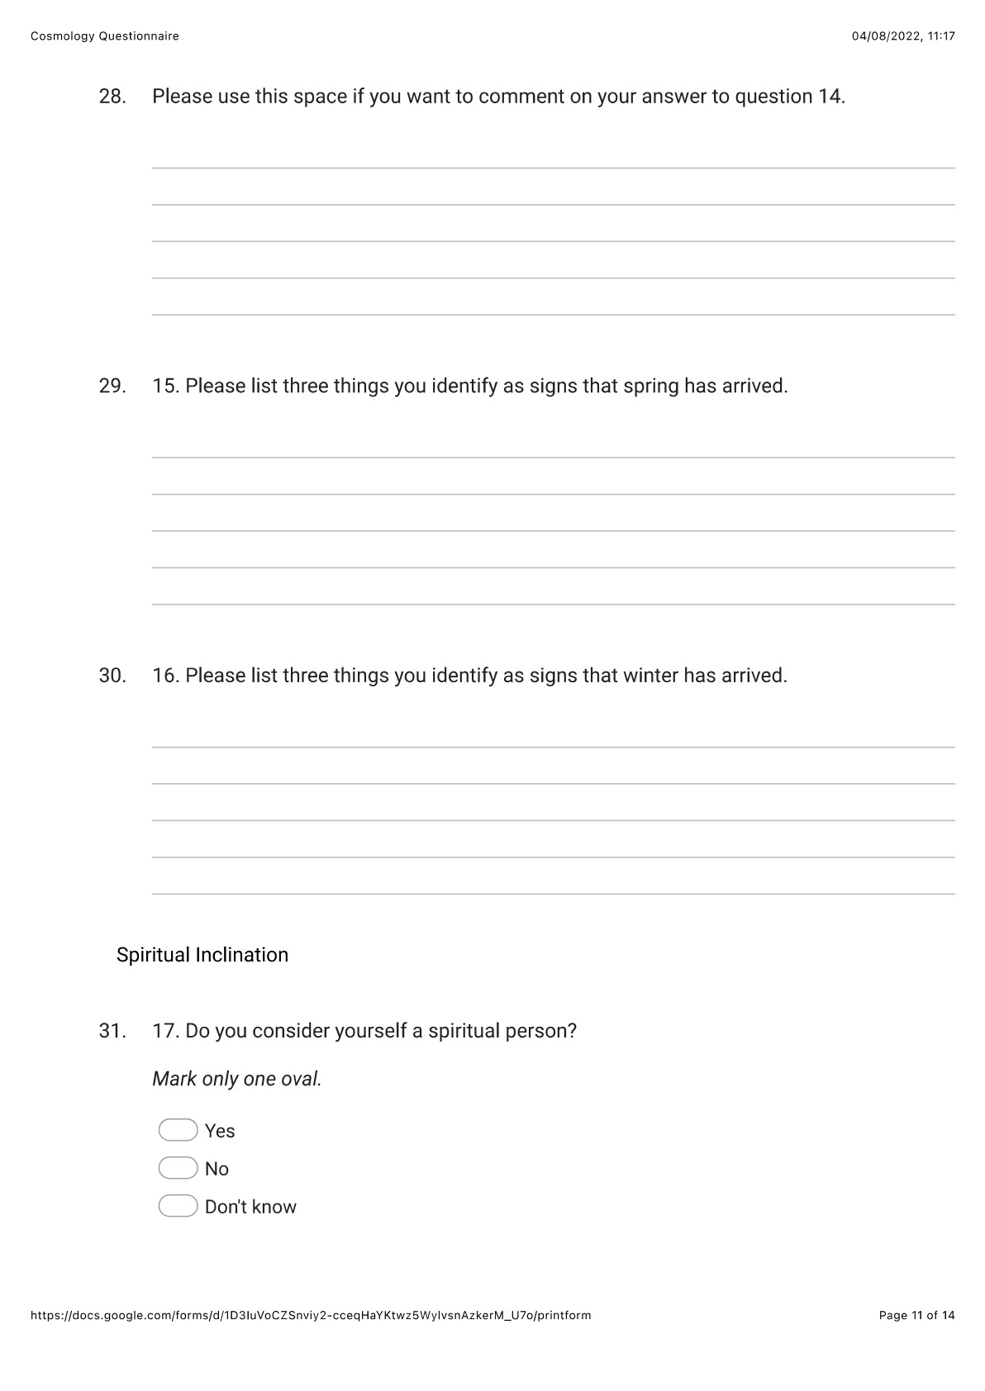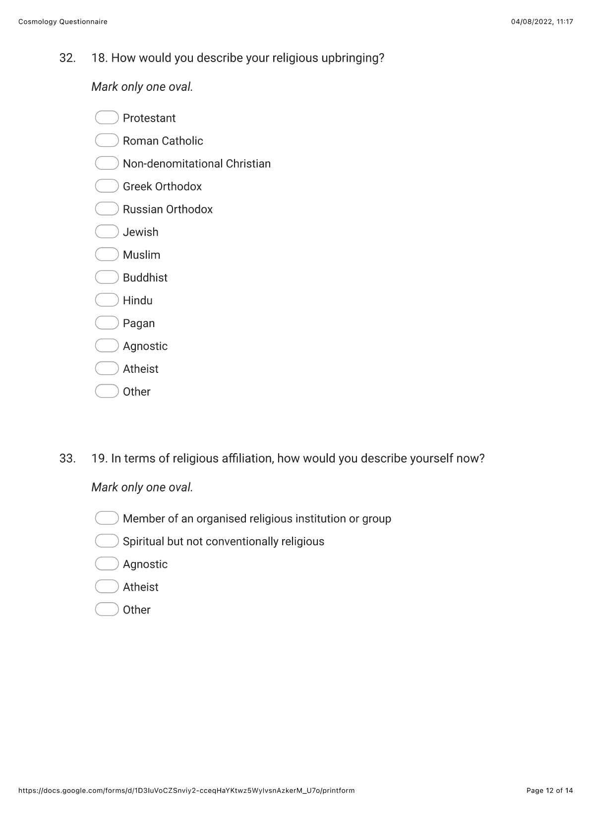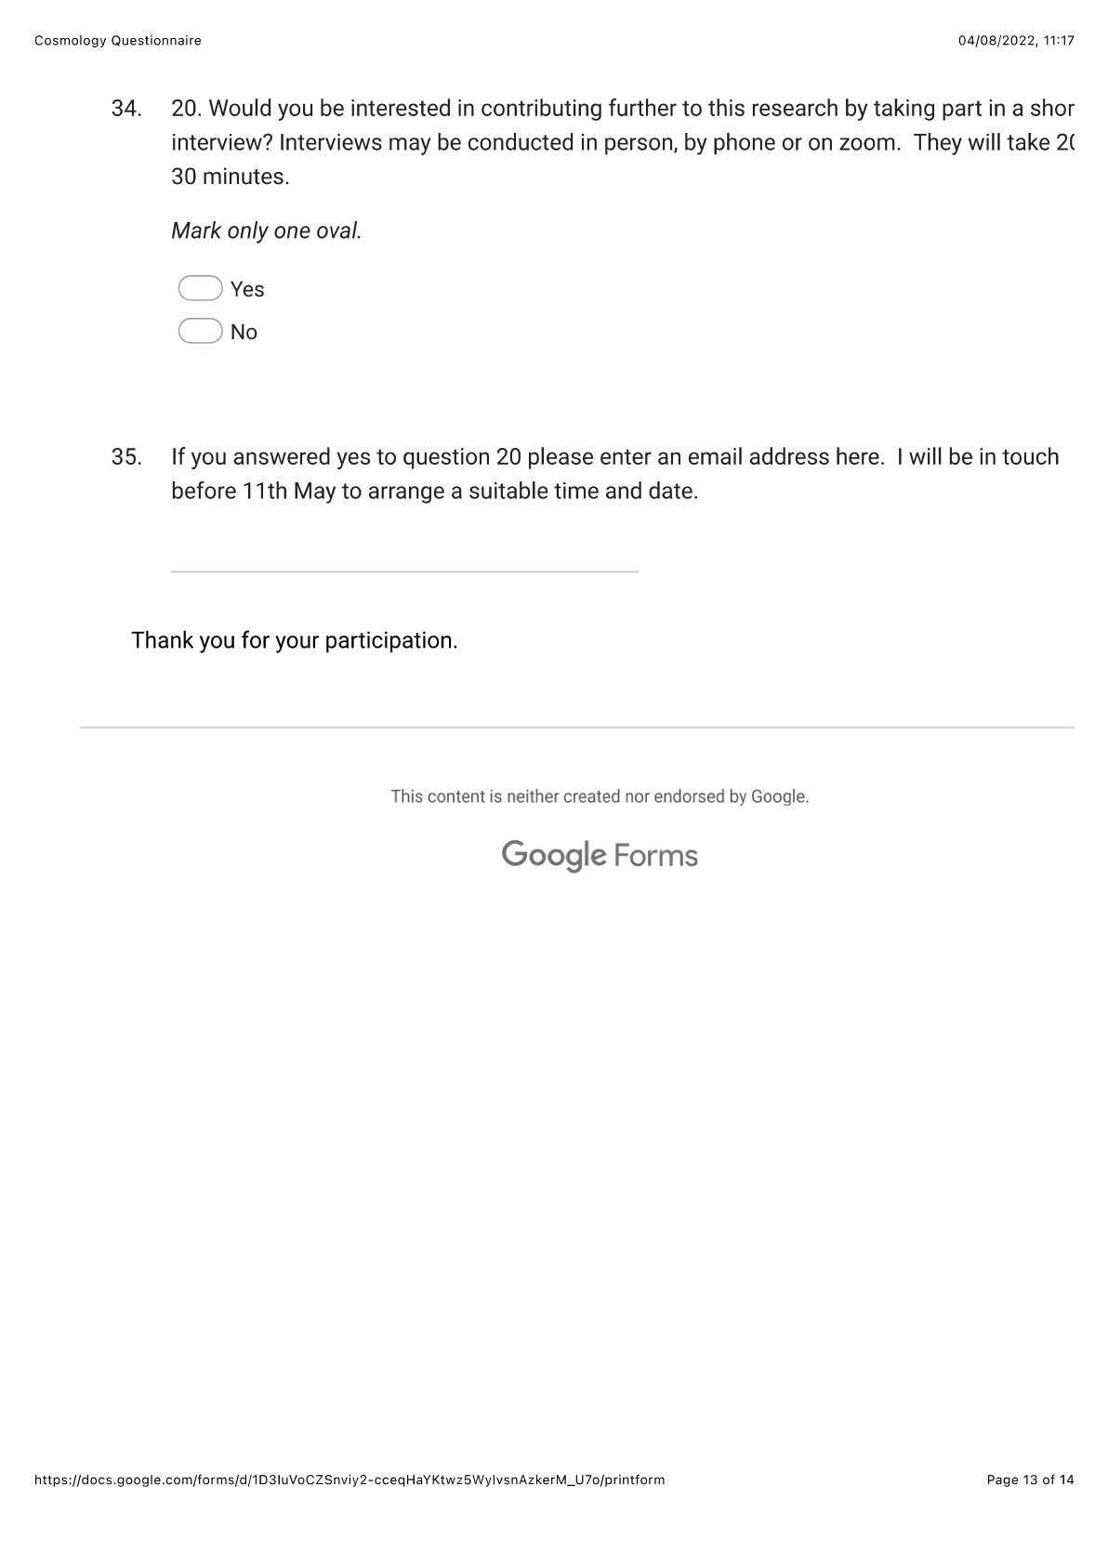

Nick Campion, Astrology and Cosmology in the World’s Religions, (New York and London: New York University Press, 2012).
Nick Campion, Astrology and Cosmology in the World’s Religions, (New York and London: New York University Press, 2012). p.4.
Judith Bell and Stephen Waters, Doing Your Research Project: A Guide for First-time Researchers, 7th edition, 2018 (London, New York: Open University Press, 1987), p.26.
Yang, Andrew, ‘Interviews with the Milky Way’, (2016), available at: <https://www. andrewyang.net>; ‘Kinshape’ in Kinship: Belonging in a World of Relations, Vol. 1 - Planet. (United States: Center for Humans and Nature, 2021). Available at: <https://www.humansandnature.org> [Accessed 28/5/2022]
Carl Sagan, Who Speaks for Planet Earth,” transcript for the final programme in the ‘Cosmos’ tv series, PBS (1980), cited by Nick Campion, Astrology and Cosmology in the World’s Religions, (New York and London: New York University Press, 2012), p.1.
Tyler Nordgren, ‘At Night’s End’, in Darrelyn Gunzburg, Ed. The Imagined Sky: Cultural Perspectives, (Sheffield: Equinox, 2016), p.192.
Ada Blair, Sark in the Dark: Wellbeing and Community on the Dark Sky Island of Sark, (United Kingdom: Sofia Centre Press, 2016).
Go Stargazing, Blog Available at <https://www.gostargazing.co.uk> [Accessed 29/5/2022]
The West Wales Walking for Wellbeing initiative is still active in 2022. <www.https://Ceredigion.gov.uk> [Accessed 30/6/2022].
Kip Redick, ‘Pilgrimage Pedagogy and Wilderness Journeys.’ In Pilgrimage as Spiritual Practice: A Handbook for Teachers, Wayfarers, and Guides, edited by Jeffrey Bloechl and André Brouillette, pp. 201–20. (1517 Media, 2022). Available at: <https://doi.org/10.2307/j.ctv29sfx9c.15> [Accessed 1/8/2022].
Leslie Scalapino "walking person who has sky flowing–by one who beside is as if...", New Time, (UK: Wesleyan University Press, 1999), p.84.
C. Geertz Local Knowledge. Further Essays in Interpretive Anthropology. (New York: Basic Books, 1983), p. 180, cited by Malighetti, Roberto, ‘The Work and Legacy of Clifford Geertz: An Essay on the Interpretive Turn in Anthropology’, in Bérose – Encyclopédie Internationale des Histoires de l’anthropology, (Paris: Università degli Studi di Milano-Biocca, 2020) pp.18-19. Available at: <
The West Wales Walking for Wellbeing initiative is still active in 2022. <www.https://Ceredigion.gov.uk> [Accessed 30/6/2022].
Leslie Scalapino "walking person who has sky flowing–by one who beside is as if...", New Time, (UK: Wesleyan University Press, 1999), p.84.
Monique Hennink, Inge Hutter, Ajay Bailey, Qualitative Research Methods, (London, California, New Delhi, Singapore: SAGE, 2011). pp.81-82.
Edmund Husserl, David Carr, trans. ‘The Crisis of the European Sciences and Transcendental Phenomenology: An introduction to Phenomenology’ (Evanston: Northwestern University Press, 1970), p.39.
Andrew Yang ‘Interviews with the Milky Way’, (2016). Available at: <https://andrewyang.net/interviews-with-the-milky-way> [Accessed 28/5/2022].
Ada Blair, Sark in the Dark, p.149
‘Moon Planting Guide’, Permaculture Principles, Website Available at: <https://permacultureprinciples.com/permaculture-calendar/moon-planting-guide/> [Accessed 20/5/2022]
Daryn Lehoux, ‘‘Parapegmata, or, Astrology Weather and Calendars in the Ancient World…’ Unpublished Phd. Thesis, (University of Toronto, 2000).
Ada Blair Sark in the Dark, p.150.
Liz Greene, ‘Mystical Experiences Among Astrologers’ Culture and Cosmos, Vol.13, no. 2, Fall 2009, pp.31-32.
Nick Campion, Cosmology and Astrology in the World’s Religions, (New York, London: New York University Press, 2012), p.165.
Link to questionnaire at Google Forms. Available at : <iframe src="https://docs.google.com/forms/d/e/1FAIpQLSdp4h6eqfAka9ZzeRv3hkpvP7J3mlrTiAeNGyG9L46K5kdRug/viewform?embedded=true" width="640" height="2453" frameborder="0" marginheight="0" marginwidth="0">Loading…</iframe> [Accessed 7/8/2022].
Monique Hennink, Inge Hutter & Ajay Bailey, Qualitative Research Methods, (London, California, New Delhi, Singapore: SAGE, 2011). pp.92-93.
Ada Blair, Sark in the Dark, pp.149-150.
Barbara Probst, ‘Both/and: Researcher as Participant in Qualitative Inquiry’, Qualitative Research Journal, Vol.16. No.2 (2016), pp.149–58
Barbara Probst, ‘Both/and: Researcher as Participant in Qualitative Inquiry’, Qualitative Research Journal, Vol.16. No.2 (2016), p.154.
Questionnaire comment in response to Question 3. Do you have particular routes that you prefer to walk at particular times of year or on specific dates?
Rafaela Giovagnoli, ‘From Habits to Rituals: Rituals as Social Habits’ Open Information Science 2, no. 1 (2018): 181-188. Here p. Available at: <https://doi.org/10.1515/opis-2018-0014> [Accessed 21/4/22]
Rappaport, Roy A., and Roy Rapaport. “OBVIOUS ASPECTS OF RITUAL.” Cambridge Anthropology 2, no. 1 (1974), pp.3–69. Available at: <http://www.jstor.org/stable/23816434.> [Accessed 20/4/2022]
West Wales Walking for Wellbeing 2022. <www.https://Ceredigion.gov.uk> [Accessed 30/6/2022].
Columella, Rei Risticae, H. B. Ash, E.S. Forster and E.H. Heffner, eds., (Cambridge MA, 1948-55), II.x.10: XI.ii.85, cited by Daryn Lehoux in ‘Parapegmata’, Unpublished Phd. Thesis, (University of Toronto, 2000), p.148.
Pliny, Naturalis Historiae, H.Rackham, ed., (Cambridge, MA, 1938), XVIII.314: hoc silente luna seri iubent, cited by Daryn Lehoux in ‘Parapegmata’, Unpublished Phd. Thesis, (University of Toronto, 2000), p.148.
Daryn Lehoux, ‘Parapegmata’, Unpublished Phd Thesis, pp.148-151.
Daryn Lehoux, ‘Parapegmata’, Unpublished Phd Thesis, p.153.
Bernadette Brady, Cosmos, Chaosmos and Astrology, (Lampeter: Sofia Centre Press, 2014), p.10.
Comment in response to question 13.
Comment in response to question 13.
Stellarium 0.22.1, Virtual Planetarium Software.
Ada Blair, Sark in the Dark, p.100.
William E. Kelly, ‘Development of an Instrument to Measure Noctcaelador: Psychological Attachment to the Night Sky’ College Student Journal 38.1 (2004). pp.100-102.
Direct quote, Interviewee One.
Direct quote, Interviewee Three
Direct quote Interviewee Two.
Ada Blair, Sark in the Dark, p. 115, 121.
Ada Blair, Sark in the Dark, p.116.
Direct quote, Interviewee Three.
Direct quote, Interviewee One.
Direct quote, Interviewee Two.
Ada Blair, Sark in the Dark, pp.122-127.
Direct quote, Interviewee One.
Direct quote, Interviewee Three.
Tyler Nordgren, ‘At Night’s End’, in Darrelyn Gunzburg, Ed. The Imagined Sky: Cultural Perspectives, (Sheffield: Equinox, 2016), p.197.
Direct quote, Interviewee Three.

