University of Wales Trinity Saint David
Wales institute of Science & Art



Motorcycle Geometry Analysis and Dynamic
Handling Investigation
Motorcycle Dynamics (ACHA4003)

Aaron Lilly
2314260
December 2023

Table of Contents
Introduction 2
Task 1 3
Motorcycle Geometry data 3
Center of Gravity 5
Task 2 8
Gearbox Calculator 8
Forces Acting on a Motorcycle – Aero Drag 11
Forces Acting on a Motorcycle – Rolling Drag 13
Total Force 13
Task 3 14
Comparing Motorcycle Geometry 15
Squat and Anti-Squat 16
Task 4 19
Ducati Desmosedici GP19 19
Suzuki GSX1400 Dragster 21
Task 5 23
Reference list 25

Task 1

Motorcycle Geometry data
I obtained 2 different motorcycles geometry data by accurately measuring the wheelbase, the front and rear wheel radius (including the tyre).
I could then insert a photo of the bikes into SolidWorks and lay this data out in relation to the two motorcycles.
The first motorcycle is the Aprilia RS660, A production made sports bike for the road, although recently been used a lot more in the racing scene in both club racing and British championship.
The second bike that I measured is the Honda NSF250r, A prototype moto3, solely made for Racing.
I wanted to compare these two bikes to see how different a prototype and a production-based motorcycle are, despite both having Racing characteristics and both being used in the British Racing championship.

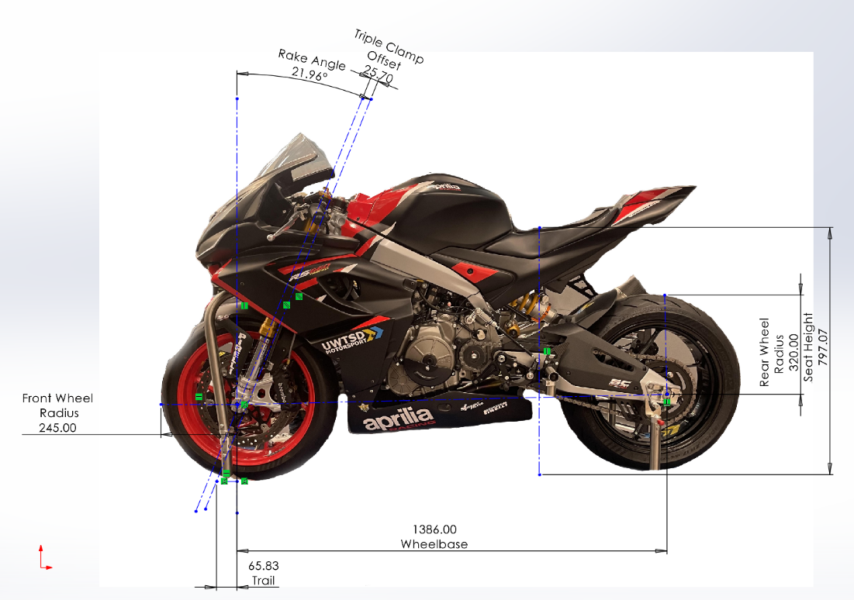
Figure 1 – Aprilia RS660 with Geometry Data

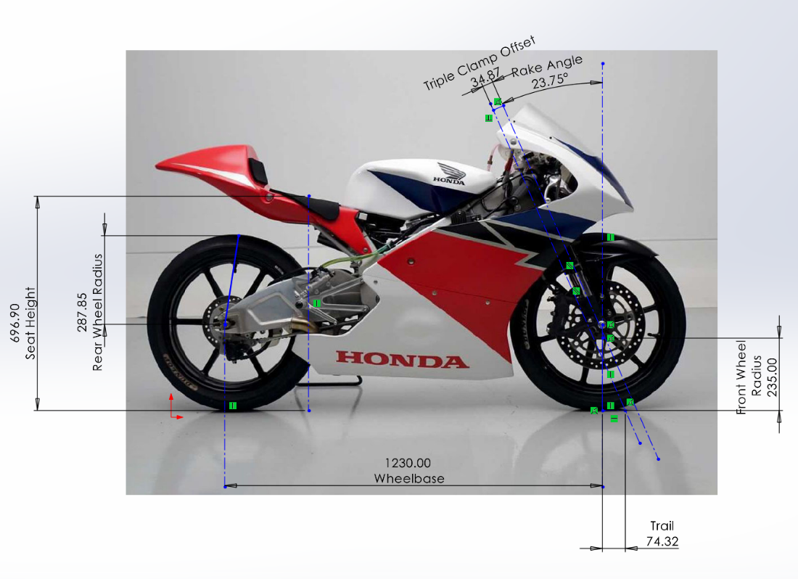
Figure 2 – NSF250R Geometry Data

Centre of Gravity
I also measured the weight of the front and rear end, with and without the rider, and the weight of the front when it was lifted.
These weights can help us determine where the Centre of Gravity positions are on the motorbike.
To take these measurements I placed two scales under each wheel of the motorbike to ensure these measurements are obtained when the bike is in a level position, except when measuring the lifted weight, where one wheel is lifted.
XCoG:
$$XCoG = \frac{\left(Wr x L\right)}{Wt}$$
Where:
- Wr = Load on the Rear wheel
- L = Wheelbase
- Wt = Total Weight of the motorcycle

YCoG:
$$YcoG = \frac{L x \left(Wr x Wlifted\right)}{Wt x \tan\left(θ\right)} + Rav$$

Where:
L- Wheelbase
Wr = Load on the rear wheel
Wlifted = Weight when one wheel is lifted
Wt = Total Weight
$θ$ = Angle of the Lifted Bike
Angle of the Lifted Bike = $\sin^{-1}\left(\frac{height of block}{L}\right)$
Rav = Average Wheel Radius = $\frac{Front Rad + Rear Rad}{2}$

With these weights we can also work out the Front and Rear wheel splits in terms of how much load sits on each wheel at a static position. We can do this by:
%FrontLoad = $\frac{Weight Front}{Weight Total} x 100$

%RearLoad = $\frac{Weight Rear}{Weight Total} x 100$

My rider was a constant through the whole measuring process to stay as accurate as possible, but it is important to remember that the CoG can change depending on the rider, and rider position.

I created an Excel file, and a script in MatLab to do these calculations and show the data.

Figure 3 – Excel File showing CoG data.
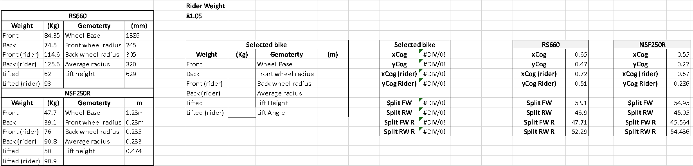
Figure 4 – CoG positions for NSF250R on Scaled graph Produced from MatLab
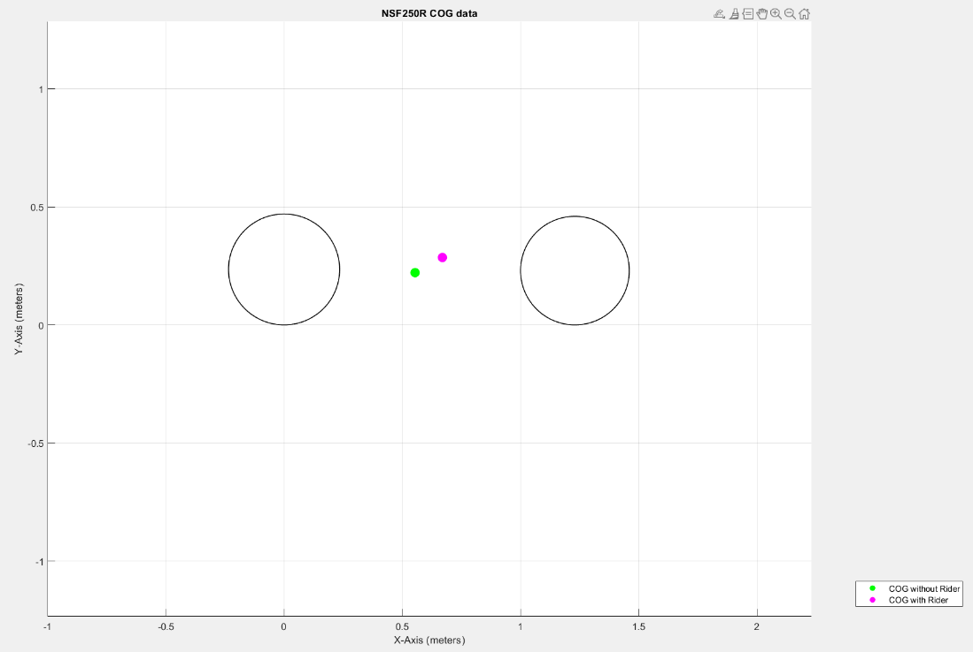
Figure 5 – CoG positions for RS660 on Scaled graph Produced from MatLab
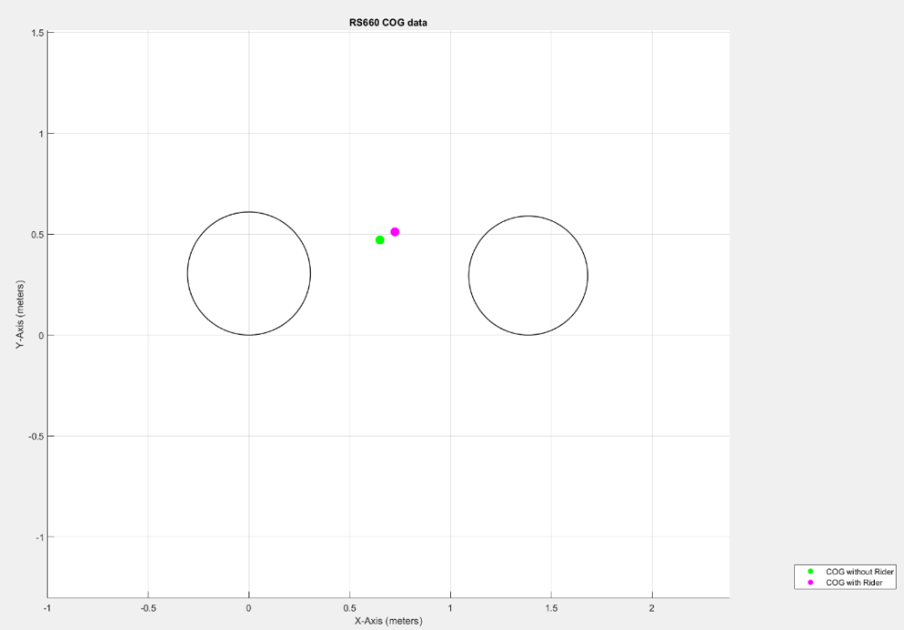

Task 2

Gearbox Calculator
Using the Workshop Manual for the Honda NSF250R, I was able to find the Gear ratios for each of the gears on both the input and output shafts.

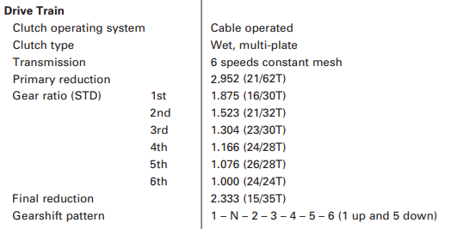
Figure 6 - (Honda, 2012, pg 2-1) NSF250R STD Gear Ratios

Using this information, we can work out the maximum speeds at a certain RPM and final ratio (front and rear sprockets, often changed from circuit to circuit in racing).
To work this out, we first need to find the tyre Diameter. This is done by taking the Width, Profile and Rim size of the rear tyre (found on the sidewall) and using this calculation:
$$Tyre DIA = \left(25.4 x RimDIA\right) + \left(\frac{Width x \operatorname{Pr}{o}file}{100}\right) x 2$$
This measurement will be in mm, Convert to M by / 1000.
We can confirm this is correct by using an online tyre calculator and comparing the results.

To then work out the speed in km/h, use this calculation:
$$Speed \left(kmh\right) = \frac{RPM x 60 x \left(\frac{input gear}{\text{output }Gear}\right) x \left(\frac{\operatorname{Pr}{i}mary in}{\operatorname{Pr}{i}mary Out}\right) x Wheel DIA x π}{1000} x \frac{Front Sprocket}{Rear Sprocket}$$

Figure 7 – Excel Spreadsheet of NSF250R Gearbox Calculator
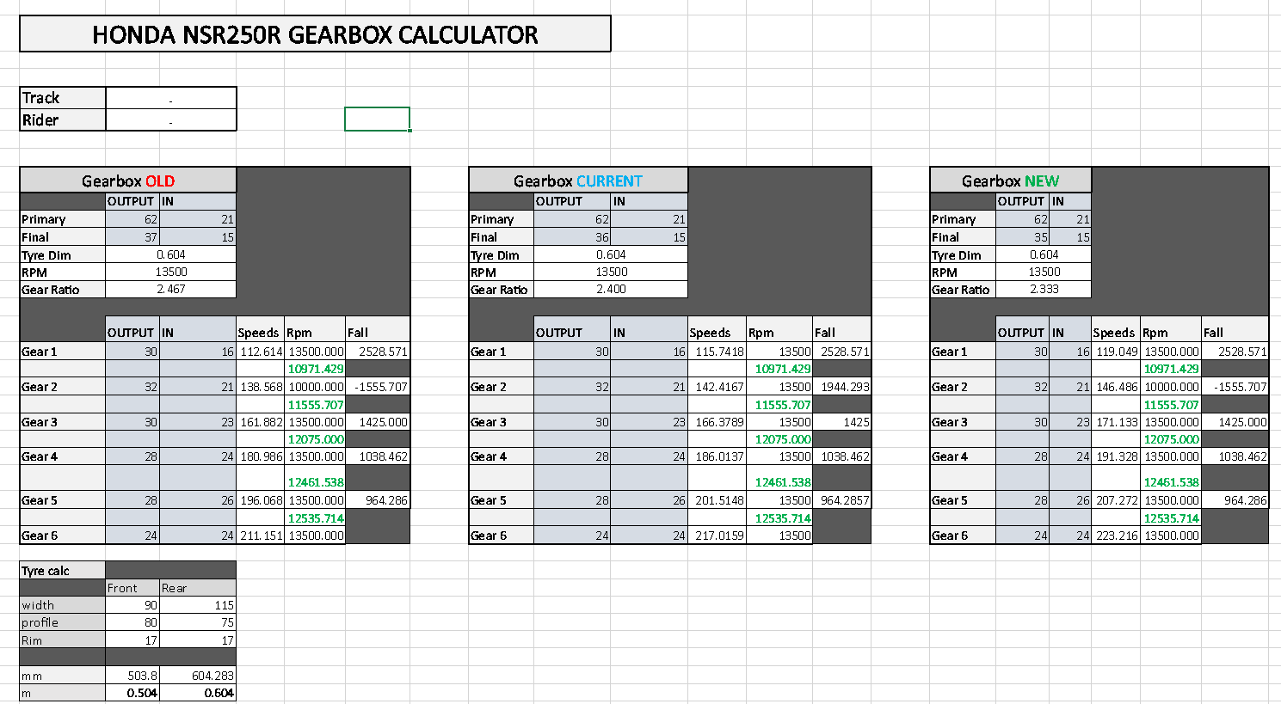
I have also calculated the new RPM once the gear has been changed (Value in green), For example, at 13.500RPM (BTC Max Rev limit) in 1st gear traveling at 99.2km/h (not including any forces acting on the bike), When changed to 2nd gear, the revs will drop 2528.5 revs to 10971 RPM.
Using the above method, I also made a Gearbox calculator for the RS660.

Figure 8 – RS660 Gearbox Calculator
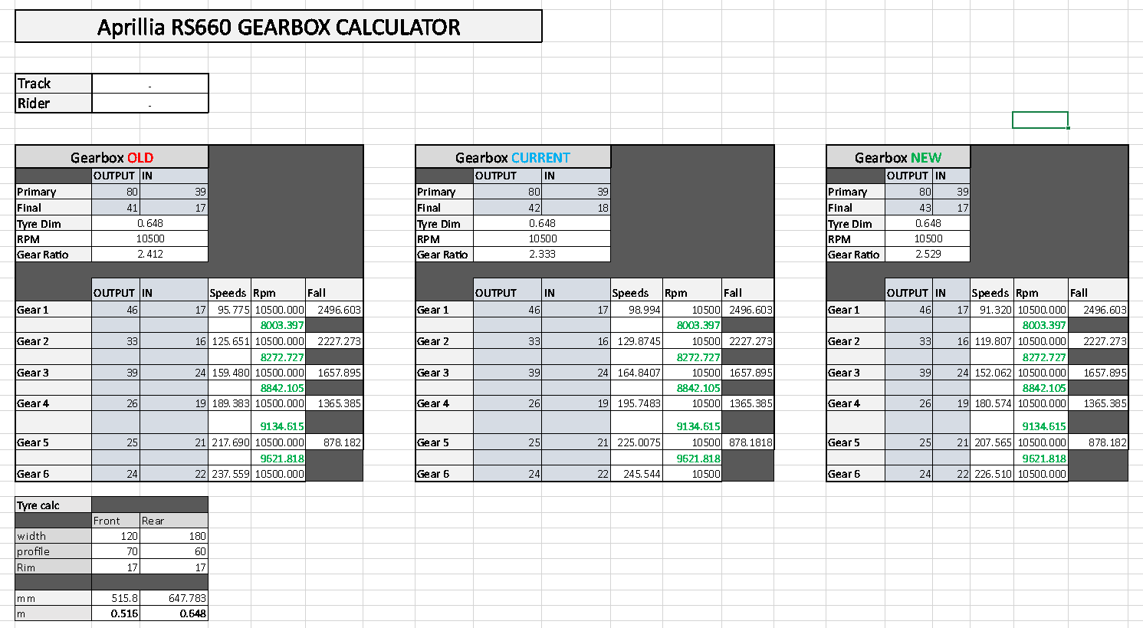
We will use the top speed of the far-right table to work out if the motorcycle has enough power to reach this speed, as this is the stock Final Ratio.

Forces Acting on a Motorcycle – Aero Drag
One of the forces acting on a motorbike when travelling is the Aero Drag force (Air Resistance).

To work out the Aero Drag Force at a given speed we need the following parameters,
$ρ$- Density of air (1.167kg/$m^{3}$ @ 20°C and 987 mbar
$C_{D}^{}$ - Drag Coefficient
A = Frontal Area
V = Velocity
We can then use these parameters in this equation.
$$F_{D }= \frac{1}{2} x ρ x C_{D} x A x V^{2}$$

(NASA, 2023) Drag coefficients are almost always determined experimentally using a wind tunnel.
As it is a complex process to work out the Drag Coefficient of an object, for this example I will use 0.7, as a standard motorbikes Drag Coefficient.

Frontal Area -
To work out the frontal area of the RS660, I took a photo with the bike and the rider from the front, scaled this appropriately in SolidWorks using the front tyre width, then drew round the bike/rider to get my area.

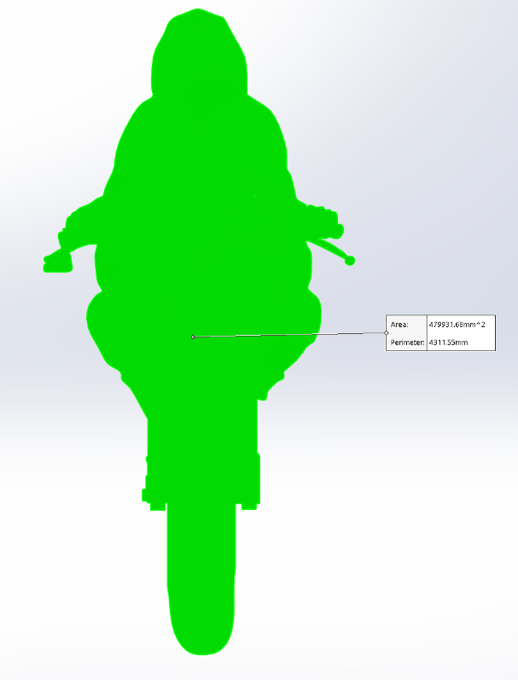
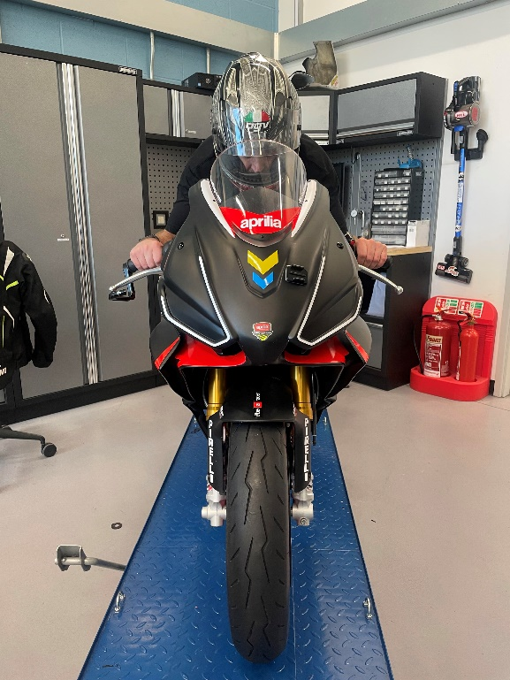
Figure 9 – Ian on Motorcycle for frontal area Figure 10 – SolidWorks drawing of Frontal Area

A = 0.45m/s

Our maximum velocity we are trying to reach (looking at figure 8) is 226.5km/h, so firstly we convert that into m/s.
$$V = 226.5 x \frac{1000}{3600}$$
V = 62.9 m/s
So, with these values put into the equation.
$F_{D }= \frac{1}{2} x 1.167 x 0.7 x 0.48 x {62.9}^{2}$
FD= 775.68N

Forces Acting on a Motorcycle – Rolling Drag

The rolling drag from the tyres can also impact the motorcycle.

To work out the Rolling Drag Force at a given speed we need the following parameters,
M = Total Mass
G = Gravity (9.81m/s2)

In the equation -
$$F_{w}= 0.02 x M x G$$

We already know the total mass of the bike and rider from when we measured the bike for the CoG data so in the equation it is.
$$F_{w}= 0.02 x 240 x 9.81$$
Fw = 47.09

Total Force
Total Force = Fd + Fw = 775.68 + 47.09 = 822.77N
Therefore, the total force acting on the motorcycle.

To work out the power required to get to this velocity:
$$Power = Force x Velocity$$
So, with our calculations,
$$Power = 822.77 x 62.9$$
$Power = 51752.23$w
$$Power = 52kw$$

Therefore, 52kw of power is required to reach 226.5 km/h.
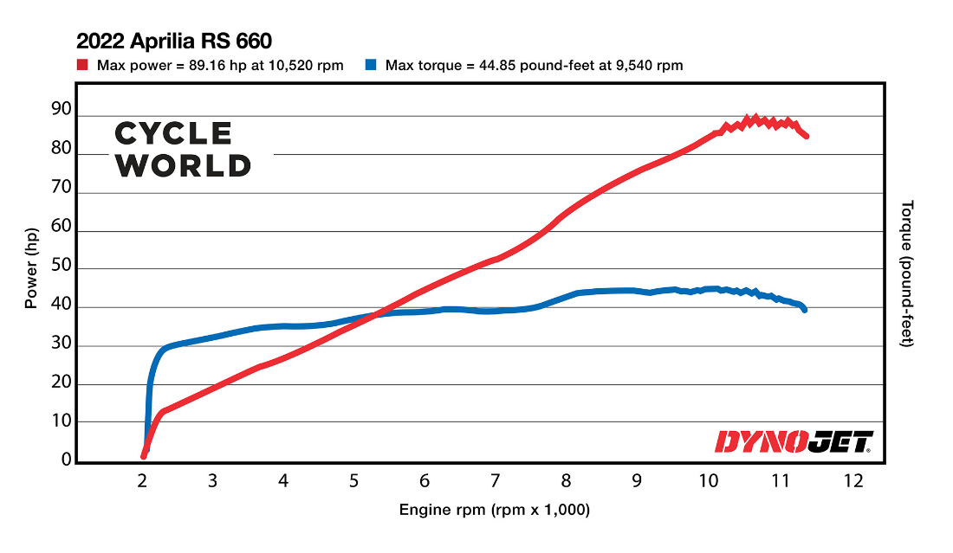
Figure 11 – Aprilia RS660 Dyno Sheet - www.cycleworld.com/story/bikes/aprilia-rs-660-dyno-test-2022/

This dyno sheet shows us that the max power output is 89.16hp at 10.520rpm.
86.16hp = 65.577 kw
With this information, we can confirm that the bike has enough power to reach the top speed comfortably, even with the forces acting on the motorcycle.

Task 3

Comparing Motorcycle Geometry
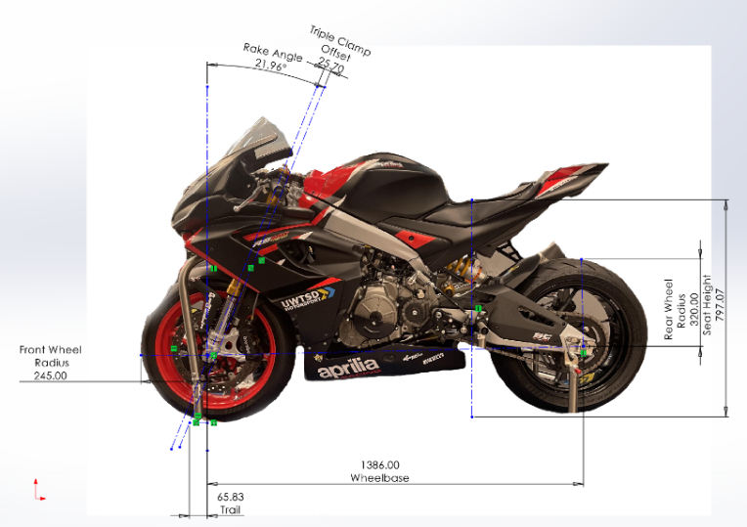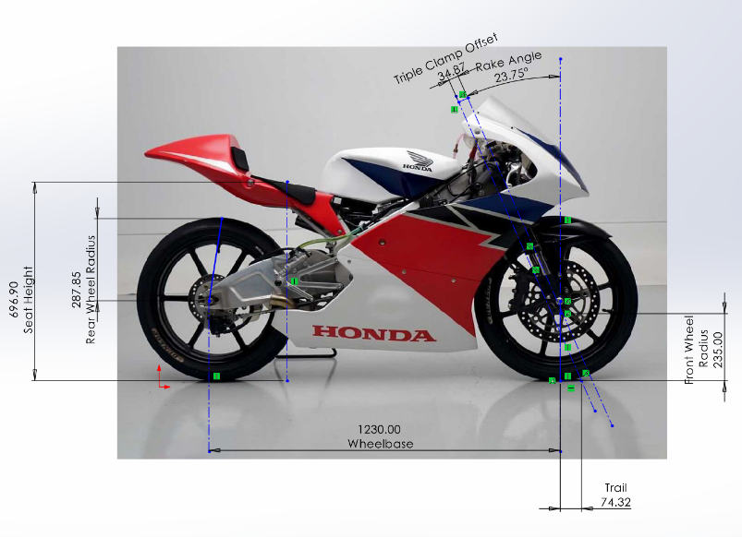
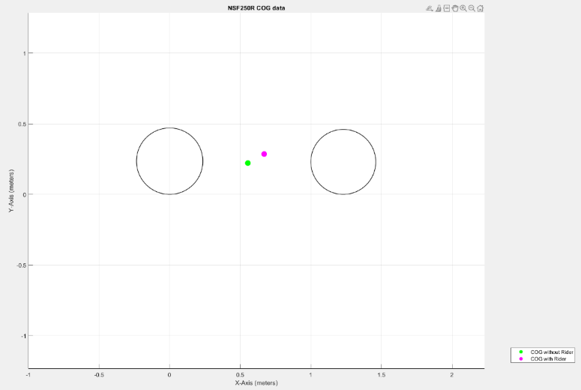
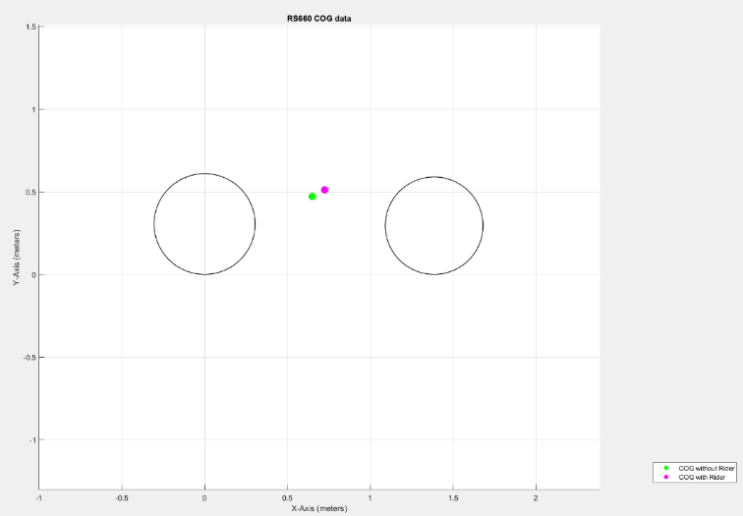
Firstly, let’s look at the Aprilia RS660.
What I found was that some variables have more than likely changed, such as ride height, fork position and suspension components, as it is being used as a track bike. You can see these differences if we compare it to data collected from the road factory spec Aprilia, which has a higher trail distance and a larger rake angle.
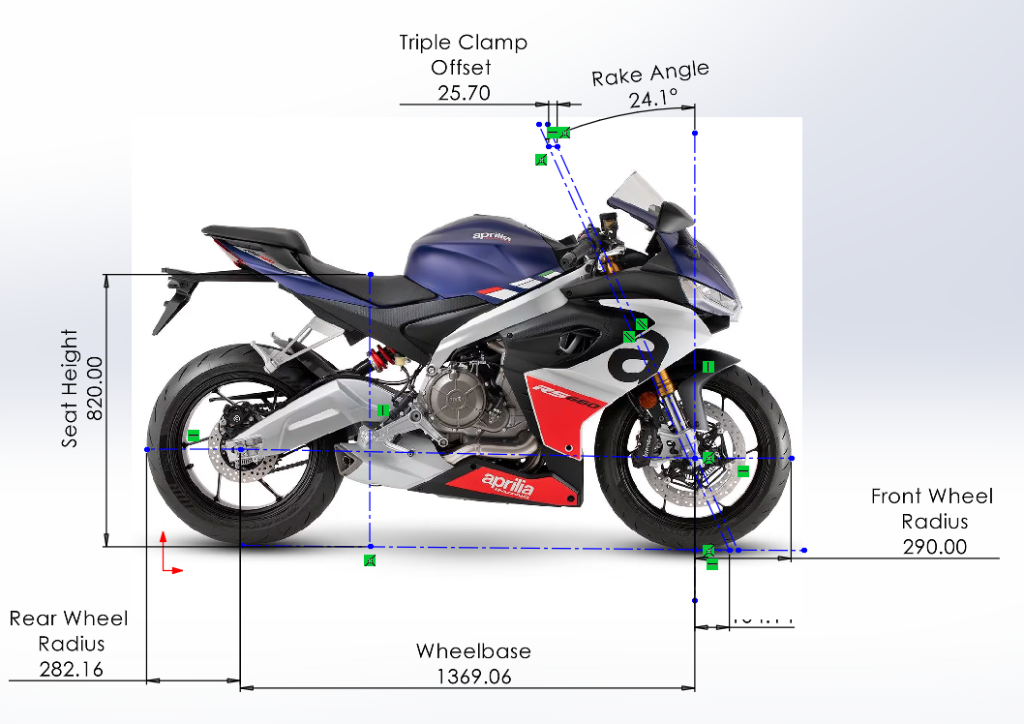

The change in Trail from 104mm to 65mm with the same triple clamp offset as the road version (as this is based on factory position, and not able to be changed on production motorbikes), has more than likely been changed by moving the forks higher in the triple clamp, and adjusting the rear ride height / rear shock. This change will make the bike turn in much more aggressively, and faster, requiring less force to turn the bike, although this can result in the bike feeling unstable when riding, especially at higher speeds.
The NSF also has a very aggressive trail at 74.32mm, this again allows the bike to turn in much easier, and with it being a smaller bike with less power, the instability effect from less trail will be less aggressive.
It is also important to note, that less trail on bikes that are being raced on can be lower as a steering damper is often used to dampen the effect of instability.

Although the NSF is a Prototype machine, there is no option to adjust the triple clamp offset on it, which could be useful for different situations.

Both Motorcycles wheelbases are similar, the Aprilia being the biggest due to the size of the bike being bigger, and to give more stability in a straight line.

The Centre of Gravity of the NSF sits lower than the RS660. This allows the Honda to easier to steer in and provides more stability in the corners and under braking. This suits the NSF as on the track, these bikes need to carry a lot of corner speed as they have less power and less torque to get out the corners. If the CoG was higher, then it would have less stability under braking and mid corner, meaning more speed would need to be scrubbed off, resulting in a slower mid corner speed.
The RS660 has a CoG a bit further back compared to the NSF, and a bit higher in position. The higher position enables more load transfer when accelerating and braking, and the CoG being further back will give the bike more rear grip but may cause more understeer as the load has been taken off the front wheel. The CoG position can be altered to move further forwards or back, by adjusting the rear swing arm, although, this may have a negative impact on the Anti-Squat.

Squat and Anti-Squat
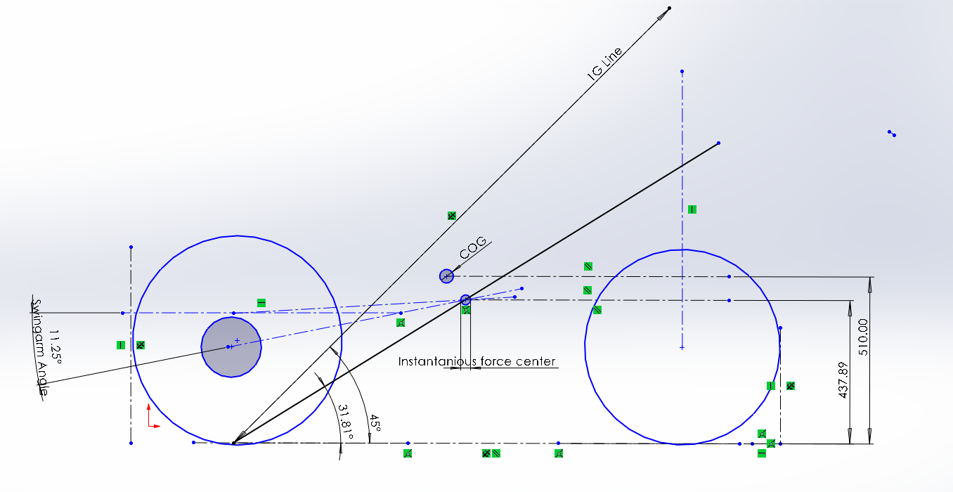

Figure 12 – Anti-squat Diagram RS660

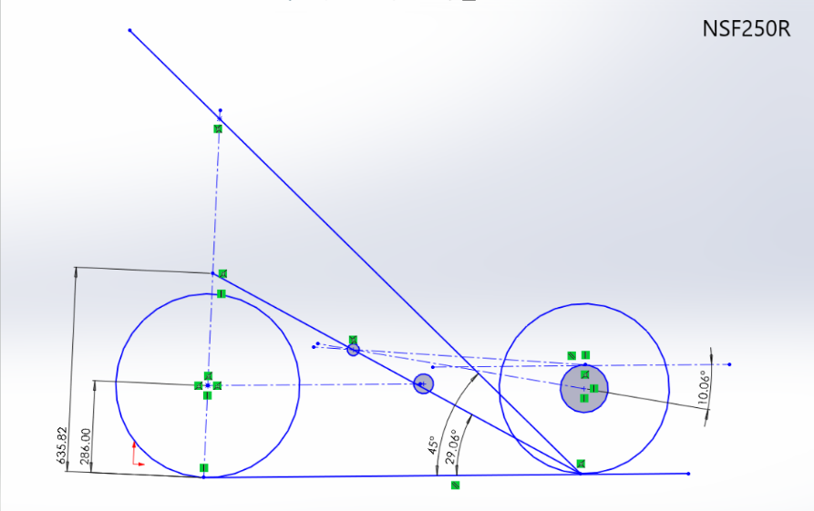

Figure 13 – Anti-Squat Diagram NSF250R

RS660 Anti Squat Percentage
$$AntiSquat\%=\frac{437.89}{510} x100=85.86\% (unloaded without rider)$$
437.89 = Anti Squat Height using the squat line, which travels from the motorcycles rear contact patch, through the Instantaneous Force Centre (the intersection of the chain line and the swingarm line)
510 = CoG Height

NSF250R Anti Squat Percentage
$$AntiSquat\%=\frac{635.82}{286} x100=222.67\% (unloaded without rider)$$

The RS660, has a Anti Squat Percentage of 86%, This means the forces extending the rear shock are higher than the forces trying to ‘squat’ or ‘drop’ the rear of the motorcycle, although the motorbike still drops slightly to help the rear tyre grip to the concrete when accelerating away. (0% anti squat means that the suspension is compressed with no force acting on the opposite way, and 100% anti squat means that there is no change to the suspension at all, and above 100% means that the suspension extends into its sag.
This however does not mean that the rear shock of the NSF is going to extend when the weight is then transferred onto the rear end of the motorcycle.
As these measurements and drawings are from an unloaded motorcycle, when weight is put on the bike from the rider, the suspension will squat as it takes the load, and the measurements used (swingarm angle etc) will also change, so instead this value will decrease when the bike is loaded.

As the NSF has a higher anti squat percentage, this means that the bike will squat less when coming out of the corners, which suits the style of riding of the NSF with its higher corner speed. The negative effect of this is that you will have less rear grip as a result.
The RS660 has more squat coming out of the corners, which puts more load on the rear tyre. This allows the tyre to have more grip, which is needed for the more powerful bikes. Although too little Anti-Squat can result in too much grip leading to excessive tyre wear.
It is important to also note that the rear shock on the Aprilia has been changed from standard, and therefore the swingarm angle has more than likely changed from factory, which will adjust your anti-squat.
None of these bikes have any way of adjusting the Swingarm pivot point, which is an easy way to set anti Squat on some prototype motorbikes, so instead a way to adjust the Anti-Squat is to change the front and rear sprockets, which effects the chain line, which effects the Anti Squat.

Task 4

Ducati Desmosedici GP19
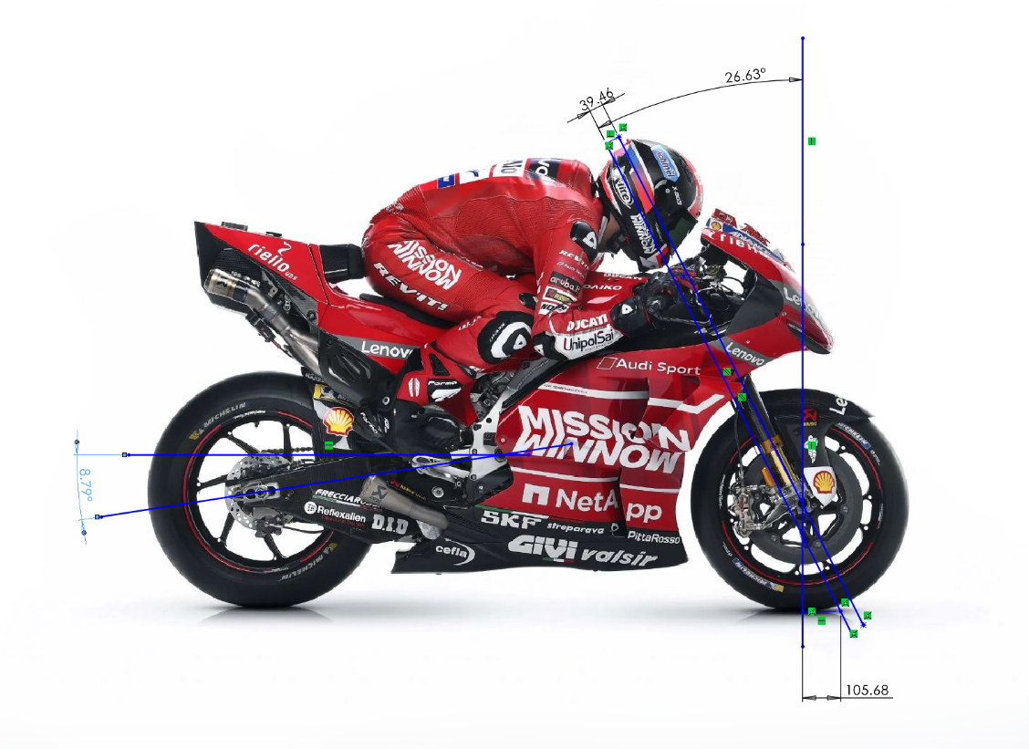
Figure 14 – Image of a Ducati 2019 MotoGP bike edited in SolidWorks to show geometry data.

Trail -
The Trail of a MotoGP is extremely important to get right, as too little trail can lead to instability, which will have an even greater effect on these machines with the power and torque that they produce.
At this state, the trail on this Ducati Is 105mm, which is aggressive enough to still help the bike turn in easily but will stay stable enough when at high speeds with help from the steering damper. The trail on these bikes can be adjusted much easier than a production-based motorbike, with different inserts that can be used to change the position of the steering head and changing the Triple clamp offset position.

Wheelbase -
Wheelbase is another characteristic of this bike that can be changed rather easily. If we look closely at the image, we can see that the rear wheel position can be changed easily, and they will also have different positions that the swingarm pivot point can sit which changes the swingarm length and makes the bikes wheelbase shorter.

Swingarm Angle -
Looking at the swingarm angle on a modern MotoGP machine, you will see many changes to this position throughout a race or a session.
Technology is developing rapidly, and new squat / anti squat devices are coming into effect.
This is where the bike squats down, and a linkage system holds the suspension in place using a pin or something of a similar nature, this allows the centre of gravity of the bike to become lower which means the rider can get on the accelerator harder and have less wheelie effect. The bikes geometry sitting heavier on the rear wheel also helps the tyre grip out of the corners and gain good traction to get the best possible exit.

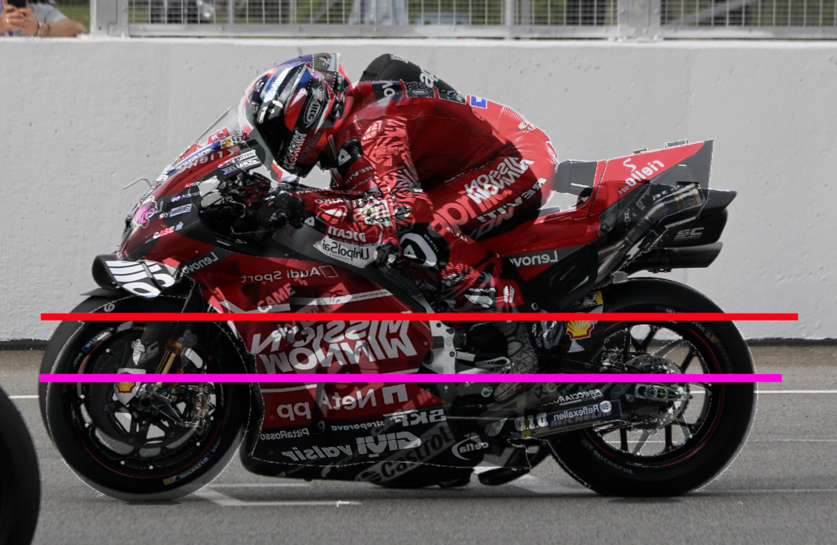
Figure 15 – Figure 14 overlayed on an Aprilia RS-GP
In the above figure you can see the difference in ride height between the Desmosedici, and the Aprilia RS-GP. The Aprilia sits a lot lower as the ride height device has been enabled, and although not to scale, the above lines on the image give a representation on the YCoG of both machines (Red line being the Ducati)

Suzuki GSX1400 Dragster
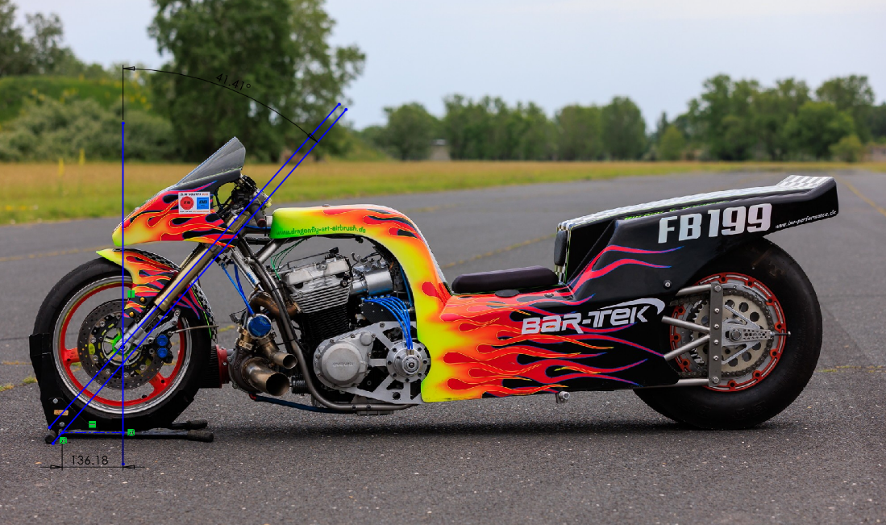
Figure 16 – Suzuki GSX1400 Dragster
By just looking at this Suzuki Drag Bike, you can immediately tell that this bike was designed for a completely different purpose to the Ducati above.
Trail-
The Rake and trail angles on this bike are extremely high, with a rake angle of 41.4°, and a trail distance of 136.1mm.
This will give the bike maximum stability, which is exactly what is needed for a drag bike, as it is a straight-line strip with no corners, so all cornering ability will be sacrificed to make the ride as stable as possible.
Wheelbase-
An obvious design point to mention on this bike is the extended swinging arm. This massively increases the wheelbase which again will make the bike less agile but gain much more stability for its intended purpose.
Key Points-
There are some key points that I have seen when looking at this bike and the way that it has been designed.
Firstly, let’s look at the weight distribution between the front and rear wheels. Although we have no data of weight, we can see that all the weight is shifted to the front of the bike, including the engine components and the exhaust. This will put much more load onto the front wheel, making it harder to wheelie the bike, which will give better acceleration.
The second key point I could see is the Direction of the chain pull. Unlike the other motorbikes we have looked at, the chain pull is going in a downward direction. This force is increasing the anti-squat and trying to extend the rear shock when riding. This again means that more weight stays on the front and the wheelie effect is minimalised. If this was the case on the bikes above, rear grip will be lost and the bike wouldn’t be fit for the intended purpose, although on the drag bike this is combated by the rear tyre. As you can see the rear tyre is much wider than the average motorcycle tyre, with a lot less profile. This is because the bike will not need to lean, so it can use as much tyre on the contact patch to gain traction.

Task 5
Taking the Honda NSF250R and the Aprilia RS660 that we measured earlier, I would suggest a few changes that could be made to the motorcycles to help with the intended handling characteristics.

Firstly on both bikes, I think a change to the triple clamps with adjustable fork offset could help the bikes excel at certain tracks, For example, at Thruxton, with the nature of the fast sweeping corners a larger trail would help keep the bike more stable, although at a track such as Cadwell park, you want the bike to turn in much more aggressively, and the track isn’t as fast as the likes as Truxton, therefore you could sacrifice some stability at higher speeds to allow the bike to turn in more aggressively and quicker.

If the RS660 was being used as a road bike, a suspension change would be necessary. I would suggest lifting the forks up through the triple clamps and extending the rear shock. This would increase the trail and give a more stable ride, sacrificing the ability for it to turn in as fast, which isn’t necessary for road riding.

I also think a simple change to the NSF which is achievable will be to add weight onto different sections of the motorcycle. This could be handy for riders of different weights, an example being multiple bikes in a team scenario. By adding weight to different parts of the bike allows the CoG to change, which can affect the steering and stability of the motorcycle.

Reference list

Beeler, J. (2019). Ducati Desmosedici GP19 MotoGP Race Bike Debuts. [online] Asphalt & Rubber. Available at: https://www.asphaltandrubber.com/motogp/ducati-desmosedici-gp19 [Accessed 16 Dec. 2023].
Benson, T. (2020). The Drag Equation. [online] Nasa.gov. Available at: https://www.grc.nasa.gov/WWW/k-12/VirtualAero/BottleRocket/airplane/drageq.html.
Chitulescu, D. (2023). Suzuki GSX1400 Dragster Took Thousands of Hours of Work for Seven Seconds of Pure Bliss. [online] auto evolution. Available at: https://www.autoevolution.com/news/suzuki-gsx1400-dragster-took-thousands-of-hours-of-work-for-seven-seconds-of-pure-bliss-218130.html [Accessed 16 Dec. 2023].
Crash. (2022). PICTURES: 2022 MotoGP holeshot devices - how low can you go? [online] Available at: https://www.crash.net/motogp/feature/996963/1/pictures-2022-motogp-holeshot-devices-how-low-can-you-go [Accessed 16 Dec. 2023].
Cycle World. (n.d.). How Much Power Does the 2022 Aprilia RS 660 Make? [online] Available at: https://www.cycleworld.com/story/bikes/aprilia-rs-660-dyno-test-2022 [Accessed 13 Dec. 2023].
Data For Motorcycles. (n.d.). Anti-Squat Geometry -. [online] Available at: https://www.datamc.org/data-acquisition/suspension-data-analysis/anti-squat-geometry/ [Accessed 16 Dec. 2023].
MotoGP (2013). MotoGPTM Workshop: Swingarms explained. [online] www.youtube.com. Available at: https://www.youtube.com/watch?v=fT4hX_co0uw [Accessed 16 Dec. 2023].
Roberts, D. (2020). Enginerding: What Is Anti-Squat & How Does It Actually Affect Mountain Bike Performance? [online] Pinkbike. Available at: https://www.pinkbike.com/news/definitions-what-is-anti-squat.html.
Vittore Cossalter (2010). Motorcycle dynamics. Lexington, Ky: Lulu.
www.motorcyclenews.com. (n.d.). Honda unveils new NSF250R Moto3 bike. [online] Available at: https://www.motorcyclenews.com/sport/motogp/2011/june/jun0211-honda-unveils-new-moto3-bike/ [Accessed 12 Dec. 2023].
Honda Racing Corp. (2012) NSF250R Owner’s Manual
Aprilia. (2023) RS660 Owner’s Manual

