Level four- Plant operations and Performance Assignment 1

Intro
“The Health and Safety at Work Act 1974 is the primary piece of legislation covering occupational health and safety in Great Britain”- HSE (2017). Health and safety are one of the most important aspects in every workplace, furthermore it can be assessed on anything you see. This report will explore the installation of compressed air in my workplace (FSG Tool and Die). It will consist of where it has been installed, showing this through a pipe and instrumentation diagram. Aspects such as health and safety, environment, provision of utilities, economics and resources are going to be considered throughout.

Main body
1.1
Compressed air may be stored differently to other energy sources as it is a gas. A website states, “Compressed air is kept under a pressure that is greater than atmospheric pressure.”, Compressed air systems (2017). This suggests that compressed air can be very dangerous, therefore containing it in such a matter is necessary in order for it to be used safely. It may be important to isolate containers keeping compressed air just in case any liquids come into contact with the immense pressure, resulting in catastrophic accidents.
Compressed air has a vast amount of usage in the engineering industry. “Compressed air is commonly accepted as a manufacturing facility’s fourth utility.”, Humphreys (2012). This implies that looking into compressed air could potentially reveal several opportunities for reducing a plant’s energy draw due to it being used so much in industry. It also suggests that it is used as much as water, electricity, and natural gas by calling it a “Utility”. As a result, many aspects may be tweaked to maximise energy saving.
Due to a complicated process, compressed air may require multiple machines to allow it to be generated. The article states “Compressed air is more expensive than the three other utilities.”, Compressed air (2020), Bawanyair Products Limited. This infers that even though it is used a lot in industry, compressed air is very costly, however this does not mean that it cannot be reduced. With the correct tweaks I believe that energy saving could be maximised.

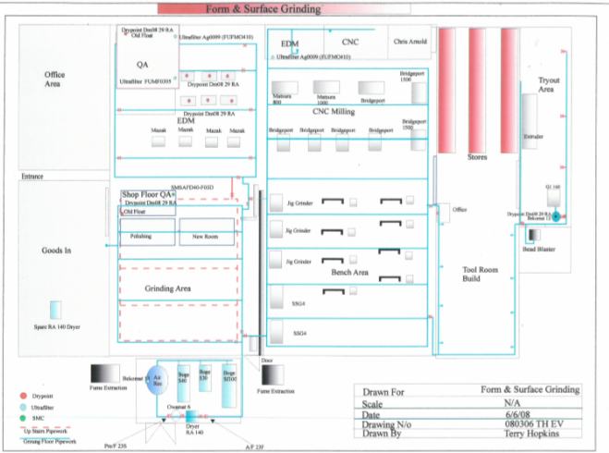
1.2
One way in which the air compressors could be looked into is by looking over the process as a whole. This may be done through any diagrams such as a Pipe and Instrumentation diagram (P and ID). This type of illustration shows all of the pipes in a plant, also what is flowing through each one.
They are used extensively in most industries “To show a graphical display of a complete system”, Freeman J. (2020). This implies that it can be used to show the piping system in a map of a workplace by using lines and symbols for representation of pipes and objects. I did not use a ‘pictorial’ diagram to show the piping system due to the fact that even though it would be simple, it would also have been too impractical. This is because I would not have been able to show much information, whereas a ‘P and ID’ diagram uses symbols and numerative data to give a lot more detail. An example of this could be ‘FIC 123’. This could mean ‘Flow Indicator Controller’, along with a temperature, volume of substance, etc.
The key states that the pipework on the ground floor is in blue. All of the pipes come from one place, which is the room comprised of the machines used to generate compressed air. This tells me that compressed air is used a lot in my workplace due to the fact that the pipes lead to every section. The majority of air in my workplace is used to clean workpieces. An example of this would be to blow out swarf stuck inside of a hole due to it not being able to be accessed appropriately.

1.3
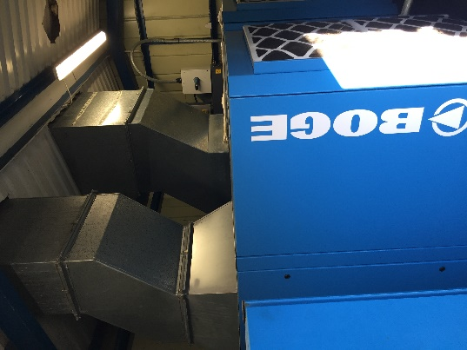
There are a number of steps that are required to create compressed air. The first step involves using a machine called a ‘screw turbine’. This uses the same principle as a ‘water wheel’ in which the potential energy is extracted through water moving on an upstream level. My workplace has three screw turbines present on site, BOGE SF 100-2, BOGE SLF 75-3 and BOGE S40-2. One is constantly running while the two smaller models are kept for spare just in case the first one powers down. They are stored in a dry place, with only team leaders and anyone above granted access.

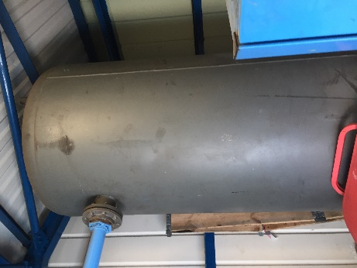
Once the energy has been generated, it moves via pipes to a moulding tank where it is stored and heated up to reduce the humidity. In my workplace there is one moulding tank which is kept next to the screw turbines. Just like the other machinery, it is essential that it is kept in a dry place. It may even be more important in some places to isolate the moulding tank to minimise the risk of any other outside liquids joining.

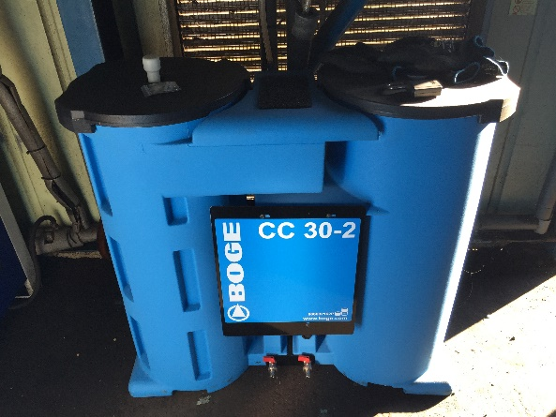
Next, the compressed air in my workplace is used in air guns to clear workpieces, work surfaces and in CNC machinery. In order for it to be used to an appropriate standard, it needs to be clean. Another pipe leads the energy into a filtration system, where any further condensation created through the previous process is cleaned out. My workplace only has one filter known as ‘BOGE CC 30-2’, furthermore this is because despite the fact that compressed air is used constantly throughout all working hours, not much is needed to supply the air guns.
Finally, the air is distributed through the pipes shown on the P and ID diagram to each workstation.
I have found that leakage occurs in my workplace at any point in the just mentioned process. The result of this is the air constantly flowing out, with energy being wasted. An outcome of this is a waste of energy, which could potentially make compressed air even more costly in my workplace.

1.4
As with all equipment used in the engineering industry, health and safety is a mandatory aspect to be discussed. PPE is always essential when working with compressed air. The following are important to be worn when working with compressed air:
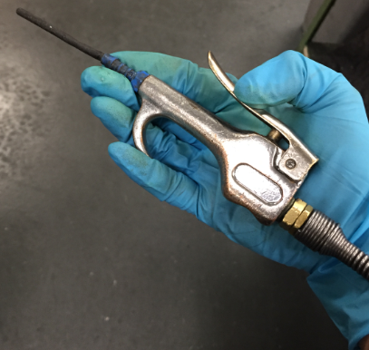
- Overalls (workwear), safety boots
- Safety glasses to protect eyes
- Gloves to protect hands
- Potentially lab coat to cover arms
It is vital that any cuts are concealed properly before working with compressed air due to the fact that if it were to accidently get shot inside of one, it could cause severe internal damage.
In any workplace, the PSI needs to be controlled. The HSE website states “As a guide 30psi/2.1 bar is effective at cleaning”. If the psi is too high, this could be dangerous because the force of either the compressed air or the excess materials flying through the air could potentially come into contact with other people within the work area.
To stay safe whilst using compressed air, there are rules in which need to be complied by. The article states “Every employer shall ensure that each of his employees who works in compressed air is under adequate medical surveillance”, Medical surveillance (1996). This implies that reconnaissance may be necessary when handling compressed air as it may be dangerous to the user.
In my workplace, this is not necessary as the amount used is always low, furthermore there are always first aiders on sight if any accidents were to happen. The only place where the PSI may be high is during a CNC operation. In this scenario, the doors will be shut to prevent it coming into contact with the operator.

Conclusion
To conclude, I have found the following:
- Compressed air is vastly used in the engineering industry, as it is considered as a utility.
- Compressed air is used in my workplace to clean machines, clean workpieces and also to keep specific cutters cool during CNC operations.
- As it is being generated, the machinery needs to be isolated from any moisture and oils.
- Compressed air in my workplace is wasted through direct leaks.
- Compressed air is quite costly.
- Compressed air can also be dangerous if not handled appropriately.

Overall, I believe that the health and safety of compressed air in my workplace is up to standard as I have not seen any compressed air related injuries for as long as I have been working in this plant.
I think that the leakage rate may be improved. A way my workplace could reduce the number of direct leaks is through suitable maintenance of the machines used in the process. Checking the air guns may also be appropriate as if they are loose on the pipes, the air will leak out.

Reference list
- Edraw Max, 2020. How to read piping and instrumentation diagram. https://www.edrawsoft.com/pid/read-piping-and-instrumentation-diagram.html. 06/03/2020.

- Engineering – frequently asked questions (1974). Health and Safety Executive. Retrieved 01/05/2020.
https://www.hse.gov.uk/engineering/faqs.htm

- Health and safety at work etc act 1974 (1974). Health and safety Executive. Retrieved 01/05/2020.
https://www.hse.gov.uk/legislation/hswa.htm

- How to read piping and instrumentation diagram. (2020). Freeman J. Retrieved 01/05/2020.
https://www.edrawsoft.com/pid/read-piping-and-instrumentation-diagram.html

- The work in compressed air regulations 1996. (1996). Legislation.Gov.UK. Retrieved 01/05/2020.
http://www.legislation.gov.uk/uksi/1996/1656/regulation/10/made

