

Student Name: Md Mohaiminul Islam Bappy
Student ID: 2431568
Module Name: Strategic Management
Title: An integrated Analysis of Starbuck’s in the UK market and the reflective practices.
Module Code: LCMB7003

Lecturer’s Name: Dr Hoang Nguyen

Submission Date: 01st May 2026

AI Use Acknowledgement
I confirm that AI‑assisted tools were used transparently and ethically in preparing this report. All AI outputs were critically reviewed, adapted, and integrated into my own analysis. No AI‑generated text was submitted as my own work without substantial modification.

Tools and example prompt used:

Consensus – to locate peer‑reviewed papers for example: “Find studies on the effectiveness of Lewin’s change model in retail hospitality”.

Quill Bot & Grammarly – for paraphrasing, grammar correction, and maintaining formal academic tone.

ChatGPT – to structure VRIO and Balanced Scorecard tables for example: “Help me design a VRIO analysis table for Starbucks’ resources and capabilities” and to refine the Gibbs Reflective Cycle structure.

I retain full responsibility for all strategic judgements, conclusions, and any errors.

Contents
1. Introduction 4
2. Organisational Context and Overview 4
2.1 History and Business Model 4
2.2 Industry and Market Positioning 4
Perceptual Map (Market Positioning): 5
3. External and Internal Environment Analysis 5
3.1 Why pestle used to impact the organizations strategic decision? 6
Political Factors 6
Economic Factors 6
Social and Cultural Factors 7
Technological Factors 8
Environmental Factors 8
Legal Factors 9
3.2 Strategic Challenges and Critical Success Factors (CSFs) 9
3.4 Internal Environment: Resources, Capabilities, and Core Competencies 11
3.5 VRIO Analysis for Strategic Capabilities 12
4. Corporate Social Responsibility (CSR) Strategy 13
5. Comprehensive and Holistic View (Balanced Scorecard) 13
6. Strategic Choices and Implementation 15
6.1 Business-Level Strategic Choice: Differentiation 15
6.2 Corporate-Level Strategic Choice: International Expansion 16
6.3 How the Two Strategic Choices Work Together 16
6.4 Critical Assessment of Change Management 17
7. Strategic Evaluation and Recommendations using Ansoff Matrix 18
7.1 Evaluate Starbucks UK’s Current Strategy using Ansoff Matrix 19
7.2 Recommendations for Starbucks UK (using Ansoff Matrix) 20
7.3 Final Conclusion on Strategic Evaluation 21
Section 2: Reflective Account (Gibbs' Reflective Cycle) 21
1. Description 22
2. Feelings 23
3. Evaluation 23
4. Analysis 23
5. Conclusion 24
6. Action Plan 24
Conclusion 25
References 26

1. Introduction
Starbucks Corporation, a global coffeehouse chain, is operated within a highly competitive and volatile UK market. A critical analysis of Starbucks’ strategic management practices within the United Kingdom is provided in this report. The alignment of the organisation’s internal capabilities with external environmental factors to achieve sustainable competitive advantage is evaluated (Barney et.al, 2019). Starbucks’ external and internal environments are analysed using PESTEL and VRIO frameworks. Its CSR strategy is assessed, and a holistic view is achieved through the utilisation of the Balanced Scorecard (Silva, A et.al,2025). Strategic choices, focusing on differentiation and international expansion, are evaluated. Finally, strategic recommendations are provided and are supported by relevant theory. In section two, a reflective account is presented using Gibbs’ Reflective Cycle (Gibbs, G., 1988).

2. Organisational Context and Overview

2.1 History and Business Model
Starbucks was founded in 1971 in Seattle and has since become a globally recognised brand. The UK market was entered in 1998, where operations have been conducted through a mixed model of company-operated and licensed stores. The mission, “to inspire and nurture the human spirit – one person, one cup and one neighborhood at a time” (Starbucks, 2025a), has been adopted as a guiding principle. The business model has been centered on premium product quality, the “Third Place” experience—defined as a welcoming environment between home and work—and convenience, which has been enhanced through digital integration, including mobile ordering and delivery services.

2.2 Industry and Market Positioning
Starbucks is positioned within the UK Out-of-Home (OOH) coffee market, where competition is encountered from branded chains such as Costa Coffee and Caffè Nero, as well as fast-food retailers including McDonald's McCafé and independent artisanal cafés. Despite prevailing economic pressures, resilience has been demonstrated by Starbucks, with a 22% increase in sales being reported in 2023, reaching £547.7 million.

Perceptual Map (Market Positioning):
A perceptual map is used to illustrate Starbucks’ strategic position relative to its competitors, based on two key dimensions: Quality/Experience (ranging from high to low) and Price/Convenience (ranging from high to low).
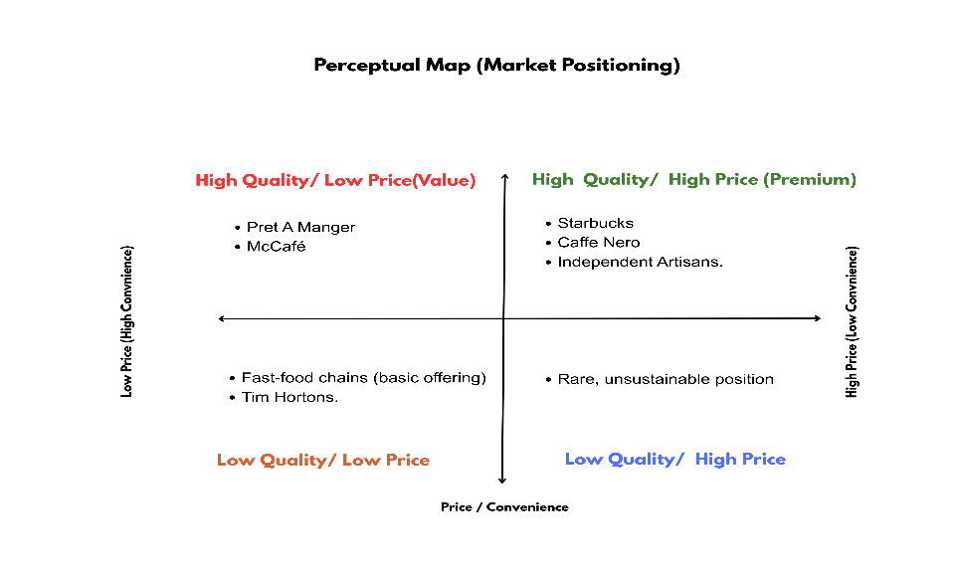

Fig: 01 Starbucks’ strategic position
Starbucks is positioned in the premium quadrant, where competition is based on customer experience and brand equity rather than cost leadership. However, strategic pressure is exerted by competitors such as Pret, which offers quality at value, and McDonald's, which emphasises convenience at low cost. In response, recent strategies, including the “Back to Starbucks” plan, have been implemented to reinforce the premium positioning. This has been achieved through enhancements in store environments and the adoption of digital innovation.

3. External and Internal Environment Analysis
External environment analysis is performed to identify macro-environmental factors that lie outside an organisation’s control but may influence its strategic decisions (Johnson, Scholes, & Whittington, 2020). Internal environment analysis is conducted to assess an organisation’s internal resources, capabilities, and core competencies (Barney & Hesterly, 2019). By using frameworks such as PESTEL and VRIO, the relationship between external opportunities or threats and internal strengths or weaknesses can be systematically evaluated, thereby enabling the identification of sustainable competitive advantage (Rothaermel, 2021).

3.1 Why pestle used to impact the organizations strategic decision?
PESTEL analysis is employed as a strategic diagnostic tool to systematically evaluate macro-environmental forces that are beyond an organisation’s direct control yet are exerted significant influence on strategic choices. Political, Economic, Social, Technological, Environmental, and Legal factors are examined so that emerging opportunities and potential threats can be identified before full materialisation occurs. As a result, strategic decisions are proactively adjusted rather than being reactively managed. In the context of Starbucks UK, PESTEL is considered a practical instrument through which strategy is shaped.

Political Factors
Post-Brexit trade agreements have been associated with increased administrative burdens and labour shortages within the UK hospitality sector (Barney et al., 2019). Higher import costs for coffee beans and difficulties in recruiting EU nationals as baristas and store managers have consequently been experienced by Starbucks. Supply chain disruptions and staffing shortages have therefore been intensified (Starbucks, 2025). This political environment has been regarded as a significant threat because operational costs have been increased, while greater investment in domestic recruitment and training programmers has been required, thereby reducing overall organisational profitability (Starbucks, 2025).

Economic Factors
Persistent inflation and the ongoing cost-of-living crisis within the UK have significantly reduced consumers’ disposable income. Although Starbucks operates within the premium coffee segment, cheaper alternatives such as McDonald’s McCafé and home-prepared instant coffee have increasingly been preferred by customers. Consequently, sales volumes and brand loyalty have been negatively affected. This economic environment has therefore been recognised as a major threat, requiring defensive strategies such as enhanced loyalty rewards and value-oriented promotional campaigns to be implemented to retain customers and sustain competitive performance (Barney et al., 2019; Starbucks, 2025).

Social and Cultural Factors
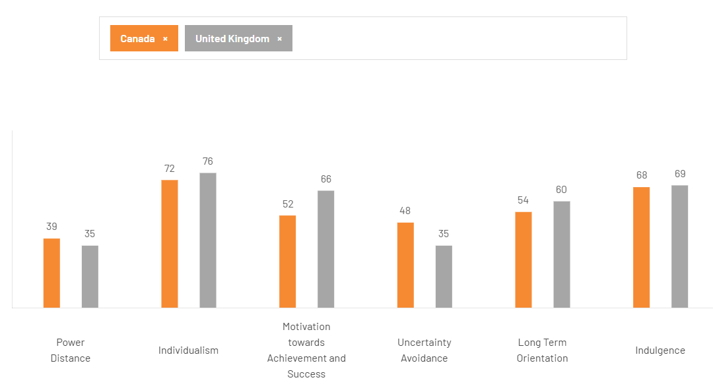
According to Geert Hofstede’s Cultural Dimensions, high levels of Individualism and Uncertainty Avoidance have been identified within the UK, where personal choice, convenience, and product customisation are highly valued by consumers (Hofstede, 2011). Simultaneously, rising health consciousness has increased demand for plant-based and low-sugar alternatives (Hofstede, 2011). Opportunities can therefore be created for Starbucks by expanding oat milk, almond milk, and sugar-free syrup offerings, as well as promoting mobile ordering services. As a result, differentiation can be strengthened and health-conscious, time-pressured customers can be more effectively attracted (Starbucks, 2025).

Fig: 02 Cultural dimensions’ difference between UK & Canada
For example, notable cultural differences between Canada and the United Kingdom have been identified. Power Distance has been scored at 39 in Canada and 35 in the UK, while Individualism has been rated highly in both countries at 72 and 76 respectively. Motivation towards Achievement and Success has been measured at 52 in Canada and 66 in the UK. Uncertainty Avoidance has been recorded at 48 for Canada and 35 for the UK, whereas Long-Term Orientation has been scored at 54 and 60. Indulgence has been measured at 68 in Canada and 69 in the UK. These findings indicate that personal choice, achievement, and flexibility are strongly valued within the UK market, thereby supporting Starbucks’ emphasis on customisation, convenience, and premium customer experience (Hofstede, 2011).

Technological Factors
The rapid expansion of AI-driven personalisation and third-party delivery platforms such as Deliveroo and Uber Eats has significantly transformed the UK coffee market. Substantial investment has already been made by Starbucks in its mobile application, through which ordering, payments, and the Stars loyalty programme have been integrated (Starbucks, 2025). By analysing customer purchasing behaviour through AI technologies, personalised offers and recommendations can be delivered, thereby increasing transaction value (Silva et al., 2025). Consequently, stronger customer relationships and higher repeat visits can be achieved, allowing competitive advantage over less digitally developed rivals to be strengthened (Silva et al., 2025).

Environmental Factors
The UK government’s commitment to achieving net-zero emissions has been strongly promoted, while increasing pressure has been exerted by consumers on brands to reduce single-use plastic waste (HM Government, 2021; Statista, 2024). In response, a compostable cup has been introduced by Starbucks in 2025, and a 25p discount has been offered to customers who bring reusable cups (Starbucks, 2025). Although upfront investment is required, alignment has been achieved with evolving regulatory expectations and changing customer values. Consequently, the environmental factor is viewed as an opportunity through which brand reputation can be strengthened, potential plastic taxes can be avoided, and environmentally conscious consumers willing to pay premium prices can be attracted (Kotler et al., 2021).

Legal Factors
Recent legal changes in the United Kingdom have included the extension of the Soft Drinks Industry Levy to certain milk-based beverages and the strengthening of employment regulations related to zero-hour contracts and the National Living Wage (Department for Business and Trade, 2024). For Starbucks, the production costs of sweetened beverages such as Frappuccino’s and flavored lattes have been increased, and staffing policies are required to be regularly reviewed to ensure compliance with fair employment standards. These legal pressures have resulted in higher operational costs and greater administrative complexity, and they are therefore considered a threat through which profit margins may be reduced unless menu reformulation and human resource adjustments are implemented efficiently (CIPD, 2024).

3.2 Strategic Challenges and Critical Success Factors (CSFs)
Strategic Challenges: Obstacles that obstruct an organisation from achieving its strategic objectives are defined as strategic challenges, as barriers to performance and goal attainment are encountered during strategy implementation (Johnson, Scholes, & Whittington, 2020).
Intense competition from established chains and fast-food retailers: Strong competition in the UK coffee market is faced by Starbucks from major chains such as Costa Coffee, Caffè Nero, Pret A Manger, and McDonald’s McCafé, where similar products are offered at different price levels (Porter, 2008). Continuous investment in differentiation is therefore required to prevent market share from being reduced.
Economic volatility and reduced consumer spending: Lower disposable incomes in the United Kingdom have been experienced due to persistent inflation and the cost-of-living crisis, leading to reduced spending on premium products (Office for National Statistics, 2024). Sales volume is consequently threatened, and value-oriented promotions are required to maintain customer demand (Kotler et al., 2022).
High barista turnover and labour retention: High employee turnover in the hospitality sector has been widely reported, resulting in increased recruitment and training costs and disruptions to service quality (CIPD, 2024). Service consistency and long-term competitiveness are therefore negatively affected when staff retention is not effectively managed (Lashley, 2018).
Critical Success Factors: Key areas in which high performance must be achieved by an organisation for rivals to be outcompeted and organisational objectives to be fulfilled are referred to as Critical Success Factors, as these factors are considered essential for long-term competitive success (Rothaermel, 2021).
Premium brand experience (“Third Place”): A welcoming and comfortable environment between home and work is delivered by Starbucks as a key differentiator, through which customer loyalty is retained despite premium pricing (Oldenburg, 1999; Kotler et al., 2022). Sustainable competitiveness would be weakened if this experience were not consistently maintained.
Digital integration (mobile app, loyalty, delivery): An integrated digital ecosystem, including mobile ordering, payment, and loyalty rewards, is utilised by Starbucks to encourage repeat purchases and enhance customer engagement (Starbucks, 2023; Chaffey & Ellis-Chadwick, 2022). Higher transaction value and stronger customer relationships are therefore supported through digital convenience.
Menu innovation (health-focused, plant-based, seasonal): Continuous menu innovation, including plant-based and healthier product options, is implemented to respond to changing consumer preferences and health awareness (Mintel, 2024). Brand relevance and customer attraction are consequently sustained in a competitive and evolving market environment.

3.4 Internal Environment: Resources, Capabilities, and Core Competencies
Internal environment factors are defined as the tangible assets (physical and financial resources), intangible assets (brand reputation, organisational culture, and intellectual property), and organisational capabilities (skills and processes) through which resources are effectively deployed (Johnson, Scholes, & Whittington, 2020). Core competencies are described as unique organisational strengths through which customer value is created and competitive advantage is sustained, as these capabilities are difficult for competitors to imitate (Rothaermel, 2021). The below table presents key organisational resources, capabilities, and core competencies in a structured format. Tangible resources are represented by strategically located stores in high-footfall areas, while intangible resources are reflected through strong brand equity and association with premium coffee culture (Barney, 1991). Capabilities are demonstrated via an integrated digital ecosystem and efficient supply chain management. Core competencies are highlighted through the consistent delivery of a “third place” experience and the ability to customise products at scale. Overall, a resource-based perspective is applied to illustrate how competitive advantage is developed and sustained (Grant, 2016).
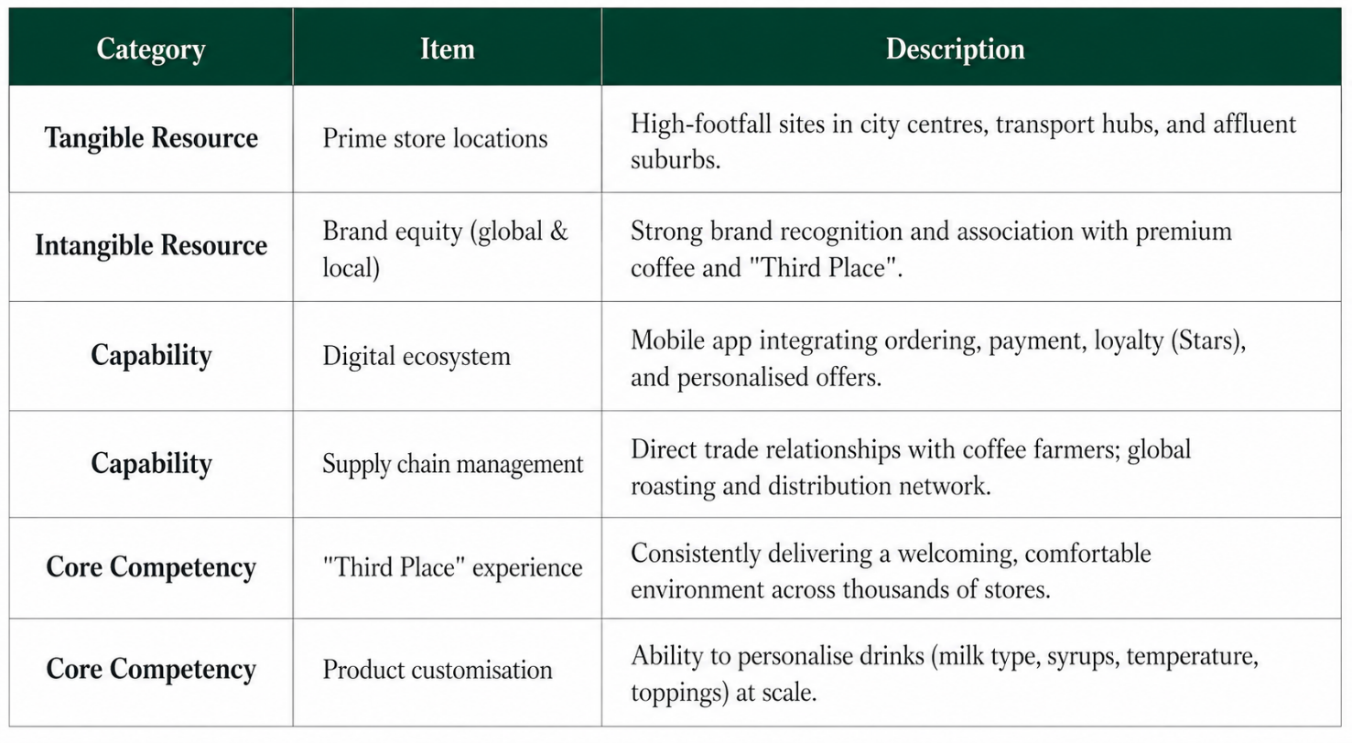

Fig: 03 Internal Resources, Capabilities, and Core Competencies of Starbucks

3.5 VRIO Analysis for Strategic Capabilities
The VRIO framework is defined as a strategic tool used to evaluate an organisation’s internal resources and capabilities based on four criteria: value, rarity, inimitability, and organisation. It is applied in this report to assess whether Starbucks’ resources can generate and sustain competitive advantage within the UK market. By systematically analysing these dimensions, key strengths are identified and strategic gaps are highlighted. As a result, informed decisions are supported, and alignment between internal capabilities and external competitive pressures is effectively achieved (Barney, 1991; Rothaermel, 2021).
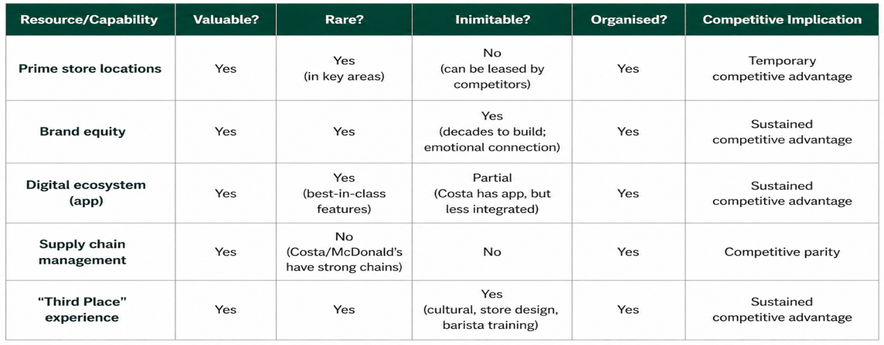
The VRIO framework is applied in the table to evaluate whether Starbucks’ key resources and capabilities can generate sustained competitive advantage. It is demonstrated that most resources are valuable and organised, enabling the firm to effectively exploit opportunities and neutralise threats (Barney et al., 2019). However, only selected capabilities—such as brand equity, the digital ecosystem, and the “Third Place” experience—are identified as rare and difficult to imitate, thereby leading to sustained competitive advantage. In contrast, resources like supply chain management are not considered rare or inimitable, resulting in competitive parity, while prime store locations provide only temporary advantage due to ease of replication. Overall, competitive advantage is shown to depend on the uniqueness and organisational alignment of internal capabilities (Rothaermel, 2021).

Fig: 04 VRIO Framework for Starbucks UK
Internal strengths are defined as attributes that provide an organisation with a competitive advantage, as identified through VRIO analysis (Barney, 1991). In the case of Starbucks UK, sustained competitive advantage is derived from the combination of strong brand equity, the differentiated “Third Place” experience, and an advanced digital ecosystem. Premium pricing and customer loyalty are supported by brand equity, while differentiation is achieved through in-store experience, and switching costs are created via digital integration. These strengths are interdependently reinforced, forming a virtuous cycle that is difficult for competitors to imitate (Rothaermel, 2021).

4. Corporate Social Responsibility (CSR) Strategy
Corporate Social Responsibility (CSR) is defined as a self-regulating business model through which social accountability to stakeholders and the public is ensured, while sustainability is understood as meeting present needs without compromising future generations. In this report, Starbucks UK’s CSR strategy is framed around the “Starbucks Commitment,” where ethical sourcing, environmental stewardship, and community engagement are prioritised. Alignment with business objectives is observed through risk reduction, enhanced customer loyalty, and improved employee engagement. However, limitations are identified, as low reusable cup adoption and infrastructure constraints for compostable cups indicate that implementation remains partial despite strong strategic intent (Deloitte, 2024).

5. Comprehensive and Holistic View (Balanced Scorecard)
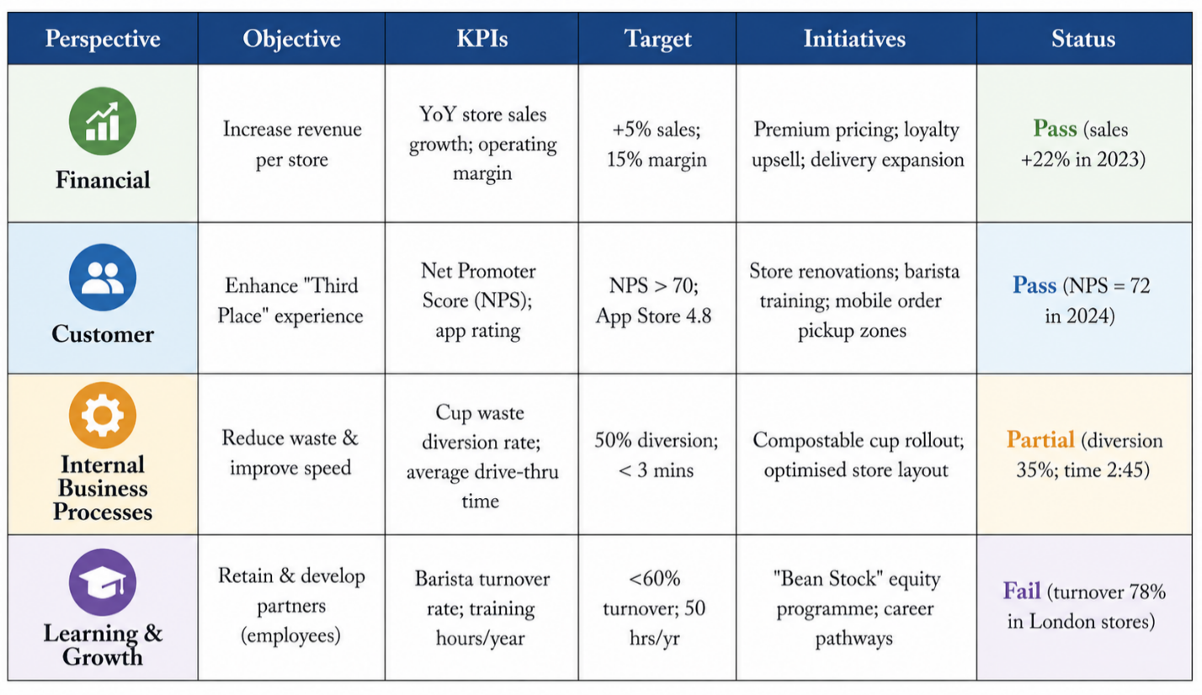
The Balanced Scorecard (BSC) is defined as a strategic performance management tool through which an organisation’s mission and strategy are translated into measurable objectives across four perspectives—financial, customer, internal processes, and learning and growth—thereby providing a comprehensive view beyond purely financial metrics (Kaplan & Norton, 1996). In this report, the BSC is applied so that a holistic evaluation of Starbucks UK’s strategic performance can be achieved, where both financial and non-financial dimensions are systematically assessed and aligned with long-term objectives. Through its application, sub-optimisation is avoided, as excessive focus on a single performance area, such as cost reduction at the expense of customer experience, is prevented. Furthermore, organisational strategy is effectively cascaded into daily operational activities, ensuring alignment between strategic goals and employee actions. As a result, Starbucks UK’s strategic initiatives, including customer experience enhancement, digital integration, and sustainability, are consistently monitored and balanced, thereby supporting informed decision-making and the achievement of sustainable competitive advantage (Kaplan & Norton, 1996).

Fig: 05 Balance Scorecard for Starbucks UK
Within the Balanced Scorecard, strong financial performance is indicated by a 22% increase in sales to £547.7 million in 2023; however, this “Pass” is considered incomplete, as profit margins are not reported and rising costs, including wages and coffee prices, may have eroded profitability, suggesting that a margin-based target (e.g., 12%) would provide a more accurate assessment (Kaplan & Norton, 1996). From a customer perspective, an NPS of 72 and high app ratings indicate strong satisfaction, yet the aggregation of dine-in and delivery experiences obscures potential service inconsistencies in third-party delivery channels. In internal processes, performance is uneven, as drive-thru efficiency exceeds targets while sustainability goals, such as cup waste reduction, fall significantly short, rendering the “Partial” classification somewhat misleading. Furthermore, within learning and growth, high barista turnover (78%) represents a critical failure, as service quality and experience consistency are undermined, while substantial replacement costs may indirectly weaken financial performance. Overall, interdependencies across perspectives suggest that the reported “Pass” outcomes may be overstated when evaluated holistically (Kaplan & Norton, 1996).

6. Strategic Choices and Implementation
Strategic choice is defined as the process through which alternative courses of action are evaluated and selected, thereby determining how an organisation competes at the business level and where it competes at the corporate level (Johnson, Scholes, & Whittington, 2020). It is positioned as a critical link between strategic analysis and strategic implementation, as insights derived from the evaluation of the external environment and internal capabilities are translated into actionable decisions. Through effective strategic choice, alignment is achieved between external opportunities and internal strengths, while potential threats are avoided and organisational weaknesses are mitigated. Consequently, organisational performance and long-term competitive advantage are enhanced, as strategic decisions are guided by both environmental conditions and resource-based capabilities (Johnson et al., 2020; Barney, 1991).

6.1 Business-Level Strategic Choice: Differentiation
Differentiation is defined as the provision of unique products or services that are perceived as superior by customers, allowing premium prices to be charged instead of competing through low-cost strategies (Porter, 1985). Within the UK coffee market, a differentiation strategy has been adopted by Starbucks because cost leadership has been viewed as impractical due to strong price competition from McDonald's McCafé, where lower pricing could weaken Starbucks’ premium brand image. A niche focus strategy has also been considered too limited for the scale required in the UK market. Differentiation has therefore been selected because premium pricing has already been accepted by loyal customers (Porter, 1985). This strategy has been supported through ethically sourced Arabica beans, the “Third Place” store experience, extensive drink customisation, and digital convenience via the Starbucks mobile application. Consequently, a price premium has been sustained because value has been associated with customer experience as well as product quality (Johnson et al., 2020).

6.2 Corporate-Level Strategic Choice: International Expansion
International expansion is defined as a growth strategy through which new geographic markets outside a firm’s existing regions are entered (Johnson et al., 2020). For Starbucks, which operates in over 80 countries, expansion has been directed towards underpenetrated rather than saturated markets. From a UK strategic viewpoint, expansion into Southeast Europe, including Serbia and Bulgaria, has been recommended because the UK coffee market has become mature, growth has slowed, competition has intensified, and operational costs have increased. As a result, sustained long-term growth within the UK alone has been considered difficult (Statista, 2025).
Alternative strategies have been evaluated but rejected. Horizontal integration, such as acquiring competitors like Costa Coffee, has been viewed as problematic due to regulatory barriers and potential brand dilution. Vertical integration through coffee farm ownership has already been partially implemented and is not considered a primary growth driver. Diversification into unrelated sectors has been rejected due to risks of brand confusion, while further UK market penetration has been avoided due to saturation and cannibalisation. Therefore, international expansion has been selected for its higher growth potential, transferable UK capabilities, and reduced market risk exposure in emerging European economies (Porter, 1985).

6.3 How the Two Strategic Choices Work Together
The business level and international expansion at the corporate level is understood as mutually reinforcing rather than conflicting. A strong differentiation advantage in the UK, reflected through brand equity, customer experience, and digital integration, is leveraged as a strategic asset when international markets are entered (Porter, 1985). Without such differentiation, expansion would be reduced to the sale of commodity coffee, which could be easily replicated by local competitors. Furthermore, international expansion is facilitated through economies of scale in supply chain operations and marketing activities, by which ongoing investments in differentiation, such as sustainability initiatives and employee training, are supported. In turn, premium margins generated through differentiation are used to fund and justify expansion strategies. Conversely, expansion enables fixed costs, including brand development and innovation, to be distributed across a larger number of outlets, thereby reducing the per-unit cost of maintaining a differentiated position (Johnson et al., 2020).

6.4 Critical Assessment of Change Management
Unfreezing
Unfreezing is defined as the stage in which existing mindsets, behaviours, and processes are broken down in order to create readiness for change. A sense of urgency is created, the limitations of current practices are communicated, and resistance to change is reduced (Lewin, 1947). In the case of Starbucks UK, unfreezing was initiated when it was acknowledged by leadership that mobile order overload had undermined the “Third Place” experience. Employees were informed that excessive emphasis on speed metrics had weakened customer connection. By openly admitting the issue and presenting performance data, such as declining Net Promoter Score (NPS), the previous belief that faster service is always better was effectively challenged (Kotter, 1996).
Change
Change is described as the stage in which new processes, behaviours, and structures are introduced and implemented. During this phase, unfamiliar ways of working are required to be adopted, often resulting in discomfort. For Starbucks UK, changes were implemented through the removal of extra charges for non-dairy milk, the reintroduction of ceramic mugs for dine-in customers, and the retraining of baristas to prioritise customer connection over speed targets. Store layouts were also redesigned to separate mobile collection from counter service. Leadership support was provided through coaching, recognition of incremental progress, and tolerance of mistakes as adaptation occurred (Lewin, 1947).

Refreezing
Refreezing is identified as the stage in which newly adopted behaviours are stabilised and embedded as standard organisational practice. Changes are reinforced through updated policies, performance metrics, reward systems, and cultural alignment (Lewin, 1947). At Starbucks UK, this stage has been reflected in the revision of key performance indicators, where greater emphasis is placed on Net Promoter Score (NPS) rather than transaction speed. Managerial bonus structures have been aligned with customer connection metrics, training materials have been updated, and successful practices have been shared across stores. Through these mechanisms, a return to previous behaviours is prevented, and the “Third Place” experience is sustained over the long term (Burnes, 2020).

7. Strategic Evaluation and Recommendations using Ansoff Matrix
Strategic evaluation is defined as the systematic process through which the effectiveness of organisational strategies is assessed against objectives, environmental alignment, and implementation outcomes (Johnson et al., 2020). Analytical tools such as SWOT, PESTEL, and the Ansoff Matrix are utilised to evaluate performance and guide future direction. The Ansoff Matrix is specifically used in this report to identify growth options by linking products and markets, thereby supporting strategic decision-making regarding market penetration, development, and diversification opportunities for Starbucks UK (Ansoff, 1957).

7.1 Evaluate Starbucks UK’s Current Strategy using Ansoff Matrix
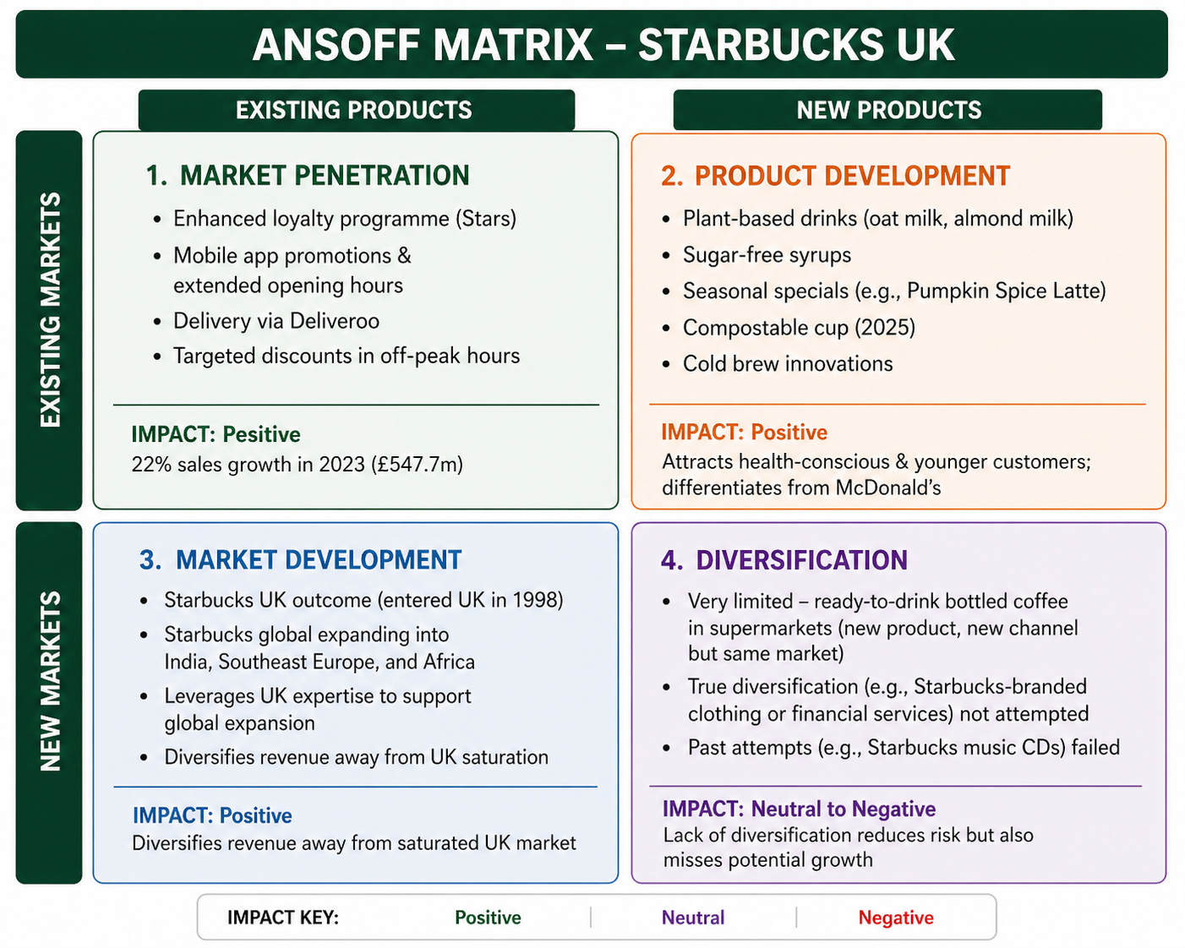

Fig: 06 Ansoff Matrix framework for Starbucks UK
The Ansoff Matrix is utilised to provide a structured overview of how Starbucks UK’s growth is pursued through four strategic directions (Ansoff, 1957). Market penetration is primarily achieved through loyalty programmes, mobile application promotions, and targeted discounts, by which customer retention has been strengthened and sales growth has been supported. However, the risk of weakening the brand’s premium positioning may be increased if excessive reliance on discounts is maintained (Johnson et al., 2020).
Product development is focused on innovation within the existing UK market, where plant-based drinks, seasonal offerings, and sustainability initiatives, such as compostable cups, have been introduced. Through these actions, differentiation is enhanced and health-conscious consumers are attracted, although operational complexity and costs are increased (Kotler et al., 2022).
Market development is driven through global expansion, where UK expertise is leveraged to enter new regions, thereby reducing dependence on the saturated domestic market and diversifying revenue streams (Johnson et al., 2020).
Diversification remains limited, as only minor initiatives have been implemented. While risk exposure is reduced, potential growth opportunities are also constrained. Overall, emphasis is placed on market strengthening and innovation, supported by selective expansion (Ansoff, 1957).

7.2 Recommendations for Starbucks UK (using Ansoff Matrix)
Based on the evaluation, three recommendations have been made – prioritising Product Development and Market Development, while cautiously exploring related diversification.
Recommendation 1: Accelerate Product Development – “Beyond the Cup”
Product development should be accelerated through the introduction of non-coffee premium beverages and high-margin food items, alongside a subscription model such as “Starbucks Pass.” This approach is supported by Ansoff Matrix, where lower risk is associated with serving existing customers, and by Michael Porter’s differentiation strategy. Evidence from Costa Coffee and Pret a Manger shows increased customer frequency and higher food attachment rates through subscription models (Ansoff, 1957; Porter, 1985).
Recommendation 2: Pursue Market Development – “UK Model Abroad”
Market development should be pursued through expansion into underpenetrated European markets using franchise or joint-venture models, supported by UK expertise. This strategy is justified by the Ansoff Matrix, where dependence on saturated markets is reduced. Core competencies, including the “Third Place” concept and digital capabilities, are considered transferable. Successful implementation has been demonstrated by Starbucks in India through partnership with Tata Group, and by Costa Coffee in international markets (Johnson et al., 2020).
Recommendation 3: Cautious Related Diversification – “Starbucks at Home Ecosystem”
Related diversification should be cautiously implemented through the development of home brewing equipment and subscription-based coffee services. This approach is aligned with leveraging existing brand equity and supply chain capabilities, thereby reducing risk compared to unrelated diversification. The success of Nespresso and Blue Bottle Coffee demonstrates the viability of extending into home consumption markets. It is therefore suggested that similar strategies be adopted to strengthen long-term growth and customer engagement (Ansoff, 1957).

7.3 Final Conclusion on Strategic Evaluation
Starbucks UK’s current strategy is considered safe but short-sighted, as strong market penetration and product innovation are achieved while longer-term opportunities in market development and related diversification are under emphasized. By adopting recommendations based on the Ansoff Matrix, a shift from a defensive to an analytical strategic posture can be enabled, where core strengths are maintained alongside exploration of new opportunities. Without such adaptation, vulnerability to emerging competitors and evolving consumer preferences is likely to be increased (Ansoff, 1957).

Section 2: Reflective Account (Gibbs' Reflective Cycle)
Gibbs’ Reflective Cycle is employed to critically reflect on the process of conducting the strategic management analysis of Starbucks UK. A structured understanding of the experience is facilitated through description, feelings, evaluation, analysis, conclusion, and action planning. Through this reflection, learning is consolidated and areas for future development are identified.

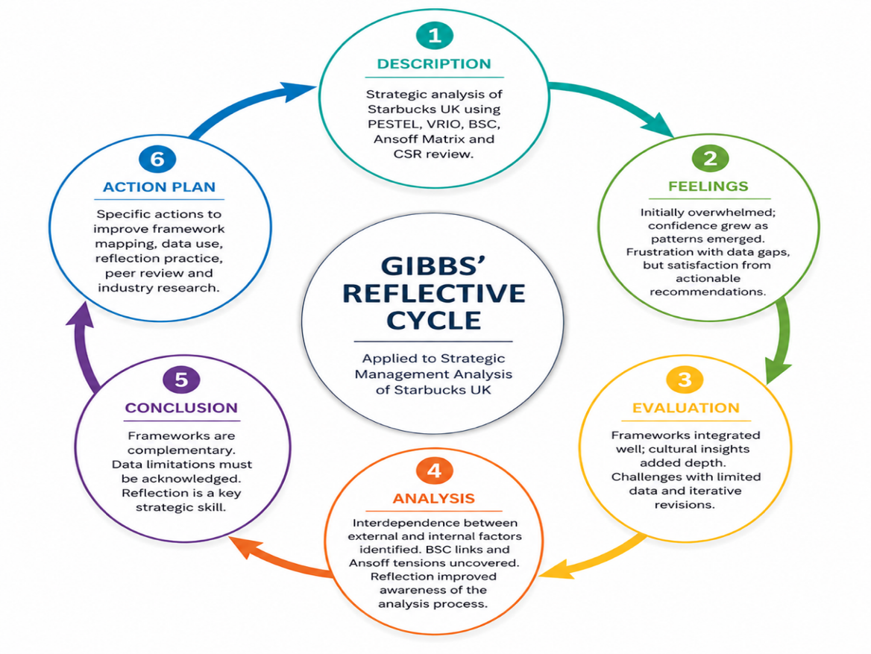

Fig: 07 Gibbs reflective cycle analysis for Starbucks UK

1. Description
A comprehensive strategic analysis of Starbucks UK was undertaken, in which multiple analytical frameworks were applied. External environmental factors were examined through PESTEL, while internal resources and capabilities were evaluated using the VRIO framework (Barney et al., 2019). A holistic performance assessment was conducted through the Balanced Scorecard, and growth strategies were explored using the Ansoff Matrix. Corporate Social Responsibility initiatives were also reviewed. Evidence-based recommendations were subsequently formulated. The entire analytical process was then structured using Gibbs’ Reflective Cycle, through which the experience was systematically captured and evaluated, enabling reflection on both the outcomes achieved and the methods employed (Gibbs, 1988).

2. Feelings
At the outset, a sense of being overwhelmed was experienced due to the breadth of strategic frameworks and the complexity of selecting the most relevant tools. As the analysis progressed, greater confidence was gradually developed, particularly as recurring strategic patterns were identified (Kaplan & Norton, 1996). However, frustration was encountered during the evaluation of the Balanced Scorecard, where inconsistencies between sustainability goals and actual performance were observed. The process of maintaining objectivity while recognising organisational efforts was found to be intellectually demanding. Despite these challenges, satisfaction was ultimately derived from the formulation of practical and innovative strategic recommendations (Gibbs, 1988).

3. Evaluation
The integration of multiple strategic frameworks into a coherent and logically structured analysis was successfully achieved. The combined application of VRIO and perceptual mapping was found to be particularly effective in demonstrating sustained competitive advantage. Additionally, cultural insights were strengthened through the application of Hofstede’s dimensions (Hofstede, 2011). However, limitations were encountered due to restricted access to detailed financial data, which constrained the completeness of the Balanced Scorecard evaluation. The iterative nature of the analysis also resulted in increased time demands. A significant learning point was identified, as strategic frameworks were understood to function as interpretive tools rather than rigid analytical checklists (Barney, 1991).

4. Analysis
It was recognised that a strong interdependence exists between external and internal analyses, where macro-environmental pressures directly influence organisational capabilities. For instance, economic conditions were observed to affect Starbucks’ premium positioning, thereby testing the strength of its brand equity. Furthermore, the Balanced Scorecard revealed that performance outcomes across different perspectives are closely interconnected. The Ansoff Matrix analysis also highlighted a strategic imbalance, where low-risk strategies were prioritised over long-term growth opportunities (Ansoff, 1957). The application of Gibbs’ Reflective Cycle enabled deeper insight into the analytical process itself, as attention was directed not only towards findings but also towards how knowledge was constructed (Gibbs, 1988).

5. Conclusion
It was concluded that strategic frameworks are most effective when they are applied in combination rather than isolation, as greater analytical clarity was achieved through their integration (Gibbs, 1988). The importance of acknowledging data limitations was also recognised, as incomplete information may influence the validity of conclusions. Additionally, the need to consistently address the strategic implications of findings was identified as essential for meaningful analysis. Reflection was understood to be a critical skill that enhances both academic and professional performance. Through this process, valuable insights were generated regarding the application of theory to practice and the development of structured analytical thinking (Johnson et al., 2020).

6. Action Plan
Based on this reflective analysis, several structured actions will be undertaken in future strategic management activities in academia and professional practice. Before analysis, a framework mapping matrix will be developed to ensure logical alignment and reduce iterative rework. A data limitation log will be maintained throughout the research phase to transparently record missing or estimated data, thereby preventing overstatement of conclusions. Structured reflection using Gibbs’ Cycle will be routinely applied to smaller tasks to build consistency and depth of learning (Gibbs, 1988). Additionally, peer review will be incorporated at the draft stage to ensure that analytical insights are critically evaluated and that strategic implications are clearly articulated. Engagement with primary industry sources, such as Mintel and professional insights, will also be prioritised to strengthen data reliability. Overall, reflection will be embedded as a continuous process, through which analytical rigor and professional competence are enhanced (Johnson et al., 2020).

Conclusion
It is analyzed through this strategic management analysis that a sustainable competitive advantage is maintained by Starbucks UK through the synergistic combination of strong brand equity, a differentiated “Third Place” experience, and an advanced digital ecosystem (Barney, 1991; Johnson et al., 2020). However, persistent external threats, including post-Brexit labour shortages, inflationary pressures, and intensified competition, are required to be continuously monitored. Through the Balanced Scorecard, critical interdependencies are identified, where high barista turnover is observed to undermine service consistency and customer experience (Kaplan & Norton, 1996). While current differentiation and market penetration strategies are found to be effective in the short term, an overreliance on low-risk options is highlighted through the Ansoff Matrix, by which a “safe but short-sighted” strategic posture is indicated (Ansoff, 1957). Therefore, accelerated product development and cautious related diversification are recommended to support long-term growth. Furthermore, through the reflective application of Gibbs’ Cycle, it is confirmed that strategic frameworks are most effective when they are applied in an integrated and interpretive manner rather than as rigid analytical tools (Gibbs, 1988).

References
Ansoff.I. (1957). “Strategies for Diversification,” Harvard Business Review.pp. 113-124.
Barney, J.B. and Hesterly, W.S., (2019). Strategic Management and Competitive Advantage: Concepts, Global Edition. Pearson Education.
Batule, R.B., Kanade, T.M., Joseph, J. and Kulkarni, S., (2025). Navigating Strategic Success: A Roadmap to Sustainable Strategic Management. Apple Academic Press.
Burnes, B. (2020). Managing Change (8th ed.). Pearson.
Chaffey, D., & Ellis-Chadwick, F. (2022). Digital Marketing (8th ed.)
CIPD. (2024). Zero-hours contracts and employment status factsheet. Chartered Institute of Personnel and Development.
Deloitte (2024). Sustainable Consumer Report UK
Gibbs, G., (1988). Learning by Doing: A Guide to Teaching and Learning Methods.
Govt UK, (2024). National Living Wage and National Minimum Wage rates. UK Government. Available at: https://www.gov.uk/government/publications/national-minimum-wage-and-national-living-wage-low-pay-commission-remit-2024/national-minimum-wage-and-national-living-wage-low-pay-commission-remit-2024
Hofstede, G. (2011) ‘Dimensionalizing cultures: The Hofstede model in context’, Online Readings in Psychology and Culture, 2(1), pp. 1–26.
HM Government. (2021). Net Zero Strategy: Build Back Greener.
Johnson, G., Scholes, K., & Whittington, R. (2020). Exploring Strategy (12th ed.). Pearson Education.
Kotler, P., Keller, K. L., & Chernev, A. (2021). Marketing Management (16th ed.). Pearson.
Kaplan, R. S., & Norton, D. P. (1996). The Balanced Scorecard: Translating Strategy into Action.
Kotter, J.P. (1996). Leading Change. Harvard Business School Press.
Lewin, K. (1947). “Frontiers in Group Dynamics.” Human Relations, 1(2), pp. 143–153
Lashley, C., (2018). What to do about how to do: Reflections on the future direction of hospitality education and research. Research in Hospitality Management, 8(2), pp.79-84.
Mintel. (2024). UK Coffee Shop Market Report. Mintel Group Ltd.
Oldenburg, R, (1999). The Great Good Place. Marlowe & Company.
Office for National Statistics (ONS), (2024). Consumer price inflation and household income statistics.
Porter, M. E. (2008). The five competitive forces that shape strategy. Harvard Business Review, 86(1), 78–93.
Porter, M.E. and Advantage, C., (1985). Creating and sustaining superior performance. Competitive advantage, 167, pp.167-206.
Rothaermel, F. T. (2021). Strategic Management (5th ed.). McGraw-Hill Education.
Silva, A., Maldonado, I., da Silva, M. and Cepeda, C., (2025). Sustainability balanced scorecard: systematic literature review. Journal of Risk and Financial Management, 18(6), p.324.
Statista. (2024). Consumer attitudes towards sustainable packaging in the United Kingdom.
Starbucks. (2023). Global Environmental and Social Impact Report. Starbucks Corporation.
Statista, (2025). Cafes and coffee shops in the UK - statistics & facts
Starbucks, (2025). Starbucks Corporate Information and Mission Statement.

