Egyptian usage (Middle Egyptian)

Suffix, dependent, independent, subject pronouns
- all are personal pronouns different in features!!!!
  - person describes participant in conversation
    - first person: speaker(s)
      - ME – indicated only by number (sing., pl., dual); in signs gender is indicated
    - second person: person(s) spoken to
      - ME – indicates gender and number
    - third person: people / things spoken about
      - ME - indicates gender and number

Suffix pronouns

- Most common Pronoun in ancient Egyptian languages
- Added at the end of the word – SUFFIX
- Always part of the word, they added to
- Appear to be similar IN FUNCTION to possessive adjective in English, but are pronouns

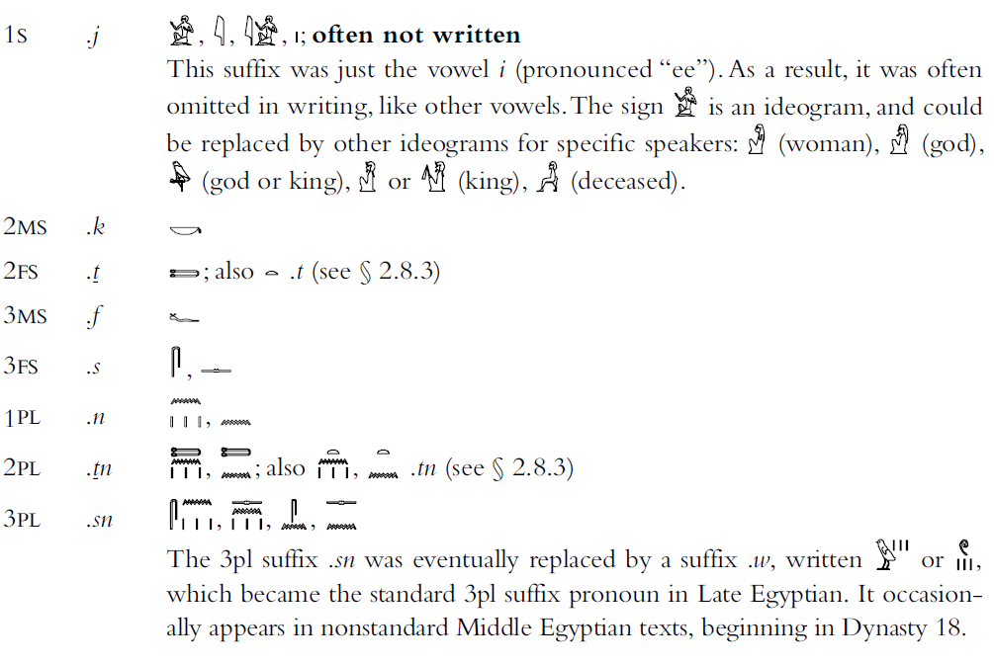

Dependent pronouns
Word in their own right, but dependent on another word

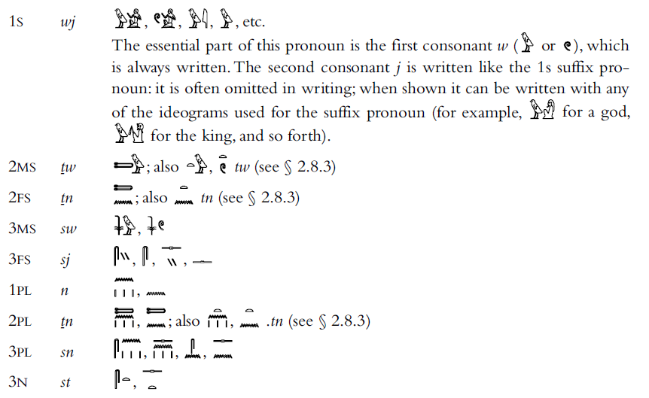

Independent pronouns
Separate words, stand in their own right in the sentence


