Raya salah Student no. 2026066 Lecturer: Muhammed Islam

EFFECTIVE TEAM WORKING AND COMMUNICATION (BMSW4002_BIRM)

Contents
Introduction 1
Model of teamwork 2
Impact of effective teamwork on team success 6
Advantages of having an effective team would be, 6
The barries to team work would be , 6
Recommendation 7
Conclusion 9

Introduction
In this report, we will discuss the importance of being a part of a team and how important teamwork is. Teams are formed when people with similar tastes, preferences, likings, and attitudes come together to work toward a common goal. Teams are extremely important in both organisations and our personal lives. Every employee relies on his coworkers to collaborate and contribute effectively to the organisation. No employee can work alone; he must rely on his co-workers to complete tasks efficiently. It has been observed that when employees work as a team rather than individually, the outcome is far superior because each individual can contribute in the best way possible. Individuals with similar interests and specialisations form teams in organisations by gathering on a common platform.

Model of teamwork

How can you develop a team based on the scenario?
With the team being unable to communicate during team meetings, it’s difficult for anything to progress or even come to conclusions. Lack of communication in this team has led to team conflict.
In order for me as a leading manager responsible of developing an effective team that would successfully launches the children’s wear, I would use the Tuckman’s model. The terms Forming, Storming, Norming, Performing, and Adjourning are used to describe these phases. According to Tuckman's model, relationships form as a team matures and gains skill, and the leadership style shifts to one that is more collaborative or shared.
When a new team first comes together, members will be unsure of the team's goals, how they fit in, and whether they will get along with one another, this stage is called forming. They can be apprehensive, intrigued, or eager to start. They will seek the team leader for guidance regardless of how they are feeling.
As people get to know their new co-workers and one another's working styles, this may take some time.
People begin to push against the established bounds during the storming stage. As team members' genuine personalities and preferred methods of working come to the surface and collide with those of others, tension or conflict can also develop between team members.
At this point, team members could contest your authority, your management approach, or even the group's goal.
The team enters the norming stage gradually. People begin to put aside their disagreements, respect one another, and recognise your leadership abilities.
Your team members will feel more at ease asking for assistance and providing helpful criticism now that they are more familiar with one another. They'll be more dedicated to the team's objectives as a whole, and they ought to move forward successfully, this istage is called performing.
Another way to develop an effective team lacking communication skills would be using the belbin's team theory, which is a suggestion that within a particular team, develop your strengths and weaknesses as a team and improve how each one of the team can contribute. Team roles can affect how people communicate, how they receive feedback, and not just what they say.
Simply by arguing from two opposing points of view, two persons with very diverse Team Roles and few shared strengths. Building connections and developing trust require an understanding of what motivates communication and how it differs for various people. In other words, it helps us communicate effectively."
In Belbin’s theory, interaction with others is really important, these roles are split into groups of three:
- Action
- Thinking
- Social roles
These three basic action schemes help allow communication to take place and get rid of any tension. The context issue must be addressed in addition to the traits of the Team Role (or collection of roles) For instance, team players are likely to be good at casual, one-on-one communication within the team but may find it difficult to speak up in meetings, especially when emotions are high. When discussing when describing their opinion of expertise, specialists and plants are most likely to communicate poorly with one another. Understanding your own and your co-workers’ communication preferences helps enhance day-to-day interactions. It's possible that you already have some thoughts about how you and them. including when it goes well, when it can cause issues, and how it aligns with the Belbin Team Roles.
It's Difficult To remember that no ones can work alone.. Each of us has a set of preferred, manageable, and least preferred Team Roles that define how we like to work, and the specific configuration of these determines how we connect with others
Sometimes we believe we can instantly recognise the team roles of our clients and co-workers.
In some situations, recognising a difference does not guarantee that our working relationships will improve.
High-performing teams don’t materialize out of the ether. They require careful cultivation from a team leader with a strong sense of team values, goals, and code of ethics. Without this leadership from the top, your employees are simply co-workers. It’s up to you to them an actual team. Here are some steps toward making that happen.
- Establish expectations from day one. The phrase “nature abhors a vacuum” is a bit of a cliché, but it’s true. New employees and new team members tend to arrive as relatively blank slates—open to an array of company cultures—but they will quickly start seeking cues for how to operate as a member of your company. Take advantage of this. Set ground rules, and let your expectations be known from the start—not just in terms of sales goals or a five-year plan, but in terms of the type of team environment you’re looking to establish. Do you want to create a culture of shared responsibility, shared problem-solving, and shared decision making? If yes, then say so. An effective leader will communicate such values from the very start; this lets new team members understand what they’re signing up for.
- Respect your team members as individuals. At work, you want your employees to be part of a team, but you must also have perspective: these are individuals with stories of their own. They got this far in life without your company, and they presumably have rich and varied lives when they leave work each day. It is important to not regard new team members as bodies who will perform tasks. A robust team environment blossoms when individuals are honoured and respected for their unique gifts and their ability to contribute toward your common goal.
- Engender connections within the team. While it’s critically important that you value and honor each individual member of the team, it’s also important that the team members themselves exhibit that same respect and care toward one another. Encourage individuals to not regard one another as a body who sits at the desk next to them, but as a business partner who will work toward a shared goal of business development, individual success, and achieving team goals.
- Practice emotional intelligence. Great leaders value the importance of emotional intelligence. In a nutshell, this means that their leadership style includes treating individuals as human beings, not living drones. Great leaders understand that not every person is motivated by the same thing. Some team players thrive on pursuing shared goals. Others seek healthy competition, either with an outside competitor or against another sales team in the same office. By embracing the realities of different work styles and different forms of motivation, an effective leader will treat people’s individual differences as an asset, not an obstacle.
- Motivate with positivity. Great leaders also subscribe to the theory that “you get more flies with honey than vinegar.” In real world terms, this means that it’s more effective to shape behavior with positive reinforcement rather than negative reinforcement. Resist the urge the criticize team members’ mistakes. Instead, create a positive team environment by citing events and behaviors that you particularly liked and encourage your team to bring more where that came from. Positive reinforcement is a far more productive manner of motivating team performance than shaming those who screwed up.
- Communication. As humans, we all love to know where we stand. Are my colleagues happy with the work I’m doing? Do I need to improve on something? Assume that people want to know. If they sense you’re unhappy but aren’t saying anything, that can lead up to built up stress and even resentment, which will result in poor performance. Or if they think they’re doing a great job but you as a boss aren’t satisfied, this can lead to unwelcome shock when you break the news that they’ve been underperforming. So brush up on those communication skills; effective communication can keep working relationships strong for decades, while silence can break things apart very quickly.
Look for ways to reward good work. People love recognition of their hard work. financial bonuses, this is a great way to show appreciation. An easy way is to practice the art of delegating. If a team member shows great judgement, allow them to make some key decisions that you may have once reserved for yourself. If they are particularly responsible with money, give them authority to use the company credit card. Find a small way to show that you’re paying close attention to your employees and their efforts are appreciated. It will reflect well on you as a boss and help remind people that they are a valued member of the team.
Diversify. When it comes to building your business, your team should be as diverse as possible—different backgrounds, experiences, ages, and opinions. Hire with the goal of covering your blind spots: surround yourself with people who will inform the judgment calls you make and the content you put out.
Find a team you trust. Find a self-starter: someone who can make decisions on your behalf and who’s going to be a good ambassador for you and your business. Groom them to be collaborators by empowering them to make leadership decisions on their own. You’re investing time and resources into this person, so consider their potential for longevity at your company or within your industry.
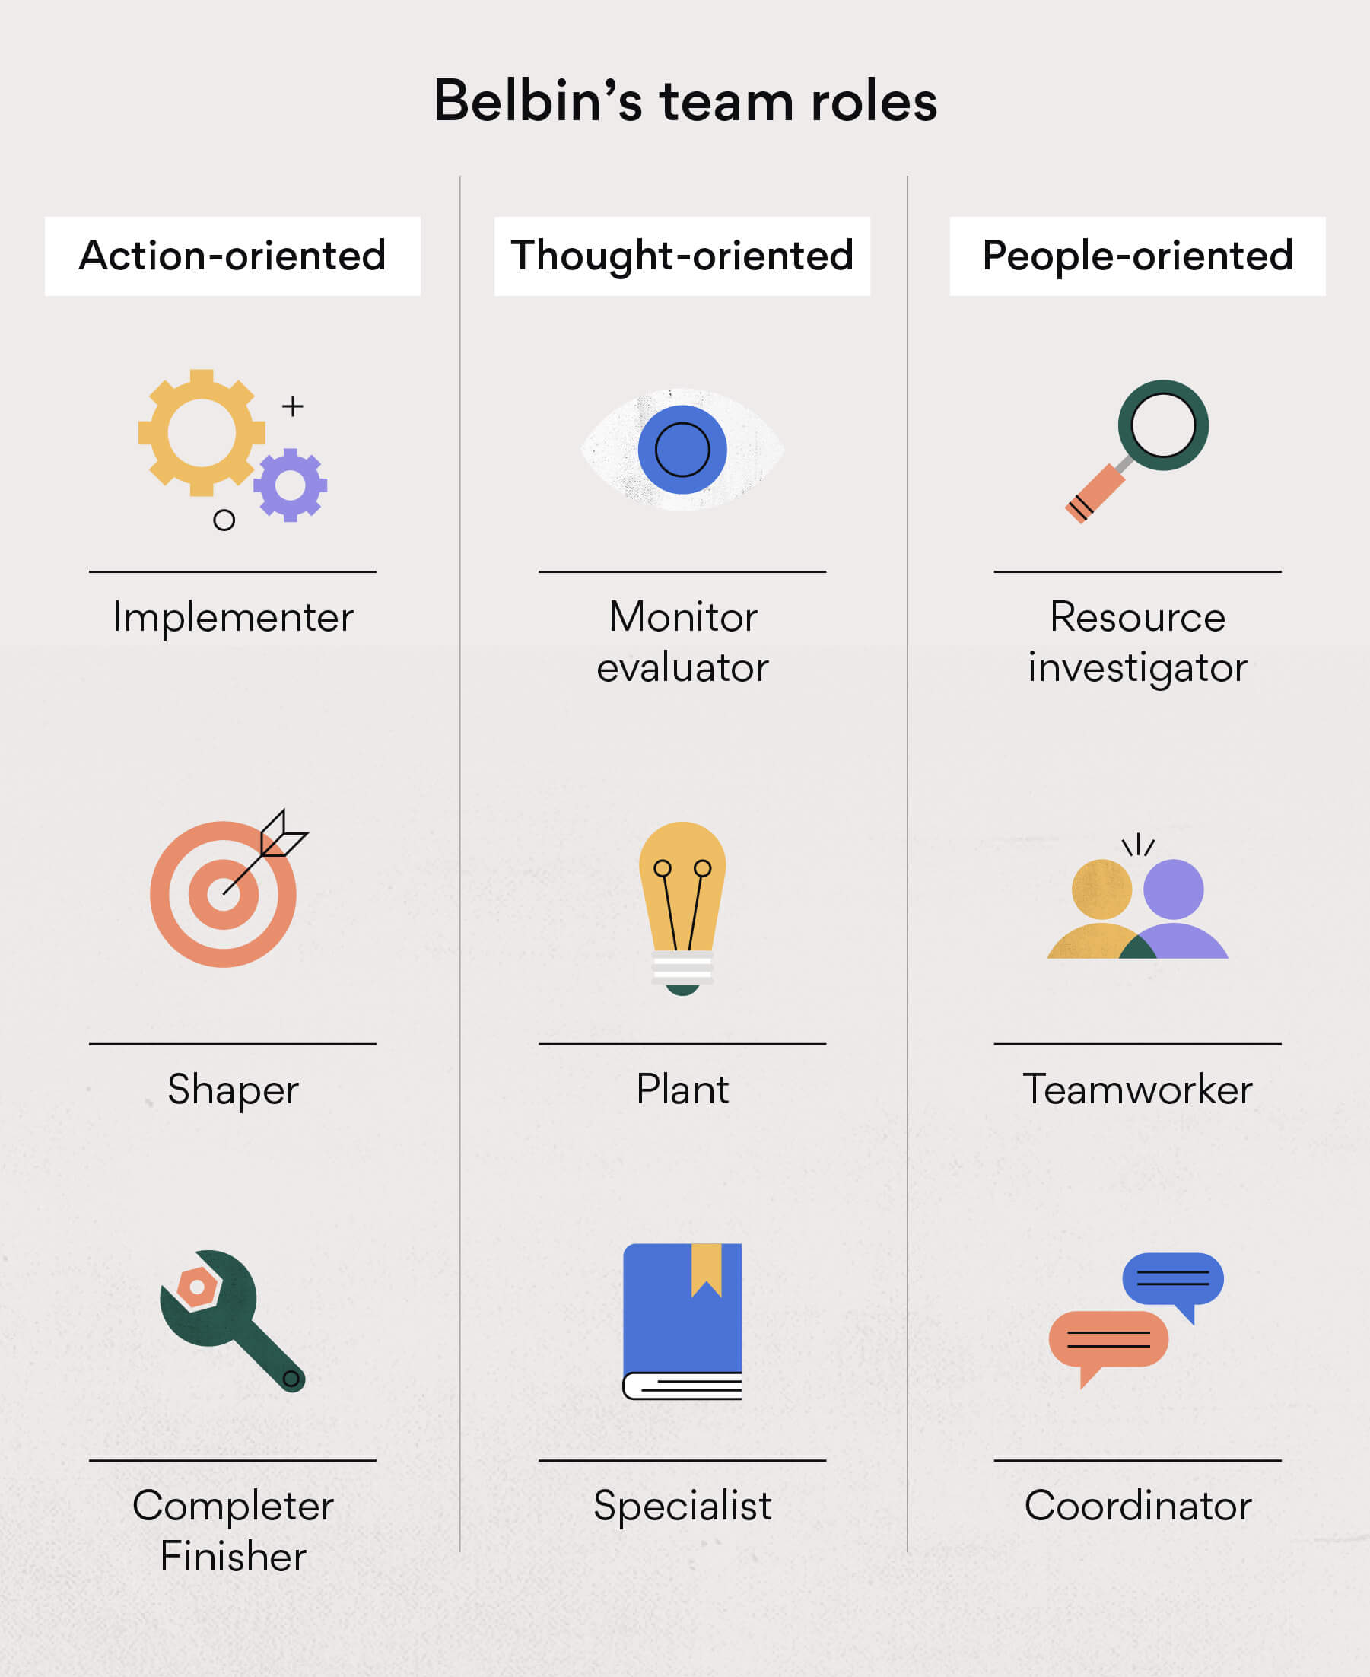

Shaper
Shapers are group individuals who drive the group forward. They are action-oriented, spurring themselves and others in spite of any issues that emerge.

Implementer
Implementers are moreover action-oriented group individuals, and they keep up arrange in their situations. They’re viable and flourish at bringing thoughts to realization. In spite of the fact that implementers like to require activity, they’re too exceedingly restrained. These people may be the spine of a group since they can unquestionably bolster other group individuals.

Completer finisher
The final of the action-oriented group parts are the completer finishers. Genuine to their title, completer finishers are heads-down people who take note fine points of interest and endeavor for flawlessness.

Plant
The plant may be a thought-oriented group part who’s an innovative and inventive scholar. In spite of the fact that plants offer assistance adjust out the group, they favor to brainstorm and set their own thoughts before sharing to the more noteworthy group.

Monitor evaluator
Another thought-oriented group part is the screen evaluator. This sort may be a sound scholar and can put their feelings aside for issue understanding. Screen evaluators work best when their ventures require progressed information and vital arranging. They evaluate thoughts to decide in case they are profitable and reasonable, at that point take the steps to thrust those thoughts forward.

Coordinator
the coordinator may be a group part with incredible communication aptitudes. Coordinators are often in administration positions since they promote collaboration and spur the group to achieve their objectives.

Teamworker
Their extroverted personalities help them function well with others and co-ordinate with their teammates.

Resource investigator
They are individuals that enjoys exploring new opportunities like finding potential marketing opportunities.

Impact of effective teamwork on team success

Advantages of having an effective team would be,

Strong relationship
Team work helps build strong bonds between team members
Flexibility
Working in team can help exchange skills and knowledge between team members and improve productivity and output.
Problem solving
Teams bring together different people with different ways of thinking varying levels of experience and different ideas
Conflict resolution skills
There is often the potential for clashes between individuale team members ,but collaborating towards shared goal often enables members to work how best to resolve disagreements for the benefit of the team.
Increased productivity
Members contributing to help a team produce results will feel valued, supported and committed to each other. This can lead to happier, productive and more motivated staff.
New ideas and opportunities
teamwork can spark creativity among your staff, which can lead to the development of innovative new ideas, products or services as well as identifying new business opportunities.

The barries to team work would be

Ineffective leadership
For teams to work together viably, they require pioneers who can direct them, offer their understanding and empower collaboration on a reliable premise.

Goal confusion
Fruitful collaboration regularly starts with the foundation of shared objectives that team individuals can work toward.

Communications Gap
Communication holes can result in group individuals missing clarity around desires and their obligations. Groups can work intentionally toward sharpening their communication abilities to fill these gaps and collaborate more successfully.

Inequitable decision-making
In a group environment, it's common for a single group part to expect more obligation than others and rule decision-making obligations.

Team size
Small teams—those that consist of three to six professionals—often collaborate more efficiently than larger ones.

Poor conflict resolution skills
Whereas teams may confront struggle as they work collaboratively toward shared objectives, it's imperative that experts know how to discover resolutions and move forward together. Without struggle determination aptitudes, this will be a challenging accomplishment.

Workflow mismanagement
A few teams discover it challenging to advance past the point of characterizing objectives and understanding the errands they have to be total to reach such objectives. To work together effectively, teams require information of how their workflow is to function and what part each group part can play in fulfilling a shared objective. To appropriately oversee workflow, teams may consider utilizing apparatuses like mapping or naming a venture facilitator to set up a clear pathway to victory.

Recommendation

Masterclass (no date) suggests: high-performing teams don’t materialize out of the ether. They require careful cultivation from a team leader with a strong sense of team values, goals, and code of ethics. Without this leadership from the top, your employees are simply co-workers. It’s up to you to them an actual team. Here are some steps toward making that happen.
- Establish expectations from day one. The phrase “nature abhors a vacuum” is a bit of a cliché, but it’s true. New employees and new team members tend to arrive as relatively blank slates—open to an array of company cultures—but they will quickly start seeking cues for how to operate as a member of your company. Take advantage of this. Set ground rules, and let your expectations be known from the start—not just in terms of sales goals or a five-year plan, but in terms of the type of team environment you’re looking to establish. Do you want to create a culture of shared responsibility, shared problem-solving, and shared decision making? If yes, then say so. An effective leader will communicate such values from the very start; this lets new team members understand what they’re signing up for.
- Respect your team members as individuals. At work, you want your employees to be part of a team, but you must also have perspective: these are individuals with stories of their own. They got this far in life without your company, and they presumably have rich and varied lives when they leave work each day. It is important to not regard new team members as bodies who will perform tasks. A robust team environment blossoms when individuals are honored and respected for their unique gifts and their ability to contribute toward your common goal.
- Engender connections within the team. While it’s critically important that you value and honor each individual member of the team, it’s also important that the team members themselves exhibit that same respect and care toward one another. Encourage individuals to not regard one another as a body who sits at the desk next to them, but as a business partner who will work toward a shared goal of business development, individual success, and achieving team goals.
- Practice emotional intelligence. Great leaders value the importance of emotional intelligence. In a nutshell, this means that their leadership style includes treating individuals as human beings, not living drones. Great leaders understand that not every person is motivated by the same thing. Some team players thrive on pursuing shared goals. Others seek healthy competition, either with an outside competitor or against another sales team in the same office. By embracing the realities of different work styles and different forms of motivation, an effective leader will treat people’s individual differences as an asset, not an obstacle.
- Motivate with positivity. Great leaders also subscribe to the theory that “you get more flies with honey than vinegar.” In real world terms, this means that it’s more effective to shape behavior with positive reinforcement rather than negative reinforcement. Resist the urge the criticize team members’ mistakes. Instead, create a positive team environment by citing events and behaviors that you particularly liked and encourage your team to bring more where that came from. Positive reinforcement is a far more productive manner of motivating team performance than shaming those who screwed up.
- Communicate. As humans, we all love to know where we stand. Are my colleagues happy with the work I’m doing? Do I need to improve on something? Assume that people want to know. If they sense you’re unhappy but aren’t saying anything, that can lead up to built up stress and even resentment, which will result in poor performance. Or if they think they’re doing a great job but you as a boss aren’t satisfied, this can lead to unwelcome shock when you break the news that they’ve been underperforming. So brush up on those communication skills; effective communication can keep working relationships strong for decades, while silence can break things apart very quickly.
- Look for ways to reward good work. People love affirmation of their hard work. If you’re fortunate enough to be able to give financial bonuses, this is a great way to show appreciation. If you’re a startup with little cash on hand, think of other ways to show gratitude and trust. An easy way is to practice the art of delegating. If a team member shows great judgement, allow them to make some key decisions that you may have once reserved for yourself. If they are particularly responsible with money, give them authority to use the company credit card. Find a small way to show that you’re paying close attention to your employees and their efforts are appreciated. It will reflect well on you as a boss and help remind people that they are a valued member of the team.
- Diversify. When it comes to building your business, your team should be as diverse as possible—different backgrounds, experiences, ages, and opinions. Hire with the goal of covering your blind spots: surround yourself with people who will inform the judgment calls you make and the content you put out.
- Find a team you trust. Find a self-starter: someone who can make decisions on your behalf and who’s going to be a good ambassador for you and your business. Groom them to be collaborators by empowering them to make leadership decisions on their own. You’re investing time and resources into this person, so consider their potential for longevity at your company or within your industry.

Conclusion

It takes great leadership to build great teams. Leaders who are not afraid to course correct, make the difficult decisions and establish standards of performance that are constantly being met – and improving at all times. Whether in the workplace, professional sports, or your local community, team building requires a keen understanding of people, their strengths and what gets them excited to work with others. Team building requires the management of egos and their constant demands for attention and recognition – not always warranted. Team building is both an art and a science and the leader who can consistently build high performance teams is worth their weight in gold.
History has shown us that it takes a special kind of leader with unique competencies and skills to successfully build great companies and teams.

Reference list

- (Advantages of effective teamwork | nibusinessinfo.co.uk, 2017)
(Belbin Team Role communication styles, 2022)
- (Forming, Storming, Norming, and Performing: Tuckman’s Model for Nurturing a Team to High Performance, 2017)
- (Belbin Team Role communication styles, 2022)
- Masterclass(no date) Available at: https://www.masterclass.com/articles/how-to-build-a-strong-team#how-to-build-a-strong-team-in-9-steps(Accessed: 09 July 2022).
- Forbes(no date) Available at: https://www.forbes.com/sites/glennllopis/2012/10/01/6-ways-successful-teams-are-built-to-last/?sh=3e5457822b55 (Accessed: 09 July 2022).

