

Module Title: Managing Enterprise in the 21 st Century
Module Code: BMSW4011

Assignment Title: Business plan, Reflection and Presentation.

Student Name: Raul Hotea
Student ID:2243424

Table of Contents

Task 1: Business Plan 1
1. Product/Service Proposition 1
2. Business Name and Ownership Type 2
3. Mission Statement, Aim and Objectives 2
4. Physical Requirements 3
5. Human Resources 3
6. Marketing Activities 4
7. Market Research 4
8. Financial Resources 4
9. Threats and Mitigation 5
Task 2: Individual Reflection 7
Definition of Gibbs Reflective Model 7
Application of Gibbs Reflective Model 7
Task 3: Presentation 9
Reference List 19

Business Plan

1. Product/Service Proposition
Description
This is a different service Music Voyage Rentals provide in giving novices the opportunity to rent different musical instruments so that they could get to experience the feeling of the instruments and find out and see which would suit the most suitable for each and everyone before purchasing them. This service is to help absolute beginners who have no idea what instrument is right for them and if their child should even play an instrument. Along with instrument renting, Music voyage Rentals offers music classes as well to help the beginners, to improve, share and gain confidence in their musical voyage. This comprehensive approach assists in nurturing existing and future artists enabling it easier and cheaper for kids to learn and gain access to instruments.

Figure 01: Company Logo
Unique Selling Proposition (USP)
Their one-of-a-kind selling point is their open rental terms and vast selection of musical instruments and it can be used in their musical classes. This combination enables users to explore different instruments on a trial basis without any real commitment and still receive professional training. Music Voyage Rentals caters to new players by providing such customised services and helps them start their musical journey in a conducive environment.

2. Business Name and Ownership Type
Business Name: Music Voyage Rentals
Ownership Type: Partnership
Rationale:
Pros: Shared responsibilities, combined expertise, easier to raise capital.
Cons: Shared profits, potential for conflicts, joint liability.

3. Mission Statement, Aim and Objectives
Mission Statement: "To inspire musical journeys by providing accessible instrument rentals and quality music education."
Aim
To become the leading provider of musical instrument rentals and music lessons for beginners in the local area.
Objectives
- Acquire 200 new customers within the first year.
- Achieve a customer satisfaction rate of 90%.
- Expand the inventory by 20% within the first 18 months.

4. Physical Requirements
Music Voyage Rentals will be located in a centrally easy to access shop with many parking spaces. Instruments like guitars, pianos and violins will be on offer at the shop. This will include computer setups for all product management and customer bookings, appropriate furniture for the store and lesson rooms and soundproof rooms to ensure the best possible music lessons.

Figure 02: Physical Location

5. Human Resources
Music Voyage Rentals will employ a Store Manager to oversee day to day operations, Customer Service Representatives to assist in rentals and lessons and Music Instructors to teach in various musical instruments (Vander Boon, 2023). Moreover, management of the company can now fill those jobs with local workers the HR can find through local job fairs, local music schools and local online job sites. Store Manager Management and Planning Customer Service Representatives as well as Rent and Customer Inquiry Music Instructors classified in Lesson and Class Performed It is designed to support the customers in the music achievements that they aspire to know.

6. Marketing Activities
Music Voyage Rentals will promote a comprehensive marketing program which would include online commercials such as Google Ads and Facebook Ads, participation in social media like Instagram, TikTok and Facebook and not to miss promoting concerts in music genres (Andreeva, 2021). The company will get agreements with schools and music shops locally to increase the local distribution and reputation. Free trial classes and open house events as this will serve as promotional events to attract prospective clients (Vilppula and Ketola, 2021). From distributing flyers at schools and community centres, to making TikTok videos on various lessons and customer reviews, to having Facebook contests and freebies that aim to encourage more participation.

7. Market Research
Music Voyage Rentals took a diversified approach to market research, creating polls, interviews and competitor analysis to capture the full picture. The company will survey the local community and potential customers and speak to music teachers and students to learn more about their wants and needs. The company will also conduct a more in-depth competitor analysis to evaluate the other music rental companies in the region. The findings revealed strong improvisations in open hiring options and a notable requirement for combined lesson products. As a result of these realisations, Music Voyage Rentals altered their rental deals by making it more casual by providing combined lesson services to meet the needs of the identified cultures. It is aimed at enhancing customer satisfaction and setting the business apart from its competition.

8. Financial Resources
Month | Opening Balance | Cash Inflows | Cash Outflows | Closing Balance
January | $10,000 | $5,000 | $7,000 | $8,000
February | $8,000 | $7,000 | $8,500 | $6,500
March | $6,500 | $9,000 | $5,500 | $10,000
April | $10,000 | $8,000 | $9,000 | $9,000
May | $9,000 | $10,000 | $6,000 | $13,000
June | $13,000 | $11,00 | $9,000 | $15,000
July | $15,000 | $10,000 | $8,000 | $17,000
August | $17,000 | $8,000 | $9,000 | $16,000
September | $16,000 | $9,000 | $8,000 | $18,000
October | $18,000 | $10,000 | $8,000 | $20,000
November | $20,000 | $11,000 | $9,000 | $22,000
December | $22,000 | $12,000 | $10,000 | $24,000
Table 01: Cash Flows

9. Threats and Mitigation
The major threat facing Music Voyage Rentals is its competition from already established music schools and renting services. The business has intended to distinguish itself through two main means to resolve the issue. It will provide easy rental options for new customers who will be able to rent instruments to see whether it fits well before making a purchase (Merrill, 2020; McNeil, 2022). Moreover, that in partnership with Music Voyage Rentals will include music lessons as well as instrument rentals which could be a far more comprehensive educational experience that other so-called competitors will not be offering. The company also plans to privilege premium customer service to establish solid relationships and generate consumer confidence, other factors that will favour it in the crowded marketplace.

Individual Reflection

Definition of Gibbs Reflective Model
The Gibbs Reflective Model is a structured framework designed to facilitate a methodical process of questioning.itemising events (Adeani, Febriani and Syafryadin, 2020). That includes six stages which are, Description, Feelings, Evaluation, Analysis, Conclusion and Action Plan. When people go through these steps, they can critically reflect on these experiences and impact better learning and growth in their careers (Hashim et al., 2020). This model is widely used in a number of domains most notably in the fields of education, healthcare and business as a means of spreading knowledge and enhancing decision-making and practice.

Application of Gibbs Reflective Model
Using the Gibbs Reflective Model, here is an organised review on the process of creating and planning Music Voyage Rentals.
Description
The concept of Music Voyage Rentals developed from the premise of newbies seeking musical instrument rentals combined with lessons. I wanted to come up with a product which would satisfy this demand and that is why I came up with the idea of allowing people to try different instruments before they buy. The beginning was determined by idea meetings to refine the business idea and specify the reality of the business.
Feelings
I was as happy as I could also be, however I couldn't shake the raising issue regarding the feasibility of such a venture. Is there a market for the demand, competition and more can this be a financially viable business idea inside me. So I tried to plan further as this was an odd inspiration and trepidation.
Evaluation
The process ended up producing some really good features in retrospect. After testing the market a bit more, I realised there was demand among aspiring musicians for options to rent instruments as needed and receive quality musical education. Surveys and interviews even on the web showed the benefit of this service by receiving better comments on this issue (Thunberg and Arnell, 2022). The groundwork helped us develop a balanced business plan with concise specific objectives and recommended strategies. The difficulties that were experienced in this system were noticed in which are financial planning, establishing the financial sources and challenges in sustainability. This leads to more complexity than I realise in predicting cash flows and finding out my initial spending needs. It made me realise how little I knew about finance in general and that I needed to be seeking expert advice in this field.
Analysis
This was helped by some effective market research which illuminated the likes and dislikes of customers and market trends. It helped us modify my services offerings and marketing approaches based on specific needs found in the collection period. Moreover, the challenges underscored the need for further teaching on financial planning and financial management. This is the gap which needs to be managed for financial health and survival.
Conclusion
The entire process was educational and reaffirmed the criticality of careful planning and detailed study in business ventures. It confirmed my view that a strong basis based on market data is essential for business success. While obstacles exist, they present chances for growth and improvement.
Action Plan
In the future, I will work on my financial planning skills and learn from others so that I become better and more advanced at it. Such as courses and tips with regard to finance management and hiring financial experts for advice so I can make better predictions and prediction errors (Tyson, 2023). I will also keep an open dialogue with partners and constantly ask for feedback to iterate on my tactics as the business scales. By doing that the company should be able to reduce risks and increase likelihood of having more long-term success with Music Voyage Rentals.
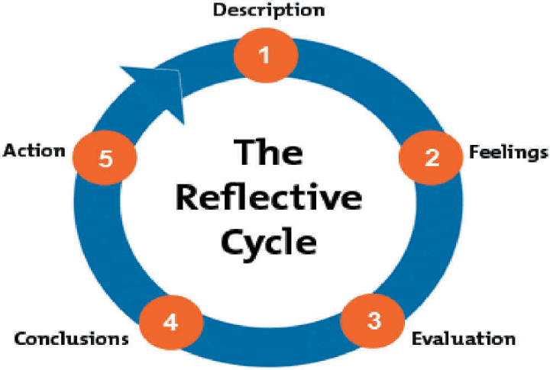
Figure 03: Gibbs Reflective Cycle
(Source: Ahmed, 2019)

Reference List
Andreeva, V., 2021. The impact of the digital era on marketing in the music business industry.
McNeil, K.S., 2022. Equipment Rental Companies Leaders’ Customer Retention Strategies (Doctoral dissertation, Walden University).
Merrill, T.W., 2020. The economics of leasing. Journal of Legal Analysis, 12, pp.221-272.
Vander Boon, A., 2023. The Musician’s Guide to Founding and Directing a Community Music Program: Based on Personal Interviews with Program Directors.
Vilppula, S. and Ketola, J., 2021. Surviving as an artist in the era of social media.
Adeani, I.S., Febriani, R.B. and Syafryadin, S., 2020. Using GIBBS’reflective cycle in making reflections of literary analysis. Indonesian EFL Journal, 6(2), pp.139-148.
Ahmed, A.M., 2019. Students’ reflective journaling: An impactful strategy that informs instructional practices in an EFL writing university context in Qatar. Reflective Practice, 20(4), pp.483-500.
Hashim, S.N.A., Yaacob, A., Suryani, I., Asraf, R.M., Bahador, Z. and Supian, N., 2023. Exploring the Use of Gibbs' Reflective Model in Enhancing In-Service ESL Teachers' Reflective Writing. Arab World English Journal, 14(2).
Thunberg, S. and Arnell, L., 2022. Pioneering the use of technologies in qualitative research–A research review of the use of digital interviews. International journal of social research methodology, 25(6), pp.757-768.
Tyson, E., 2023. Personal finance for dummies. John Wiley & Sons.
Verhulst, S.L. and DeCenzo, D.A., 2021. Fundamentals of human resource management. John Wiley & Sons.

