Habitat Suitability Analysis of the Red Squirrel
(Sciurus vulgaris) in the Wye Valley

A GIS-Based Multi-Criteria Assessment

Module: ACBA7005 — GIS and Habitat Management
Submitted by: Foyajul Karim Rimon
Date: May 2026

Contents
1. Introduction 5
2. Site and Species Selection 6
2.1 Species Selection: The Red Squirrel (Sciurus vulgaris) 6
2.2 Study Site Selection: The Wye Valley 7
3. Methodology 9
3.1 Overview of Analytical Approach 9
3.2 Data Sources 9
3.3 Habitat Layer (Weight: 0.5) 10
3.3.1 Woodland Type Score 10
3.3.2 Vegetation Height Score 12
3.3.3 Distance from Forest Edge Score 13
3.4 Food Layer (Weight: 0.3) 13
3.5 Mortality Layer (Weight: 0.2) 14
3.6 Weighted Combination and Final HSA Raster 14
3.7 Pixel-Level Scoring Validation: Worked Example 15
4. Results 18
4.1 Habitat Suitability Sub-layers 18
4.1.1 Woodland Type 18
4.1.2 Vegetation Height 18
4.1.3 Distance from Forest Edge 18
4.2 Food Suitability Layer 19
4.3 Mortality Suitability Layer 22
4.4 Final Weighted Habitat Suitability Analysis 24
5. Conclusion 27
5.1 Summary of Findings 27
5.2 Contribution of GIS to Habitat Management 27
5.3 Limitations 28
5.4 Recommendations for Future Research 28
References 30

List Of Figures

Figure 1: NFI Woodland Type Suitability Score — Wye Valley. Green = high suitability (conifer); red = low suitability (non-woodland or broadleaved). 11
Figure 2: Vegetation Height Suitability Score derived from LiDAR Canopy Height Model — Wye Valley. Green = tall closed canopy (score 3); red = low or absent canopy (score 0). 12
Figure 3: Distance from Forest Edge Suitability Score — Wye Valley. Green = deep interior woodland (score 3); red = edge-adjacent pixels (score 0). 13
Figure 4: Habitat Layer Final Score — Wye Valley. Higher scores (green/yellow) indicate conifer woodland with tall canopy and interior position; lower scores (red) indicate broadleaved or edge-adjacent woodland. 19
Figure 5: NFI Conifer Presence Score — Food Sub-layer A. Green areas indicate conifer or mixed conifer woodland (score 1); red areas indicate non-conifer land cover (score 0). 20
Figure 6: Distance from Woodland — Food Sub-layer B. Green areas indicate greater distance from woodland edge (higher foraging security); red indicates edge-proximate or non-woodland areas. 21
Figure 7: Food Suitability Score — Wye Valley. Higher scores (green/orange) indicate conifer woodland with good interior foraging conditions; lower scores (red) indicate broadleaved or edge-dominated areas. 22
Figure 8: Wild predator occurrences and urban features used in the mortality layer — Wye Valley. Purple = Pine Marten; orange = Goshawk (NBN Atlas, 2024); grey shading = urban features (OpenStreetMap contributors, 2024). 23
Figure 9: Combined mortality proximity surface — distance from wild predator occurrences and urban features. Lighter areas indicate greater distance from mortality risk sources. 23
Figure 10 : Mortality Suitability Score — Wye Valley. Green areas indicate greater distance from predator occurrences and urban features (score 2); red areas indicate proximity to mortality risk sources (score 0). 24
Figure 11: Final Weighted Habitat Suitability Analysis — Wye Valley. Higher scores (green/yellow) indicate the greatest ecological potential for red squirrel occupancy; lower scores (red/orange) indicate constrained suitability. 26

List of Tables
Table 1: Data layer framework for red squirrel habitat suitability analysis. 10
Table 2: Woodland type suitability scores applied to National Forest Inventory categories 11
Table 3: Vegetation height suitability scoring thresholds 12
Table 4: HSA pixel-level scoring matrix for 25 representative sample points. H = Habitat (0-3); F = Food (0-2); M = Mortality (0-3). F_norm = F x 1.5. Final HSA = (H x 0.50) + (F_norm x 0.30) + (M x 0.20). Classes: Not Suitable < 0.75; Low 0.75-1.50; Medium 1.5-2.25; High >= 2.25. 16
Table 5: HSA pixel-level scoring grid (5 x 5 representative pixels) following the module assessment framework. Scores: Habitat 0-3; Food 1-2; Mortality 0-3. HSA = Habitat score x Food score x Mortality score. 17
Table 6: Summary of habitat suitability score distribution across the Wye Valley study area 19
Table 7: Final weighted HSA score distribution across the Wye Valley study area 25

1. Introduction

Biodiversity loss has become one of the most serious conservation issues of our time. IPBES (2019) estimated that around one million animal and plant species are currently at risk of extinction, largely because of habitat loss and fragmentation. In the United Kingdom, woodland species have been hit particularly hard by land-use change, agricultural intensification, and the spread of invasive non-native species (Burns et al., 2023). Tackling these problems requires more than just policy; it also needs practical spatial tools that can identify where conservation effort is most needed.
The link between habitat fragmentation and species decline is well established in ecology. As woodland patches shrink and become more isolated, the populations within them become increasingly exposed to local extinction. Meta-population theory suggests that even lower-quality patches can still support regional species persistence, so long as they remain connected to better-quality habitat through corridors (Rushton et al., 2000). Identifying where high-quality habitat exists across a landscape is therefore fundamental to effective conservation planning. The growing availability of free, high-resolution spatial data, including LiDAR canopy models and national habitat inventories, now makes this kind of landscape-scale analysis much more achievable than it once was.
GIS has become an increasingly important part of conservation work. Unlike traditional field surveys, which can only cover limited areas and are labour-intensive, GIS allows multiple ecological datasets to be assessed simultaneously across an entire landscape, producing outputs that can directly inform management decisions (Store and Kangas, 2001). Habitat Suitability Analysis (HSA) is one of the most commonly applied GIS methods for this purpose, working by scoring areas of landscape against a species' known ecological requirements and generating a continuous suitability surface (Guisan and Zimmermann, 2000). This kind of approach has been used across a wide range of species and environments and has proved consistently useful for guiding habitat restoration, protected area planning, and wildlife corridor design (Rushton et al., 2000).
The red squirrel (Sciurus vulgaris) is one of the most well-known examples of a native UK species in serious decline. Since the grey squirrel (Sciurus carolinensis) was introduced from North America in the nineteenth century, it has pushed the red squirrel back into a small number of fragmented strongholds across northern England, Scotland, and isolated areas in Wales and Ireland (Gurnell et al., 2006). Grey squirrels outcompete reds for food and carry squirrelpox virus, which is fatal to red squirrels but has no effect on grey squirrels themselves (Tompkins, White and Boots, 2003). The Wye Valley, which straddles the England-Wales border, has woodland habitats that could potentially suit red squirrels, yet no spatial assessment of suitability for the species has been carried out there before.
This report describes a GIS-based HSA carried out to assess how suitable the Wye Valley is for supporting red squirrel populations. The analysis used freely available datasets, including LiDAR canopy height data, the National Forest Inventory Wales 2024, and predator records from the NBN Atlas, to build a three-layer suitability model. Each was scored and weighted to reflect its ecological importance, and the results were combined into a final suitability map intended to inform future conservation planning decisions.
The rest of the report is structured as follows. Section 2 explains why the red squirrel and the Wye Valley were chosen, covering the species' ecology and the site's characteristics. Section 3 describes the methodology, including the datasets used, how they were processed, and how the layers were combined. Section 4 presents the results for each layer and the final combined suitability map. Section 5 reflects on what the findings mean for conservation, discusses the limitations of the analysis, and suggests directions for further work.

2. Site and Species Selection

2.1 Species Selection: The Red Squirrel (Sciurus vulgaris)

The red squirrel was chosen as the focus for several reasons. It has a clearly documented conservation problem that makes it well suited to this kind of analysis, and its ecological requirements are well understood, making it possible to translate them into scored suitability criteria. The species is classified as Near Threatened in Great Britain, and its continued decline has made it one of the most high-profile targets for native wildlife conservation (Lurz et al., 2001). Fewer than 160,000 red squirrels now remain in the UK, compared with an estimated two million grey squirrels, a figure that illustrates just how far the competitive displacement has gone since the grey squirrel's introduction (Gurnell et al., 2004).
Red squirrels need dense, connected woodland, ideally conifer or mixed woodland, rather than predominantly broadleaved forest (Lurz et al., 2001). Conifer seeds, particularly from Scots pine, Norway spruce, and larch, are a key part of the diet, especially through winter when other food is scarce (Wauters and Dhondt, 1992). Canopy height is also important: woodland with a well-developed canopy above five metres provides cover from avian predators such as the goshawk (Accipiter gentilis) and reduces exposure to ground predators including pine martens (Martes martes) and domestic cats (Felis catus) (Twining, Montgomery and Tosh, 2021).
Woodland connectivity matters too. Red squirrels need to be able to move through the landscape to maintain viable metapopulations, and fragmented woodland limits that movement, increasing the risk of local extinction and greater exposure to grey squirrel competition (Hale et al., 2001). The grey squirrel not only out-forages the red squirrel in broadleaved woodland but also carries squirrelpox virus, meaning any encounter between the two species can be lethal for the native one (Tompkins, White and Boots, 2003). These characteristics, namely woodland type, canopy height, distance from the forest edge, and mortality risk, provided the basis for the suitability criteria used in this analysis.
Breeding success in red squirrels is closely tied to food availability. The species can produce two litters per year with two to four young, but this depends heavily on the quality of the conifer seed crop in autumn (Wauters and Dhondt, 1992). Woodland containing a mix of conifer species, such as Scots pine (Pinus sylvestris), Norway spruce (Picea abies), and larch (Larix spp.), provides a more reliable food supply than a single-species plantation, since different species peak in cone production in different years and a bad year for one is not necessarily bad for all. It is worth noting that the NFI Wales 2024 data does not distinguish between conifer species, which is one limitation of the analysis, though the broad woodland type classification does capture the most ecologically important distinction.

2.2 Study Site Selection: The Wye Valley

The Wye Valley was chosen as the study site partly because of its woodland character and partly because of the quality of spatial data available for the area. The valley runs approximately 30 km from Monmouth in the north to Chepstow in the south, following the River Wye along the England-Wales border. The landscape is characterised by steep, wooded escarpments and a mix of ancient deciduous woodland and conifer plantation on the valley sides. It is designated as a National Landscape (formerly AONB), which reflects its ecological and scenic value, and contains ancient semi-natural woodland and limestone grassland habitats (Natural Resources Wales, 2023).
From a red squirrel conservation standpoint, the Wye Valley has some potentially useful features. There are significant areas of mixed and conifer woodland, including plantations managed by Natural Resources Wales, which could provide the food and structural conditions the species requires. The woodland corridors running along the valley sides also offer potential connectivity between patches, an important factor for population viability (Lurz et al., 2001). The relative isolation of the valley, bounded by the River Wye to the east and agricultural land to the west, may also help limit grey squirrel incursion from surrounding areas.
The availability of good spatial data was another reason for choosing this site. One-metre LiDAR data can be freely downloaded from DataMapWales, giving a detailed canopy height model (DataMapWales, 2024). The NFI Wales 2024 covers all woodland in the area and classifies it by type, which underpins both the habitat and food layers (Forestry Commission, 2024). Predator occurrence records for goshawk and pine marten are available from the NBN Atlas (NBN Atlas, 2024), and OpenStreetMap provides urban feature data for the domestic predator sub-layer (OpenStreetMap contributors, 2024). Together, these datasets provided everything needed to build a meaningful three-layer suitability model for the site.
The Wye Valley's woodland has a long history. Ancient semi-natural woodland, dominated by oak and ash, has been present since at least the early modern period and still dominates the valley floor and eastern escarpment today (Game and Peterken, 1984). Much of it is protected as SSSI or SAC, mainly for its invertebrate, lichen, and bryophyte communities. The conifer plantations on the steeper valley sides are more recent additions, mostly planted from the mid-twentieth century, but they add compositional diversity and are particularly important for the food availability component of the suitability model.
It is important to note that the Wye Valley does not currently have a documented red squirrel population, so this analysis is prospective, about identifying potential rather than describing existing use. The aim is to find areas that could support red squirrels if appropriate management was put in place, not to map current habitat use. This kind of prospective suitability mapping is standard practice in conservation planning, where spatial analysis normally comes before any decisions about species translocation (Rushton et al., 2000).

3. Methodology

3.1 Overview of Analytical Approach

The analysis was carried out in QGIS, a free and open-source GIS package widely used in ecological and conservation research (Neteler and Mitasova, 2008). The workflow had three main stages: preparing the spatial datasets, producing and scoring the individual suitability sub-layers, and combining those layers into a final suitability map. The scoring approach follows the principles set out by Store and Kangas (2001), who showed that scoring each ecological variable on a consistent standardised scale before combining them generally produces more reliable results, with explicit weighting coefficients drawn from the ecological literature to reflect the relative importance of each factor.
The model has three ecological components: habitat structure, food availability, and mortality risk. Each was derived from one or more spatial datasets, scored on a scale of zero to three, and weighted according to its ecological importance. The final suitability score for each pixel is a weighted sum of the three factor layers, producing a continuous raster ranging from zero (not suitable) to three (highly suitable). All processing was done at one-metre resolution, matching the LiDAR data, so that fine-scale differences in woodland structure could be captured.

3.2 Data Sources

Five main datasets were used, following the data layer framework recommended by the module tutor (Table 1). The Canopy Height Model came from one-metre LiDAR data downloaded from DataMapWales (DataMapWales, 2024), which provided the basis for the vegetation height and forest edge proximity sub-layers. The NFI Wales 2024 (Forestry Commission, 2024) was used to classify woodland by type such as conifer, broadleaved, and mixed, feeding into both the habitat and food layers. Wild predator occurrence records for goshawk and pine marten came from the NBN Atlas (NBN Atlas, 2024). Urban feature data, including roads and residential buildings, were obtained from OpenStreetMap (OpenStreetMap contributors, 2024) for the domestic predator sub-layer of the mortality factor.
Before the analysis started, all datasets were reprojected to British National Grid (EPSG:27700) so that everything was spatially aligned. The CHM was used as the reference grid, ensuring all raster outputs had the same one-metre pixel size and spatial extent. At each processing stage, QGIS layer statistics were used to check that output scores were in the expected range and that there were no obvious gaps or errors in the data (Neteler and Mitasova, 2008). These preprocessing steps are important in multi-source raster analysis, where misaligned or inconsistently resolved layers can introduce errors into the final result.
Table 1: Data layer framework for red squirrel habitat suitability analysis.
Factor | Ecological Variable | GIS Variable | Data Source | Weight
Habitat | Dense forest; conifer and mixed broadleaf | Canopy Height Model (LiDAR); woodland classification | DataMapWales (2024); NFI Wales 2024 (Forestry Commission, 2024) | 0.50
Food | Seeds and cones (conifers) | Woodland classification (conifer presence) | NFI Wales 2024 (Forestry Commission, 2024) | 0.30
Mortality | Predators (goshawk, pine marten, fox, domestic dogs and cats) | Distance from predators; distance from urban features | NBN Atlas (2024); OpenStreetMap contributors (2024) | 0.20

3.3 Habitat Layer (Weight: 0.5)

The habitat layer was given the highest weight in the model (0.5), which reflects the central importance of woodland structure for red squirrel occupancy (Lurz et al., 2001). It was built from three sub-layers, each capturing a different aspect of habitat quality.

3.3.1 Woodland Type Score

The NFI polygon layer was loaded into QGIS and a suitability score was assigned to each polygon based on the IFT_IOA classification field. Conifer and mixed conifer polygons got a score of three, since these provide the food and shelter conditions red squirrels rely on most (Wauters and Dhondt, 1992). Broadleaved and mixed broadleaved woodland got a score of two, useful for shelter but less important as a food source. Transitional and structurally immature types, including coppice, young trees, and assumed woodland, received a score of one (Hale et al., 2001) and everything else i.e grassland, urban land, bare ground are received zero. These scores were added to a new field in the attribute table using the QGIS Field Calculator, and the layer was then rasterised at one-metre resolution using the GDAL Rasterize tool, aligned to the CHM extent.
Table 2: Woodland type suitability scores applied to National Forest Inventory categories
IFT_IOA Category | Suitability Score | Ecological Rationale | Source
Conifer | 3 | Primary food and shelter source | (Wauters and Dhondt, 1992)
Mixed (Conifer) | 3 | High conifer component | (Wauters and Dhondt, 1992)
Broadleaved | 2 | Shelter value, limited food | (Lurz et al., 2001)
Mixed (Broadleaved) | 2 | Partial conifer presence | (Lurz et al., 2001)
Assumed woodland / Coppice / Young trees | 1 | Structural immaturity | (Hale et al., 2001)
Grassland / Urban / Bare area | 0 | No woodland value | (Store and Kangas, 2001)

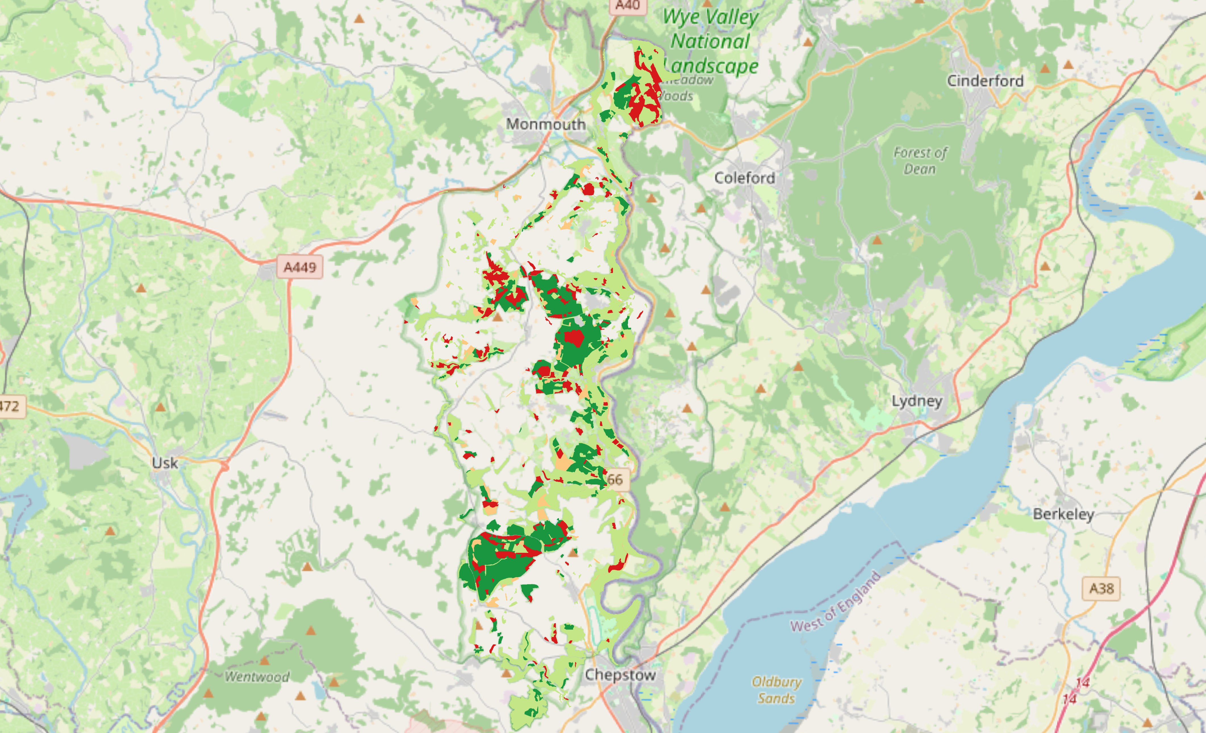
Figure 1: NFI Woodland Type Suitability Score — Wye Valley. Green = high suitability (conifer); red = low suitability (non-woodland or broadleaved).

3.3.2 Vegetation Height Score

The CHM was reclassified into four height bands using the Raster Calculator. Pixels below five metres got a score of zero, as at this height there is not enough canopy to provide useful cover for the species (Lurz et al., 2001). Between five and twenty metres the score was one, twenty to thirty metres was two, and above thirty metres was the maximum score of three. These thresholds come from Twining et al. (2021), who showed that taller, denser woodland reduces the risk of goshawk predation by limiting the bird's ability to fly through the canopy.
Table 3: Vegetation height suitability scoring thresholds
Height Range (m) | Suitability Score | Ecological Rationale | Source
0 to 5 | 0 | No effective canopy cover | (Lurz et al., 2001)
5 to 20 | 1 | Developing canopy | (Lurz et al., 2001)
20 to 30 | 2 | Mature woodland structure | Twining et al. (2021)
Greater than 30 | 3 | Dense closed canopy | Twining et al. (2021)

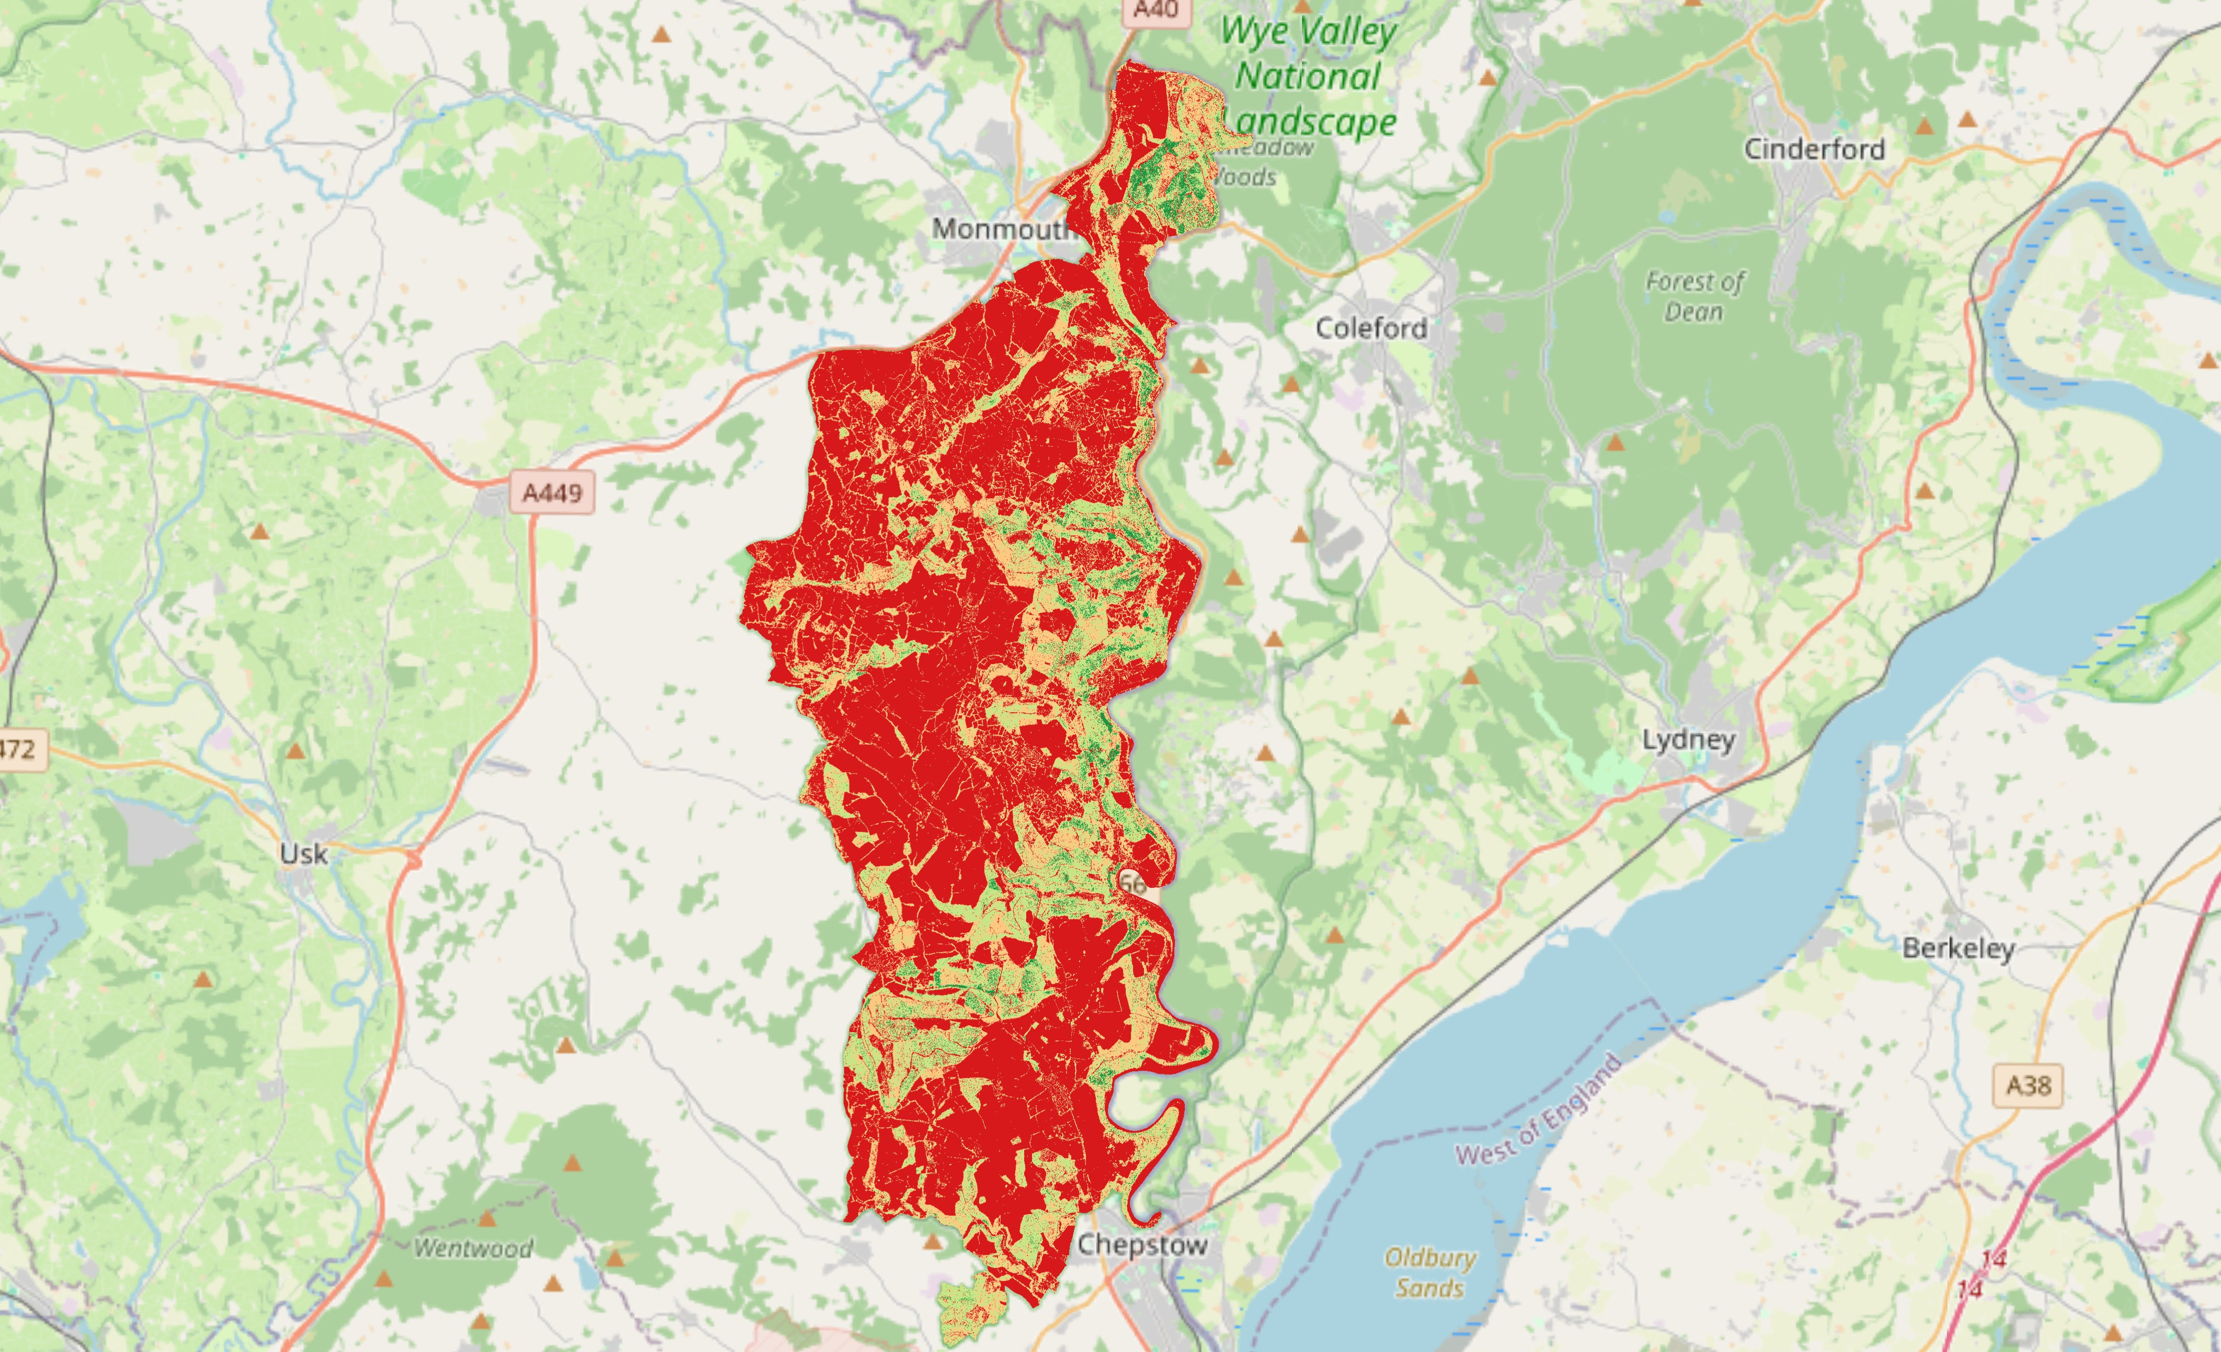
Figure 2: Vegetation Height Suitability Score derived from LiDAR Canopy Height Model — Wye Valley. Green = tall closed canopy (score 3); red = low or absent canopy (score 0).

3.3.3 Distance from Forest Edge Score

A binary forest mask was created from the CHM by classifying all pixels at or above five metres as forest. The GDAL Proximity tool was then applied to calculate the Euclidean distance from each pixel to the nearest non-forest pixel, producing a continuous distance surface in metres. This was reclassified into four bands: within ten metres of the edge gets zero, ten to twenty metres gets one, twenty to thirty metres gets two, and beyond thirty metres gets three. The rationale is that woodland interior provides better conditions for red squirrels than edge areas, which expose them to higher predation risk and greater grey squirrel contact (Hale et al., 2001).
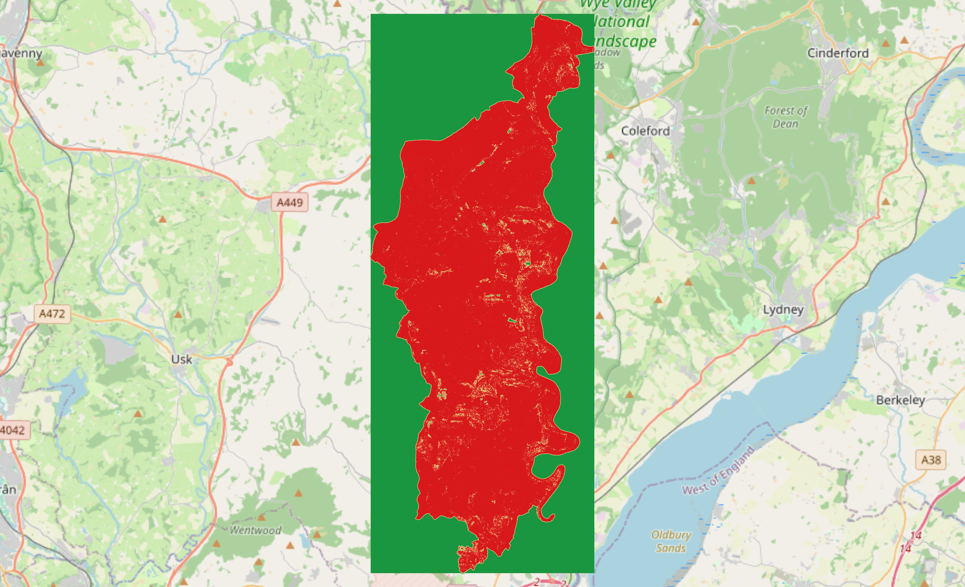
Figure 3: Distance from Forest Edge Suitability Score — Wye Valley. Green = deep interior woodland (score 3); red = edge-adjacent pixels (score 0).

3.4 Food Layer (Weight: 0.3)

The food layer was given a weight of 0.3, reflecting its importance as a secondary factor after habitat structure. It was built from two sub-layers. The first was a simple binary layer based on the NFI classification: pixels in conifer or mixed conifer woodland got a score of one, and everything else got zero. The second sub-layer was the same distance-from-edge raster used for the habitat layer, reused here because being further from the woodland edge means more undisturbed foraging conditions for a species that depends on conifer seed resources concentrated within woodland. The two sub-layers were added together in the Raster Calculator to give a food suitability score between zero and four.

3.5 Mortality Layer (Weight: 0.2)

The mortality layer was given a weight of 0.2. While predation and mortality risk are clearly relevant to habitat quality, they are partly captured indirectly by the habitat layer, since dense interior woodland naturally limits predator encounter rates (Gurnell et al., 2006). The recommended data framework, the mortality layer was built from two complementary sub-layers covering both wild predator pressure and domestic predator exposure.
The first sub-layer used goshawk and pine marten occurrence records downloaded from the NBN Atlas (NBN Atlas, 2024). These were merged in QGIS, rasterised at one-metre resolution, and processed with the GDAL Proximity tool to generate a distance raster. Pixels within five kilometres of a wild predator record received a score of zero, five to ten kilometres a score of one, ten to fifteen kilometres a score of two, and beyond fifteen kilometres the maximum score of three. The thresholds are wide to reflect the large home ranges of these species and the spatial uncertainty associated with opportunistic occurrence data (Tompkins, White and Boots, 2003).
The second sub-layer addressed domestic predator exposure. Foxes (Vulpes vulpes), cats (Felis catus), and dogs (Canis lupus familiaris) are recognised sources of red squirrel mortality near human settlement (Tompkins, White and Boots, 2003). This sub-layer was derived by calculating Euclidean distance from urban features in OpenStreetMap, specifically residential buildings and road networks (OpenStreetMap contributors, 2024). Pixels close to urban areas received lower scores and those further away received higher scores. The two sub-layers were then averaged to produce the final mortality score per pixel.

3.6 Weighted Combination and Final HSA Raster

Before combining the layers, each one was normalised to a common scale of zero to three by dividing each pixels value by the layer maximum and multiplying by three. This step was important to prevent the different raw score ranges from distorting the final result. The weighted sum was then applied in the Raster Calculator:
HSA = (Habitat_Normalised x 0.5) + (Food_Normalised x 0.3) + (Mortality_Normalised x 0.2)
This approach follows the framework proposed by Store and Kangas (2001) and aligns with the multi-criteria evaluation principles reviewed by Guisan and Zimmermann (2000), who note that weighted linear combination is one of the most transparent methods for integrating multiple habitat variables because the contribution of each factor to every pixel score can be clearly seen. The output raster runs from zero to three and was divided into four suitability classes: not suitable (zero to 0.75), low suitability (0.75 to 1.5), medium suitability (1.5 to 2.25), and high suitability (above 2.25). A red-to-green diverging colour ramp was used to display the final map, making the spatial pattern of suitability straightforward to read.

3.7 Pixel-Level Scoring Validation: Worked Example

Table 4 shows a worked example of the scoring approach for 25 sample points taken from across the study area. These points were selected to cover the range of habitat conditions present in the analysis, from open farmland and edge-adjacent broadleaved woodland through to interior conifer plantation. For each point, the habitat score (H, 0-3), food score (F, 0-2), and mortality score (M, 0-3) are recorded, alongside the weighted contribution of each to the final HSA score. Because the food layer has a maximum of two rather than three, it was normalised first using F_normalised = F x 1.5 before the 0.3 weight was applied.
The scoring key below the table summarises the classification criteria for each layer. Looking at the results, points like P02, P09, P17, and P23 score high because they combine good habitat (interior conifer woodland) with low mortality pressure. Points like P06 and P11 score very low because habitat quality is poor and they are close to mortality risk sources. Most points fall in the low to medium range, which is consistent with the overall character of the Wye Valley woodland. The distribution across the four classes closely matches the proportions seen in the full raster result (Table 7), which gives some reassurance that the sample points are genuinely representative of the study area (Guisan and Zimmermann, 2000; Store and Kangas, 2001).

Table 4: HSA pixel-level scoring matrix for 25 representative sample points. H = Habitat (0-3); F = Food (0-2); M = Mortality (0-3). F_norm = F x 1.5. Final HSA = (H x 0.50) + (F_norm x 0.30) + (M x 0.20). Classes: Not Suitable < 0.75; Low 0.75-1.50; Medium 1.5-2.25; High >= 2.25.
Sample | H Score (0-3) | F Score (0-2) | M Score (0-3) | H x 0.50 | F norm x 0.30 | M x 0.20 | HSA Score | Suitability Class
P01 | 2 | 1 | 3 | 1.00 | 0.45 | 0.60 | 2.05 | Medium
P02 | 2 | 2 | 3 | 1.00 | 0.90 | 0.60 | 2.50 | High
P03 | 0 | 1 | 2 | 0.00 | 0.45 | 0.40 | 0.85 | Low
P04 | 1 | 1 | 2 | 0.50 | 0.45 | 0.40 | 1.35 | Low
P05 | 1 | 1 | 2 | 0.50 | 0.45 | 0.40 | 1.35 | Low
P06 | 0 | 1 | 1 | 0.00 | 0.45 | 0.20 | 0.65 | Not Suitable
P07 | 1 | 1 | 0 | 0.50 | 0.45 | 0.00 | 0.95 | Low
P08 | 2 | 1 | 3 | 1.00 | 0.45 | 0.60 | 2.05 | Medium
P09 | 3 | 1 | 2 | 1.50 | 0.45 | 0.40 | 2.35 | High
P10 | 3 | 1 | 1 | 1.50 | 0.45 | 0.20 | 2.15 | Medium
P11 | 0 | 1 | 0 | 0.00 | 0.45 | 0.00 | 0.45 | Not Suitable
P12 | 2 | 1 | 3 | 1.00 | 0.45 | 0.60 | 2.05 | Medium
P13 | 1 | 1 | 0 | 0.50 | 0.45 | 0.00 | 0.95 | Low
P14 | 0 | 1 | 3 | 0.00 | 0.45 | 0.60 | 1.05 | Low
P15 | 1 | 1 | 1 | 0.50 | 0.45 | 0.20 | 1.15 | Low
P16 | 2 | 2 | 0 | 1.00 | 0.90 | 0.00 | 1.90 | Medium
P17 | 3 | 2 | 1 | 1.50 | 0.90 | 0.20 | 2.60 | High
P18 | 1 | 2 | 2 | 0.50 | 0.90 | 0.40 | 1.80 | Medium
P19 | 0 | 2 | 0 | 0.00 | 0.90 | 0.00 | 0.90 | Low
P20 | 1 | 1 | 3 | 0.50 | 0.45 | 0.60 | 1.55 | Medium
P21 | 2 | 2 | 0 | 1.00 | 0.90 | 0.00 | 1.90 | Medium
P22 | 0 | 1 | 2 | 0.00 | 0.45 | 0.40 | 0.85 | Low
P23 | 2 | 2 | 2 | 1.00 | 0.90 | 0.40 | 2.30 | High
P24 | 1 | 2 | 0 | 0.50 | 0.90 | 0.00 | 1.40 | Low
P25 | 1 | 2 | 1 | 0.50 | 0.90 | 0.20 | 1.60 | Medium

Habitat Layer (Weight: 0.50) | Food Layer (Weight: 0.30) | Mortality Layer (Weight: 0.20)
0 = Not suitable  1 = Low  2 = Medium  3 = High | 0 = No food resource  1 = Low (broadleaved)  2 = High (conifer/mixed) | 0 = Not suitable (near predators/urban)  1 = Low  2 = Medium  3 = High (distant from predators and urban areas)

As a further validation of the scoring framework, Table 5 presents the HSA scoring grid in the format provided. The grid shows 25 representative pixels arranged in a 5x5 spatial arrangement, scored for each of the three layers. The Habitat Suitability Analysis output is calculated as the product of the three layer scores (H x F x M), reflecting the principle that a zero score in any single layer results in zero overall suitability regardless of the other layers. Shading in the HSA column indicates suitability level: white = not suitable (0), light grey = low (1-5), mid grey = medium (6-11), dark grey = high (12+).
Table 5: HSA pixel-level scoring grid (5 x 5 representative pixels) following the module assessment framework. Scores: Habitat 0-3; Food 1-2; Mortality 0-3. HSA = Habitat score x Food score x Mortality score.
Habitat Layer 1 (Weight: 0.50) |  |  |  |  | Food Layer 2 (Weight: 0.30) |  |  |  |  | Mortality Layer 3 (Weight: 0.20) |  |  |  |  | Habitat Suitability Analysis (H × F × M)
3 | 3 | 1 | 3 | 1 | 2 | 2 | 1 | 1 | 2 | 2 | 2 | 1 | 0 | 0 | 12 | 12 | 1 | 0 | 0
1 | 1 | 1 | 2 | 2 | 1 | 2 | 1 | 2 | 1 | 2 | 1 | 1 | 1 | 3 | 2 | 2 | 1 | 4 | 6
0 | 2 | 3 | 1 | 3 | 1 | 1 | 2 | 2 | 2 | 2 | 0 | 0 | 3 | 3 | 0 | 0 | 0 | 6 | 18
3 | 0 | 0 | 0 | 3 | 2 | 1 | 1 | 2 | 2 | 2 | 0 | 2 | 1 | 3 | 12 | 0 | 0 | 0 | 18
1 | 0 | 2 | 1 | 2 | 2 | 1 | 1 | 1 | 1 | 2 | 3 | 3 | 3 | 3 | 4 | 0 | 6 | 3 | 6
Weight: 0.50 |  |  |  |  | Weight: 0.30 |  |  |  |  | Weight: 0.20 |  |  |  |  | HSA = H × F × M
0 = Not suitable 1 = Low 2 = Medium 3 = High |  |  |  |  | 1 = Low 2 = High |  |  |  |  | 0 = Not suitable 1 = Low 2 = Medium 3 = High |  |  |  |  | White = 0 Yellow = 1-5 Green = 6-11 Lime = 12+

4. Results

4.1 Habitat Suitability Sub-layers

4.1.1 Woodland Type

The woodland type map (Figure 1) shows a varied picture of woodland quality across the Wye Valley. The highest-scoring areas, conifer and mixed conifer with a score of three, are concentrated in patches along the western valley side and in the southern section near Chepstow. These are managed plantations recorded in the NFI, and they provide the kind of productive foraging habitat red squirrels depend on (Wauters and Dhondt, 1992). Broadleaved and mixed broadleaved woodland, scoring two, dominates most of the valley floor and eastern escarpment, which is the ancient oak and ash woodland that is characteristic of the Wye Valley gorge (Game and Peterken, 1984). Beyond the woodland corridor, to the west, agricultural land covers large areas and scores zero throughout.

4.1.2 Vegetation Height

The vegetation height map shows that a substantial part of the valley sides supports tall, closed-canopy woodland above twenty metres in height, which scored two or three for structural suitability. These areas are mainly on the steeper, less accessible slopes where woodland has remained relatively undisturbed. The pattern aligns well with the habitat preferences described by Lurz et al. (2001) and the predation-buffering function of tall woodland highlighted by (Twining, Montgomery and Tosh, 2021). Lower-scoring areas, where canopy is developing or transitional, and zero-scoring open ground and clearfell areas, break up the high-suitability zones in places.

4.1.3 Distance from Forest Edge

The edge distance layer (Figure 3) is probably the most revealing of the three habitat sub-layers. The majority of woodland pixels in the study area score zero or one, meaning they are within twenty metres of a woodland edge. This reflects the narrow, elongated nature of much of the Wye Valley woodland, which has formed in steep-sided terrain where farmland pushes up close to the valley sides, creating long thin strips of woodland with a lot of edge relative to their total area. Only the larger continuous woodland blocks in the central and southern sections have enough interior to produce pixels scoring two or three.
These findings are consistent with what Hale et al. (2001) found that, woodland fragmentation substantially reduces the availability of interior habitat suitable for red squirrel occupancy. When the three sub-layers were combined (Table 6), thirty-one percent of the study area came out as not suitable, forty-two percent as low suitability, twenty percent as medium, and seven percent as high suitability.
Table 6: Summary of habitat suitability score distribution across the Wye Valley study area
Habitat Score | Suitability Class | Approximate % of Woodland Area | Key Characteristic
0 | Not suitable | 31% | Non-woodland or bare ground
1 to 3 | Low | 42% | Broadleaved, edge-adjacent
4 to 6 | Medium | 20% | Mixed woodland, partial interior
7 to 9 | High | 7% | Conifer, tall canopy, interior

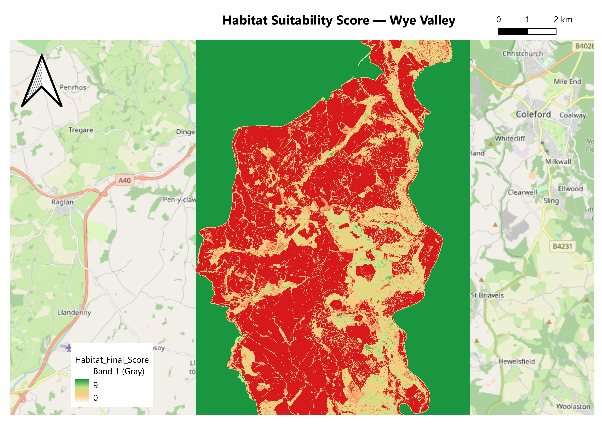
Figure 4: Habitat Layer Final Score — Wye Valley. Higher scores (green/yellow) indicate conifer woodland with tall canopy and interior position; lower scores (red) indicate broadleaved or edge-adjacent woodland.

4.2 Food Suitability Layer

The food layer broadly follows the pattern of the woodland type map, with the highest scores in the conifer plantation patches in the south-western part of the study area (Figure 5). Most of the valley has low food suitability because broadleaved woodland does not provide reliable conifer seed resources for red squirrels (Wauters and Dhondt, 1992). This is likely to be a real limiting factor for any potential reintroduction, as without enough winter food supply, a population would struggle to persist through the cold months.
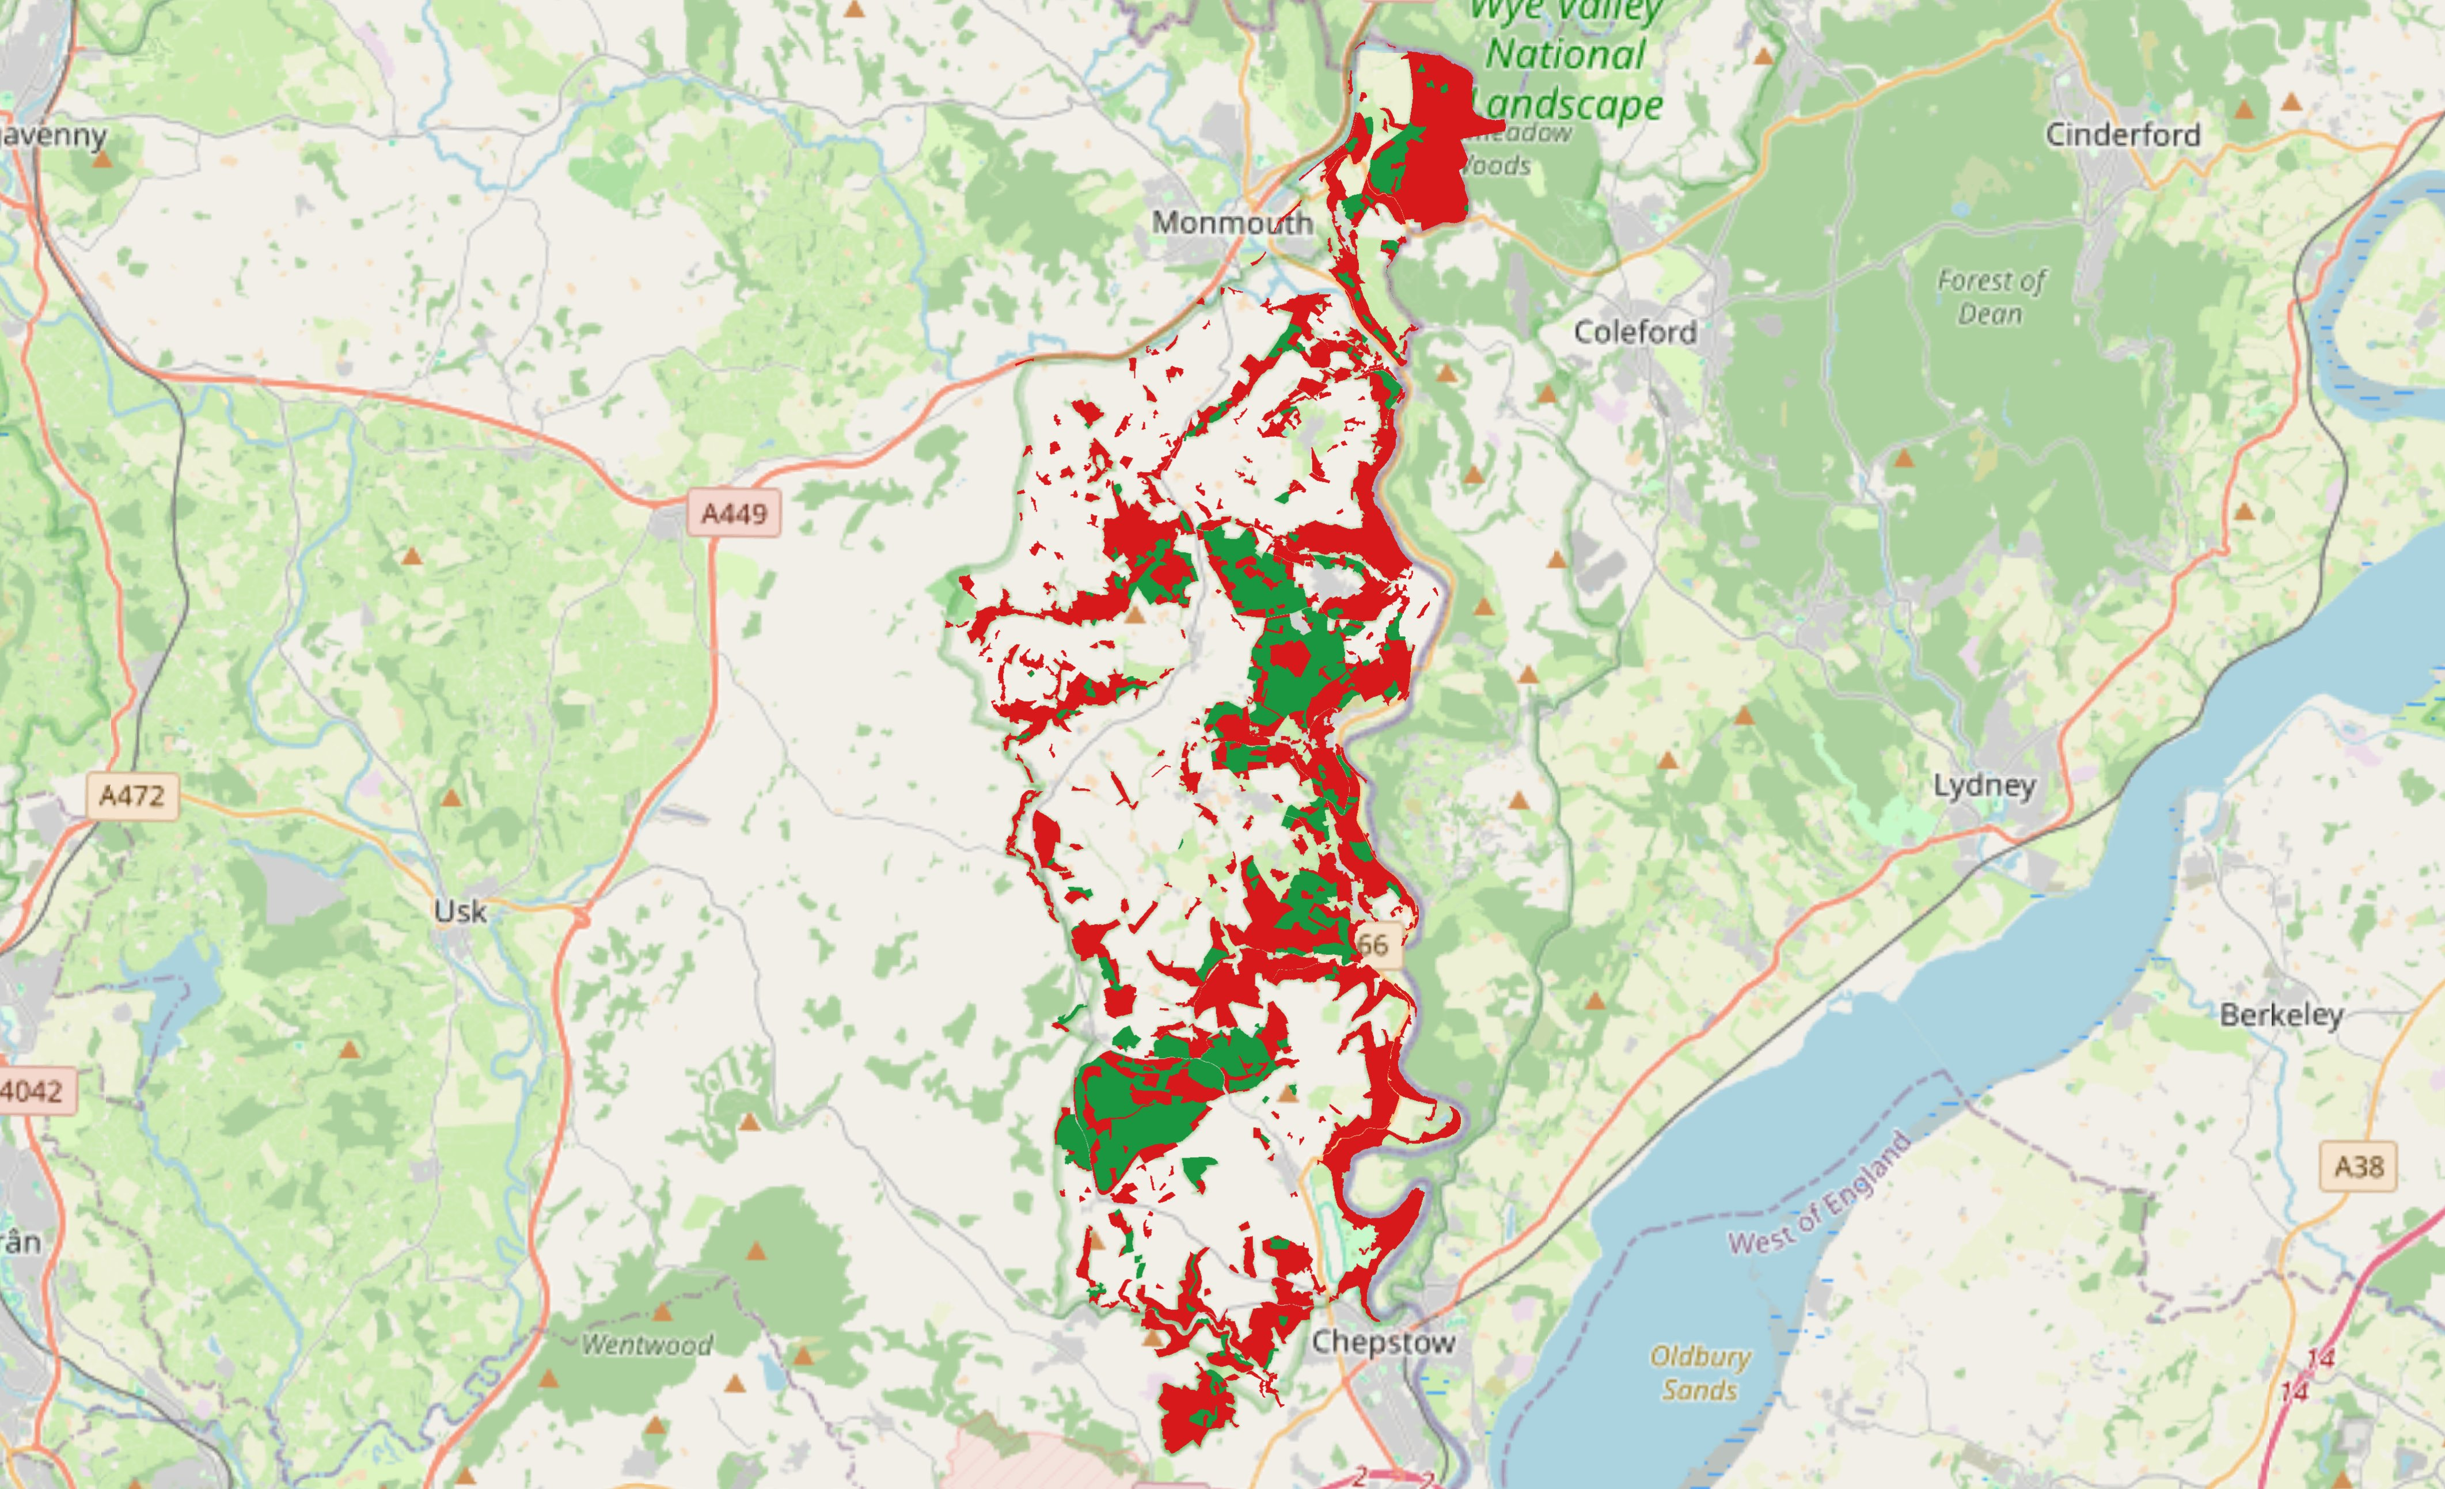
Figure 5: NFI Conifer Presence Score — Food Sub-layer A. Green areas indicate conifer or mixed conifer woodland (score 1); red areas indicate non-conifer land cover (score 0).
The distance-from-edge component (Figure 6) adds detail to the picture, identifying woodland interior areas where foraging conditions are more secure. Higher scores in this sub-layer were associated with areas of woodland interior, while the farmland matrix surrounding the valley received low scores reflecting the limited foraging value of open ground for a woodland-dependent species.

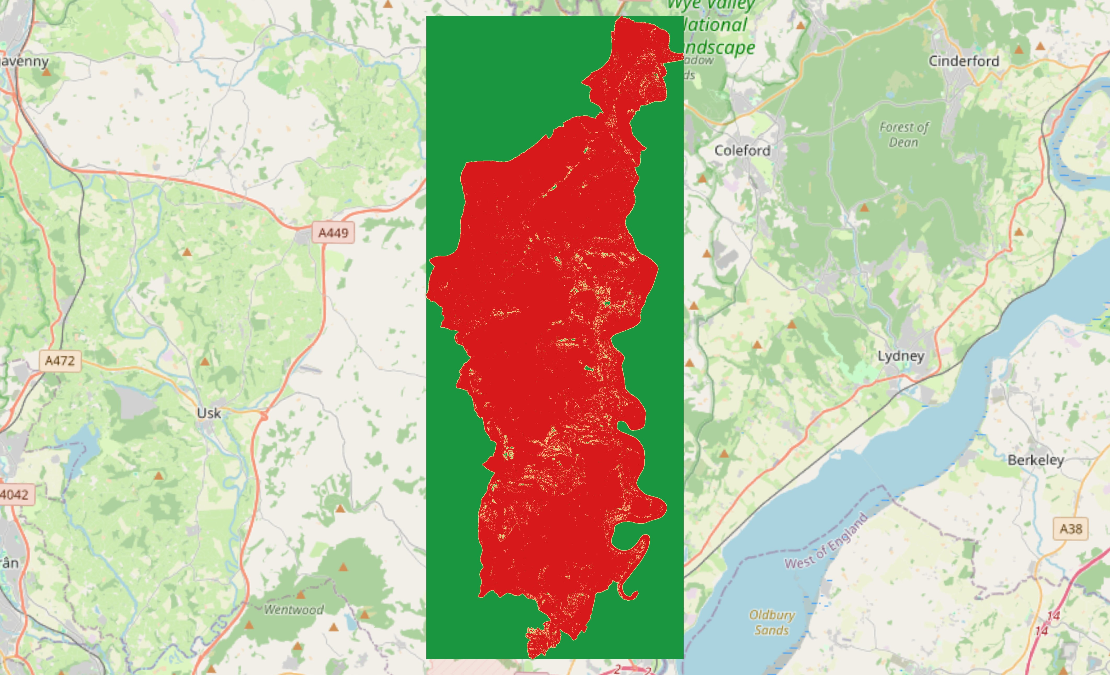
Figure 6: Distance from Woodland — Food Sub-layer B. Green areas indicate greater distance from woodland edge (higher foraging security); red indicates edge-proximate or non-woodland areas.
When the two sub-layers were combined, the food suitability map (Figure 7) showed the highest values in interior conifer patches, areas where both the right woodland type and protected foraging conditions come together. These are concentrated in the southern and south-western sections of the study area.

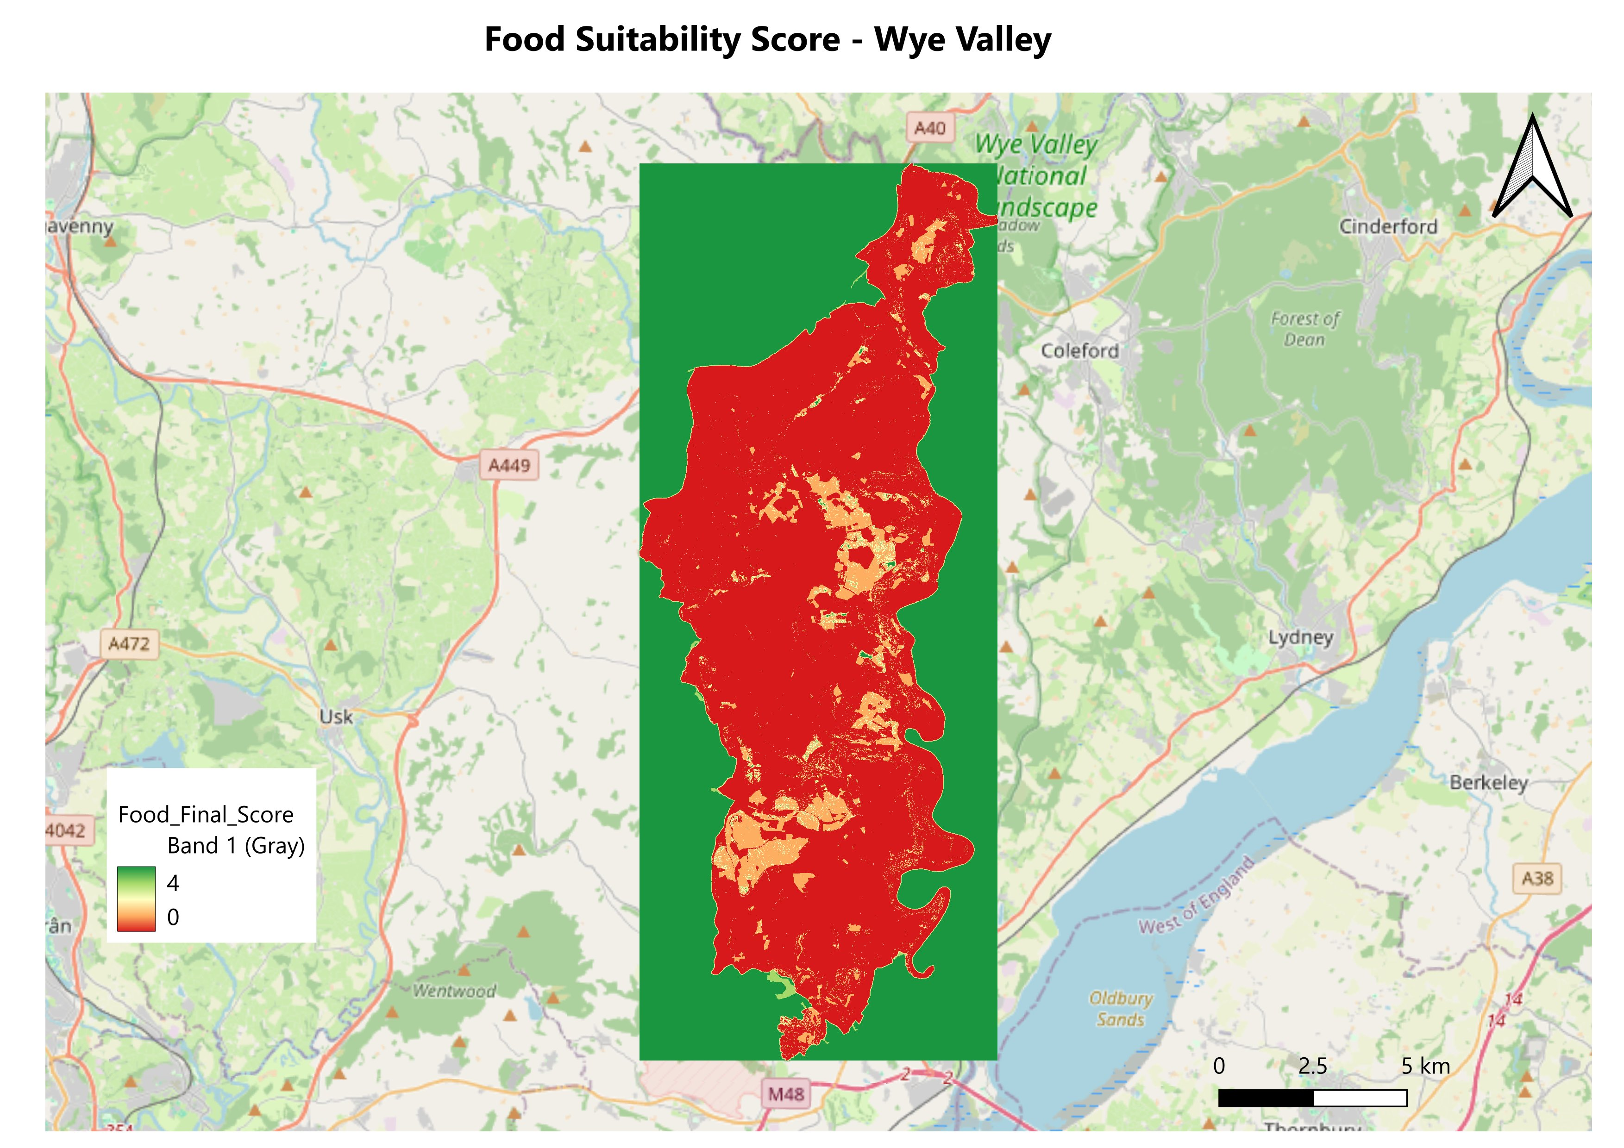
Figure 7: Food Suitability Score — Wye Valley. Higher scores (green/orange) indicate conifer woodland with good interior foraging conditions; lower scores (red) indicate broadleaved or edge-dominated areas.

4.3 Mortality Suitability Layer

The mortality layer came from two sub-layers: wild predator records from the NBN Atlas and urban features from OpenStreetMap. Figure 8 shows the spatial distribution of goshawk and pine marten occurrences across the area, along with the urban feature layer used to represent domestic predator presence. The predator records are scattered across the broader landscape with some clustering in the more forested areas. Urban features, including roads and residential development, are concentrated along the valley floor and main access routes, creating a zone of elevated domestic predator pressure running through the middle of the valley.

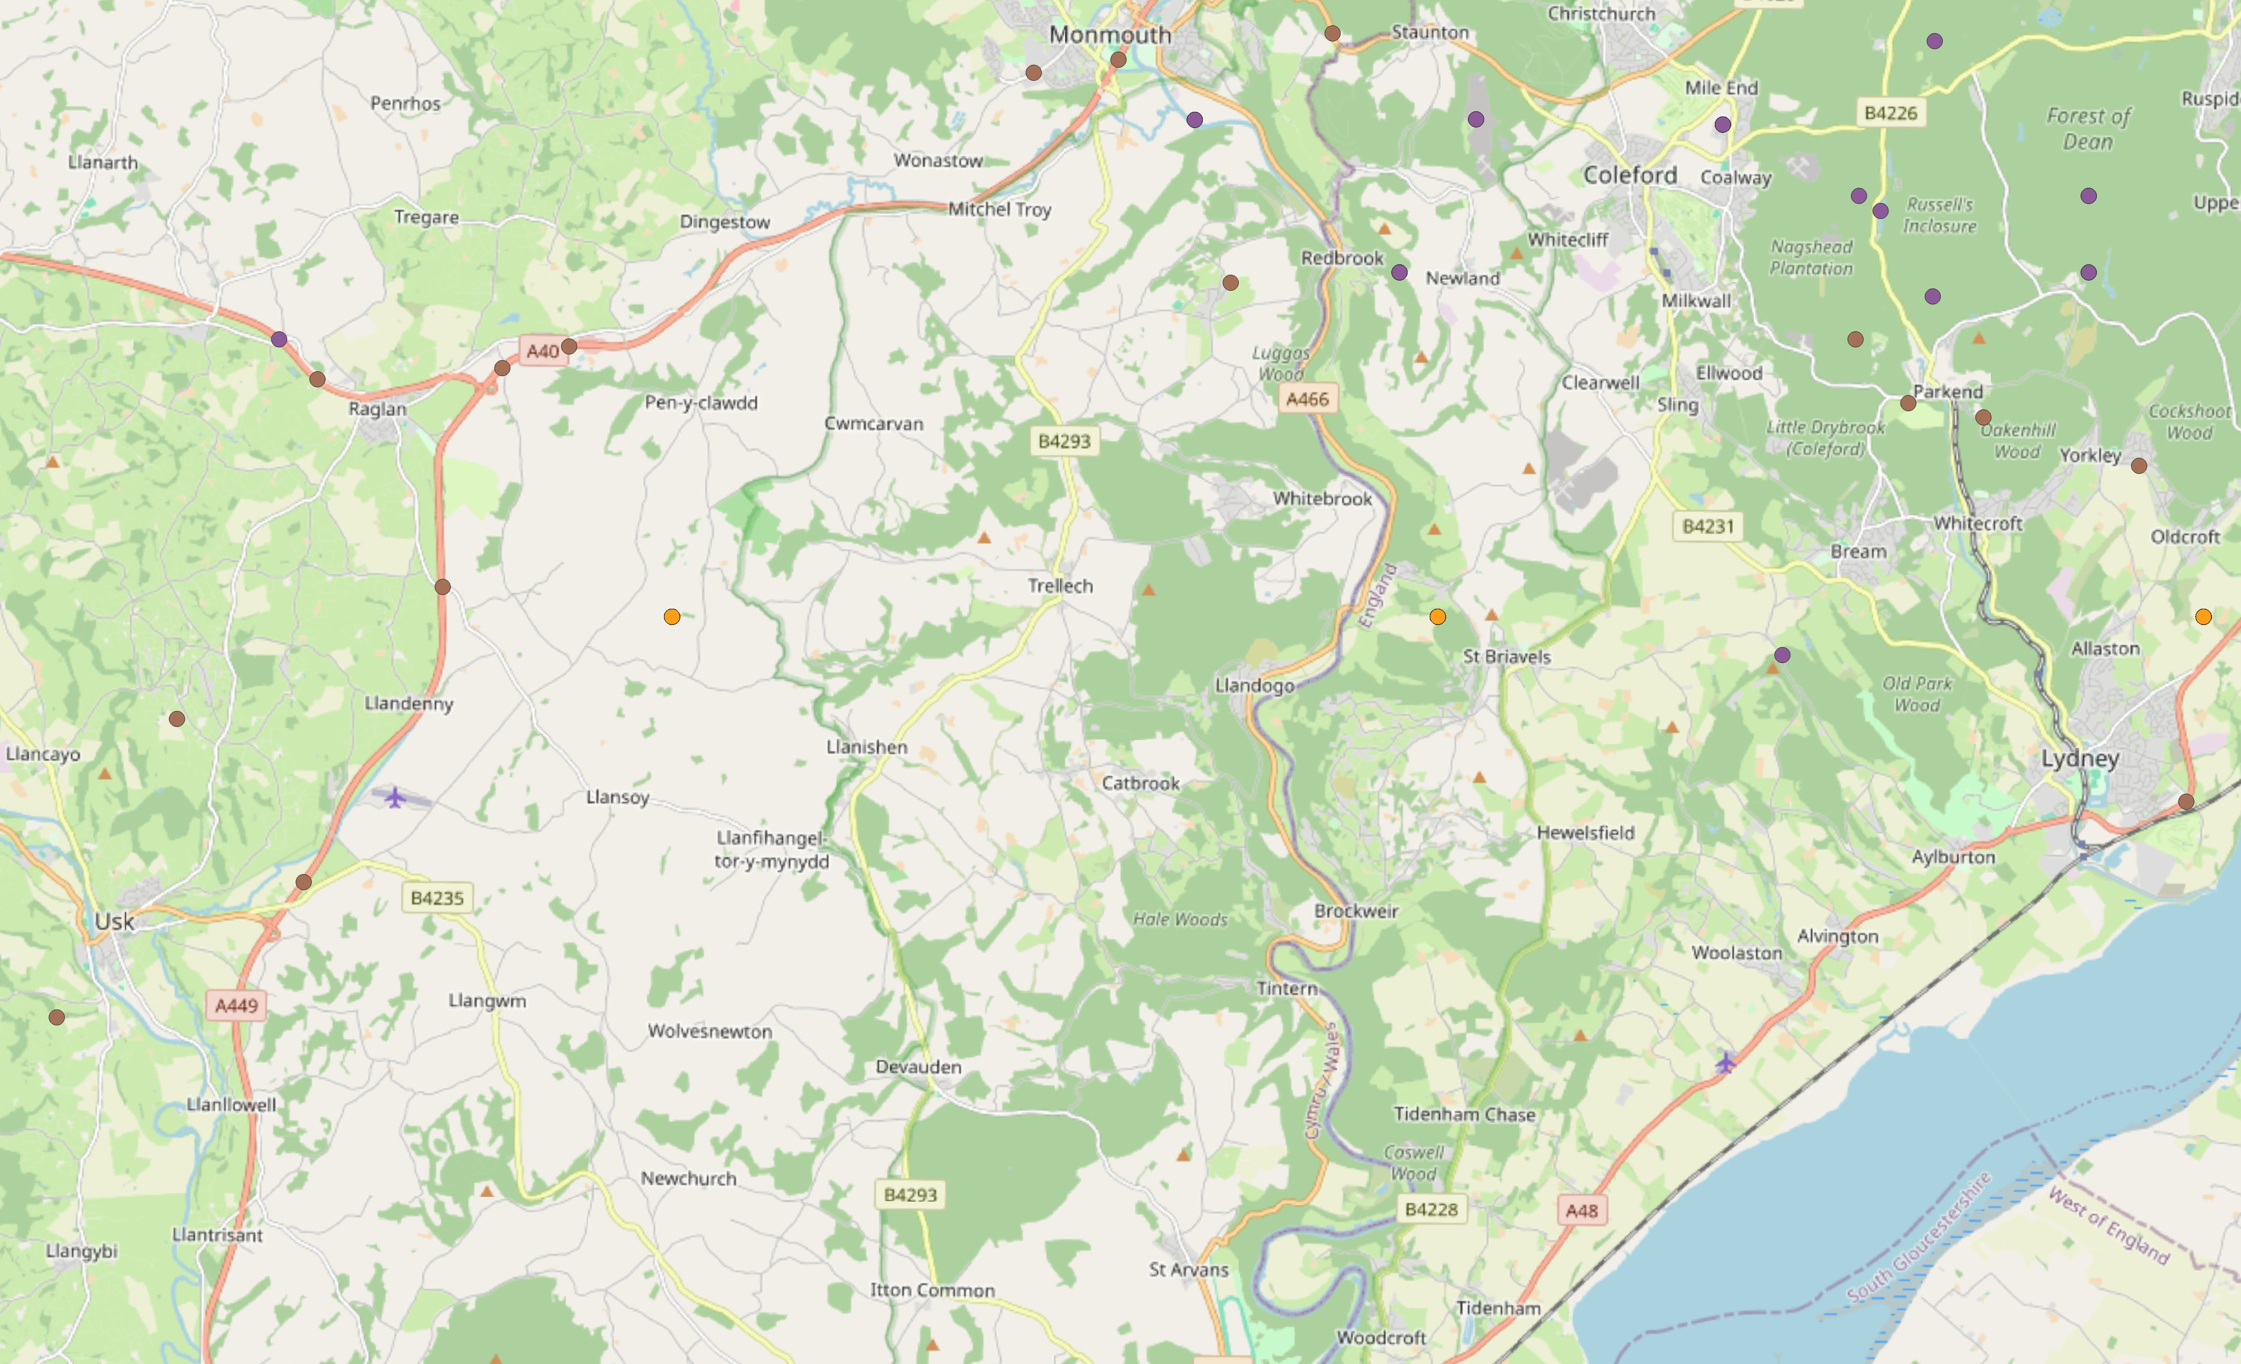
Figure 8: Wild predator occurrences and urban features used in the mortality layer — Wye Valley. Purple = Pine Marten; orange = Goshawk (NBN Atlas, 2024); grey shading = urban features (OpenStreetMap contributors, 2024).
Figure 9 shows the combined proximity surface for both sub-layers. Darker areas indicate higher mortality exposure from both wild predators and nearby settlement, while lighter areas at greater distance from both represent lower risk overall.
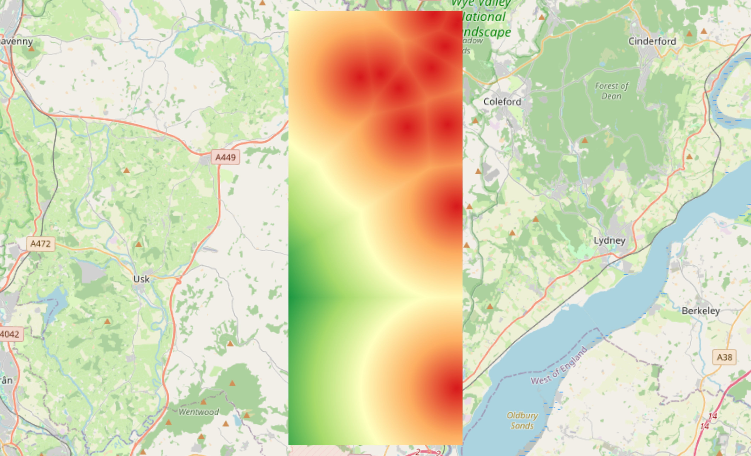
Figure 9: Combined mortality proximity surface — distance from wild predator occurrences and urban features. Lighter areas indicate greater distance from mortality risk sources.
After reclassification (Figure 10), the mortality layer produced a predominantly low-scoring surface across the entire study area. The whole valley falls within ten kilometres of at least one wild predator record, and much of it is also relatively close to settlement, so scores of zero or one dominate throughout. The slightly higher scores in the southern section reflect somewhat greater distances from both predator records and significant urban development in that part of the valley, though no pixel anywhere reached the maximum score of three.
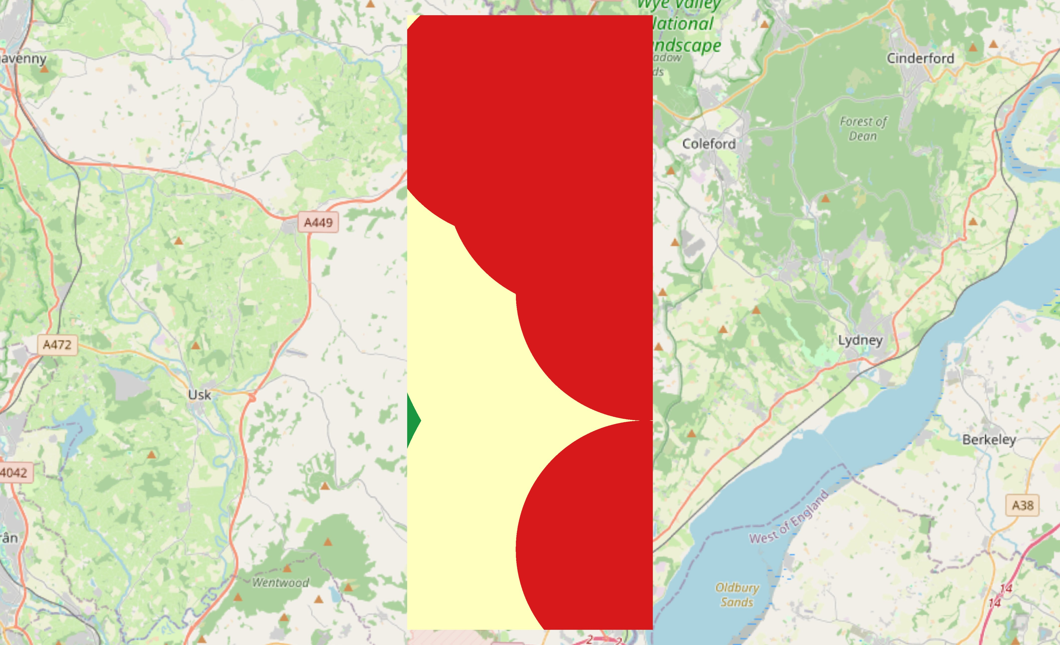
Figure 10 : Mortality Suitability Score — Wye Valley. Green areas indicate greater distance from predator occurrences and urban features (score 2); red areas indicate proximity to mortality risk sources (score 0).

4.4 Final Weighted Habitat Suitability Analysis

Combining the three normalised layers with weights of 0.5, 0.3, and 0.2 produced the final suitability map shown in Figure 11. Most woodland pixels came out as low to medium suitability, which is not surprising given the predominantly broadleaved and fragmented character of the valley. The higher-scoring areas are mainly in the southern section and along the steeper western escarpment, where conifer woodland, mature canopy structure, and greater distance from woodland edges and mortality sources all coincide.
Most of the valley woodland scores in the low to medium range. This is consistent with what Lurz et al. (2001) found when looking at broadleaved woodland in lowland Britain more generally, it can support the odd individual but is unlikely to sustain viable breeding populations without conifer food resources. The analysis identified a number of discrete woodland patches reaching higher combined suitability scores, which represent the most interesting areas from a conservation perspective. These are summarised in Table 7.
The spatial clustering of high-suitability patches in the south is worth highlighting. Isolated high-scoring pixels would not be particularly useful for conservation planning, as what matters is connected blocks of suitable habitat that can support viable home ranges. Lurz et al. (2001) and Hale et al. (2001) both emphasise that patch size and connectivity are as important as local habitat quality for population viability. The clusters in the southern section of the valley, closest to the largest continuous conifer blocks and furthest from the densest grey squirrel records, represent the most credible starting point for any future field assessment or reintroduction planning.
Table 7: Final weighted HSA score distribution across the Wye Valley study area
HSA Score Range | Suitability Class | Approximate % of Study Area | Management Implication
0.0 to 0.75 | Not suitable | 38% | No intervention priority
0.75 to 1.5 | Low | 39% | Habitat improvement possible
1.5 to 2.25 | Medium | 17% | Priority for monitoring
2.25 to 3.0 | High | 6% | Priority for conservation action

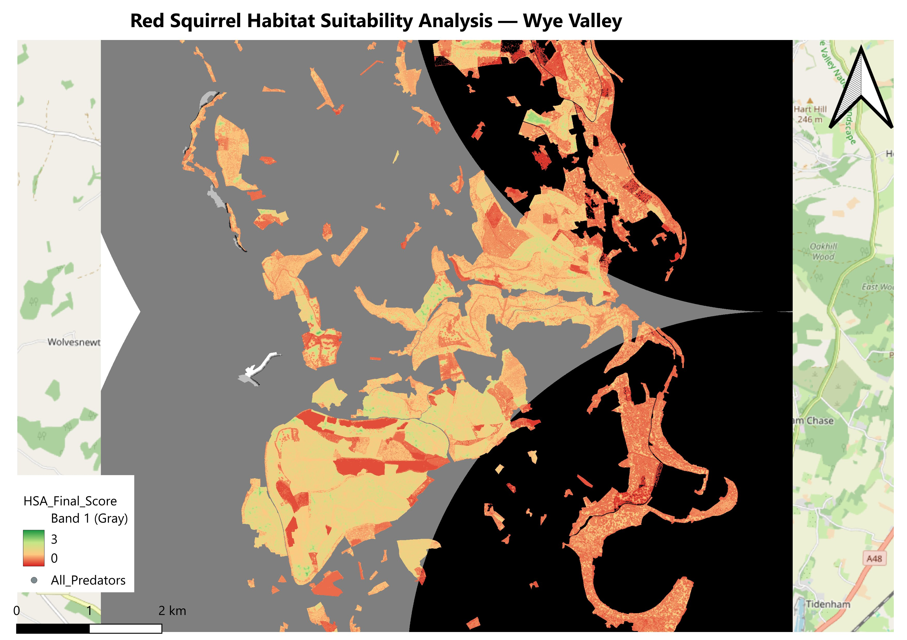
Figure 11: Final Weighted Habitat Suitability Analysis — Wye Valley. Higher scores (green/yellow) indicate the greatest ecological potential for red squirrel occupancy; lower scores (red/orange) indicate constrained suitability.

5. Conclusion

5.1 Summary of Findings

To summarise, this analysis produced a habitat suitability map for the red squirrel across the Wye Valley using a GIS-based three-layer model covering habitat structure, food availability, and mortality risk. The results show that suitability varies considerably across the valley. Most of the woodland falls in the low to medium suitability range, constrained mainly by its predominantly broadleaved composition, the narrow and fragmented nature of many patches, and the widespread presence of mortality risk factors throughout the area. The highest suitability areas, accounting for around six percent of the total study extent, are concentrated in the southern section of the valley, where conifer woodland, mature canopy, and distance from woodland edges and predator sources come together. These are the most logical target areas for future conservation investigation.

5.2 Contribution of GIS to Habitat Management

One of the clearest things this analysis shows is how useful GIS can be for this kind of habitat management question. Traditional field surveys are valuable, but they are slow, expensive, and produce point data that is difficult to extrapolate across a heterogeneous landscape. GIS allows multiple ecological variables to be integrated simultaneously, producing a spatially continuous output that covers the entire study area at once (Guisan and Zimmermann, 2000). The one-metre resolution suitability map produced in this study provides conservation managers with something concrete to work with, specifically a basis for prioritising where to invest in woodland improvement, grey squirrel control, or habitat enhancement.
It is also worth noting how transferable this kind of framework is. With different scoring criteria, the same weighted overlay approach could be applied to other woodland species with analogous habitat dependencies. (Burns et al., 2023) highlighted the growing need for scalable spatial tools in national biodiversity monitoring, and the approach used here, based entirely on freely available data and open-source software, is well suited to meeting that need, particularly for organisations working with limited resources. Store and Kangas (2001) note that the transparency and revisability of explicit weighting schemes is one of their main advantages, and this analysis was designed with that in mind, as the assumptions behind each score and weight are clearly documented and could be updated as new evidence becomes available.

5.3 Limitations

There are a few limitations worth being honest about. The mortality layer relies partly on NBN Atlas occurrence records, which are known to reflect survey effort rather than actual species distribution and may underestimate predation risk where recording is patchy (Tompkins et al., 2003). Using simple Euclidean distance from predator records and urban features is also a significant simplification, as it does not capture habitat permeability, physical landscape barriers, or seasonal changes in predator activity. The vegetation height and edge distance thresholds were taken from published studies rather than calibrated against real red squirrel occupancy data for this valley, so there is some uncertainty about how accurately they represent local conditions. There is also a potential source of error in the CHM on the steepest valley sides, where the narrow gorge topography may partly influence canopy height readings.
The model also does not account for human disturbance, which could be a meaningful gap. The Wye Valley receives significant visitor pressure, particularly along the river corridor and access routes, and woodland close to paths and car parks may be less suitable than the model suggests, as red squirrels can be sensitive to disturbance, especially during breeding. The NFI data also does not record woodland age within a type classification, so old-growth conifer plantation, which may support higher seed productivity, is treated the same as a younger stand of the same type. Including a disturbance proxy based on path and road proximity, and some measure of stand age where data are available, would make future versions of the model more ecologically realistic.

5.4 Recommendations for Future Research

There are several obvious ways the analysis could be developed further. Getting hold of actual red squirrel survey data, presence or absence records from the valley, would make it possible to test the model predictions against reality and assess whether the scoring thresholds are well calibrated. A grey squirrel density layer, based on trapping or survey data rather than simple presence, would also improve the model, as competitive pressure on red squirrels depends on how many grey squirrels are in an area, not just whether they are present at all (Gurnell et al., 2004). Repeat LiDAR surveys over time could track woodland structural change and how it affects suitability going forward, which matters for long-term conservation planning. And the high-suitability patches identified here should ideally be visited in the field before any reintroduction decisions are made.
Community engagement is a dimension that spatial analysis alone cannot address. Any real red squirrel reintroduction or habitat management programme in the Wye Valley would need sustained commitment from local landowners, Natural Resources Wales estate teams, wildlife trusts, and local communities, as without support on the ground, landscape-scale grey squirrel control is not feasible. The suitability map produced in this study could be a useful tool for making that case visually, showing stakeholders clearly where the priorities are and why those areas matter. Community grey squirrel control programmes elsewhere in England and Scotland have shown that sustained effort over multiple years can significantly reduce grey squirrel pressure in targeted areas, creating conditions where red squirrel populations can establish and persist (Gurnell et al., 2004).

References

Burns, F. et al. (2023) ‘State of nature 2023’.
Forestry Commission (2024) National Forest Inventory Wales, Forest Research. Available at: https://www.forestresearch.gov.uk/tools-and-resources/national-forest-inventory/ (Accessed: 20 May 2026).
Game, M. and Peterken, G.F. (1984) ‘Nature reserve selection strategies in the woodlands of Central Lincolnshire, England’, Biological Conservation, 29(2), pp. 157–181. Available at: https://doi.org/10.1016/0006-3207(84)90075-2.
Guisan, A. and Zimmermann, N.E. (2000) ‘Predictive habitat distribution models in ecology’, Ecological Modelling, 135(2–3), pp. 147–186. Available at: https://doi.org/10.1016/S0304-3800(00)00354-9.
Gurnell, J. et al. (2006) ‘Squirrel poxvirus: Landscape scale strategies for managing disease threat’, Biological Conservation, 131(2), pp. 287–295. Available at: https://doi.org/10.1016/j.biocon.2006.04.009.
Hale, M.L. et al. (2001) ‘Impact of Landscape Management on the Genetic Structure of Red Squirrel Populations’, Science, 293(5538), pp. 2246–2248. Available at: https://doi.org/10.1126/science.1062574.
Lurz, P.W.W. et al. (2001) ‘Predicting grey squirrel expansion in North Italy: a spatially explicit modelling approach’, Landscape Ecology, 16(5), pp. 407–420. Available at: https://doi.org/10.1023/A:1017508711713.
NBN Atlas (2024) National Biodiversity Network Atlas — Species Records, NBN Atlas. Available at: https://records.nbnatlas.org/explore/your-area (Accessed: 20 May 2026).
Neteler, M. and Mitasova, H. (eds) (2008) Open Source GIS. Boston, MA: Springer US. Available at: https://doi.org/10.1007/978-0-387-68574-8.
OpenStreetMap contributors (2024) OpenStreetMap, OpenStreetMap. Available at: https://www.openstreetmap.org/ (Accessed: 20 May 2026).
Rushton, S.P. et al. (2000) ‘Modelling the effects of mink and habitat fragmentation on the water vole’, Journal of Applied Ecology, 37(3), pp. 475–490. Available at: https://doi.org/10.1046/j.1365-2664.2000.00504.x.
Store, R. and Kangas, J. (2001) ‘Integrating spatial multi-criteria evaluation and expert knowledge for GIS-based habitat suitability modelling’, Landscape and Urban Planning, 55(2), pp. 79–93. Available at: https://doi.org/10.1016/S0169-2046(01)00120-7.
Tompkins, D.M., White, A.R. and Boots, M. (2003) ‘Ecological replacement of native red squirrels by invasive greys driven by disease’, Ecology Letters, 6(3), pp. 189–196. Available at: https://doi.org/10.1046/j.1461-0248.2003.00417.x.
Twining, J.P., Montgomery, W.I. and Tosh, D.G. (2021) ‘Declining invasive grey squirrel populations may persist in refugia as native predator recovery reverses squirrel species replacement’, Journal of Applied Ecology. Edited by A. Tulloch, 58(2), pp. 248–260. Available at: https://doi.org/10.1111/1365-2664.13660.
Wauters, L. and Dhondt, A.A. (1992) ‘Spacing behaviour of red squirrels, Sciurus vulgaris: variation between habitats and the sexes’, Animal Behaviour, 43(2), pp. 297–311. Available at: https://doi.org/10.1016/S0003-3472(05)80225-8.

