October 29, 2023
Lydia Manley (2307320)

Securing Successful Study Skills
(ECES4012/C)
Part 1: Presentation
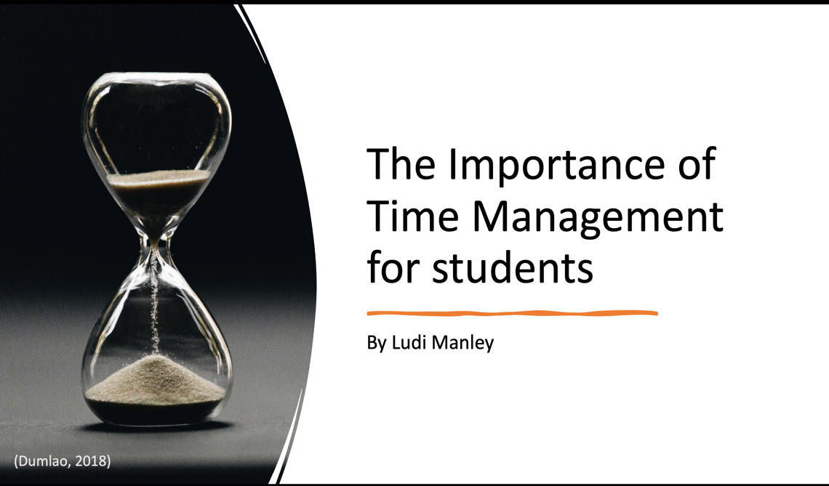

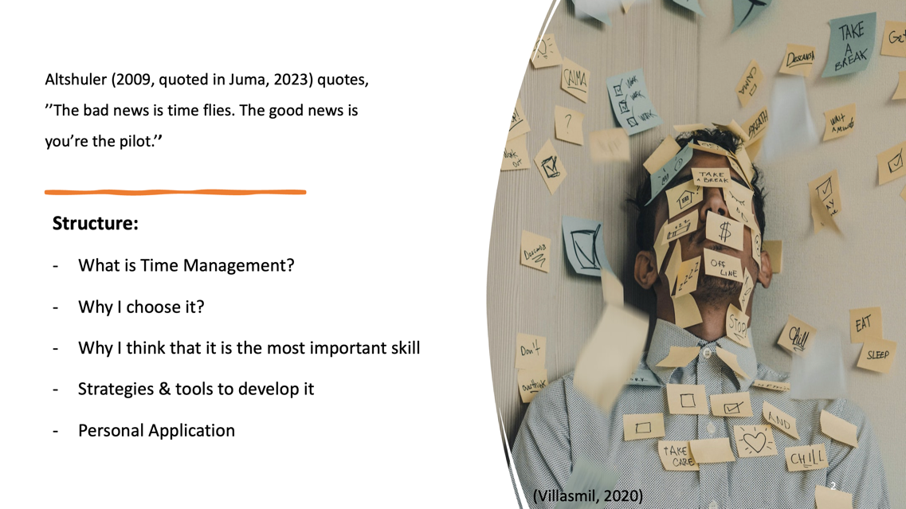
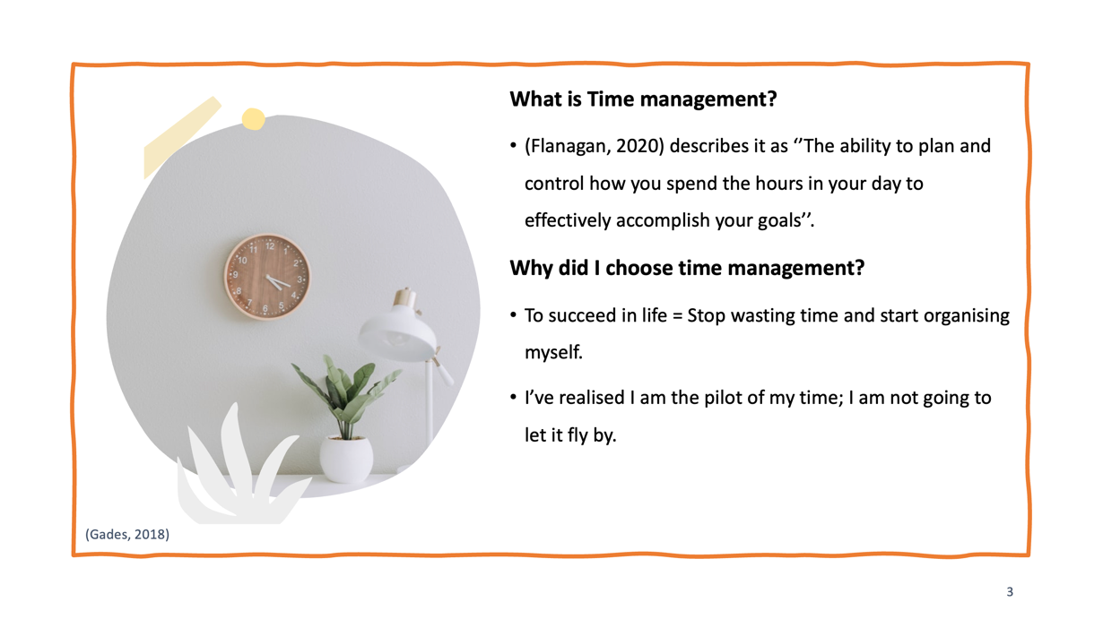
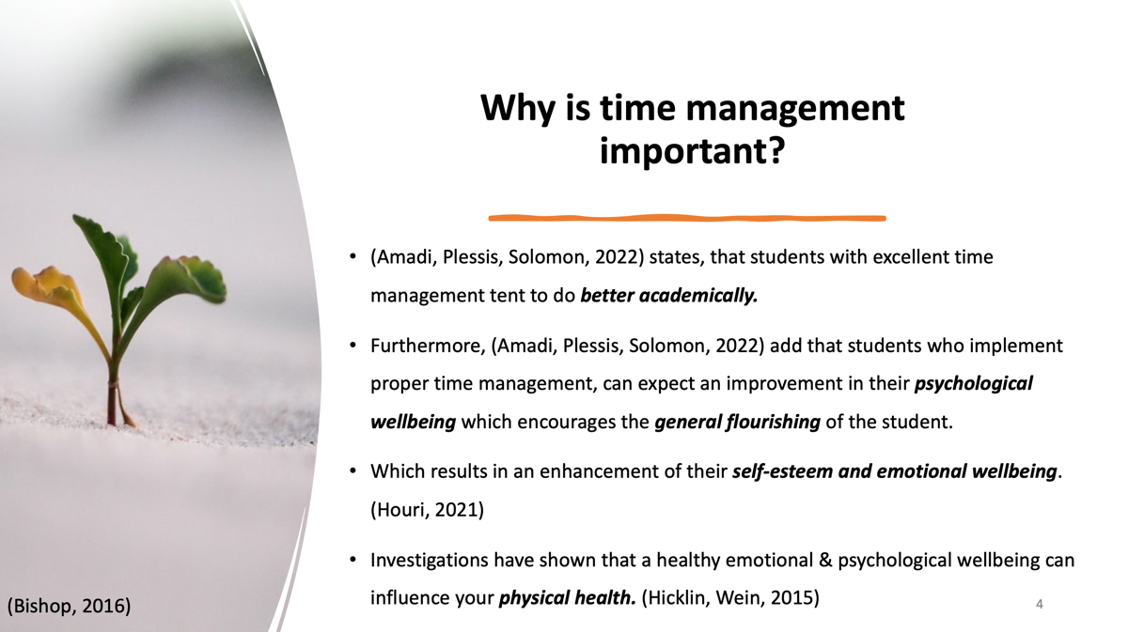

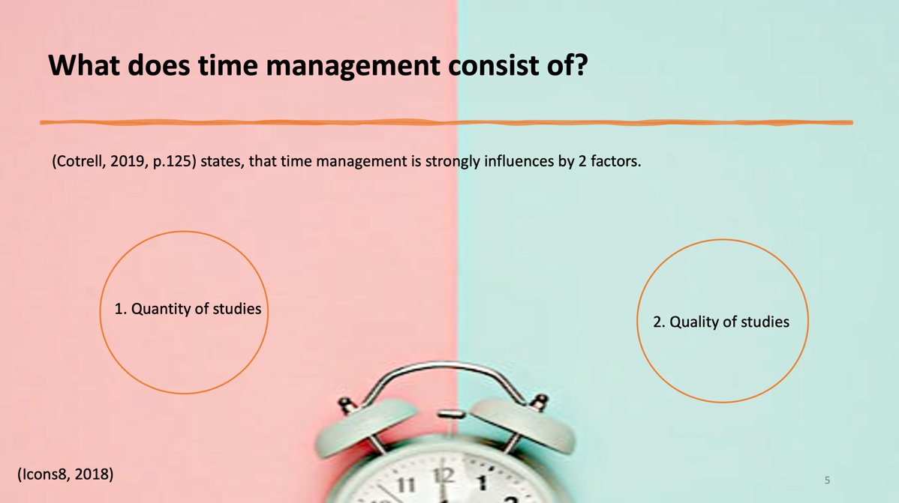

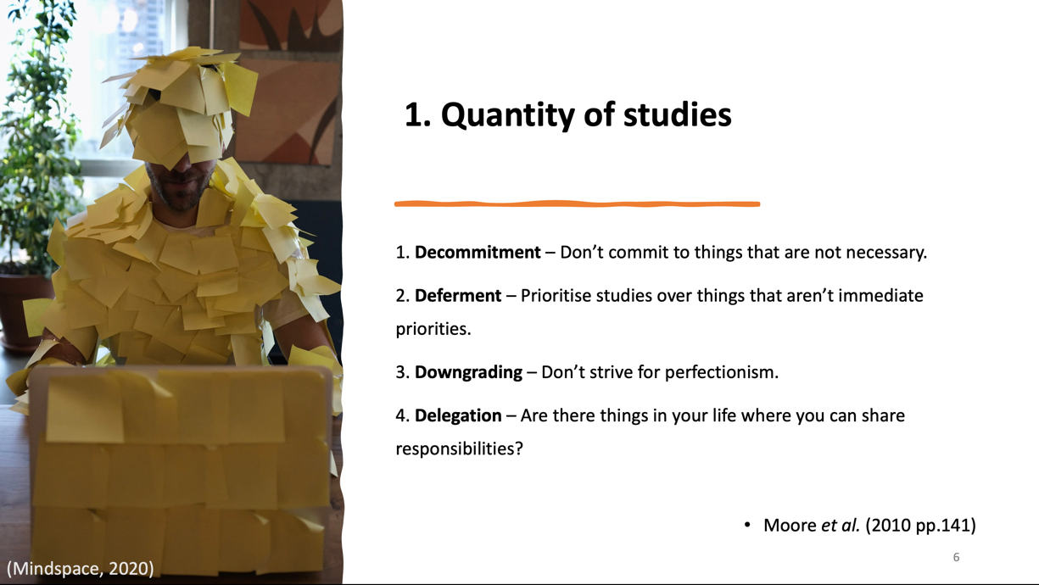
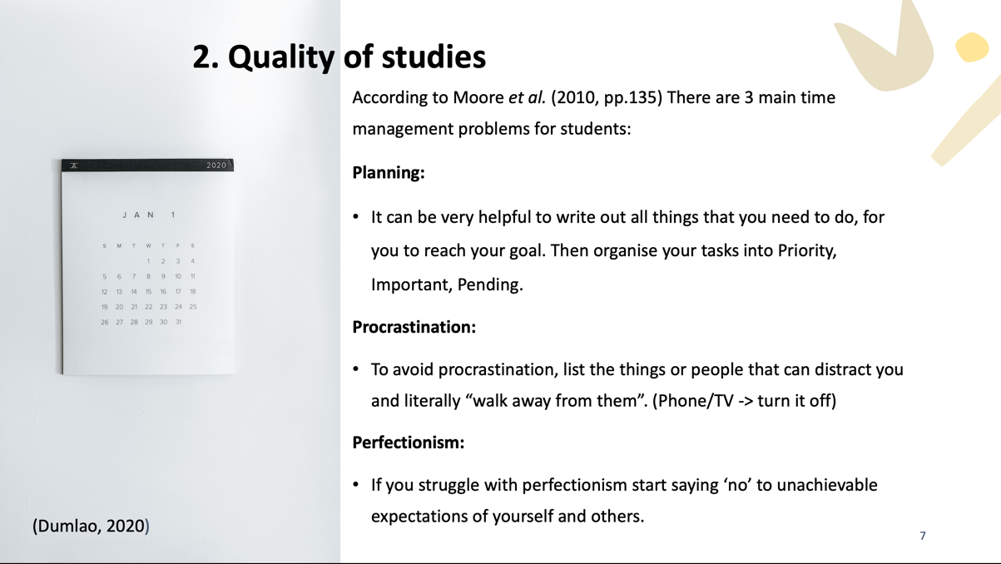

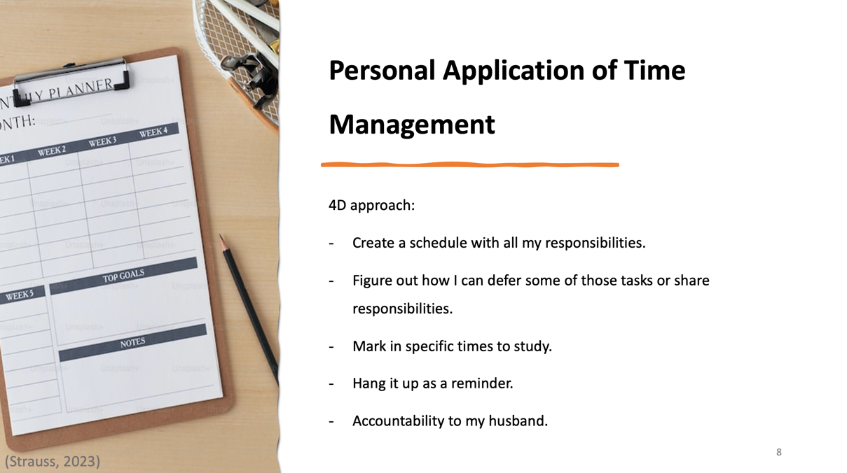

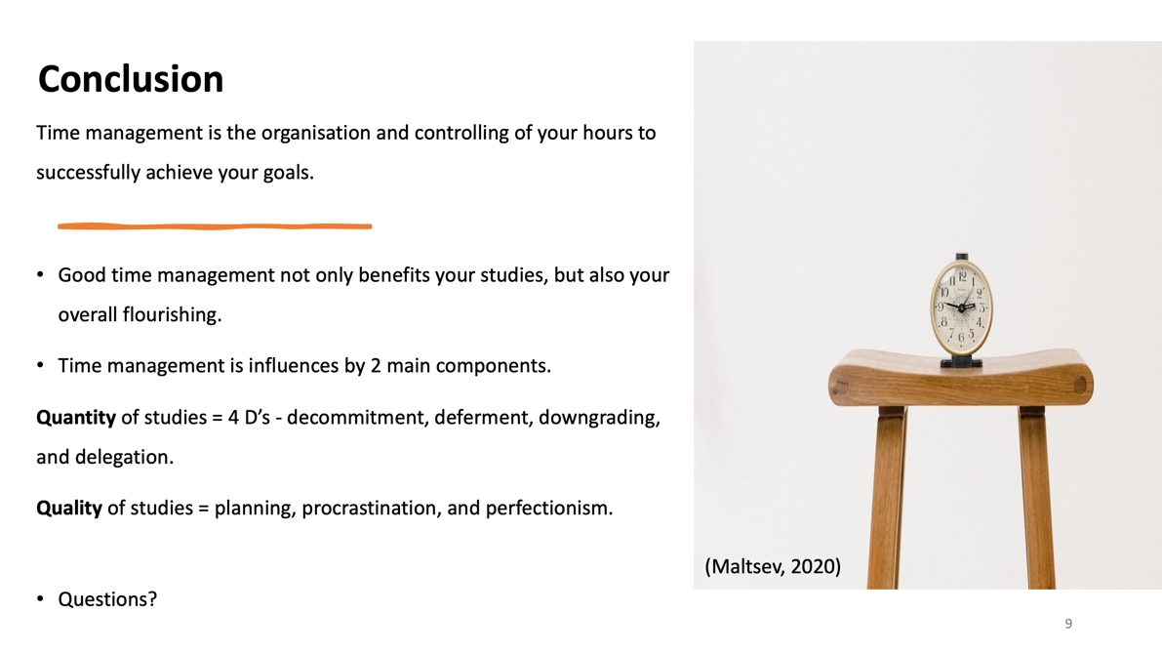
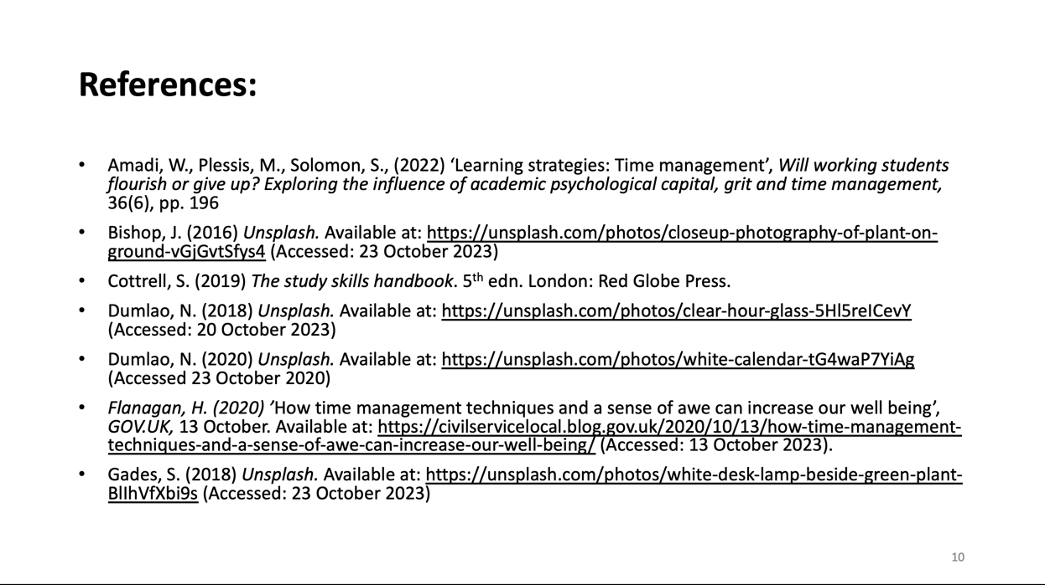
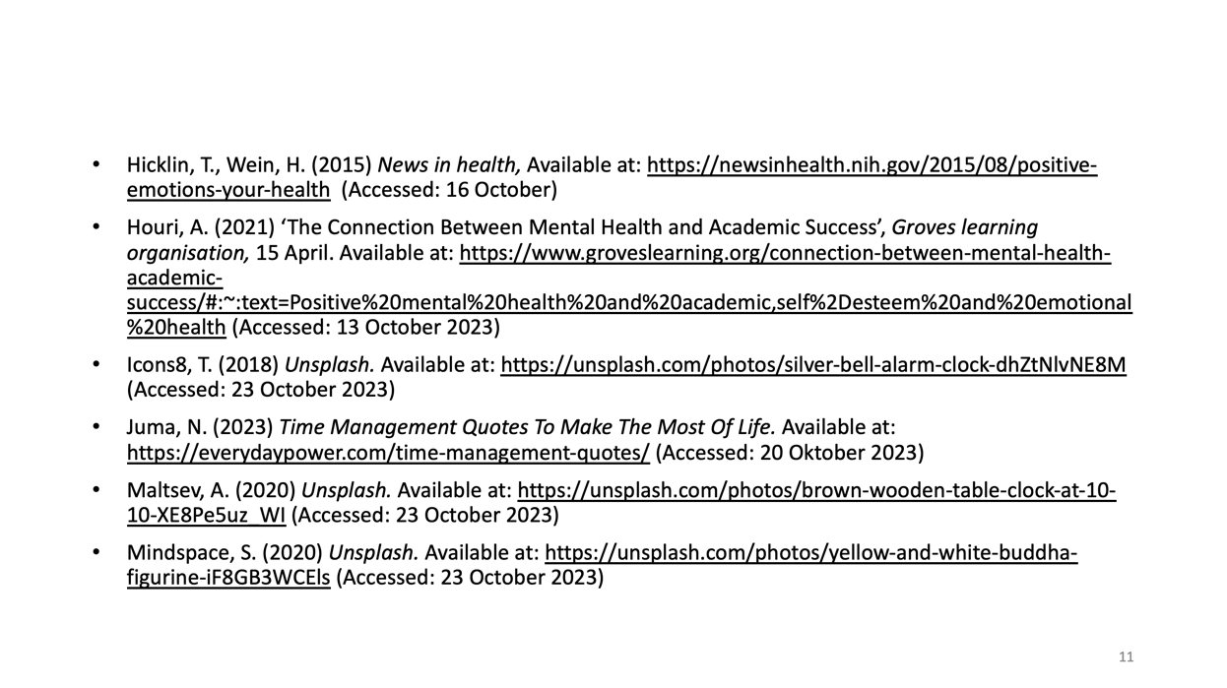
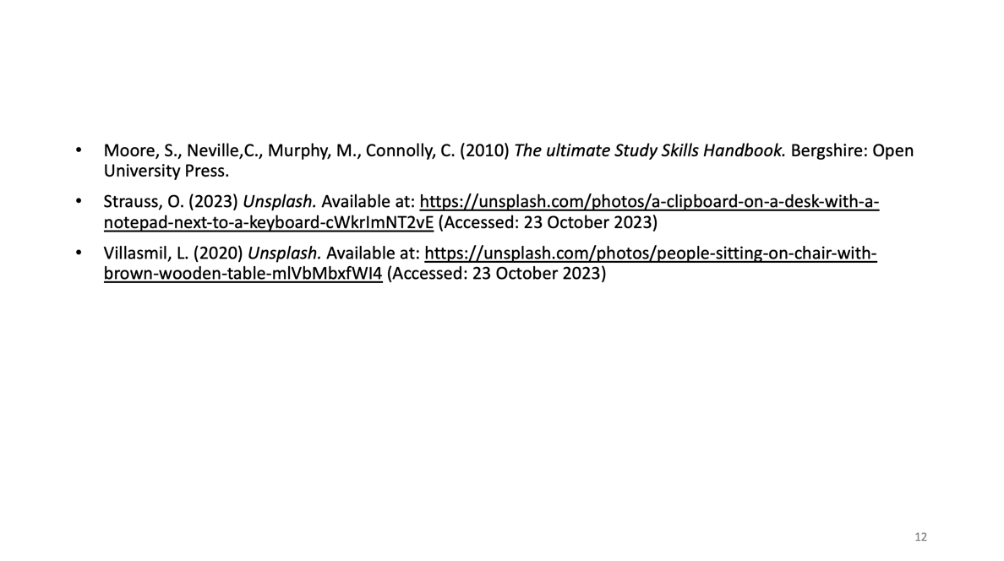

Link to watch my presentation on time management:
https://uowtsd.sharepoint.com/teams/ECES4012SecuringSuccessfulStudySkills-SwanseaCohort_GRP-LydiaManley/Shared%20Documents/Recordings/New%20channel%20meeting-20231023_172850-Meeting%20Recording.mp4?web=1

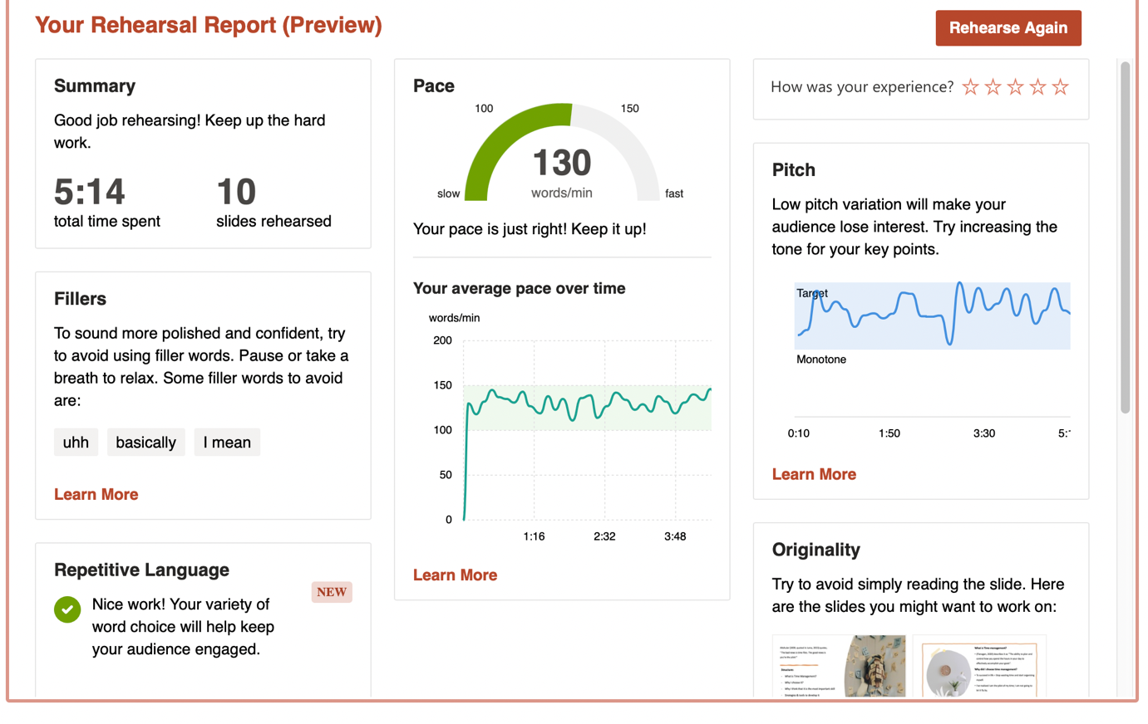
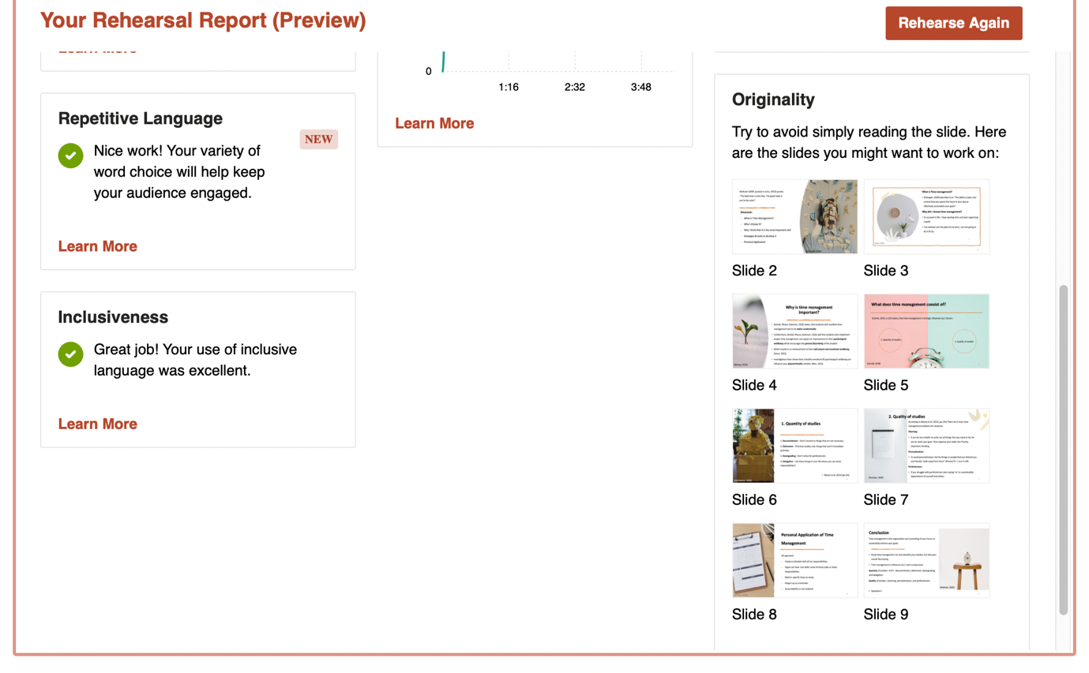

Part 2: Reflective piece

Before starting the course, I was already a little nervous of all the new skills I had to learn, such as academic writing and referencing. Initially I chose the topic of critical thinking for my presentation. Cottrell (2019, p. 119) encourages students to constantly challenge themselves by setting new and higher goals, but only after they have achieved a previous goal. Therefore, I instead chose the topic of time management, a topic I already had some knowledge on, to prioritise learning academic writing and referencing skills, rather than a new topic. I realised the importance of realistic goal setting, as Cottrell (2019, p. 119) claims, that it does not just help students academically but positively influences phycological wellbeing.

I felt excited about my presentation on time management, as I have a fair amount of experience in public speaking. Although, I had some prior knowledge about time management, I was excited to learn more about the topic, as I knew how relevant and beneficial it would be for my time in university. However, I did feel slightly anxious about recording my presentation, specifically using both PowerPoint Coach and recording my Teams call at the same time, as both programs were new for me. Nevertheless, I was able to shelf those feeling to concentrate on my preparation, as I knew from previous experience that worrying about things can often hinder my performance.

When presenting my PowerPoint, I felt nervous about the technical side of recording my video, whilst also using PowerPoint coach. I struggled to do both things at the same time, and therefore had to keep restarting the presentation, which made me more nervous and pressured as every attempt was shown on my personal chat on teams. Not only that, balancing the explanation of time management, being interactive, trying to not read off the slide, acknowledging my PowerPoint coach feedback, and considering what slide was coming next, was difficult to manage.

However, my content reassured me. I think a strength of my presentation was my variation of different sources and the way I connected them all together. My report highlighted a few other strengths, which were the use of inclusive language, not using repetitive language and keeping a consistent pace throughout. I am very pleased with my positive feedback. However, I want to consider my constructive feedback so that I can further my presentation skills.

After delivering my presentation the rehearsal report provided me with three suggested improvements. The first one was my pitch. That surprised me, because I was already aware of the significance of varied tone of voice. However, Becker and Van Emden (2016, p. 17) explain, that varying the sound of your speech can help the audience to discern the importance of your material. They suggest, emphasising a point of major importance by slowing down and raising one’s voice. I realised varying my pitch, does not only mean to occasionally raise my voice, but also to lower my voice sometimes and vary my speed, to emphasis the most important statements.

My second suggestion was to avoid using filler words. Despite Ravinal (2023) arguing that filler words are beneficial, as they can signal deeper thinking, the rehearsal report encouraged me, to instead take a deep breath and pause. I was aware, that filler words can result in a distracted audience. Zandan (2018) compares using filler words excessively to using crutches. The use of excessive filler words can lead to a side-tracked audience, who may then question the speaker’s credibility.

My third suggestion was to improve my originality. The report encouraged me to avoid reading my slide and instead elaborate on a point verbally. Johnson (2009) supports this suggestion and says ‘I tell people that every slide gives the eyes something to look at while it shuts down the ears. Even the speakers stop hearing themselves!’. Taking this into account, I need to consider putting less material on my slides in future.

There were two main things that I would like to have done differently if I would present again. Firstly, I would like to be in a better mindset when presenting my PowerPoint. It took me so many attempts to figure out the technical issues, which resulted in me being tired and exhausted when it came to finally presenting. I probably should have just moved the recording of my presentation to the next morning, having renewed energy and feeling more refreshed.

Secondly, if I would present again, I would need to improve my notes by making them more clear and less jumbled. That would include using shorter sentences, more bullet points and making use of different font sizes and colours. It would also solve a lot of my presentation feedback as inconsistency and jumbled notes, can lead to using filler words, not managing my pitch, and reading off my slides.

In conclusion the two main area I want to improve on in the future, are both related to my general self-awareness. Firstly, I want to become more aware of using filler words. I am aware of the negative impact filler words can have on my presentation skills. Instead of using filler words, I want to replace them with pauses. To achieve that, I want to make a list with my filler words, and I am also going to use Zandan’s (2018) method of tapping my leg every time I catch myself using a filler word and replace it with a pause. The second area I want to improve on is my self-awareness with regards to when I get stressed and anxious whilst doing university studies. I want to ask my husband to keep me accountable during my studies to take more breaks and pauses as I have realised, not having the self-awareness can have a negative result on my academic work and on my mental work.

Reference list:
Cottrell, S. (2019) The study skills Handbook. 5th edn. London: Red Globe Press.

Johnson, M. (2009) 'PowerPoint Intervention: By nixing the bullet points and PowerPoint slides form your presentation, you'll gain back your audience and make your speech more memorable', ProQuest, 22(16). Available at:
https://www.proquest.com/docview/205951959?accountid=130472&parentSessionId=bbnBONAzSPQ4kCuKACnS%2BhxSeEiJKd7ZefWL2uaihCU%3D&pq-origsite=primo (Accessed: 25 October 2023).

Ravinal, R. (2023) 'Why filler words can be good for you', Rosemary Ravinal, 25 April.
Available at: https://rosemaryravinal.com/why-filler-words-can-be-good-for-you/
(Accessed: 25 October 2023).

Van Emden, J. and Becker, L. (2016) Presentation skills for students. 3rd edn. London: Palgrave.

Zandan, N. (2018) How to Stop Saying “Um,” “Ah,” and “You Know”.
Available at: https://hbr.org/2018/08/how-to-stop-saying-um-ah-and-you-know
(Accessed: 25 October 2023).

