Application Development
ACCA5012
Connor Dewi Ellement 1803452
Web Development

Contents
1) Introduction 3
2) Application Development Concepts 3
2.1.1) Online Support 3
2.1.2) Progressive Web Apps 3
2.1.3) Responsive Web Design 3
2.1.4) Message pop-up with websites 3
2.1.5) Quick answer voice search 4
2.1.6) Single-Page/One-Page Website 4
2.1.7) Motion User Interface 4
2.1.8) Saying goodbye to the Flash Player 4
2.2.1) My chosen trend – One-Page Websites 4
2.2.2) The Mobile Experience 4
2.2.3) The Target Audience 5
2.2.4) The Downsides 5
2.2.5) When to use a One-Page Website 6
3) Requirements 6
3.1) Introduction to my site 6
3.2) Mobile first strategy 7
3.3) My chosen API 9
4) Design & Implementation 9
4.1 Overview of the website 9
4.2) Screenshots of website 11
5) Evalutation 14

Introduction
In this assignment I will research current and upcoming development trends in my area of study, which is Web Development, and list a few of the ones that gain my attention most, and then will pick one to talk about in detail.
For the other half of this assignment, I will be building a responsive website that will be visually appealing, consume a JS Web API, provide another function using JS, and support multiple browsers.

Application Development Concepts
My specific area of application development for this module is Web Development, so I have researched the top upcoming Web Development trends for 2020 and the foreseeable future and will be listing them as well as giving a brief description of each.

2.1.1) Online Support
Online support chatbots and chat windows that are available 24/7 to be able to help a user who may be struggling.

2.1.2) Progressive Web Apps (PWAs)
PWAs are becoming increasingly popular with companies and users, as they take away the need of downloading an app onto a device, as the website itself looks and feels like the user is using an app.

2.1.3) Responsive Web Design
Responsive Web Design is an extremely important development technique as it gives users access to be able to use a website on essentially, any device they would like. According to the company Adobe, they did research and found that [1] “Nearly 8 in 10 of consumers would stop engaging with content that doesn’t display well on their device”

2.1.4) Message pop-up with websites
Pop-up messages are used for sending data directly to a consumer, which would be related to the website, making it a good way of advertising information.

2.1.5) Quick answer voice search
A lot of companies have an AI voice these days, Google have, well Google, Apple have Siri and Microsoft have Cortana. These AI are becoming more frequent on websites as they offer quick access to information that a consumer may need.

2.1.6) Single-Page/One-Page Website
One-Page websites are relatively new on the scene of Web Design, and they do, pretty much what the name suggests. They are websites that run off a single page rather than multiple pages for different sections.

2.1.7) Motion User Interface (MUI)
An MUI’s job is to retain the attention of a user. The average attention span in 2013 was 8 seconds, and now in 2019, we can be fairly sure that has dropped to around 6-7 seconds. So, what better way to keep attention than a visually appealing motion interface.

2.2.1) Chosen trend – One-Page Websites
As previously mentioned, Single-Page websites are relatively new, however that doesn’t mean they aren’t popular. Actually, it is the opposite, single-page websites are extremely popular at the moment. Businesses/companies are more often now choosing to go with one-page sites rather than building over complicated multi-page sites.

2.2.2) The Mobile Experience
J. Clement with Statista had this to say on mobile users, [2] “According to April 2019 data, the global mobile population amounted to 4 billion unique users. As of February 2019, mobile devices accounted for 48 percent of web page views worldwide, with mobile-first markets such as Asia and Africa leading the pack”. This quote alone shows the impact mobile users have on the online market, and it has been found that typically, one-page websites give mobile users a better experience than a multi-page website. This is the case because one-page websites load much faster than traditional multi-page ones, and this is great for businesses as people’s attention spans are so low, that quick load times means there is greater chance to keep the user interested.

2.2.3) The Target Audience
Single-Page websites offer a good method of control over the website to be able to target specific audiences easier and give the users a better viewing experience. This control factor is good for companies because it means they can display all the information/data to users on one-page compared to multiple pages reducing the chance of users getting lost on the site and being on the wrong page to what they need, and it also allows companies to dictate what order the information gets viewed in. However, this can also be a negative fact, as mentioned before, users’ attention spans are low, so if the user is viewing information, they don’t deem useful, they will click off the website.

2.2.4) The Downsides
As One-Page websites are typically built and made for a single purpose, it limits the information and keywords that are put on the website. This is negative as the lack of keywords limits the hits a website would get if being searched for on a search engine such as Google or Bing.
Adam Heitzman with SEJ said this, [3]“Another downfall to single page sites is that the content published on them is generally not as specific as what is published on multi-page sites”. As much as a one-page site might be helpful with aiming the site towards one specific audience, they don’t give you the option of dedicating separate pages to different areas you might want to cover. A website could be the most beautifully constructed website of all time, however, it could still leave some visitors dissatisfied with the lack of relevant content they might be after.

2.2.5) When to use a One-Page Website
Now that I have discussed some of the up and down sides to one-page websites, I feel that I can give an accurate explanation on when it is a good time to use one over a multi-page website.
It is then down for that business to decide whether the site is going to only include information on this specific topic and who the target audience is. If the purpose of a website is to solely display information about one specific topic and caters towards one specific audience, then it is probably a good idea to use a single-page site.
If a company is building a website to suit multiple purposes (For example, ul.ign.com cover films, books, games reviews, as well as have their own blogs on various topics) then it is probably best to use a multi-page website so that each page can have a dedicated subject rather than the information being in all one space. It also gives companies more creative freedom.

Requirements

3.1) Introduction to my site
The website I have created is called “Pokémon Top 10’s”. The websites purpose is to display top 10 lists of Pokémon in certain categories. The categories I have listed are all 18 types found in the Pokémon universe, as well as top 10 list in mega-evolutions and in the “legendary” status of Pokémon. The target audience for the site is anyone who has an interest in Pokémon, or anyone who is looking to get into Pokémon. We can get a more accurate idea of the target audience if we take a look at some statistics from when Pokémon Go was launched in 2018, provided by an anonymous writer by the name of SurveryMonkey Intelligence on medium.com, [4] “A couple of weeks after Pokémon GO’s initial launch on July 6, the game’s average player demographic was characterized by a 25-year-old white woman with a college degree making about $90,000 per year”. Below is a stats chart provided by the same site and author: [4]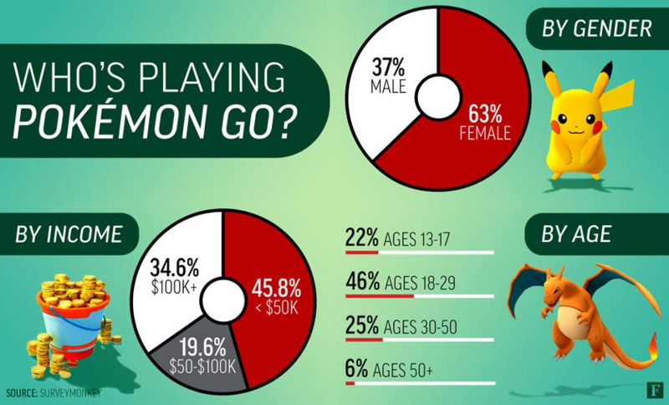
Obviously, these statistics are a few years old, however, these stats are to the most part still relatively close to what they would be now, due to adults growing up with Pokémon and young children only now discovering it.

3.2) Mobile first strategy
The mobile first strategy is simply the term given to websites that are built towards mobile compatibility before anything else. This strategy is very popular when building websites these days because of all the internet browsing that comes from mobile usage.
My website also follows this strategy and is responsive towards mobile devices as well as desktop monitors and TV screens. The mobile first strategy is accomplished by using the ‘@media’ tag in CSS documents like stylesheets. The ‘@media’ tag allows a website creator to tell what a website should do if being viewed on a smaller set of dimensions (for example, 1920px x 1080px, or 444px x 315px). The main use of the ‘@media’ tag for me is for use of my navigation bar. The navigation bar spreads out horizontally across the page of the website, unless the website goes under 600 pixels wide. If the site is being viewed on a width of 600pixels or under, the navigation bar collapses into what is called a burger bar and is then hidden until the burger bar image is clicked to reveal the navigation links. I used 600px for the end point because when using Google’s responsive check, that is when a lot of the content was getting squashed in and needed to be re-arranged.
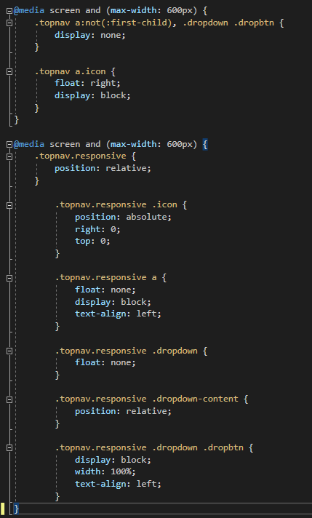
Another big part of making a website responsive for mobile devices, is scaling the website via percentages (%) rather than using pixels, which I have done. This is because percentages can work via the dimensions they are given, rather than for example an image being given a set amount of pixels to always stay at, and another way of explaining this is that 100% of a laptop screen is different to 100% of a mobile screen, so the ratios differ. I also used ‘float’ in CSS which was also extremely helpful when it comes to responsiveness as it gives the creator the control of containers, images, paragraphs. By using ‘float: left’ combined with the ‘@media’ tag, it tells content to go to the left of whatever content before it, so on a mobile device, if there is a paragraph before an image, the image would float left and go underneath the paragraph as there is no space to the left due to the width region of the device. An example of this can be seen below:

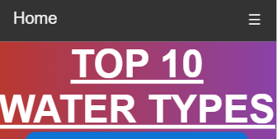

3.3) My chosen API
The API I chose to go with is called PokeAPI. It is essentially a Pokémon database filled with data on each Pokémon. My JavaScript using the API retrieves specific Pokémon’s data via an ID, and then displays the requested data of that Pokémon on the top 10 list. This API holds a lot of data, and I am only using a portion of it to not make the list overcomplicated, so I am only using the data I am deeming necessary. To get an idea about how the API worked, I watched a tutorial on YouTube from iEatWebsites [5].

Design & Implementation

4.1 Overview of the website
My website used colours that complement each other quite well, and the reason I have done this is so that the website is visually appealing, there is nothing worse than having content you cannot read or see because it blends in with the background. I have used what I deem a ‘content switch’ to change to content on my pages without loading a new page and staying on one URL. This gives the website an impression of a one-page website, while still being able to delegate different pages to different subjects/topics. I have included a navigation bar that sits at the top of my website, but also collapses into a burger bar icon when being viewed on a mobile device to contribute to the mobile first strategy. I followed a coded tutorial from W3 Schools for the collapsible menu [6]. As mentioned in my API section, my API JS code retrieves the JSON data for a specific Pokémon when a specific Pokémon’s name is entered into an ID that is found in the class ‘.Pokemon’, it then displays the chosen data, onto the top 10 list that the Pokémon is involved in. The code for my functions and JS can be found below:
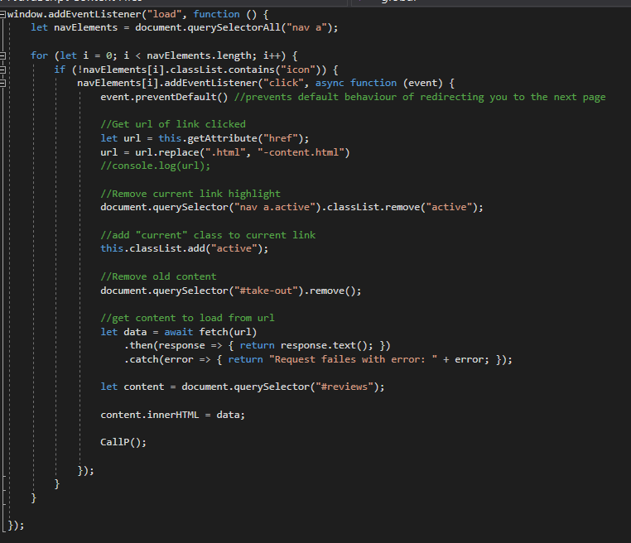
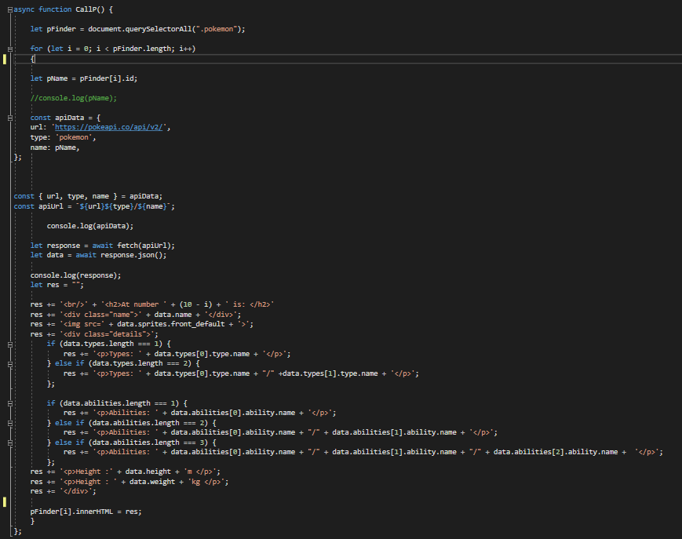
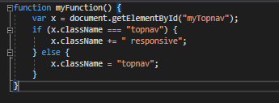

4.2) Screenshots of website
Here are the screenshots from my website. I haven’t included all pages under the “types” drop down due to the amount there are, but they all follow the same code and design.
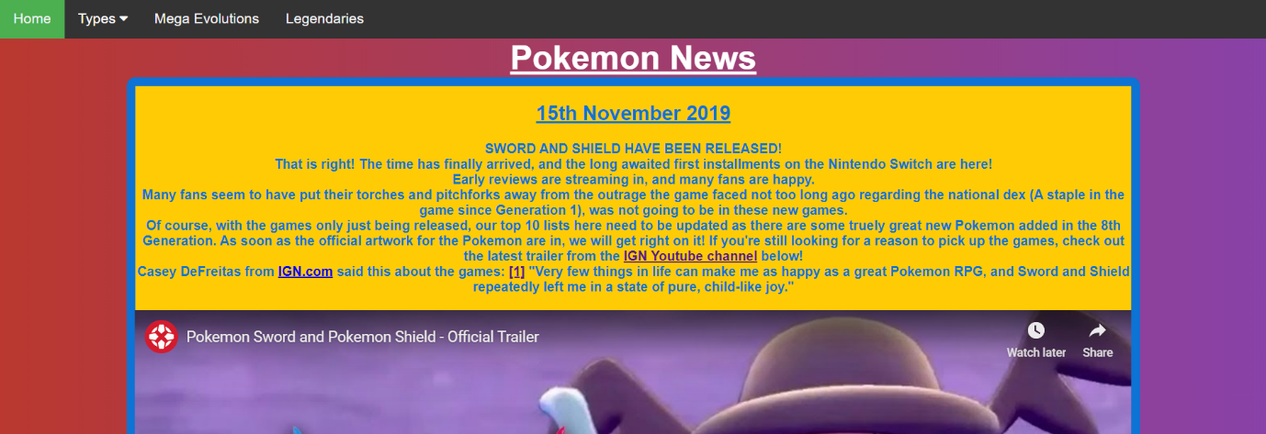

*”ACTIVE” CLASS IS SHOWN IN THE “TYPES” DROP MENU*
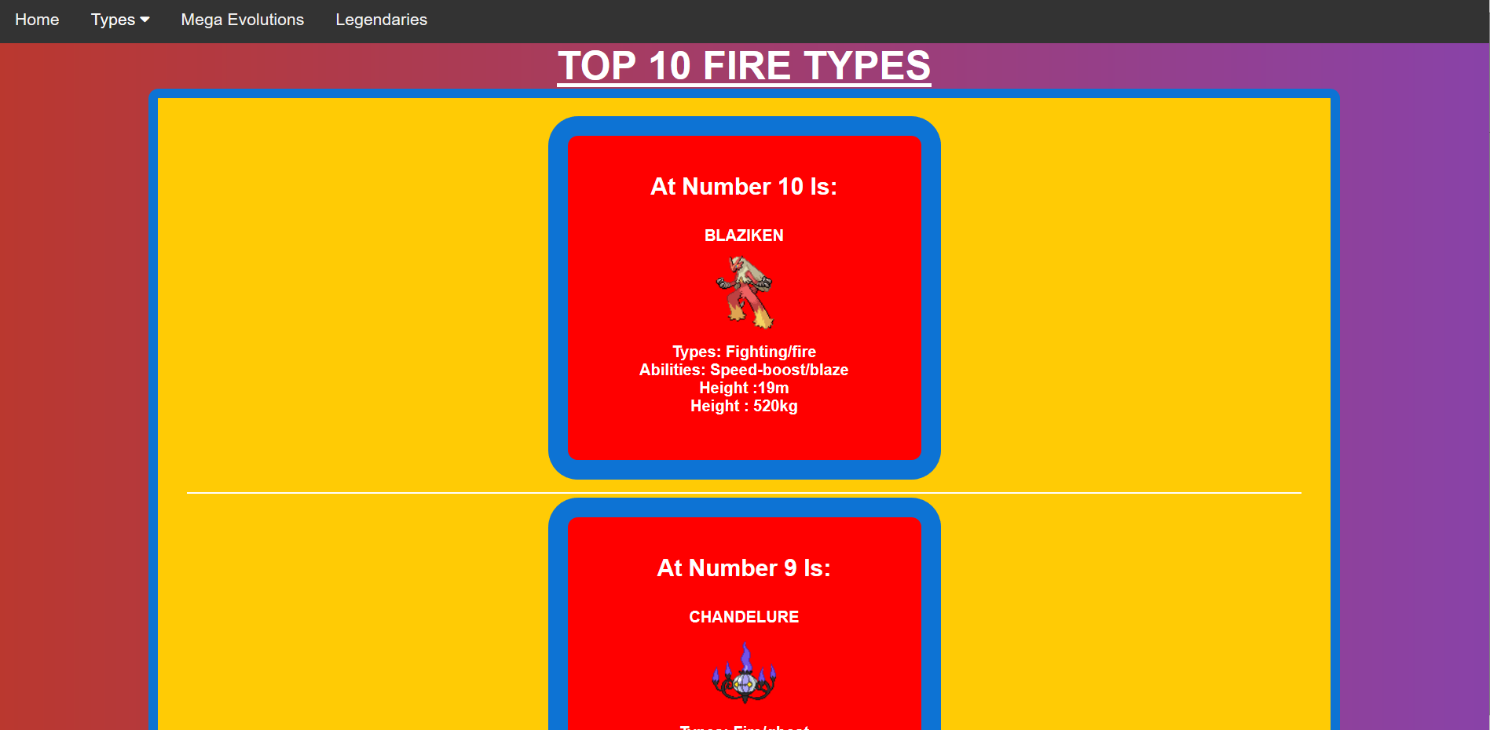
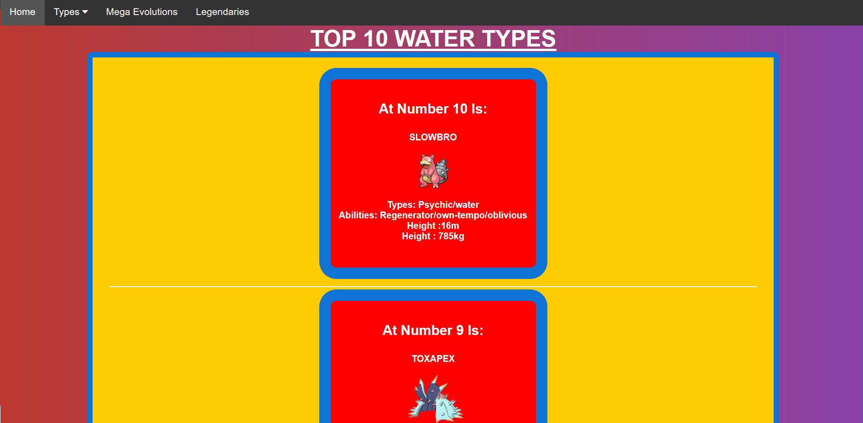
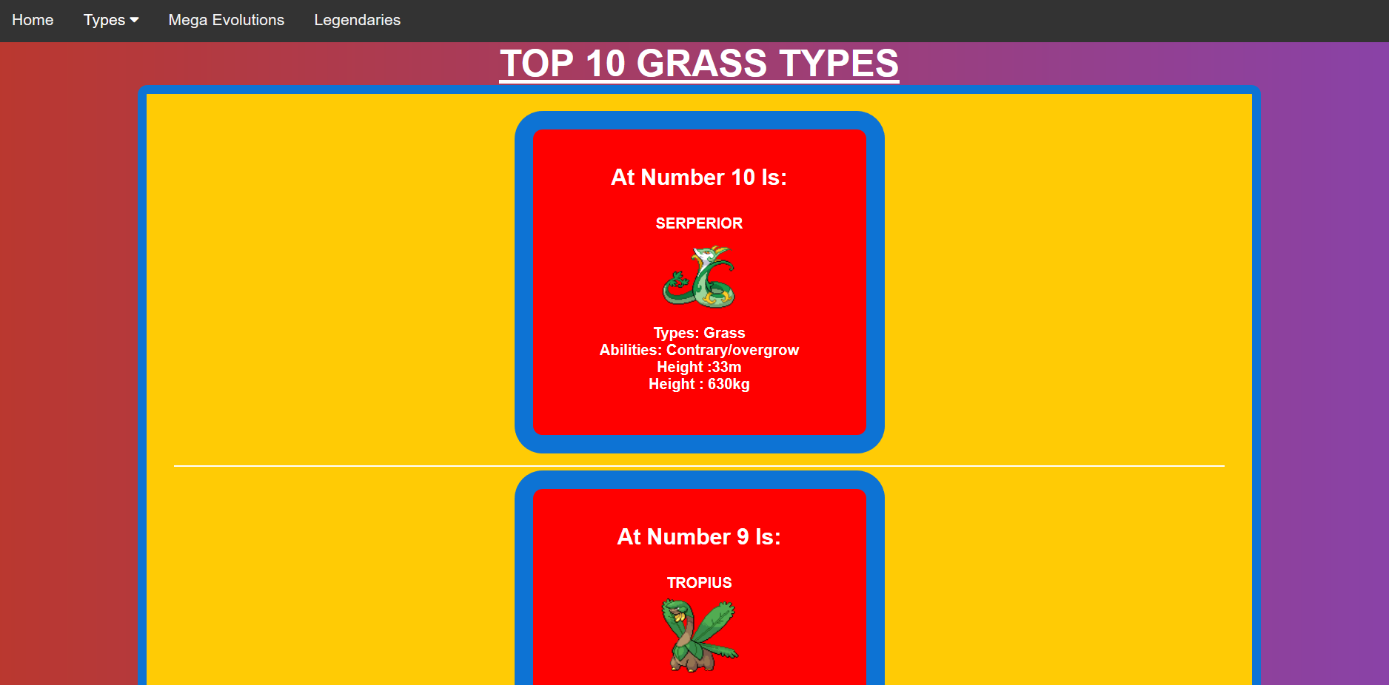
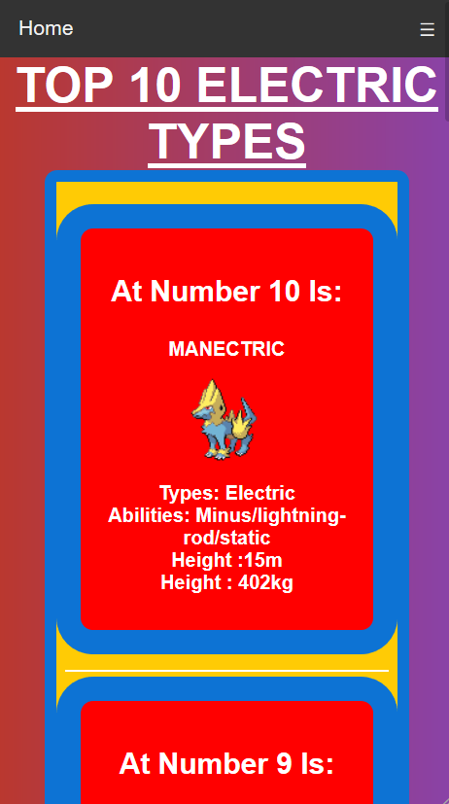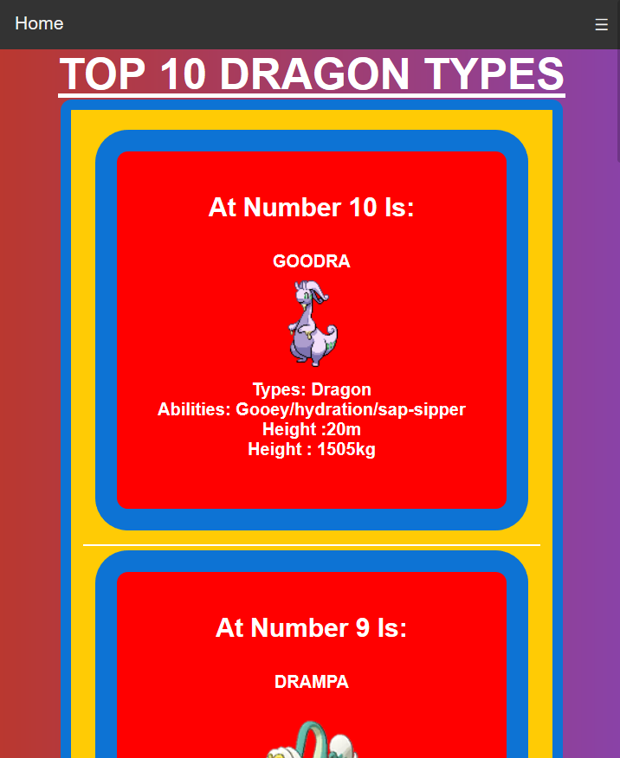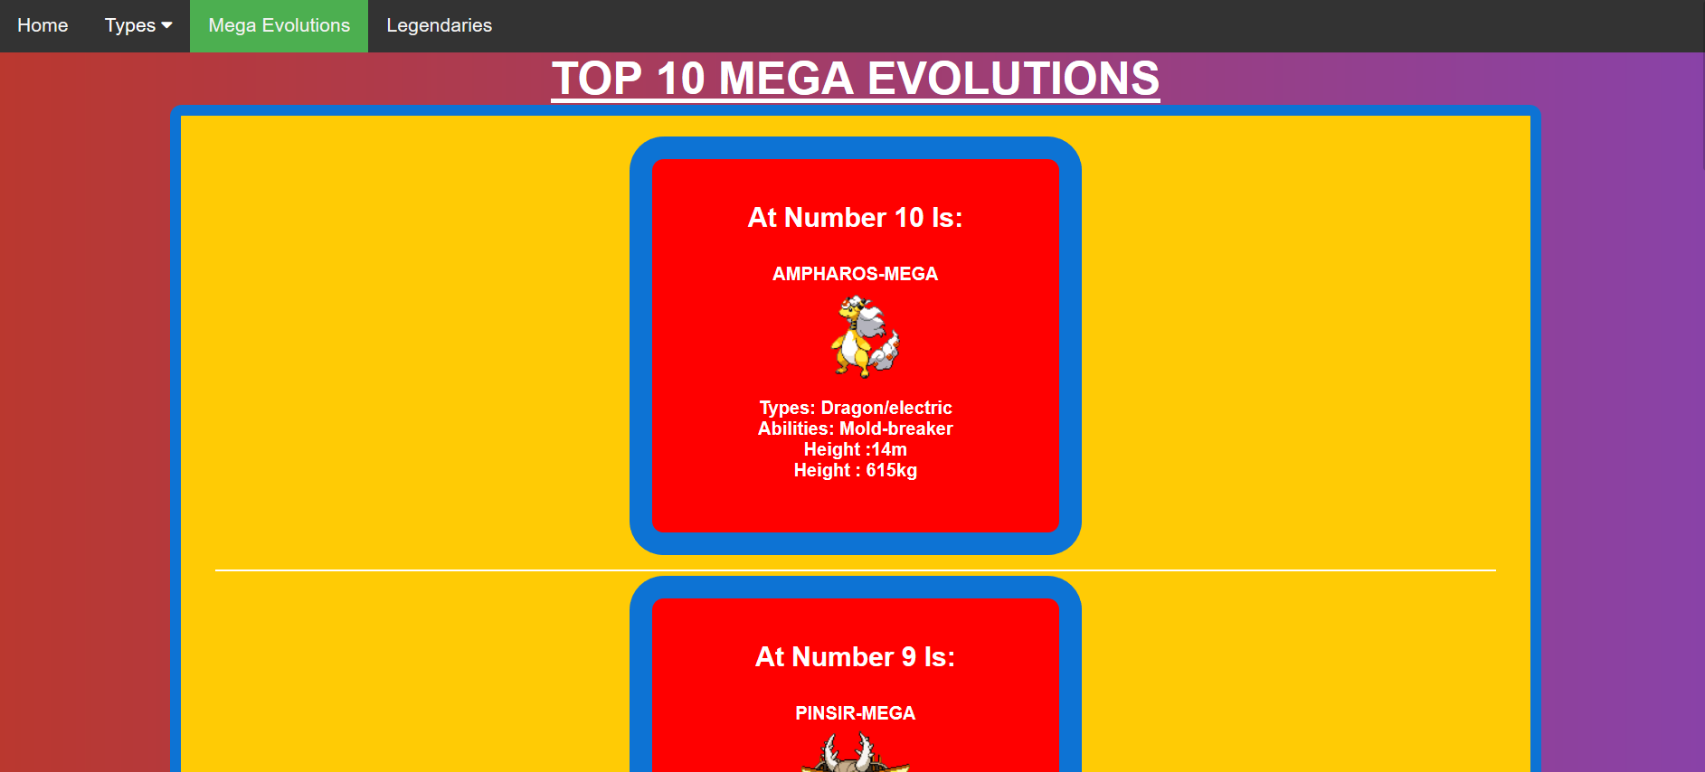
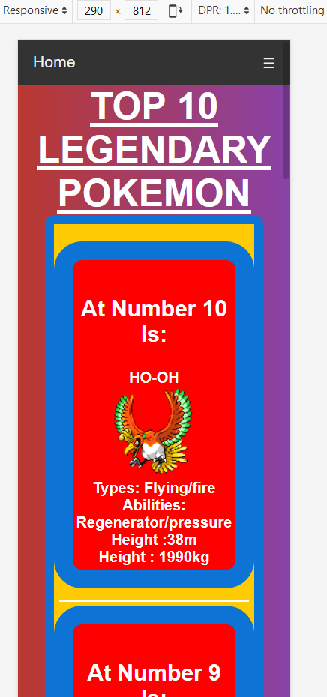

Evaluation

5.1) Test cases
Test No. | Summary | Prerequisites | Steps | Expected Result | Actual Result | Status
1 | Navigation bar collapsed into burger bar icon | Website needs to be smaller that 600px wide | Starting with website about 600px wide | Navbar to collapse into burger bar icon | Navigation bar collapses successfully | Pass
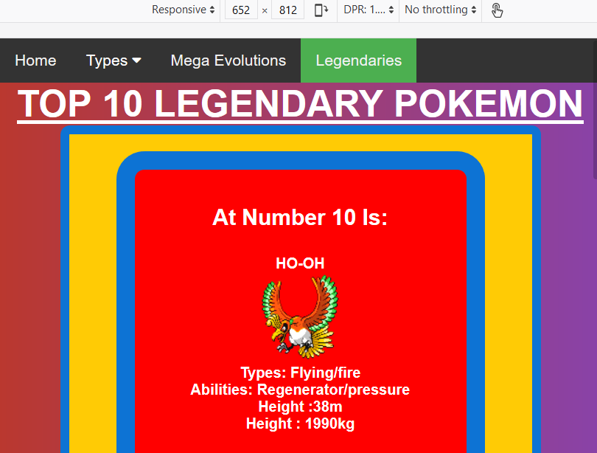
Above 600px wide Below 600px wide
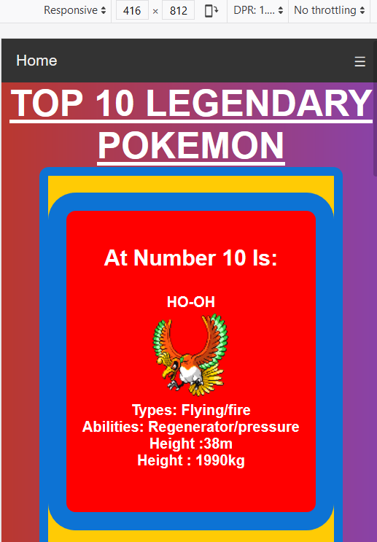

Test No. | Summary | Prerequisites | Steps | Expected Result | Actual Result | Status
2 | Content on the page changes without changing the URL | Being on the any page | Being on the home page, and changing to another page | The content on the page to change, without the URL changing | The content changed without changing the URL in the search bar | Pass

Before test:

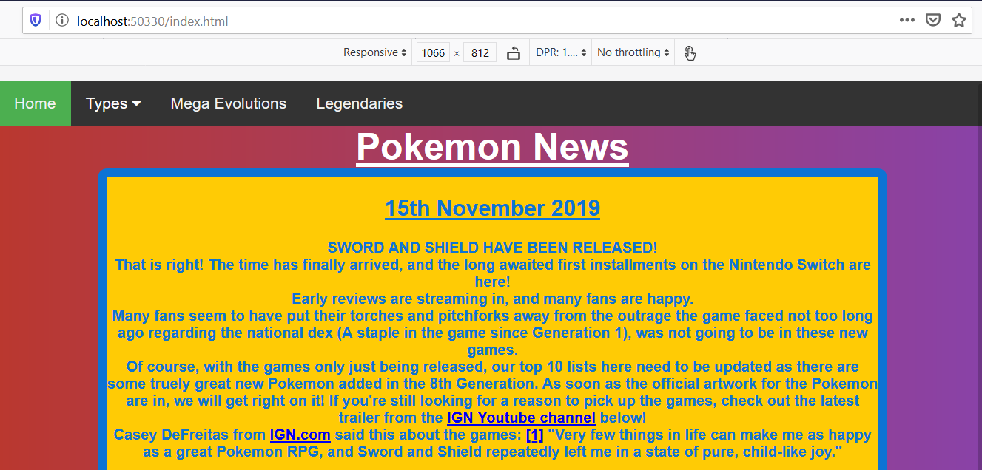
After test:

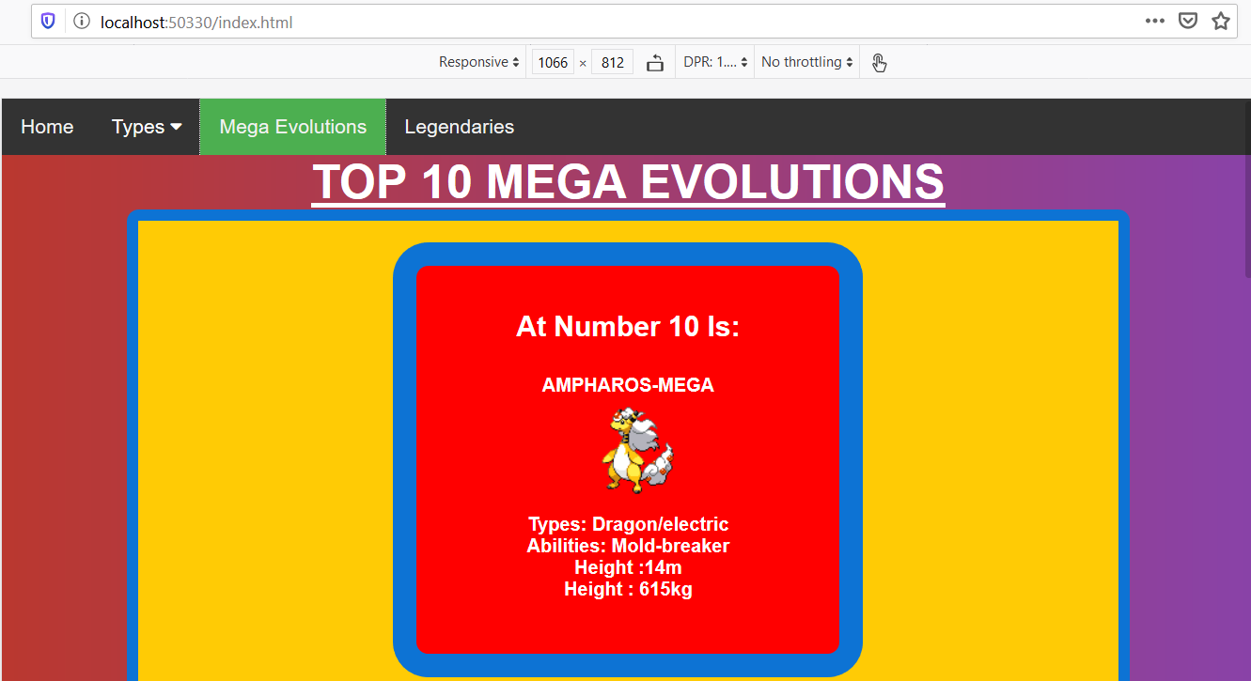
Test No. | Summary | Prerequisites | Steps | Expected Result | Actual Result | Status
3 | Testing the “types” drop down menu | “Types” to be un-expanded | Hovering over the “types” section in the navbar to see if expands | The drop-down menu works | The drop-down menu expanded upon hovering | Pass
*CURSOR IS OVER “TYPES” HOWEVER DOESN’T SHOW IN SCREENSHOT*
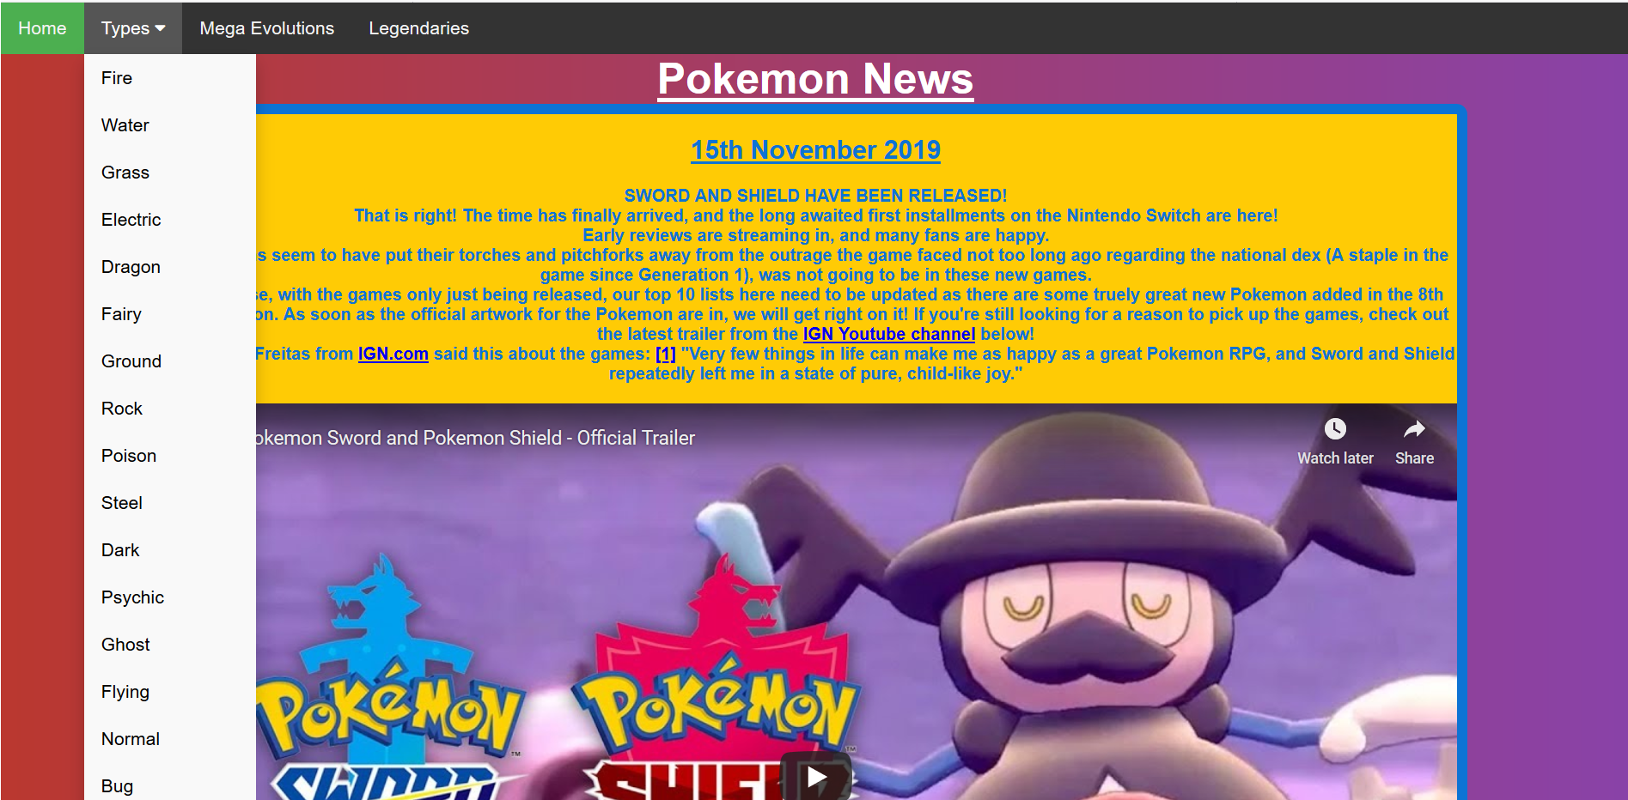

5.2) Reflection
I believe that I have successfully created a fully functional responsive website. I have managed to consume an API and output the data retrieved via my JavaScript code. The website is easy to use and is accessible on all browsers (Maybe not old versions of IE, couldn’t test). The website operates on the smallest of mobile devices and the content is always visible to read and see.
If I was to do this again, I would speak up in class about not understanding API’s when we went through them as I was afraid to speak due to the pace of the class. I would also start the assignment a lot early and try not to procrastinate so much. Lastly, I would test that I can get a chosen API working before basing my entire website on it, to avoid the possibility of having to re-do the entire website like I had to this time around.

Bibliography

[1] | “Web Design Statistics for 2017,” ironpaper.com, 08 01 2017. [Online]. Available: https://www.ironpaper.com/webintel/articles/web-design-statistics-2017/?fbclid=IwAR1UR5SFEz-O_RyKpxzvddOgs4N4pkLie_IMG9K0s-d0CoNraiEy-pNWOZ4. [Accessed 07 12 2019].
[2] | J. Clement, “Mobile internet usage worldwide - Statistics & Facts,” 11 September 2019. [Online]. Available: https://www.statista.com/topics/779/mobile-internet/. [Accessed 07 12 2019].
[3] | A. Heitzman, “Single Page Websites: Are They Good or Bad for SEO?,” 21 03 2017. [Online]. Available: https://www.searchenginejournal.com/single-page-websites-good-bad-seo/190095/. [Accessed 08 12 2019].
[4] | medium.com, “Pokémon GO demographics: The evolving player mix of a smash-hit game,” medium.com, 2016.
[5] | iEatWebsites, “Using a Public API with Modern Javascript,” 02 09 2019. [Online]. Available: https://www.youtube.com/watch?v=tFVdxGgJPCo&feature=youtu.be&fbclid=IwAR0Gq9soqW1Y-2tDCJ05aJFchwBmGoj6E_kZhckixGnzU1Wun_GQX0n7VP8. [Accessed 05 12 2019].
[6] | W3Schools, “How TO - Responsive Navbar with Dropdown,” [Online]. Available: https://www.w3schools.com/howto/howto_js_responsive_navbar_dropdown.asp. [Accessed 06 12 2019].
[7] | PokeAPI, “PokeAPI,” PokeAPI, [Online]. Available: https://pokeapi.co/. [Accessed 06 12 2019].
[8] | C. DeFreitas, “Pokemon Sword and Shield Review,” IGN, 20 11 2019. [Online]. Available: https://uk.ign.com/articles/2019/11/13/pokemon-sword-and-shield-review. [Accessed 06 12 2019].

marking criteria and Student FEEDBACK

This section details the extent to which the assessment criteria are demonstrated by you, which in turn determines your mark. The marks available for each category of skill are shown. Lecturers will use the space provided to comment on the achievement of the task(s), including those areas in which you have performed well and areas that would benefit from development/improvement.

Common Assessment Criteria Applied (Assignment 1) | Marks available | Marks  awarded
1. Engagement with Literature Skills

A very good introduction and overview of current application trends and a very good discussion of the chosen application trend too. The required background from a relevant peer-reviewed study is, however, limited. Expand the scope of references to include more academic references and further improve your research work. (Grade mark: 72.00%) | 25 | 18
2. Knowledge and Understanding Skills

3. Cognitive and Intellectual Skills

A good set of test cases focussed on successful test cases, but consider expanding test cases to include unexpected/alternative scenarios. A good, though somewhat basic, evaluation has been provided. (Grade mark: 55.00%) | 20 | 11
4. Practical Application Skills

A very good attempt featuring a single-page application website. Good use of JavaScript to implement the single-page application functionality, but please note that you did not need that many content page templates especially as the layout for the pages was the same. Using a JSON object similar to what we did in the last class exercise is an alternative and better way to implement this. As mentioned previously, there was very little variation between the pages and I would have liked to see some more variation to demonstrate other skills. Good use of the API. (Grade mark: 76.00%) | 50 | 38
5. Transferable Skills for Life and Professional Practice

The report is of a good standard. See your report for some suggested improvements. (Grade mark: 60.00%) | 5 | 3

Assignment Mark (Assessment marks are subject to ratification at the Exam Board. These comments and marks are to give feedback on module work and are for guidance only until they are confirmed. ) | Late Submission Penalties (tick if appropriate) |  | 70%
 | Up to 1 week late (40% Max) |  | 70%
 | Over 1 week late (0%) |  | 70%

