
Student name: | Rozar Robertbhai MacWan
Student ID number: | 2509179
Programme: | Master of Business Administration
Module: | Marketing Management
Module code: | LCMB7024
Assignment Title: | Assessment component 1:  Marketing Environment Analysis: Tesla (Pioneer) vs BYD (Follower) in the UK EV Industry
Lecturer: | Laila Maazouz  Dian Mayasari
Word count: | 2544
Submission date: | 25/02/2026

Table of Contents
1. Introduction 4
2. Conceptual Foundation: Macro Environment & Pioneer–Follower Theory 5
TASK 1 6
3. UK EV Industry Overview & Competitive Context 6
4. Macro Factor 1: Political–Regulatory Environment (400 words) 7
4.1 Impact on Tesla 7
4.2 Impact on BYD 8
4.3 Critical Comparison 8
5. Macro Factor 2: Economic Environment 9
5.1 Impact on Tesla 9
5.2 Impact on BYD 9
TASK 2 10
6. Strategic Responses to Macro Forces 10
6.1 Porter’s Generic Strategies 10
6.2 Ansoff Growth Matrix 12
7. Critical Strategic Judgement 13
8. Conclusion 14
References 15

List of Figures
Figure 1 Tesla vs BYD 5
Figure 2 Global EV Sales Comparison – BYD vs Tesla 7

List of Tables
Table 1 Political–Regulatory Impact on Competitive Position 6
Table 2 Economic Environment Impact on Tesla vs BYD 8
Table 3 Porter’s Generic Strategy Positioning 9
Table 4 Ansoff Growth Strategies in UK Context 11

1. Introduction
Strategic marketing management demands organisations to constantly observe and react to the change in the macro-environment. High-technology products like electric vehicles (EVs), due to rapid innovation and capital-intensive nature are highly susceptible to regulatory and economic forces that would substantially alter competitive advantage and sustainability in the long term. The case of the UK EV market demonstrates how the industry is being impacted by an incoming policy and the uncertainty of the economy. Electrification has been expedited by the Net Zero 2050 promise given by the government and a stage-by-stage back off of new petrol and diesel motor vehicles by 20302035 (Department for Transport, 2024). Even though EV market share records are at their highest point, the demand is still vulnerable to the general economic trends (SMMT, 2025). In this context, Tesla is the first company that possesses early technological and brand superiority, and BYD is a low-cost company-follower which has vertically integrated battery production (BYD, 2024).
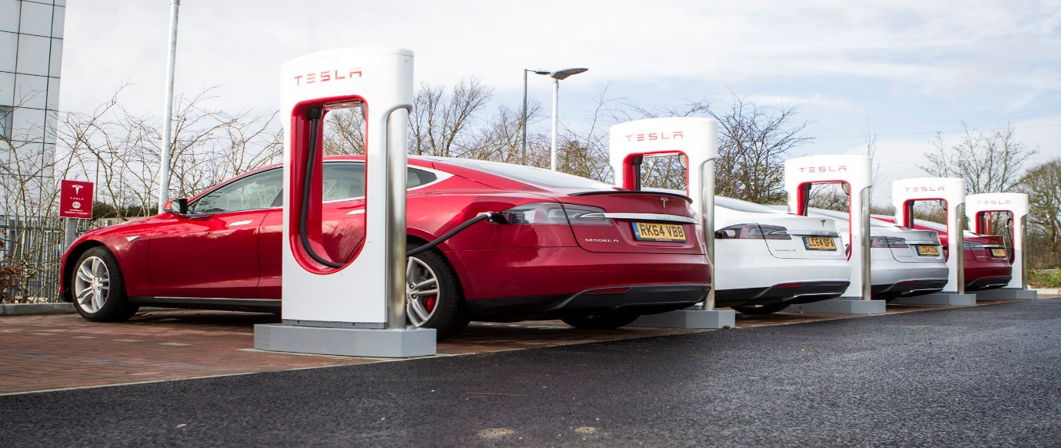
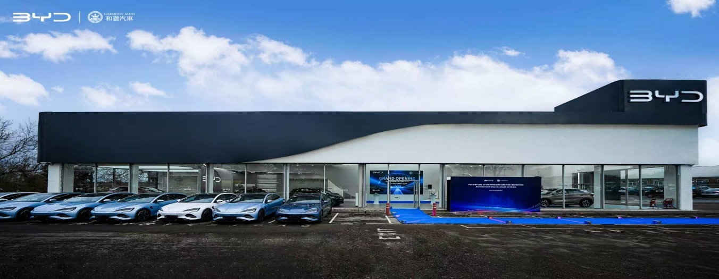
Figure 1 Tesla vs BYD
Source: (Gear, 2023; StreetInsider.com, 2021)

2. Conceptual Foundation: Macro Environment & Pioneer–Follower Theory
Macro-environment is defined as forces which are of the external nature and influence the organisational performance but are not in the control of the managers. To facilitate systematic scanning of the environment, these forces are classified under Political, Economic, Social, Technological, Legal and Environment PESTLE framework promotes environmental scanning. In industries with high technology like electric vehicles, Political and Economic factors particularly affect it because of the regulatory requirements and the intensity of the capital (Sun et al., 2024).
The theory of First-Mover Advantage suggests that first-to-market companies assume technological innovation, brand reputation and switching costs (Halberstadt et al., 2022). Nevertheless, these benefits do not exist in the long-term because follower firms can use the technological learning and reduced entry costs to reduce gaps in competition (Halberstadt et al., 2022).
The adoption studies by consumers have shown that the sensitivity to price, necessarily as status perception and the availability of infrastructure has a great impact on buying EVs (Bryła et al., 2022; Buhmann and Criado, 2023). Dynamic Capabilities theory also indicates that strategic resilience relies on the potential of the firms to reorganize resources as a reaction to macro shocks (Huang and Qian, 2021).

TASK 1

3. UK EV Industry Overview & Competitive Context
There has been a hasty rise in the UK EV market due to the action of the regulation and the environmental policy. The government requirements of the market to switch to internal combustion engine transition have spurred demand and shaped industry trends in terms of investment (Department for Transport, 2024). Nonetheless, the diffusion of EVs is still vulnerable to the system of charging and consumer trust. The experimental modelling evidences that when the infrastructure growth is high, the adoption rates grow significantly (Zheng et al., 2025).
The market projections show that the industry will continue to expand in Europe, which will make EVs one of the primary growth parts of the automotive market (Tschiesner et al., 2024). According to BloombergNEF (2025) the experience of long-term electrification in the face of temporary economic fluctuations continues to benefit sustained growth in EVs globally economically.
In the UK, Tesla has established itself as a high-quality, technologies-oriented brand, capitalizing on its own proprietary software, battery advanced technology, and Supercharger network (Tesla, 2024). In the UK, BYD is a newcomer, and the company focuses more on price and self-contained battery manufacturing to lower the production expenses (BYD UK, 2024).
The intensity of competition is also growing with the old producers and the newcomers playing the price of the product and rivalry based on technology and brand popularity. The regulatory dependency is also high, and switching costs are being affected by charging compatibility and integration into an ecosystem. The volatility in the industry thus poses strategic tension between the differentiation of the premium and the market expansion through lowering the cost.
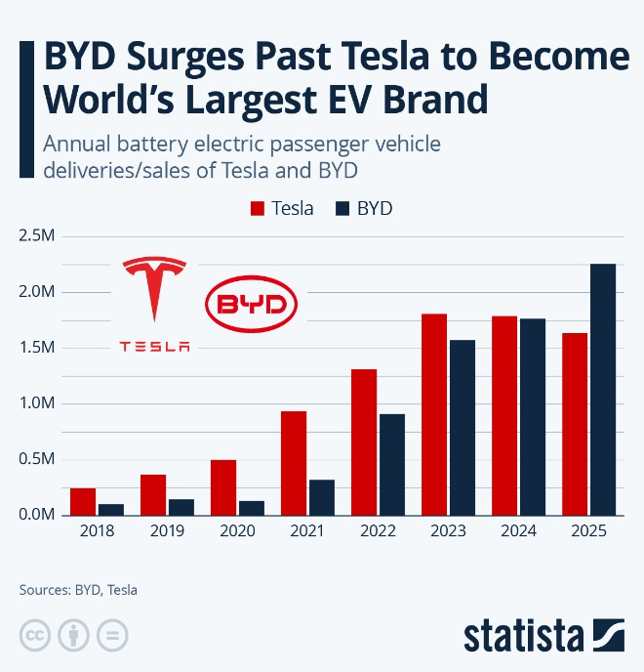 | 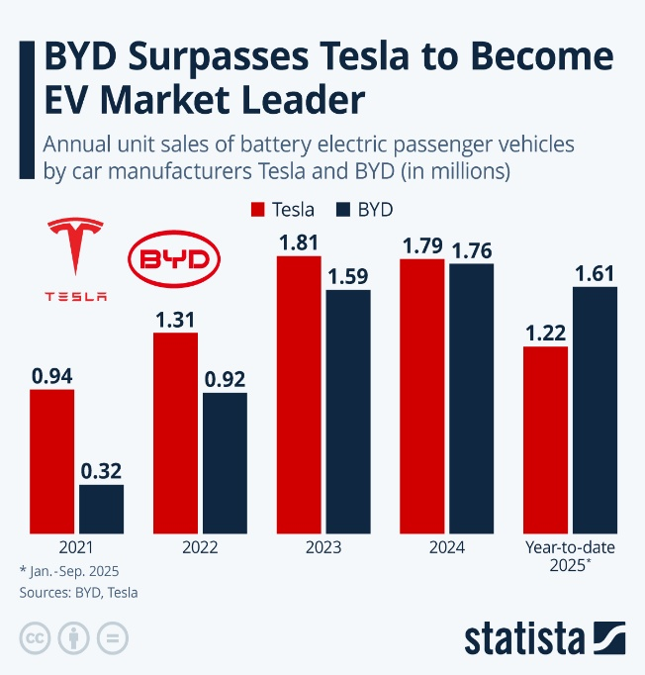
Figure 2 Global EV Sales Comparison – BYD vs Tesla
Source: (Statista, 2025)

4. Macro Factor 1: Political–Regulatory Environment (400 words)

4.1 Impact on Tesla
The internal combustion engine (ICE) ban in the UK (2035) presents structural opportunity to Tesla in terms of speeding the fully electric car demand due to the policy (Department for Transport, 2024). Tesla commands the legacy of brand credibility as a pioneering company in the industry of EVs related to sustainability and innovation.
Also, policies of the charging infrastructure development strengthen the competitive edge of Tesla, since the availability of infrastructure raises adoption rates (Gifford, 2022). Tesla has its own charging system, which enables resistance to switching.
Nevertheless, decreased EV garnered subsidies and heightened regulation negatively affect it. Policy changes can squeeze the expansion of the demand and exaggerate competition over the price. Moreover, other post-Brexit trade complexities might also be an impact on supply chain and regulatory compliance.
In strategic terms the premium positioning of Tesla is being strengthened by a policy that is solving more towards no-emission vehicles but, by expensive price set up, Tesla becomes susceptible to a fall in subsidies.

4.2 Impact on BYD
Political control also opens opportunity to BYD because of the increasing EV demand. The lower price positioning means that BYD will be able to compete in case consumer incentives are reduced.
Nevertheless, reputational and tariff risks are brought in by political sensitivity of Chinese imports. Friction in trade might establish regulatory impediments to the legitimacy of the market.
Facing the problem of brand trust and passing through the political examination is the strategic limitation of BYD. However, this exposure to supply chain volatility can be addressed by vertical integration (BYD, 2024).

4.3 Critical Comparison
The policy frameworks promote innovation as well as affordability. Where Tesla is advantageous due to the initial investment in infrastructure and the connection of the brand with sustainability, the cost leadership of BYD will be prosperous in the event of the reduction of subsidies. Political risk seems to be more structurally higher in the case of BYD because of the geopolitical sensitivity around it, but Tesla has a greater premium pricing model which can be exposed more to regulatory withdrawal of incentives. In that way, regulatory convergence is beneficial to the technological dominance of Tesla, yet the ability to withstand changes in policy could have an advantage on the cost model of BYD.
Table 1 Political–Regulatory Impact on Competitive Position
Factor | Impact on Tesla | Impact on BYD | Competitive Outcome
2035 ICE Ban | Reinforces EV demand | Expands market entry opportunity | Both benefit structurally
EV Subsidy Reduction | Threatens premium pricing | Strengthens low-cost appeal | BYD advantage in subsidy withdrawal
Infrastructure Expansion | Tesla Supercharger advantage | Relies on public infrastructure | Tesla switching cost benefit
Trade & Geopolitics | Moderate exposure | Higher scrutiny for Chinese imports | Higher political risk for BYD

5. Macro Factor 2: Economic Environment
The economic conditions in the UK are characterised by inflationary pressures, elevated interest and cost-of-living restrictions. TOA and source availability of finance among other factors are sensitive to EV adoption. The investigations into cost competitiveness indicate that the affordability of EVs continues to be the main factor in the process of adoption (Franzò et al., 2022).

5.1 Impact on Tesla
A decrease in the price-elasticity of demand can affect the growth of the premium segment in Tesla in times of inflation. The funding expenses raise monthly payments that may end up deterring the middle-income consumers. The primary statistical analysis of the trends in costs reveals that the dynamics in EV pricing can have an impact on the purchasing behaviour (Goetze and Hasanuzzaman, 2022). One measure that Tesla has undertaken is price cuts to sustain volume. Nonetheless, this type of reduction shrinks margins, with the vehicle of crushing premium differentiation.

5.2 Impact on BYD
The cost leadership strategy used by BYD is in line with the inflationary pressure. The low-end models are also attractive to the price sensitive consumers, which improves their competitive position in times of economic recession.
Slim margins and exposure to currency are however risky. Price war can be triggered by the cost-based competition which limits long-term profitability.
5.3 Critical Evaluation
The impact of inflation is arguably that it dilutes the variousiation on premiums whilst enhancing the affordability positioning. Status perception according to consumer preference research that modulates EV buying also has an impact on sales, although the effect is softened on economic constraints (Buhmann and Criado, 2023).
The brand equity of Tesla partially compensates the price sensitivity, but the continued inflation adds pressure on the high-end pricing model. BYD seems to be better-structurally placed to survive in the circumstances of a downturn, although its sustainability in terms of profitability is questionable.
Table 2 Economic Environment Impact on Tesla vs BYD
Economic Variable | Tesla | BYD | Strategic Implication
Inflation | Weakens affordability | Supports cost positioning | BYD short-term advantage
Interest Rates | Higher financing cost for premium models | Lower priced models less affected | BYD demand resilience
Consumer Affordability | Price sensitivity increases | Competitive appeal strengthens | Cost leadership more attractive
Margin Pressure | Price cuts reduce profitability | Thin margins already constrained | Both face profit risk

TASK 2

6. Strategic Responses to Macro Forces

6.1 Porter’s Generic Strategies
Tesla: Differentiation Strategy
The model proposed by Porter determines differentiation and cost leadership as the main tracks to the competitive advantage (Acar, 2024). Tesla focuses on its differentiation strategy in the UK EV market, where their main approach is highly developed battery technology, the uniqueness of software working with it, and the high brand image. Its ecosystem strategy, the connectivity between vehicles, an over-the-air update system and charging networks, contributes to an idea of technological superiority. Minor vertical integration enhances the control of the supply chain and promotes the uniformity of quality (Tesla, 2024). Nonetheless, the ongoing price cuts are pointing to the tactical convergence into the realm of competitiveness in terms of costs. Although this kind of adjustment boosts volume and market penetration in the short-term perspective, it may jeopardise the premium positioning. The key strategic dilemma is whether in a market that is growing more price-sensitive differentiation is defensible.
BYD: Leadership Strategy Cost
In comparison, BYD pursues the strategy of cost leadership, which is backed up by mass battery production and integrated manufacturing (BYD, 2024). The structure allows the company to produce cheaply, and offer competitive prices during inflation. The future of this benefit lies in the ability to sustain the scale efficiencies without eroding the margins. Overcapacity competition on prices would lead to commoditisation in the industry.
Critical Comparison
The inflationary forces within the UK have favoured affordability-oriented strategies which indicates that the position of BYD can be resilient in the short run. Nonetheless, when the regulatory changes are directed towards electrification, innovative ecosystems are favored. Hybrid approaches make the EV industry more reflective of harder-to-categorise approaches typical of Porterian. The long-run benefit might not rely quite on direct cost or distinction but rather be found in combination of technological innovation and efficiency in the operations.
Table 3 Porter’s Generic Strategy Positioning
Firm | Primary Strategy | Supporting Capabilities | Risk Under UK Macro Conditions
Tesla | Differentiation | Software integration, brand equity, charging ecosystem | Margin erosion from price competition
BYD | Cost Leadership | Battery vertical integration, scale production | Commoditisation and price wars
Emerging Pattern | Hybridisation | Price adjustments + innovation | Industry convergence risk

6.2 Ansoff Growth Matrix
The Growth Matrix conceptualisation of growth at Ansoff considers the four strategic options available to corporations to grow, including market penetration, product development, market development and diversification (Zupic et al., 2025). Using this framework on the UK EV market can be used to identify discordant growth orientations between Tesla and BYD due to existing macro pressures.
Tesla’s Growth Approach
The recent UK price cuts by Tesla are an effort to enter the market penetration strategy so that share can be read between the established customer segments. Technological differentiation is strengthened by concurrent product development, both via the model updates and software improvements. Customer lock-in and long-term ecosystem control is enhanced by the infrastructure growth, specifically the integration of charging ecosystem. The strategies are however capital intensive and they expose the firm to loss of margin during an inflationary environment. Also with a rise in market maturity, there is a risk of saturation in penetration strategies especially in high-end divisions.
BYD’s Growth Approach
The entry to the UK makes BYD an inherent activity of market development by expanding the existing products into a new market framework (BYD UK, 2024). Continued battery development indicates product development, which contributes to cost-ease and technological competitiveness. Long term wellbeing can be improved by potential diversification into energy storage. The expansion is however limited to brand legitimacy issues and potential political uncertainty in the UK regulatory landscape.
Critical Insight
Tesla depends on its strategy that is more capital intensive and vulnerable to macroeconomic swings, but BYD takes advantage of its expansian capabilities using scale efficiencies and lower cost to its benefit. The strategy adopted by BYD does not seem to be so macro sensitive to the current conditions of the UK economy, but long term sustainability will be affected by the need to uphold the legitimacy through supporting profitability and growth.
Table 4 Ansoff Growth Strategies in UK Context
Growth Strategy | Tesla | BYD | Risk Level
Market Penetration | UK price reductions | Expansion via competitive pricing | Medium (margin pressure)
Product Development | Software updates & model refresh | Battery innovation | High capital requirement
Market Development | Limited (already established) | UK market entry & expansion | Political/regulatory risk
Diversification | Energy ecosystem integration | Energy storage potential | Long-term strategic risk

7. Critical Strategic Judgement
Tesla still enjoys the symbolic market leadership in the UK EV market, driven by technological prestige and brand awareness based on its first-mover status. Nevertheless, first-mover benefit is not necessarily sustainable; late movers might utilize the historical industry experience, economies of operation, and lowered levels of uncertainty to defy first-mover impact (Halberstadt et al., 2022).
In the existing UK inflationary situation, BYD cost-leadership strategy is more congruent with increased consumer price sensitivity and tightened affordability. It has structurally lower production costs that help it to be resilient during economic capitalism.
However, Tesla has created strategic advantages that go beyond the mere price competition due to its dynamic capabilities, especially its integrated software ecosystem, in-house charging infrastructure and never-ending product updates. Such impacts on the ecosystem enhance brand differentiation and customer retention.
Thus, although BYD might have short-term economic fit, the long-term competitiveness of Tesla will be based on its ability to maintain the innovation-based differentiation. Finally, the adaptive capability stipulates strategic excellence in the UK EV market as opposed to entry timing.

8. Conclusion
This analysis has evaluated the influence of the Political-Regulatory and Economic macro-environmental factors on the competitiveness of Tesla and BYD in the EV sector in the UK. Regulatory requirements provide growth prospects to the structure, but they cause dependency on subsidies and trade risks. Economic pressures increase the price sensitivity, it proxies the premium positioning and the focus is on cost. Task 1 shows that Tesla enjoys the advantage of the early technological leadership and integration of infrastructure, and BYD takes advantage of its affordability in the context of regulatory growth. Task 2 shows that differentiation and cost leadership do coexist in the shifting macro pressures and strategic hybridity is thus seen. In order to have sustained competitive advantage as a strategic marketing management in technology-intensive industries, pioneering status would not be enough but dynamic capability alignment with macro-environmental change.

References
Acar, S. (2024). A review of Porter’s generic strategies: Strategy examples in international firms. International Social Sciences Studies Journal, 10(11), 1902-1918. Available At: https://sssjournal.com/files/sssjournal/e5935340-8b65-4cf6-a1c1-cf266026257d.pdf (Accessed: 23 Feb 2026).
BloombergNEF (2025). Electric Vehicle Outlook - BloombergNEF. [online] BloombergNEF. Available at: https://about.bnef.com/insights/clean-transport/electric-vehicle-outlook/.
Bryła, P., Chatterjee, S. and Ciabiada-Bryła, B. (2022). Consumer Adoption of Electric Vehicles: A Systematic Literature Review. Energies, 16(1), p.205. doi: https://doi.org/10.3390/en16010205.
Buhmann, K.M. and Criado, J.R. (2023). Consumers’ preferences for electric vehicles: The role of status and reputation. Transportation Research Part D: Transport and Environment, [online] 114(114), p.103530. doi: https://doi.org/10.1016/j.trd.2022.103530.
Burra, L.T., Al-Khasawneh, M.B. and Cirillo, C. (2024). Impact of charging infrastructure on electric vehicle adoption: A synthetic population approach. Travel Behaviour and Society, 37, pp.100834–100834. doi: https://doi.org/10.1016/j.tbs.2024.100834.
BYD (2024). Periodic reports-BYD. [online] www.bydglobal.com. Available at: https://www.bydglobal.com/cn/en/BYD_ENInvestor/InvestorAnnals_mob.html. (Accessed: 23 Feb 2026).
BYD UK (2024). BYD UK Continues Rapid Growth In 2024 - BYD. [online] Bydukmedia.com. Available at: https://bydukmedia.com/en/news-articles/byd-uk-continues-rapid-growth-in-2024.html. (Accessed: 23 Feb 2026).
Department for Transport (2024). Phasing out the sale of new petrol and diesel cars from 2030 and Support for the Zero Emission Transition. [online] Available at: https://assets.publishing.service.gov.uk/media/679382182de28ea2d392f37f/phasing-out-the-sale-of-new-petrol-and-diesel-cars-from-2030-and-support-for-the-zero-emission-transition.pdf. (Accessed: 23 Feb 2026).
Franzò, S., Nasca, A. and Chiesa, V. (2022). Factors affecting cost competitiveness of electric vehicles against alternative powertrains: A total cost of ownership-based assessment in the Italian market. Journal of Cleaner Production, 363, p.132559. doi: https://doi.org/10.1016/j.jclepro.2022.132559.
Gear, T. (2023). Tesla Supercharger network: where can I charge in the UK? [online] Top Gear. Available at: https://www.topgear.com/car-news/Tesla-supercharger-network-uk. (Accessed: 23 Feb 2026).
Gifford, S. (2022). The Importance of Charging Infrastructure to the Electric Vehicle Revolution. [online] Available at: https://www.faraday.ac.uk/wp-content/uploads/2022/11/Faraday_Insights_14_FINAL.pdf. (Accessed: 23 Feb 2026).
Goetzel, N. and Hasanuzzaman, M. (2022). An empirical analysis of electric vehicle cost trends: A case study in Germany. Research in Transportation Business & Management, 43, p.100825. doi: https://doi.org/10.1016/j.rtbm.2022.100825.
Halberstadt, J., Kollhoff, S., Kraus, S. and Dhir, A. (2022). Early bird or early worm? First-mover (dis)advantages and the success of web-based social enterprises. Technological Forecasting and Social Change, 181, p.121784. doi: https://doi.org/10.1016/j.techfore.2022.121784.
Huang, Y. and Qian, L. (2021). Consumer adoption of electric vehicles in alternative business models. Energy Policy, 155, p.112338. doi: https://doi.org/10.1016/j.enpol.2021.112338.
SMMT (2025). Record EV market share but weak private demand frustrates ambition - SMMT. [online] SMMT. Available at: https://www.smmt.co.uk/record-ev-market-share-but-weak-private-demand-frustrates-ambition/.
Statista. (2025). BYD Surpasses Tesla in Global EV Deliveries [online]. Available at: https://www.statista.com/chart/31496/global-battery-electric-vehicle-deliveries-sales-tesla-byd/ (Accessed: 23 Feb 2026).
StreetInsider.com (2021). BYD Opens New Branch in Bristol and Warwick, UK, Marking a Milestone in Electric Vehicle Expansion. [online] StreetInsider.com. Available at: https://www.streetinsider.com/Globe%2BNewswire/BYD%2BOpens%2BNew%2BBranch%2Bin%2BBristol%2Band%2BWarwick%2C%2BUK%2C%2BMarking%2Ba%2BMilestone%2Bin%2BElectric%2BVehicle%2BExpansion/24123876.html (Accessed: 23 Feb 2026).
Sun, J., Sun, S., Chen, B. and Hu, Y. (2024). Charging change: Analysing the UK’s electric vehicle infrastructure policies and market dynamics. Energy policy, [online] 191, pp.114178–114178. doi: https://doi.org/10.1016/j.enpol.2024.114178.
Tesla (2024). Annual Report (Form 10-K) 2024. [online] Sec.gov. Available at: https://www.sec.gov/Archives/edgar/data/1318605/000162828025003063/tsla-20241231.htm. (Accessed: 23 Feb 2026).
Tschiesner, A., Hertzke, P., Schaufuss, P. and Heuss, R. (2024). Europe’s economic potential in the shift to electric vehicles. [online] McKinsey & Company. Available at: https://www.mckinsey.com/industries/automotive-and-assembly/our-insights/europes-economic-potential-in-the-shift-to-electric-vehicles. (Accessed: 23 Feb 2026).
Zheng, Y., Liu, D., An, F., Wang, J., Gao, X. and Jia, N. (2025). Impact of Charging Infrastructure Construction on Electric Vehicle Diffusion based on a Multi-agent Model. iScience, pp.112257–112257. doi: https://doi.org/10.1016/j.isci.2025.112257.
Zupic, I., Čater, T., Caputo, A. and Uršič, D. (2025). Mapping the Influence of Ansoff’s Corporate Strategy. Strategic Change. doi: https://doi.org/10.1002/jsc.70023.

