Foreign Languages and Cultural Awareness
BMIH5003
Intercultural Competence Report

Lecturer:Lisa Bassler
Student name:Ionela Lacramioara Balta
Student id:2208099
Date:26 02 2023

- Executive summary
This paper analyses cultural and leadership differences between the UK and South Korea using the GLOBE Project framework to help Inclusivity Hotel & Spa integrate South Korean staff into its London location. It identifies possible areas of conflict, such as hierarchical vs egalitarian work methods and individualism versus collectivism. The paper highlights the significance of intercultural leadership in the hospitality sector, emphasising difficulties in communication and decision-making approaches. Recommendations involve cultural competency training and techniques to establish an inclusive environment that respects multiple cultural norms, ensuring smooth operations and top-notch service in this multicultural context.

Table of Contents
- Executive summary 2
- Introduction 4
- Cultural differences between South Korea and England 4
- Culture and leadership comparison 6
- Challenges of intercultural leadership 7
- Conclusion 8
- Recommendations 8
- References 9

Inclusivity Hotel & Spa

- Introduction
Christiansen, Branch, and Karmowska, (2020) suggest that international customs and culture refer to the varied practices, beliefs, social conventions, and material characteristics of communities worldwide. The conventions and cultures have a profound influence on persons' daily lives, moulding their behaviour, interactions, and perceptions of the world. They encompass language, religion, cuisine, social behaviours, music, and arts, collectively creating the intricate fabric of human diversity. This study is intended to ready the management and staff of the Inclusivity Hotel & Spa in London for the incorporation of personnel from our South Korean branch. This document aims to identify potential areas of conflict and provide realistic recommendations for a smooth transition and an inclusive, effective, and harmonious working environment by comparing the cultural and customs differences between England and South Korea, analysing them through the GLOBE Project's culture and leadership study, and discussing the challenges of intercultural leadership in the hospitality industry.

- Cultural differences between South Korea and England

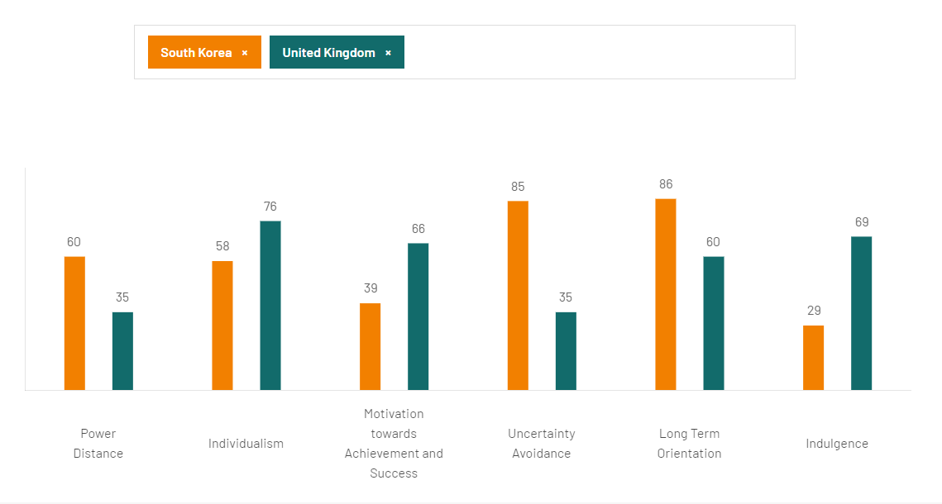
Fig 1 . Hofstede Insights (2024). South Korea- England
South Korea has a Power Distance Index score of 60, indicating a hierarchical society that accepts and expects power imbalances. Conversely, England's lower score of 35 indicates a culture that prioritises reducing inequities and advocates for a more equal distribution of power (Hofstede Insights, 2024). South Korean employees value distinct hierarchies and defined responsibilities in the workplace, while British employees prefer flattened organisational structures and democratic decision-making procedures. South Korea scored 58 points on the Individualism against Collectivism scale, indicating a society that leans towards collectivism but still encourages individual achievement and initiative in economic settings (Hofstede Insights, 2024). The UK's high score of 76 reflects a culture that values personal autonomy and self-expression, indicating a more individualistic society. This may result in varying expectations on teamwork, responsibility, and personal accountability in the professional environment (Hoftede, Hoftede and Minkov, 2010). The significant difference in Indulgence versus Restraint scores between the UK (69) and South Korea (29) indicates distinct social perspectives on leisure, enjoyment, and fulfilling needs (Hofstede Insights, 2024). The indulgent aspect of British culture may conflict with the more restrained, norm-driven attitude of South Korean culture, which could impact workplace norms related to social activities, rewards, and employee motivations (Gu et al., 2021). Uncertainty Avoidance Index (UAI) scores highlight a notable difference. South Korea's high score of 85 suggests a society that favours controlled environments and well-defined regulations, which may result in reluctance towards uncertain or flexible scenarios. The UK's score of 35 indicates a higher level of comfort with ambiguity and a more adaptable attitude towards planning and norms. This could affect how each group views risk, innovation, and change management in the hotel's operations (Hofstede, Hofstede, and Minkov, 2010). The Long-Term Orientation scores indicate contrasting emphasis on tradition versus future difficulties, perseverance, and thriftiness, with South Korea scoring 86 and the UK scoring 60. South Korean workers prioritise long-term benefits and strategic planning, while British employees take a pragmatic approach that combines tradition with adaptability to changing circumstances.

- Culture and leadership comparison
The cultural elements of The GLOBE Project offer a structure for comprehending and contrasting cultural behaviours and leadership expectations across many countries. The comparison of the United Kingdom and South Korea through the GLOBE Project's research shows clear differences in cultural practices and leadership preferences that mirror the societal norms and values in each country. South Korean society has historically valued in-group collectivism, emphasising group cohesion and loyalty. In contrast, the UK emphasises individualism, highlighting personal success and autonomy (Globeproject.com, 2020). The UK's lower power distance score indicates a society that promotes egalitarianism and flatter organisational structures, in contrast to South Korea's higher power distance, which implies a stronger embrace of hierarchical order and power disparities. Leadership expectations vary greatly. South Korean leaders are typically expected to exhibit a humane-oriented approach, showing compassion and charity, in line with the cultural emphasis on humane values (Hampden-Turner, and Trompenaars, 2020). In contrast, the UK may prioritise participative leadership due to a cultural inclination towards inclusivity and collaborative decision-making.

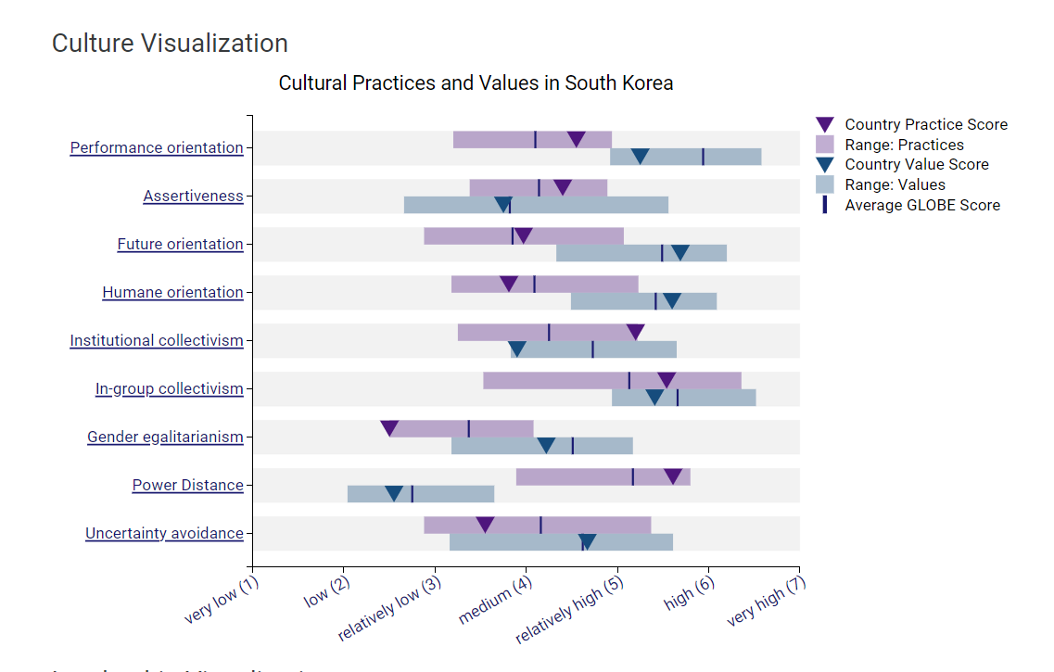

Fig 2. Globeproject.com. (2020). South Korea Results
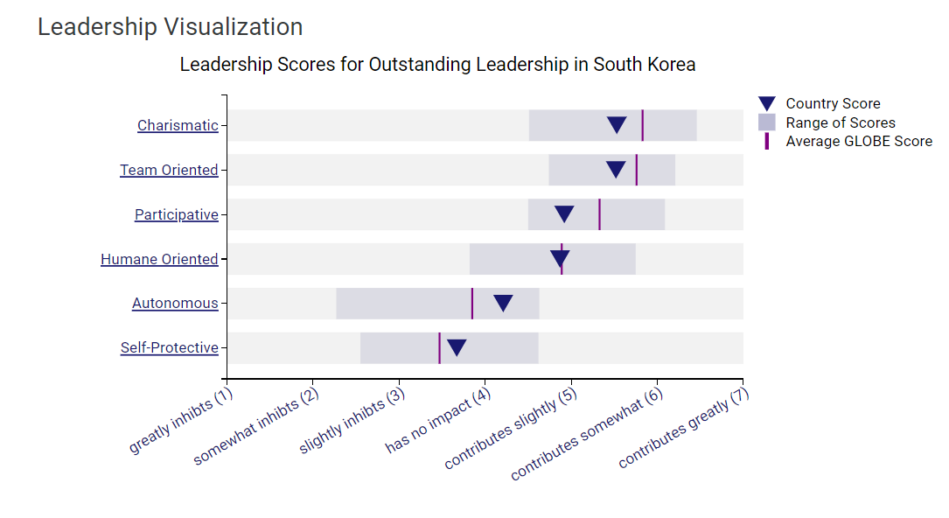
Fig 3. Globeproject.com. (2020). South Korea Results

- Challenges of intercultural leadership

Intercultural leadership in the hospitality business faces distinct problems arising from the varied cultural origins present in teams and in serving a worldwide consumer. Successful leadership in this setting involves an in depth awareness of cultural distinctions, sensitivities, and the skill to manage potential conflicts stemming from these differences (Ribiere, 2018). A South Korean manager working in a UK-based hotel may have difficulties because of contrasting cultural norms related to hierarchy and communication. South Korean culture emphasises hierarchical structure and respect for authority, which may conflict with the UK's more egalitarian approach, where subordinates anticipate involvement in decision-making and the freedom to publicly share their viewpoints. These differences might cause misunderstandings or confrontations, as UK team members may see the South Korean leadership style as authoritarian, while the manager may consider the UK staff's approach as disrespectful. Hospitality CEOs must navigate between the cultural expectations of their personnel and guests, which may differ significantly (Asialink Business, 2018). Leaders must possess cultural agility to navigate situations when guest interactions deemed polite in one culture may be seen as intrusive or informal in another.

- Conclusion
To conclude, successful intercultural leadership at Inclusivity Hotel & Spa requires a sophisticated approach that integrates and balances the unique cultural characteristics of South Korean and British workforce. Cultural competency training and open communication are crucial for creating an inclusive environment, improving teamwork, and providing excellent hospitality services to a diverse customer.

- Recommendations
- Intercultural training and a dedication to cultivating an inclusive, culturally sensitive work environment are crucial to address these difficulties. Leaders need to recognise, comprehend, and close cultural divides to foster a cohesive and productive work environment, thereby improving the service quality for visitors of various cultural backgrounds (Deresky, 2017).
- Implement routine cross-cultural communication training to improve comprehension and minimise misunderstandings, promoting a cooperative atmosphere that values other cultural viewpoints as suggested by (Abramson and Moran, (2018).
- Implement a mentorship programme that pairs UK with South Korean staff to promote mutual understanding and facilitate knowledge sharing regarding cultural expectations and professional practices.

- References
Abramson, N.R. and Moran, R. (2018) Managing Cultural Differences: Global Leadership for the 21st Century. 10th Ed. Abingdon: Routledge.

Asialink Business (2018). Korean business culture and etiquette. [online] Asialink Business. Available at: https://asialinkbusiness.com.au/republic-of-korea/conducting-business-in-korea/korean-business-culture-and-etiquette?doNothing=1.

Christiansen, B., Branch, J.D. and Karmowska, J. (2020) Cultural Factors and Performance in 21st Century Businesses. Hershey : IGI Global.

Deresky, H. (2017) International Management: Managing Across Borders and Cultures: Text and Cases. 9th Ed. Harlow: Pearson Education Ltd.

Globeproject.com. (2020). South Korea Results - GLOBE Project. [online] Available at: https://globeproject.com/results/countries/KOR%3Fmenu=list.html#list [Accessed 19 Feb. 2024].

Gu, M., Li Tan, J.H., Amin, M., Mostafiz, M.I. and Yeoh, K.K. (2021). Revisiting the moderating role of culture between job characteristics and job satisfaction: a multilevel analysis of 33 countries. Employee Relations: The International Journal, ahead-of-print(ahead-of-print). doi:https://doi.org/10.1108/er-03-2020-0099.

Hampden-Turner, C. and Trompenaars, F. (2020) Riding the Waves of Culture. 4th Ed. London: John Murray Press

Hofstede, G., Hofstede, G.J. and Minkov, M. (2010) Cultures and organizations: software of the mind. 3rd Ed. New York: McGraw-Hill.

Hofstede Insights (2024). Country comparison tool. [online] Available at: https://www.hofstede-insights.com/country-comparison-tool?countries=south+korea%2Cunited+kingdom.

Ribiere, D.V. (2018). ICMLG 2018 6th International Conference on Management Leadership and Governance. [online] Google Books. Academic Conferences and publishing limited. Available at: https://www.google.co.uk/books/edition/ICMLG_2018_6th_International_Conference/WU9mDwAAQBAJ?hl=en&gbpv=1&dq=5.%09Challenges+of+intercultural+leadership&pg=PA60&printsec=frontcover [Accessed 16 Feb. 2024].
‌

‌

