L4 – quality and business improvements

Intro
The problem that must be solved is the manufacturing process of a drill base unit and the defects that have raised form is production. Looking at the data there are 4 operators working independently of each other with 5 main categories of defects listed for the drill base, surface finish, defective finishing, blow hole, improper shape and ‘others’. There are also two separate processes of sandcasting and machining using a vertical milling machine.
To identify the problems and come up with the required solutions, the data must be analysed using a number of different problem solving tools. These tools will aid my investigation into the defects and underline a number of root causes which will support my action plan and corrective action.

Check Sheet
Data collection can often be an unstructured and messy exercise. A check sheet is a simple form you can use to collect data in an organized manner and easily convert it into readily useful information. Using this method the drill base data can now be seen in numerical data, this makes it much easier to analyse. Data collection is important because it is the starting point for statistical analysis. This data will allow easier use of other problem solving tools.
Check sheet analysis
The values from the check sheet are clearly defined in contrast to the original data. The largest defect is surface finish with 124 defects through out the week considerably higher than any other defect throughout the week. The least occurring defect is ‘others’ with only 4 defects all week. Wednesday has a large number of defects when compared to any other day of the week with surface finishing defects totalling 37 throughout the day.
Histogram
A histogram (or frequency plot) is commonly used to graphically view the distribution of your process data. This chart shows how often each value occurs using the data collected from the check sheet the histogram will visually compare similar processes and similar data.
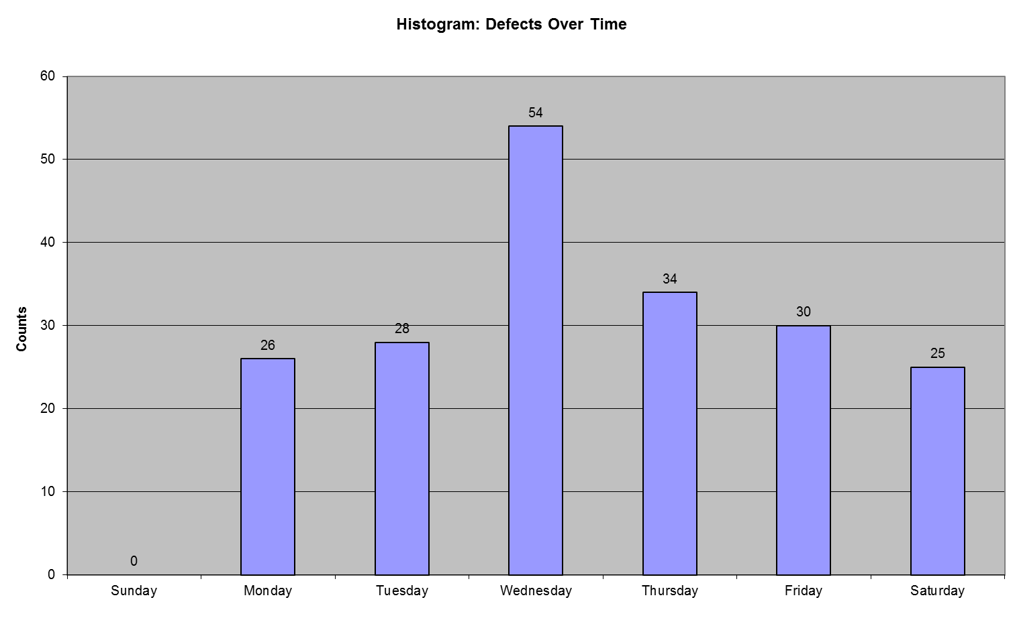
Histogram analysis
Using the histogram as a tool allows the number of defects to be compared with the time, in this case it is each day of the week. The data shows clearly similar to the check list that Wednesday is problematic day with a high number of defects when compared to another day of the week.

Environment
Material
Machine
Method
Person
Effect
Surface finishing
Improper shape
Work pressure
Lack of training

Shift in cast
Operators working independent of each other

Milling tool
Blowholes appearing frequently

Organisation of the area and ease of spotting issues
Type of material/metal used for casting

The quality and durability of the cutting tool

Cause and effect analysis
This allows me to reveal all underlying causes that may be causing or contributing to the problem and quickly communicate all potential causes under consideration. Under the ‘person’ branch and using assumptions, a lack of training and work pressure may be contributing to the defects. 8 blow hole defects which result from sandcasting are reported as defects for operation 2. This means the defects were not spotted by workers A and B and passed onto the next phase of machining.
Under method branch, the operators are working independently from each other. This could prove as a weakness as there is no cross over between the workers to allow handovers, problems to be discussed and potential improvements to be set in place. Also on the same branch the method be for the sand casting may need analysing as the number of blowholes are 34 which is the most frequent defect for operation 1.
The machine branch of cause and effect improper shape could result from a shift or a mismatch in the sand casting process caused by improper alignment during mould preparation, misalignment of flask, this can be rectified by using the correct alignment of moulding boxes, correct mountings of pattern on plates and checking the alignment of flask
On the material branch, this again could be related to the cutting tool used, the quality of the metal used in the sandcasting process and the sand quality. On the final branch ‘environment’ The organisation of the area could pose a problem as sandcasting defects ‘blowholes’ appear on the machine process defects.

Pareto method
The pareto method is useful as it analyses what problems that need attention first. This theory maintains that 80% of the output is produced by 20% of the input. This will allow a focus on the main root causes of problems.

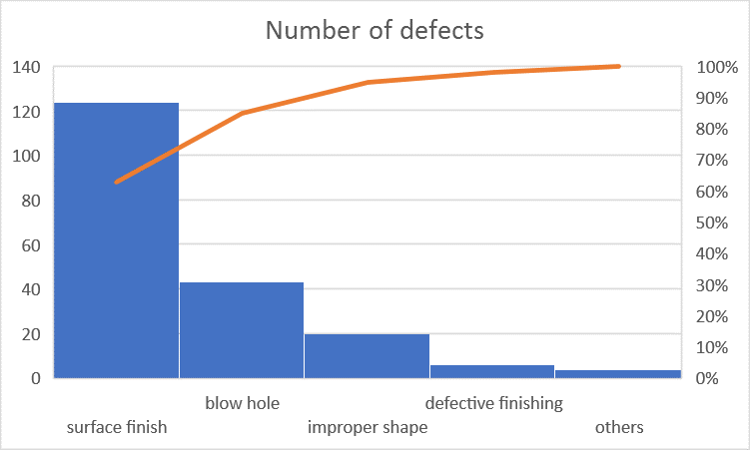
Pareto analysis
Using the pareto method and focussing on the 20% of problems the majority is surface finish defects, this is where the most effort should be focussed on in order to achieve the greatest improvement. Using this theory, by targeting surface defects the biggest cause of defects, it will have the greatest impact on the number of overall defects. The data also allows for defects to be prioritised in order of urgency.
Priority | Defect | No. of defects
 | Surface finish | 124
 | blowhole | 43
 | improper shape | 20
 | defective finishing | 6
 | others | 4

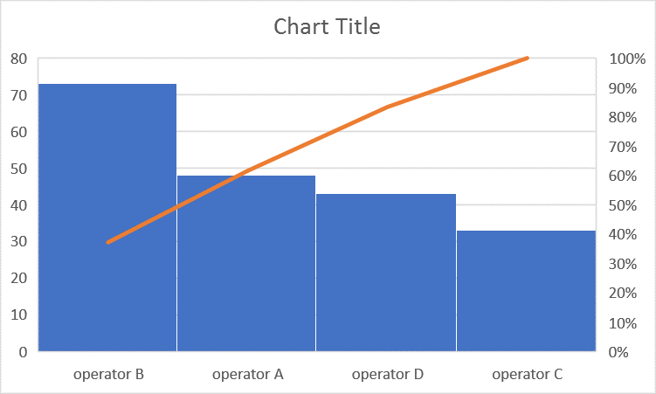
Using the pareto method on the operators clearly shows that the majority of the defects come form operator B, with a considerable number of defects coming from operators A and D. Using the pareto theory operators B,A and D should be prioritised when investigating the cause of the defects.

5 why analysis
5 why analysis is an assessment phase used to diagnose the root cause of the underlying problem. By repeating asking why to a problem the layers of symptoms will lead to the root cause, it can numerous benefits as the root cause if found, the relationship between the different root causes of the problem and it’s a simple tool to use.
Using this theory on the drill base unit defects and using assumptions 4 possible underlying root causes were found. The first problem ‘surface finish’ could be defective as the finish is uneven which can relate to a problem while moulding that the liquid could penetrate the gaps as it is a poor sand quality as it is low strength and has high permeability. The poor sand or poor material leads to the root cause that it is a low cost product.
The second problem ‘defective finishing’ also lead to an uneven finish as the surface roughness is out of tolerance as the cutting tool was dull. The cutting tool had not been changed as there were no guidelines, tolerances or time periods in place for the operator to change the cutting tool this leads the root cause of the safe operating procedure needs to be set in place or need to be adapted.
The third problem ‘blow hole’ defects can be traced to a problem in the sand casting process where the pouring on the liquid metal was too slow, this can be a result of the metal being too cold as it wasn’t in the furnace or heated for enough time. This lead to the assumption that the operator did not time the process as he was rushing due to time constraints.
The fourth problem improper shape may result of a misalignment between the cope and the drag. This may be a result of loose pins on the flask, they were not secured properly as the pins and lugs are made of wood and the design is poor.

Scatter diagram
Using the total number of defects per day, as shown in this table a scatter diagram can be used to plot any possible trends. This is helpful as there is separate data on defects split into morning and afternoon errors. This diagram will show the relationship of errors between morning and afternoon can help determine if there is a direct relationship between them.
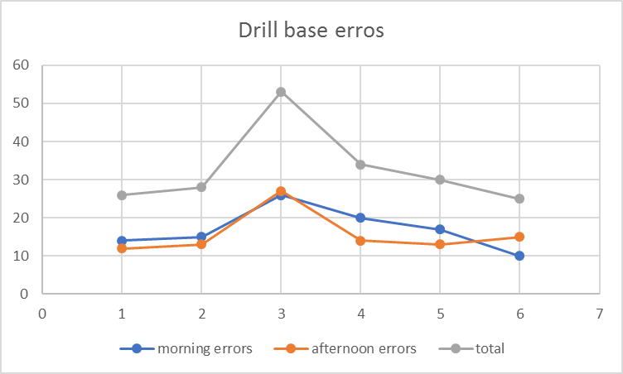

Scatter diagram analysis
The trend in the scatter diagram clearly shows that errors in the morning and afternoon progressively increase and spike on Wednesday then slowly decline towards the end of the week.
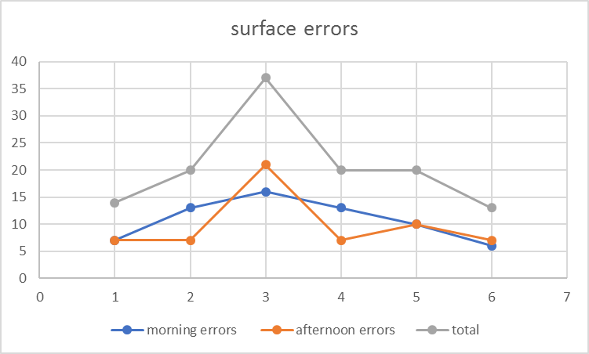
Using a scatter diagram to compare the most common defect surface finishing by itself shows that there is a slight distinction between morning and afternoon errors if Wednesday was excluded. Looking at the results afternoon errors for surface finishing is abnormal compared to the average results across the rest of the afternoon defects across the week.

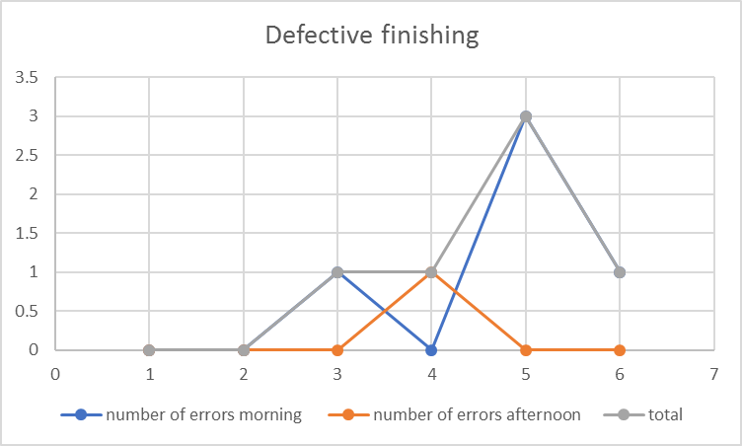
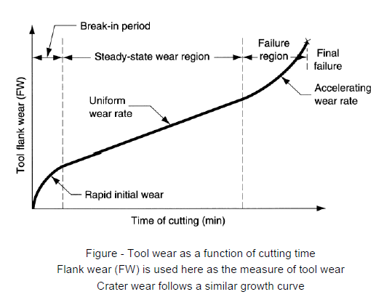
Defective finishing has a consistent number of errors until Friday where errors increase to 3 the whole day then the next day on the Saturday the number of errors decrease. The type of finishing defects the operators could come across are crater wear and flank wear over time of using the tool and considering a break in period for the cutting tool.
When comparing the finishing defects scatter diagram with an estimated tool wear diagram the results are similar, the reason of the surface finish defects is related to the roughness of the cutting tool and the tool entering the failure region of the graph. Using an alternative cutting tool and regular cutting tool changes defects will be reduced.
Conclusion
The corrective action that should be taken after using the problem solving tools and analysing the drill base defect data draws to numerous root causes. From the cause and effect method the corrective action that should be taken is shift handovers should be set in place between operators. This would allow the operators to have a line of communication on potentials problems and the improvements to the process that could be made. It would also be beneficial that all operators have a weekly meeting to discuss the process, as certain defects such as blow holes which originate from the sand casting process appear as defects in machining. This number totals 7. Nearly half (45 percent) of manufacturers acknowledged considerable room for improvement when it comes to proactively preventing problems with assets in their organization By having regular meetings and shift handovers these improvements can be discussed and implemented.
The cutting tool for the vertical mill should be changed on a more regular basis, the number of defective finishing defective drill bases gradually rise throughout the week then spike on Friday and return to a lower value on Saturdays, to combat this the cutting tool should be changed twice a week on Tuesdays and Fridays to avoid the risk of drill base units being processed through sandcasting successfully then to fail on machining. A high speed steel material should be used such as Molybdenum M2. This will allow the cutting tool to have some flexibly in order to make angled cuts but retain strength and durability.
Operator B produces 73 defects which is just over 30% more than the closest operator A. a plan should be set in place to further train operator B and note any differences in operations between operator A and B during the sandcasting process but it is also worth noting that the sandcasting process tends so have more defect (121) generally than machining (76). A uniform safe operating procedure should be created to ensure the sandcasting process is carried out using the same methods across both operators to ensure a consistent reliable process.
The largest defect surface finishing, can be reduced by analysing the materials being used for the sandcasting process. Due to the number of defects it may lead a problem early on in the process of sandcasting where the liquid metal is penetrating gaps in the moulding sand. This may a result of poor sand quality of it lacks strength and has high permeability. An alternative sand should be used for the sandcasting process a sand with a lower grain size to allow air and moisture to escape.
To reduce the number improper shape defects which likely are a result of the sandblasting process, metal lugs and pins should be used to secure the drag and the cope to ensure there is a reduced likelihood of a mismatch occurring. These lugs will be easy to install and have a low cost but a potential big cost saving on the shape defects.
A certain number of the defects must be considered and expected as they may fall under human error. A study by Vanson Bourne found that 23 percent of all unplanned downtime in manufacturing is the result of human error, compared with rates as low as 9 percent in other sectors. This could mean that out of the 196 errors that occurred in the process, 45.08 were human error. This takes up a considerably large portion of the defects that could be avoided. By using the 5s method of sort, set, shine, standardise and sustain the amount of human error will lower in turn lower the amount of defects.
Action plan
priority | Action | Description | Responsibility | Cost potential: high, medium low
1. | Sand quality | Using a higher quality of sand will improve the sandcasting process and reduce defects | Material engineer | medium
2. | Implement team meetings and shift handovers | This will allow potential problems and solutions to be discussed. | Shift manager | low
3. | Cutting tool changed on a more regular basis | Changing the cutting tool more often will result in a better finish and lower the defect rate. | Shift manger and operators | medium
4. | Operator B training | Further train operator B to reduce the number of defects. | Shift manager | low
5. | Insert metal lugs and pins to the flask | Inserting metal lugs and pins and securing will lower the chances of a mismatch occurring in the sandcasting process. | Mechanical engineer | low
6. | Implement 5s | Implement 5s across the workplace to ensure the number of defects decrease | Production manager | low

Bibliography
(online pdf) http://www.uphs.upenn.edu/gme/pdfs/Observations_Tips%20for%20making%20Check%20Sheets%20for%20data%20collection.pdf accessed April 2 2019

(online pdf) http://www.uphs.upenn.edu/gme/pdfs/Observations_Tips%20for%20making%20Check%20Sheets%20for%20data%20collection.pdf accessed April 2 2019

www.ASQ.org (Excel Template) https://www.google.com/url?sa=t&rct=j&q=&esrc=s&source=web&cd=6&ved=2ahUKEwj-56G3oMDhAhXysaQKHb7PAsIQFjAFegQIABAC&url=https%3A%2F%2Fasq.org%2F-%2Fmedia%2Fpublic%2Flearn-about-quality%2Fdata-collection-analysis-tools%2Fcheck-sheet-histogram.xls%3Fla%3Den&usg=AOvVaw2s_l6pp1rOEAntJOGPAbqn accessed April 2 2019

Carpenter group LLC (website) https://www.quality-improvement-matters.com/histogram.html accessed April 2019

Cause and Effect (“Fishbone”) Diagram (website) https://uihc.org/sites/default/files/documents/asset-3737.doc (accessed 2 April 2019)

SHArPEdgeGlobal [ Sand Casting ] - Learn More about Sand Casting Process – YouTube
https://www.youtube.com/watch?v=pwaXCko_Tkw accessed 2 April 2019

Mishra, Pankaj(online Photograph) https://www.google.com/search?rls=com.microsoft%3Aen-GB%3AIE-SearchBox&biw=838&bih=632&tbm=isch&sa=1&ei=pxqjXOLMGu3ImwX10a74DQ&q=sand+casting+defects&oq=sand+casting+defects&gs_l=img.3..35i39j0i24l6.9155.11948..12104...0.0..0.75.896.15......1....1..gws-wiz-img.......0i7i30.pU01jdGCi8Q#imgrc=TtmVGjWCnsBxgM:&spf=1554193076487
Accessed 2 April 19.

Margaret Rouse, whatis.com (website) https://whatis.techtarget.com/definition/Pareto-chart-Pareto-distribution-diagram accessed April 2 2019.

Sunny Wong intouch.com (website) https://www.intouch-quality.com/blog/21-casting-defects-and-how-to-prevent-them-in-your-products accessed April 4 2019

SHArPEdgeGlobal (youtube video) https://www.youtube.com/watch?v=pwaXCko_Tkw accessed April 4 2019

© Karn G. Bulsuk.(excel template) http://karnbulsuk.blogspot.com

© Karn G. Bulsuk.(excel template) http://karnbulsuk.blogspot.com accessed April 5 2019

The Quality Toolbox, Second Edition, ASQ Quality Press. (website) https://asq.org/quality-resources/scatter-diagram accessed April 5 2019

Iitk.ac.in (PDF document) http://home.iitk.ac.in/~nsinha/Machining%20II.pdf accessed April 15 2019

Vason Bourne (website) https://www.engineering.com/AdvancedManufacturing/ArticleID/15974/Human-Error-is-Worse-in-Manufacturing-Compared-to-Other-Sectors.aspx accessed April 12 2019

(online pdf) http://www.uphs.upenn.edu/gme/pdfs/Observations_Tips%20for%20making%20Check%20Sheets%20for%20data%20collection.pdf accessed April 2 2019
(online pdf) http://www.uphs.upenn.edu/gme/pdfs/Observations_Tips%20for%20making%20Check%20Sheets%20for%20data%20collection.pdf accessed April 2 2019
www.ASQ.org (Excel Template) https://www.google.com/url?sa=t&rct=j&q=&esrc=s&source=web&cd=6&ved=2ahUKEwj-56G3oMDhAhXysaQKHb7PAsIQFjAFegQIABAC&url=https%3A%2F%2Fasq.org%2F-%2Fmedia%2Fpublic%2Flearn-about-quality%2Fdata-collection-analysis-tools%2Fcheck-sheet-histogram.xls%3Fla%3Den&usg=AOvVaw2s_l6pp1rOEAntJOGPAbqn accessed April 2 2019
Carpenter group LLC (website) https://www.quality-improvement-matters.com/histogram.html accessed April 2019
Cause and Effect (“Fishbone”) Diagram (website) https://uihc.org/sites/default/files/documents/asset-3737.doc (accessed 2 April 2019)
SHArPEdgeGlobal [ Sand Casting ] - Learn More about Sand Casting Process – YouTube https://www.youtube.com/watch?v=pwaXCko_Tkw accessed 2 April 2019
Mishra, Pankaj(online Photograph) https://www.google.com/search?rls=com.microsoft%3Aen-GB%3AIE-SearchBox&biw=838&bih=632&tbm=isch&sa=1&ei=pxqjXOLMGu3ImwX10a74DQ&q=sand+casting+defects&oq=sand+casting+defects&gs_l=img.3..35i39j0i24l6.9155.11948..12104...0.0..0.75.896.15......1....1..gws-wiz-img.......0i7i30.pU01jdGCi8Q#imgrc=TtmVGjWCnsBxgM:&spf=1554193076487 Accessed 2 April 19.
Margaret Rouse, whatis.com (website) https://whatis.techtarget.com/definition/Pareto-chart-Pareto-distribution-diagram accessed April 2 2019.
Sunny Wong intouch.com (website) https://www.intouch-quality.com/blog/21-casting-defects-and-how-to-prevent-them-in-your-products accessed April 4 2019
SHArPEdgeGlobal (youtube video) https://www.youtube.com/watch?v=pwaXCko_Tkw accessed April 4 2019
© Karn G. Bulsuk.(excel template) http://karnbulsuk.blogspot.com
© Karn G. Bulsuk.(excel template) http://karnbulsuk.blogspot.com accessed April 5 2019
The Quality Toolbox, Second Edition, ASQ Quality Press. (website) https://asq.org/quality-resources/scatter-diagram accessed April 5 2019
Iitk.ac.in (PDF document) http://home.iitk.ac.in/~nsinha/Machining%20II.pdf accessed April 15 2019
Iitk.ac.in (PDF document) http://home.iitk.ac.in/~nsinha/Machining%20II.pdf accessed April 15 2019
Vason Bourne (website) https://www.engineering.com/AdvancedManufacturing/ArticleID/15974/Human-Error-is-Worse-in-Manufacturing-Compared-to-Other-Sectors.aspx accessed April 12 2019
Vason Bourne (website) https://www.engineering.com/AdvancedManufacturing/ArticleID/15974/Human-Error-is-Worse-in-Manufacturing-Compared-to-Other-Sectors.aspx accessed April 12 2019

