Postgraduate/Distance Learning

Assignment coversheet & feedback form

THIS SHEET MUST BE THE FIRST PAGE OF THE ASSIGNMENT YOU ARE SUBMITTING (DO NOT SEND AS A SEPARATE FILE)

For completion by the student:

Student Name: Clarissa Jane Fowler

Student University Email: 2310967@student.uwtsd.ac.uk
Module code:HPCA7015  Module title: Foundations in Cultural Astronomy and Astrology | Student ID number:  2310967 |  |  | Educational support needs:  Yes/No

Assignment title: 2000 word essay on a topic in the subject area

Assignment due date: 30/11/2023

This assignment is for the 1st 2nd 3rd 4th 5th 6th module of the degree

I confirm that this is my original work and that I have adhered to the University policy on plagiarism.

Signed ……………………………………………………………

Email submission:if you are submitting this form via email, please tick this box □

(as a substitute for your signature) to confirm that you agree to the above declaration.

Assignment Mark

1st Marker’s Provisional mark

2nd Marker’s/Moderator’s provisional mark

External Examiner’s mark (if relevant)

Final Mark

NB. All marks are provisional until confirmed by the Final Examination Board.

For completion by Marker 1 :

Comments:

Marker’s signature: |  |  | Date:

For completion by Marker 2/Moderator:

Comments:

Marker’s Signature: |  | Date:

External Examiner’s comments (if relevant)

External Examiner’s Signature: |  | Date:

2000 word essay on a topic in the subject area

ASSIGNMENT 2: Essay based on a Sky Journal

Word count: 2059 (including poem in figure 8)

Introduction:
The aim of this research is to explore the sky’s relationship to the landscape, and in turn in relation to the statement, “Be clearly aware of the stars and infinity on high. Then life seems almost enchanted after all.” by Vincent Van Gogh. Employing a qualitative, phenomenological approach, this project distilled sky journal research from March 2023 - November 2023, exploring a personal cosmology and the sky’s relationship to the sea and landscape of Conwy County, North Wales. I Observed the celestial bodies and how they reflected on the water, as well as touching on subjects of ‘Colour, Weather and Mood’, and contemplating infinity on high, ultimately leading to the creation of a personal cosmology, highlighting the importance of contemplating the ‘beyond’. Through analysis of the sky journal entries in conjunction with a literature review, namely of the works of Daryn Lehoux, Nick Campion, Liliana Albertazzi, Clive Ruggles and Daniel Brown as well as Walt Whitman, while keeping in mind Van Gogh’s ‘infinity on high’. This research sought to understand how contemplation of the relationship of the sky and sea, as well as the stars and infinity ‘on high’ can mould a personal cosmology or worldview.

Academic Rationale
This research sought to explore the profound connection between humanity and the cosmos, in conjunction with Van Gogh’s ‘infinity on high’ statement. Focusing on North Wales. This work adopts a phenomenological approach, examining personal cosmology as a “meaning-system”. This research aligns with Clive Ruggles' insight that “From an anthropological point of view, the whole concept of a ‘path of progress’ in astronomical discovery is anathema since it implicitly downgrades other cultural perspectives.”, ensuring a multifaceted understanding of the cosmos beyond a singular scientific narrative. Additionally, Daniel Brown insight that "Therein lies a huge challenge since modern societies are generally less aware of the skyscape than their forefathers.", serves as a backdrop to this research, emphasising the rekindling of a relationship with the celestial realm. I conducted this research to gain a dialogue with the sky through its relationship with the landscape, as Nick Campion notes “The word [astrology] is derived from the Greek astron (star) and logos. Logos is simply translated as ‘word; so the word astrology is then the ‘word’ of the stars: the stars ‘speak’”; it was this wisdom from the stars, that this research sought to find, recorded through a sky journal. In summary, this research is not just an academic exercise, but a quest to rekindle a conversation with the stars.

Methodology
This study finds its methodological roots in phenomenology, Liliana Albertazzi’s notes that “Appearances occurring in the perceptual fields are colour, tones, configurations, scenes, sources of light, movements, shape, transformations, shadows, space, whatever can be subjectively experienced in the perpetual fields”, which I thoroughly explored throughout this research, crucial for capturing the subjective nuances of my observations of the sky and sea. Most entries were recorded at Colwyn Bay Victorian Pier, which faces North into a Bay to the Irish Sea (see figure 1). The data was collected in nine sections including location, date, time, tidal information, solar and lunar times/phases, meteorological conditions, observations and thoughts and insights. Although this research was grounded in naked-eye observations, I also occasionally employed tools including binoculars, a basic telescope and a sky mapping application, supplemented with photographic documentation (Figures 6, 7 and 8). Furthermore, a series of paintings documented in figures 2, 3 4 and 5, to add a layer of personal depth, focusing on moments and encounters that resonated deeply with me. This methodology, balancing personal narrative with scholarly inquiry, presents an intimate exploration of the sky and sea, a reflective journey, highlighting the transformative impact of the natural world on personal perception and understanding.

Reflective considerations
I am a white British woman in my mid-twenties and have spent much of my life in the research area, so watching these sky’s and their relationship to this landscape is nothing new for me. Moreover, I have also sky watched for extended periods (2 months or more) in other locations including Edinburgh Scotland, North Yorkshire, New York, Montreal and Kalambo Falls, Zambia. Academically, I studied a BSc in Evolutionary Anthropology, as I wanted to gain a deeper understanding of humanity in time and space through both a social and scientific perspective. Through this, I realised humans are simultaneously fragile and strong beings with a deep connection with the sky and landscape, bringing new perspectives in my world-view. During a previous research project (The Deep Roots Project), at Kalambo Falls I kept a personal diary in which I would often note the beauty of the skies and the ancient landscape, I also used a small hand-held telescope, which I would sometimes use to observe the moon and stars. In summary, although I have sky watched before, this is my first in-depth study. It is important to note that my background could present bias, however this research conveys a personal narrative.

Literature review
Daryn Lehoux, in 'Tomorrow’s News Today', opens with a thought experiment challenging the reader to “Imagine for a minute that astrology is true”, challenging conventional scientific views and underscoring the importance of openness in research and understanding. This aligns with my approach in this study, allowing for the invitation of new perspectives and a richer experience. The interplay between the empirical study of the sky and its deeper, subjective meaning has been a point of inquiry in various disciplines, and a theme prominently reflected in my research. Walt Whitman’s poem "When I Heard the Learn’d Astronomer" captures this contrast beautifully, portraying the divide between the analytical side of astronomy and the awe-inspiring experience of directly engaging with the night sky. Nick Campion’s perspective that “The sky and the earth are reflections of each other and the movements of the heavenly bodies… a dialectical and symbiotic relationship between repetitive consistency and endless change, and revealing messages and meaning to those who care to look and listen.”, from his book ‘Astrology and Cosmology in the worlds religions’, is a major theme in the research, and reflective of Van Gogh’s ‘infinity of high’ statement, serving as an inspiration for my journal and resonating with my artistic expressions and my exploration of the sky’s impact on personal cosmology.

Fieldwork and Discussion
My fieldwork was conducted primarily at Colwyn Bay Pier, providing a clear view into the bay for observing the sky’s relationship to the sea, and contemplating the stars and infinity. Over eight months, I collected 82 journal entries with concentrated observations in March/April and November. Throughout most of the year I visited the pier to record my sky journal at varying times of day/night, to experience a varied array of skies and experiences. However, in November, I kept within a 1-hour window (17:30-18:30), for 3 weeks, to gain a more stable insight and reflection of smaller changes each day - when the weather, or rather the clouds permitted. My fieldwork revealed a great connection between the sky’s ‘moods’, reflecting not merely upon the landscape, but also within my own emotional landscape. On clear or particularly ‘colourful’ days, a sense of wonder, joy and serenity prevailed, indeed life did feel enchanted. Conversely, on overcast days and dark nights often left me feeling more “closed in” and introspective in mood, allowing for a deeper contemplative experience and exploration of my personal cosmology. Moreover, I started to feel a closer connection to the rhythmic cycles of our world through the inner cycles within myself. On March 20th I noted “Today is the Vernal Equinox…with a new moon approaching…also menstruating, makes me feel closer to the moon phase and cosmic cycles, a cleansing almost”. The reflections of the sky not only impacted the way I viewed the landscape, but also how I viewed myself, in turn reflecting M. D. Stafleu’s notion that “We cannot observe the universe as an object, from outside. By considering the universe as a whole we cannot escape even ourselves in our observations.”.

Weather, Colour & Mood
Through observing and being ‘aware’ of the sky, it seemed to act as the canvas on which nature painted its moods, each stroke resonating with the palette of my human emotions, with the sea serving as a mirror, bringing the heavens closer to the earth, making the ‘beyond’ feel almost tangible. Weather, colour, and reflection had a great impact on this immersive research. At sunset on the 14th of November, I noted “The colours are just magnificent…. reflections in the sea are just so beautiful, the pink, the blue, the yellow and oranges right back to Horizon”, it sparked such joy I could not help but move and dance under the setting sun, evoking a sense of fullness and connection with the cosmos. Contrastingly, on the 18th of November, I noted the “deep dark reflections of the sky create such a moody sense across the whole of the landscape…the stillness of the night brings a calm”, for which I also wrote a poem (see Figure 8). However, as Campion notes, “The notion of reflections, though, is only part of the story. Equally important is the concept of relationship - that the cosmos is alive and that everything in it exists in a series of relationships with all other things.” And it was times such as on 12th November, noting “Ursa Major is one of my favourite sites to see, and seeing it move so slightly in the sky is amazing”, going out each evening and seeing these relationships and movements really did make the cosmos feel alive, once more bringing ‘enchantment’ of life to the forefront.

Contemplating Infinity on High: Creation of a Personal Cosmology

Vincent Van Gogh’s ‘infinity on high’ statement became the philosophical bedrock on which this research was conducted. It transformed my nightly sky observations into a meditative experience on the cosmos, resulting in the creation of a personal cosmology which I named 'Harmony in Flux'. I imagined a narrative of cosmic rhythm, a sequence of creation, existence, and dissolution, resonating throughout the universe, a series of ‘bangs’ and ‘crunches’ dancing in an infinite loop, bridging the gap between the momentary and the perpetual, offering a fresh lens to view the universe. While expanding my personal cosmology, Clive Ruggles’ statement about the anthropological perspective on astronomical discovery reminded me to remain open to diverse cosmological views. This approach enriched my research, ensuring it was balanced and inclusive. Additionally, Daniel Brown's observation about modern societies’ disconnect from the skyscape motivated me to reconnect with the universe in a way often overlooked in contemporary times. Inspired by Van Gogh, I discovered the enchantment of life within the cosmic dance. The infinite sky, with its constellations and galaxies, became a source of inspiration, leading me to a newfound appreciation for the transient beauty within the universe's ceaseless motion.

Conclusion
In this study, I explored the relationship between the sky and the landscape of Conwy County, drawing inspiration from Vincent Van Gogh's reflections on contemplating infinity on high. I adopted a phenomenological approach to capture the sky’s essence as more than just a scientific entity, but as a profound human experience. This approach prioritised qualitative observations, allowing for a deeper, more personal understanding of celestial phenomena. My fieldwork infused personal observation with artistic expression, revealing how colour and weather can impact emotional experiences with the sky. This exploration into the impact of gazing upon the ‘stars and infinity’ showed its profound influence on shaping a worldview, leading to new perspectives on the cosmos and our place within it. However, it’s important to acknowledge the inherent subjectivity of this approach, while insightful, it represents a singular personal narrative. Future research could expand on this by incorporating diverse settings, a larger sample size or blending these personal narratives with quantitative data. In conclusion, this work highlights the significance of our connection with the sky, in line with Van Gogh’s profound statement. It goes beyond scientific observation to a more intimate human-centric understanding of how the sky touches our lives and shapes our perceptions.

Figure 1: View of viewing platform, 7th November 2023.

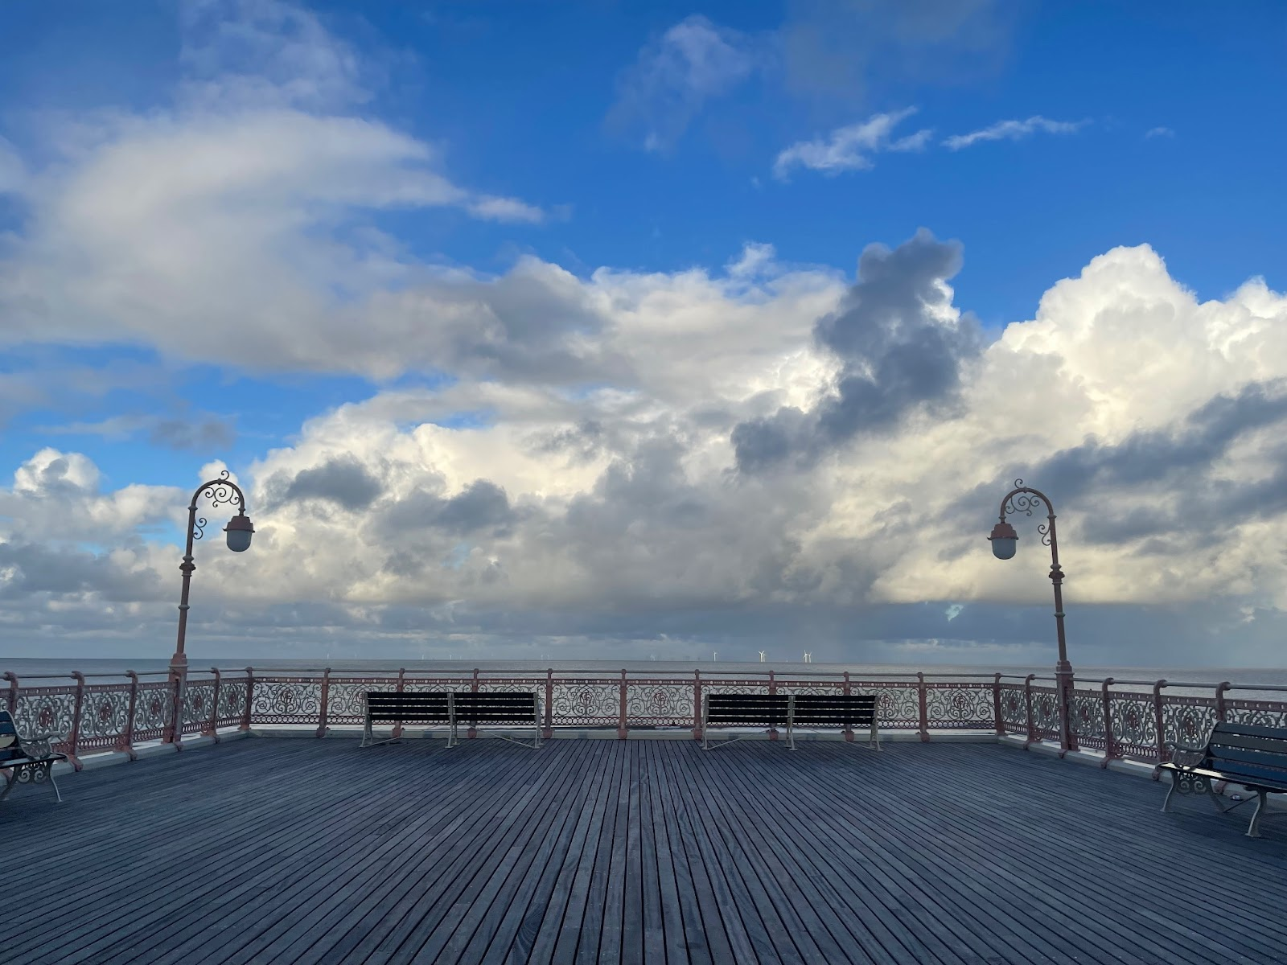

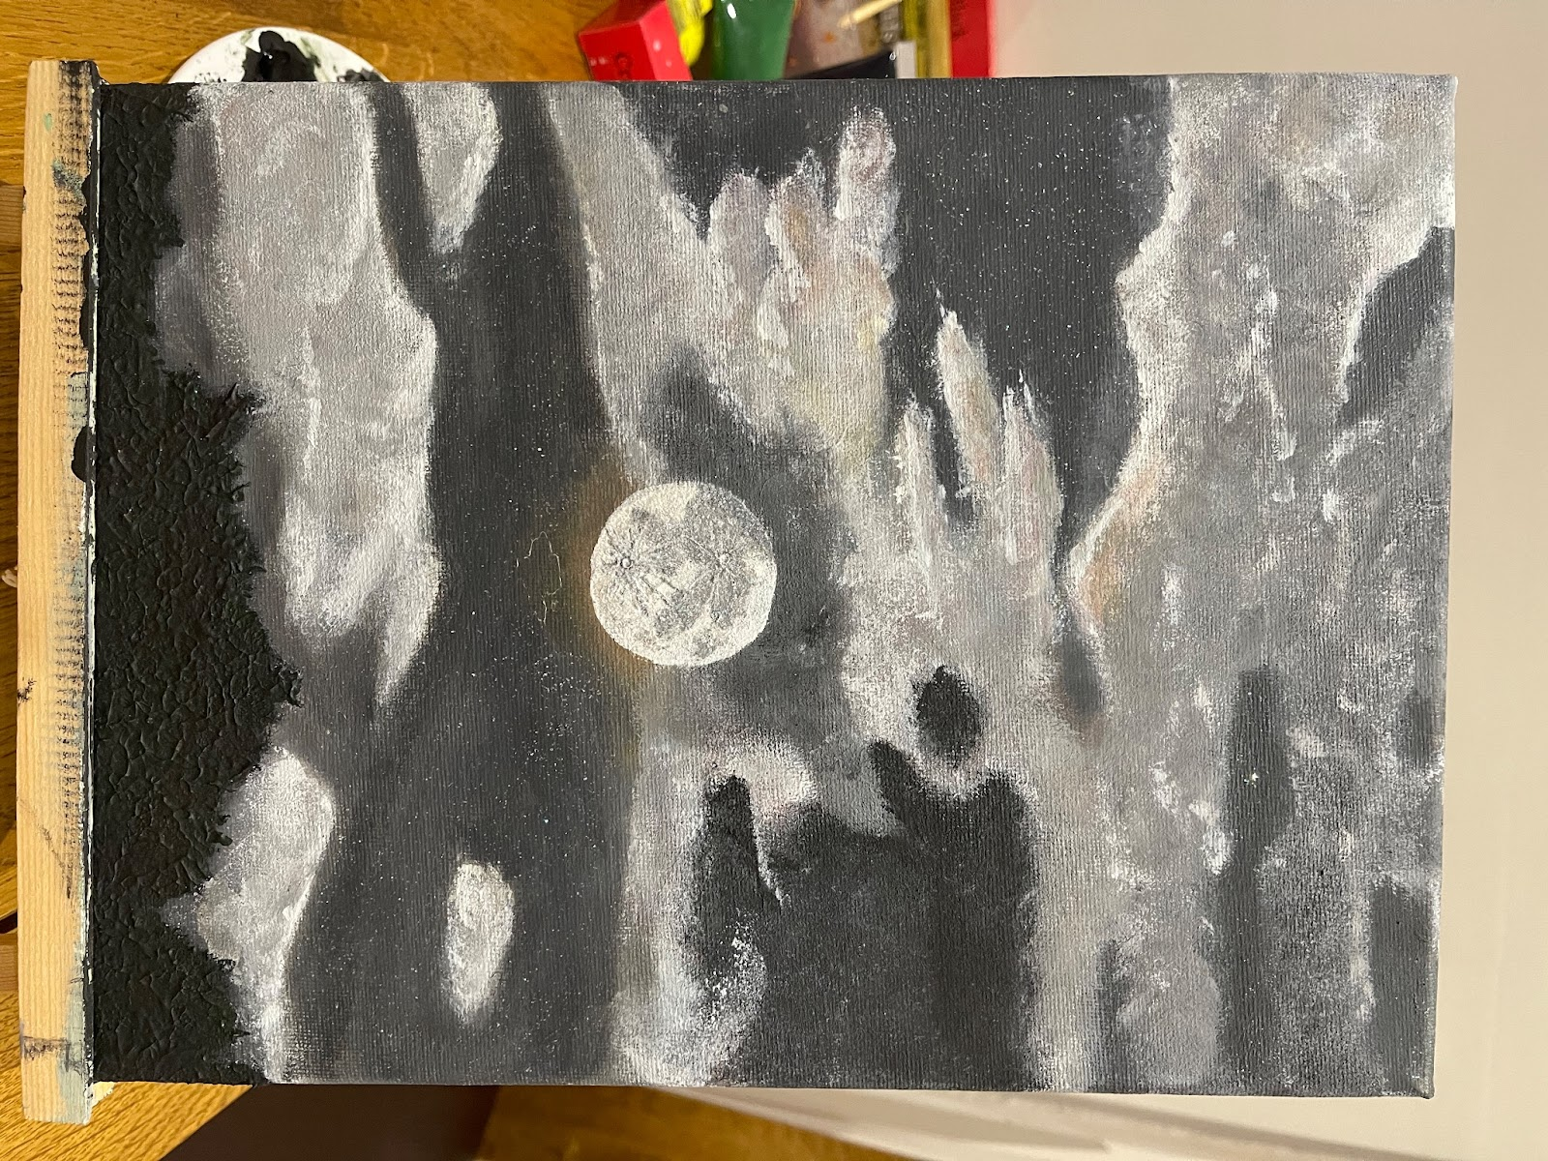
Figure 2: Moons glow painting of 5th May 2023.

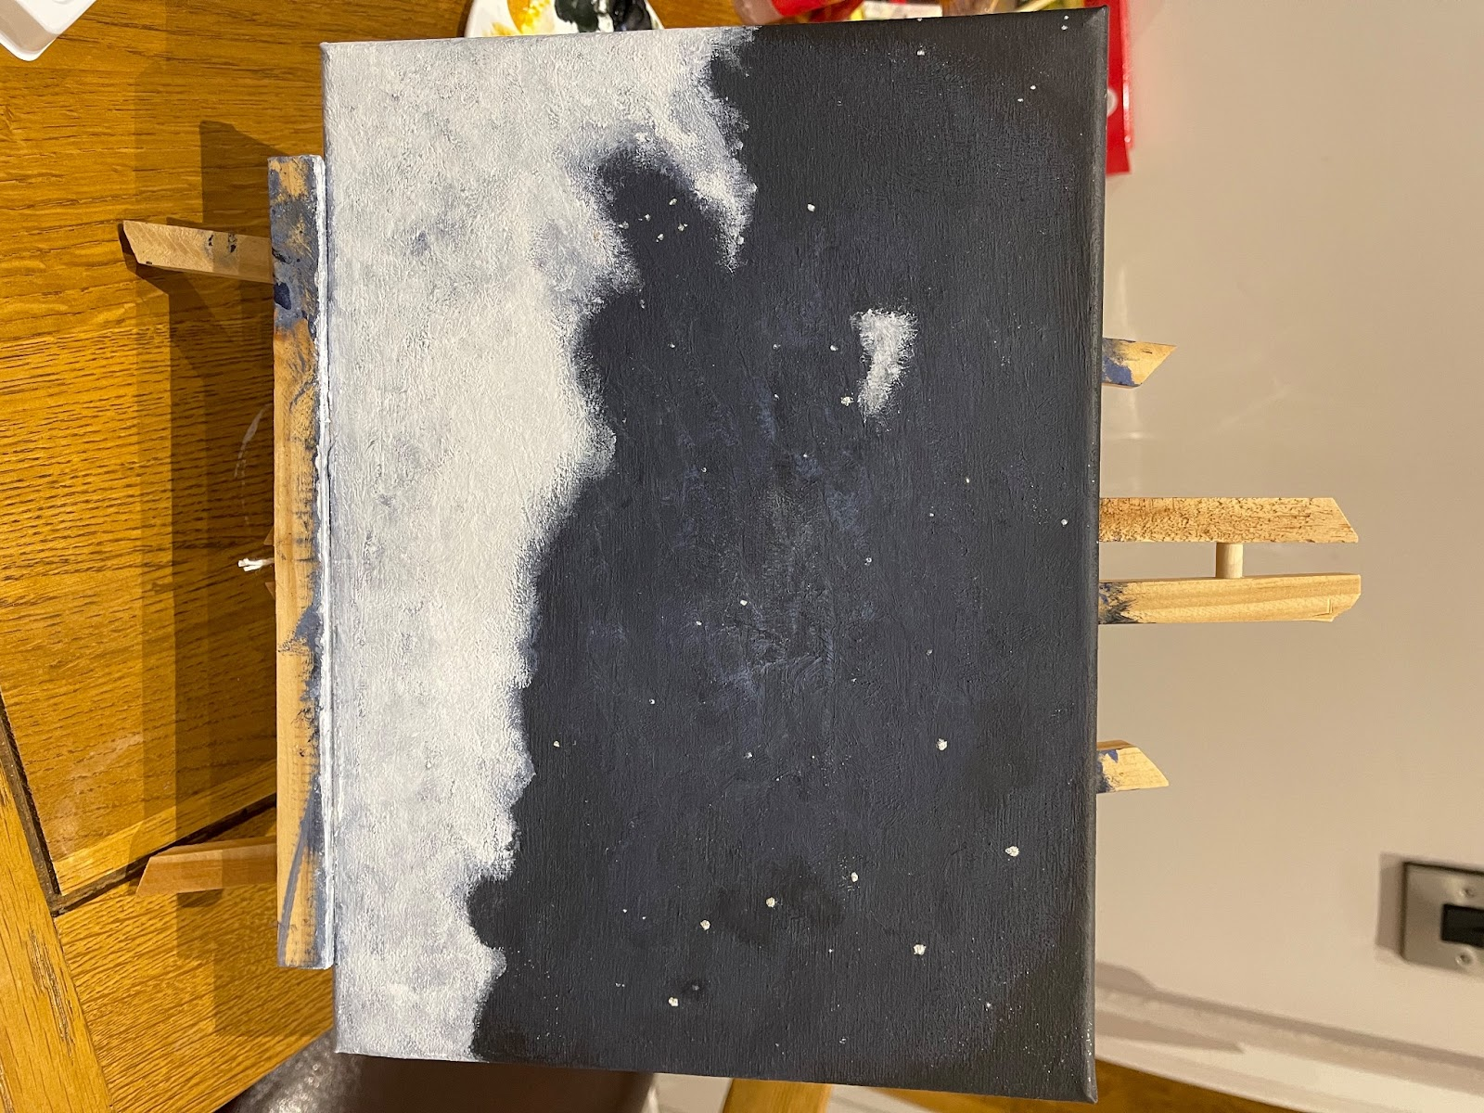
Figure 3: Painting of Ursa Major on March 16th 2023.

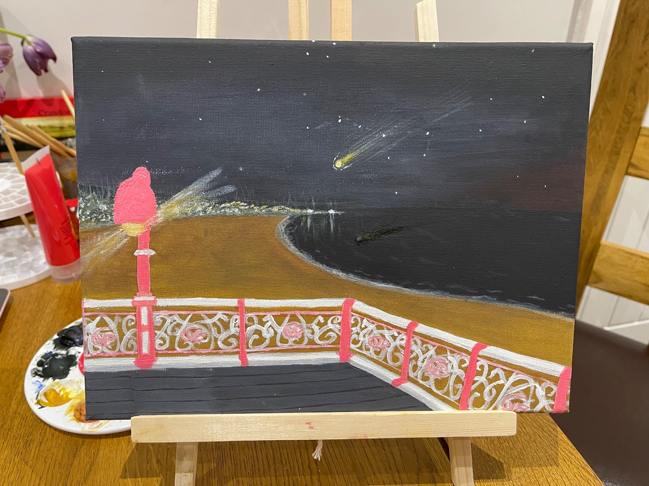
Figure 4: Painting of 'shooting star' on 11th November 2023.

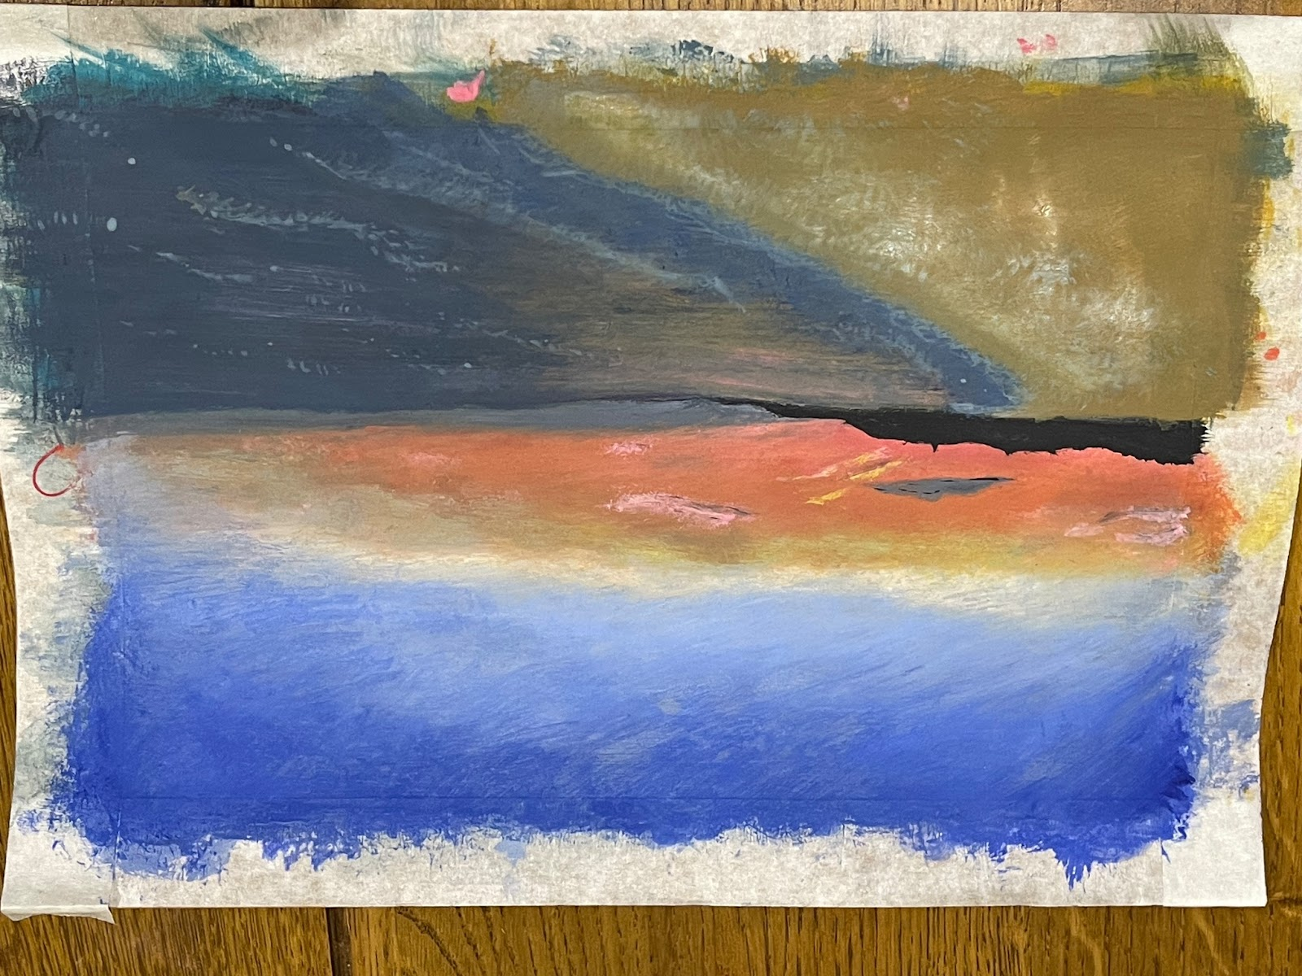
Figure 5: Painting of solstice sunset, 21st June 2023.

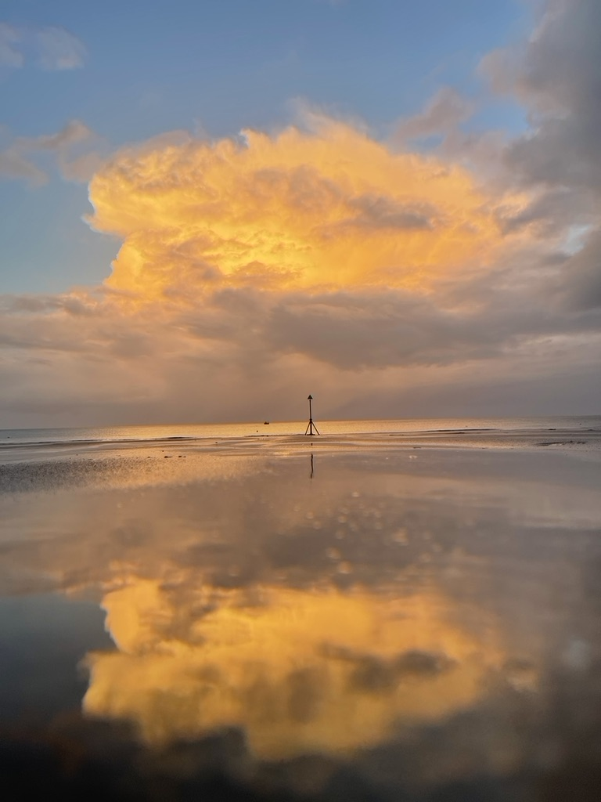
Figure 6: Sunset 14th November 2023.

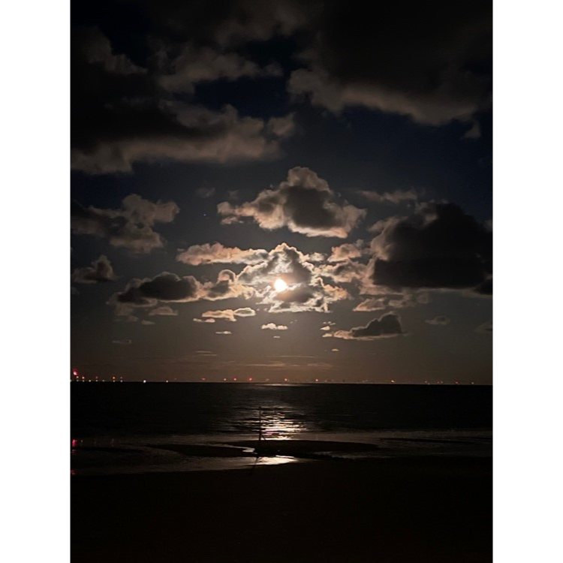

Figure 7: Moons reflections 30th November 2023

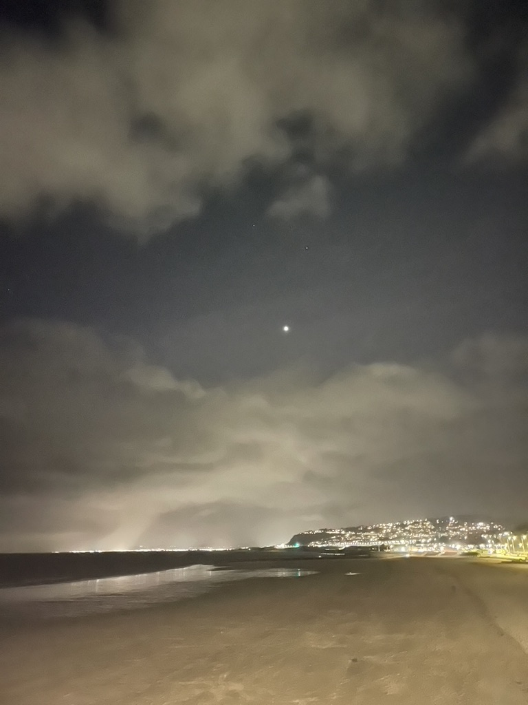

Figure 8: 18th November view of Saturn.
Poem: In the quiet of Conwy's night, beneath the stars' eternal light, where the sea meets the sky in a dance of twilight, there my thoughts sail far and wide, on cosmic waves where dreams reside. In every star, a story told, of timeless tales and mysteries old. The sky, a canvas vast and clear, reflects the souls of the cosmos near.

Bibliography
Albertazzi, L. ‘Experimental phenomenology: What it is and what it is not’, Synthese, 198(S9), 2019, pp. S9-2212. doi:10.1007/s11229-019-02209-6.
Campion, N. (2012c) Astrology and cosmology in the world’s religions. New York University Press. 2012
Gogh, V. van, Leeuw, R. de and Pomerans, A.J. ‘'Be clearly aware of the stars and infinity on high. Then life seems almost enchanted after all.’’, in The letters of Vincent Van Gogh. London etc.: Penguin Books, 1997, p. 392.
LEHOUX, D. ‘Tomorrow’s news today: Astrology, fate, and the way out’, Representations, 95(1), 2006, pp. 105–122. doi:10.1525/rep.2006.95.1.105.
Ruggles, C.L.N. ‘Indigenous astronomies and progress in modern astronomy’, Proceedings of Accelerating the Rate of Astronomical Discovery — PoS(sps5) [Preprint]. 2010, doi:10.22323/1.099.0029.
Silva, F., Campion, N. and Brown, D. ‘4 Skyscapes: Present and Past – From Sustainability to Interpreting Ancient Remains’, in Skyscapes: The role and importance of the Sky in archaeology. Oxford: Oxbow Books, 2015, pp. 32–41.
STAFLEU, M.D. ‘Being human in the cosmos’, Philosophia Reformata, 56(2), 1991, pp. 101–131. doi:10.1163/22116117-90001561.
Whitman, W. When I heard the learn’d astronomer, Poetry Foundation. Available at: https://www.poetryfoundation.org/poems/45479/when-i-heard-the-learnd-astronomer, 1865, (Accessed: 30 November 2023).

(Vincent van Gogh and Ronald de Leeux. The letter of Vincent Van Gogh. London: Penguin Books, 1997, p.392).
Campion, N. ‘1: Cosmology and Religion ’, in Astrology and cosmology in the world’s religions. New York University Press, 2012, pp. 1–10. Page 1.
Ruggles, C.L.N.‘Indigenous astronomies and progress in modern astronomy’, Proceedings of Accelerating the Rate of Astronomical Discovery — PoS(sps5) [Preprint]. 2010, doi:10.22323/1.099.0029. Page 1.
Silva, F., Campion, N. and Brown, D. ‘4 Skyscapes: Present and Past – From Sustainability to Interpreting Ancient Remains’, in Skyscapes: The role and importance of the Sky in archaeology. Oxford: Oxbow Books, 2015, pp. 32–41. Page 32.
Albertazzi, L. ‘Experimental phenomenology: What it is and what it is not’, Synthese, 198(S9), 2019, pp. S9-2212. doi:10.1007/s11229-019-02209-6. Page s2195.
LEHOUX, D. ‘Tomorrow’s news today: Astrology, fate, and the way out’, Representations, 95(1), 2006, pp. 105–122. doi:10.1525/rep.2006.95.1.105. Page 105.
Whitman, W. When I heard the learn’d astronomer, Poetry Foundation. 1865.
Campion, N. ‘1: Cosmology and Religion ’, in Astrology and cosmology in the world’s religions. New York University Press. 2012, Page 3.
STAFLEU, M.D. ‘Being human in the cosmos’, Philosophia Reformata, 56(2), pp. 101–131. doi:10.1163/22116117-90001561. 1991, Pages 115-116.
Campion, N. ‘2: Astrology’, in Astrology and cosmology in the world’s religions. New York University Press, 2012, pp. 11–23. Page 14.

