Is the external challenge a good or a bad?
Analyse the impacts of the external environment on employee recruitment and retention

BMIH5005
Personnel Resourcing and Development
Helen Lee

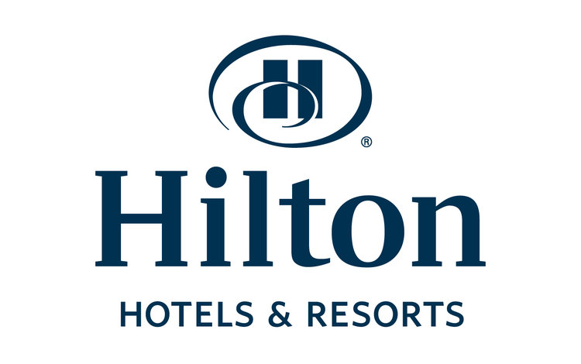
Alexandra Paunescu
2125393


Executive Summary
This report analyzes external factors affecting employee recruitment and retention at Hilton Hotels. The hospitality field encounters distinct challenges in sustaining a stable and skilled workforce amidst global disruptions like Brexit, the COVID-19 pandemic, and economic changes.
Hilton Hotels has observed varying recruitment and retention rates due to external factors. Brexit has resulted in a decrease in talent pools, specifically from European countries, which have historically contributed a substantial portion of the labour force. The pandemic initially impacted recruitment negatively, but it prompted a reevaluation of working conditions and employee expectations, prioritising job security and workplace safety. Hilton Hotels has had to review its compensation packages due to economic inflation and shifts, to stay competitive.

This report assesses the impact of external factors on Hilton Hotels' recruitment and retention strategies, prompting the need for innovation. The organisation has implemented flexible work arrangements, improved health benefits, and competitive compensation packages. Investing in employee development and recognition programmes is now recognised as a crucial strategy for enhancing staff loyalty and satisfaction.

Hilton Hotels should adapt its HR strategies to navigate the current external environment. The recommendations suggest investing more in employee well-being programmes, actively engaging with emerging labour markets, and utilising technology for streamlined recruitment procedures. These measures will improve employee retention and position Hilton Hotels as a preferred employer in the competitive hospitality industry.

Table Contents

Introduction 4
Methodology 5
PESTLE Analysis Summary 6
SWOT Analysis of Hilton Hotels 7
Discussion on Recruitment and Retention 9
Strategic Response to External and Internal Factors 11
Evaluation and Recommendations 12
Conclusion 14
References 16
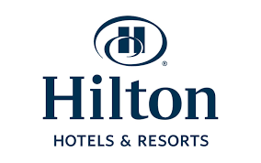

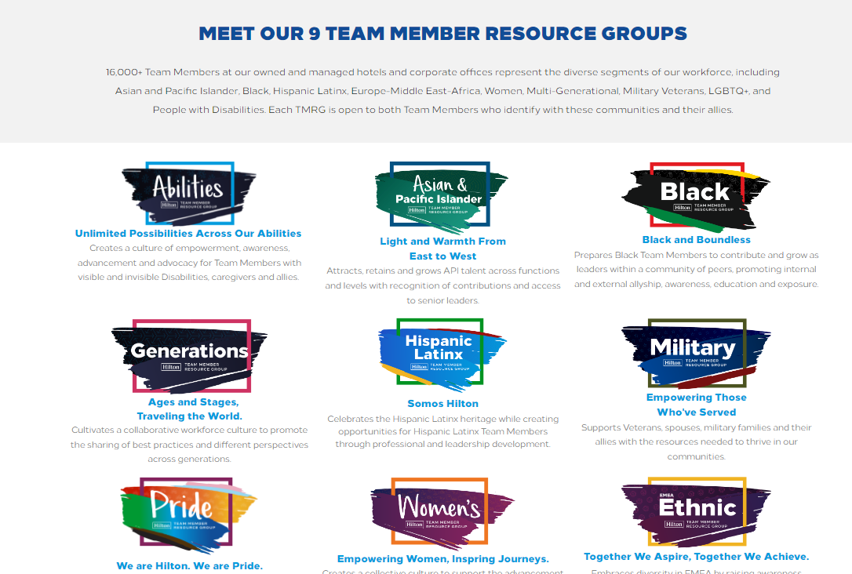 The hospitality industry is a critical junction between global dynamics and local service provision, where the effectiveness of employee recruitment and retention strategies is crucial. This report examines the complex environment of Hilton Hotels, a prominent player in the global hospitality industry known for its prestigious brand and extensive operations. This report aims to examine the various external factors that impact Hilton's recruitment and retention of high-quality employees in a rapidly changing environment.
This report analyzes the impact of economic, political, technological, social, environmental, and legal factors on recruitment and retention. A SWOT analysis of Hilton Hotels is conducted to estimate its internal weaknesses and strengths in connection with external threats and opportunities. The report offers a comprehensive perspective on the strategies that Hilton Hotels can adopt to build a strong and resilient workforce by incorporating various analytical frameworks.
This report analyzes Hilton's approach to addressing recruitment challenges in the context of a constantly evolving labour market, which is influenced by various factors such as Brexit and the pandemic. The research aims to assess the effectiveness of retention strategies in light of economic trends and shifting workforce expectations. Additionally, it delves into the impact of technology on recruitment efficiency and employee engagement. Hilton Hotels must make necessary changes to its HR policies and practices in response to these various factors. The strategic response should prioritise employee well-being, which is crucial in the current employment environment. This report seeks to offer practical insights and recommendations to address Hilton's current challenges and promote long-term growth in employee recruitment and retention.

Methodology
This report utilises a mixed-methods approach, combining qualitative and quantitative research to evaluate the factors impacting employee recruitment and retention at Hilton Hotels.
Qualitative Analysis:
Phalavandishvili et al. (2023) analysed Hilton's annual reports and strategic documents to examine the company's strategies for addressing external challenges.
Academic literature, such as Vasquez (2014) and Shin et al. (2021), offers a comprehensive understanding of workforce dynamics in the industry.
Quantitative Analysis:
The paper investigates Hilton's financial and operational data, as well as industry benchmarks provided by Toksöz (2021) and Irina et al. (2022), to identify recruitment and retention trends.
Data Integration and Synthesis:
The combination of qualitative and quantitative data, as demonstrated by Guerra-Papellero (2019) and Boella & Goss-Turner (2019), provides a thorough understanding of Hilton's strategic position in the hospitality sector.

PESTLE Analysis: Impact on Recruitment and Retention
Political: Phalavandishvili (2023) argues that geopolitical factors, such as the Russia-Ukraine conflict, impact Hilton's working choices, leading to office closures and the suspension of regional projects. Political climates can impact employee stability and retention in affected areas.
Economics: Economic factors, such as inflation and downturns, have a direct influence on Hilton's labour market. Inflation can result in higher wages, impacting recruitment expenses and potentially causing staff reductions in times of economic difficulties (Vasquez, 2014).
Social: Shin et al. (2021) found that social factors, such as travel trends and the consequences of the COVID-19 pandemic, have a substantial influence on Hilton's workforce requirements. Variations in travel patterns can impact staffing needs, while health-related considerations can affect the retention and recruitment of personnel.
Technological: Technological advancements provide Hilton with opportunities to enhance recruitment processes and employee engagement through the utilisation of tools such as digital key access and artificial intelligence, leading to improved workforce management (Guerra-Papellero, 2019).
Legal: Hilton is required to comply with employment laws in different regions, affecting recruitment and employee retention, particularly concerning data security and equal employment opportunities (Boella & Goss-Turner, 2019).
Environmental: Hilton's dedication to environmental practises can improve its appeal as an employer, attracting environmentally conscious job seekers and promoting staff retention through a positive corporate image (Toksöz, 2021).


SWOT Analysis of Hilton Hotels on Recruitment and Retention
Strengths
• Diverse Brand Portfolio: Hilton's range of brands across different market segments attracts a wide array of job seekers, offering varied career paths which aid in recruitment and employee retention (Rocha, 2022).
• Global Presence: Its international footprint provides diverse cultural and career growth opportunities, making it attractive to potential employees globally (Rocha, 2022).
• Hilton Honors Program: This could be utilized for employee rewards, aiding in retention by enhancing job satisfaction and loyalty (Irina, et al., 2022).
• Innovation and Technology: The use of advanced technology in operations streamlines the recruitment process and improves the work environment, contributing to employee satisfaction (Guerra-Papellero, 2019).
Weaknesses
• Limited Property Ownership: Gillis, Combs, and Yin, (2020) journal exemplify some aspects that may restrict Hilton's control over recruitment and staff management in franchised properties, possibly leading to inconsistencies in employee experiences and challenges in maintaining retention standards.
• Economic Sensitivity: According to Radwan, (2017) being part of a sector heavily influenced by economic conditions, Hilton might face challenges in maintaining competitive salaries and benefits during downturns, affecting its ability to attract and retain top talent.
• Alternative Accommodation Competition: Marinakou, and Giousmpasoglou (2019) expose a possible threat in the rise of platforms like Airbnb intensifying talent competition, as these companies often offer flexible work arrangements that could be more appealing to potential employees.
Opportunities
• Emerging Market Expansion: This offers Hilton the chance to tap into new talent pools, providing opportunities for local recruitment and global career progression, which can be attractive to prospective employees (Irina, et al., 2022).
• Enhanced Employee Programs: According to Irina, et al. (2022), leveraging strategic partnerships for employee development programs and benefits could further improve Hilton's attractiveness as an employer.
Threats
• Economic Fluctuations: Hilton's recruitment and payroll budgets could be significantly impacted during economic downturns, affecting its ability to retain staff (Radwan, 2017).
• Franchise Model Management: Ensuring consistent HR practices and retention strategies across franchised properties is challenging, potentially impacting the overall brand's employer reputation (Gillis, Combs, and Yin, 2020).
• Regulatory Compliance: Diverse legal frameworks in different regions necessitate adaptive HR policies, where failure to comply could lead to staff dissatisfaction and increased turnover (Boella, and Goss-Turner, 2019).

Discussion on Recruitment and Retention

The hospitality industry is highly competitive, making it challenging for Hilton to recruit and retain skilled workers without offering higher compensation according to Ghani et al. (2022). Losing key management personnel may pose risks to strategic relationships and business strategy execution. Simmons (2023) found that the failure to attract and develop skilled employees can result in increased employee turnover, reduced guest satisfaction, decreased morale, inefficiency, and potential internal control issues. Hilton faces challenges in acquiring skilled employees at properties, which may limit operational capabilities and expansion plans.

According to Joshi (2023), Hilton's retention strategies prioritise the development of a corporate culture that values innovation, creativity, and teamwork. Culture is crucial for fostering employee engagement and satisfaction. As Hilton expands, maintaining its culture within increasingly intricate organisational and management systems becomes a potential challenge. The effectiveness of retention strategies is linked to a company's capacity to adapt and preserve its corporate culture while growing (Markos and Sridevi, 2010).
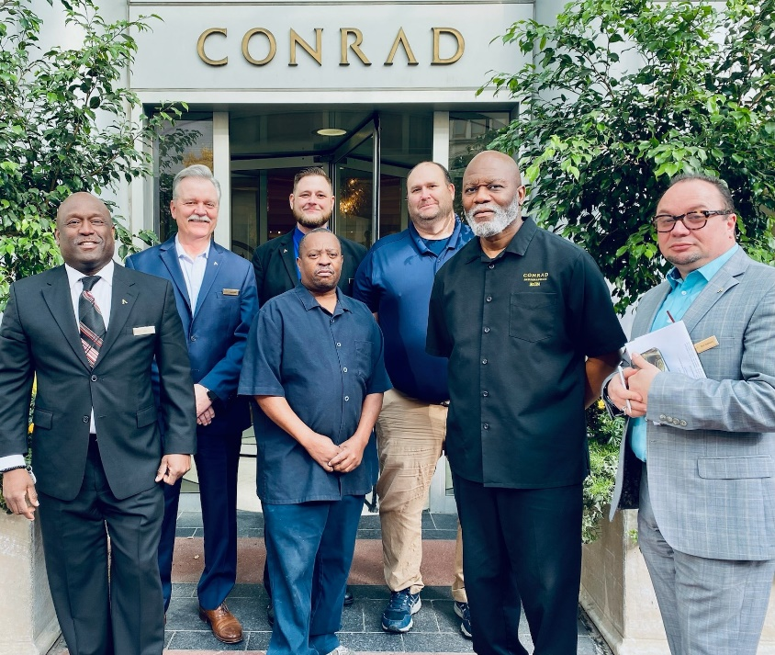
Analysis of External and Internal Factors Impacting Retention Retention is influenced by a confluence of external and internal factors Vasquez (2014) states that economic variables and the competitive landscape of the hospitality industry impact labour market conditions. Hilton's corporate culture, compensation packages, and career development opportunities are influential factors (Irina, et al., 2022). Hilton needs to manage these factors to reduce turnover and enhance employee satisfaction. This entails strategic human resource planning, competitive compensation, investment in employee development, and a focus on fostering a positive work environment. Maintaining a nurturing and innovative culture is crucial for Hilton's continued success in retaining a committed workforce (Greer, 2021).

Strategic Response to External and Internal Factors:
Hilton employs a comprehensive approach to tackle the challenges of recruitment and retention, encompassing external market conditions and internal organisational requirements.
HR policy and practise adjustments Hilton has revised its HR policies to conform to the changing labour market, prioritising diversity in recruitment to enhance its attractiveness to a wider range of potential employees. This strategy aligns to make a positive impact on local communities and facilitate global expansion (Dawson and Abbott, 2011).

He, Morrison, and Zhang (2019) state that the company has made investments in Hilton Worldwide University to provide employee well-being and ample learning opportunities for professional development. Furthermore, the company has introduced family-friendly benefit programmes, which are currently only available to employees in the United States. This demonstrates the organization's dedication to promoting a healthy equilibrium between work and personal life.
The integration of technology in recruitment and retention. Technological advancements are utilised to optimise the recruitment process and improve the employee experience, thereby enabling Hilton to maintain its competitiveness in attracting high-quality talent (Guerra-Papellero, 2019).

Creating a Competitive Work Environment Hilton's emphasis on fostering a supportive corporate culture, promoting ongoing learning, and investing in employee development enhances its ability to create a competitive workplace that attracts and retains staff (Irina, et al., 2022).
Hilton's strategic approach demonstrates its dedication to achieving a harmonious equilibrium between external market demands and internal workforce contentment, thereby establishing itself as an attractive employer within the hospitality sector.

Evaluation and Recommendations
Effectiveness of Hilton's Response Strategies:

Alias et al. (2017) found that Hilton's success in employee retention can be attributed to strategic initiatives. The company's goal with these initiatives is to enhance their capacity to both attract and retain employees.. The strategies involve reevaluating HR policies, investing in employee well-being, using advanced technology for recruitment, and fostering a competitive work environment. Hilton's sustained industry position and recognition as a leading employer demonstrate the effectiveness of these strategies. Hughes and Christensen (2021) claim that recruitment diversification has expanded the talent pool, and Hilton Worldwide University initiatives have boosted employee engagement and development. Technology integration has enhanced recruitment processes, rendering them more efficient and attractive to technologically inclined employees (Guerra-Papellero, 2019). Hilton's corporate culture, focusing on teamwork and innovation, consistently attracts high-quality employees and decreases turnover rates.
Recommendations for Enhanced Recruitment and Retention:

Hilton's strategies have been successful, but there is still room for improvement. Blumberga and Berga (2022) suggest that implementing family-friendly benefits and work-life balance programmes globally can promote employee satisfaction and loyalty. Hilton should improve its professional development programmes by offering a variety of in-person training workshops, mentorship opportunities, and clear career progression pathways to all employees (Hedge and Rineer, 2017). The utilisation of predictive analytics in anticipating and managing staffing requirements and satisfaction levels has the potential to proactively address concerns before they lead to employee turnover (Boella and Goss-Turner, 2019). Additionally, fostering an inclusive culture that extends beyond mere diversity can cultivate a more inviting and innovative environment, thereby attracting a wider range of skilled individuals to the organisation. Marketing and branding strategies should reflect an inclusive culture to attract diverse guests and appeal to a global clientele (Ghani, et al., 2022). By strengthening these aspects, Hilton can maintain its leadership position in the hospitality sector as a preferred employer, capable of attracting and retaining top talent in a highly competitive environment.

Conclusion


In conclusion, Hilton's strategic approach to managing the complexities of recruitment and retention reflects a deep understanding of the interplay between external market conditions and internal organizational dynamics. The company's robust response strategies—diverse recruitment efforts, investment in employee well-being, technological integration, and a competitive work environment—demonstrate its commitment to maintaining a leading position within the hospitality industry.
Despite these efforts, Hilton must continue to evolve and adapt these strategies to meet the changing demands of the workforce and the industry. The recommendations provided aim to enhance Hilton's recruitment and retention further by fostering an inclusive culture, expanding employee benefits globally, and leveraging analytics for predictive HR management.
The success of these strategies will be measured not only by reduced turnover rates and high employee satisfaction but also by Hilton's ability to consistently deliver exceptional guest experiences, drive brand loyalty, and achieve business growth. As Hilton moves forward, the company must remain proactive, agile, and innovative, ensuring that it not only responds to current challenges but also anticipates future trends within the dynamic landscape of global hospitality.

References
1. Blumberga, S. and Berga, S., 2022. PERSONNEL LOYALTY, AND WORK-LIFE BALANCE DURING REMOTE WORK. Proceedings of CBU in Social Sciences, 3, pp.20-27. Available at: https://ojs.cbuic.cz/index.php/pss/article/view/300/646
2. Boella, M.J. and Goss-Turner, S., 2019. Human resource management in the hospitality industry: A guide to best practice. Routledge.
3. Dawson, M. and Abbott, J., 2011. Hospitality culture and climate: A proposed model for retaining employees and creating competitive advantage. International Journal of Hospitality & Tourism Administration, 12(4), pp.289-304.
4. Ghani, B., Zada, M., Memon, K.R., Ullah, R., Khattak, A., Han, H., Ariza-Montes, A. and Araya-Castillo, L., 2022. Challenges and strategies for employee retention in the hospitality industry: A review. Sustainability, 14(5), p.2885. Available at: https://www.mdpi.com/2071-1050/14/5/2885
5. Gillis, W.E., Combs, J.G. and Yin, X., 2020. Franchise management capabilities and franchisor performance under alternative franchise ownership strategies. Journal of Business Venturing, 35(1), p.105899. Available at: https://www.sciencedirect.com/user/institution/login?targetUrl=%2Fscience%2Farticle%2Fpii%2FS0883902617307760
6. Greer, C.R., 2021. Strategic human resource management. Pearson Custom Publishing.
7. Guerra-Papellero, E.L., 2019. The Hotel Industry’s Retention Management’s Success Factors of Selected Major Hotels in Abu Dhabi, United Arab Emirates. Partridge Publishing Singapore.
8. He, J., Morrison, A.M. and Zhang, H., 2019. Improving millennial employee well-being and task performance in the hospitality industry: The interactive effects of HRM and responsible leadership. Sustainability, 11(16), p.4410. https://www.mdpi.com/2071-1050/11/16/4410/pdf?version=1565854466
9. Hedge, J.W. and Rineer, J.R., 2017. Improving career development opportunities through rigorous career pathways research. RTI Press.
10. Hughes, J.C. and Christensen, J.D., 2021. Talent management innovation in a time of unprecedented disruption: implications for practice and research. In Talent Management Innovations in the International Hospitality Industry (pp. 153-179). Emerald Publishing Limited.
11. Irina, Y.Y., Liu, C., Yang, M.X. and Zeng, K.J., 2022. Looking forward or looking back: Feedback strategies in tier-based hotel loyalty programs. International Journal of Hospitality Management, 102, p.103164. Online Available at: https://www.sciencedirect.com/user/institution/login?targetUrl=%2Fscience%2Farticle%2Fpii%2FS0278431922000263
12. Joshi, M.P., 2023. Talent Management: A Significant Approach to Strategic HRM in the Hotel Industry. In Strategic Human Resource Management in the Hospitality Industry: A Digitalized Economic Paradigm (pp. 193-207). IGI Global.
13. Marinakou, E. and Giousmpasoglou, C., 2019. Talent management and retention strategies in luxury hotels: evidence from four countries. International Journal of Contemporary Hospitality Management, 31(10), pp.3855-3878. Available at: https://connect.liblynx.com/go/emerald?sachoose=1&target=https%3A%2F%2Fwww.emerald.com%2Finsight%2Fredirect%3Ftarget%3Dhttps%253A%252F%252Fwww.emerald.com%252Finsight%252Fcontent%252Fdoi%252F10.1108%252FIJCHM-10-2018-0862%252Ffull%252Fhtml
14. Markos, S. and Sridevi, M.S., 2010. Employee engagement: The key to improving performance. International journal of business and management, 5(12), p.89.: https://www.academia.edu/download/77045834/6332.pdf
15. Phalavandishvili, N., Bakhtadze, E., Robitashvili, N. and Popluga, D., 2023, January. ANALYSIS OF THE DIFFERENCE IN OCCUPANCY AND PROFITABILITY IN INTERNATIONAL BRAND HOTELS BEFORE AND AFTER THE PANDEMIC CAUSED BY COVID-19. In Economic Science for Rural Development Conference Proceedings (No. 57). Online Available at: https://lbtufb.lbtu.lv/conference/economic_science_rural/2023/Latvia_ESRD_57_2023-268-275.pdf
16. Radwan, H.R.I. and Radwan, I., 2017. Managing hotels during economic challenges: A case study on hotels in Sharm El-Sheikh and Hurghada, Egypt. Journal of Tourism and Hospitality Management, 5(2), pp.84-100. Available at: http://jthmnet.com/journals/jthm/Vol_5_No_2_December_2017/9.pdf
17. Shin, H., Sharma, A., Nicolau, J.L. and Kang, J., 2021. The impact of hotel CSR for strategic philanthropy on booking behaviour and hotel performance during the COVID-19 pandemic. Tourism Management, 85, p.104322. Available at: https://www.sciencedirect.com/science/article/pii/S0261517721000418/pdfft?md5=3e991e2773296c48f0ec338411475a36&pid=1-s2.0-S0261517721000418-main.pdf
18. Simmons Jr, M., 2023. Retention Strategies Utilized by Hotel Managers to Retain Talent in Job Positions and Reduce Employee Turnover Within Small-and-Medium Enterprise (SME) Hotels: A Phenomenological Study (Doctoral dissertation, Northcentral University). Available at: https://media.proquest.com/media/hms/PFT/2/gl0CT?_s=mkxCROHfypmLMH2egwdcnLHzvkw%3D
19. Toksöz, S., 2021. The impact of engagement exists in organisations’ internal environment on employees’ motivation, satisfaction, commitment and turnover intention. In E3S Web of Conferences (Vol. 258, p. 10010). EDP Sciences. Available at: https://www.e3s-conferences.org/articles/e3sconf/pdf/2021/34/e3sconf_uesf2021_10010.pdf
20. Vasquez, D., 2014. Employee retention for economic stabilization: A qualitative phenomenological study in the hospitality sector. International Journal of Management, Economics and Social Sciences, 3(1), pp.1-17. https://papers.ssrn.com/sol3/Delivery.cfm/SSRN_ID2409917_code1834185.pdf?abstractid=2409917&mirid=1&type=2

