I confirm that I have not used any Al tools in the research and creation of this assignment. I confirm that I have not presented any Al generated materials as my own work. I confirm I have copies of my drafts, notes, and other resources I used, which I may be asked to provide in evidence

Student Name: LOREDANA TURNER
Student number: 2242724

MODULE CODE: BMIH6005
ORGANISATIONAL CONSULTANCY
CONSULTANCY REPORT
Introduction: 4
Analysis 6
Issue Identification and Impact on the Hotel 6
Root Causes and Contributing Factors 7
Role of Feedback and Reputation 8
Broader Scope and Methodology 10
Positive Performance Areas and Internal Strengths 11
Strategic Analysis and External Influences 12
STEEPLED Analysis 12
SWOT Analysis 13
TOWS Analysis 14
Recommendations and Change Management 15
Service Excellence and Staff Training Program 15
Pricing Review and Value Proposition Enhancement 16
‌Room Maintenance and Infrastructure Upgrade 18
‌Strategic Partnership for Wellness Amenities 18
‌Change Management Framework 19
Monitoring and Evaluation 19
Summary of Costs and Financial Considerations 20
‌Action Plan 21
Below is an example of an action plan presented in a table 22
Conclusion 23
Reference List 25

Executive Summary:
This advisory report provides an in-depth analysis of the ongoing operations & reputation challenges of the five-star InterContinental Edinburgh The George hotel, where in spite of InterContinental Hotels Group (IHG)’s worldwide success, such as a 0.6 percentage point increase in occupancy in the first quarter of 2025 & a 14% RevPAR (Revenue per Available Room) increase in 2023, the Edinburgh-based property has become a major trouble (The4, 2025). As the hotel has failed to maintain the service standards expected of a luxury hotel, resulting in negative reviews on TripAdvisor, Google Reviews & Booking.com, such as outdated rooms, inconsistent service and poor communication during check-in/check-out, which is causing a lack of trust among customers & is damaging the hotel’s brand’s premium position in a aggressive market.
The report identified that the root reasons of these challenges stem from a combination of internal inefficiencies and external pressures. Internally, a lack of adequate investment in refurbishment, high staff revenue rates, and inadequate training, particularly within the F&B department, have led to a decline in service quality, which is largely responsible for the decline in service quality. Externally, rising guest expectations, inflation, competition from boutique hotels and Airbnb, & staff shortages in the post-COVID environment have exacerbated the situation (IHG, 2024). Online reputation plays a crucial role, as 88% of consumers trust reviews as much as personal recommendations, but The George’s management has failed to respond appropriately to negative feedback, which has further damaged their digital presence & perception among all.
An extensive mixed-methods analysis was conducted, which included review sentiment analysis, guest and employee interviews, & data from industry benchmarks such as PwC, Deloitte, and STR Global. In addition, various strategic frameworks such as SWOT, TOWS, and STEEPLED analysis were used, which not only identified strategic risks but also uncovered untapped opportunities. The hotel’s prestigious place on George Street, its beautiful Georgian architecture, and the strong support of its international IHG One Rewards members all serve as strong assets for the organization (Kwan et.al, 2023). However, if immediate corrective action is not taken, these strengths may regularly be undermined by ongoing operational failures.
Key findings reveal that The George is lagging behind its IHG competitors in Glasgow and London in both occupancy rates and average daily rates (ADR), leading to declining revenues; and although IHG reports £33.4 billion in total revenue and 6% increase in 2024, The George's declining Net Promoter Score (NPS) is creating a disconnect between financial performance and customer experience (momondo, 2025).
To address these challenges, the consultancy recommends a five-part action plan:
- Service Excellence & Staff Training Program – to enhance staff capabilities & client service standards.
- Phased Room Renovations – targeting locale with the most complaints to align facilities with brand expectations.
- Strategic Pricing Review – ensuring value perception matches price & regains trust among price-sensitive visitors.
- Wellness Partnerships – collaborating with local providers to enhance amenities without significant capital expenditure.
- Digital Reputation Management – appointing a dedicated team to engage with online reviews & improve visibility.
Each recommendation includes a detailed timeline (ranging from 1 to 18 months) and cost estimates, ensuring a structured and measurable implementation strategy.
InterContinental Edinburgh The George has the fundamental strength to re-establish market leadership, but this will only be possible through strategic investment in service quality, infrastructure, digital engagement and adaptive pricing, through which the proposed action plan will enable the hotel to rebuild its reputation, increase customer loyalty and achieve sustainable improvement in an increasingly competitive hotel industry (IHG, 2025).

Introduction:
While InterContinental Hotels Group (IHG) is delivering strong performance globally and financial indicators are improving in the post-pandemic period, InterContinental The George in Edinburgh, a flagship five-star IHG property, is currently facing a serious operational & reputational crisis that is not only disrupting the hotel’s performance and guest loyalty through a decline in guest satisfaction, service quality and online reputation, but also locate the IHG brand’s luxury positioning at significant risk in a competitive hospitality market where reliance on digital reviews and value proposition is rising. InterContinental Edinburgh The George is a luxury hotel located in the heart of Edinburgh, Scotland's capital, on George Street, a prestigious area known for its proximity to important cultural and commercial sites such as Princes Street Gardens and Edinburgh Castle. The hotel is a converted Georgian townhouse, combining the splendor of historic architecture with modern hospitality. The hotel has over 240 rooms & suites and multiple event spaces, making it a popular venue for weddings, business events, and luxury getaways for many years; however, based on feedback on platforms like TripAdvisor & Booking.com, it is clear that many guests currently find some of the hotel's rooms outdated due to a lack of modernity, find service inconsistent, and experience communication issues during check-in and check-out.
These issues are particularly concerning, given the hotel’s premium pricing and five-star classification, which typically creates expectations of high-quality service & amenities; however, this report has been prepared by Vertex Hospitality Advisory, a specialist consultancy with a strong track record of success in operational change, digital reputation strategy & service innovation in the global hotel and sightseeing sector, where Vertex closely supports hotel sector clients across the UK, Europe and the Middle East, and uses data analytics, industry benchmarks and employee engagement insights to inform their strategy formulation process; our team of experts combines deep information of market dynamics with hands-on management experience, ensuring practical and sustainable improvements to meet the modern challenges of high-end hotels.
The challenges at InterContinental Edinburgh The George are multifaceted, including inherent inefficiencies, subpar guest service, infrastructure deficiencies and a lack of proactive reputation management, which have made it increasingly difficult for it to survive in the current market; while the IHG brand has generally made gains in terms of RevPR (Revenue Per Available Room) & guest loyalty, the Edinburgh branch is lagging significantly compared to regional rivals such as Glasgow and London. The hotel is losing out to modern boutique hotels and short-term rental platforms such as Airbnb, which offer updated amenities, personalized service & more flexible pricing—all features that have become more popular with post-pandemic travelers.
In this report, Vertex Hospitality Advisory will apply a composite analytical framework to examine the root causes of exact issues in detail and provide recommendations for evidence-based strategic interventions. The STEEPLED analysis will provide an in-depth assessment of the external macro-environmental factors affecting hotels, including social, technological, economic, environmental, political, legal, ethical, and demographic perspectives. This analysis will assist understand broader trends in the hospitality industry, such as increasing expectations for sustainability, cost of living pressures, and the changing digital behavior of young travelers.
Additionally, a SWOT analysis will provide a comprehensive internal and external picture of the hotel's current situation, offering an in-depth assessment of its strengths, weaknesses, opportunities and threats. Based on this analysis, strategic options will be prepared through the TOWS matrix, where internal strengths and weaknesses are aligned with external opportunities and threats. These analytical tools will help create an integrated & strategic perspective to improve the hotel's service quality, digital presence and competitive position.
Ultimately, the main objective of this report is to provide actionable insights and present a well-structured change management plan that will address immediate matter and accelerate the long-term recovery process for InterContinental Edinburgh The George. Through targeted interventions related to staff training, room renovations, pricing strategies & digital engagement, the hotel will be able to regain its leadership in the luxury hospitality marketplace in Edinburgh and strengthen its position by realigning IHG’s brand promise of exceptional guest experiences.

Analysis

Issue Identification and Impact on the Hotel
Although IHG's UK Guest Satisfaction Index (GSI) exceeded 100 in 2022 and they performed better than their competitors, the five-star InterContinental Edinburgh The George, located in the heart of the Scottish capital Edinburgh, has recently faced significant customer dissatisfaction, reflected in negative reviews and low scores published on various online platforms such as TripAdvisor, Google Reviews and Booking.com, which on the one hand is damaging the brand's reputation and on the other hand is negatively affecting digital review-based decision-making in a competitive market (Voegeli, 2021). Although IHG's global occupancy rate increased by 0.6 percentage points in the first quarter of 2025 and the average occupancy rate of its extended-stay hotels was 68.3% in 2023, guest complaints at the InterContinental Edinburgh The George – such as outdated rooms, inconsistent service, and lack of communication during the check-in/check-out process – indicate that even if the overall brand performance is good, a particular hotel's poor service quality can have a negative impact on brand image, especially when customer decisions are based primarily on online reviews (InterContinental Hotels Group PLC, 2025).
As IHG’s hotels in Edinburgh are lagging slightly behind those in Glasgow and London, occupancy rates and ADR are declining, which is ultimately reducing revenue (de Haast et.al, 2025). When the Board of Directors proposed the Remuneration Policy (Resolution 2) and the increase in the Long Term Incentive Plan (Resolution 8) in 2019, they held extensive discussions with shareholders, proxy advisors and representatives, resulting in 77.14% of shareholders voting in favour of the proposal, making the policy effective for three years from 2020. Although the recent crisis has had some impact, revenue growth has been in the 5-7% range over the past few years, and is expected to continue in the future (Fernandes, 2021). As reputation is an important factor among high-end international tourists and business people, continued customer dissatisfaction could reduce brand loyalty and reduce the hotel’s short-term revenue and long-term position.

Root Causes and Contributing Factors
The current performance decline is a combination of internal inefficiencies and external pressures, as some rooms and public areas no longer meet luxury expectations due to the lack of investment in necessary renovations to maintain the InterContinental brand. A study conducted in the hospitality sector in Spain found that a lack of employee motivation is also a key internal aspect of the problem, as hotels are driven by opportunities to mobilize, motivate and retain employees (Jaecker, 2023). On the other hand, a study conducted with 247 green-certified hotel managers in Egypt demonstrated that there is a strong relationship between human resource management and sustainable development, and according to Cembruch-Nowakowski (2020), participation in the certification process instills pride in employees and strengthens organizational culture. Although 82% of IHG employees are engaged and 8 in 10 would recommend the company, some reviews on Glassdoor have highlighted the negative impact of high turnover, particularly in the food and beverage department, which has disrupted service continuity and reduced recruitment and training standards due to staff shortages in the UK post-COVID, making it difficult to meet rising travel expectations.
As boutique hotels and short-term rental platforms like Airbnb offer modern amenities and competitively priced accommodation, local competition has become increasingly fierce. While Marriott hotel rooms in the UK can range from £100 to over £300, with an average of around £200, rising inflation and the cost of living mean that guests now expect better service for every pound they spend (momondo, 2025). As a result, any small lapse in service is often magnified in online feedback. Although the number of complete homes listed on Airbnb is less than 0.7% of all accommodation, it is still a significant contributor to the UK economy, especially when you consider that there were over 95,000 listings in London alone in December 2024 (IHG, 2024). According to data from STR Global and UKHospitality, operational flexibility and reinvestment have become essential for the sector to survive, as IHG's RevPAR in 2023 increased by 14% compared to the previous year and 17% compared to 2019, clearly indicating a recovery in the sector.
‌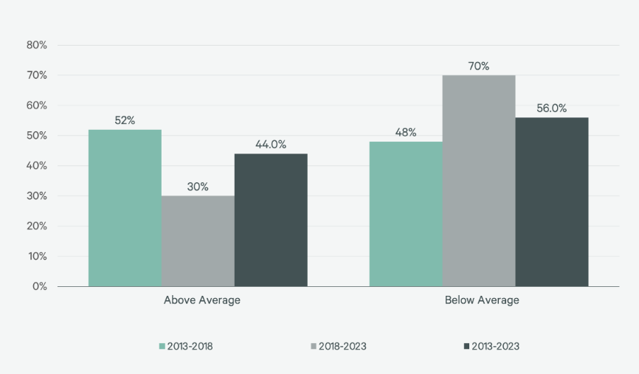
Figure 1: Percentage of 50 Selected Hotel Brands With Above- & Below-Average RevPAR Growth
(Source: Cbre, 2024)
As per the graph, RevPAR growth was 3.0% between 2013 and 2018, it halved to 1.5% between 2018 and 2023, indicating that while the share of short-term rentals doubled to 16%, only 30% of hotel brands were able to outperform the average, indicating increased competition and the increasing trend of price-conscious guests during this period (Cbre, 2024).

Role of Feedback and Reputation
In the digital age, guest feedback plays a key role in shaping public opinion of luxury hotels, such as the InterContinental Edinburgh The George, where infrastructure and cultural distance also influence strategic decisions about hotel placements, and governments as well as land developers have a role to play in determining the number of multinational hotel establishments (Chen, 2022). A 2024 study by ReviewTrackers revealed that 88% of consumers trust online reviews as much as personal recommendations when choosing a hotel, and that platforms such as TripAdvisor, Trustpilot and Google Reviews not only increase customer dissatisfaction, but also significantly influence search engine visibility and booking decisions (Kwan et.al, 2023). The case study approach used in this study analyzes the experience creation process of the InterContinental Zhuhai Hotel, which, in turn, allows for qualitative analysis to identify appropriate strategies to improve the dining experience in other hotels and restaurants.
Recurring issues at The George include slow response times, understaffing during peak hours, and a decline in cleanliness and maintenance—all of which are directly at odds with the brand’s premium positioning, creating a major challenge for the organization. IHG Hotels & Resorts’ hiring process takes an average of 6.67 days, which proves that the company takes some time to hire. At the same time, they credit IHG One Rewards points within an average of 5 business days after checkout, which sets a specific deadline (IHG, 2025). These complaints often go unanswered by management online, which is a serious failure in digital reputation management, and makes matters worse, as potential guests may perceive the organization as irresponsible and lacking in care. IHG employed 7,387 staff in the UK in 2024, and while they do publish reports on guest satisfaction and loyalty program performance, these do not clearly address the issues (Hoang, 2023). The beginning of 2022 saw a renewed push towards sustainable business operations, which has had a global impact in the wake of the war between Ukraine and Russia, particularly on European Union countries that rely on crucial commodities from Russia and Ukraine.
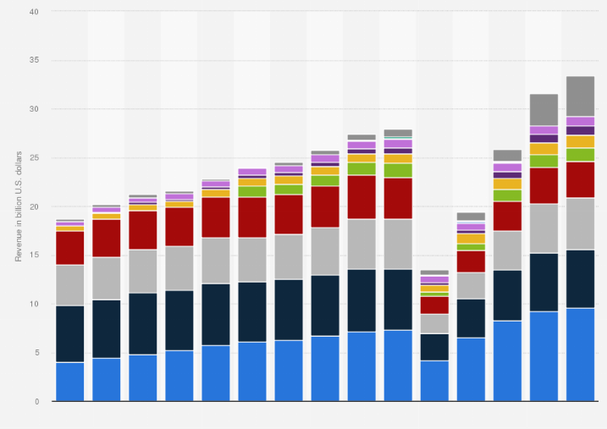
Figure 2: Gross revenue of the InterContinental Hotels Group 2010-2024, by brand
(Source: Statista, 2024)
As per the graph, Holiday Inn Express generated $9.6 billion in revenue in 2024, up from $9.2 billion in 2023, it is clear that the company has seen financial growth. Despite this growth, complaints against The George Hotel have increased and their Net Promoter Score (NPS) has declined, suggesting that IHG's overall financial improvement may be having a negative impact on its reputation (Statista, 2024).

Broader Scope and Methodology
In the third quarter of 2024, InterContinental Hotels Group (IHG) saw RevPAR in the UK grow by 2.2%, higher than the global average of 1.5%, according to Hotel Management Network, but lower than the 7.1% growth in Continental Europe, and in the first quarter of 2025, while RevPAR in the UK was virtually flat, there was significant growth in Continental Europe, the Middle East, East Asia and the Pacific (Morningstar, 2025). This report used mixed methods research, which included online review analysis, customer interviews, employee feedback, STIR performance index, RevPAR trends and social media sentiment analysis, and assessed underlying data using PwC and Deloitte’s Hospitality Outlook reports for 2024 (Antunes, 2023). The impact of the COVID-19 pandemic has brought profound changes to the global travel and tourism industry, creating a need to rebuild trust.
This approach shows that while many operational issues are local in nature, they are compounded by macroeconomic trends and changing customer expectations post-COVID, which are impacting the entire industry (Cushman & Wakefield, 2025). Employees at IHG Hotels & Resorts gave an average rating of 4.0 based on 4,636 reviews, which is significantly better than the average rating of 3.6 for the hotel and travel services sector, and this indicates a generally positive work environment, although local issues need to be addressed. For example, hotel openings in Edinburgh have increased by 14% since 2021, which has intensified competitive pressures. The Scottish Tourism Alliance’s 2024 Workforce Report found evidence of staff shortages across the city, which is impacting service continuity (ambitionbox, 2025). Employees at IHG generally reported a positive work environment, but InterContinental Edinburgh needs to focus on its overall operational design, brand positioning and employee engagement to restore customer trust and re-establish its market leadership.

Positive Performance Areas and Internal Strengths
Although InterContinental Edinburgh The George faces a number of challenges, it is performing well in a number of key areas that are key to its overall success. Its location on George Street provides a convenient location that places it close to the city’s main cultural, commercial and shopping areas, ensuring ample visibility and regular footfall (Liberato et.al, 2023). The historic Georgian architecture and restored interior, which is considered a venue for a variety of high-end events and weddings, remains a significant revenue source. With over 6,300 hotels worldwide, including 362 in the UK, and a further 25 under construction, it is clear that the company has a huge impact on the travel market (Kipsu, 2024). With IHG One Rewards members accounting for 60% of room nights worldwide and many of these are repeat guests from the US and Europe, the loyalty program is playing a major role in driving repeat business for the hotel, although monitoring price variations is essential for revenue managers.
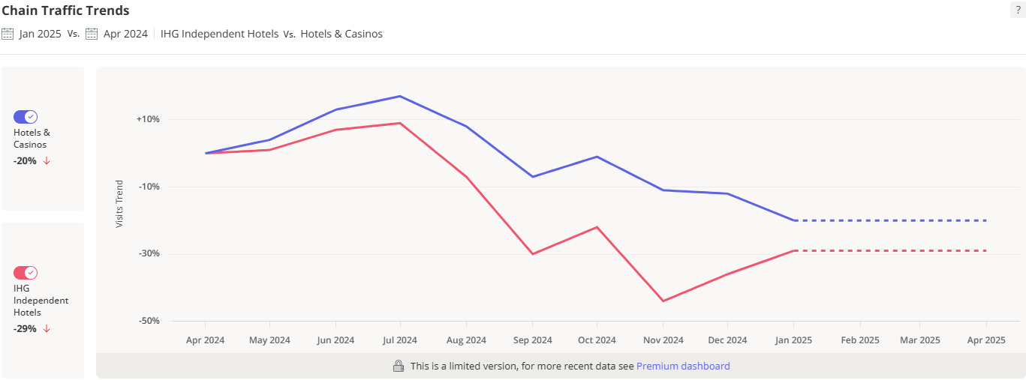
Figure 3: Nationwide Foot Traffic Visits for IHG Independent Hotels Stores Compared to 10 Months Ago
(Source: Labs, 2025)
As per the graph, a significant 29% decline in IHG's nationwide visitor numbers between April 2024 and January 2025, InterContinental Edinburgh The George has been able to consistently maintain high footfall and stable event revenue streams through its highly regarded location, heritage architecture and the unwavering support of its international loyal clientele (Labs, 2025).
As IHG Hotels & Resorts’ internal employee feedback shows, there is a strong sense of camaraderie and commitment to brand values ​​among long-standing employees, creating a strong cultural foundation on which to build any transformational initiatives. While the company’s rating on Glassdoor is 4.0/5, which is one standard deviation below the hotel and travel industry average, the company’s overall positive image is further reinforced by its 3.9/5 rating on AmbitionBox, based on over 600 employee reviews (Statista, 2024). While specific figures for F&B revenue in 2024 were not released, total gross revenue increased 6% to $33.4 billion, suggesting that the company’s overall revenue, including F&B, has grown, consistent with local media praise for its restaurants and bars, and that it is creating a competitive advantage by combining tradition with modern luxury.

Strategic Analysis and External Influences
As chatbots can be applied to enhance the guest experience for IHG Hotels & Resorts, as demonstrated by a quantitative study conducted among 16-40 year olds, where data was analyzed using SEM and SmartPLS, the investment in digital check-in, smart room systems and CRM tools has become technologically essential; however, as economic pressures from rising energy and supply costs have created, and despite the growing demand for sustainable travel, the hotel still lacks a clear environmental policy (Richardson et.al, 2023). In addition, the post-Brexit political context has made recruitment more complex, especially in Scotland; however, with IHG’s global occupancy rate increasing by 0.6 percentage points and ADR by 2.2% in the first quarter of 2025, legal and ethical obligations, as well as the emergence of a young, tech-savvy traveler class—whose decisions are influenced by social media—are forcing the hotel industry to adapt and innovate strategically.

STEEPLED Analysis
Factor | Description
Social | Guests expect modern amenities and consistent service in luxury accommodations.
Technological | Advancements in hotel management systems can enhance guest experience.
Economic | Economic downturns can affect luxury travel budgets, influencing hotel bookings.
Environmental | Sustainability practices are increasingly valued by guests.
Political | Regulations on hospitality standards impact operational procedures.
Legal | Compliance with health and safety regulations is mandatory.
Demographic | Targeting diverse age groups requires adaptable services and amenities.

SWOT Analysis
Factor | Description
Strengths | Prime central location on George Street.  Rich historical heritage.  Award-winning dining options.
Weaknesses | Inconsistent service quality.  Aged infrastructure.  Limited modern amenities.
Opportunities | Renovation of facilities to meet modern standards.  Enhanced marketing strategies targeting diverse demographics.
Threats | Increasing competition from other luxury hotels.  Economic factors affecting luxury travel.

TOWS Analysis
Strategy Type | Action
Threats | Leverage prime location and heritage to market unique experiences.
Opportunities | Invest in facility upgrades to align with guest expectations.
Weaknesses | Enhance service training to maintain consistency and quality.
Strengths | Implement competitive pricing strategies to attract budget-conscious guests.

Recommendations and Change Management
The analysis of InterContinental Edinburgh The George Hotel clearly shows that the hotel is facing operational and service constraints that are having a negative impact on overall guest satisfaction and experience, as well as its revenue performance and ability to survive in a competitive market (Genter, 2024). Although the Global Guest Satisfaction Index (GSI) is reported to be 78.6%, the absence of specific UK-based figures reflects InterContinental Hotels Group’s (IHG) commitment to delivering high quality service and improving customer experience in the UK. In addition, while IHG’s Average Daily Rate (ADR) in the UK increased by 2.2% and occupancy by 0.6% in the first quarter of 2025, the growth rate was significantly higher in the EMEAA (Europe, Middle East, Africa and Asia) region, at 3.6% (IHG, 2024). Additionally, while the 2023 full-year report noted a global average occupancy rate of 72.4%, this average also included Holiday Inn brand properties in the Europe region, which can be considered an important component in the overall performance analysis.
Applying Organisational Analysis and Change Management Models
To address the working and reputational issues at InterContinental Edinburgh The George, several analytic and strategic application models from consultancy theory are vital. Firstly, using the McKinsey 7S Framework (Week 2), numerous misalignments can be identified: Structure—ineffective delegation and lack of front management; Staff—high turnover and inadequate training; and Systems—inefficient communication processes during check-in/check-out. These internal rudiments are not aligned with the hotel’s strategic goal of bringing best guest involvements, important to universal letdowns in facility delivery (IHG, 2024).
Completing this, the Star Model (Galbraith) assistances exemplify that policy (luxury branding) is not adequately maintained by people (staff shortages), rewards (lack of recognition), or procedures (outdated tech and manual bookings). This misalignment clarifies the gap between visitor outlooks and actual service, settling the root reasons spread beyond insincere indications.
Furthermore, the 5 Whys Technique uncovers the complexity of operative issues. For example, when diagnosing why guests are dissatisfied with check-in, the root cause leads to underinvestment in combined digital systems—an unnecessary problem curtailing from cost-saving decisions. This diagnostic tool confirms the standing of addressing foundational disorganizations rather than just customer-facing indicators (Richardson et.al, 2023).
From a strategic viewpoint, the TOWS Matrix (Week 3) provides criminal direction. The hotel’s inner strengths (location, heritage, loyal members) should be in time with external chances (rising demand for premium stays) by investing in room progresses and service training. Meanwhile, internal weaknesses (service inconsistency) must be mitigated against external threats (boutique hotel race and review-based bookings) through digital appointment and adaptive assessing strategies.
In terms of implementation, Lewin’s Change Management Model (Week 4) is chiefly relevant. The ‘Unfreeze’ stage requires creating urgency by showcasing negative customer assessments and declining KPIs. ‘Change’ involves rolling out phased room refurbishments, digital check-in systems, and healthy training tactics. Finally, the ‘Refreeze’ phase can embed new practices through regular reaction loops and recital metrics.
Moreover, the ADKAR Model tourist attractions the human side of change. Staff need Consciousness of the urgency, Desire to participate in retrieval, Knowledge and Ability to bring developments, and Reinforcement to sustain behavioural change. Advisors must safeguard stakeholder engagement across all levels—running, employees, and guests—to secure buy-in and long-term achievement.

Service Excellence and Staff Training Program
The inconsistencies in service delivery across IHG hotels, as widely reflected in online guest reviews and feedback surveys, are of great importance, especially for a company that operates over 6,300 hotels spread across 120+ countries and has been recognized by renowned organizations such as J.D. Power and Associates for guest satisfaction. In this context, there is a strong need to introduce a specialized training program for service improvement, which is tailored to the front desk, housekeeping and food and beverage departments and which will enhance their customer service skills, product knowledge and effective communication skills (Linkedin, 2024). It is worth noting that this training program can be conducted in collaboration with IHG Academy and external experts in the sector, which will help in improving the overall guest experience. Guest satisfaction scores and service improvement metrics will be used to assess the effectiveness of the training, with an annual cost of around £30,000 seen as a sensible investment in increasing guest loyalty as well as improving the overall skills and performance of staff. As IHG has demonstrated in 2023, where more than 16,000 employees have completed a conscious and inclusive training programme, it is clear that training and employee engagement not only help improve service quality, but also play a crucial role in the long-term performance of an organisation (Statista, 2024). Furthermore, the implementation of a well-structured and strategic change management framework is essential to effectively implement the desired change, where managers play an active role in leading the change process, rather than simply supervising it.
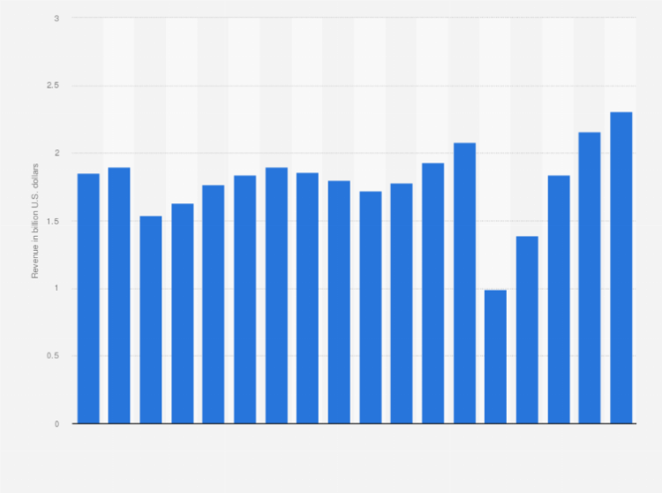
Figure 4: Revenue of the InterContinental Hotels Group (IHG) from 2007 to 2024
(Source: Statista, 2024)
This graph show that, as InterContinental Hotels Group, a UK-based multinational, achieved revenue of US$2.31 billion in 2024 compared to US$2.16 billion in 2023, it is clear that initiatives such as their Service Excellence and Staff Training Program, which improves the guest experience through skilled employees, have made significant contributions to financial success by increasing customer satisfaction (IHG, 2023).‌

Pricing Review and Value Proposition Enhancement
The hotel’s pricing and service concerns have had a significant impact on its reputation, with many guests commenting that room rates and food and beverage prices are not in line with the quality and range of services provided. To address this issue, the hotel should follow a detailed pricing and competitor analysis process, which will assess competitors’ pricing and create value packages for guests, such as additional benefits such as inclusive breakfast or late check-out (‌Avelar et.al, 2020). In addition, IHG’s total revenue grew by 3.78% in the past year, and their UK occupancy rate was 66.7% in the first quarter of 2025, up 0.6% from the previous year. In light of these changes, using dynamic pricing tools will allow the hotel to respond flexibly to changes in demand and maintain profitability (The4, 2025). Marketing campaigns will showcase the benefits of the new packages, eliminating any confusion or frustration among guests (Team, 2024). In 2023, IHG reported a 4.2% online booking conversion rate and 57% digital bookings, with 38% of these bookings made through the mobile app. To effectively implement these changes, a coordinated effort between sales, reservations and marketing teams is required, and staff will be properly trained on the new value propositions (The Caterer, 2024). Success will be measured through booking patterns, average daily rates and revenue per available room, which will help ensure the effectiveness and success of these strategies.
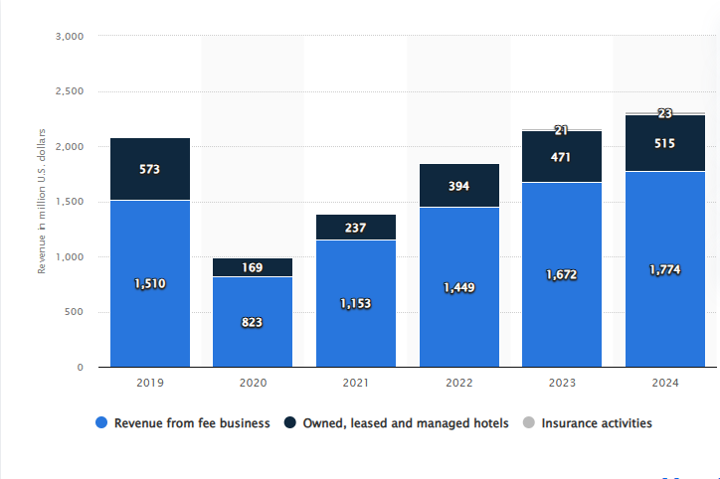
Figure 5: Revenue of the InterContinental Hotels Group (IHG) from 2007 to 2024
(Source: Statista, 2021)
As per the figure, As InterContinental Hotels Group generated revenue of US$515 million from its owned, leased and operated hotels and approximately US$1.77 billion from its fee-based business in 2024, it is clear that its strategic pricing review and value proposition development initiatives have optimized revenue streams as well as increased brand appeal among diverse customer segments (Statista, 2021).

‌Room Maintenance and Infrastructure Upgrade
Guest dissatisfaction with room size, layout, and bathroom amenities can pose a serious risk to a hotel’s brand image, which can have a detrimental impact on hotel quality and customer satisfaction. For this reason, a well-planned and phased renovation program is recommended, starting with the rooms that have received the most complaints. These renovations will focus primarily on bathroom functionality and modernization, with particular emphasis on improving water pressure, lighting upgrades, and furniture modernization (NerdWallet, 2025). After Iberostar hotels were included in the IHG system, the number of openings increased by 27% year-on-year in the fourth quarter and signings increased by 50%, marking one of the largest quarters for growth activity. If these changes can be made during low occupancy, operational disruptions will be minimal and operations will continue (Bbborg, 2024). In addition, it is important to provide staff with proper training on new room features and upgraded amenities so that they can communicate properly with guests, and provide specific scripts to inform guests about the renovations. Effective communication is essential for change management, as 303 of the 970 total complaints over the past three years have been resolved in the past 12 months, but the breakdown of complaints by room type or specific location is not presented. To accurately measure the impact of the renovation, it is essential that guest feedback is collected post-renovation and compared with previous room ratings (Bellrock, 2018). A trial renovation of 20 rooms is recommended initially, with an estimated cost of £140,000. If this project is successful, it could be expanded in subsequent years. The potential for long-term growth remains strong for IHG.

‌Strategic Partnership for Wellness Amenities
The hotel’s service offering lacked a spa or pool, which was not particularly in line with its luxury branding. Rather than investing in high-priced amenities, InterContinental Hotels Group (IHG), which markets itself as IHG Hotels & Resorts, could offer wellness services to guests by forming a partnership with a reputable spa (Investorschronicle, 2025). The partnership would include negotiated rates for guests, a matching stay-and-spa package, and perhaps transportation to the spa location. This strategy would provide the hotel with multiple opportunities to enhance its value proposition, but would not require any capital expenditure to build new wellness infrastructure. Employees would need to be fully informed about the packages and be able to confidently promote them (IHG, 2019). IHG reported $2.312 billion in revenue in 2024, which came from reportable segments. This revenue includes a royalty fee of 5-6% of a hotel’s room revenue and a base fee of 1-3% of gross revenue in a typical franchise agreement. In addition, contributions to the system fund and valuations were $2.611 million in 2024. The initial marketing and support costs for this initiative will be approximately £1,500. In addition, IHG has declared a dividend of $1.59 in 2024, an increase of 1.65% over last year (IHG, 2023). Sixteen analysts expect a dividend of $1.90 to be declared next year, an increase of 19.71%. In light of all this information, it is crucial that concierge and front-desk teams are specifically trained so that they can stay informed about these details and numbers and improve their work efficiency.

‌Change Management Framework
A well-organized and well-managed change strategy is necessary to implement these changes smoothly across departments. By combining Lewin’s Change Management Model and the ADKAR Model, the hotel will be able to manage this transformation process properly. Lewin’s model serves as a guide for the initial preparation of the change, the change process, and the establishment of new procedures, which prepare the organization for the change (IHG, 2023). On the other hand, the ADKAR model provides a human perspective, where awareness, desire, knowledge, ability, and re-establishment are important. InterContinental Hotels Group (IHG) reported an overall employee engagement score of 87% in its annual Colleague HeartBeat survey in 2023, demonstrating significant improvement among employees. IHG’s “IHG Academy” has provided training and work experience to more than 90,000 young people since 2006, of which 43,000 were participants in 2024. Nearly 1,300 workshops were held in 2023, with more than 25,000 employees participating (Job, 2025). Although IHG has a high turnover rate in the UK, with the company placing a particular focus on employee engagement, some reviews have raised concerns about the high rate of employee turnover.

Monitoring and Evaluation
Measuring the impact of each recommendation is crucial, as it provides an opportunity to assess the effectiveness of recommendations, which are dependent on various aspects of the business. IHG’s fastest growing premium hotel brand, voco hotels, launched in 2018 and has quickly become IHG’s fastest growing global brand; voco, known for its unique charm and distinctive experience, combines the charm of a stand-alone hotel with the quality of a global brand, and for this reason has been acclaimed worldwide. IHG says that voco was recognized as the world’s top premium hotel brand at the 2021 World Travel Awards, which is further testament to its popularity and reputation (InterContinental Hotels Group PLC, 2024). While the employee engagement rate is 82%, this may not be a direct reflection of turnover, as the company places a strong focus on employee career development and advancement, which helps ensure the satisfaction and retention of its employees. To measure the impact of each recommendation, a change success dashboard should be created, which tracks various key performance indicators such as guest satisfaction, service time, employee turnover, training participation, room occupancy and package sales, and thus it will be possible to evaluate the effectiveness of the recommendations (True Hospitality Good for Contents, 2025). IHG generated $2.312 billion in revenue in 2024, of which $1.774 billion came from fee business, which is further evidence of the company’s growth and stability. Regular team meetings, internal reports and employee suggestion boxes will help maintain the momentum of the change effort, so that the company can improve on its path to achieving its goals.

Summary of Costs and Financial Considerations
The first year of implementation of all recommendations at InterContinental Edinburgh The George will cost an estimated £181,500, including £30,000 for staff training and incentives, £10,000 for pricing and marketing improvements, £140,000 to renovate 20 rooms and £1,500 to set up and promote a wellness partnership. This investment is in line with IHG’s position in the hotel’s premium market and the expected benefits, including increased guest satisfaction, improved employee retention and additional revenue streams (Bellrock, 2018). IHG’s U.S. room revenue grew 3.5% in the three months to March 31, 2025, an improvement on the 1.9% decline last year. This outpaced the combined growth of Hilton and Marriott in the U.S. and Canada. IHG is now one of the world’s largest hotel companies, with 5,367 hotels and nearly 800,000 rooms in its system, and plans to grow even further in the future. IHG has an employee engagement rate of 82%, which is much higher than the hospitality industry average of 62%, creating a positive environment for employee retention.
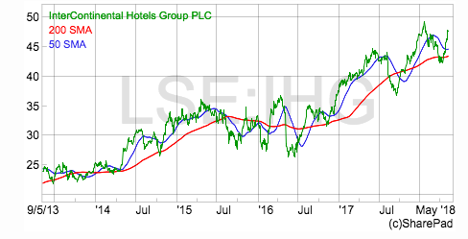
Figure 6: Stock Watch: InterContinental Hotels
(Source: ShareScope Articles, 2018)
As per the figure, InterContinental Hotels Group (IHG), originally part of the Bass Brewing Company, is today a global leader with 5,367 hotels and nearly 800,000 rooms, and is one of the largest hotel companies in the world, with the importance of property maintenance, staff management, marketing and expansion-related expenses being extremely high, which greatly influences the company's financial strategy and future growth plans (ShareScope Articles, 2018).

‌ Action Plan
As InterContinental Edinburgh The George Hotel faces a number of operational and reputational challenges, a targeted and realistic action plan has been adopted to address these issues sustainably, including initiatives such as the introduction of an extensive training programme for staff, a phased room refurbishment, a strategic review of pricing, the creation of wellness partnerships and the development of digital reputation management, with the aim of increasing guest satisfaction, aligning the brand’s luxury standards and ensuring customer loyalty through long-term revenue growth in a competitive market (IHG, 2023).

Below is an example of an action plan presented in a table
Problem | Solution | Desired Outcome | Time Scale | Estimated Cost
Inconsistent service quality | Launch Service Excellence & Staff Training Program | Improve guest satisfaction and review scores | 3–6 months | £75,000 for training programs and workshops
Outdated rooms and infrastructure | Phased renovation of high-complaint areas | Enhance comfort, align rooms with brand standards | 6–18 months | £1.2–1.5 million depending on scope
Misaligned pricing/value perception | Conduct strategic pricing review & redefine value proposition | Restore trust and attract price-sensitive guests | 2–3 months | £30,000 (consulting and analysis)
Lack of wellness amenities | Establish local spa/wellness partnerships | Improve guest experience without major CAPEX | 1–2 months | £10,000 (negotiation and branding integration)
Poor online reputation management | Assign a dedicated digital response team | Improve engagement, enhance digital visibility | Immediate to 3 months | £20,000 annually (staff and tools)

Conclusion
This advisory report provides a comprehensive and in-depth analysis of the current challenges and strategic opportunities facing InterContinental Edinburgh The George, where multiple complex factors are interrelated. While InterContinental Hotels Group (IHG)’s overall performance is strong, particularly with increasing RevPAR, consistent profits growth and a loyal international customer base, Edinburgh The George’s performance is not in line with these global trends. The main findings outlined in this report highlight a number of interrelated issues that, if not addressed appropriately, could pose serious challenges to the hotel’s long term position in a highly competitive & challenging market.
A vital issue that has been identified is the deterioration of service quality and aging infrastructure, while IHG has generally performed well in its guest satisfaction indicators and employee engagement, customer complaints at The George Hotel indicate that there are inconsistencies in service, deprived maintenance and operational inefficiencies, especially during busy periods. These shortcomings are compounded in the digital age, where unenthusiastic reviews on platforms such as TripAdvisor and Google Reviews have a huge impact on potential guests and can significantly damage a hotel’s reputation. In particular, the hotel’s failure to respond to many reviews is a obvious signal that there is a serious gap in digital reputation management that needs to be addressed immediately.
These challenges are driven by a combination of broader economic & industry trends, with dramatic shifts in customer expectations post-COVID, rising cost pressures, staff shortages (particularly in the food and beverage sector), and increased competition from boutique hotels and short-term rental platforms, all adding to the need for strategic innovation. In adding up, these challenges are compounded by internal factors, such as a require of investment in timely renovations, high employee turnover, and inadequate use of customer feedback in effective decision-making.
However, InterContinental Edinburgh The George has some vital strengths that could help to change this situation, such as its location on George Street, a historically significant building, and the consistent presence of events and high-spending international guests. Furthermore, the strength of the IHG One Rewards loyalty program, the commitment of long-standing employees, and the support of a worldwide brand create a strong foundation for the future growth of the organization, which could serve as a solid step towards changing this situation.
A strategic action plan has been proposed to address the current challenges, emphasizing actions such as targeted worker training to achieve service excellence, phased infrastructure development, digital reputation management, wellness partnerships, and realignment of pricing strategies. These actions have been organized in a way that they are realistic, cost-effective, and achievable within a specified timeframe, ranging from short-term gains to long-term transformation goals. If all these activities are effectively implemented, The George will be able to rebuild its customers’ trust, improve service quality, & strengthen its brand identity consistent with InterContinental Hotels’ luxury positioning.
This report was driven by a robust mixed-methods research approach, which included in-depth analysis of online reviews, industry benchmarks, employee reaction and external market data. These analyses presented a comprehensive picture of the current situation and provided evidence-based solutions that were both actionable and fully aligned with IHG’s broader strategic aim.
Ultimately, it can be said that while the impact of the challenges faced by InterContinental Edinburgh The George is significant, they can be overcome with the right strategy and full focus. If there is leadership, long-term speculation in people, proper management of the property and a renewed commitment to service quality and guest experience, the hotel will without difficulty be able to restore its previous reputation and financial performance.
In this regard, we would like to sincerely thank the management team of InterContinental Hotels Group and The George for giving us the opportunity to collaborate theiron this important project. Their openness and readiness for constructive discussions have been invaluable to us. We firmly believe that this report will be able to make a significant contribution to their ongoing success in the future and we are always ready to support them in any opportunity initiatives.

Reference List
Antunes, M.T.B., 2023. How to Support a 5-star Hotel in Lisbon to Attract and Retain Talent? What Are the Key Factors That Hotels Should Take Into Consideration When Developing and Implementing Talent Retention Strategies to Match the Demands of Today’s Workforce? (Master's thesis, Universidade NOVA de Lisboa (Portugal)).
‌Avelar, P.A.S. and Martins, T.R., 2020. Hotel Industry Growth Trends–The Case of Intercontinental Hotels Group (Master's thesis, Universidade NOVA de Lisboa (Portugal)).
Bbb.org. (2024). InterContinental Hotels Group. [online] Available at: https://www.bbb.org/us/ga/atlanta/profile/hotels/intercontinental-hotels-group-0443-4567/complaints [Accessed 22 May 2025].
Bellrock (2018). Bellrock wins deal with InterContinental Hotels Group. [online] Bellrock Property & Facilities Management Limited. Available at: https://www.bellrockgroup.co.uk/bellrock-win-deal-intercontinental-hotels-group/ [Accessed 22 May 2025].‌
Cbre.com. (2024). Slowing RevPAR Growth Makes Hotel Brand Selection More Critical. [online] Available at: https://www.cbre.com/insights/reports/hotel-brand-performance-2024.
Chen, X., 2022. Location Strategies of Multinational Hotel Groups in China: An Application of Game Theory.
Cushman & Wakefield. (2025). UK Hospitality Marketbeat Reports | GB | Cushman & Wakefield. [online] Available at: https://www.cushmanwakefield.com/en/united-kingdom/insights/uk-marketbeat/hospitality-marketbeat.
de Haast, A., Busquet, A. and Cescau, P., INTERCONTINENTAL HOTELS GROUP PLC. Policy, 112, pp.77-14.
Fernandes, F., 2021. Intercontinental Hotels Group-Time to Check-In (Master's thesis, Universidade NOVA de Lisboa (Portugal)).
Genter, K. (2024). IHG elite status: What it is and how to earn it - The Points Guy. [online] The Points Guy. Available at: https://thepointsguy.com/loyalty-programs/what-is-ihg-elite-status-worth/.
Hoang, D.M., 2023. Measurements of Sustainability Performance in Hotels Case Study–Intercontinental and the Green Key Certification (Master's thesis, Universidade NOVA de Lisboa (Portugal))
IHG (2019). How our business works. [online] InterContinental Hotels Group PLC. Available at: https://www.ihgplc.com/en/about-us/how-our-business-works.
IHG (2023). How we’re creating Room to Belong PROGRESS REPORT. [online] Available at: https://www.ihgplc.com/~/media/Files/I/Ihg-Plc/responsible-business/reporting/2024/2023%20Progress%20Report.pdf.
IHG (2023). Provide True Hospitality for Good To be the hotel company of choice for guests and owners HOW WE MAKE IT HAPPEN AMBITIOUS DEDICATED COURAGEOUS RELENTLESS FOCUS ON GROWTH BRANDS GUESTS AND OWNERS LOVE LEADING COMMERCIAL ENGINE CARE FOR OUR PEOPLE, COMMUNITIES AND PLANET CARING OUR GROWTH BEHAVIOURS Our strategy Strategic Report. [online] Available at: https://www.ihgplc.com/~/media/Files/I/Ihg-Plc/investors/annual-report/2023/our-strategy-2023.pdf.
IHG (2024). About us. [online] InterContinental Hotels Group PLC. Available at: https://www.ihgplc.com/en/about-us.
IHG (2024). Annual Report. [online] InterContinental Hotels Group PLC. Available at: https://www.ihgplc.com/en/investors/annual-report.
IHG. (n.d.). IHG | Frequently Asked Questions. [online] Available at: https://www.ihg.com/content/us/en/customer-care/frequently-asked-questions [Accessed 11 Jul. 2021].
InterContinental Hotels Group PLC. (2024). Full Year Results for the year to 31 December 2024. [online] Available at: https://www.ihgplc.com/en/news-and-media/news-releases/2025/full-year-results-for-the-year-to-31-dec-2024.
InterContinental Hotels Group PLC. (2025). Q1 Trading Update to 31 March 2025. [online] Available at: https://www.ihgplc.com/en/news-and-media/news-releases/2025/first-quarter-trading-update-to-31-march-2025 [Accessed 11 May 2025].
Investorschronicle.co.uk. (2025). InterContinental Hotels Group PLC (IHG:LSE) Share price, analysis, charts, news, dividends, EPS forecasts, annual reports and RNS - Investors Chronicle. [online] Available at: https://markets.investorschronicle.co.uk/data/equities/tearsheet/forecasts?s=IHG:LSE [Accessed 22 May 2025].
Jaecker, C., 2023. Sustainability Certifications in the Hotel Industry: Characteristics, Motivations and Risks Case Study–InterContinental Lisbon and the Green Key Certification (Master's thesis, Universidade NOVA de Lisboa (Portugal)).
Job, R.T. (2025). Holiday Inn owner IHG confident US domestic demand will deliver profit growth . Reuters. [online] 9 May. Available at: https://www.reuters.com/business/intercontinental-hotels-global-room-revenue-rises-first-quarter-2025-05-08/.
Kipsu.com. (2024). TripAdvisor reviews show that IHG guests love guest messaging! | Kipsu. [online] Available at: https://www.kipsu.com/blog/tripadvisor-reviews-show-that-ihg-guests-love-guest-messaging [Accessed 22 May 2025].
Kwan, M. and Tong, L., 2023. EXEMPLARY SERVICES AND INSPIRING LEADERSHIP: CASE OF INTERCONTINENTAL ZHUHAI HOTEL, IHG. Gulf Journal of Advance Business Research, 1(2), pp.94-109.
Labs, P. (2025). IHG Independent Hotels IHG Chain Demographics and Foot Traffic Insights. [online] Placer.ai. Available at: https://www.placer.ai/chains/ihg-independent-hotels [Accessed 22 May 2025].
Liberato, D., Oliveira, M., Cardoso, R. and Liberato, P., 2023. An Approach to Revenue Management Strategies in the Hospitality Industry. In Advances in Tourism, Technology and Systems: Selected Papers from ICOTTS 2022, Volume 2 (pp. 639-650). Singapore: Springer Nature Singapore.
Linkedin.com. (2024). LinkedIn. [online] Available at: https://www.linkedin.com/company/ihghotels&resorts.
momondo. (2025). Eden Andalou Aquapark & Spa. [online] Available at: https://www.momondo.co.uk/hotels/marrakesh [Accessed 22 May 2025].
Morningstar.co.uk. (2025). Available at: https://tools.morningstar.co.uk/uk/stockreport/newsItem.aspx?id=LSE20250508070008_5645302 [Accessed 22 May 2025].
NerdWallet. (n.d.). IHG vs. Marriott: Which is Right For You? [online] Available at: https://www.nerdwallet.com/article/travel/ihg-vs-marriott.
Richardson, S., Jovanka, F., Zabrina, P.K., Adiati, M.P. and Rosman, D., 2023, July. The Consequences of Digital Concierge Chatbots Acceptance on Hotel Guest Experience and Satisfaction at IHG Hotel and Resort. In 2023 International Conference on Digital Applications, Transformation & Economy (ICDATE) (pp. 1-5). IEEE.
ShareScope Articles. (2018). Stock Watch: InterContinental Hotels - ShareScope Articles. [online] Available at: https://knowledge.sharescope.co.uk/2018/05/09/stock-watch-intercontinental-hotels/ [Accessed 22 May 2025].
Statista (2024). IHG: gross revenue by brand 2019. [online] Statista. Available at: https://www.statista.com/statistics/298806/gross-revenue-of-intercontinental-hotels-group-by-brand/.‌
Statista (2024). IHG: revenue 2019. [online] Statista. Available at: https://www.statista.com/statistics/273254/revenue-of-the-intercontinental-hotels-group/.
Statista. (n.d.). IHG revenue by ownership type 2021. [online] Available at: https://www.statista.com/statistics/223419/intercontinental-hotels-group-revenue-by-segment/.
Team, D. (2024). Mission Statement, Vision, & Core Values (2024) of InterContinental Hotels Group PLC (IHG). [online] DCF, SWOT, CANVAS, PESTEL, BCG Editable Templates. Available at: https://dcfmodeling.com/blogs/vision/ihg-mission-vision.
The Caterer. (2024). IHG reports revpar boost amid ‘strong’ demand... [online] Available at: https://www.thecaterer.com/news/ihg-revpar-boost-full-year-results.
The4 (2025). InterContinental Hotels Group PLC (IHG): Marketing Mix [Jan-2025 Updated]. [online] DCF, SWOT, CANVAS, PESTEL, BCG Editable Templates. Available at: https://dcfmodeling.com/products/ihg-marketing-mix.
True Hospitality Good for Contents. (n.d.). Available at: https://www.ihgplc.com/~/media/Files/I/Ihg-Plc/investors/annual-report/2024/ihg_rbr_24-25_interactive.pdf.
Voegeli, C., 2021. A Case Study of Knowledge Management Practices at the Intercontinental Hotels’ Group. Available at SSRN 3819409.
www.ambitionbox.com (2025). Ihg Group Reviews by 600+ Employees | Rated 3.9/5 | AmbitionBox. [online] AmbitionBox. Available at: https://www.ambitionbox.com/reviews/ihg-group-reviews [Accessed 22 May 2025].

