

MODULE CODE: Digital Skills for Personal Development and Business Growth BMSW4008

ASSESSMENT COMPONENT: PORTFOLIO

STUDENT NAME: Donna watkins

STUDENT NUMBER: 2508071

LECTURER: Aqsa Shabir

DATE: Friday 12th December 23:59
Contents
Task 1 3
Assessment of Digital Skills 3
References 3
Task 2 4
LinkedIn Learning Certificates for Office365 4
Task 3 5
Essay on Relevance of Excel in professional and personal life. 5
References 5
Task 4 6
7 Minute Reflective Presentation 6
References 6

ASESSMENT OF DIGITAL SKILLS
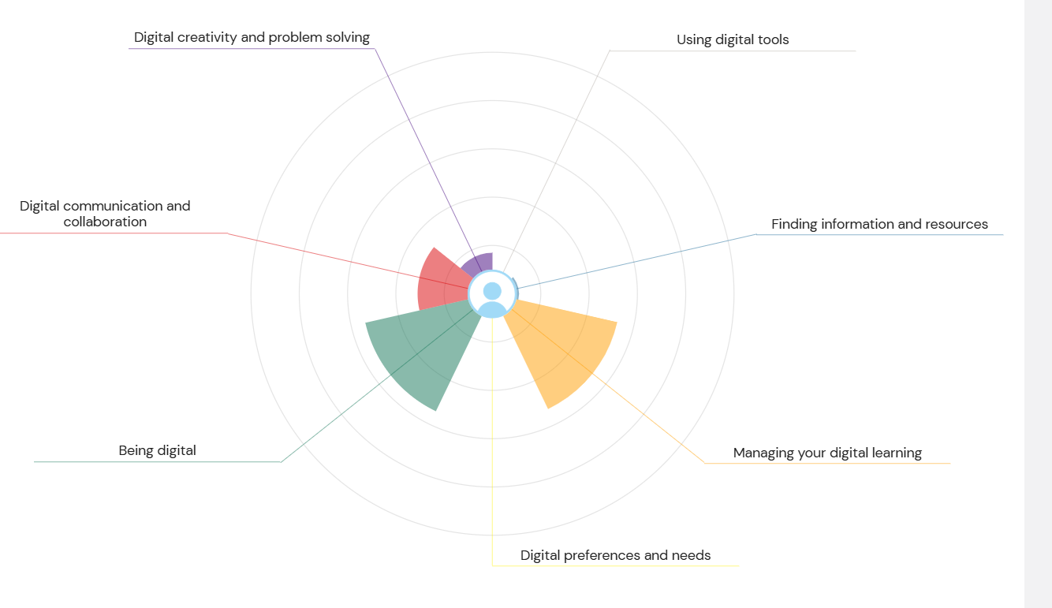

The Essential Role of Digital Skills: A Reflective Analysis and Plan for Growth
​In the 21st-century educational and professional landscape, digital skills have transitioned from beneficial assets to fundamental necessities. They underpin almost every aspect of modern life, enabling communication, access to information, professional development, and economic participation (Scheel, Vladova & Ullrich, 2022). Developing these competencies is therefore crucial for academic success, future employability, and effective engagement in an increasingly digital society. This essay will summarise the results from my JISC digital capabilities assessment, discuss my key strengths, identify areas for improvement, and propose an action plan with SMART goals to foster continued growth.
​The JISC framework assesses an individual's confidence across six elements of digital capability: digital well-being, communication, creation, dealing with data, learning, and identity (JISC, 2017). My self-assessment indicates a strong foundation in Digital Communication and Managing Digital Learning, but highlights Digital Creativity and Problem-Solving and Formal Digital Tone as areas needing development.
​Digital Capabilities: Strengths and Weaknesses
​Strength 1: Digital Communication
​Digital communication stands out as a core strength. I am comfortable using a range of online platforms, including social media, messaging apps, and email, to stay connected with others and share information quickly and clearly. This confidence allows me to express my ideas effectively through messages and posts, facilitating collaboration and understanding. Research confirms that digital competence in communication, interaction, and collaboration is essential for effective participation in online learning and society (Scheel, Vladova & Ullrich, 2022). My comfort with various tools supports positive engagement and ensures my ideas are conveyed, a skill critical for group work and networking (European Commission, 2018).
​Strength 2: Managing Digital Learning
​My ability to manage digital learning resources is a second significant strength. I am adept at keeping my apps organised, storing files logically, and maintaining the digital tools necessary for my academic work. This organisation helps me work smoothly and find materials quickly, a key aspect of digital competence related to managing learning resources and materials effectively (European Commission, 2018). My proactive plan to enhance this by using LinkedIn learning and educational YouTube channels demonstrates a commitment to continuous self-improvement, ensuring my efficiency grows alongside new technologies.
​Weakness 1: Digital Creativity and Problem-Solving
​One area requiring significant practice is digital creativity and problem-solving. While I find this area exciting, I currently lack confidence in using a wide range of digital tools and apps to express creativity or troubleshoot complex digital issues. Improving this involves moving beyond consumption to actively using digital tools for generating ideas, creating content, and effectively identifying and resolving technical or conceptual problems, a key component of the European DigComp framework (European Commission, 2018). By exploring new resources and learning from mistakes, I can develop these essential adaptive skills.
​Weakness 2: Formal Digital Tone and Etiquette
​While I am confident in informal communication, a notable weakness is ensuring my tone translates effectively in more formal digital settings, such as professional emails or institutional learning platforms. The nuances of tone are often lost in text, and an informal approach can unintentionally undermine a message's professionalism or importance (Scheel, Vladova & Ullrich, 2022). Improving this skill is vital for communicating with instructors, potential employers, and professional contacts, where clear, respectful, and formal etiquette is expected.
​Action Plan for Improvement
​To address my identified weaknesses,Conclusion: Reflecting on Growth
​Developing these skills will have a profound positive impact on both my academic and professional career. Academically, enhancing my digital creativity will allow me to present assignments in more innovative ways, moving beyond text to incorporate effective visuals or digital solutions, which is often expected in higher education (Beetham & Sharpe, 2020). Mastery of formal digital tone will ensure clear, professional engagement with academic staff, potentially leading to better opportunities and references. Career-wise, a strong foundation in both efficient learning management and professional communication is non-negotiable. Furthermore, digital problem-solving is a highly sought-after soft skill that demonstrates resilience and adaptability to employers across all sectors (van Deursen & van Dijk, 2019). By proactively improving these weaker areas, I will become a more well-rounded, responsible, and highly employable digital citizen, ensuring my competence supports my goals in a continuously evolving digital world.
Weak Area SMART Goal Relevance to Growth
Digital Creativity & Problem-Solving S: Successfully complete an introductory online module (e.g., using Canva or a basic coding platform) and apply the tool to create 3 pieces of academic/project-related content. M: Successfully submit the 3 created pieces as part of relevant coursework; complete the module. A: Yes, many free introductory resources exist. R: Develops skills for complex academic assignments and future innovation roles. T: Complete the module and 3 pieces of content within the next 10 weeks.
Formal Digital Tone and Etiquette S: Complete a short online course or tutorial specifically on professional email etiquette and formal digital communication. M: Pass the end-of-course quiz and use formal etiquette in all communications with lecturers/tutors for one academic term. A: Yes, via LinkedIn Learning or equivalent. R: Essential for professional communication and academic success. T: Complete the training and implement the formal tone practice immediately for the current term.

References
​Beetham, H., & Sharpe, R. (2020). Rethinking Pedagogy for a Digital Age: Designing and Developing for Digital and Blended Learning. 3rd ed. Abingdon: Routledge.

​European Commission. (2018). DigComp 2.2: The Digital Competence Framework for Citizens. Publications Office of the European Union.

​JISC. (2017). Building Digital Capabilities: The six elements defined. Available at: https://www.jisc.ac.uk/guides/building-digital-capability [Accessed 1 December 2025].

​Scheel, K. L., Vladova, G., & Ullrich, A. (2022). The structure of digital competence in higher education: a systematic review. International Journal of Educational Technology in Higher Education, 19(1), 1-28.

​van Deursen, A. J., & van Dijk, J. A. (2019). The first decade of internet skills research: Achievements and challenges. New Media & Society, 21(5), 1144-1161.

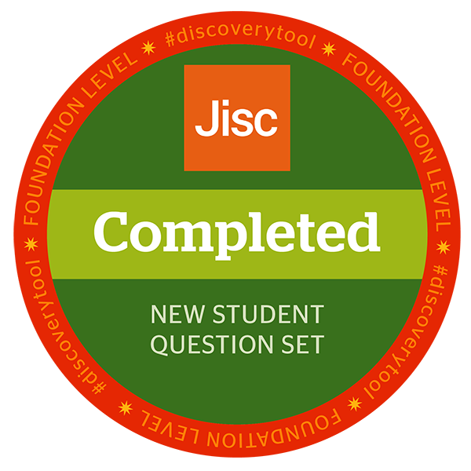

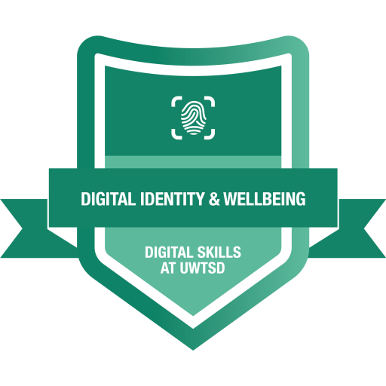

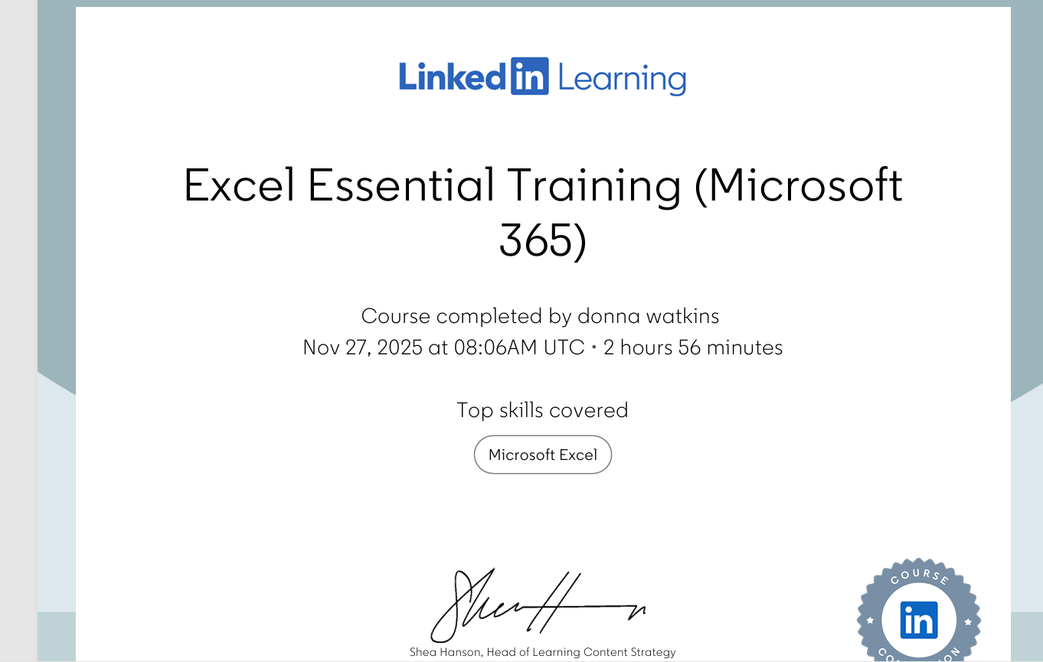

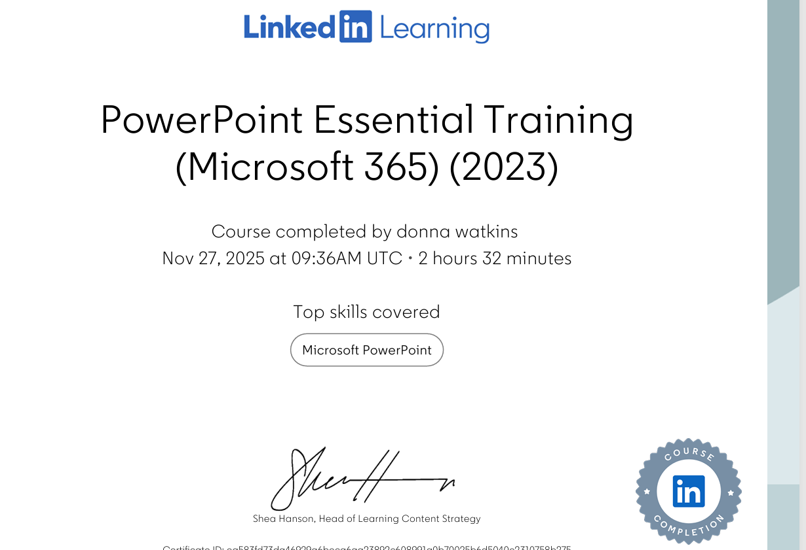

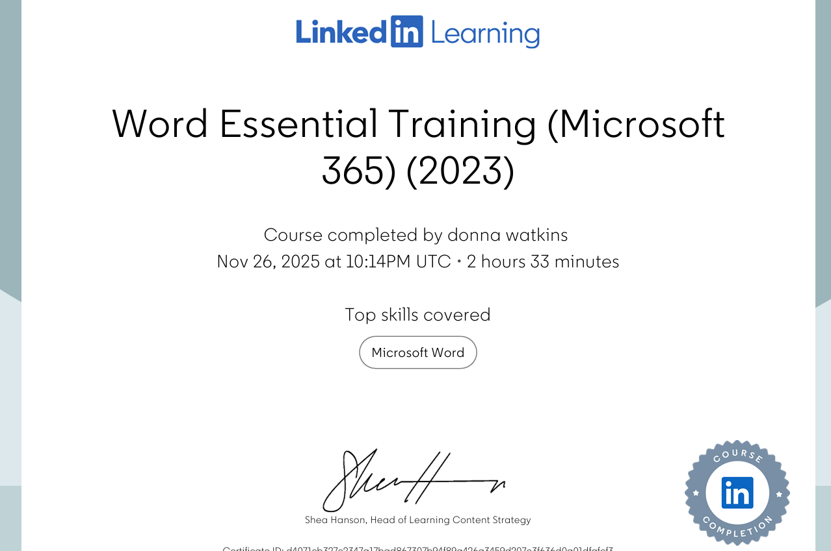

Discussing the relevance and importance of Microsoft excel (1000 words)

The following essay will look at the relevance and importance of Microsoft Excel in the new digital era. It will look at its role in tasks such as data analysis, budgeting, reporting and decision making. It will discuss its functions and uses and where these positions excel in terms of it being a useful tool in everyday and professional life.

Microsoft Excel is a program that was created in 1982 (MAX, 2024) and was designed to make graphs, complete statistical analysis and financial functions. It was initially particularly useful in professional settings such as the financial sector (The Wall Street School, 2013). It enabled companies and institutions to complete tasks such as investment analysis, loan and mortgage calculations, accounting and tax planning with more ease and efficiency. Over time, it has become used in other sectors such as with students (Formby et al, 2013) researchers, academics and healthcare (Lapolla, 2020). It is now a more widely used and accessible tool that has been incorporated into modern life and the new digital era (Charlesworth, 2024).

Excel has hundreds of functions, but some are particularly important for data analysis. It helps calculate data quickly for example, the ‘IF’ function allows for automated decision making, SUMIF’s allow for creating sums based on specific criteria, VLOOKUP helps combine data and look for certain values in a data set (Murray, 2025). Excel makes tasks that would be time consuming and difficult for the human brain to complete, a lot easier and quicker. The filtering and organizing aspect allow the user to also select criteria and find answers at the click of a button, for example, if one was to create a monthly home cleaning schedule, a spreadsheet could include tasks that needed to be completed monthly, weekly and daily. By filtering, the user would be able to select the ‘daily’ option and find easily what would need to be completed that day. This would be a lot quicker than paper-based methods. Furthermore, if any amendments needed to be made this could be done quickly and efficiently, without the need to complete a whole new schedule. In the professional world, analysing data is key - whether this be reviewing how well a quarter has done and evaluating profits or loss or used in forecasts to predict different scenarios and project sales on various growth rates. These tasks are fundamental to a business’s survival, so having a tool like excel is crucial in the business world.

Excel further supports businesses in terms of developing a budget such as creating spreadsheets for time keeping, clocking in and out and payroll. It also helps with managing and logging expenses. Many industries benefit from using excel such as retail where spreadsheets can be kept keeping track of stock and the average sales or profit margin of stock. Excel can help with budgeting at home with things like creating lists to keep track of food and bill budgets or to keep track of savings to help create a savings plan. It can also be used to create shopping lists where prices can be included to ensure there is no overspending on the grocery budget, tracking spending habits (GyanSetu, 2025)

Excel helps with reporting findings and presenting them in a more efficient and timely way. Within excel you can create graphs and charts easily, which are more visually appealing and easier to understand. Graphs and charts can be used in situations such as budgeting for example, creating a pie chart to represent home expenditures and analysing incoming and outgoing finances. This is also helpful in education settings such as schools where budgets need to be created to keep track of the financial year and submitted to the local authorities, graphs can be created with the data set and sent for easier reviewing and planning. When looking at students, excel can be used to keep track of grades and assignments or track study time. It can be incorporated into part of the research planning phase for projects such as creating a timeline to visualize how long is needed to complete an assignment.

Using excel for the things mentioned above, then helps inform decisions for example; if a pie chart was created using income and outgoings of a home, if one part of the pie chart was dedicated to a particular area such as bills, it would be easily identifiable and then excel could be used to breakdown each bill and decisions could be made in regards to reducing a certain bill such as energy, switching to a different supplier or making more economic decisions, therefore using excel has real life positive implications which span both professional and home settings.

In conclusion, excel has become a really important tool in both professional and home life. It has hundreds of functions and tools which can make tasks more efficient and understandable. Using excel can help with making financial decisions, keeping track of income and expenses and calculating savings automatically. For this reason, it is highly relevant that students learn how to use excel as it has become a tool that businesses also use to monitor their progress, make financial decisions and forecasts and report to shareholders and investors. This is also relevant across various sectors and career paths, therefore a student having knowledge and understanding of excel is vital for career development and progression. Research has shown its implementation and use in areas such as academia, healthcare, retail, finance, home and hospitality can have positive outcomes; therefore, it would not be wrong to conclude that excel is a highly relevant and important tool in today's digital era.

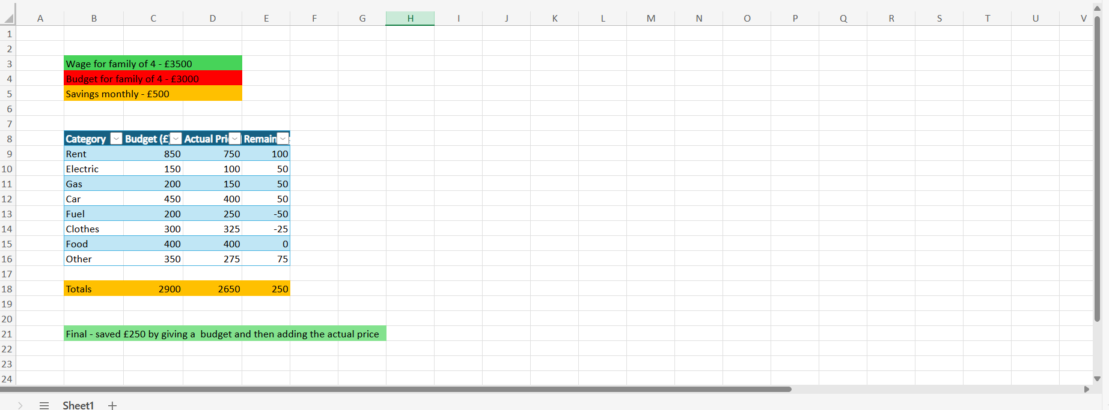

References
Charlesworth, A. (2024) Is Microsoft Excel still relevant? Kaplan. Available at: https://kaplan.co.uk/blog/features/is-microsoft-excel-still-relevant (Accessed: 12 December 2025).
Formby, S.K., Medlin, B.D. and Ellington, V.B. (2013) ‘Microsoft Excel®: Is it an important job skill for college graduates?’, Journal of Learning in Higher Education, 9(1). Available at: https://eric.ed.gov/?id=EJ1140801 (Accessed: 12 December 2025).
Gyansetu (2025) 10 best uses of MS Excel in daily life. Available at: https://www.gyansetu.in/blog/best-10-uses-of-ms-excel-in-daily-life/ (Accessed: 12 December 2025).
LaPolla, F.W. (2020) ‘Using Excel for data management in clinical research’, Journal of Community Hospital Internal Medicine Perspectives, 10(1). Available at: https://pmc.ncbi.nlm.nih.gov/articles/PMC6919992/ (Accessed: 12 December 2025).
Max (2024) When was Excel created? Max Training. Available at: https://maxtrain.com/2024/02/19/when-was-excel-created/ (Accessed: 12 December 2025).
Murray, S. (2025) Most useful Excel functions for data analysis. GoSkills. Available at: https://www.goskills.com/Excel/Resources/Most-useful-Excel-functions-for-data-analysis (Accessed: 12 December 2025).
The Wall Street School (2013) Why is Excel important in finance? Available at: https://www.thewallstreetschool.com/blog/why-is-excel-important-in-finance/ (Accessed: 12 December 2025.



