Component 2 - Research Report
Student Name: Larisa Denisa Bardas
Student Number: 2217305
Lecturer Name: Rebecca Stewart
LCHS4002_BIRM
Digital Skills and Research Methods.

Contents
1. Introduction 3
2. Research design 3
2.1. Research Question 4
2.2. Method 4
2.3. Ethical Considerations 5
3. Results 6
4. Discussion 9
5. Conclusion 9
6. Reference List 11
7. Appendix A – A blank copy questionnaire. 12

Introduction

The following report aims to analyse the responses of the participants to the questionnaire with the question, “Which digital tool is most commonly used for collaboration at UWTSD?” and identify the importance of collaboration through digital tools. Collaborative learning is extremely important amongst students, helping them to discuss concepts or find solutions to different problems, preparing them for working in a group in their future careers, and can bring benefits such as developing oral communication, self-management, leadership, initiative, and creativity, promoting interaction between the students and the lecturers, increasing the student’s self-esteem and responsibility and preparing them for real-life situations either in their social or professional environment (Cornell University, 2022).

Research design

Research design is defined as a framework of a number of different research methods and techniques that are used by a person in order to create a collection of data made out of critical information called research. The most important element so research design includes the method used for analysing the data, the methodology involved in the research, the purpose statement, the possible objections, the techniques used to collect and analyse the research, the timeline, the measurement used, and the settings for the study (Leverage Edu, 2022). Another important tool nowadays for students is digital literacy, as technology is part of everyone’s life, and it is highly important for any career. Digital literacy is highly important for students in order to use technology safely, effectively, and responsibly, to support educational progress, to increase the online safety, to understand digital responsibility, to improve digital equity and to support lifelong skills that can be applied to various types of technology even for the developments of the future (Learning, 2022).

Research Question

The chosen research question for the following research is related to the digital tools’ students use to collaborate at UWTSD, what is the most commonly used tool by the students, and the students collaborate efficiently through used MS Teams. The research question will be answered by using primary research, a quantitative method, by creating and sharing a questionnaire with a number of students from UWTSD.

Method

In order to collect and analyse the data, the research method chosen was the quantitative research with a little qualitative research in order to produce new knowledge and use it along the way. The quantitative research is defined as a system used in order to gather quantifiable data, in order to perform statistical techniques, and use sampling methods in order to collect information about the subject through methods such as online surveys, polls, or questionnaires. The main characteristics of a quantitative research include using structured tools to gather the data, using a sample size that represents the target market, using close-ended questions, taking into consideration prior studies, using tables, charts, graphs, or other non-numerical forms, and creating a generalisation of the results (Question Pro, 2022). Some of the main advantages of the quantitative research include the replication of the study, the comparisons of the results, the large samples, and the testing of the hypothesis, while the disadvantages include superficiality, narrow focus, a structural bias, and a lack of context. The method of using surveys is useful, especially when the results need to be shared with a number of people, when the researcher needs to gain some details and insights into the interests of a group of people, and because it is cost-effective, generalisable, reliable and versatile (Saylordotorg, 2022). The chosen method for this particular survey was a survey created and shared with the target market of students from UWTSD. The question asked in the research include:
“I give consent to use my data for this research.”
“Are you confident in using MS Teams to work with your peers?”
“I use MS Teams most frequently to collaborate with others.”
“I use both MS Teams and OneDrive equally often when working with others.”
“I am confident in completing tasks that involve working with others using MS Teams?”
“What's your Gender?”
“What's your age?”
“Rank these applications in order according to how frequently you use them to collaborate with others. (Most frequent at the top).”
The respondents to the questionnaire were recruited based on the chosen target market of being a student, and more particularly, being a student at UWTSD. There were a number of 16 participants that responded to the questionnaire, which is relevant for the group that did this assignment. A bigger number from different courses will be necessary in order to generalise the conclusion that students are confident in using MS Teams and that MS Teams is the most frequently used application that students at UWTSD use to collaborate digitally.

Ethical Considerations

The ethical consideration related to this questionnaire was related to using the data collected in an ethical manner, not forcing the students to participate in the research in any way against their will, respect for the dignity of the research, and full consent to be obtained from the participants, protection of privacy, an adequate level of privacy, the anonymity of individuals, the communication related to the survey was done in an honest and transparent way, and no misleading information was presented in the primary data (Research Methodology, 2022).

- Results

The first question of the research was related to consent, and 100% of the participant have given a positive answer, as seen in Image 1.
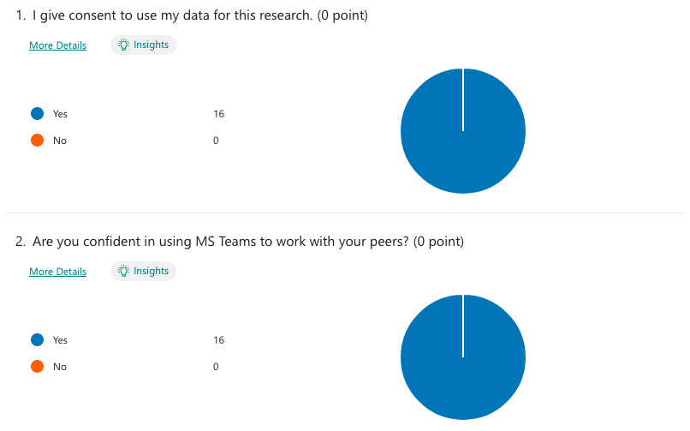
Image 1 – Question 1 & 2

The second question was related to the confidence in using the MS Teams and 100% of the participants admitted that they feel confident in using this tool in order to collaborate with peers, as seen from Image 1.
The third question identifies if the participants actually use MS Teams to collaborate with others. Nine people out of 16 admitted that they use the tool, two were neutral and five disagreed and admitted that even if they know how to use it, they don’t, as seen in Image 2.
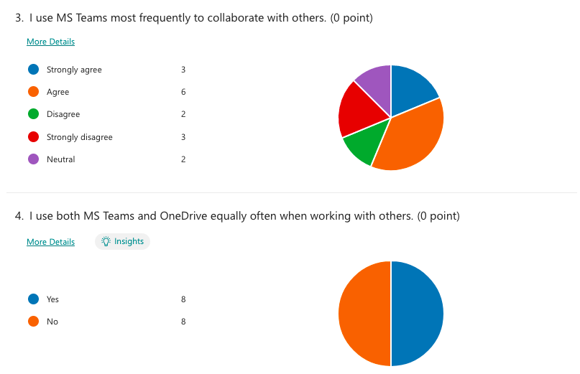
Image 2 – Question 3 & 4

The fourth question asked the participants if they use equally often MS Teams and OneDrive when working with other people, and the response was that 50% of the people use both of the tools for collaboration, while the other 50% don’t use both tools, as seen in Image 2.
The fifth question asked about the confidence of the participants in using MS Teams while working with others, and all the participants agreed that they felt confident in using the tool, as seen in Image 3.
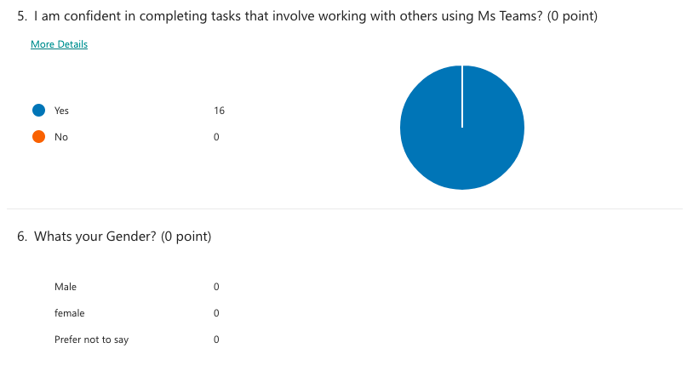
Image 3 – Question 5 & 6
The sixth and seventh questions, as seen in Images 3 and 4, were related to demographics, and people decided to skip answering them because they were not mandatory.
The last question was the ranking of the applications used to collaborate with others, and the people ranked WhatsApp as the most app to collaborate with others, with MS Teams and MS Word coming in second place, as seen from Image 8.
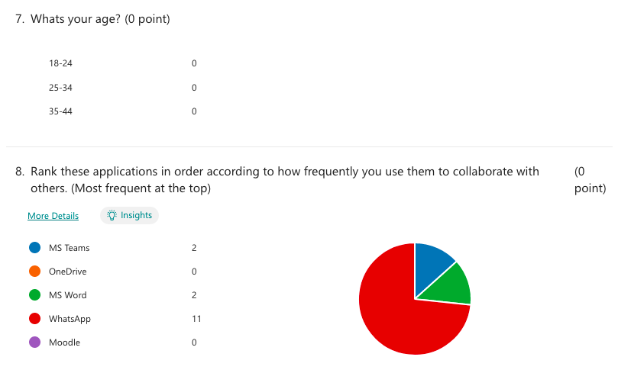
Image 4 – Question 7 & 8

Discussion

The main aim of the questionnaire was to identify the most common digital tools used for collaboration amongst students and see where MS Teams ranks in the preferences of students for peer collaboration. Based on the results seen from above, there wasn’t a large number of students that participated in the survey, but all of them participated freely and gave their consent for the data to be used for research. Also, all the participants in the survey agreed that they are confident in using MS Teams to work with others and that they believe it is a good tool for collaboration. Although people felt comfortable to use the tools, three people strongly agreed that they use them most frequently for collaboration, six people agreed, two people disagreed, three people strongly disagreed, and two people were neutral, meaning that they might use it sometimes but not always. Another important result was that half of the participants used MS Teams to collaborate while the other half used OneDrive to collaborate in a frequent manner. In the end, although MS Teams is a good professional app for collaboration, most of the students still prefer WhatsApp, as it is an easy way to communicate, to collaborate, and work in groups even if it doesn’t have the features of the professional apps and it requires the use of additional apps such as Word, Excel or PowerPoint. Ranked second after WhatsApp is MS Teams and MS Word. For more conclusive results that will be relevant to the entire university, a bigger number of participants from different courses and years will be needed. These results are conclusive for the students of the module Digital Skills and Research Methods.
The results fit with the introduction because the digital tools, regardless of which ones, are highly used by students for collaboration, and most of the assignments cannot be done successfully without the use of apps such as MS Word, MS Excel, or MS PowerPoint at least. Also, for the assignment that needs to be done in groups, collaboration is extremely important, time is very limited, especially the time spent at the university, and the digital collaboration is the best way to create a good assignment and prepare the presentation with the colleagues. The results confirm the hypothesis that all the students need to have at least basic skills of digital literacy, that learning how to use technology and different types of software is very important for the academic and professional life, and that collaboration is key for great results. In a world that is already driven by technology is highly important to know how to use it in order to obtain important advantages, development in the professional life, and even the small pleasure such as playing a game, watching movies, or even scrolling through social media.

Conclusion

In conclusion, the important points of these report are related to collaboration amongst students that help develop certain key skills for a future career or even personal development, the digital literacy of the students, which is not optional anymore in the world driven by technology that we already live in, where all the jobs are based more and more on technology and the students are required to have at least basic digital skills when they finish the university. Also, the report focused on quantitative research to see which tools are the most used for collaboration at UWTSD, and the results indicated that WhatsApp, MS Teams, MS Word, and OneDrive are the digital tools used by the students in order to collaborate, create documents and exchange the information needed for successful assignments. In order to conclude and answer the research question: “Which digital tool is most commonly used for collaboration at UWTSD?” the answer, with more than half of the participants in the survey admitting it, is WhatsApp.

- Reference List

Cornell University (2022) Collaborative learning, available at: https://teaching.cornell.edu/teaching-resources/active-collaborative-learning/collaborative-learning (Accessed at: 12 Nov 2022)
Learning (2022) 5 reasons digital literacy is important for students, available at: https://www.learning.com/blog/reasons-digital-literacy-is-important-for-students/ (Accessed at: 12 Nov 2022)
Leverage Edu (2022) Research Design, available at: https://leverageedu.com/blog/research-design/ (Accessed at: 12 Nov 2022)
Question Pro (2022) Quantitative research: What it is, tips and examples, available at: https://www.questionpro.com/blog/quantitative-research/ (Accessed at: 12 Nov 2022)
Research methodology (2022) Ethical considerations, available at: https://saylordotorg.github.io/text_principles-of-sociological-inquiry-qualitative-and-quantitative-methods/s11-survey-research-a-quantitative.html (Accessed at: 12 Nov 2022)
Sailordotorg (2022) Survey research: a quantitative technique, available at: https://saylordotorg.github.io/text_principles-of-sociological-inquiry-qualitative-and-quantitative-methods/s11-survey-research-a-quantitative.html (Accessed at: 12 Nov 2022)

- Appendix A – A blank copy questionnaire.


