Networks and Cyber Security Essentials

Synthesize a solution to a potential real-life scenario

David Berry (0450146)

Cyber Security

8/01/2021

Table of Contents

Networks and Cyber Security Essentials 1
David Berry (0450146) 1
Cyber Security 1
1.0 Introduction 3
2.0 Potential Threats 3
2.1 Device control. 3
2.2 On-site network protection. 3
2.3 Remote connection security. 4
3.0 DNS Spoof Man in the middle attack. 4
3.1 Introduction 4
3.2 Setting up a web server to re-direct to. 4
3.3. Setting and targets 5
3.4. Starting the plugin and sniffing and testing. 6
3.5. Capturing the user’s details. 7
3.6. Receiving the user’s details. 7
3.7. How can this attack be mitigated? 8
4.0 Digital Signatures and data encryption. 8
4.1 Digital Signatures 8
4.2 Data Encryption 8
5.0 Che-Si IT Security Policy amendment 9
6.0 Bibliography 10

1.0 Introduction
With unrestricted access to Che-Si’s network from any device at any time and in any location they may be leaving themselves open to a number of threats to the integrity of the network and the privacy of data within. According to Dan Swinhoe, Editor at CSO of 65,000 hack attempts each day on small to medium sized businesses with 4,500 of them being successful. Additionally, 44% of clients or customers stop dealing with businesses for a time after being breached. [1]

2.0 Potential Threats
Che-Si’s network is as mentioned above, open to a number of common threats. These include theft and loss, malware, phishing, man in the middle and denial of service. [2] Currently with a freely open network transferring data un-encrypted means a man in the middle attack can easily capture snapshots of data which can be clearly read. This includes data transferred over the internet and Wi-Fi. Other major issues are that every device used to connect to Che-Si’s network not only communicates in plain text data but also stores non-encrypted data from passwords and documents potentially containing sensitive data. Having so any device connectable suggests there is no protection against limiting who can connect regardless where they are based. This could mean multiple connection attempts can be made without restrictions allowing for potential denial of service attacks.

2.1 Device control.
With the uncontrolled sharing of potentially sensitive data the risk is extended to every device that has access to it. If a user loses a device or it gets stolen, then the information is at risk to the recipient of the device. It’s for this reason every device that has access to data should be encrypted with strong passwords, password protected on both system and OS accounts. This way if a device is stolen or lost and found it’s likely the data will be overwritten, and device sold on as it will take too much time and effort to make the data readable.

2.2 On-site network protection.
On-site WiFi access should be tightened down. Turning off SSID broadcast will hide the network and only those that are given the required information with be able to connect. Passwords should be strong, and the data should be encrypted using WPA2-PSK with AES. [3] Switch ports should be secured and limited to corporate device mac addresses. This will prevent users from plugging directly into the network via ethernet with their personal devices that may not have the required security. [4] Network device cabinets should also be locked. Many companies leave cabinets unlocked exposing the whole network to an on-site attack.

2.3 Remote connection security.
Communication to and from sites should be encrypted using a Virtual Private Network. Essentially this encapsulates the valid encrypted data within large quantities of meaningless data that’s ‘hides’ the valid data. So should a man-in-the-middle attack obtain this data it would not be practical to attempting to decode. Also, connection attempts should be filtered based on IP ranges, use blacklisted IP databases and limit the amount of connections that can occur in any given time before re-connection timeouts.

3.0 DNS Spoof Man in the middle attack.

3.1 Introduction
I simulated a man in the middle attack using Ettercap and the ARP DNS Spoof Plugin. The idea is that when a user tries to connect to facebook.com the target computer will have DNS information provided by Ettercap to forward to a webserver I have setup. This webserver will attempt to capture a persons password and username by being a clone of facebook.com (only for this demo I opted just for proof of concept and didn’t attempt to clone Facebook. However a screen shot of facebook with HTML forms would have been a fast and effective method . The target machine was a Windows 10 machine within VMware with an IP address of 192.168.1.43

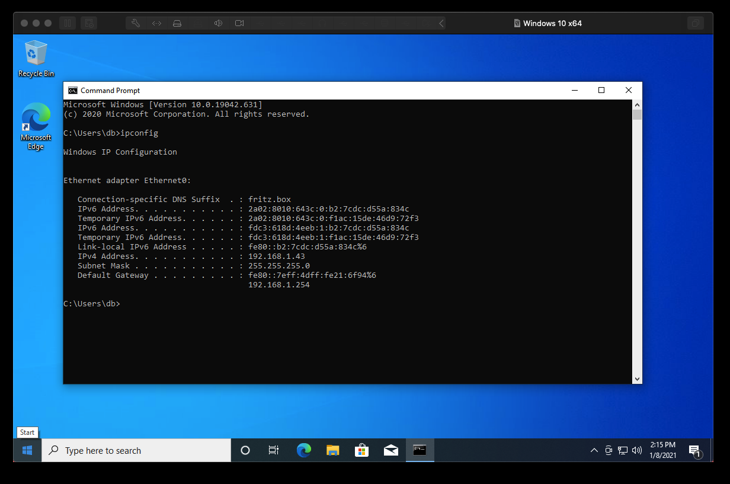
Fig1. Image showing the target machines IP address.

3.2 Setting up a web server to re-direct to.
Originally, I attempted to re-direct directly to another URL but for some reason this didn’t but Apache built into Kali did so I created a HTML file with a link to another website that had the form instead of forwarding directly and creating the website in Kali. This was purely due to time limitations and setting up STMP properties when I already have them setup in WordPress.

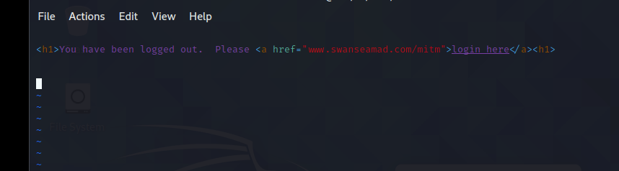
Fig2. Image showing the HTML that makes up index.html

3.3. Setting and targets
Before moving on I just wanted to ensure that all machines could ping each other. All systems are on the 192.168.1.0 network and a ping tests were successful. In Ettercap I first setup the DNS_spoof plugin so that [anything].facebook.com would be forwarded to 192.168.1.43, the machine hosting the server and Ettercap application. Then in the graphical version of Ettercap I initiated a host scan via Eth0 which is the virtual ethernet card interface.

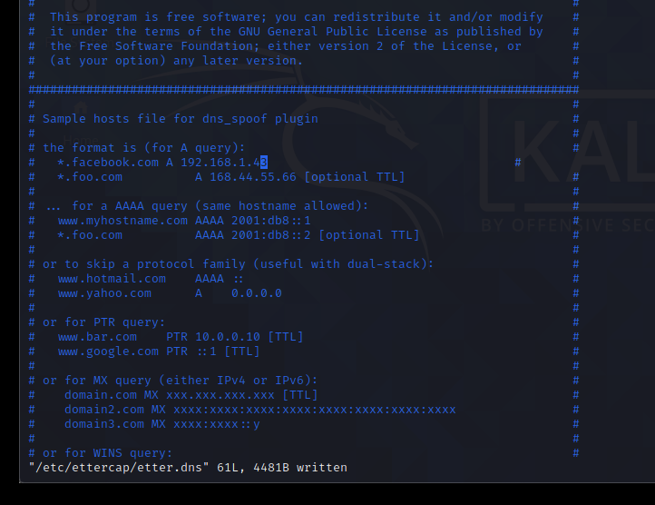
Fig 3 Showing Vi editing of the dns spoof pluging file.

Once the host scan completed, I set the target computer as Target 1 (192.168.1.43) and the networks Gateway as Target 2 (192.168.1.254).
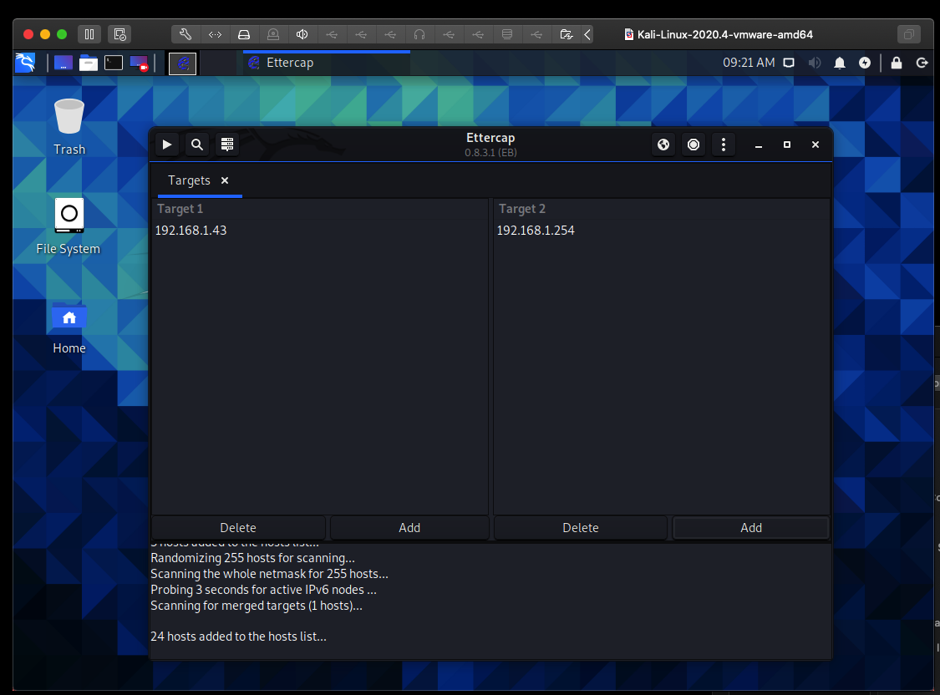
Fig 4 Showing the two target computers

3.4. Starting the plugin and sniffing and testing.
After adding the DNS plugin and restarting the sniffing process, facebook was now forwarding to the fake server.

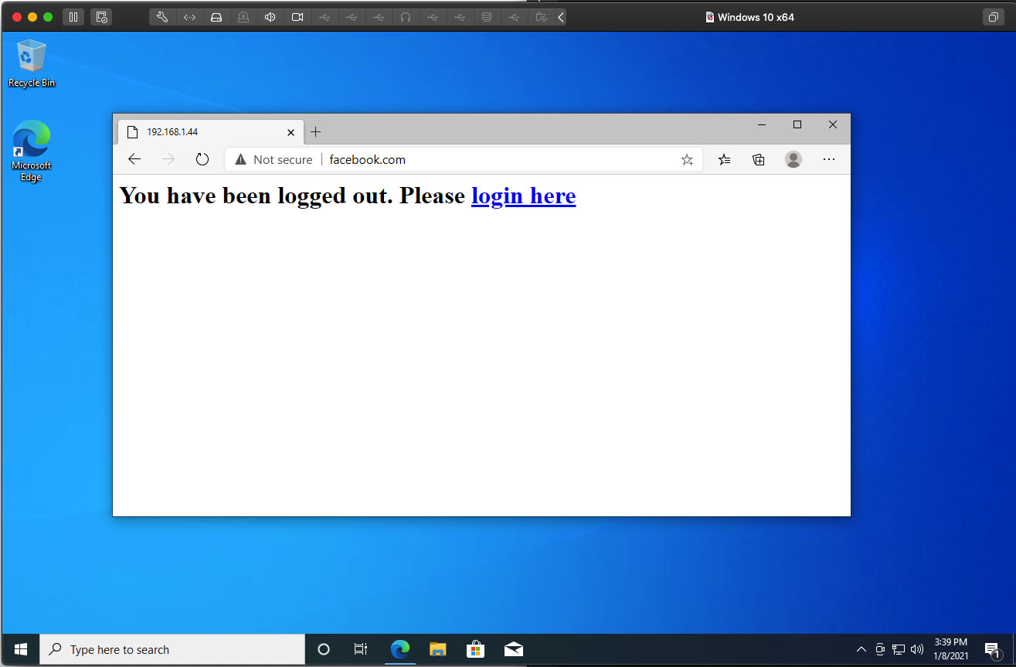
Fig 5 Showing facebook.com being directed to the 192.168.1.44

3.5. Capturing the user’s details.
If the users click on Login, they will be taken to a new page which in a real work attack maybe a scrape of Facebook.com to look identical only with a form that sends the data to the email address of the hacker. In this case I’ve kept things simple for proof of concept.

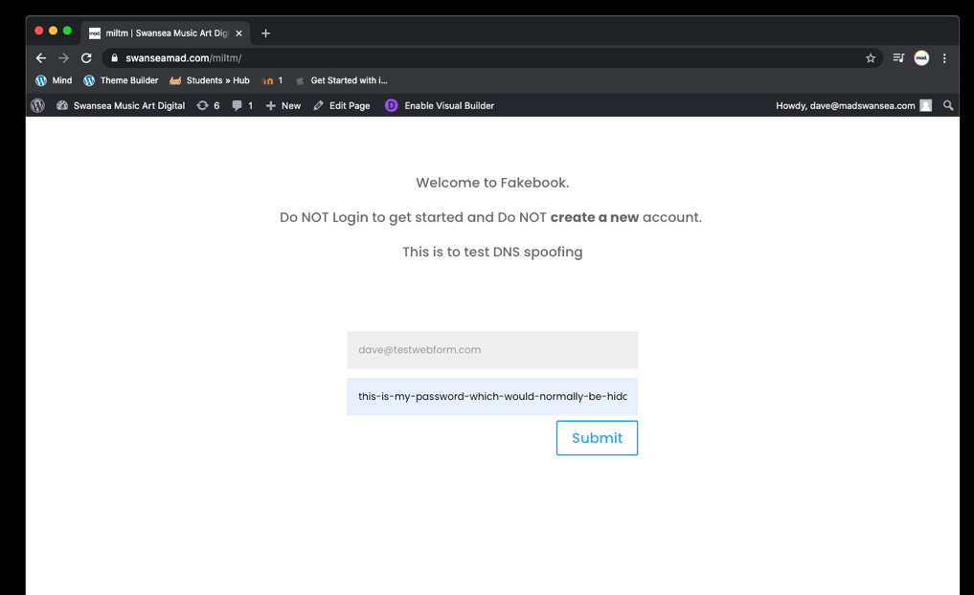

3.6. Receiving the user’s details.
Here is my email inbox where the users details have been sent.

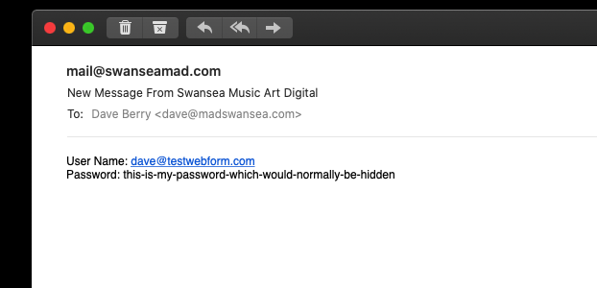

3.7. How can this attack be mitigated?
Switch ports should be secured. This will stop staff bringing in laptops or other devices and being able to attach them to the network to be able to carry out such attacks simply.

Secondly staff should be trained on how to spot potential giva-aways. Ensure staff can identify sites that may not look genuine or don’t have a SSL certificate from the correct source. However more advanced methods could be applied. Such as copies of the original site even certificates that seem to be genuine can in theory be hosted locally. For this its important software is updated. Also forced HTTPS could have been applied in this case meaning it wouldn’t have worked.

4.0 Digital Signatures and data encryption.

4.1 Digital Signatures
Unlike electronic signatures, digital signatures use encryption to ensure the document cannot be altered after it has been signed. Electronic signatures are generally a simple image of a signature placed into a document, much like any image. A digital signature however uses mathematical algorithms to generate keys based on the contents of the document. This means that if the document is changed in anyway then it becomes invalid. Digital signatures are also legally enforceable. This is important for document integrity to ensure that fraud cannot take place and legally binds a person to a document. [5] Che-Si would benefit from using digital signing to reduce risks of document fraud especially if documents are at risk of being exposed.

4.2 Data Encryption
Data encryption essentially takes information and uses another string of information (key), to change the original data based on a rule (algorithm). There are many algorithms and complexities of encryption that can be used. The importance of encryption is to secure sensitive data and to attempt to keep it safe away from it getting into the wrong hands. Cloud based sharing is already encrypted to good standards. However, Che-Si connected devices should be encryption in event of loss or theft of devices.

5.0 Che-Si IT Security Policy amendment

- Purpose
This document provides security policies that cover potential security risks to Che-Si’s corporate data and personal user data. It is mandatory that Security Policies are adhered to when accessing any part of Che-Si Global network.

- Scope
This policy should be adhered to anyone accessing any Che-Si shared network services. This includes:

- Che-Si employed staff
- Agencies or Third Parties under contract to Che-Si
- A Client of Che-Si
- A Volunteer of Che-Si

Access outside of the above scope and outside the time frame access is permitted is forbidden and would be a breach of the law.

- Policy

3.1 Sharing
Only recourses required should be shared. Files should be organised in a way that allows minimum branches to be shared at any one time and shares should be terminated when not required.

Shares should be set into levels of senility with more sensitive data being stored separately under stricter policy’s on encrypted storage and accessible only through a VPN connection that have been whitelisted.

3.2 General Login and Passwords
Passwords for Internal and External Accounts
Passwords must meet Che-Si’s strong password minimum. That is at least an uppercase and a lowercase letter, a number, a non-alphanumeric character and be at least 8 charters long [1]. This applies to personal accounts with access to shared resources on Che-Si’s network.

Two Form Factor
Where you have access to a shared cloud service from an external network external user must enable 2 Form Factor on their accounts.

  - Computers and Data storage

All data storage drives should have encryption turned on and strong passwords used for access to operating system. Passwords should also be setup on BIOS / EFI.

6.0 Bibliography

[1] | D. Swinhoe, “csoonline.com/,” CSO, 06 05 2020. [Online]. Available: www.csoonline.com/article/3440069/uk-cybersecurity-statistics-you-need-to-know.html. [Accessed 07 01 2021].
[2] | Cisco.Com. [Online]. Available: cisco.com/c/en_uk/products/security/common-cyberattacks.html#~types-of-an-attack.
[3] | C. HOFFMAN, “howtogeek.com/,” 07 20 2017. [Online]. Available: https://www.howtogeek.com/204697/wi-fi-security-should-you-use-wpa2-aes-wpa2-tkip-or-both. [Accessed 07 01 2021].
[4] | Cisco, “Cisco Port Security,” [Online]. Available: https://www.cisco.com/c/en/us/td/docs/switches/lan/catalyst4500/12-2/25ew/configuration/guide/conf/port_sec.html.
[5] | Docusign, “Docusign,” [Online]. Available: https://www.docusign.co.uk/how-it-works/electronic-signature/digital-signature/digital-signature-faq.

