Health, Wellbeing and Sustainable Development
(BMHP6021_BIRM)

REPORT

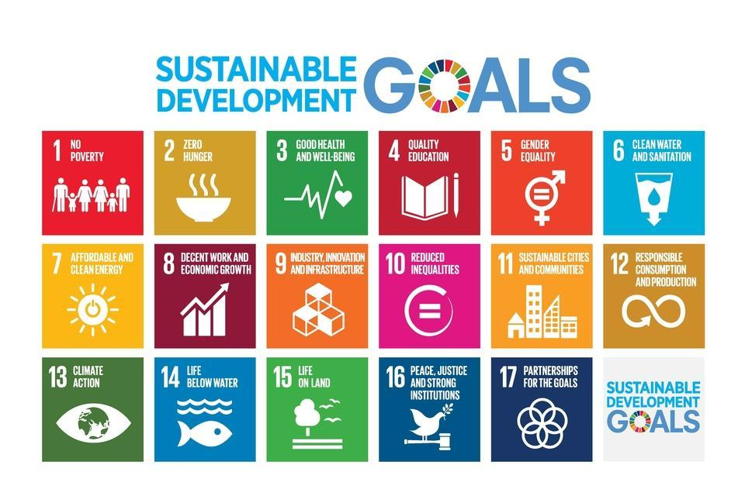

Ramona Robu 1913214 Lecturer: Besty Jose
Table of Contents

1. Introduction…………………………………………………………………………….. 3
2. Goal 3: Good Health and Wellbeing………………………………………………… 3
2.1 About the third goal………………………………………………………………….. 3
2.2 The progress made so far in the UK………………………………………………. 4
2.3 Strategies & Programs……………………………………………………………….5
2.4 Challenges in implementing the goals……………………………………………...6
2.5 Recommendation……………………………………………………………………..7
3.Goal 11………………………………………………………………………………….. 7
3.1 Explanation of the goal ………………………………………………………………7
3.2 Progress made so far to implement the 11th SDG in the UK…………………… 9
3.3 The strategies / programs…………………………………………………………... 10
3.4 Impact of SDG11 on the health, wellbeing & SD within the healthcare in the UK…………………………………………………………………………………………..11
3.5 Recommendations…………………………………………………………………... 12
4. Goal 17………………………………………..……………………………………….. 13
4.1 Explanation of the goal……………………………………………………………… 13
4.2. Progress, Challenges & Strategies……………………………………………….. 14
4.3 Challenges in accomplishing the targets………………………………………….. 15
5. Conclusion……………………………………………………………………………... 16
6. List of references……………………………………………………………………… 17

- Introduction

The following report is addressed to the NHS chief, and it will outline the progress made so far in achieving the Sustainable development goals (SDG) to improve the health, wellbeing, and sustainable development within the UK. Throughout the report will be discuss about three goals out of the total SDG’s that are proposed for implementation. Therefore, there is the third SDG which stands into good health and wellbeing, the eleventh SDG which stands into sustainable cities and communities, and the seventieth goal that stands into partnerships for the goals proposed for discussion. Each goal is going to be described, defined, along with a discussion about the progress and strategies that have been implemented by the United Kingdom as well as other countries towards the accomplishment of the goals. Before going towards the main body, it is important to mention what is meant by the SDG (French, 2018). Therefore, the Sustainable Development Goals are defined as being the blueprint to achieve a better and more sustainable future for all. They address the global challenges we face, including poverty, inequality, climate change, environmental degradation, peace, and justice (United Nations, 2022). Further, discussing about the health sustainable wellbeing, it is important to point out that it is defined as being the happiness that contributes to individual, community and/or global well-being and does not exploit other people, the environment, or future generations. It is also mentioned that sustainable well-being means both an equitable global distribution of well-being at present as well as the securing of well-being for future generations. Studies often equate well-being with happiness, life satisfaction, or a high standard of living (Lloret, 2019).
2. Goal 3: Good Health and Wellbeing
2.1 About the third goal
As it has been mentioned in the introduction, the third goal from the Sustainable development goals stands into good health and wellbeing, keeping this in mind, describing the goal, the United Nations has thought about making solid lives and advancing satisfaction at all ages is fundamental for manageable turn of events (Lee, 2019). As of now, the world is confronting an uncommon worldwide wellbeing emergency - the Covid is spreading human misery, undermining the worldwide economy, and upsetting the existences of billions of individuals. individuals on the planet. Some of the main strategies that have been thought about by the authorities in order to accomplish this goal, stand into the following: promote things such as proper sleeping, eat a balanced diet, deal with stress, exercise daily, be social.
Apart from the mentioned, another objective part of this goal stands into reducing mortality from the non-communicable diseases and promote mental health. As part of the plan, this goal should be accomplished by 2030 (Sommerville, 2016).
In order to include the societies in the accomplishment of the goal as well, on the website of the United Nations under the third goal sections, people are encouraged to donate to charities that they do support, to vaccinate themselves and encourage their families to vaccinate too, to donate the blood as blood can even save lives, and lastly the authorities are encouraging people to register on the organ and tissue donors’ (United Nations, 2022).
For this goal, a global action plan framework has been developed. This plan is containing four main elements including engage, accelerate, account, and align. The engage step stands into all countries aligning and implementing solutions together to priorities people in need. The accelerate element stands into the progression of countries to joint actions under seven programmatic themes as well as on gender equality. Further the account step stands into reviewing each action and ensuring that there is shared accountability towards improving the lives of people. Lastly, the align step stands into the support of countries by harmonizing operational and financial strategies which to act in the benefit of people that need support with their wellbeing.
2.2 The progress made so far in the UK
Further in the discussion it is important to discuss about the progress that has been made for far in the UK with this goal. Therefore, it is important to mention that based on the data that has been accumulated between the 2015-21 there have been some changes in 84% of the births that occurred worldwide and this because these have started to be assisted by skilled health professionals out of which could have been medical doctors, nurses, and midwives (Mickler & Ramutsindela, 2019). This is seen as being a progress because in the past throughout the period between 2008-14 there was a percentage of only 77% births which have been assisted by professionals. About the progress that has been discussed, it is mentioned by the World’s Health Organization that in the progress data the period of Coronavirus Pandemic is not being considered. This is just one aspect out of the many that have been proposed for improvement, however, there are other objectives towards which progress has been made since starting to work in the sustainable development goals. For example, there has been a significant progress in the decrease in the number of AIDS-related causes, however, it is mentioned that due to the Coronavirus Pandemic the progress towards this has been slowed down because the healthcare professionals have focused on the limitation of the spread of the coronavirus (Kimura, 2022).
2.3 Strategies & Programs
The Farm Families Health Checks Programme (FFHCP)
This is the programme providing a comprehensive physical as well as mental health screening while advice is also provided to farmers that are visiting the 29 livestock markets throughout Northern Ireland (DAERA, 2022).
Looking into the strengths of the programme, it is important to mention that the programme does contribute to the stable physical and mental health of people that are working in farming industry, agriculture and so on.
When it comes to the weaknesses, one thing to point out is that the programme is mainly focused on Northern Ireland and because of this, other people from England may feel discriminated against.
The Best Start for Life
This distribution sets out a dream for splendour in the 1,001 basic days from origination to mature 2. We realize that these 1,001 basic days are a novel period for a child that sets the establishments for deep rooted profound and actual prosperity. 'The best beginning forever: a dream for the 1,001 basic days' beginnings with the necessities of the child and depicts 6 activity regions intended to assist with making things more straightforward for occupied guardians and carers: consistent help for families: a rational signed up Start for Life offer accessible to all families, an inviting centre for families: family centres as a spot for families to get to Start for Life administrations
To get a better understanding of the targets and indicators as part of this goal, it is important to be familiarized with some of the targets existing. Therefore, some of these include by 2030 to decrease the global maternal mortality ratio until it becomes less than 70 per 100k live births, to end the epidemics of AIDS, tuberculosis, malaria, and other neglected tropical diseases by 2030, to strengthen the prevention and treatment of substance abuse including narcotic drug abuse and harmful use of alcohol (United Nations ,2022).
2.4 Challenges in implementing the goals
Looking into the challenges that are being met in the process of implementing these goals, it is mentioned on multiple sources that some of the main challenges include:
Funding: Since the 80s (the early days of the neoliberal political system with reduced national health budgets, promotion of privatization, and liberalization of regulatory structures), medical funding has been constrained at the national and global levels. Since then, there have been a number of alternative financing mechanisms that have resulted in disease-focused silos at the expense of strengthening the entire health system and at the expense of inadequate attention to primary health care (Dodds, 2017).
Growing Corporate Influence
Corporate commercial influence in the formation of the global health agenda has increased significantly in recent years after falling into defense during a fierce anti-corporate movement against breast milk substitutes and tobacco. The four major industries of major pharmaceutical companies, tobacco, alcohol, and sugar (including soft drinks) are deeply concerned about how global and domestic health standards are set. Fingerprints of the tobacco industry already exist in Goal 3.a, and the call to "strengthen the implementation of the WHO Framework Convention on Tobacco Control in All Countries" implies "as needed" in UN language. It is modified with the word "te". Considerable dilution (Hurt, 2019).
The challenge of equity and equality: Goal 3.8 seeks to achieve universal health care but (perhaps understandably) tells relatively little about the pathways by which this will happen. However, there is growing concern that these pathways could be crucial in determining whether those responsible for implementing the UHC approach, nationally and globally, are limited to Whether reaping the fruits of the near future is within reach or addressing the most difficult health challenges faced by those at the UHC approach traditionally concerned economic inequality and whether the health system economy protect and promote the health of the poor. However, at the bottom of most socio-economic scales, inequality is not only economic but is also reinforced by factors such as gender, caste, race, ethnicity, disability, gender identity or sexual orientation. This type of alternating inequality is often unsuitable for universal approaches and requires targeted approaches. Additional combinations of the two types of approaches may be necessary if the UHC pathways do not disrupt the terminal pathways (2030spotlight.org, 2022).
- Impact of SDG3 on the health, wellbeing & SD within the healthcare in the UK
2.5 Recommendation
Even now days the world is looking into a nutrition crisis, therefore the malnutrition is responsible for a large number of diseases and premature deaths. Annually there are over 11 million deaths caused by poor diets and is the leader risk factor for deaths, which could be addressed by a healthy food system. Therefore, the healthy food system needs to be improved (Reisch, 2016).
3. Goal 11
3.1 Explanation of the goal
To begin with, the 11th Sustainable Development Goal has ten main goals to be achieved, which are measured by 15 indicators. Seven "outcome goals" include safe and affordable housing, affordable and sustainable transportation systems, comprehensive and sustainable urbanization, protection of the world's cultural and natural heritage, and the negative effects of natural disasters. To reduce the impact on the environment of the city, and to enable safe and comprehensive greenery-and public spaces. The three “means” for achieving the goals are strong national and regional development plans, inclusions, resource efficiency, policy implementation to reduce disaster risk, and least developed countries are sustainable and resilient.
Currently, 3.9 billion people, half of the world's population, live in cities around the world. By 2030, 5 billion people are projected to live in cities. Cities around the world make up only 3% of the earth's land surface but make up 60-80% of energy consumption and 75% of Carbon emissions. As urbanization progresses, access to basic resources such as food, energy and water needs to be increased and improved. In addition, basic services such as hygiene, health, education, mobility, and information are needed. However, these requirements are not met globally and pose serious challenges to the feasibility and security of cities to meet growing future demand (Saleth, 2020).
Since the 11th Sustainable Development Goal focuses on poverty as a rural phenomenon, cities in the Global South in particular face major challenges such as extreme poverty, environmental degradation, and the risks of climate change and natural disasters. It represents a change in international development cooperation towards recognizing that. Despite its vague missions and objectives, it remains an important tool for tackling urban challenges, and in specific cities to achieve something more sustainable, inclusive, and impartial. Encourage stakeholders to develop realistic, locally defined indicators and results that fit the situation of the city (Gilbert, 2004).
The world population continues to increase. To work for everyone, we must build modern and sustainable cities. For all of us to survive and thrive, we need smart new urban planning that creates safe, affordable, and resilient cities with inspiring and green living conditions. culturally.
SAFE AND REASONABLE HOUSE: By 2030, ensure all people have access to adequate, safe, and affordable housing as well as basic services and slum improvements.
SUSTAINABLE AND SUSTAINABLE URBANIZATION: By 2030, strengthen inclusive and sustainable urbanization and participatory, integrated, and sustainable human capacity to plan and manage neighbourhoods in all countries (United Nations, 2022).
REDUCING THE SIDE EFFECTS OF NATURAL DISEASE: By 2030, significantly reduce the number of deaths and affected people and significantly reduce the direct economic losses relative to global gross domestic product caused by natural disasters, including water-related disasters, with emphasis on protecting the poor and vulnerable.
A summary of the 11th Sustainable Goal is being provided through the imagine that has been attached on the next page. That scheme has been published by the United Nations on their website to make it easier for people to understand what the issues regarding this are, and why new solution are being aimed.
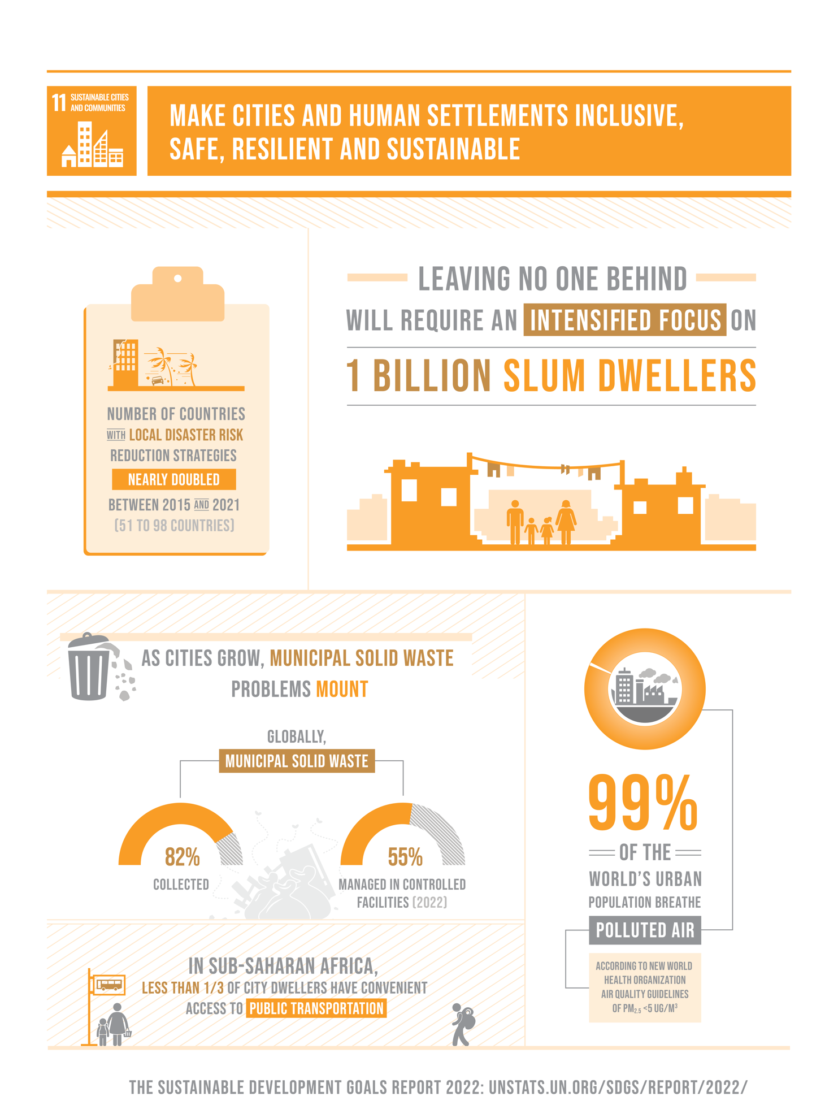
Figure 1. Sustainable cities and communities (Gov.UK,2022)
3.2 Progress made so far to implement the 11th SDG in the UK
Looking into the progress of the goal plays an important role in drawing conclusions regarding the movements towards the full accomplishment of the Sustainable Development Goal 11. Therefore, on the United Nations website there is a section entitles “Progress and Info” and their multiple data and information is being pointed out regarding the goal of interest. Therefore, looking into the 11th goal, it is mentioned that due to the Coronavirus emergencies, many urban communities have flawed general welfare frameworks, lack of essential administration, lack of highly coordinated public vehicle frameworks, lack of open public spaces, and are experiencing economic implications because of lockdown. After that, the pandemic could further increase the number of ghetto residents. There is an urgent need to prepare for the further development of well-being, proper housing, basic management, sustainable mobility, and connectivity to work for the presence of more than a billion ghetto residents. In the long run, the number of ghetto tenants continues to evolve, reaching over one billion in 2020. Ghetto tenants are most strongly represented in the three districts (central and southern), where approximately 85% of the world's ghetto residents live. Asia (360M), East Asia and Southeast Asia (310M), Sub-Saharan Africa (230M).
According to 2020 information from 1,510 urban areas around the world, about 37% of metropolitan areas are typically operated by open vehicles, and the distance travelled to less restrictive transportation systems (such as transportation and cable cars). Is estimated to be 500m and 1,000m. For the upper limit framework (trains, ships, etc.). Given the different population centres of these urban communities, this means that about 52% of the total population has convenient access to public transport.
3.3 The strategies / programs
West Yorkshire devolution deal
This record sets out the conditions of a proposed understanding for a devolution bargain between the public authority and the neighbourhood specialists of West Yorkshire, involving Bradford, Calderdale, Kirklees, Leeds, and Wakefield Councils, and the West Yorkshire Combined Authority (Nice, 2022).
This understanding is dependent upon confirmation by those chambers and the Combined Authority, and to the legal prerequisites for making the auxiliary regulation carrying out the arrangements of the arrangement. These legal prerequisites incorporate those gatherings and the West Yorkshire Combined Authority consenting to the regulation and Parliament endorsing it. When that regulation is made the devolution arrangement will be affirmed (Sunak, 2021).
Getting Building Fund
The public authority reported a £900 million Getting Building Fund to convey occupations, abilities, and framework the nation over. This speculation is being designated in regions confronting the greatest financial difficulties because of the pandemic. It is supporting the conveyance of digging tool prepared framework projects, concurred with city hall leaders and Local Enterprise Partnerships to help monetary development, and fuel nearby recuperation and occupations (GOV UK, 2022).
3.4 Impact of SDG11 on the health, wellbeing & SD within the healthcare in the UK
The following examples are not exhaustive and may be relevant to a particular industry. Gather relevant stakeholders through a common neutral platform to co-develop and / or participate in sustainable communities that analyse, discuss and act on urban functionality, resilience, and sustainable development. Leverage technical expertise to build the capabilities of building owners, provide solutions to improve building energy efficiency, and enable sound building management practices with superior data on building performance. To work with cities and governments, to find solutions to future mobility needs that make transportation safer and more affordable for everyone, with minimal environmental impact. Reform private sector financial investment strategies to support integrated and sustainable urban development, including sustainable urban transport, low-carbon buildings, and resilient infrastructure. Invest in safe and sustainable infrastructure for operating communities and cities, such as lighting, transportation, and warning systems. (sdgcompass.com, 2022).
Because as part of this goal the biggest thing is to forester the incorporation of transformative public policies into urban-planning actions, the authorities have worked towards the development of a framework for urban planning under the smart-city vision to provide a better understanding of what is being expected and at the same time what is being planned.

3.5 Recommendations
By following the proposals underneath, we will be further developing SDG 11`s conveyance since, as per our functioning speculation, "supportability strategies will have better execution whenever executed through urban planning mediations". Also, on the off chance that we are to help the execution of suggestions with ICT, it is proposed to upgrade the execution of metropolitan arranging intercessions as these will take into consideration estimation and execution responsibility (U4SSC Series, 2022).
Strategy: To safeguard and deal with the regular and constructed climate in urban areas and domains, including biodiversity, land, and normal assets, and to guarantee coordinated manageable turn of events and flexibility to environment related and cataclysmic events.
Suggestions on actual metropolitan arranging intercessions are increment the general green spaces in the city, increment the city`s tree covering (9m2 per person), advance reusing and give a second life to unused things; green retrofitting as a feature of building reconsidering programs; advance environment tough foundation - structures, streets and other actual framework; make unused spaces of the city more appealing by changing over them into green spaces and furnishing them with portable offices.
Suggestions on non-actual metropolitan arranging activities: definite execution plans ought to be made by focusing on spending plan designations; public meeting and resident commitment activities ought to be urged to raise public consciousness of the effects of environmental change and to co-plan execution plans; expanded feeling of pride of metropolitan arranging intercessions is supported by including gathering pledges crusades with regards to public-private financing plans, for example, 'framework encourage projects' and group subsidizing crusades (Biron & Scruggs, 2017).

4. The 17th Sustainable Developmental Goal
4.1 Explanation of the goal

Manageable Development Goals 17 (SDG 17 or Global Goals 17) relate to “Associations for Goals”. The prestigious statement, one of the 17 Sustainable Development Goals set by the United Nations in 2015, is to "strengthen practices and update the global association for viable events." The goal has 17 priorities to be achieved by 2030 and is divided into five classes: finance, innovation, limit setting, exchange, and policy issues. Progress towards the goal is estimated using 25 markers (McCowan, 2019).
The SDG 17 hints at the requirements for inter-territorial and inter-country collaboration to continuously achieve each goal through 2030. It is a call to the nation to adapt their strategy .(Skeete, 2010) The SDG 17 is a dream of improved, more equitable sharing and promoted risk initiatives to drive practical progress across borders. It involves incorporating the SDGs as a shared system and incorporating the vision that characterizes this collaborative path to strengthen and facilitate participation between established and emerging economies. The goal is to promote global exchanges and help emerging markets expand their products to ensure a fair, open, useful, broad, policy-based, and equitable exchange framework for all. (Aagaard, 2018).
As part of this Sustainable Development goal there are some key targets and indicators these including the following:
-Created nations to carry out completely their authority improvement help responsibilities, including the responsibility by many created nations to accomplish the objective of 0.7 percent of ODA/GNI to non-industrial nations and 0.15 to 0.20 percent of ODA/GNI to least created nations; ODA suppliers are urged to consider setting an objective to give no less than 0.20 percent of ODA/GNI to least created nations (United Nations, 2021)
- Help agricultural nations in achieving long haul obligation maintainability through composed arrangements pointed toward encouraging obligation supporting, obligation alleviation and obligation rebuilding, as fitting, and address the outside obligation of exceptionally obligated unfortunate nations to pay off past commitments trouble

-Upgrade three-sided local and worldwide collaboration on and admittance to science, innovation and development and improve information sharing based on commonly concurred conditions, including through better coordination among existing components, specifically at the United Nations level, and through a worldwide innovation help instrument

4.2. Progress, Challenges & Strategies

Despite the unfamiliar direct ventures and solid recovery of payment flows in the world, many emerging markets are addressing competing needs for limited financial space, with more financial recovery than ever in recent memory. It's getting harder. The pandemic is nearing its end, and the extent of immunization is so heterogeneous around the world that there is a risk of recovery from the COVID-19 pandemic to "two stages." As the global framework faces many of the social, well-being, ecological, harmony and security emergencies, there is an urgent need to increase global participation focused on finding lasting agreements. It has become (Verma, 2018).
Data and Exchange Innovations
The latest information shows that the use of the Internet is increasing during the pandemic. In 2021, the number of customers reached 7.8B, contacting 5 B, or 63% of the population, up from 4 billion in 2019. By 2020, 63% of males generally used the Internet and 58% of females used the Internet.
Fixed broadband memberships are evolving, reaching an average of 18 memberships for each one hundred people worldwide in 2021. While double-digit growth is seen in all countries created, fixed broadband remains an honor for a small number of people, with only 1.6 memberships for each one hundred inhabitants. Development was 5% in exchange for the healthy innovation of the planet in 2015-20, which was positive while addressing the decline in overall development rates prior to Covid (2015-). The development rate since 2019 was 8%. Covid-19 has a negative impact on global exchanges, so countries with a solid economy, vast agglomeration, or potential monetary base and a focus on development will expand their ventures and create environmentally friendly innovations.

4.3 Challenges in accomplishing the targets

Regardless of the headway made, speakers referenced that none of the social economic improvement objectives would be by and large accomplished by 2030 and that there might be relapse corresponding to a portion of the objectives.
Various foundational hindrances were distinguished and divided between the members, for example, the accessibility and unwavering quality of information; absence of political will; powerless limit and specialized expertise; insufficient systems, designs to perceive monetary open doors and access accessible monetary assets (Dorothee, 2021).
The environment emergency and the test of relocation that would make the execution of a portion of the SDGs in Asia troublesome. Among the most underestimated are ladies and native individuals, for instance ladies in Bangladesh "bring in during their whole lives less cash than a CEO of an organization in only four days." The ongoing monetary model prohibits many individuals and increments disparities. Proposals focusing on improvement entertainers to cultivate an empowering nearby climate to conquer the difficulties of SDGs execution included: institutional limit working for CSOs and LAs; empowering and supporting public state-run administrations in talking with CSOs and neighbourhood entertainers, arranging and planning to remember CSOs for public objectives; empowering decentralized and neighbourhood cooperation; and creating projects that are need as opposed to benefactor driven.
Reduce the risk from terrorism to the UK
Challenge is the UK's counter psychological oppression procedure. It expects to diminish the dangers from psychological warfare, so that individuals can approach their lives uninhibitedly and with certainty. Challenge has 4 strands: forestall- to stop individuals becoming fear-based oppressors or supporting psychological warfare, seek after- to stop psychological oppressor assaults, secure-to fortify our insurance against a fear-based oppressor assault and plan-to moderate the effect of a fear monger assault.
Impact of SDG17 on the health, wellbeing & SD within the healthcare in the UK (City of Westminster, 2021)
5. Conclusion

Overall, the authorities worldwide are working towards the accomplishment of the Sustainable Development Goals, despite throughout this report only three sustainable development goals have been exposed, in reality there are seventeen goals and each one in particular receives the same attention due to the desire of its accomplishment and improvement of the world.
It has been demonstrated throughout the report, that there are factors influencing the progress of the sustainable development goals, the biggest factor recently being the Coronavirus pandemic for each of the goals that have been discussed throughout the report.
Each sustainable development goal is interlinked, there are targets and indicators and therefore, all strategies and actions that are being taken are thought based on the targets and indicators that are being set.

6. List of references:
Aagaard, A. (2018) Sustainable business model. 1st Edition. Springer Publishing.

Biron, C. L. & Scruggs, G. (2017) Goal 11th: The opportunities of the urban SDG. (online) Available at: https://www.devex.com/news/goal-11-the-opportunities-of-the-urban-sdg-86980 (Accessed: 15th July 2022).

City of Westminster, (2021) Counter terrorism, (online) available at: https://www.westminster.gov.uk/businesses/major-incidents-and-contingency-planning/counter-terrorism-contest (Accessed: 30th July 2022).

DAERA, (2022) Northern Ireland local authority collected municipal waste management statistics. (online) Available at: https://www.daera-ni.gov.uk/ (Accessed: 30th July 2022).

Dodds, F. (2017) Negotiating the Sustainable Development Goals. 2nd Edition. Routledge Publishing.

Dorothee, F. (2021) The challenges of implementing the Sustainable development goals. (online) Available at: https://europa.eu/capacity4dev/articles/challenges-implementing-sustainable-development-goals-asia (Accessed: 17th July 2022).

French, D. (2018) Sustainable development goals: law, theory, and implementation. 2nd Edition. Edward Elgar Publishing.

Gilbert, G. (2004) World poverty: a reference handbook. 2nd Edition. Springer Publishing.

GOV.UK (2022) Getting Building Fund. (online) Available at: https://www.gov.uk/guidance/getting-building-fund (Accessed: 30th July 2022).

GOV.UK. (2022). Implementing the Sustainable Development Goals. (online) Available at: <https://www.gov.uk/government/publications/implementing-the-sustainable-development-goals/implementing-the-sustainable-development-goals--2> [Accessed 4 August 2022].

Hurt, A. E. (2019) The dominance of global corporations. 2nd Edition. Greenhaven Publishing.

Kimura, F. (2022) Sustainable development goals and pandemic planning: role of efficiency based regional approaches. 2nd Edition. Springer Nature.

Lee, S. W. (2019) SDG3: Good health and wellbeing. 2nd Edition. Emerald Group Publishing.,

Lloret, J. (2019) Health, wellbeing, and sustainability in the city. 2nd Edition. Routledge.

McCowan, T. (2019) Higher Education for and beyond sustainable development goals. 1st Edition. Springer Nature.

Mickler, D. & Ramutsindela, M. (2019) Africa and the sustainable development goals. 1st Edition. Springer Nature.

Nice, A. (2022) Devolution to West Yorkshire. (online) Available at: https://www.instituteforgovernment.org.uk/explainers/devolution-west-yorkshire (Accessed: 30th July 2022 ).
Reisch, L., (2016). Healthy Diets as a Global Sustainable Development Issue: Reasons, Relationships, and a Recommendation. SSRN Electronic Journal, (online) Available at: <https://research.cbs.dk/en/publications/healthy-diet-as-a-global-sustainable-development-issue-reasons-re> (Accessed: 4 August 2022).

Saleth, R. M. (2020) Issues and challenges of inclusive development. 1st Edition. Springer Nature.

SDGCompass, (2022) Examples of key business actions and solutions. (online) available at: https://sdgcompass.org/sdgs/sdg-11/ (Accessed: 10th July 2022).

Skeete, H. (2010) The future of the Financial Exchanges: Insights and Analysis. 2nd Edition. Elsevier Publishing.

Sunak, R. (2021) West Yorkshire devolution deal. GOV UK.

Sommerville, J. (2016) Variability and Individual Differences in Early Social Perception and Social Cognition. 1st Edition. Frontiers Media.

United Nations (2022) Act for the Sustainable Development Goals. (online) available at: https://www.un.org/sustainabledevelopment/sustainable-development-goals/ (Accessed: 20th June 2022).

United Nations (2022) Good health and well-being: things to do. (online) available at: https://www.globalgoals.org/take-action/ (Accessed: 20th June 2022 ).

United Nations (2022) Ensure healthy lives and promote well-being for all ay all ages. (online) available at: https://sdgs.un.org/goals/goal3 (Accessed: 20th July 2022).

United Nations, (2022) Make cities and human settlements inclusive, safe, resilient, and sustainable. (online) available at: https://sdgs.un.org/goals/goal11 (Accessed: 16th July 2022).

United Nations (2020) Sustainable Development Goal 11: Progress and info. (online) available at: https://sdgs.un.org/goals/goal11 (Accessed: 20th July 2022).

United Nations (2021) Target and Indicators: Sustainable Development Goal 17. (online) available at: https://sdgs.un.org/goals/goal17 (Accessed: 15th July 2022).

U4SSC Series, (2022) Guidline document: design of an active framework to successfully achieve Sustainable Development Goal 11. 1st Edition. Springer.

2023spotlight.org (2022) The health SDG: Some progress but critical concerns remain. (online) available at: https://www.2030spotlight.org/en/book/605/chapter/ii3-health-sdg-some-progress-critical-concerns-remain (Accessed: 20th July 2022).

Verma, S. (2018). Developmental science and sustainable development goals. 2nd Edition. Springer Publishing.

