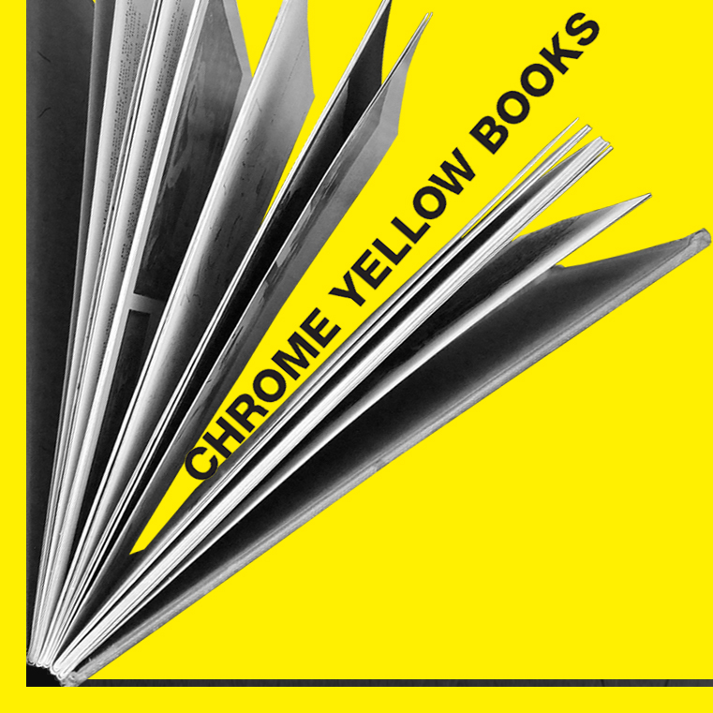

Exclusive One Day Book Sale

Chrome Yellow focus on International Publications, gallery catalogues etc. (not available to buy online) in areas such as jewellery, textiles, fashion, ceramics, glass, 3d design, interior

Not to be missed by our Design and Maker based students!

When? Monday October 22nd 10 - 3

Where? Dynevor Canteen 3rd Floor

