
University of Wales - Trinity Saint David Management Report on
NHS Current Situation (Analysis)
Akram Hussain Chowdhury (1704801) Submission Date: 20th April 2018 Submitted to: Shehla Khan

Executive Summary
This report will be explaining the current situation of NHS and the impact that it is having on stakeholders. It will be looking at the problems NHS is facing and will be using models that have been discussed and looked at during this module. The different ways and opportunities for improvement will be displayed and problem-solving skills will be shown.

Contents
Executive Summary________________________________________________________________2
Introduction_______________________________________________________________________4
Main Body________________________________________________________________________5
PESTLE Analysis____________________________________________________________5
Stakeholder Analysis________________________________________________________7
Current Problems___________________________________________________________9
Aging Population____________________________________________________9
Uses of A&E_________________________________________________________10
Changes in Lifestyle_________________________________________________10
Problem Solving and Decision-Making Models____________________________________11
5 W's Model_________________________________________________________11
The Fishbone________________________________________________________11
Brainstorming and Mind Mapping________________________________________12
PMI_________________________________________________________________12
GRID Analysis________________________________________________________12
Edward de bono Six Thinking Hats______________________________________13
Conclusion________________________________________________________________________15
Reference List_____________________________________________________________________16

Introduction
NHS is the acronym for ‘National Health Service’. It is a funded national healthcare system for England, and one of the four for United Kingdom. It is the largest single-payer healthcare service in the entire world. It was founded in 1948 on July 5th in England by Aneurin Bevan. It was created to look after people's health including long term illnesses like arthritis, osteoporosis, heart failure, dementia, depression, C.O.P.D (Chronic Obstructive Pulmonary Disease), and diabetes.
The NHS is made up of a lot of organisations, each taking a part to help the overall outcome. Some of these small organisations are NHS Digital, Healthwatch, Public Health England, MHR, NICE, Care Quality Commission, NHS Improvement and many more others.
Although there are so many workers who all want the best of everyone's health, there are quite a lot of issues the NHS are facing. Some of these problems include ageing population, population growth, increasing needs of healthcare and support, medical advancements costs rising by large amounts every year, shortages of hospital beds, and not enough doctors, nurses, and other staff.
This report will be discussing and analysing all the problems and issues that are facing the National Health Service (NHS) and it will explain all the ways of analysing them.

Main Body - PESTLE Analysis
PESTLE is an analysing technique used to discover the surroundings of an organisation, business or company when investigating business change. The acronym ‘PESTLE’ stands for Political, Economic, Sociological, Technological, Legal, Environmental. We use it to identify the things that help or hinder the organisation. The technique is used to find the factors that are involved in change rather than actually finding solutions to the problems or issues. It is also used to investigate the factors that are not in control of the organisation but are external to them. There are many variations like PEST, PESTLIED, and STEEPLE. All of these acronyms stand for very similar things.
Political
The government is in great power since they are the one of the major funders of NHS. This means that the National Health Service must stay on good terms with the government. There are lots of other minor groups that try and help fund the NHS but the government is the main one. If it wasn't for the government, the NHS would have not been able to stay together. In the past, the government took great care of the NHS. They would give immediate help if the NHS needed anything. Nowadays, the government is working less hard to help keep up NHS. This is why the National Health Service is struggling more on the political side of things than before due to the lack of help from the government. When the time of elections for government come along, they say they will help provide all the things the National Health Service needs and will provide equipment, supplies, and medical tools when needs be. Unfortunately, when they are elected to be government, they don't keep their word completely. When it comes to providing them with help, they give them 50% of their effort. They don't help as much as they did in the past. Another point is that taxpayers pay their taxes and the money is distributed to different aspects. Most of the money goes to welfare and health care/ NHS. Even though so much money is said to be given to NHS by the government, the public isn't seeing much improvements.
Economic
The National Health Service has a lot of problems on the financial side of things. Their social debt has almost trebled since 2015 to £2.45bn. A decision that impacted them a lot was also made, they transferred £950m from the NHS budget for buildings and IT to pay staff's wages. The NHS is spending much more money than it ever did in history, right now they spend an average of £2,160 per person, per year on healthcare. The NHS is predicted to have an aggregate funding shortfall of £20-30 billion by 2020/21. This will impact them in a negative way since they use so much money on healthcare already, if their funding goes through such a massive shortfall, they won't be able to get all the supplies, staff, beds, and other essential medical needs they want.
If this shortfall does really happen, which most likely it will, it won't just be affecting them but all their customers and workers. They will need to come up with an effective way of dividing the money up for all the things they need.
Sociological
The National Health Service tries to look after and take care of their patients. Unfortunately, with the lack of staff, hospital beds, medical supplies, and more, they find it hard to keep up with all the patient's queries and needs.

Technological
Technology is growing and growing every time someone makes mistakes. People use their mistakes for inspiration to make a new project and improvement. Since technology is starting to develop further, the NHS could use the new technology for building and improving their organisation further. It will help organise and pursue with appointments quicker. They could also use professionally trained robots to help with surgeries, daily care, and health advice. It would help with the lack of doctors/ nurses/ other staff issue.
Legal
The NHS try their best to protect the data that their patients and customers provide them with since it is one of their priorities. They also need to keep the data that they are already provided with safe. In 2017, a ransomware attack happened because they did not follow their cyber-security recommendations. This attack led to at least 9,600 NHS appointments being cancelled. Fortunately, the NHS say that no patient’s information had been stolen. The NAO chief also had something to say about the attack, the chief said that the Health Department and the National Health Service must now “keep its act together” so that nothing like this would happen in the future.
Environmental
The NHS don't sell any plastic bags or give them away so that's not a problem. Although they do use vehicles like ambulances. The vehicles will contribute to global warming and pollution but that is out of their hands since these vehicles are a must have for them so that they can reach patients quicker and be in time to save more and more lives.

Stakeholder Analysis
A stakeholder’s analysis is used to access a decision’s impact on different parties. The information that is gathered by the analysis is used to investigate how the interests of those stakeholders can be presented in the project plan or program. A stakeholder is a person, group, or organisation that is somehow related with the business. A stakeholder will affect a business’s decision and planning. Here are some templates of a stakeholder’s analysis:
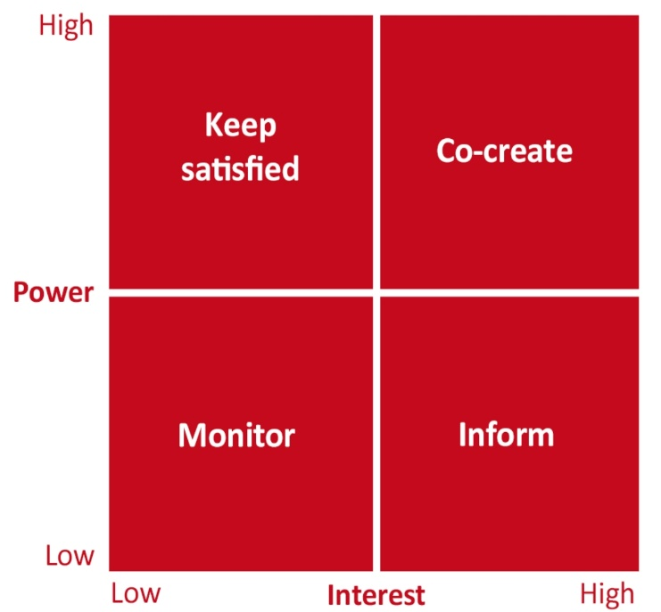

The Government:
The government would be in the high power / low impact category because they fund the NHS. This puts them at the top of the chart because the NHS would not be able to run on just funds from minor groups, other than the government. The government collect taxes from the local and from the money they already have and fund it to the NHS. They also won't be impacted so much when there is a change in the way the NHS functions since all they do is fund the National Health Service.
Patients/ Customers:
Patients are not influential on the NHS like how the government are. They are a more minor group but are still brought up in discussion and business visioning or planning. The customers/ patients the NHS receive play a part in business discussions because they are the whole reason why the NHS was created in the first place. The customers and patients help the National Health Service see the mistakes they make and the different areas they need to improve and develop further. Although their patients are in low power and will not be a massive influence on the National Health Service, they receive the greatest impact. Every change the NHS makes, it will impact their patients greatly. The customers/ patients are the ones who receive the care so this means, whatever that gets changed in the procedure of healthcare for them. This is why this specific stakeholder would be in the low power / high impact category.
Doctors and Nurses:
The doctors, nurses and other working staff will also fall into the low power / high impact category. The organisation does include them in discussion and bring them up for investigating the impact that the staff will have through a new change. Much like the customers / patients, they do not have great power so this means they are not usually contributing to great changes and developments. New developments are usually made considering the NHS's good and are made without really being concerned about how staff will react or benefit from the change. Though, this does not mean they are not brought up in organisation planning for change.
The Founder (Aneurin Bevan) :
The founder of the National Health Service is very important to us, even today. He was the one who created the whole thing in the first place and without him, we would have never had a National Health Service. Aneurin Bevan was very important back in the days as well. He was known for his intelligence and of course, for being the founder of our beloved NHS. Although he is such a major part of the NHS, nowadays when decisions are being made he is reviewed little to even none at all. This is because he is no longer with us today and it will most probably make no difference if we considered him in discussion for business development. This means this stakeholder will be place in the low power / low interest section.

Current Problems
The NHS goes through daily stress, meaning they have a lot of problems that they need to resolve. Some of these problems include the following:
- Population growth.
- Ageing population.
- More negative lifestyle factors e.g. not getting enough exercise, drinking too much alcohol, smoking, unhealthy diets etc.
- The changing of expectations - originally, NHS was made to tackle diseases but now they are expected to do much more like advice on healthcare/ mental health/ social health, maternity services, vaccination programmes, and very effective organisation of our medication and appointments.
- Unnecessary uses of the Accident and Emergency department.
- Continuous rising in cost of medical services and supplies.

Ageing Population (PMI Method)

Positive | Minus | Interesting
• People will have a longer life.  • More time to experience everything you can.  • Working longer means better retirement savings | • Longer lifespans won't help poverty, wars and other major issues like these.  • We would have food shortages.  • If water levels rise higher and higher, then there won't be enough land for everyone to have a house or at least some sort of shelter.  • Siblings could be born 50 to 60 years apart  • You would be about 100 years younger than your parents.  • Social interactions will change drastically.  • The National Health service won't be able to keep up with all the elderly patients who will most likely be in need of care for long term illnesses.  • Many more hospitals will be needed to be built  • More medical supplies will be needed along with hospital beds  • Many more doctors, nurses, midwives, and other staff will be needed to be employed. | • Social interactions will change drastically  • Siblings could be born 50 to 60 years apart  • You would be about 100 years younger than your parents.

The PMI (Positive, Minus, Interesting) grid displays that the National Health Service will be affected negatively more than positively since there is more content in the ‘minus’ category than in the ‘positive’ category. The National Health Service can attempt to solve these problems by constructing more hospitals and employing many, many more doctors, nurses, midwives, and other staff.

Uses of the Accident and Emergency Department (6 Thinking Hats)

Blue Hat: Process
At the moment, the queues are very long for the Accident and Emergency Department. They need to think about how they can shorten it or get to all the patience quicker. They also need to think about on how to get their patients to go to the right place instead of taking the A&E option straight away.

Red Hat: Feelings
The National Health Service is feeling very stressed out and are struggling on improving. They don't have enough doctors, nurses, and other staff so this means it is difficult for them to keep up with all their patients that visit almost daily.

Yellow Hat: Benefits
The only good thing about this problem is that they are getting lots of customers/ patients and are receiving respect from them. They can try and solve the problem like making more than one
Accident and Emergency Department. The benefit of this is that one department will have to deal with only have of the patience. Thus, will speed up the process a lot.

White Hat: Facts
One thing that is for sure is that not all the patients go there for emergency. Some go there for advice on their long-term illnesses which us not using the department for what it is there for. We can solve this by giving more opportunities for the people with long term illnesses so that they won't be needing to go to the Accident and Emergency Department.
Green Hat: Creativity
There are many ways of solving this problem. Like mentioned before, the NHS can build one or two more departments for accidents and emergencies. This will speed up the process and take stress off of their shoulders. It is a win win for everyone!

Black Hat: Caution
The problems of having another Accident and Emergency Department is that it could lead to more people that are in need of advice for their long-term illness going there. This could start the whole problem again, long queues and stress and pressure on the National Health Service.

Changes in Lifestyle (5 Whys Model)

- Problem - people are smoking and doing drugs more often
- Why? - it's the new way of getting rid of pain and making you calm in the moment
- Why? - nicotine helps the body calm down only for a moment but there are chemicals in a cigarette that can contribute to the cause of cancer
- Why? - 43 other known cancer-causing chemicals are in a single cigarette
- Why? - to keep a cigarette the way it is

After using this model, it shows that all the bad decisions people are making in their lives are affecting the NHS as well. With the number of people with cancer rising, all it will do is drive the National Health Service crazy. They can solve this issue by encouraging people to quit smoking by using products like ‘Niquitin’. They can help spread the word and make everyone cautious about what could happen in the future if they don't stop.

Problem Solving and Decision-Making Models

5 W's Model

The 5 Whys technique is simple but at the same time, very effective for narrowing down the main cause of a problem. You start with the problem then ask yourself “why?”, answer it then ask “why?” again and keep on doing this process until you get to the factor that has caused this problem in the first place. Here is an example:
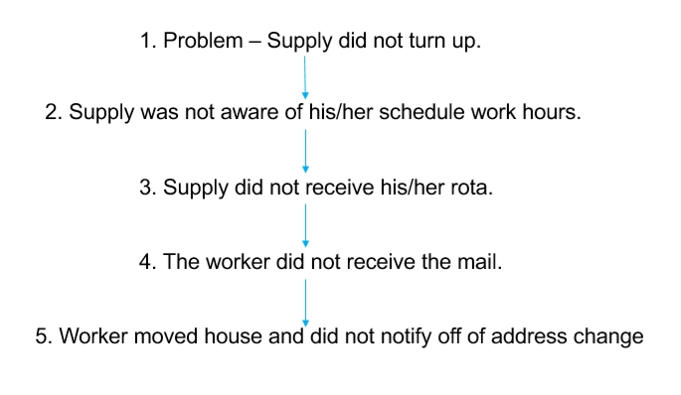
Fishbone

Gathering from the name, this method is set out like a fish's skeleton. The way it works is that the biggest or longest bones will be recorded with the major problems. The smaller branches/ bones are meant to be recorded with the minor effects of the problem. After gathering all the major and minor issues, analyse the diagram and try and come up with solutions to the problems. This method is useful in gathering all the factors that may be reason behind or the cause of the effect/ problem. The following is a basic layout of the fishbone/ cause and effect method:
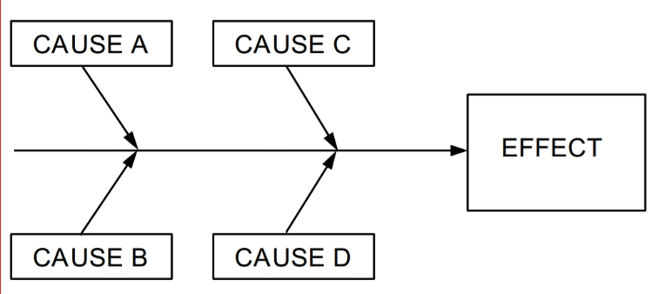
Brainstorming and Mind mapping

Brainstorming or mind mapping is an easy way of gathering all your ideas. All you need to do is draw the main point in the middle and then write everything that comes to your mind relating to the topic, write them all around the centre topic and see if you can connect any of the ideas with each other. This method helps get everything out and viewing all of it at once, which will enable you to work the next steps that are needed to be taken in order to solve the problem. It also allows discussions to be held and to be intake. The technique allows you to build on other ideas, elaborate, and it encourages wild ideas. It's simple but very effective.

PMI

PMI stands for Plus, Minus, and Interesting. It is usually set out as a table with three columns. PMI was created by Dr. Edward de Bono. It helps weigh out all the pros and cons of a decision that is being made for the organisation, company, or business. It is an important decision-making tool that helps display whether the decision or opportunity that has been forwarded is worth taking. Here is how you would usually set out a PMI table:
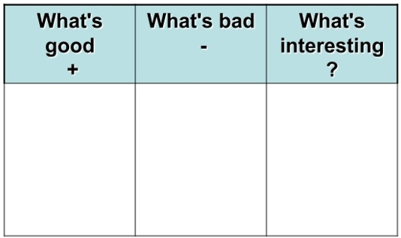
GRID Analysis

Grid analysis is another technique to use for making a decision. It is most useful when you have a number of good alternatives and many other factors that are going to improve and be helpful for business growth if it is taken into account. Here is an example of the method:

This person wanted a car that would be suitable for his needs but did not know which type of car he should go for;
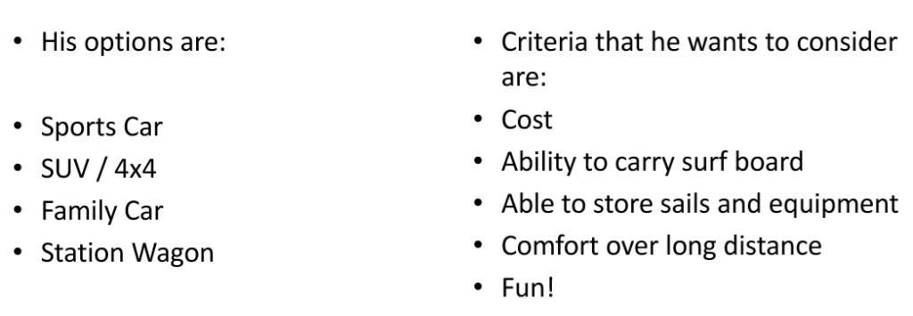
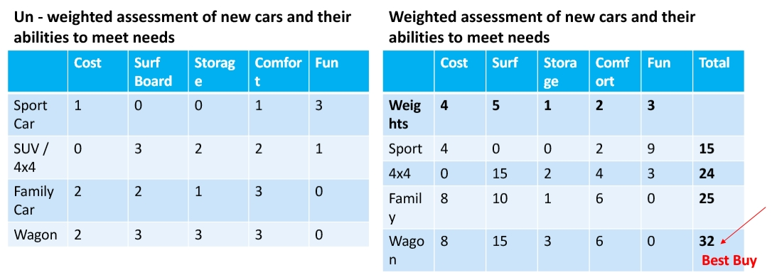
Edward de Bono Six Thinking Hats

The six-thinking hat method allows you to look at a problem from different perspectives but not all at once, avoiding confusion in your thinking processes. It forces you to move outside your thinking area so that you can look at the problem how the people around you are seeing it as. It's also a powerful decision checking technique for group situations since it is allowing all the group members to see things from your perspective and the others. This problem-solving method was created by Edward de Bono and was published in his book, also called Six Thinking Hats, in 1985.
These six thinking hats have their own meanings and have colours to show the differences. They are the following:

Blue Hat: Process

This hat is used to think about the big picture on the whole and the thinking process. You need to think about what thinking needs to be done and explained. You also need to know what stage you are at now and which step you need to take next. Some questions you could ask yourself are:
- What thinking is needed?
- Where are we now?
- What do we need to do next?

Red Hat: Feelings

The red is used to discover the way you and your team members are feeling about the decision that might be made. You need to think about your intuitions, instincts, and hunches. Your feelings and the feelings of the people around you play a big part in the decision-making process because everyone will have to agree with the final decision meaning that all your team members should feel good and happy with the final conclusion. Here are some questions you may ask yourself:

- How do I feel about the decision that is being made?
- Do I feel good about it?
- Do I feel like it is unnecessary or not effective?
- What do l like about these feelings?
- What don't I like about these feelings?

Yellow Hat: Benefits

The yellow hat is for thinking about the positive side. You are meant to be thinking about all the benefits you will be getting through the outcome and why it is a good idea. You also need to think about how this decision or idea will help build the business to a higher standard and how it will help with business growth. Some questions you should take in are as follows:
- Why is this a good idea?
- What are the advantages?
- What are the benefits?
- What are the good things that will happen in the outcome?

White Hat: Facts

The use of this hat is to remind yourself of the things you already know. It helps you understand everything you have learnt about the topic and what research or questions are needed to be asked to help you understand thoroughly. You also need to know how you are going to investigate for answers whether it's the old fashion way by using books, or the method most people would go for which is using the internet. These are some question you should ask yourself when using the white hat:
- What do I know?
- What do I need to find out?
- How will I get the information I need?
- Is there anything that I don't understand?

Green Hat: Creativity

This is where you need to engage the creative side of your brain. Instead of thinking technically, think creatively. Try and think of new ways to make things better. Try and think of changes you can make that will help contribute to improvement and development. Think of unique and new ways of improving something. The following questions will be helpful when using the green hat:
- What new ideas are possible?
- What is my suggestion?
- How can this be changed or improved?

Black Hat: Caution

The black hat is for thinking about the negativities. It is for discussing the disadvantages and what can be done to avoid them. You will need to think about the problems that may occur during the process. Think about the things that may hinder your decision-making process and the factors that won’t be leading to a positive outcome. Some question that you could be asking yourself are:
- What problems could arise?
- What are the disadvantages?

Conclusion
Overall, this report explains the situation the National Health Service is in at the moment. It discusses the problems and issues it is facing and how the NHS can overcome them and move onto improving their business for all stakeholders. Some of the problems they face are aging population growth, population growth, shortages on medical equipment like hospital beds, and other supplies, and shortages on staff. Decision making and problem-solving models were also described and used in this report.

Reference List
My Health London (2018) ‘Today's NHS - Our Current Challenges’
Available from: https://www.myhealth.london.nhs.uk/help/nhs-today
Accessed 13th April 2018
Involvement (date not found) ‘Identifying Stakeholders’
Available from: http://www.nhsinvolvement.co.uk/connect-and-create/identifying-stakeholders
Accessed 13th April 2018
NHS England (not found) ‘Partners and Stakeholders’
Available from: https://www.england.nhs.uk/healthcare-science/partners-and-stakeholders/
Accessed 13th April 2018
National Health Service History (not found) ‘Aneurin Bevan’
Available from: http://www.nhshistory.net/cvbevan.htm
Accessed 13th April 2018
Health Careers (not found) ‘General practice (GP)’
Available from: https://www.healthcareers.nhs.uk/explore-roles/doctors/roles-doctors/general-practice-gp
Accessed 13th April 2018
NHS Choices (July 2015) ‘The history of the NHS in England’
Available from: https://www.nhs.uk/NHSEngland/thenhs/nhshistory/Pages/NHShistory1948.aspx
Accessed 13th April 2018
Richard Murray (March 2018) ‘How the NHS is funded - The King's Fund’
Available from: https://www.kingsfund.org.uk/projects/nhs-in-a-nutshell/how-nhs-funded
Accessed 13th April 2018
NHS England (not found) ‘Funding and efficiency’
Available from: https://www.england.nhs.uk/five-year-forward-view/next-steps-on-the-nhs-five-year-forward-view/funding-and-efficiency/
Accessed 13th April 2018
Business Dictionary (2018) ‘Stakeholder’
Available from: http://www.businessdictionary.com/definition/stakeholder.html
Accessed 13th April 2018
The Medic Portal (2018) ‘Challenges Facing the NHS and Current NHS Issues’
Available from: https://www.themedicportal.com/application-guide/the-nhs/challenges-facing-the-nhs/
Accessed 13th April 2018

Nick Triggle (February 2018) ‘10 Charts that Show Why the NNS is in Trouble’
Available from: http://www.bbc.co.uk/news/health-38887694
Accessed 13th April 2018

NHS Choices (April 2016) ‘About the National Health Service (NHS) in England’
Available from: https://www.nhs.uk/NHSEngland/thenhs/about/Pages/overview.aspx
Accessed 13th April 2018

Pamela Brooks (March 2012) ‘What is the NHS - Net doctor’
Available from: http://www.netdoctor.co.uk/health-services/nhs/a4489/what-is-the-nhs/
Accessed 13th April 2018

NHS Choices (July 2015) ‘NHS Services Explained’
Available from: https://www.nhs.uk/NHSEngland/AboutNHSservices/Pages/NHSServices.aspx
Accessed 13th April 2018

NHS England (not found) ‘Our Policies and Procedures’
Available from: https://www.england.nhs.uk/contact-us/pub-scheme/pol-proc/
Accessed 13th April 2018

