Name: Mohsina Khanam Mitu
ID: 2012555

Module title: Personnel Resourcing and Development
Module code: BMIH5005

Lecturer’s name: Emily Williams

Employees Engagement and Retention are key to success of a hotel: A study on Holiday Inn Express in London

Table of Contents
1.0 Introduction: 4
1.1 About the organisation: 4
1.2 Rational of the research: 4
2.0 Research methodology and discussion: 5
2.1 Research Methodology 5
2.1.1 Data collection Method: 5
2.1.2 Data collection and sampling technique: 6
2.1.3: Ethical consideration: 6
2.2 Discussion: Based on secondary research 7
2.2.1 Employees Engagement: 7
2.2.2 Benefits of employee’s engagement: 7
2.2.3 Employee’s retention: 8
3.0 Evaluation and Conclusion: 10
3.1 Evaluation: 10
3.2 Conclusion: 11
4.0 References: 12
5.0 Appendix: Questionnaire: 14

List of figures:
Figure 1: Logo of holiday Inn Express hotel 5
Figure 2: Strategies to improve employee's productivity 8
Figure 3: Employee's engagement benefits 9
Figure 4: Benefits of employee’s retention 10
Figure 5: Employee's strategies 11
Figure 5: Employee's strategies 9

1.0 Introduction:

1.1 About the organisation:
Holiday Inn bath Express at Lower Bristol Road is one of the most popular three-star hotels in the United Kingdom. Holiday Inn Express is a mid-priced hotel chain under the InterContinental Hotels Group family of brands. Their concentration is on giving fewer facilities at a modest price. Standard amenities focus around the simple and functional, which cater to business travellers and short-term visits. As of September 2021, there are 3004 Holiday Inn Express hotels with approximately 314808 rooms globally (development, 2021). The Holiday Inn Express idea targeted the "upper economy" market sector, offering minimal service, low-price lodging. It is part of the renowned hotel brands holiday Inn (Newmediadl.cas.msu.edu, 2021). Hotel chains such as Courtyard and Hampton Inn directly compete with these two names (Hotel Tech Report, 2021). The 2020 financial year is expected to bring around 4.2 billion dollars in gross income for Holiday Inn Express properties worldwide. Compared to the last year's total of 7.3 billion U.S. dollars, this is an overall drop of 42.4% (Statista, 2021). Below the logo, this hotel is presented.

Figure 1: Logo of holiday Inn Express hotel
Source: (ihgdevelopment, 2021)

1.2 Rational of the research:
Employee engagement may have a beneficial influence on employee attrition, work culture, customer relationships, productivity, and corporate profitability. It is possible to increase productivity and efficiency when staff are engaged. Engaged employees had a 21% gain in productivity, according to Chandani, Mehta, Mall and Khokhar, (2019). In the hospitality industry, customers engagement plays a vital role than any other industry because, in service sectors, customers and employees can not be separated. The more the employees engage with the customers, the better they can provide service. This will ensure customer happiness in the organisation, creating a competitive advantage in the challenging market (insights.ehotelier.com, 2021).
In contrast, employee retention is another critical issue in the service sector. Because services vary from employee to employee, the hotel organisation must ensure the retention of the most experienced employees; otherwise, service will be varied, which will affect the customer's mindset to a greater extent told by ZAINOL HUSSIN and OTHMAN (2018). Besides, when new employees are recruited in the hotel, they will take much time to learn Service SOP; organisations can not provide good service in the competitive market; therefore, customers will be lost added by Kossivi, Xu and Kalgora, (2019). Due to the lack of customer engagement and employee retention, the management thinks that holiday Inn Express has lost profits than the previous year. Through this research, the researcher wishes to know to what extent employees are engaged in this organisation. Besides, the researcher wishes the benefits of employee engagement and the importance of employee retention to the organisation.

2.0 Research methodology and discussion:

2.1 Research Methodology

2.1.1 Data collection Method:
The researcher will collect both primary and secondary data for conducting the research. Primary data is a sort of data obtained by researchers primarily from essential origins through interviews, surveys, experiments, Etc. Primary data are generally acquired from the source—where the data initially derives from and are regarded as the most significant sort of data in research. The main benefit of the primary data is that it is reliable as well as accurate. Besides, primary data can be tailored according to the specific needs of the research (Golden, 2017). The researcher will collect primary data because the employee's engagement rate of this hotel will differ from other hotels; therefore, there is no alternative to primary data for getting exact and accurate results.
On the other hand, Secondary data is the data that has already been obtained from primary sources and made publicly available for researchers to utilise for their study. It is a form of data that has already been obtained. Secondary has offered several benefits to the readily available researchers; therefore, the researchers do not waste time and money collecting data. Besides, this allows the researchers to gain insights from the existing research (Cowton, 2016). Therefore, the researchers might gain much practical information, which helps the researchers to reach a reasonable conclusion. The researcher will collect secondary data to present the concept of employee engagement and the benefits of employee engagement that the organisation gets in the hospitality industry. Holiday Inn Express takes the necessary steps for engaging employees in the organisation.
In contrast, through secondary data, the concept of employee retention will be apparent to the hotel authority and what techniques they might apply for retaining the employees. The concept, benefits and techniques are mostly the same in all types of the company; therefore, no need to collect primary data. Secondary data will be appropriate in this case.

2.1.2 Data collection and sampling technique:
For collecting the primary data, the researcher has employed a survey method. The researcher will use collect the data through Pen and paper. As a data collection instrument, the researcher will use the questionnaire method. The questionnaire will be given to 100 employees of the organisation where 50 employees will be 18-35 years old, while the other 50 employees will be over 50 years old. The researcher has divided the sample into two categories because the existing research has shown that young employees are more engaged than old ones. After all, young employees were given much more importance in the organisation than old employees as they have new techniques and are tech-savvy (ZAINOL, HUSSIN and OTHMAN, 2018). Through this research, the researcher will wish to see whether the same condition is prevalent in Holiday Inn Express hotel or not. For collecting secondary data, the researcher will use articles, journals, websites. All the information will be collected from up to data source.
The researcher will be employed non-probability sampling. In non-Probability sampling, all the elements do have not an equal possibility of being selected. This method can be applied when the researcher lacks complete information about the population (Thompson, 2017). The researcher will use this method because the researcher has not completed information about the employees of Holiday Inn Express.

2.1.3: Ethical consideration:
Ethical issues will be considered in this research paper with great importance. The researcher will apply GDPR- General data protection regulation 2010. Under this act, the researcher will not use the information for research purposes, and the information will not be shared with anyone without the respondents' permission (Staunton, Slokenberga and Mascalzoni, 2019). Besides, the researcher will use ensure the anonymity of the respondents. For ensuring anonymity, the researcher will collect only the age of the respondents, and the researcher will not collect any identifiable personal information of respondents such as respondent names, phone numbers, employees ID No. Therefore, there will not be any way to trace the respondents.

2.2 Discussion: Based on secondary research

2.2.1 Employees Engagement:
The term "employee engagement" refers to the degree of excitement and devotion a person has for their job. Engaged workers are motivated by a shared sense of purpose and ownership over their job and the success of the firm they represent. An engaged employee is motivated by more than just a salary and may view their well-being as directly correlated to their company's success (Carbonara., 2017). Chandani, Mehta, Mall and Khokhar (2019) have agreed with carbonara and said that having a high level of employee engagement may significantly impact a company's success since it has a direct correlation to employee happiness and morale. Employee engagement is impossible to achieve without effective communication. Employees who are engaged are more likely to be effective and successful. The following figure represents the way of improving employee’s engagement:
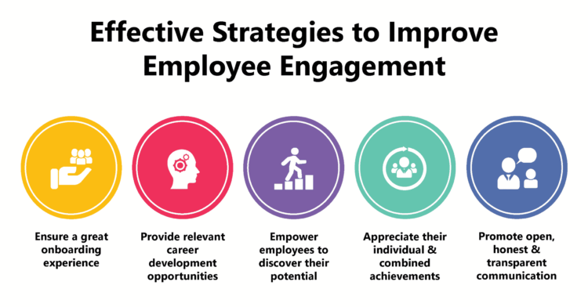
Figure 2: Strategies to improve employee's productivity
Source: (Bailey, 2017)

2.2.2 Benefits of employee’s engagement:
Employee’s safety may be improved with employee engagement surveys, which allow businesses to establish an emotional and mental connection with their staff. Employees who are actively involved in their job are more likely to have a sense of ownership over their work environment, which increases their sense of safety. There are 70% fewer unexpected accidents in highly engaged settings than in disengaged ones told by Kruse (2018). Below the benefits of employee’s engagement are presented:
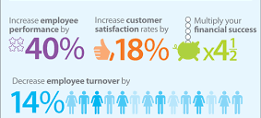
Figure 3: Employee's engagement benefits
Source: (Budriene and Diskiene, 2020)
Employers need to find specific employee vulnerabilities in order for their businesses to flourish. This can only be done through employee engagement surveys, which give HR managers vital information about the strengths and shortcomings of specific employees. Using this information, the hotel would be more productive and successful because of reducing total worker deficiencies, said to Danish, Ahmad, SiRamza and Khan, (2014). It is essential to conduct frequent employee engagement surveys to keep track of how well staff are performing. Without surveys, it is practically difficult for firms to tell whether or not their staff are pleased. Therefore, the Holiday Inn Express authority has decided to do employees engagement research. Birdie (2017) also added that in order to keep things in control, regular polls of employee engagement are necessary. Employers would be remiss if they did not note what these surveys reveal about workers' emotional requirements. Employers may save money by making their workers happier. According to the American Psychological Association, more than $500 billion is wasted annually due to job stress (Open-Sourced Workplace, 2021). Aside from this, satisfied workers are more likely to stay with a company. Employees who are dissatisfied at work will look for a new employer that better satisfies their demands.

2.2.3 Employee’s retention:
A company's objective for employee retention is to retain the best people on the payroll and reduce turnover by creating a happy work environment, expressing gratitude to employees, and offering competitive compensation and benefits. During periods of low unemployment and increased competition for talent, employers are especially concerned about maintaining their workforce, according to Phillips and Connell (2017). In this modern time, the need for a talented workforce has increased while the hotel industry has become competitive over the period. Therefore, the need for employee's retention has increased over the period. Below the benefits of employee retention are presented:
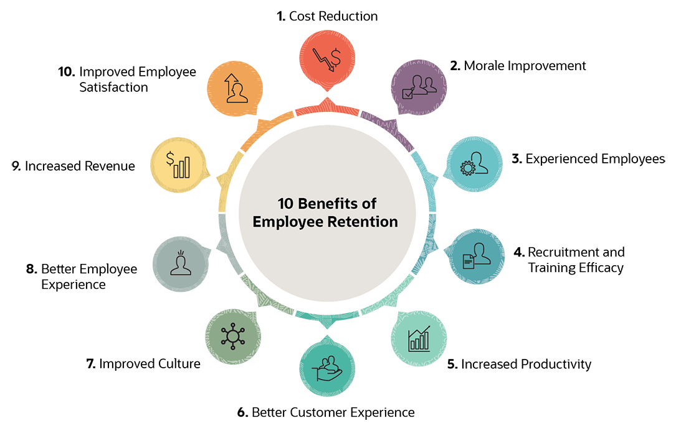
Figure 4: Benefits of employee’s retention
Source: (Kossivi, Xu and Kalgora, 2019)
Assist the workers in their creativity: Even though many corporations claim to promote creativity, they do not appear to be doing much to assist it. For example, St Peterburg’s hotel provides staff with a 20% option to work on side projects that they find interesting (Borovskaya and Dedova, 2018). Having faith in management and the individuals who give them work improves the performance of employees. Those who have faith in the person leading them toward their objectives are more likely to accomplish them. Forty-six per cent of employees said that a lack of open and honest communication from their bosses is a significant factor in their decision to leave their current job. Employees that are engaged have 79% faith in their managers, according to Hom, Allen and Griffeth, (2019). Apart from these two, there are some other strategies that the company can apply. Below the employee’s strategies are presented:
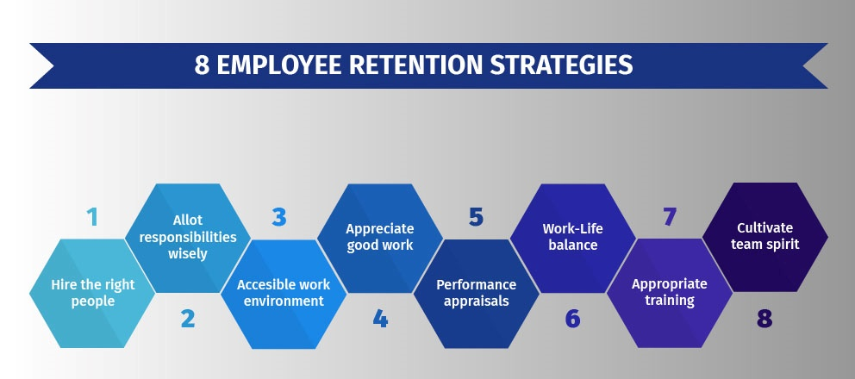
Figure 5: Employee's strategies
Source: (SHRM, 2021)
There is a positive relationship between employee’s engagement and retention. If employees are properly engaged with the organization, then they will feel happy at the organization therefore they will stay at the organization. Therefore, it will reduce the employee turnover of Holiday Inn Express and reduce the cost associated with it and creates a great impact on the profit margin of this company.

3.0 Evaluation and Conclusion:

3.1 Evaluation:
The researcher will use both primary and secondary data for conducting this research. The primary research will know to what extent the hotel employees are engaged with the organisation. The researcher will use primary data because employee's engagement differs from organisation to organisation; therefore, first-hand information is necessary, and, in this case, primary research is required. Birdie (2017) also added that for knowing about employee’s enragement regular survey is necessary for the business organisation. A survey is a popular tool for collecting primary data. As a research instrument, the researcher will use the questionnaire method.
In contrast, the researcher will use secondary data in this research paper because implementing employee engagement and retention is nearly the same in all organizations and if organization can ensure employee engagement, then they will be able to retain the employees of the company. However, organizations need to which method they apply depending on the organisation's rules, regulations, and policies. In their research, Danish, Ahmad, SiRamzan and Khan (2014) said that there are no fundamental differences in employee's engagement and retention across the industry, but it differs from company to company. Therefore, the knowledge that Holiday Inn Express hotel will get from secondary knowledge will add more excellent value.

3.2 Conclusion:
This research paper will enable the Holiday Inn Express to know the level of employee's engagement in this organisation. Besides, they will be able to know at what questions employees are highly disengaged with this organisation. Besides, through secondary research, they will know how to increase the engagement of the employees in the organisation and retain the best employees in the organisation. Then, ultimately, this organisation will increase employee engagement in the organisation and retain the best employees in the company. Therefore, the profit of this company will be increased to a greater extent which has been reduced significantly in 2020. Although there might have many reasons which could be changed the profit employee's engagement and retention could be another reason.

4.0 References:
Bailey, C., 2017. Employee engagement in theory and practice. 3rd ed. London: Routledge.
Birdie, A., 2017. Employees and employers in service organisations. 1st ed. London: Apple Academic Press.
Borovskaya, I. and Dedova, M., 2018. Creativity in Hospitality Industry: Study of Hostels in St. Petersburg. Coactivity: Philosophy, Communication, 26(2), pp.137-144.
Budriene, D. and Diskiene, D., 2020. EMPLOYEE ENGAGEMENT: TYPES, LEVELS AND RELATIONSHIP WITH PRACTICE OF HRM. Malaysian E-Commerce Journal, 4(2), pp.42-47.
Carbonara., S., 2017. Manager's Guide to Employee Engagement. 4th ed. London: McGraw-Hill.
Chandani, A., Mehta, M., Mall, A. and Khokhar, V., 2019. Employee Engagement: A Review Paper on Factors Affecting Employee Engagement. Indian Journal of Science and Technology, 12(15).
Cowton, C., 2016. The use of secondary data in business ethics research. Journal of Business Ethics, 19(4), pp.423-434.
Danish, R., Ahmad, F., SiRamzan, S. and Khan, M., 2014. Determinants of Employee Engagement in Service Sector. Universal Journal of Management, 2(2), pp.64-71.
Golden, C., 2017. The data collection toolkit. 1st ed. London \: Brookes Publishing.
Hom, P., Allen, D. and Griffeth, R., 2019. Employee retention and turnover. London: Routledge.
Hotel Tech Report, 2021. IHG's 17 Hotel Brands Explained. [online] Hotel Tech Report. Available at: <https://hoteltechreport.com/news/ihg-hotel-brands> [Accessed 27 November 2021].
ihgdevelopment, 2021. Holiday Inn Express® | IHG® Midscale Hotel Development. [online] ihgdevelopment. Available at: <https://development.ihg.com/en/americas/home/our-brands/holiday-inn-express> [Accessed 27 November 2021].
insights.ehotelier.com, 2021. Why employee engagement is so important in the hospitality industry. [online] Insights. Available at: <https://insights.ehotelier.com/insights/2021/09/20/why-employee-engagement-is-so-important-in-the-hospitality-industry/> [Accessed 27 November 2021].
Kossivi, B., Xu, M. and Kalgora, B., 2019. Study on Determining Factors of Employee Retention. Open Journal of Social Sciences, 07(05), pp.261-268.
Kruse, K., 2018. Employee Engagement 2.0. 6th ed. The Kruse Group.
Newmediadl.cas.msu.edu, 2021. A HOLIDAY EXPRESS CAMPAIGN."AFFORDABLE FAMILY FUN". [online] Newmediadl.cas.msu.edu. Available at: <https://newmediadl.cas.msu.edu/homework/906/106108> [Accessed 27 November 2021].
Open-Sourced Workplace, 2021. 50 Workplace Stress Statistics. [online] Open-Sourced Workplace. Available at: <https://opensourcedworkplace.com/news/50-workplace-stress-statistics> [Accessed 27 November 2021].
Phillips, J. and Connell, A., 2017. Managing employee retention. 14th ed. Oxford: Butterworth-Heinemann.
SHRM, 2021. Managing for Employee Retention. [online] SHRM. Available at: <https://www.shrm.org/resourcesandtools/tools-and-samples/toolkits/pages/managingforemployeeretention.aspx> [Accessed 27 November 2021].
Statista, 2021. Holiday Inn Express hotels gross revenue 2020 | Statista. [online] Statista. Available at: <https://www.statista.com/statistics/223347/holiday-inn-express-hotels-revenue/> [Accessed 27 November 2021].
Staunton, C., Slokenberga, S. and Mascalzoni, D., 2019. The GDPR and the research exemption: considerations on the necessary safeguards for research biobanks. European Journal of Human Genetics, 27(8), pp.1159-1167.
Thompson, S., 2017. Sampling. 5th ed. Hoboken, NJ: Wiley.
ZAINOL, S., HUSSIN, S. and OTHMAN, M., 2018. Determinants of Employee Engagement in Hotel Industry in Malaysia. A Theoretical Model. International Journal of Academic Research in Accounting, Finance and Management Sciences, 6(3).

5.0 Appendix: Questionnaire:
1 | 2 | 3 | 4 | 5
No engagement | Little engagement | Moderate engagement | A little engagement | Highly engaged

Questions | No engagement | Little engagement | Moderate engagement | A little engagement | Highly engaged
My line manager discussed with me for making my business decisions.
I ultimately know about the culture, rules and regulations of the company.
Holiday Inn Express arranges a training facility for employee's development.
Leadership style favours the employee's development.
Employees are recognised for their tasks in the organisation.

