Programme Name: Master of Business Administration
Module Code: LCMB7023
Module Title: Human Capital Management
Title: The influence of national and international labour market on HRM and IHRM strategies
Lecturer Name: Ejike Udeogu
Student Name: Aman Kaushal
Student ID: 2437693
Submission Date: 17th October 2025

Table of Contents
Introduction 5
Q1. Technological Advancements & Labour Markets 5
Q2. Demographic & Geopolitical Factors 7
Q3. Addressing Skills Gaps via Strategic HRM 8
Q4. Reflective Report on International Readiness 10
Conclusion 12
References 13

Introduction
Enterprises are after people with skills in the labour markets that have evolved rapidly with changes in technology, demographics and unpredictable geopolitical conditions. The paper will review those forces and how they affect the human capital strategy and finally review my preparedness to work effectively in international environments. The practical intention to change important trends to certain HR decisions concerning workforce planning, skills development, and ethical people strategies and to recognize personal strengths to contribute to a global team. The report has been divided into four sections. First, it talks about the way AI, automation and digital platforms are transforming the nature of work, what work requires and how work is related. Second, it covers such issues of demographics and geopolitics as aging, migration, generational expectations and policy risk and identifies the challenges they pose to the HR. Third, it proposes strategic intervention to address the existing skills gaps in several industries that emphasize on talent pipelines, learning environment, and data-driven retention. Fourth, it is a self-reflective analysis of my technological preparedness, intercultural communication, team, leadership and self-directed learning. The findings are included in the conclusion in a single structure of strategic HRM and reflect on the short-term priorities with the assistance of my personal development plan. The intended group is experienced HR professionals.

Q1. Technological Advancements & Labour Markets
Technological change is a non-chain sequence of overlapping chain events of automation, augmentation and platformization and not a wave and thus needs to be put into context. The automation is undertaken with the view of eradicating the boring human resource in the clerical and manufacturing and service sectors. Their improvement of analytics and copilots transforms them into workflow participants and improves intellectual abilities of each job. These are platformised markets and ecosystems that transform the labour industry in that they separate the place of value creation and workers (Aghion et al., 2023). The combination of these forces reduces half-lives of the jobs, increases the digital, data and human capacities and transforms the companies according to the hierarchical order into the operations models, according to the skills.
Technological change Technological change is not a wave and a non-chain series of overlapping chain events of automation, augmentation and platformization and need to be contextualized. The automation is embraced with the perception of eliminating the repetitive human resource in the clerical and manufacturing and service fields. They multiply analytics and copilots, which means that they are the representatives of working process and they supplement intellectual abilities of any job. They are market place and ecosystems which platformise the labour industry as they decouple the place of value creating with the workers (Aghion et al., 2023). The forces have come together to shorten half-lives of the jobs, amplify the digital, data and human capacities, and remodel the companies based on the hierarchical order into the operations models, basing on the skills.
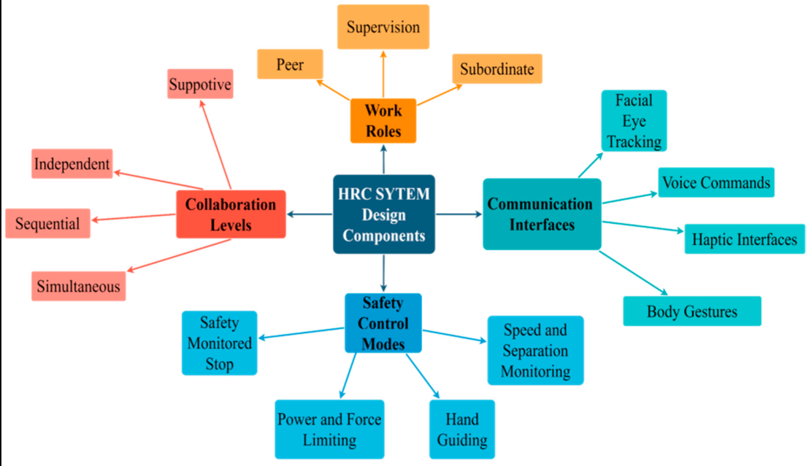
Figure 1: Structural components of HRC system.
(Source: Othman and Yang, 2023)
Threats and countermeasures Displacement, inequality, and gradual extension of surveillance are the biggest threats. Automation at a rate exceeding the ability to reskill results in disparities in the favor of the already privileged. The gap is enhanced with the fact that availability of education and activities of value is pegged on pre-existing bias. Surveillance creep happens when instruments of safety or quality intrude into intrusive surveillance. Risk responses are effective and quantifiable. First, invests a multi-year reskilling scheme linked to strategic workforce plans, particular learning time, recognised qualifications, and career paths into promotion roles. Second, infuse equity into talent systems: test algorithms and results; employ diverse panels; disclose the test criteria; and monitor demographic and geographic mobility. Third, practice privacy by design in people analytics: reduce data collection, purpose-define, consent where necessary, and data retirement. Lastly, adopt a participatory culture: engage employees in technology testing, co-design new processes, and negotiating change where group agreements are to be used. The high performers will view technology as a way to do better work, which is easier, less risky, and more meaningful and develop the skills and confidence and manage them to maintain performance anywhere. It must be implemented regularly and appear to be approved. Track limited outputs such as time to proficiency, rate of internal fill of key positions, sustainability of cycle time with automation, error rate and quarterly learning engagement. Begin with two high-output processes, redesign the work, and incorporate automation and job redesigning and education.

Q2. Demographic & Geopolitical Factors
Key Demographics
The aging workforce, decreased birth rates, and the rising life expectancy are being experienced in most countries. This will cause the skill sets to be shifted to experience, organization learning and slowness in decision making and increase the pressure in the ergonomic design, gradual retirement and flexing schedules in regards to care giving. Gen Z is meanwhile entering the workforce with high ambitions, openness, diversity in culture as well as developing rapidly. They are also flexible, open and are comfortable with mobile careers which are skilled based and not title based. Migration gives strength to mosaic: on the one hand, in certain regions where the migration is to bring about the diversity and the breaking of the scarcities, and on the other, the migration brings about the loss of precious resources. Gender involvement is not regular and it depends on the availability of childcare and social conventions (Duggan et al., 2023).
Geopolitical/Economic Volatility
Geopolitical tension and economic instability determine the locations and modalities of capability building in organizations. In order to reduce the concentration risk, trade regulations and lead times, the firms reorganize based on near shoring, friend shoring and plus one strategy. The international cooperation or the flow of talents is hampered by the visa policies, conditions of data storage and other privacy regulations. The increasing inflation and wage pressure require more drastic intervention on policies on remuneration, payment packages and productivity spending. Energy fluctuation of prices influences location costs; export prohibitions and sanctions influence the viability of partners; electoral conditions include uncertainties of labour policies and taxes. Remote and hybrid work continues to be prolific with distributed teams being enabled and experience and security and performance monitoring inconsistency being brought to light.
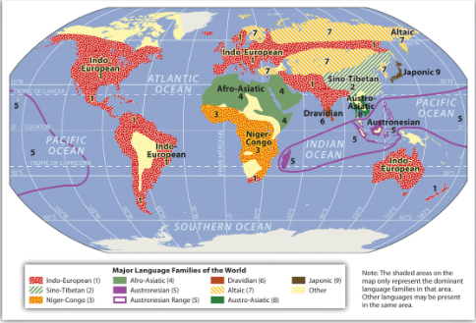
Figure 2: World map with layered demographic bars and geopolitical markers
(Source: Berglee, 2012)
HR Challenges & Responses
The strategic issue in this case is the way to evolve the system of people which would be locally oriented and globally centered. The response action that should be taken first is to divide the labour force: identify the main gaps and skills shortage and be able to offer it according to the region and to the market. The location strategy, mobility choice and talent funnel should be measured through continuous scenario planning as a response to shock such as regulatory change, supply shock or political instability (Nagarajan and Sixsmith, 2023). Generalize the movement to incorporate the traditional terms of expatriation of short-term assignment, virtual assignment, and hub and spoke group which incorporates intimacy and distance as one. Minimal universal ethical behaviour, health and safety, non-disclosure of data and non-discrimination are set and benefits, timing of teaching and teaching method are made regionally. Enhance wellbeing and financial security programs so that human beings become less prone to volatility.

Q3. Addressing Skills Gaps via Strategic HRM
Problem Definition
The point is that these skills are differences between the strategy, technology and customer needs and the education opportunities and labour mobility. The skills gaps in technology revolve around the cloud engineering, data science, cybersecurity, AI product management, and human-cantered design skills being a product insight and stakeholder interaction and the technical skills. The resources of healthcare are delayed by the greying workforce, clinician burnout and nursing, primary care and allied training, and policies and credentialing prohibits cross-border migration. Hospitality and retail are new and it has high turnovers, seasonal strain and low profits that cannot afford training. In other places, automation is turning work to a more mature and cross-functional work, where priority is put on systems thinking, data literacy, and service quality (Nguyen Ngoc et al., 2022). The result is an ongoing mismatch: companies are demanding intersectional abilities and versatile behaviours, and workers are presenting little experience or indication of potential ability.
Strategic Levers
The commencement of effective response is evidence. Develops a model of skills basing on the business outcomes and divides into behaviours, competencies and activities. The structured skills inventory is designed on self-reporting by an employee, verification by the managers, work sample and micro assessment. Use analytics to identify the necessary skills and the locations that are associated with the same that can be used to make changes faster in the nearby areas. Build an organizational talent market, matching time-constrained projects with talent one-to-one, availability and purpose; improving experiential learning and engagement and finding new talent (Vaiman et al., 2021). Create learning forks in small steps and practice and feedback of badges or micro-credentials, which open projects and salary increase. Partnership with colleges, boot camp and professional organizations to reciprocally conduct programs and work or clinical placements. Test the employee value proposition: flexible working hours, standard working hours, career development and helpful supervisions reduce the turnover of employees in low-level positions. Diversify recruiting using skills-based recruitment, realistic job previewing and work trial audition rather than degree qualifications.
Measurement & ROI
The implementation has a clear dashboard, where the leading indicators and the lagging indicators are. The indicators that have high values include registration and pathways completion, interaction on mentors, placement of projects in the market place, time allocation in learning and positive results of the practical tests. Some of the lagging indicators are internal mobility, time to hire, quality of hire, time to competence, key segment retention, customer satisfaction, error or rework rate, and productivity per full-time equivalent (White III, Rajwani and Lawton, 2021). Correlation to value drivers: the skill improvement, in this instance, is connected to the increase of the revenue, reduction of the service cost, safety and risk and experience ratings. Weigh the impact of attributes accordingly with the help of test and learn pilots respectively with control groups and hence accumulate on the effective strategies. The administration has a responsibility: raise the unmistakable qualification, promotion, and remuneration standards, in order to be reputed.
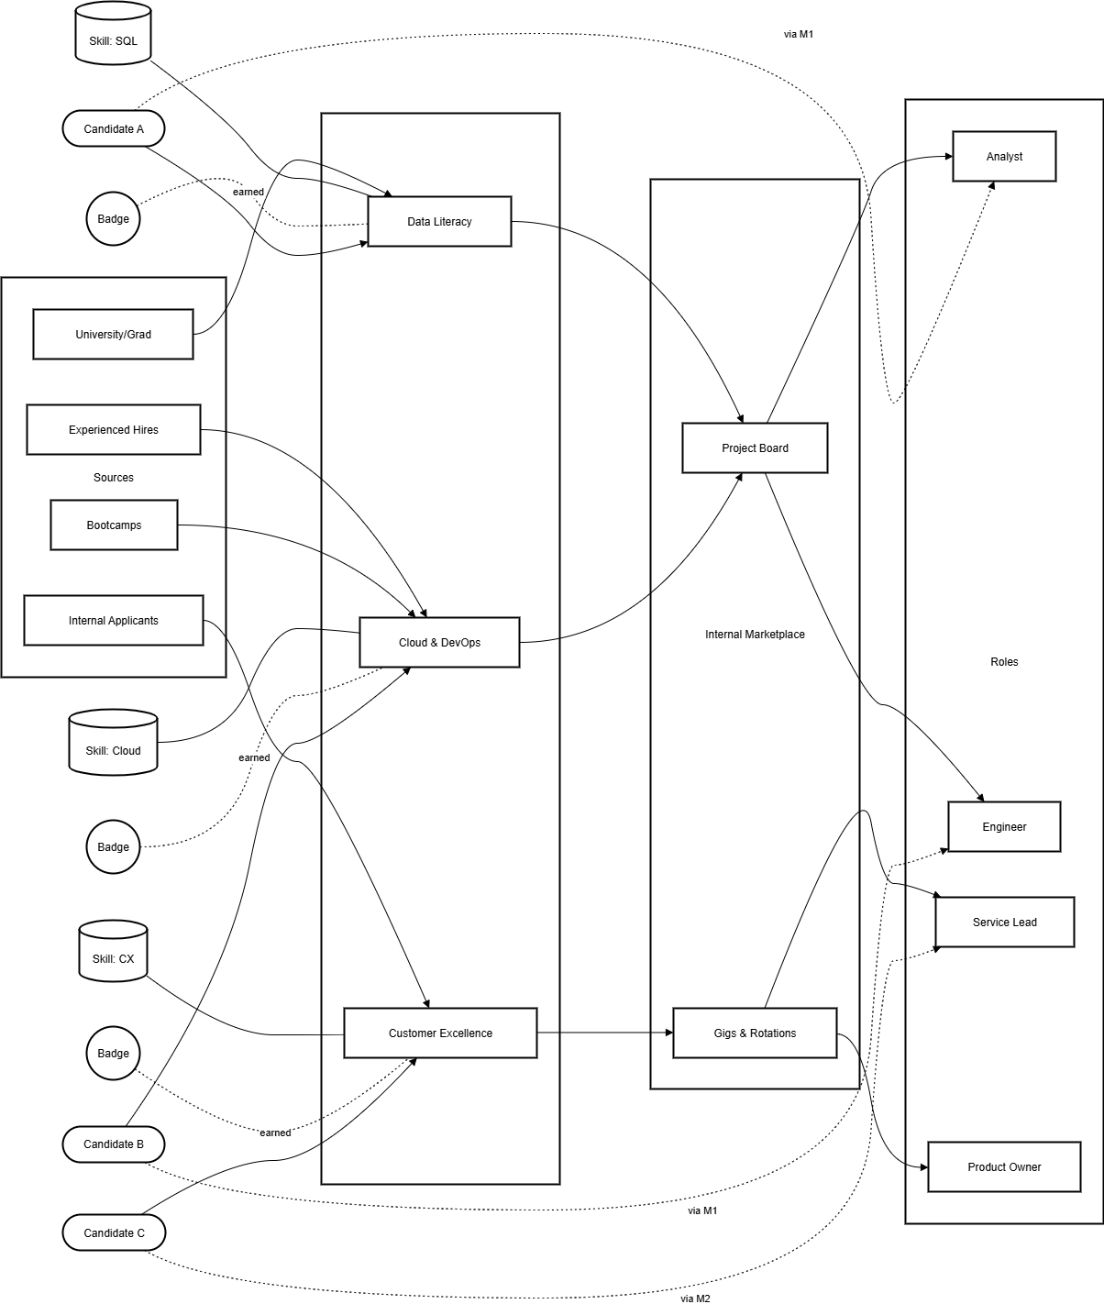
Figure 3: Talent pipeline diagram
(Source: Self-designed)

Q4. Reflective Report on International Readiness
Technology Readiness
I feel at ease with the usual productivity packages, team meeting tools as well as data management tools that enable one to work within groups even in the absence. I can establish virtual working conditions, the hierarchy of files structure, automatizing repetitive working processes to minimize the number of handoffs. My weakness is in the area of advanced analytics and a gigantic low-coding automation, I can read dashboards, however, I cannot always look under-the-hoods or write automations that can be easily used by various users (Jooss et al., 2024). After six months, I will make a middle step in data analysis and create two small automatizations in order to address the actual issues in the workflow. Safe actions, hygiene of taking good credentials, responsible sharing, and writing documents that are sensitive to privacy will also make me take good actions in order to make my contribution in the cross-border cases effective and accountable.
Communication Across Cultures
I am also an effective communicator, I can update, the decisions and the actions taken by me can easily be observed by the stakeholders. It is my duty as well to summarize, ensure that all is comprehended, and write agreements during meetings. I am also more prone to rushing the communication process rather than making it contextual when addressing the populations of other cultures and timezones, which may also introduce the element of ambiguity (Yanamala, 2024). My adjustments will be having a direct straight forward language, lack of use of idioms, intent, audience, and expectations. The other practice I will implement is that there is no surprise in the matter: I will be providing pre-reads with questions of interest, and provide asynchronous instances in the case of incongruent schedules.
Teamwork & Collaboration
I would most likely assume the integrator roles in the team setups that have the ability to tie the various tasks and make sense of the tasks and the people interacting are the right ones. I will always receive and provide feedback because I would do anything to ensure that the risks are detected early enough without blaming anyone. I also tend to worry too much about quality in terms of time-bounded that will not allow delegation. In order to create, I am going to apply the principle of 80/20 first draft to collaborative work: establish acceptance criteria, divide work and accept decent versions before polishing them. I will also engage in organized collaboration rituals: I will report on a daily (spend five to ten minutes on the roadblocks), show to stakeholders weekly (to get feedback), and conduct retrospective sessions where we will compile knowledge. The team is also useful in minimizing the confusion and maintaining the momentum in other locations and functions by maintaining a record of decision-making process and ownership demarcation.
Leadership & Influence
My leadership style is the service to others: I remove the obstacles, give the clear direction and track it. I am comfortable directing, identifying the outcomes and planning work effectively. Another aspect I have to learn to be more decisive and open minded at the moment when there is less evidence. I will embrace an open cadence to set the decision, draw the options and trade-offs, place a time constraint on the discussion and organize the arguments (Lastra, 2025). I will also invest in stakeholder mapping so as to become familiar with interests, influence as well as desirable mode of engagement. Global leadership must include ethics, which will be revealed with the inclusion criteria, data protection, and wellbeing, and influence constructive criticism without fear of punishment.
Self-Directed Learning
My learning is established in tiny circles associated with the projects I am undertaking whereby theory succeeds shortly after practice. My history of experiments, blunders, and what I would have done differently in the future are simply straightforward. The danger is that of hoarding resources and not rehearsing. To counter this I will establish quarterly themes that are characterized by two milestones that are reachable and this is to have a working prototype and a very short description of the way it was achieved. I will design peer review sessions in a way that challenges assumptions and improves communication. To perpetuate prolonging, I will use leading indicators like the practice hours and the number of micro tasks completed during a week, instead of certificates. I intend to learn in the same vein in my future projects, meaning learning quickly, trying on people and using feedback without getting offended.

Conclusion
In this report I have included 4 flows of thinking as a single action human capital strategy. To begin with, technology is transforming the labour markets too and making the planning of workforce, job redesign, ethical governance and reskilling a given. Secondly, the requisites of population shifts and insecurities in geopolitical arrangements necessitate globally legitimized concepts, which provide localized pliable and situation-specific predictions and enlarged prospects of mobility, which combine permanence with possibilities. Third, the skill-based deficiencies will need to become multi-dimensional: opening the house, recruitment, selectively on the basis of the skills-first approach, formation of alliances, and intelligent robotization, in which the system will be more effective than human beings.
The fourth is individual preparedness. As it turned out during the analysis, harsh strong points of the collaborative work, service-oriented leadership exist, and low in 1 area of advanced analytics and cultural signalling. The initiative that helps in the actualization of this agenda can also involve me through participation in the short-cycle learning, the components of decision-making and the more visible trans-boundary communication.
The actions that need to be taken immediately to an HR leader include the following; collecting of the vocabulary of the organization, its inventory, mini marketplace in the organization and synchronization of incentives to laud change of direction and learning. Meanwhile, the global and local standardize the flexibility and tie together the product of talents with value suppliers. All these activities are what comprise the knowledge action.

References
- Aghion, P., Antonin, C., Bunel, S. and Jaravel, X., 2023. The effects of automation on labor demand. Robots and AI, pp.15-39.
- Duggan, J., Carbery, R., McDonnell, A. and Sherman, U., 2023. Algorithmic HRM control in the gig economy: The app‐worker perspective. Human Resource Management, 62(6), pp.883-899.
- Nagarajan, N.R. and Sixsmith, A., 2023. Policy initiatives to address the challenges of an older population in the workforce. Ageing International, 48(1), pp.41-77.
- Nguyen Ngoc, T., Viet Dung, M., Rowley, C. and Pejić Bach, M., 2022. Generation Z job seekers’ expectations and their job pursuit intention: Evidence from transition and emerging economy. International Journal of Engineering Business Management, 14, p.18479790221112548.
- Vaiman, V., Cascio, W.F., Collings, D.G. and Swider, B.W., 2021. The shifting boundaries of talent management. Human Resource Management, 60(2).
- White III, G.O., Rajwani, T. and Lawton, T.C., 2021. Open for business in a closed world? Managing MNE nonmarket strategy in times of populism and geopolitical uncertainty. Multinational business review, 29(4), pp.441-450.
- Jooss, S., Collings, D.G., McMackin, J. and Dickmann, M., 2024. A skills‐matching perspective on talent management: Developing strategic agility. Human Resource Management, 63(1), pp.141-157.
- Yanamala, K.K.R., 2024. Strategic implications of AI integration in workforce planning and talent forecasting. Journal of Advanced Computing Systems, 4(1), pp.1-9.
- Lastra, R., 2025. On the decoding of skills and competency in the age of atomized education. Widening Participation and Lifelong Learning, 27(2), pp.33-59.
- Lv, J. and Lv, J., 2025, March. Research on Human-Machine Collaboration Efficiency in the Digital Transformation of the Labor Market. In Proceedings of the 2nd Guangdong-Hong Kong-Macao Greater Bay Area International Conference on Digital Economy and Artificial Intelligence (pp. 863-871).
- Othman, U. and Yang, E., 2023. Human–robot collaborations in smart manufacturing environments: review and outlook. Sensors, 23(12), p.5663.
- Berglee, R., 2012. World Regional Geography: People, Places and Globalization. Saylor Academy. Available at: https://saylordotorg.github.io/text_world-regional-geography-people-places-and-globalization/ [Accessed 10 Oct. 2025].

