Monitoring in the workplace
A study on how surveillance impacts performance of UK employees

Chapter 1: Introduction
Monitoring in the workplace is an elemental part of the human resource professional role because it provides information about employee performance, and this is crucial to company strategy. However, the main problem is born when supervisors do not do a proper job and abuse surveillance. This produces untrust between employer and employee and putting company goals in danger. This study analyses the effects that surveillance produces on employees in the workplace, and how it impacts their performance. We will do focus on the employees and what are the government laws that regulate them. This study wants to be a manual in which we are going to show how several times HR professionals do not know how to apply the rules.
Different studies show us that surveillance produces a positive or negative impact on employee performance and this is due to multiple factors such as what is the business of the organisation, how companies explain the benefits of surveillance in the workplace or if the organisations have clear surveillance policy. The UK has legislation about surveillance in the workplace that we can identify in the middle of world tendency since we are going to see countries such as the USA or Russia where surveillance law is biased to organisations, instead the EU are more respectful of privacy rights even in the workplace. Our country follows Human Rights Act in which privacy is a crucial right, but under specific situations, companies can appeal to general interest and implement even covert surveillance. However, in the UK, organisations are changing their policy about monitoring trying to find a balance between negative impact on the employees and surveillance of the company.

1.1 Workplace Surveillance
According to McParland and Connolly (2020), the workplace surveillance theme has received little attention within the literature. Although it is an important topic, especially for the human resource profession, there are a few studies and most of them only answer the question: what the benefits are to use CCTV in the workplace. Our study will do focus on employees. Armstrong (2020) remarks that human resource professionals have an internal structure about their task, in which they have three fundamental activities: planning, executing and controlling. This last is our study object in order to analyse how human resource professionals can apply monitoring in the workplace but not make errors because they may play against their organisation. In this study, we see a workplace like panopticons in which surveillance create a sensation of constant surveillance. This control system used by HR professionals have similar characteristics with building thought by Jeremy Bentham. Panopticon is a peripheral structure divided into cells that cross the entire with of the building, in which there is a security guard on a central tower who can control any person in the cells (Rocha, 2015). We use panopticism term as a metaphor because a workplace is not a panoptic prison and even employees can limit the use of surveillance technologies by employers (Manokha, 2020). We are going to analyse this topic from a Foucauldian approach, in which panopticon in the workplace means a set of technologies that employer uses in order to help a better organisation development and controlling employees. Thus, businesses use technology solutions to collect, watch and analyse how employees coordinate daily supply chain activities (Cantor, 2016).
According to Townley (1993), HR professionals look for goal-directed activity in organisations, in which workers are selected and appraised depending on their performance. It is the view of the author that human resource develops a role with a direct result, and they need tools that help to achieve their aims. In this sense, CCTV is a crucial mechanism especially in workplace where physical presence is difficult due to size of organisation or healthy restrictions. Nowadays is not necessary a physical presence of a visible supervisor (Sarpong and Rees, 2014), due to omnipresence of the HR professionals is ensured by the digital tools and storage of all information concerning productivity, in which employees must assume that they are constantly observed (Manokha, 2020). Thus, in the workplace, there is a growing tendence to evaluate employees using technologies, in which appraisal is clear because HR literature affirms that the resource most likely to yield a competitive advantage for the firm is its human capital (Weiskopf and Munro, 2012). These authors say that an organisation need human capital with a satisfactory performance, and it is important to measure it constantly.
Although CCTV may be useful to approach safety in a proactive manner such as incidents happen (Cocca, Marciano and Alberti, 2016), monitoring could produce a fracture between organisation and employees. This divorce could have profound consequences for the company. Ball (2010) explains that monitoring is a strong message to workers about the kind of behaviours the employer expects or values. The idea of the organisation is not only surveillance; it is creating an atmosphere where the company shows them that it can see them. In this sense, Stanton and Lin (2003) explain that HR professionals have a legitimate interest in protecting the assets of the company and monitoring help to reduce the possibility of harassment or hostile workplace problems. Employers can gather information about workers by watching what they are doing during working hours (Oliver, 2002). This right of the companies is valid in order to protect employees and assets, but its right have a limited based to government laws. Pistorius (2009) writes that technologies in the workplace are an important change, and they affect the way in which employees are expected employee performs. However, when exist an elevated level of control, this can naturally be linked to lack of trust in organizations and may have negative individual level outcomes and to be potentially costly for the companies (Tabak and Smith, 2005). In these terms, are monitoring by CCTV a practical choice for organisations?

1.2 Problem statement
Surveillance produces pressure, untrust and impact on the employee performance. Organisations use it to control and to show that they are present in the workplace even when they are not a physical presence. When employees feel that their privacy is being violated, this impact negatively in their performance. The problem is when supervisors do not know what the limits of monitoring are, and they abuse surveillance such a Copland v UK in which Carmarthenshire College monitored telephone and internet use of its employee without having a clear surveillance policy and without informing her. Copland was unfairly dismissed, but finally she won because the college did not respect her privacy right. In the same line, we have Halford v UK in which Alison Halford could prove that her calls at the office were illegally intercepted for her employer. In both cases, that then we are going to analyse, the Court considered that the employers did nor respect private life of employees.
Surveillance includes not only knowing that camera system to use, but organisations also need to know what their responsibilities may be, and what the legal pitfalls may be (Shilling, 2021). Under this context: is surveillance a good mechanism to improve the performance of workers? Using CCTV in the workplace produce advantages, but are these greater than disadvantages? Companies can have better control of employee performance and identifying work risks, but could abuse the use of CCTV, break trust in the work environment? What happens in an organisation in which environment is based on untrust? Companies want to reduce costs and increase efficiency by investing in technologies to monitoring employees in the workplace (McParland and Connolly, 2020), but CCTV presence could create an atmosphere of permanent control, in which employees feel pressure about their performance.
Employees are in the same role as the prisoners of Bentham’s panopticon, knowing they are being watched all the time (Kelly, 2015). Monitoring could break the trust between organisations and workers due to bad management of this tool, affecting employee productivity and it can violate the right of employees and that atmosphere is not healthy for any company. The role of HR professionals is essential to regulate the impact of surveillance in the workplace. Mishra and Crampton (1998) conclude that monitoring has positive motives and helps protect employees, but it could invade its rights. Although the privacy of employees is crucial, the employer has sometimes power to dictate the levels of privacy which can be expected in a workplace (Oliver, 2002). This power could create a conflict between employer and employee if do not exist a clear limit. Abuse of monitoring is illegal and creates an environment of untrust, that situation could affect employee performances. O'Rourke, Teicher and Pyman (2011) argue that there is a power asymmetry because HRM uses sophisticated practices such as CCTV and it can decline in union membership. Using CCTV in the workplace is to control over employees to increase organisational efficiency and productivity (Agustina and Coudert, 2013), but control of productivity does not mean that productivity is going to increase.
Surveillance or no surveillance? The main dilemma for HR professionals is to supply a secure workplace without violating the privacy of employees (Cooney, 1991). Organisations argue that the use of CCTV is part of their right to protect their workers and this is not part of our discussion. However, Ball (2010) explains that the nature and intensity of surveillance say much about how an organisation views its workers. This author remarks that surveillance produces a little benefit on the employee, but it increases the asymmetries power. Employers want efficiency and protect their assets in an environment in which the performance of the employees should be better, but are CCTV the best tool to improve performance?
Panorama behind a CCTV could contrast with the situation in a real workplace setting. This study wants to be a practice framework based on a theoretical understanding guide about how HR professionals could apply monitoring in the workplace. Our analysis wants to show what is the impact of surveillance on the employees, and how to use CCTV in order to follow government rules. Our theoretical analysis will be from a Foucauldian approach because it supplies an interesting perspective on the surveillance problem. In this sense, Cooney (1991) argues that employees want no monitoring. How can companies combine surveillance and security? This tendency to surveillance could affect employee tasks in order to increase or decrease their performance.

1.3 Ethical of organisations
What is the limit of ethical conduct? How do organisations decide this limit? It is decided by the laws or the criteria of who watches? Using CCTV is a great mechanism to know what happens in the workplace, but inappropriate use could violate employee rights. Knowing the rules about the use of CCTV is vital for HR professionals not only because of legal issues but also in order to create a safe environment. Ethical issues are crucial to controlling the different activities of employees and their performances (Leclercq, Isaac and Kalika, 2014). When existing a proper use of tools, and organisation follows the rules, employees should feel safer and confident; unfortunately, sometimes employers abuse about use of CCTV.
Inappropriate use of CCTV could damage the reputation of an organisation (Holland, Cooper and Hecker, 2015), and the consequences could be serious for the company. Thus, employee privacy is a complicated issue in the field of HR professionals, especially when some CCTVs are installed secretly since employees do not know they are present (Mishra and Crampton, 1998). It is necessary that employees know that they are being watched (Agustina and Coudert, 2013). As we are going to see, government rules do not allow covert surveillance. In the same vein, Cocca, Marciano and Alberti (2016) explain that employees have to be aware that the aim of the CCTV is to record videos showing machinery, workers, and the working environment, thus allowing an analysis of the safety practice inside the company.
Walsh and Papworth (2007) argue that the decision to implement surveillance should involve weighing up the interests of the business and the privacy interests of the individual. In the middle exist a limit that rules impose, and they are compulsories. Supervisors must provide a secure workplace without violating employees' privacy, and they must bear the responsibility for supplying a safe and secure workplace for all employees (Cooney, 1991). Therefore, HR professionals have to implement clear policies and procedures following government rules and it is necessary that each company harmonize its policies in order to follow legal regulations. Fiona (2010) remarks that each employer is responsible for the policies, resources, and management of the CCTV system. However, companies have covert CCTV, and this is not allowed. We are going to see that it is not only illegal but also it shows that there is great mistrust between the company and its workers. According to Whittaker (2015), the use of covert surveillance implies that the mutual trust as laid out in terms of employment are broken.
Currently, in the workplace, employees are living under this environment in which control and supervision are part of the daily task of HR professionals. Workers are under a “new workplace”, where most of them are disciplined for any or no reason not contrary to law (West and Bowman, 2016). Although CCTV help to keep an evaluation without a bias, employees could feel that their right is being violated. Oliver (2002) proposes a solution to this problem, his idea is to have an agreement to privacy-invasive practices in the workplace that could include it as part of the contract of employment. Unfortunately, this kind of agreement are sine qua non before signing an employment contract, in which employees cannot change them.

1.4 Purpose of the study and research question
Is surveillance in the workplace a valuable tool to improve the performance of the employees? Our first question to answer is to know what produces monitoring on employees. Do they feel motivated or demotivate when they are monitoring? We want to understand this topic from the employee side. We know that policies and procedures are design for organisation following government rules and strategies, but we also think that it is crucial that HR professionals can predict the impact of their mechanism on the workers. Our motivation is also our topic does not have a lot of studies, especially in the UK post-Brexit.

1.5 Research aims and objectives
Our aim is exploring what is the impact of monitoring on the employees in the workplace. We want to know if employees are agreeing or not about CCTV in the workplace and how they think that it can affect their performance. Our focus is on the employees. To achieve it, we have the next goals:
-We want to analyse articles in which our theme was studied from the companies and employee side by literature review.
-We want to analyse the different problems that can cause an inappropriate use of CCTV by case study. In this sense, we want to list what are the government rules and how to apply them. This can be a guideline for HR professionals, especially now that we are experiencing profound changes due to the pandemic and Brexit.
-We want to analyse at least 5 Study Cases in our country to have a clear idea about how the courts are applying the legislation.
-We are going to survey to understand what employees think the impact of surveillance on their performance is.
-We want to design recommendations and a practice framework about our topic.
1.6 Outline of the dissertation
This study is divided into six chapters:
Chapter 1: Introduction: This chapter is a brief study about what is the main problem of our topic. Also, we mention the subthemes that are born of our topic. We analyse the main points that we are going to study and what is our aim.
Chapter 2: Literature review: This chapter is a recompilation and analysis of diverse surveys made about monitoring in the workplace. Also, we will analyse the ideas of authors who have a Foucauldian approach to our topic. Finally, we are going to study the legal aspects that involve surveillance in the workplace.
Chapter 3: Research methodology: This chapter explains what the methodology is we are going to use to analyse our study. This part describes the methods and strategies used in this study.
Chapter 4: Data analysis: This chapter provides primary data through our survey in which we want to show what employees think about surveillance in the workplace. We are going to summarise and interpret the collected primary data.
Chapter 5: Recommendations and implementation plan: This chapter wants to be a guide to HR professionals implement these ideas.
Chapter 6: Conclusion: This chapter is a summary of all our studies. Our conclusion is also an open door to future investigations.
References: This part will show us all the resources that we use to do our study.
Appendices: In this part we added other documents about our study.

Chapter 2: Literature review
2.1 Foucauldian approach
Our study looks to develop an analysis from a Foucauldian approach in which is crucial an analyse from employees’ gaze. According to Carter, McKinlay and Rowlinson (2002), Foucault has displaced Marx and Braverman as the scion of labour process theory, which is now largely subsumed in critical management studies. We have a Foucauldian approach because he studied what are the control strategies and how to apply them in different sectors of society. In terms of our study, surveillance means control and it is part of the strategic company. Control and power are part of the same strategy. Surveillance is power and this power build subjectivities. The pressure that employee feel when they know that they are being watched in the workplace produces a redesign about how they see their self. The benefit of Foucault studies is that now people are understanding that management and employees' subjectivities are the product of power/knowledge regimes (Townley, 2005).
This dissertation argues that surveillance under workplace context is a control mechanism used by HR professionals to supervise employees but also to show them the presence of the company which is watching them permanently. Dear (1998) explains that Foucault inspired a study about the management of people in the workplace, and he remarks two crucial topics: power/knowledge, discipline and surveillance, and power/knowledge and the constitution of subjectivity. This author states that surveillance is a mechanism of Power/Knowledge in which organisations express their presence in terms of their asymmetric power. Surveillance means create an atmosphere in which employees know that they must follow the organisation rules. Surveillance creates an idea about what organisation want. However, we think that control in the workplace is not totally an asymmetric power because companies are understanding that they need to find a balance between control and trust.
Semple (1992) manifests that Foucault describes the panopticon as an emblem of modern power. Our dissertation explains that, from Foucault gaze, the workplace is a new panopticon in which a company is always watching, even when they are not watching. This is the main idea about how panopticon works in the sense that employees feel permanent control. When we talk about the workplace, it is not only the physical space where workers traditionally do their tasks. We are going to see that the modern panopticon extends its presence for example on different electronic devices that employees use to do their works. Maybe Foucault never thought about the electronic panopticon, in which there is someone watching to thousands of kilometres, but nowadays that situation occurs, and it builds subjectivities. Panopticon exists but with the crucial differences that we are going to study.
Thus, Galič, Timan and Koops (2017) formulate that panopticism has become the most widely used metaphor for surveillance, becoming its synonym. This idea about surveillance is part of a mechanism of control and power of organisations. Barratt (2002) articulates that from a Foucauldian point of view exists a new panopticism era at work, where companies are applicating sophisticated surveillance techniques, and advances in control technologies have led to an increase of the managerial gaze. Technological monitoring transformed workplaces, where modem electronic are used by a supervisor who is always "looking" (Manokha, 2020). Organisations need to remark their presence permanently, they must express their visibility in all the spaces of the workplace because they understand that its presence is power.
McKinlay et al. (2010) declare that Foucault conceptualized power as inscribed in the humdrum routines of everyday life. Organisations invest constantly buying innovative technology to supervise, control is part of HRM routine in which monitoring is a crucial role to know what is happening in the workplace. HRM programmes promote control that it is inherent dangers associated with these circulations with selective investment (Weiskopf and Munro, 2012). Each control mechanism used by HR professionals shows what the discourse of the organisation is. This discourse is elemental to build knowledge about what want the company. Power and knowledge are thus for Foucault two sides of the same social relationship, giving rise to the concept of power/knowledge (Cowton and Dopson, 2002). Control is power, and this mechanism adapted to sophisticated tools is evolving every day.
Studies about monitoring in the workplace are limited to theoretical parts without having practical experience. We want to bear in mind how employees receive information about surveillance. We think that this kind of study needs to combine theoretical and practice parts to have a clear idea about our topic. Studies about panopticon in the workplace do not go out of typical Foucault structure in which researchers try to identify how control builds subjectivities. However, what about employees? We believe that control has different impacts depending on the position or motivation of an employee. Our study wants to identify how this control can get different results, even when surveillance is developing in the same space.

2.2 Using CCTV in the workplace
Monitoring in the workplace is a topic studied through different research around the world. In our study, we also want to understand if surveillance has the same impact on different countries with diverse kinds of organisations. It is not the same effect when a company use CCTV with administrative employees or when an organisation monitoring worker performances for security reasons. The most recent study about this topic was made in New York with a survey under the title: Employees object to workplace monitoring. This study showed that workers did not feel comfortable about the protection of their privacy in the workplace, and they were opposed to being monitored through personal sources (Summit, 2018). This survey was designed especially to be a focus on the opinion of HR professionals, and their main conclusion was that 80% of companies are using employee records and data to measure performance. We can see that this tendency is growing, and organisations are using technological information to analyse the performance of the employees but also because of the need to control them. This study shows us that surveillance creates an insecure work atmosphere due to employees feel that companies do not care about their privacy. However, this research is not enough because it does not show what is the real impact of surveillance on the employee since it was designed to HR professionals can analyse it without bearing worker opinions. From a supervisor perspective, we can have only a part of the total effect. We are going to see that most investigations about surveillance in the workplace are over organisation gaze.

Using CCTV produces a direct impact on the performance of employees since the environment influences on worker activities. In the UK, a study about workplace surveillance showed that employees feel a potential interference with their privacy rights, especially with methods such as recording telephone calls, monitoring e-mails, or using CCTV (Vallely, 2001). This study revealed an increasing trend in the workplace for employers to keep regular surveillance over employee activity. We can see that both studies -in the UK and the US- have the same results: employees feel their privacy is violated, and companies are using more technologies to control them. Due to several organisations do not have a clear policy about surveillance in the workplace, employees are working under an insecure work atmosphere in which control creates a sensation of permanent pressure. This study is one of the few that has been carried out in the United Kingdom, but it has limitation because do not show the different mechanism that companies use to surveillance and how they impact on the worker performances. Instead, we want to analyse the impact under the current situations: Covid-19 context and the UK post-Brexit. Covid-19 extended the ways in which organisations can surveillance workers because during the pandemic process a lot of employees were working from their homes.
Using CCTV could help employers to employee control, but in a lot of situations it produces a negative answer by workers. We can see that surveillance have a real influence on the employees and affect their tasks. In Australia, a study showed that employees who are watched tend to form negative attitudes towards surveillance (Martin, Wellen and Grimmer, 2016). This study concluded that workers under surveillance perceived a negative effect. Control is part of company rights, but the problem is how they use these rights without having a clear internal policy in order to be careful about employee rights. A negative impact on the employee tasks produces an elevated risk of organisation goals, and this is dangerous for any company. Studies in the UK, the US and Australia show us that surveillance produces a negative impact on the employees. However, we want to analyse not only the effect because our study also wants to measure the impact in terms to understand if this has an important effect on employee productivity. We are going to have primary data from the worker side in order to analyse how they feel surveillance impact their tasks. Measuring employee impact on the performance cannot limited to employer opinions about monitoring, it is necessary to analyse it with a productivity table in which we can compare if surveillance produces benefits to employer although workers affirm that it produces a negative impact.
In Italy, it was a study with atypical features to above analysed in which researchers wanted to understand if CCTV produces a negative effect when employees know that this kind of control creates a secure work environment. The metal sector is a business where security is crucial to the protection of employees, and they have to follow the procedures strictly. Cocca, Marciano and Alberti (2016) studied what was the behaviour of the employees who work in this sector. This research concluded that surveillance could foster a more proactive approach to safety management due to surveillance supports the identification of the risks connected to unsafe behaviours of the workforce. This study showed that CCTV helps to find unsafe practices, and this control is crucial to avoid accidents and promotes safe practices. In this case, CCTV plays a vital role in the security of employees, they know that, and they feel more comfortable working under surveillance.
We can see a different impact on how control affects employees because CCTV creates a safe environment. This impact can depend on how a company inform what are the result of control or why they are using this kind of system. Information is important because if employees do not have a clear idea about the benefit of control, they are going to answer with negative behaviour. However, the impact of CCTV also can depend on what is the sector of the company since if employees feel that CCTV helps to keep a safe environment, they are going to change their behaviour about control and their performance could receive a positive impact.

Number of people employed in the private sector in the UK 2020, by sector
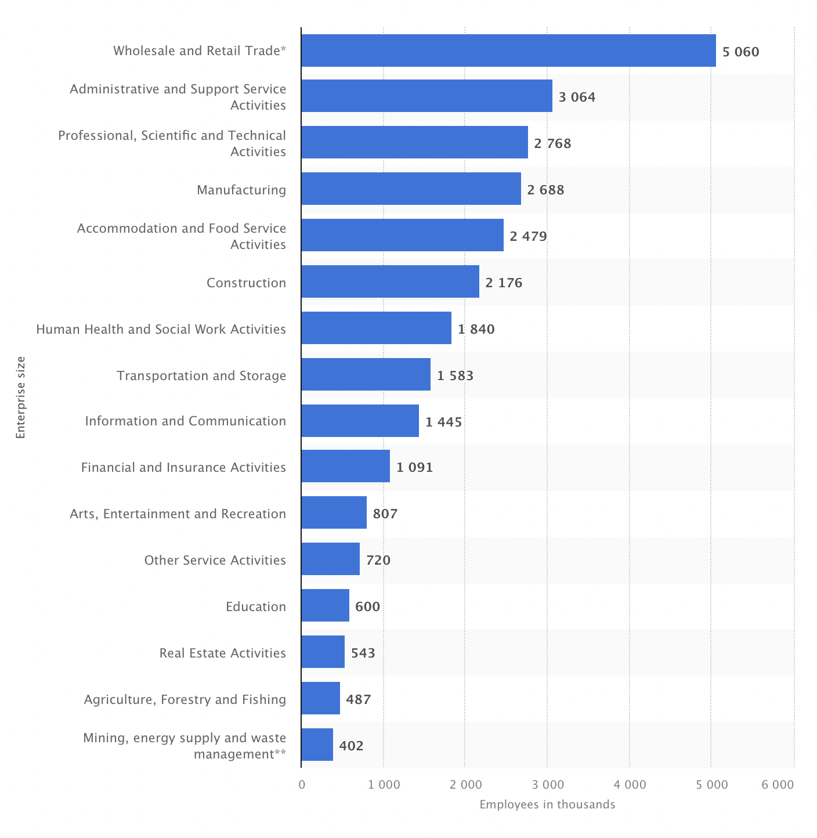
(UK private sector workforce2021 | Statista, 2021)

There are specific sectors in which CCTV are not only important but also necessary due to the business and necessity to customer protection. Human Health and Social Work Activities is in position 7 of number of people employed in the private sector in the UK, this is an area in which CCTV plays a crucial role. In Wales, a study in Care Homes about what is the impact of surveillance in the workplace revealed that CCTV had a good impact due to it creates a secure work atmosphere since CCTV is not found in the powerful actors but rather exist a necessity to protect to risk groups who are monitored (Vuokko, 2008). We understand that CCTV is used to care for and protect people who are part of risk groups, and employees have a responsibility to work properly. Surveillance is not only important but also vital since CCTV also supports to prove that employees are doing their tasks properly. This study and the research in Italy show that CCTV plays a crucial role depending on what is the sector in which they are using. Employees feel secure because recording can prove that they are working following the policies of the company, but this kind of sector has a limited number of employees. We want to analyse how surveillance influences the productivity of employees but under a context in which organisations use that information to control their performance.

We can see that CCTV does not always promote or encourage the satisfactory performance of employee tasks since an adverse impact can affect employee behaviours and that has a direct impact on the performance of workers. Researchers such as Weiskopf and Munro (2012) remark that HR professionals have a contemporary discourse in which there is an idea behind the management of human capital is to encourage their controlled circulation. Control is a paradigm in the current times by HRM. Barratt (2002) studied the workplace as a space in which HRM contributes to the ordering of employees by supplying much of the underpinning architecture for the inspection of the subject at work, but Knights (2002) argues that several organisation researchers focused on surveillance, through the gaze of institutional procedures in which employees are controlled in the workplace. We think that the main problem is those studies about surveillance in the workplace are especially based on organisation gaze. Our paper is about what is the impact of surveillance but from the employee side. In this sense, Barratt (2003) could define our paper as a ‘panopticon thesis’ due to it creates a view in which human resource practices are implicated under a gaze of discipline and control. In this constant struggle for control and discipline in the workplace, exist a control/resistance dualism between employer and employee.

2.3 Impact of CCTV
The impact of CCTV depends on different situations in which is not only involve what is the condition of the employee since it is important how an organisation encourage its employees to work under surveillance. In a study of 3200 Australian citizens, Martin, Wellen and Grimmer (2016) concluded that surveillance is critically dependent on the attitudes that employees formulate when they encounter it, employees who feel important levels of surveillance in the workplace tend to form negative attitudes. The impact is determinate by employee reactions. Every work environment is different, CCTV can motivate or demotivate employees depending on the context. As we saw, it is not the same impact of surveillance in a Care Home, where CCTV produces a security sensation in the workplace. The main difference is also about how organisations use the information and how they explain the benefits of surveillance. When organisations do not have a strategic plan in order to motivate employees about using CCTV, surveillance produces a negative effect on the workers. HR professionals have an important challenge about how to design and coordinate a plan that encourages the idea that CCTV is beneficial to workers. In this sense, it is vital that companies have a clear idea about what are the aims of CCTV.
Nowadays, organisations have technologies to surveillance not only through CCTV but also monitoring is extended to other dimensions like telephones, GPS or how employees use company computers. Under this context, surveillance means discipline because when workers do not achieve an ideal performance, organisations can find a way to punish deficient performance. According to Manokha (2020), recent studies show us that companies are better equipped to detect any non-productive activity of the employees. In this sense, CCTV influences directly on employee performances. Surveillance is not only about how employees are doing their tasks but also if they are going to achieve the company goals and what will be their reward or punishment. In terms to control employees, surveillance has a predominant role but not only about procedures and proper development of tasks of the employees, surveillance influence the behaviour of workers, and this is a direct impact on their performance.
An important problem is when organisations do not have a clear idea about their legal limits. Whittaker (2015) studied a conflict that originated due to the use of covert CCTV in Welsh. The council used covert CCTV in the workplace to monitor the activities of employees. In this case, the organisation had an employee who justified her absence because she felt anxiety and stress, but the council believed that the worker was simply using this absence to do not attending meetings. This case shows us that employer decides how they use CCTV even without following government rules. If the organisation has sufficient reason to monitor an employee, they have to be respectful about the privacy of their employees. We are going to analyse this situation in our Case Studies. In this sense, when a company does not show a clear policy about what are the limits of surveillance, the work atmosphere can be unstable and create an unsafe sensation. This situation influences and can be crucial to the performance of employees.
On the other hand, as we said, the CCTV effect depends on how the company encourage their employees to work under surveillance. We could see that under specific sectors CCTV produces a positive effect. Sarpong and Rees (2014) remark that a study about using surveillance in ambulances produced a favourable worker reaction. That reaction happened is due to existing an understanding of its relevance in the workplace and workers acknowledged that it is for their own safety and protection. We can see a contrast between the different effects that produce work under surveillance. CCTV always produces a positive or negative impact, and this depends on what is the business or how a company manage a program in which explains the benefit of CCTV. Knowledge is vital to have successful surveillance because if employees have a clear idea about what are the limits of the company and why CCTV can help them, they are going to feel motivation, and this it will improve their performance.
A study made by Ball (2010) wanted to measure the real impact of surveillance in the workplace and he concluded that surveillance has consequences for workers, affecting employee well-being, productivity, creativity, and motivation. Does monitoring improve performance and motivation? That depends on different situations. We want to advance a little more and discover if exist a patron in which surveillance impact positive or negatively on performance employee under a context in which CCTV is not using to produce a security environment. Martin, Wellen and Grimmer (2016) explain that a good leadership practice could reduce some of the negative effects of surveillance. We think that this practice has to be part of organisation procedure and not only to be in charge of charismatic leadership. In a work environment, surveillance influences the employees, who could feel pressure and tension about their task, and it could be important a strong presence of a leader who shows that control is a good mechanism to help them, but they also are employees.

We can see that from Foucauldian approach, control is discipline, and this is the goal of organisation. Discipline produces docile bodies, which are under constant surveillance. Employees naturalize the system and accept it with different effects. People internalise control, morals, and values, discipline is power (Galič, Timan and Koops, 2017). Employees who are monitored perceive an environment of distrust, and this may lead to higher levels of stress and frustration (Tabak and Smith, 2005). We are going to analyse if this prominent level of control and stress increase or not worker productivity, since an environment in which exist stress and frustration could be the worst setting for a company. Organisations have to try to reduce stress, along with workers who worry about their own health and well-being (Carneiro et al., 2019). However, there are other authors who claim that surveillance in the workplace has several benefits like Sarpong and Rees (2014) who explain that monitoring can increase productivity and reduce absenteeism. We are going to analyse if surveillance in the workplace has a positive or negative impact on the performance of the employees.

2.3.1 Monitoring improves performance?
Monitoring without clear limits could affect the performance of employees because excessive control creates an environment with permanent tension, and it could difficult normal tasks of the employees. Manokha (2019) affirms that physical workplace surveillance was the gaze of the supervisor, but now it is omnipresent as electronic devices record employee performance in real-time. We think that technologies are a vital mechanism for organisations that want to grow because this kind of information is important to be a focus on the strengths and weaknesses of the company, but sometimes employees could see affect their privacy, performance, and trust. The omnipresence of companies through electronic devices are crucial in terms to keep control and stimulate employee performance while organisation understand that they have a boundary in order to respect privacy workers in line to Article 8 of Human Right Act.
On the other hand, Villadsen (2007) remarks that technologies used by HRM help to support information about achievements and curricula of the employees, and it supplies an unbiased method of performance evaluation to prevent manipulation of the managers (Mishra and Crampton, 1998). We believe that electronic monitoring is a valuable tool used by HR professionals, but it is also essential to have a human gaze of performance. Electronic monitoring shows us numbers without analysis. We think that HRM has to understand that information based on electronic devices is a part of the evaluation, but it is not all the evaluation. Human Resource Management is to know how to combine different tools to have an adequate analysis of employee performance.
We do not have doubts about technologies have an unbiased gaze and they are necessary in order to stop supervisor subjectivities, but information without content could be dangerous in the way to find for an impartial evaluation. An important challenge to HR professionals is to adapt technological information with a human sense in which can reflect a more comprehensive analysis. Thus, Carneiro et al. (2019) explain that methods used by human resource professionals such as Electronic Performance Monitoring (EPM) are an essential element because it provides a wide range of information about employees' performance. Technologies and control are using to have an objective panorama of performance in the workplace, but this analysis needs to have more elements in which HR professionals can apply their knowledge. Ring (2016) argues that some of the very latest studies of surveillance and control show that invisibility of power does not mean its absence. We think that organisations need to be present or at least shows that they are watching, they do not want to be absent, and they try to remark constantly that they are controlling since monitoring works like control but also like prevention in terms to inform that an organisation is always watching.

2.3.2 Discrimination
Although monitoring by CCTV helps to keep an objective evaluation of the employees, HR professionals are human beings, and they can be subjective under some circumstances. Stanton and Lin (2003) argue that companies could monitoring with more emphasis some employees. We think that organisations could focus on specific groups (women, black people, younger workers, etc.) and this could create work discrimination. A clear policy would help to limit this kind of control since ethical use of CCTV is not enough. If a company does not have a clear policy and procedure about monitoring, surveillance could be biased. Evans (2007) affirms that employers could use data of employees to discriminate against them revealing personal attributes that the employer does not like. we will see that in some cases organisations exceeded the legal limits and they had to pay compensation to their employees due to the violation of their privacy.

2.4 Monitoring in Covid-19 times
Covid-19 pandemic changed the work environment, and HR professionals had to adapt their tools to the current times in which physical presence is restricted but it is growing virtual control. Under that panorama, technologies play a key role in order to help the performance of HR professionals. However, these professionals need to understand not only how to use them but also what are the rules about monitoring. Covid-19 accelerated use of diverse electronic mechanisms, but this process has to be gone with to legal training. In this sense, organisations had to extend of goals when they used CCTV, for example, they were cameras which counted the number of employees in the workplace, and if the number is more than the designated seats, it alerted the company (Singh et al., 2021). We think that under that context, CCTV helped to prevent virus expansion in the workplace, and employees feel more secure. However, pandemic increased monitoring of employees at work, and post-COVID "back to work" planning has included monitoring the health of employees, which is some of the most personal data workers have (Darnton, Morganand Ghuliani, 2021). We think that nowadays, monitoring is more invasive in part because Covid-19 changed some rules such as health. Even for employees who work from home, the pandemic prompted the creation of new forms of control such as screen capture, measuring keystrokes, webcam photos, and web monitoring.
Manokha (2020) remarks that due to the current pandemic, there are products such as ActivTrak, InterGuard, and Activity Monitor are used by employers to record and analyse employee activity. We think that these products existed before Covid-19 and companies were using them looking for a way to have better control. Covid 19 only showed massively something that already was happing: surveillance in the workplace is multiplying without an organisational policy that contains it within its legal limits. We are going to see how our country manages surveillance in the workplace under specific legal parameters in which there are also exceptions that we will analyse.

2.5 Legal frameworks for CCTV use in the UK
Although the UK is not part of the EU, our country keeps some of its laws, and it follows EU directives on the subject matter of employee monitoring and surveillance. Etsebeth (2007) explains that government rules encourage UK companies to have a clear policy about privacy in the workplace, and if an employee wants to base his/her claim on infringement of privacy, the Code of Practice will be the most effective regulation. We believe that this practice has sense because although the UK is living a post-Brexit process, we are going to see that European legislation have a strong link with British legislation about monitoring and surveillance since there is part of a global legislation of privacy. From the UK implemented the European Convention on Human Rights, this produced an important change about general rights in our country (Vallely, 2001). We think that the UK is in the middle in terms to categorize how countries are respectful of privacy in the workplace. The UK does not allow that companies can surveillance employees without informing them priorly, although sometimes British Courts decided in base to covert surveillance but justified them under the general interest of the community. However, those situations were under specific reasons that we are going to analyse them then.

2.5.1 The Human Rights Act (HRA) 1998
Regarding surveillance, article 8 of HRA remarks on the right to respect for privacy. Oliver (2002) concludes that this law has a direct impact on workplace practices. This article says: “Everyone has the right to respect for his private and family life, his home and correspondence”. Is the workplace a public or private space? That is not important because this article refers to the privacy of people no matter where they are, and we consider this right includes the workplace. This article explains that every person has the right to its privacy, and this does not do a difference between people roles or spaces. Privacy is inviolate even when employees use tools of the company such as computers or the internet for personal activities. If CCTV is intrusive, it could violate privacy workers because monitoring must have a purpose, and this has to be explained with a clear organisational policy. We understand that even in the workplace, employees have the right to their private life.

2.5.2 The UK GDPR
After Brexit, the UK is not regulated by the European General Data Protection Regulation (GDPR) and our country created UK GDPR (the United Kingdom General Data Protection Regulation). This regulation does not have significant differences to GDPR before Brexit and applies to the personal data process. This regulation consists of employees have the right to be informed about the collection of their personal data. Workers have the right to know what the purposes are to process their personal data, and how it will be shared. CCTV in the workplace is part of this regulation. Companies must inform to its employees how they are going to use their information and workers have the right to know what is information that companies have about them. For example, employees have the right to ask for to their companies all the recording of CCTV in the workplace where they are present, but they have to justify it.
2.5.3 The Data Protection Act (DPA) 2018
In order to respect privacy of employees, this legislation remarks that collection of personal data needs to have a purpose, and this has to be in line with legal parameters. Companies have right to surveillance, and they can record information, even they can manage confidential information of employees, but this collection needs to be justified. In this sense, a clear policy of companies is vital because supervisors who manage information of monitoring have to know what the limits are and what are their responsibilities. The second principle of the Data Protection Act says: “The law enforcement purpose for which personal data is collected on any occasion must be legitimate (…), and personal data collected must not be processed in a manner that is incompatible with the purpose for which it was collected”. This principle has the same sense as UK GDPR in that it is important to have a legal purpose when a company is watching and recording. CCTV data in the workplace has to be legitimate in order to follow government rules without having a subjective aim. The organisation cannot decide when it is necessary use CCTV, they have to justify their surveillance.

2.5.4 Surveillance Camera Code of Practice (2013)
In the same line with laws above mentioned, this Code of Practice remarks that uses of CCTV have to be oriented with a legal purpose. Using CCTV is not subjective since it has to be in line with a legal justification. This code also explains that information of CCTV has a restricted access because it is not public information and even people who access them have to have justification. This code regulates the use of CCTV in public spaces, but it is important because is a reference about using CCTV in the workplace. This code clarifies that CCTV is a valuable tool to manage safety and security in the protection of people and property, but it must have a legitimate aim, and this have to be in the same line with other regulations. This code remarks that data information has to be used for a legitimate purpose and record information implied a legal responsibility.

2.6 Surveillance law in other countries
Knowing how other countries manage privacy in the workplace is going to help us to understand what the position of the UK on the topic is. We saw that our country follows the Human Rights Act, especially article 8 in which the privacy of employees cannot be violated, even when workers are in the workplace, and they are using company tools such as computers. In the same line, our legislation does not allow that organisations do covert surveillance, although we are going to see that under specific cases companies can use it. As we saw, the UK has different laws in order to protect the privacy of employees and our country requires organisations to implement a clear policy on the use of CCTV in the workplace. We are going to see briefly what happens around the world.
2.6.1 US
In the US, privacy is understood as a faculty that organisations have the ability to decide what are the limits. American courts affirm that tools used in the workplace are property of organisations, and they have the right to monitoring how these are used. This is not in line with European legislation in which employees have the right to privacy and monitoring must be justified. Etsebeth (2007) criticizes US legislation because exist a tendency that workers do not have a right to privacy in the workplace.
2.6.2 Canada
In Canada exist two schools about how to manage surveillance in the workplace. These tendencies express two oppositive positions. There is one that argues that organisations are the owners of the tools in the workplace, and they have a right to monitor how their property is being used. This school receives the influence of the US ideas. However, there is a school that argues that employees' rights to privacy should weigh more than that of any employer (Etsebeth, 2007). This last is close to the EU idea about surveillance in the workplace. In this context, Canadian law keeps a balance between both. Personal Information Protection and Electronic Documents Act (PIPEDA) protects the privacy of employees in the workplace, but remarks that organisations can monitoring computers and email because they are company tools.
2.6.3 Australia
In Australia there is not a clear boundary to restrain employer surveillance of employees, although Australian employees have a reasonable expectation that their privacy in the workplace is not monitored by their employers. This expectation reflects the lived reality of most Australian workers (O'Rourke, Teicher and Pyman, 2011). Companies can surveillance even the privacy of employees in the workplace under specific situations like national security.
2.6.4 Russia
In Russia, the situation is different because employers can surveillance even without obtaining consent from the employees to process their personal data (Ofman and Sagandykov, 2020). In general terms, the situation in Russia is quite like the US due to for video surveillance to be legal, organisations must inform workers, but it does not require their consent. It is compulsory to inform that organisation is recording, or it is processing the personal data of employees, but they do not need prior consent.
2.6.5 Spain
In Spain is growing a tend to the legitimization of the use of covert monitoring in the workplace, but organisations have to justify a legitimate interest (Agustina and Coudert, 2013). This is an important topic because the use of covert CCTV implied play on the limit of legality. Depending on what is the level of justification, an organisation could use CCTV in an illegal way since justification needs to be reasonable.
2.6.6 Hong Kong
In Hong Kong, employers must notify their workers that monitoring is taking place, by what means, and the purposes for which it will be used (Walsh and Papworth, 2007). Privacy Ordinance allows that organisations can collect data by means which are fair in the circumstances. Employees have to be informed about the monitoring process, although it is not necessary for them to give their consent.
2.7 Human resource policies
Surveillance in the workplace implies legal issues and organisations have to design a plan in order to implement a clear policy about using CCTV. This policy is not only about government rules but also is think about how surveillance will affect the employees. We could see that a lot of times surveillance can be useful depending on how HR professionals encourage employees and avoid a stressful work environment. McParland and Connolly (2020) explain that companies are leaning towards the implementation of workplace policies in which there is a balance to the conflict of interest between organisations and workers. A balance means a good symptom because organisations are understanding that control without employee engagement will create an atmosphere where demotivation could negatively affect employee performance. These authors also remark that management has to consider the ethical and social impacts that techniques could produce in order to minimise the negative implications. We think that companies should not seek a balance because that means they try to find a way where they have two oppositive positions. Organisations must rebuild surveillance sense in order to create a secure work atmosphere where they remark that employees have the right to their privacy in the workplace.
In the same vein, O'Rourke, Teicher and Pyman (2011) explain that surveillance in the workplace is important due to studies shows us that sometimes workers misuse of technology would otherwise cause wastage and loss, but organisations need to follow anti-discrimination laws. we understand that companies need to have a procedure policy in which are detail ethical and social aspects of surveillance. Nowadays, we are living in a work context where organisations feel the necessity to produce employee engagement, but monitoring could avoid it, so it is vital that HRM create a plan in which monitoring generates a positive impact on the performance. Companies have to invest in supervisors training since how to use CCTV implies understand the legal consequences in case a bad use is.

2.8 Conceptual Framework
This study wants to analyse what is the real effect of surveillance on performance employees. In this sense, we need to define some concepts about our investigation to demark what is the field in which we are going to do our research. Surveillance is a concept that involves different parts of control since an organisation can implement different methods such as electronic devices, CCTV, or physical presence. Also, we are studying the control concept like an idea in which employees think that they are being watched. Control is the result of company surveillance and this idea that employees bear in mind while they are working. Control is a mechanism that needs both sides to exist.
When we analyse how surveillance affects employee tasks, we are studying what are the effects produced by control on employee performance, but what is the meaning of performance? Leatherbarrow and Fletcher (2019) explain that it is how people are fulfilling their aims, as an organisation or as an individual. Performance is an activity in which a person needs to achieve aims. In the work context, it is crucial to know what an organisation wants to achieve and what is way to do it. Each employee has a role as a worker and as a part of a team. Performance includes different activities depending on what are the targets such as speed or accuracy. However, performance has a strong relationship with behavior because it is to do something.
Torrington et al. (2020) affirm that performance can be measured with a link between input/output data of employees. Input because workers need to understand what the target is, and output because is how a worker does the tasks assigned to him. In the same vein, Baker (2019) remarks that performance is a combination of factors within and beyond the jobholder. Performance synthesizes a symbiosis between understanding and activity. Performance is a physical activity but also a mental one because it shows how the worker sees himself. Armstrong (2010) analyses performance only of output because affirms that it is the outcomes achieved. In order to keep the information updated and analyse workers activities, companies evaluate what are the results of employee tasks, these results are the performance employee. Performance combines two crucial aspects of employee activities: receive information and do tasks. It means that performance is when a workers have knowledge about what are their role, what is the organisation aim and how they are doing their tasks.
On the other hand, monitoring refers to control telephone calls, electronic correspondence, workers activities at the computer at work, video surveillance and GPS monitoring (Ofman and Sagandykov, 2020). Our study uses the meaning of monitoring and surveillance interchangeably to reflect the control of employees in the workplace. Nowadays, monitoring extended his presence to different spaces of the work atmosphere, including electronic tools. Monitoring reflects how each organisation supervise and analyse employee performances. In this sense, an organisation is a group of people in which they are working for the same goal. Leatherbarrow and Fletcher (2019) explain that organisations are persons. An organisation is a team in which there are diverse levels of responsibilities. Allen (1984) remarks that organisation is the process of identifying and grouping work to be analysed, and there are distinct roles, but they have the same goal.
Organisations need a workplace where employees need to work. We understand the workplace in the modern sense in which is a space in which employees do their tasks. A workplace is not only a building where a company works, because currently, but workers can also work from their homes. Heathfield (2011) concludes that a workplace is a space where a worker provides work for an employer. This can include offices, factories, stores, out-of-doors or employee homes. The workplace can be different depending on what is the kind of organisation. Nowadays, due to Covid-19, a lot of employees started to work remotely from their homes. Workplaces are an important part of the way organisations achieve their goals due to each person needs a space where they can work.

2.9 Conclusion
We could see that there are different positions about surveillance in the workplace. Studies of diverse parts of the world show us that employees feel afraid of their privacy, and this could affect their performance. However, depending on the context and how to use CCTV, monitoring can be a magnificent tool. Some authors remark that is crucial that organisations explain what the benefits of CCTV in the workplace are. Cantor (2016) argues that if companies use surveillance, it is necessary they have transparency with its monitoring since workers will become wary of how HR professionals use the worker-monitored data. We think that monitoring means building a vision about what the company wants. Organisation uses CCTV because is important to have a presence in the workplace, but also because the company designs its discourse. Subjectivities of employees and their identities are elaborated through discourses operating within the workplace (Carter, McKinlay and Rowlinson, 2002). Our approach analyses this discourse and what is the real impact on the employees.
Surveillance is not only surveillance, but it also means the idea about what an organisation wants about their employees. Analysis of Foucault is crucial in our topic because he describes the power and its levels, in which knowledge/truth and subjectivity/ethics are shown to map the main concerns of HRM regarding control, productivity, and motivation (Knights, 2002). Identify what is company discourse will help us to understand what the impact of monitoring on the workers is and if surveillance produces motivation or not. HRM measure physical and subjective aspects of labour, HR professionals build a link between promise and performance, and they organize labour into a productive force (Townley, 1993). However, our main question under this context is: do HRM use monitoring only for surveillance?
Regarding government rules about surveillance, our country is in a position in which it tries to find a balance between control and privacy. English privacy rules are more comprehensive than in the American system (Evans, 2007). As we saw, British law is influenced by the EU. in the UK, monitoring must be reasonably based, proportional, transparent and non-discriminatory (Etsebeth, 2007). Instead, we could see that the Russian model is like the USA model, in which organisations can surveillance and manage data information without a lot of restrictions, but EU countries have a different position since they respect the privacy of employees even in the workplace. In our case, the UK is in the middle of the board. It is important remarks that CCTV can be used without authorisation of employees, but it is necessary that they have knowledge about that, and they have the right to require for their data information. Organisations have to use CCTV in a proportionate way and to have a clear goal following UK legislation about privacy.
In our country, companies can manage the personal data of employees, but it is necessary to do it following the data transfer law. All employees have the right to know why, how and who manage their personal data. In the same sense, there is restricted access to the personal data of employees, and it is crucial that each organisation have a clear policy about why they are using CCTV in the workplace and to detail the procedures. Data Protection Act regulates CCTV recording and organisations which do not use CCTV properly can be fined up to £500,000. We think that organisations have to bear in mind a misuse of CCTV implies not only a fine, but also jeopardizes the integrity of a company and the level of trust of its employees. CCTV could work as a mechanism of persuasion to avoid dishonesty activities or to increase performance, but companies have to build a proper way to stimulate and control.

Chapter 3: Research methodology

3.1. Introduction
Our study will be analysed from theoretical/philosophical method. This method involves abstract theoretical, philosophical, and epistemological opinions. Theory and philosophy are a crucial part of our investigation due to our analyses are based on a philosophical approach. However, our paper is also based on a pragmatism epistemology since we are going to analyse different case studies and current situations in which our topic is being analysed. Data primary is also elemental to conclude our study, for this reason, we are going to survey since we need to have actualized information about our topic.
A mixed-methods approach is used in this study. The quantitative survey will achieve the data collection for research aims and understand what employees think the impact of surveillance on their performance is. We are going to use a Quantitative method because we are going to do a survey, in which we are going to interpreted numbers. For our study is crucial to have current data about our topic because we want to know what the impact of surveillance in the workplace on the UK post-Brexit is. Our target group will be male and female employees who are living in the UK. With our survey, we are going to collect primary data that is elemental to achieve a conclusion. Also, we are going to use a qualitative method to analyse Case Studies and understand how the British Courts are applying surveillance legislation in the workplace. Case Study is vital to analyse what is the empirical practice of our topic.
3.2. Research approach
Our research approach is based on the Research Onion of Saunders et. al. (2019). The Research Onion helps us to understand what the stages of our investigation are. Our strategy chosen is based on our aim. Our deductive approach will go with a mixed method. Our study will follow its way with a survey that will be analysed with our Case Study and Literature Review. Our analysis will of deductive approach because we want to prove the most common view of the relationship between theory and research (Saunders, Lewis and Thornhill, 2019). Our online questionary will help us to collect data quickly.
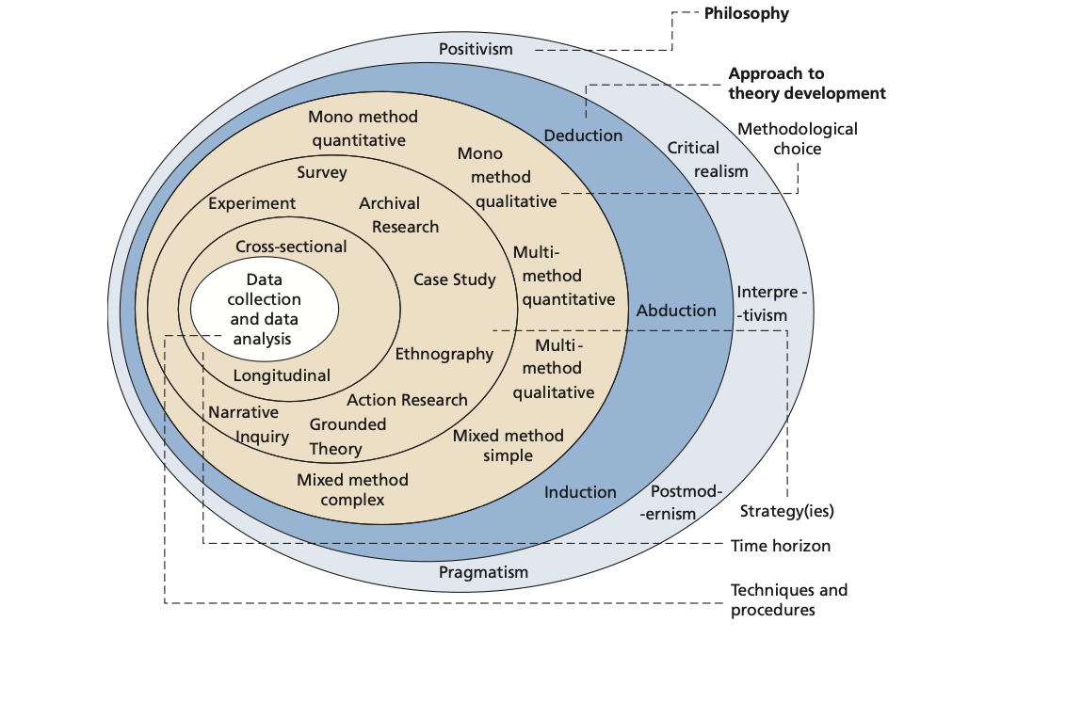Research Onion (Saunders et. al., 2019).

3.3. Methodological choice
Methodological choice can be qualitative, quantitative or both. We are going to analyse our study from a quantitative method because we need quantitative data (survey) for our analysis in which we can conclude our theory about our topic and qualitative (case study). Saunders, Lewis and Thornhill (2019) remark that a paper also needs research strategies like Case Studies. Those authors affirm that these strategies will influence the choice of an adequate Time Horizon. Our Case Study is going to be Longitudinal because we want to analyse how surveillance law was applied in different moments, but our survey will be Cross-sectional because we are going to collect data at a specific point in time.
3.4. Data source and collection
Our data source and collection include our survey in which we are going to quantify data. Saunders, Lewis and Thornhill (2019) determine that one way of differentiating quantitative investigation from qualitative is to differentiate between numeric data (numbers) and non-numeric data (words, images, audio recordings or similar material). Our quantitative data (survey) will be studied with a data analysis procedure (graphs). It is sine qua non that the people surveyed feel or have felt at least one kind of monitoring in the workplace. In case this does not happen, that information will not be considered for our final analysis. We have a defined target (people who are working in the UK). Our online survey is a method is that is a fast and cheap way of data collection (Acharyya and Bhattacharya, 2020). The structure of our survey will be crucial to have a study without bias. Our survey will be with volunteer participants who will answer with multiple choice answers.

3.4.1. Online questionnaire survey data collection
Our survey has a target to employees who are working in the UK, it will be divided between male and female because even we can find that CCTV impact could be different between genders. Our result will not be limited to the final number, it is crucial to understand them in order to design a theory about our topic. Wolf et. al. (2016) describe that quantitative data is not only the numbers since it is necessary to know how to interpretate them. Our link to take part will be send using emails, WhatsApp and other social media and will be open for two weeks.
3.5. Data analysis
Acharyya and Bhattacharya (2020) explain that after the data collection, a study needs to tabulate them using some software. The next part is to work with data cleaning because we need to reduce the errors. In the case of people who did not feel surveillance in the workplace, our result will exclude their answers. Data analysis is crucial for us because is our primary data about our topic. Saunders, Lewis and Thornhill (2019) remark that a theory is a result of the data analysis. In this sense, the data analysis procedure is how we categorised data in which with numbers we create non-numerical data.

3.6. Case study
The case study is going to help us to understand how the Courts are applying the laws in the UK. Lines above, we could see different theories and governments rules that regulate monitoring; However, we need to bear in mind that practice cases are going to show us what is the situation in which each law can be used. We wrote the UK follow the EU directives about privacy, but under some situations employees cannot use the article 8 of Human Right Act. Cases of protection of privacy in the workplace is a topic that is growing because organisations do not have a clear boundary about monitoring. British courts are upholding the notion of reasonable expectation of privacy in which companies are responsible if they cannot justify employee surveillance. Human Rights Act is the main law that employees use when they see their right are violated. We are going to analyse five cases about this theme.

3.7 Conclusion
We use a theoretical/philosophical method in our investigation due to our analysis is based on a Foucauldian approach. Theory and philosophy were relevant aspects of our study in which real practice was structured with theoretical aspects of our topic. Our study used a mixed-methods approach since we had a survey in which we use the quantitative method to collect data; however, we also used the qualitative method because we studied different case studies. Our research approach was based on the Research Onion of Saunders et. al. (2019). We used two kinds of Time Horizon since our Case Study was Longitudinal and our survey was Cross-sectional. Regarding our Case Study, we want to study how British Courts are applying the law on cases in which surveillance in the workplace creates a conflict.

Chapter 4: Data analysis and discussion
4.1 Introduction
This chapter aims to organise and analyse the primary data collected from the online questionnaire survey. We made a survey of 62 people who work in the UK. We wanted to analyse if surveillance in the workplace creates a positive or negative impact on performance employees and what they think about CCTV in the work environment. Our survey was online through Survey Monkey. We shared the survey link through different social media such as Facebook, Instagram and WhatsApp. Our study was made during the second week of October 2021. Answers had multiple choices.
4.2 Sample structure
Our survey had 10 basic questions. In the first part, we wanted to identify different social characteristics of surveys such as age, gender or how long they work in the UK. In the second part, we made questions about what they think to surveillance in the workplace. We tried to repeated questions with other words to analyse consistency of answers. All questions had as aim to analyse if employees think that monitoring in the workplace affects or not their performance.

4.3 Demographics questions
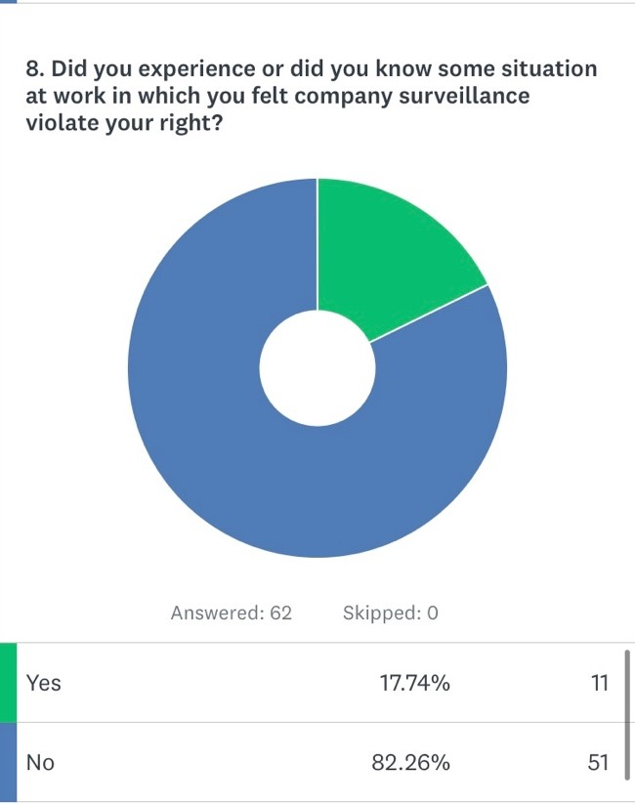
Our surveyed are predominant more than 20 and less than 50 years old. In this group we have 87% of our surveyed.

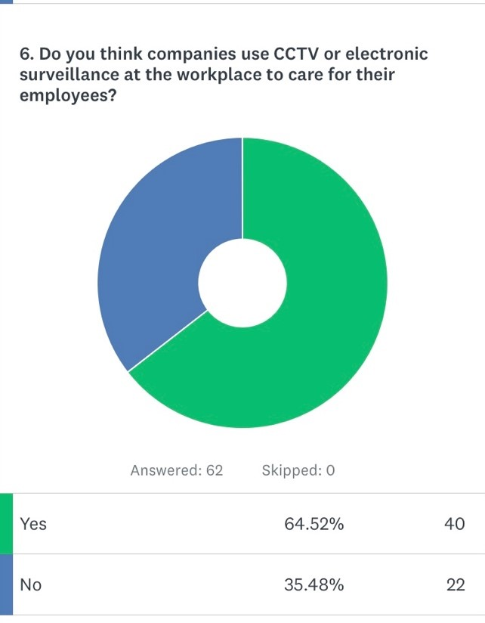
We have a predominant number of females surveyed.

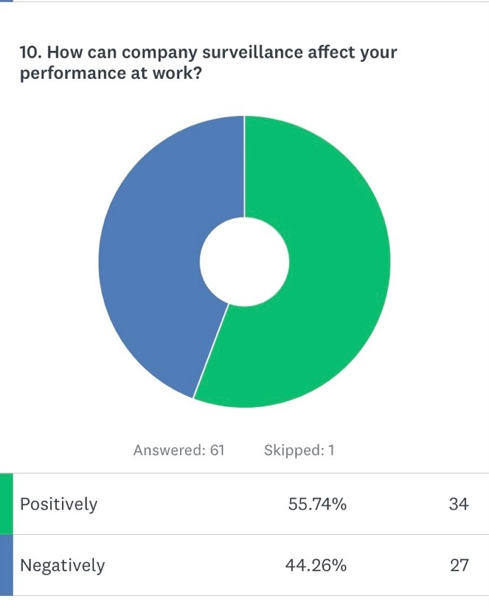
Regarding how many years our surveyed are working in the UK, we have that the most have between 1 and 10 years working in our country. It was necessary that all surveyed are working in the UK.

4.4 Impact of surveillance
We need to remark that we have an equitation average between those who think that CCTV in the workplace motivates and demotivates. There is a balance between the idea of monitoring in the workplace. People who think that the use of CCTV in the workplace creates demotivation are a little most, but they are not an important majority.

Although there are most who think that companies use CCTV in the workplace to control employees, they also think that organisations use it to care for them as well. We can interpret that employee feel control due to the use of CCTV, but also, they feel secure when companies use CCTV.
The most of surveyed think that the use of CCTV or electronic surveillance could violate their privacy right. They are not sure that organisations follow government rules about surveillance.
However, the most of surveyed did not have a personal experience with companies that violated their privacy right. Even, most do not know a case in which organisations violated the privacy rights of other people in the UK.
The most of surveyed think that surveillance could improve their performance at work, and this goes in line with the next question in which we try to find consistency.

Although our first hypothesis was that surveillance in the workplace could negatively affect employee performance, most of our surveyed answered that surveillance could affect them positively.

4.5 Discussion
In general lines, our primary data show us that surveillance seems do not to be a problem in the work environment context, even there is a tendency to feel monitoring creates a positive impact. Most of our surveyed affirmed that companies use CCTV to control employees, but also to care for them, and this create an environment where surveillance is not stressful. The most people surveyed think that surveillance could improve their performance, but this most is not absolutely and both opinions are close. We can see that the most people think that organisations could violated their privacy, but it is only a sensation because the most of our surveyed do not know some personal or external case in which privacy right were violated due to surveillance in the workplace. Although exist a majority who think that surveillance impact positively on their performance, this is not far if we have to compare with opinion people who think that surveillance creates a negative impact.
Regarding motivation, averages are close. We can interpret that most employees think that surveillance could negatively affect their tasks because they can feel demotivation. However, our survey shows us that employees do not feel CCTV is a threat, because they think that CCTV can control them, but also work as a tool to protect their security. In this sense, impact affects all employees in the same terms without being different of gender or ages. This sensation about organisations could violate their privacy rights could be generated due to companies do not inform their employees properly what is the role of control in the workplace. This is not a minor theme because most employees feel that bad communication could affect their performance. We can see that although there is an important number of people who think that surveillance could affect positively their tasks in the workplace, that it is not the absolute majority.

4.6 Case Study
4.6.1. Halford v UK
Alison Halford was appointed as Assistant Chief Constable with the Merseyside Police. When she was working, she applied on eight occasions for promotion, but they were unsuccessful. She claimed that she had been sex-discriminated because she was never promoted despite many of her workmate males achieved job promotions. She threatened her employer with legal actions because she understood that her gender was the main reason that she couldn’t promote. After that, she accused her employer of intercepting her calls at the office to gather evidence if she decided to start legal actions. She could prove that interception of her calls in the workplace were true.
The Court considered that the employer did not respect her private life and infringed her rights-violating her privacy since private conversation is part of her rights, even if she used a phone of her organisation in the workplace, that is still considered part of her private life. In this sense, the Court decided in base to the Article 8 of the Human Rights Act about privacy. Halford also did not receive a warning about monitoring her calls in the workplace and she had a reasonable expectation of privacy for such calls. The employer had to pay her in respect of pecuniary and non-pecuniary damage. This case has a strong link with the issue of electronic surveillance of workers in the workplace because a lot of times organisations do not differentiate between work activities and private life.
Companies can record calls in order to control the performance of employees, but it is necessary to inform them about controlling. Organisations have to justify if the recording is necessary. When employees are aware of the recording, then they cannot argue the company is violating their rights or they had a reasonable expectation of privacy. The main problem is created when an organisation does not have a policy clear about surveillance since supervisors do not have a clear limit on their roles and after they cannot justify why the organisation exceeded its duty of control.

4.6.2. Copland v UK
Copland was a worker at Carmarthenshire College. She was problems with her employer due to Carmarthenshire College saw how Copland wasted time using her phone and company internet for personal activities like social media or personal communications when she had to work. However, her employer did not have tangible evidence about that and decided to monitor its employee activity. Because Carmarthenshire College suspected the misuse of work time by Copland, it decided to surveillance her phone and communications. Her phone was monitored in order to know if she was having excessive personal use of it since Carmarthenshire College needed to have evidence to dismiss her.
Copland accused her employer to intercept her communications. Disputed was about the nature and duration of employee monitoring. The Court decided that the College monitoring infringed Copland privacy base of Article 8 of the Human Rights Act. Even when an employee is using company tools such as the internet or computer, personal activities are protected by the Human Rights Act. The State had to pay Copland in respect to non-pecuniary damage such as anxiety, low mood, inability to sleep, stress and costs and expenses.
Like in Halford v UK, telephone calls in the workplace can be part of the private life of workers and monitor them are intrusive since employees have legitimate expectations about their privacy. Monitoring employees are part of organisations rights in order to protect and stimulate better performance, but it is crucial that companies have a clear procedure in which employees have knowledge about the nature and reasons of monitoring. In our case, the College did not have a clear policy in which it can notify its employees about monitoring can give rise to a breach of Article 8, and the Court decided in order to protect employee privacy.

4.6.3. McGowan v Scottish Water
McGowan v Scottish Water case shows us how Courts analyse each case under its specific circumstances. Organisation surveillance cannot be studied in the same terms because government rules have exceptions. Mr McGowan worked in Scottish Water. He worked at a water treatment plant and lived nearby there. While he was working from his home, there were some indications in the performance of its employee and the organisation thought that McGowan was absent when he had to be working. The company did not trust the work he claimed to be doing and concluded that McGowan was falsifying his timesheets, but it needed proof to dismiss him.
Scottish Water decided to use covert surveillance of his home. The idea of the company was to discover if McGowan was into his home while he was working. McGowan was dismissed because Scottish Water could prove that its employee was outside his home in worktime. McGowan did personal activities outside while he claimed that he was working. Although Scottish Water had proof about McGowan activities, these were obtained under convert surveillance, which is an illegal activity, and it is not allowed. Mr McGowan accused the company of violating his privacy under Article 8. However, the Court rejected his claim due to Scottish Water justification that converts surveillance was used under the interests of public safety.
There is an interest that is superior and is the general interest. This means that even if organisations use ways that can be illegal for other companies, it all depends on what justification is. In our case, public safety allows the use of covert surveillance because Courts understand that employees are not going to have expectations of their privacy with activities in which jeopardise public health. This case shows us an exception in government rules about surveillance.
4.6.4. City and County of Swansea v. Gayle
This case shows us that covert surveillance can be used even when there is not a public interest. Mr Gayle was a council employee who played squash when he had to work. He preferred to play sports in part of his work time. The council decided to engage a private investigator to prove that Gayle was not in his workplace during working hours. Investigator filmed Mr Gayle outside the sports centre when he had to work, and the council dismissed him because it had evidence on.
Employment Tribunal upheld that the dismissal was unfair due to the use of covert surveillance was illegal and infringed Article 8 about the private life of Gayle. In this case we do not have general interest or public safety involved. However, Employment Appeal Tribunal overturned the first decision because covert surveillance was on a public road and there was no reasonable expectation of privacy. Finally, Mr Gayle was dismissed. The Court understood that Mr Gayle was a fraudster because he knew his activities were not allowed. Final decision included that in public places, such as road public, recording or take photographs do not form a breach of Article 8.
4.6.5. Vaughan v. Lewisham LBC
In this case, we have a different panorama because is the employee who had evidence-based in a covert recording, and we understand that cover recording is part of a covert surveillance in a work context. Ms Vaughan accused her employer because she was unfairly fired due to her disability and depression that she suffered from. Ms Vaughan was suffering psychological problems that affected on her performance and how she behaved with her co-workers. That was the main reason she was dismissed.
However, she said to have evidence about the discrimination she suffered bases on covert recordings with colleagues and her manager. She said that her covert recordings were evidence of the mistreatment he received at his job. Employment Tribunal refused her application because she did not supply copies of the tapes and she could not show evidence about that. Employment Appeal Tribunal upheld the tribunal decision because this was correct. However, this case is important because EAT remarked that even covert recordings can be admitted as evidence at work context if the Court understand that it is necessary and justified.
4.7. Conclusion
Our survey was made to 62 people who work in the UK. This study showed us that surveillance in the workplace in the UK is an important theme because only almost half of our surveyed think that monitoring could help to improve their performance. We used Survey Monkey to do this study in which we shared the survey link through different social media such as Facebook, Instagram, and WhatsApp during the second week of October 2021. Our survey had multiple choices with 10 questions about demography and how employee think that surveillance impact on their performance. We could see that most of our surveyed work in the UK between 1 and 10 years. Regarding to motivation, surveyed who think that the use of CCTV in the workplace creates demotivation are a little most, but they are not an important majority.
61% of employees think that companies use CCTV in the workplace to control them, but 65% think that organisations use CCTV to care for them as well. In this sense, most of surveyed think that surveillance control and care them, and this could reduce employee’ negative feeling towards control through surveillance. Also, this survey showed us that although workers in the UK think that organisation could violate their privacy rights with surveillance, only 18% experienced or they knew a situation at work in which they felt company surveillance violated their privacy rights. This shows us that is a big challenge to HR professionals to implement policies and procedures in which employees have active participation with knowledge and opinions about what is monitoring and how this can affect on their performance. On the other hand, we our Case Study we could see that Courts understand that it is necessary a reasonable expectation of privacy in which companies can surveillance following government rules.

Chapter 5 Recommendations and Implementation Plan
We could see that monitoring in the workplace generates different feelings for the employees, especially when there is a stressful work environment. Although our surveyed feel that surveillance could violate their privacy rights, they do not have an experience, or they do not know some cases in which surveillance in the workplace violated privacy rights. This sensation is created as a consequence of natural mistrust of human beings, especially when they do not know who is watching them. When surveillance has name and surname, employee could naturalize it and even understand that control could be part of a process of professional grown. When we talk about name and surname of surveillance, employees need to know who is behind CCTV or at least what are the reason to watch them. Our recommendations are:
1.- Bimonthly virtual meetings: It is crucial to have online meetings in which HR professional use a time to detail what is the proper procedure of CCTV uses and how employee can defend their rights. Government rules says that employees have rights to know how companies manage their personal data and this include video recording.
2.- Email communications: Although most of the employment contracts have these clauses about surveillance, most of the employees do not take them into account and think that the company may exceed in the monitoring violating their right to privacy. It is at this point that HR professionals must work and pay special attention to ensuring that employees know that their rights are respected with constant emails.
3.- Annual meeting: A plan has to include at least an annual meeting about this topic with summaries via emails in which company explains what the procedure in case employees is feel that their privacy rights are violated.
Posters: Having posters at the main points of the workplace in which companies remark that CCTV follows the government rules are essential to remember to employees about surveillance in the workplace.
Human Resource professionals have the important task regard to keeping workers updating about what are the benefits of monitoring in the workplace. In this sense, the strategy of HR professionals must involve employees about what are the reasons of surveillance. Explanation does not mean submission; it means create a bridge of communication in which all wins. The main challenge of HR professionals is to build a link with employees to inform them that surveillance is a right of the organisation and they are respectful of their privacy rights.
Chapter 6 Conclusion
6.1. Summary of key findings
Our study showed us that employees in the UK feel that companies violate their privacy although most of them did not experience that situation. From a Foucauldian approach, this sensation is part of a mechanism implement in different spaces where a human being is doing activities. Our main goal was to explore how surveillance impact employees performance in the workplace. Our study was based on employee opinions since we found some papers in which researchers were based only on organisations views. We could see that surveillance in the workplace is an important aspect of employee performance, especially because it influences their tasks. Throughout employees' opinions, we could see that CCTV and electronic devices used to surveillance them influence negatively on employees motivation. However, there is 48% of surveyed think that surveillance could motivate them.
Why do have surveillance in the workplace a majority negative number? Although 82% of employees did not experience a situation in which privacy rights were violated in the workplace, exist a negative feeling about that. A Foucauldian approach explains that human beings feel constantly surveillance as part of a mechanism in which organisations need to show that they control them. Even when companies are not watching them, workers still feel that organisations control them through monitoring sometimes because they do not know who is watching them or because they do not know the surveillance reason.
6.1.1 Foucauldian approach
In our study, surveillance means control used as a company mechanism in which this is part of its strategy to have a presence over all aspects of the organisation. Control is power and power build subjectivities, this last means what a company wants of its employees. Organisations need to show that they are watching permanently because even when they are not watching, workers are going to do their tasks properly due to the idea of constant surveillance. Power generates discipline and this last one is essential if the organisation wants employees who follow the rules and do their tasks properly. This is an asymmetric power in which organisations want to create an idea about control with its corresponding rewards and punishments.
From Foucault gaze, the workplace is a new panopticon in which organisations are always watching, even when they are not watching. In this sense, we talk about the workplace, it is not only the physical space where workers traditionally do their tasks because employees work from their homes. Panopticon is nowadays used with electronic devices and the physical presence of a supervisor is not necessary. We believe that the modern Panopticon works better without physical presence because, through electronic devices, supervisors can be present around the world. However, organisations need to remark to their employees that they are present to create the permanent idea of surveillance.

6.1.2 Reasonable expectation of privacy
Our study could show us that Courts are analysis surveillance cases from a reasonable expectation of privacy in which organisations must understand that employees have privacy rights. We could see when companies do not monitor in order to follow the government rules, they violate important human rights. In this case, the main problem for the companies is not pay a fine, but it is crucial that they keep a good image. When a company loss trust and when employees feel untrust, aim of organisations are in danger. With our Case study we saw that organisations need to have a clear policy of surveillance because when supervisor do not know about that, this can imply big problems for the company.
However, in some specific cases, our legislation allows that companies exceed privacy rights in order to defend general wellbeing. There are organisations such as water or electric companies that in some cases can jump employee privacy rights. This is a reasonable expectation of privacy, in which when exist a justifiable reason, companies or employees can jump privacy rights to prove an illegal situation. Courts have to evaluate each case under their contexts and as an exception. Nowadays, Brexit did not change rules about surveillance in the workplace.
6.2. Contribution of the paper
The contribution of this research is to show that surveillance in the workplace produces a work atmosphere of mistrust although employees admit that it could help improve their performance. The workers emphasize that surveillance in the workplace is to control them but also to take care of them. With this study we can understand that HR professionals have a fantastic possibility to develop a great tool with CCTV, but it is crucial to have knowledge about government laws because a company could suffer damage not only economically but also with its image. Whittaker (2015) remarks that there are contracts of employment in which implied conditions of mutual trust and confidence that need to be upheld. Thus, the decision to implement workplace surveillance could damage the interests of the business and the privacy interests of the individual (Walsh and Papworth, 2007). It is possible that an innovative idea is that employees could take part in CCTV implementation. In that case, workers could be wary of how management uses the worker- watched data (Cantor, 2016).
Our paper wants to help us to understand the importance of using CCTV in the workplace is, and to analyse the consequences. West and Bowman (2016) explain that the employer-employee relationship could be negative if surveillance does not respect privacy. However, Agustina and Coudert (2013) affirm that trust is something built because only time can ground relationships on trust and work relationships are too sporadic to rely 100% on trust. In this sense, we hope that our paper helped us to clarify this panorama. Our study wants to be a guide in which HR professionals should understand their role holistically, in which are necessary knowledge of law, sociology and managing people. HRM is much more than managing people, it is understood people and apply policies in concordance with government rules. This paper wanted show us if surveillance produce a negative or positive effect on employee performance and how HR professional have to deal with this topic.
6.3. Further research areas
From our survey arose questions such as have the same impact surveillance in the workplace on older and new employees? Surveillance in the workplace is the same in all areas of a company? We believe that future research on the subject should include more detailed surveys differentiated by sector and role levels. We believe that this study opens the way for a more detailed analysis in which in-depth interviews can be included in order to understand answers such as why employees think that surveillance helps them to improve their performance or why not?
Monitoring in the workplace is an important topic that could be studied from the organisations and employee side at the same time and analyse what are the links and the problems. It is possible that in the coming years, some government rules on workplace surveillance will change because Brexit has not yet affected this issue, so Human Resources professionals must keep up to date in order to implement the proper policies. at the precise moment.
6.4 Research limitations
Our paper was oriented to the impact of surveillance on employees such as members team or workers with a low range. Currently, we do not know what managers think about surveillance in the workplace. Our study made focus on employees' gaze without bearing in mind if the supervisor thinks the same because we wanted to analyse over who receive the impact. Managers or supervisors normally are behind CCTV, and they could identify some characteristics of impact, but we wanted to study it from protagonists. On the other hand, we conducted a general survey without separating it into job sectors. Our sample includes workers from all sectors, excluding managers.

