
Module: LCMB7002 Financial Management
Assignment Title: Financial Performance and Strategic Financial Management of Marriott International
Student ID: 2536659
Student Name: Rajveer Singh
Word Count: 5200
Table of contents
Introduction 4
Organisational Overview: Marriott International 4
Report Purpose 5
Report Context 5
1. Financial Health Check 5
1.1 Financial Statement Analysis (Five-Year Analysis) 5
1.2 Ratio Analysis 6
1.2.1 Profitability Ratios 6
1.2.2 Liquidity Ratios 6
1.2.3 Efficiency Ratios 6
1.2.4 Gearing Ratios 7
1.2.5 Investment Ratios 7
1.2.6 Cash Flow Ratios 7
1.3 Financial Trends, Strengths and Weaknesses 7
1.4 Liquidity Ratio Comparison with Industry Benchmark 8
2. Working Capital Management Analysis 9
2.1 Cash Operating Cycle 9
2.2 Strategies to Improve Liquidity 9
2.3 Short-Term vs Long-Term Financing Options 11
3. Strategic Financial Restructuring Plan 12
3.1 Financial Restructuring Options 12
3.2 Impact: Shareholder Value, Debt Structure & Operational Flexibility 13
3.3 International & Ethical Considerations 14
4. Investment Appraisal and Capital Budgeting 14
4.1 Project Information 14
4.2 Payback Period (PBP) 15
4.3 Accounting Rate of Return (ARR) 15
4.4 Net Present Value (NPV 16
4.5 Profitability Index (PI) 16
4.6 Internal Rate of Return (IRR) 17
4.7 Investment Recommendation 18
4.8 Capital Rationing 18
5. Critical Reflection on AI Usage 18
5.1 Tool Disclosure 18
5.2 Critical Evaluation of AI Output 19
5.3 Contribution Analysis 19
5.4 Ethical and Professional Reflection 19
Conclusion 20
References 21
Appendices 27

Introduction

Organisational Overview: Marriott International
Marriott International, Inc. is an American multinational hospitality company founded in 1927, with its official headquarters in Maryland, United States. With more than 30 leading brands and over 9,900 properties in 146 countries and territories, it showcases a powerful portfolio presence in the industry (Marriott International, 2026). The company is a global operator, franchisor, and licensor of hotels, residential properties, timeshare resorts, and other lodging facilities, and also engages in management, franchising, and licensing of hospitality services. The notable hotel brands of Marriott include JW Marriott, The Ritz-Carlton, St. Regis, W Hotels, and The Luxury Collection. It operates through long-term management agreements, a network of franchised and licensed properties across the globe, including North America, Europe, Africa, the Middle East, Asia-Pacific, the Caribbean, and Latin America (Globaldata, 2024).
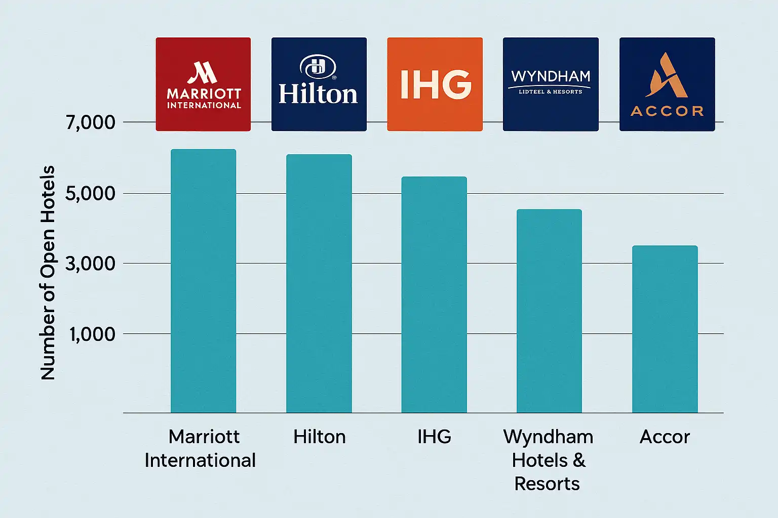
Figure 1: Marriott International position
(Source: Takahashi, 2025)
Marriott operates through an asset-light business model by avoiding significant capital expenditures in regard to acquiring, developing, or maintaining hotel properties. The company reduced financial risk by generating revenue through franchising and management contracts with independent property owners (Busch, 2023). This has supported Marriott in gaining a position as the biggest hotel chain globally (Takahashi, 2025). Moreover, the ability of Marriott to meet capital requirements makes it highly scalable globally.

Report Purpose
The key purpose of this report is to focus on the role of the Chief Financial Officer (CFO) in terms of conducting a comprehensive financial review and proposing a forward-looking financial strategy for Marriott International. In this regard, the report will assess the financial performance of Marriott over the past five years, with the identification of strengths and weaknesses, in addition to the impact of key trends. The outcome of the report will offer the Board evidence-based recommendations to sustain long-term profitable growth while gaining financial resilience.

Report Context
The report is broadly classified into five main sections to gain a comprehensive insight into factors impacting the financial strategy of Marriott. In this aspect, the report will assess financial health by analysing Marriott’s financial performance over the past five years. Further, it will briefly evaluate operational efficiency by reviewing capital management and liquidity and the effort to manage seasonality and economic volatility. Strategic plans for financial restructuring will be provided in response to enhancing shareholder value, managing debt structure, and securing overall global operational flexibility. Additionally, the report will also analyse and evaluate three proposed capital projects leveraging investment appraisal techniques, such as PBP, ARR, NPV, PI, and IRR and recommend the optimal allocation.

1. Financial Health Check

1.1 Financial Statement Analysis (Five-Year Analysis)
As is evident in Marriott's five-year financial performance, it is clear that it has begun to show signs of recovery and growth from 2021 to 2025. Revenue increased from $13.86 billion in 2021 to $26.19 billion in 2025. The same was true for operating profit, which went up from $1.75 billion to $4.14 billion in the period. The net income increased from $1.10 billion to $2.60 billion. The operating cash flow has increased from $1.18 billion to $3.21 billion. This marks a rise in revenue, profitability, as well as cash generation. Shareholders' equity was, however, found to be negative at $3.77 billion in 202,5 which decreased from $1.41 billion in 2021.

1.2 Ratio Analysis

1.2.1 Profitability Ratios
Profitability Ratios tell how well a business can make a profit on revenues and operations (Wall Street Prep, 2024). Marriott's profitability continued to be strong over the five years. The net profit margin increased from 7.93% in 2021 to 9.93% in 2025. The operating profit margin was also higher at 12.63% compared to 15.81%. The improvement indicates improved operating performance and increased profits. The net profit margin of the 2023 results was particularly good at 13.00%.

1.2.2 Liquidity Ratios
A company's liquidity ratios are used to assess its ability to pay its short-term financial commitments (Fachrian and Hidayat, 2023). Marriott's liquidity was poor during the 5-year period. The current ratio declined from 0.57 in 2021 to 0.43 in 2025. That is, current assets have been less than current liabilities. In 2025, it was slightly higher at 0.40, compared to 2024. The quick ratio was also on the decline from 0.57 to 0.43.

1.2.3 Efficiency Ratios
Efficiency ratios are used to gauge a company's efficiency in using its assets to generate revenue (Corporate Finance Institute, 2026). In the past 5 years, the efficiency of Marriott has increased. The inventory turnover ratio went from 2.92x for 2021 to 4.61x in 2025. This means that the speed at which goods are turning over within operations has increased. This ratio had climbed to 5.02 times in 2023, but dipped slightly in that year. The receivable turnover ratio rose from 6.99 times in 2021 to 9.00 times in 2025.

1.2.4 Gearing Ratios
Gearing ratios are indicators which reveal the extent of debt financing of a company and its capacity to control the cost of such financing (Rusu and Roman, 2022). The gearing position is a sign of increasing financial pressures for Marriott. The debt-to-equity ratio changed from 17.07 in 2021 to -8.30 in 2025. This reflected the negative shareholders' equity which occurred from 2024. In 2022, the ratio of interest coverage was 8.59 times and in 2025, it fell to 5.12 times. The ratio was 4.17 times in 2021.

1.2.5 Investment Ratios
Investment ratios are used to measure the returns earned by the shareholders and the earnings from the company's investment (Accaglobal, 2026). When it comes to ROE, it has made a significant change over the five years as compared to Marriott. ROE was 0.78 in 2021 and increased to 4.15 in 2022. This subsequently turned negative when shareholders' equity went negative. The ratio reached -4.52 in 2023 and improved to -0.69 in 2025. Marriott’s EPS increased from $3.36 in 2021 to $9.53 in 2025. This is a positive sign of improved earnings per share (EPS). The negative ROE indicates that the company is in a negative equity position.

1.2.6 Cash Flow Ratios
Cash flow ratios are used to determine how much cash a business can produce by operating and investing in its business (Seretidou et al, 2025). The performance of cash flow improved over the five years for Marriott. The operating cash flow margin increased from 8.49% in 2021 to 12.27% in 2025. This means that the company has better operating cash flows. The ratio reached 13.37% in 2023 before declining in 2024. The free cash flow margin also improved from 7.17% in 2021 to 9.96% in 2025. This indicates a higher level of cash available for other purposes once capital expenditure has been made.

1.3 Financial Trends, Strengths and Weaknesses
1.3.1. Financial trends
Financial Trends indicate the trend in the financial performance of a business over time. The revenue of Marriott increased at a healthy rate over 5 years. Revenue increased from $13.86 billion in 2021 to $26.19 billion in 2025. There was a rise in operating profit from $1.75 billion to $4.14 billion. The net income rose from $1.10 billion to $2.60 billion, too. The amount of cash flow generated by the business increased from $1.18 billion to $3.21 billion. EPS increased from $3.36 to $9.53 (Marriott, 2026).
1.3.2. Strengths
While there are some problematic issues at Marriott, the company does have several strengths to help bolster its performance going forward. Revenue increased strongly from $13.86 billion in 2021 to $26.19 billion in 2025. In addition, there was an increase in operating profit from $1.75 billion to $4.14 billion. The net income for 2025 was $2.60 billion. Operating cash flow turned around to $3.21 billion, helping meet internal funding requirements. The number of times the receivables were turned over in 2025 was 9.00. This means that there is good management of receivables. EPS also increased from $3.36 in 2021 to $9.53 in 2025 (Marriott, 2026).
1.3.3. Weakness
There are several financial challenges that can be a threat to Marriott's financial stability. The current ratio has not been above 1 during the last 5 years. It currently has little coverage of current assets, as it grew to only 0.43 in 2025. The liquidity pressure was also similar,r with the quick ratio of 0.43. In 2025, shareholder equity turned negative for the first time, down to -$3.77 billion. This led to negative ROE and made the debt-to-equity ratio that was calculated unhelpful to interpret. The interest coverage also decreased from 8.59 times in 2022 to 5.12 times in 2025. These are higher levels of finances pressures (Marriott, 2026).

1.4 Liquidity Ratio Comparison with Industry Benchmark
There are several financial challenges that can be a threat to Marriott's financial stability. The current ratio has not been adequate (less than 1) for five years. It currently has little coverage of current assets, as it grew to only 0.43 in 2025. Liquidity pressure was also at risk in the quick ratio, which was at 0.43. In 2025, shareholders' equity turned negative as it dropped to -$3.77 billion. This led to a negative ROE and complicated the use of the debt-to-equity ratio to analyse the firm. The interest coverage also decreased from 8.59 times in 2022 to 5.12 times in 2025 (Marriott, 2026).

2. Working Capital Management Analysis

2.1 Cash Operating Cycle
According to Karim et al. (2023), the cash operating cycle is a significant tool for measuring the liquidity of a company in response to the time between actually paying for manufacturing inputs and collecting from debtors. This means the process is relevant for measuring the effort of the company to pay for operational inputs and additionally generate cash from customers. In the context of international hospitality cooperation, such as Marriott operating in an asset-light model, the cycle is found to be influenced by components such as the inventory holding period, the receivables collection period and the payables deferral period (Busch, 2023; Karim et al., 2023). The inventory holding for Marriott is likely to be minimal, as it operates only on a just-in-time basis in regard to food, beverage and housekeeping suppliers (Barlow, 2022). Moreover, the primary inventory risk can be highlighted with franchised and managed properties, rather than at the corporate level.
Marriott generates receivables mainly from franchise royalties, management fees, and marketing contributions (Marriott, 2024). The collection period in this aspect relies on billing cycles, regional payment practices, and the financial health of franchisees, where economic downturns can create pressure on corporate liquidity. Besides, the payables deferral period is driven by services central to technology, marketing, and administrative support (Marriott, 2024). This allows the hotel company to negotiate extended payment terms with suppliers as a result of potential global bargaining power. It can be implied that the asset-light model of Marriott is detrimental to pursuing operations, regardless of a negative cash cycle. Therefore, the effective management of the cash operating cycle is pivotal for maintaining liquidity while eliminating reliance on external borrowing.

2.2 Strategies to Improve Liquidity
Improving liquidity, as argued by Wang and Nie (2025), is significant for aligning inventory levels with actual demand by streamlining processes that can lead to a faster cash conversion cycle. In relevance to Marriott, to improve liquidity through working capital reforms, it must ensure to address core areas, including:
Receivables optimisation:
This will allow Marriott to accelerate cash conversion cycles and improve liquidity, within the implementation of centralized operations, such as billing and collections platforms across all global regions. This will also lead to standardisation of invoice timing and automated reminders, thereby providing real-time visibility of supply chain performance, reduced costs, and increased supply chain efficiency. Also, this will guarantee early payment incentives for franchisees can be accelerated for cash inflows (Shah, 2025). This will moreover realign activities in terms of credit monitoring process by lowering the risk of delay and default, while allowing proactive support to improve cash conversion cycle.
Payables management:
The optimisation of payables management strategy can be feasible for Marriott to enhance global supplier contracts and secure funds by strategically extending payment terms. Moreover, the focus of hotel venture on pursuing supplier agreements will help to consolidate spend and negotiate consistent payment terms in the global market (Lien, 2024; Zheng et al., 2025). For instance, it can introduce a voluntary supplier finance program, assuring that suppliers are able to receive early payment from a third-party financier, despite the company paying it later (Zheng et al., 2025). Overall this will help Marriott to improve supplier relationships, particularly for, eliminating negative impact of corporate liquidity.
Treasury and cash centralisation:
Marriott highlights the presence of 30 leading brands and manages over 9,900 properties in 146 countries and territories, where the cash is often held in multiple currencies and legal entities (Marriott International, 2026). In this regard, implementation of treasury and cash centralisation will allow the deployment of global cash pooling structure (Kubranová, 2020). This will enhance operational efficiency and optimise resource utilisation by minimising food and beverage waste and reducing inventory holding.

2.3 Short-Term vs Long-Term Financing Options
Criteria | Short-Term Financing | Long-Term Financing
Purpose | Meets seasonal working capital needs and addresses temporary cash gaps (Prudential, 2019)  Impact on Marriott: Manages fluctuations in occupancy and owner payment timing | Enhances financial strategic investments and supports acquisitions and major capital projects (Prudential, 2019)  Impact on Marriott: Boost global operation/expansion and technology upgrades
Cost Structure | Low interest rates, but they can vary due to market changes (Shah, 2025)  Impact on Marriott: Cost-effective in stable rate environments | A fixed interest rate provides cost certainty for a longer period (Shah, 2025)  Impact on Marriott: Expensive, however safeguard against rate volatility
Risk Profile | Higher risk of refinancing, but vulnerable to liquidity pressure and downturn (Shah, 2025)  Impact on Marriott: Despite offering flexibility, Marriott can experience credit vulnerability | Lower refinancing risk, however, relies on covenant obligations (Prudential, 2019)  Impact on Marriott: Stability and enhances overall credit ratings
Capital Portfolio | Limited flexibility (Shah, 2025)  Impact on Marriott: Funding base is narrow (Prudential, 2019) | Greater flexibility with access to diverse resources and funding capital (Prudential, 2019)  Impact on Marriott: Space out debt maturities, with access to the bond market and investors
Table 1: Short-term vs long-term financing options
(Source: Self-Developed)

3. Strategic Financial Restructuring Plan

3.1 Financial Restructuring Options
Financial restructuring, according to Oord (2024), is vital to determine the root cause of the cash flow problem by deeply understanding the factors that require financial remediation. In terms of Marriott, this will allow it to strengthen its balance sheet and enhance global operations and rely on options such as:
Option 1: Divestiture of non-core assets
In response, Marriott's divestiture of non-core assets involves selling non-core assets, such as owned real estate, joint ventures or brands, which lack alignment with its core asset-light strategy. The cash generated from this can be feasible for reducing the impact of debt and fund share, additionally enhancing reinvestment in high-growth segments, including luxury and extended stays. Moreover, for Marriott, divestiture can be vital for simplifying its portfolio by eliminating the impact of its operational complexity and allowing management to effectively make use of fee-based revenue streams (Oktaviyani et al., 2020). Thus, the hotel brand can improve its asset efficiency while eliminating focus on capital-intensive operations that are likely to generate lower returns.
Option 2: Strategic merger
The financing restructuring option pertaining to a strategic merger for Marriott can bring a vital opportunity to accelerate growth across its priority global markets and segments through technology-driven merger initiatives, such as a technology platform to support and enhance direct bookings or the maintenance of a regional brand portfolio. Moreover, this specific option will offer the hotel venture an opportunity to scale benefits in terms of cross-selling and access to new customer segments (Shijaku et al., 2025). Nevertheless, it is significant to realise synergies, as it demands for careful integration planning and cultural alignment.
Option 3: Equity injection
Through the option of equity injection, Marriott can temporarily pause aggressive shareholder returns while retaining earnings, which is vital to strengthen its equity (Prokop, 2025). Moreover, the focus on this specific option will help the hotel brand raise significant cash for funding a major merger, thereby eliminating dependence on other sources. Overall, the option will help Marriott improve its financial resilience, with flexibility to act promptly on opportunities, particularly during economic uncertainty.

3.2 Impact: Shareholder Value, Debt Structure & Operational Flexibility
Shareholder Value
For Marriott, divestiture on shareholder value is likely to create short-term value as a result of higher cash flow and improved Return on Invested Capital (ROIC). However, profit brought by sold assets can dilute Earnings Per Share (EPS) (Teschner and Paul, 2020). On the other hand, mergers can be attractive for generating long-term cash if Marriott realises synergies promptly; however, failure in response to integration will lead to the risk of value destruction (Giannopoulos et al., 2023). Conversely, equity injection is likely to cause short-term share price pressure; however, it will help to develop long-term value by reducing the risk of funding growth (Nguyen Thi et al., 2025). Overall, restructuring of financial strategies by Marriott will enhance its ability to boost sustainable EPS, particularly in regard to shareholder returns.
Debt Structure
Through divestiture, Marriott can directly reduce dependencies, as cash generated from non-core assets will help it to reduce debt while improving credit metrics and borrowing capacity (Oktaviyani et al., 2020). Mergers funded with debt are likely to increase pressure on credit ratings, necessitating the hotel venture to develop a clear deleveraging plan. However, in response to the debt structure, equity injection can effectively de-risk the balance sheet by exploring opportunities for future borrowing. Moreover, a stronger debt profile for Marriott means low interest costs and flexibility to respond to market volatility.
Operational Flexibility
In this regard, divestiture will help Marriott to increase its operational flexibility by simplifying operations and eliminating distractions for management. Moreover, it will allow allocation of resources to core brands and maintain its value as a high-margin hotel corporation. Besides, the merger will impact Marriott's operational flexibility as it will integrate demands for short-term due; however, it supports its capabilities to enter into new markets (Shijaku et al., 2025). While equity injection is significant for offering maximum flexibility by driving opportunity or responding to risks, lowering the demands of expensive capital markets.

3.3 International & Ethical Considerations
Hospitality industry financial restructuring must adhere to several dynamics of jurisdictions to secure trader pricing benefits and sustainable operation (Widjaja, 2021). In this instance, as a global operator, the financial restructuring plan of Marriott must adhere to taxation policies across several jurisdictions. For the hotel brand, this implies compliance with OECD (Organisation for Economic Co-operation and Development) minimum tax rules (OECD, 2026). The framework supports a coordinated reallocation system, highlighting taxation rights for multinational cooperation in market jurisdiction (OECD, 2026). This further implies considering the impact of divestiture or merger on employees, franchisees, and local communities with the pursuit of responsible transition (Amiri et al., 2022). In this regard, Marriott must not overlook Corporate Social Responsibility (CSR) and Environmental, Social, and Governance (ESG) commitments during restructuring (Christensen et al., 2021). Therefore, Marriott needs to prioritise capital with the assurance of energy-efficiency retrofits, in addition to diversity initiatives and ethical sourcing or operations.

4. Investment Appraisal and Capital Budgeting

4.1 Project Information
Marriott is thinking of investing in three projects and is ready to invest £50 million in each project. The investment period will be five years for each project. Project A has cash inflows of £10 million, £12 million, £14 million, £10 million and £8 million. Project B can produce a value of £11 million per annum. Project C yields £5million, £10million, £20million, £25million and £5million. PBP, ARR, NPV, PI and IRR will be used to evaluate the projects. NPV and PI calculations are made using an 8% discount rate.

4.2 Payback Period (PBP)
Definition
Payback Period (PBP) is the period of time needed to return net cash flow generated by the investment to the initial investment (Wall Street Prep, 2025).
Payback Period: Project A
The first investment needed for Project A is £50 million. Its cumulative cash inflows add up to £46 million after Year 4. The amount that is not recovered is £4m. The PBP for Project A is 4 years and 6 months.
Payback Period: Project B
The cost of Project B is £50 million. It has an annual value of £11million. After 4 years, the total cash inflow amounts to £44 million. This is paid back in Year 5 for the remaining £6m. The PBP, based on the above calculation, appears to be 5 years.
Payback Period: Project C
The cost of Project C is £50m. The net cash flow is £35 million at the end of Year 3. The remaining £15m is recouped from the £25m that is paid in in year 4. The PBP is 7.2 months and 7 years.
Better investment
PBP is used to compare the merits of two projects. Project C is a better investment based on PBP.

4.3 Accounting Rate of Return (ARR)
Definition
Just like an average rate of return, the Accounting Rate of Return (ARR) is the ratio of average accounting profit to the average investment (Rajgopal et al, 2023).
Accounting Rate of Return: Project A
The total accounting profit for Project A over 5 years is £4m. The annual profit is an average of £0.8 million. The typical investment is £25 million. The ARR is 3.20%. This means that the return on accounts is relatively low.
Accounting Rate of Return Project B
Project B has an overall accounting profit of £5 million. The average profit is £1 million per year. The average investment is £25m. The ARR is 4.00%. This is higher than Project A's Environmental Value Index rating.
Accounting Rate of Return: Project C
Project C gives a total accounting profit of £15 million. The average profit per year is £3 million. The average investment is £25m. The ARR is 12.00%. Among the three projects, this is the top one.
Better investment
It is concluded that Project C is the better investment based on ARR. Its 12.00% ARR is higher than Project B at 4.00% and Project A at 3.20%.

4.4 Net Present Value (NPV
Definition
Net Present Value (NPV) is the net value of cash flows at the present value. Takes into account the time value of money (Corporate Finance Institute, 2026).
Net Present Value: Project A
Project A is £50m. The initial investment in Project A is £50m. The present value of the future cash flows is £43 million at a discount rate of 8%. The net present value (NPV) of the calculation is negative at £7 million.
Net Present Value of Project B
The cost of Project B is £50 million. The present value of the future cash flows is £44 million with a discount rate of 8%. The NPV is - £6m. This remains negative. The selected discount rate is not sufficient to generate value for Project B.
Net Present Value Project C
The cost of Project C is £50 million. The present value of its future cash flows is £51 million. The NPV = £1 million. When the time value of money is taken into account, Project C has value creation potential.
Better investment
The NPV of Project C is higher than that of Project B. It is the only project with a positive NPV value.

4.5 Profitability Index (PI)
Definition
Profitability Index (PI) is the value of present value for each dollar of investment. It supports comparison of the value added of various projects (Ogunbiyi, 2023).
Profitability Index Project A
The initial investment of Project A is £ 50 m. The present value of £43 million for future cash flows is found at an 8% discount rate. Based on these figures, the PI is 0.86 (£43m/£50m). This means that for every £1 invested in a project, the PV is less than £1 for project A.
Profitability Index Project B
The cost of project B is £50m. The present value of its expected cash flows is £44 million. The PI is 0.88 (£44m/£50m). This remains below 1.00. PV of Project B is not enough to cover the investment.
Profitability Index for Project C
The cost of the project is £50 million for Project C. It has a present value of its future cash flows of £51m. The PI is 1.02 (£51m/£50m). This is above 1.00. The investment is used to add value to Project C.
Better investment
The PI of Project C is higher than that of Project D.

4.6 Internal Rate of Return (IRR)
Definition
Internal Rate of Return (IRR) is the rate of return that an investment is expected to earn per year. The discount rate at which the NPV is zero is the value of the IRR (Wall Street Prep, 2026).
Internal Rate of Return: Project A
There is an initial investment needed in Project A of £50 million. It has a net cash inflow of £8m to £14m for 5 years. The IRR is calculated to be 3%. This means that the return is relatively low compared to the 8% discount rate. If the rate is the same as the chosen rate, Project A is not financially attractive.
Internal Rate of Return: Project B
Project B costs £50m and produces £11m per year in income. It has an estimated IRR of 3%. This return is below the 8% discount rate.
Internal Rate of Return for Project C
The cost of Project C is £50 million. The cash inflows are different in each of the five years. Project C is profitable at a 10% discount rate. Project C offers a positive return ata 10% discount rate.
Better investment
On the basis of IRR, Project C is the better investment.

4.7 Investment Recommendation
From the results of the investment appraisal, Project C is recommended for Marriott. It offers the best overall financials of the 5 appraisal methods. The shortest payback period is for Project C: 3 years and 7.2 months. The present value of the returns is greater than the initial investment. It has an IRR of 9%, which is greater than the 8% discount rate. Both projects A and B have negative NPVs and lower returns. This is because of the financial return that Project C is providing to Marriott, which is the most attractive.

4.8 Capital Rationing
When a company has a limited amount of money to invest in its projects, the process of choosing the best investment projects is called the process of capital rationing (Lorentzen and Osmundsen, 2023). It enables management to spend limited capital on those projects that offer the most financial returns. Project C will give the best financial performance. It has an NPV of £1m, a PI of 1.02 and an IRR of 9%. If Marriott is faced with restricted investment funds, it is best to prioritise Project C. This can help capital allocation and value creation be done efficiently.

5. Critical Reflection on AI Usage

5.1 Tool Disclosure
Digital tools were used in the preparation of this report to assist with analysis and presentation. These tools were used by me to structure my thoughts and clarify my financial discussion. I also applied them to aid my learning of financial management concepts and techniques of investment appraisal. The financial information that I used was from Marriott International's financial information and the sources listed in the report. The financial ratios were computed based on the reported data for 5 years. I have also checked the calculation of PBP, ARR, NPV, PI and IRR with the data provided for the project. I verified the data before its use in my conclusion.

5.2 Critical Evaluation of AI Output
I discovered that digital tools were helpful in coming up with initial explanations and in structuring financial analysis. The outputs were useful for me to learn more about the financial things I couldn't grasp. I also realised that the information might be wrong. I didn't consider generated content to be correct by default. Compared the financial information with the data from the Marriott provided in the report. The calculations of the financial ratios and investment appraisal techniques were also checked. A few outputs needed to be modified to reflect the financial data available and the analysis's purpose. This gave me an understanding of how important it is to be able to make critical decisions based on the use of digital tools. I found out that they can increase efficiency and aid understanding.

5.3 Contribution Analysis
I made my own judgment in preparing the report. I chose the appropriate financial ratios and explained the trends of these ratios over the 5 years. I also evaluated Marriott's strengths and weaknesses in the company's finances, based on the financial information available. The results of all three projects were reviewed for the investment appraisal, and the PBP, ARR, NPV, PI and IRR were calculated and compared. I found that Project C was the best as it was better across the appraisal methods. I also took into account the liquidity situation and financial risks of Marriott in making the investment recommendation. Digital tools helped to organise and explain some information, but I was still the decision-maker for what was relevant information.

5.4 Ethical and Professional Reflection
I understand the importance of responsible use of digital tools in academic and professional work. I understand that information generated should not be accepted without checking for accuracy. Responsible for reviewing the financial information and valuing the relevance of an analysis. I also took into account the value of integrity in education while employing digital instruments. Financial decisions must be based on information that is accurate; otherwise, poor business decisions will result. This report helped me to realise that I must be transparent and think critically and professionally. Additionally, I realised that although technology is great, it should complement my analytical skills, not replace them. I will check for important information in my future professional work.

Conclusion
The financial performance of Marriott was excellent over the 5 years. There was tremendous growth in revenue, operating profit, net income and cash generation. Profitability and efficiency values were still positive, too. Financial worries highlighted by the analysis include liquidity concerns and a deteriorating equity overall. Marriott needs to improve liquidity management and have strong control over the financing structure. Project C was determined to be the best investment using the investment appraisal. It had the lowest payback period, the highest ARR, and its NPV, PI and IRR were greater than zero. The best overall financial result is given by Project C and should be recommended to be invested. A robust financial plan can help facilitate Marriott's future financial health and stability.

Refrences
Marriott. (2026) Marriott International. Available at: https://marriott.gcs-web.com/annual [Accessed: 12 August 2026].
Amiri, S., King, D.R. and Duesing, R.J. (2022). Managing divestments as projects: Benefits of stakeholder orientation. International Journal of Project Management, [online] 40(4). Available at: https://www.sciencedirect.com/science/article/abs/pii/S0263786322000461.
Barlow, G.L. (2022). Just-in-time: Implementation within the hotel industry—A case study. International Journal of Production Economics, [online] 80(2), pp.155–167. Available at: https://www.sciencedirect.com/science/article/abs/pii/S0925527302003158.
Busch, G. (2023). How Marriott’s business model generates high returns and excess cash flow. [online] American Money Management. Available at: https://www.amminvest.com/how-marriotts-business-model-generates-high-returns-and-excess-cash-flow/ [Accessed 12 Aug. 2026].
Christensen, H.B., Hail, L. and Leuz, C. (2021). Mandatory CSR and sustainability reporting: Economic Analysis and literature review. Review of Accounting Studies, 26(3), pp.1176–1248. doi:https://doi.org/10.1007/s11142-021-09609-5.
Giannopoulos, G., Lianou, A. and Elmarzouky, M. (2023). The impact of M&as on shareholders’ wealth: Evidence from Greece. Journal of Risk and Financial Management, [online] 16(3), p.199. Available at: https://www.mdpi.com/1911-8074/16/3/199.
Globaldata (2024). Marriott International Inc: Overview. [online] www.globaldata.com. Available at: https://www.globaldata.com/company-profile/marriott-international-inc/ [Accessed 12 Aug. 2026].
Karim, R., Mamun, A. Al and Kamruzzaman, A.S.Md. (2023). Cash conversion cycle and financial performance: Evidence from manufacturing firms of Bangladesh. Asian Journal of Economics and Banking, [online] 8(1). Available at: https://www.emerald.com/ajeb/article-pdf/8/1/67/9525823/ajeb-03-2022-0033.pdf [Accessed 12 Aug. 2026].
Kubranová, M. (2020). Cash concentration and liquidity policy. [online] Available at: https://www.shs-conferences.org/articles/shsconf/pdf/2020/11/shsconf_appsconf2020_01039.pdf [Accessed 12 Aug. 2026].
Lien, C. (2024). Liquidity Management through Contracts with Customers. [online] Available at: https://papers.ssrn.com/sol3/Delivery.cfm/4210805.pdf?abstractid=4210805&mirid=1.
Marriott (2024). FRANCHISE DISCLOSURE DOCUMENT MARRIOTT INTERNATIONAL, INC. . [online] Available at: https://www.hotel-development.marriott.com/resourcefiles/fdd-document/2024-ff-fdd-3-31-2024.pdf.
Marriott International (2026). About marriott international | corporate information. [online] marriott. Marriott International. Available at: https://www.marriott.com/marriott/aboutmarriott.mi [Accessed 12 Aug. 2026].
Nguyen Thi, C., Anh, K.T. and Tran, K.B.N. (2025). Corporate distress and financial restructuring decisions in different stages of life cycle. Journal of Economics and Development, [online] 27(3), pp.264–276. Available at: https://www.emerald.com/jed/article/27/3/264/1276086/Corporate-distress-and-financial-restructuring [Accessed 12 Aug. 2026].
OECD (2026). Cross-border and international tax. [online] OECD. Available at: https://www.oecd.org/en/topics/cross-border-and-international-tax.html [Accessed 12 Aug. 2026].
Oktaviyani, Sudhartio, L. and Wahyuni, S. (2020). Financial need vs core business focus. Proceedings of the International Conference on Business and Management Research (ICBMR 2020). [online] Available at: https://www.researchgate.net/publication/348106366_Financial_Need_vs_Core_Business_Focus_Which_is_Essential_in_Divestiture [Accessed 12 Aug. 2026].
Oord, B. (2024). What is financial restructuring? [online] FBM Corporate Finance. Available at: https://www.fbm.nl/en/what-is-financial-restructuring/ [Accessed 12 Aug. 2026].
Prokop, S. (2025). Restructuring capital and business turnaround financing. [online] Medium. Available at: https://medium.com/@stanprokop/restructuring-capital-and-business-turnaround-financing-08f6dcabb84a [Accessed 12 Aug. 2026].
Prudential (2019). The benefits of long-term vs. short-term financing. [online] www.prudentialprivatecapital.com. Available at: https://www.prudentialprivatecapital.com/perspectives/the-benefits-of-long-term-vs-short-term-financing [Accessed 12 Aug. 2026].
Shah, A. (2025). Strategic Financing: Choosing Between Short-Term, Medium-Term, and Long-Term Options. [online] Available at: https://medium.com/@arjunshah311220/strategic-financing-choosing-between-short-term-medium-term-and-long-term-options-fce10e2811a4.
Shah, O. (2025). Gain transformation momentum early by optimizing working capital. [online] McKinsey & Company. Available at: https://www.mckinsey.com/capabilities/transformation/our-insights/gain-transformation-momentum-early-by-optimizing-working-capital [Accessed 12 Aug. 2026].
Shijaku, E., Lou, B. and Bauer, F. (2025). Exploring synergies in business restructuring: A dynamic framework. Business Horizons, [online] 69(2), pp.179–196. Available at: https://www.sciencedirect.com/science/article/pii/S0007681325001752 [Accessed 12 Aug. 2026].
Takahashi, M. (2025). Top hotel chains: The world’s largest hospitality groups in 2025. [online] Prostay. Available at: https://www.prostay.com/blog/top-hotel-chains/ [Accessed 12 Aug. 2026].
Teschner, N. and Paul, H. (2020). The impact of divestitures on shareholder wealth – The DACH case. European Journal of Management and Business Economics, [online] 30(1), pp.55–71. Available at: https://www.emerald.com/ejmbe/article/30/1/55/453177/The-impact-of-divestitures-on-shareholder-wealth [Accessed 12 Aug. 2026].
Wang, D. and Nie, H. (2025). Business process digitalization and efficiency of corporate working capital management. International Review of Economics &amp; Finance, [online] 104, p.104606. Available at: https://www.sciencedirect.com/science/article/pii/S1059056025007695 [Accessed 12 Aug. 2026].
Widjaja, G. (2021). Impact of transfer pricing toward benefits and sustainable of multinational hotel industry. Linguistics and Culture Review, [online] 5(S4), pp.2090–2101. Available at: https://www.researchgate.net/publication/356809134_Impact_of_transfer_pricing_toward_benefits_and_sustainable_of_multinational_hotel_industry.
Zheng, M., Wang, R., Ye, J. and Li, T. (2025). How does supply chain finance enhance firms’ supply chain resilience? International Review of Economics & Finance, [online] p.104231. Available at: https://www.sciencedirect.com/science/article/pii/S1059056025003946.
Wall Street Prep. (2024) Wall Street Prep. Available at: https://www.wallstreetprep.com/knowledge/profitability-ratio/ [Accessed: 12 August 2026].
Fachrian, Z. and Hidayat, W.W. (2023). The Influence of Liquidity Ratio as Current (CR),(DER) Ratio Leverage and Asset Structure on Return on Investment of Coal Companies. International Journal of Accounting and Management Information Systems, 1(1), pp.17-31. https://www.researchgate.net/profile/Zian-Fachrian/publication/368898848_The_Influence_of_Liquidity_Ratio_as_Current_CR_DER_Rasio_Leverage_and_Asset_Structure_to_Return_on_Investment_of_Coal_Companies/links/640000d30cf1030a5661afa4/The-Influence-of-Liquidity-Ratio-as-Current-CR-DER-Rasio-Leverage-and-Asset-Structure-to-Return-on-Investment-of-Coal-Companies.pdf.
Corporate Finance Institute. (2026). Corporate Finance Institute. Available at: https://corporatefinanceinstitute.com/resources/accounting/efficiency-ratios/ [Accessed: 12 August 2026].
Rusu, V.D. and Roman, A. (2022). The relationship between financing decision of SMES and their performance. In Business Development and Economic Governance in Southeastern Europe: 13th International Conference on the Economies of the Balkan and Eastern European Countries (EBEEC), Pafos, Cyprus, 2021 (pp. 353-367). Cham: Springer International Publishing. https://link.springer.com/chapter/10.1007/978-3-031-05351-1_20.
Accaglobal. (2026) Ratio analysis, Home. Available at: https://www.accaglobal.com/gb/en/student/exam-support-resources/fundamentals-exams-study-resources/f2/technical-articles/ratio-analysis.html [Accessed: 12 August 2026].
Seretidou, D., Billios, D. and Stavropoulos, A. (2025). Integrative analysis of traditional and cash flow financial ratios: Insights from a systematic comparative review. Risks, 13(4), p.62. https://www.mdpi.com/2227-9091/13/4/62.
Wall Street Prep. (2025) Wall Street Prep. Available at: https://www.wallstreetprep.com/knowledge/payback-period/ [Accessed: 12 August 2026].
Rajgopal, S., Srivastava, A. and Zhao, R. (2023). Do digital technology firms earn excess profits? Alternative perspectives. The Accounting Review, 98(4), pp.321-344. https://publications.aaahq.org/accounting-review/article-pdf/98/4/321/96249/i0001-4826-98-4-321.pdf.
Corporate Finance Institute. (2026) Corporate Finance Institute. Available at: https://corporatefinanceinstitute.com/resources/valuation/net-present-value-npv/ [Accessed: 12 August 2026].
Ogunbiyi, J.O. (2023). Practical Demonstrations of the Use of Select Property Investment Viability Appraisal Models: Net Present Value, Profitability Index and Net Terminal Value. Urban Economics & Regional Studies eJournal, 16(82). https://papers.ssrn.com/sol3/papers.cfm?abstract_id=4459379.
Wall Street Prep. (2026) Internal rate of return (IRR): Formula + calculator, Wall Street Prep. Available at: https://www.wallstreetprep.com/knowledge/irr-internal-rate-of-return/ [Accessed: 12 August 2026].
Lorentzen, S. and Osmundsen, P. (2023). Capital rationing and business cycles in the Norwegian petroleum industry. Available at SSRN 4549624. https://papers.ssrn.com/sol3/papers.cfm?abstract_id=4549624.

Appendices
Appendix 1: Ratio analysis data
Consolidated income statement 2024 - 2025
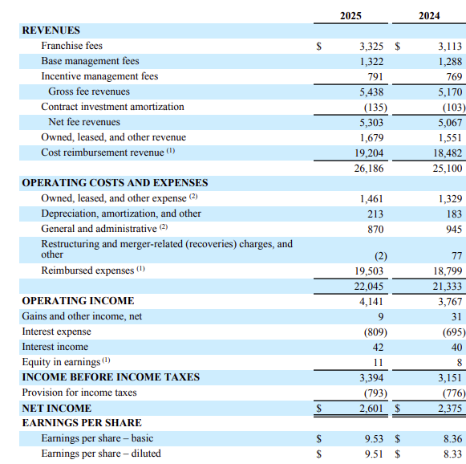
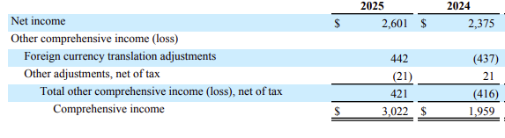
Figure 1: Consolidated income statement 2024 - 2025
(Source: Marriott International, 2026)

Consolidated statement of financial position: 2024 - 2025
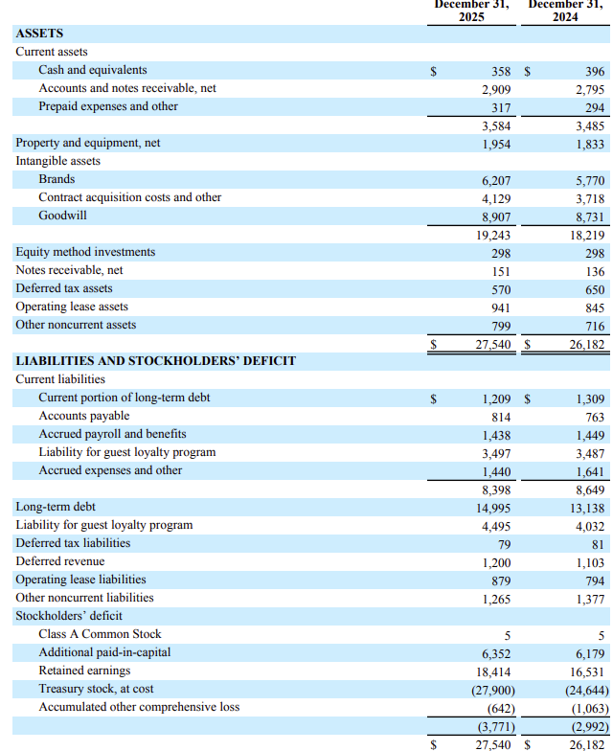
Figure 2: Consolidated statement of financial position: 2024 - 2025
(Source: Marriott International, 2026)

Consolidated income statement 2022 - 2023
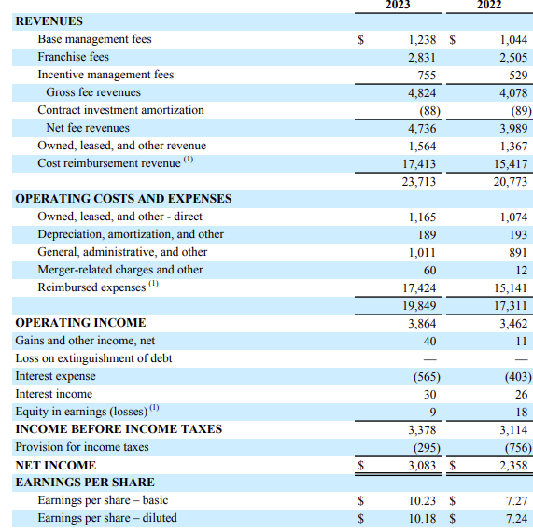
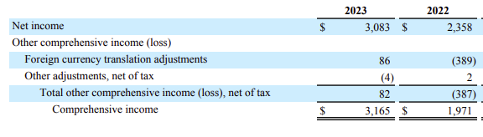
Figure 3: Consolidated income statement 2022 - 2023
(Source: Marriott International, 2026)
Consolidated statement of financial position:
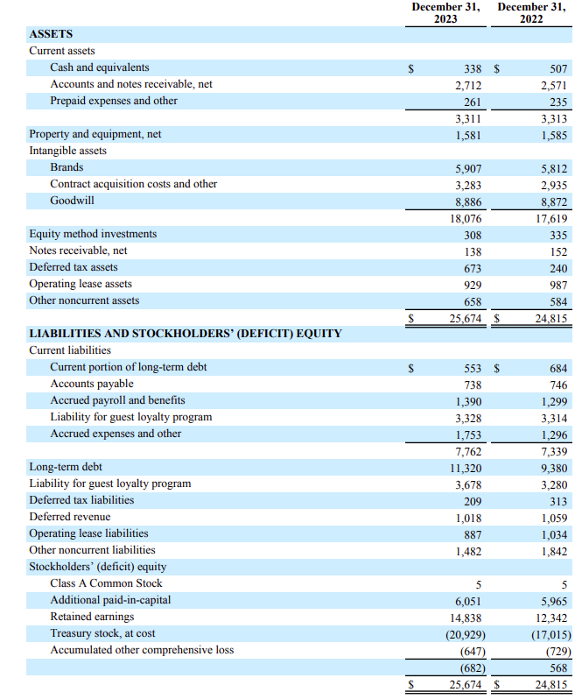
Figure 4: Consolidated statement of financial position
(Source: Marriott International, 2026)

Consolidated income statement 2021
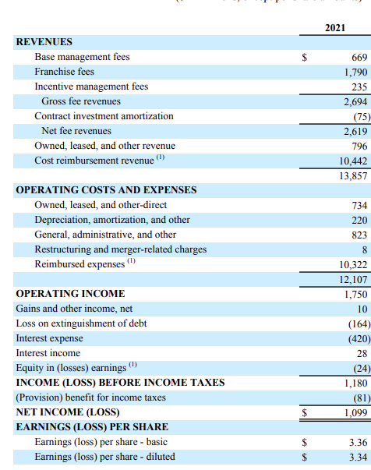
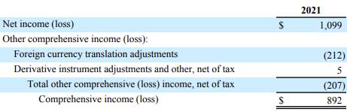
Figure 5: Consolidated income statement 2021
(Source: Marriott International, 2026)

Consolidated statement of financial position:
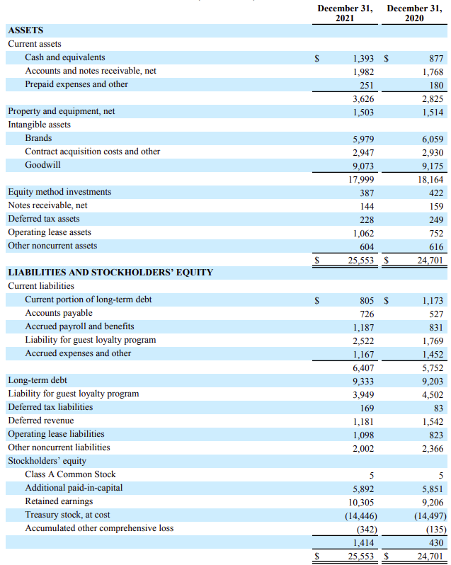
Figure 6: Consolidated statement of financial position
(Source: Marriott International, 2026)
Appendix 2: Ratio analysis
Profitability Ratios
Net profit margin
Profitability ratio
Net profit margin
Particulars | 2025 (Million) | 2024 (Million) | 2023 (Million) | 2022 (Million) | 2021 (Million)
Net income ($m) | 2,601 | 2,375 | 3,083 | 2,358 | 1,099
Net sales / Total revenue ($m) | 26,186 | 25,100 | 23,713 | 20,773 | 13,857
Net profit margin = (Net income / Net sales) * 100 | 9.93 | 9.46 | 13.00 | 11.35 | 7.93
Table 1: Net profit margin
(Source: Marriott International, 2026)
Operating profit margin
Profitability ratio
Operating profit margin
Particulars | 2025 (Million) | 2024 (Million) | 2023 (Million) | 2022 (Million) | 2021 (Million)
Operating profit / Operating income ($m) | 4,141 | 3,767 | 3,864 | 3,462 | 1,750
Net sales / Total revenue ($m) | 26,186 | 25,100 | 23,713 | 20,773 | 13,857
Operating profit margin = (Operating profit / Net sales) * 100 | 15.81 | 15.01 | 16.29 | 16.67 | 12.63
Table 2: Operating profit margin
(Source: Marriott International, 2026)
Liquidity Ratios
Current ratio
Liquidity ratio
Current ratio
Particulars | 2025 (Million) | 2024 (Million) | 2023 (Million) | 2022 (Million) | 2021 (Million)
Current assets ($m) | 3,584 | 3,485 | 3,311 | 3,313 | 3,626
Current liabilities ($m) | 8,398 | 8,649 | 7,762 | 7,339 | 6,407
Current ratio = (Current assets / Current liabilities) | 0.43 | 0.40 | 0.43 | 0.45 | 0.57
Table 3: Current ratio
(Source: Marriott International, 2026)
Quick ratio
Liquidity ratio
Quick ratio
Particulars | 2025 (Million) | 2024 (Million) | 2023 (Million) | 2022 (Million) | 2021 (Million)
Current assets ($m) | 3,584 | 3,485 | 3,311 | 3,313 | 3,626
Current liabilities ($m) | 8,398 | 8,649 | 7,762 | 7,339 | 6,407
Inventory (€m) | 0 | 0 | 0 | 0 | 0
Quick ratio = (Current assets - Inventory) / Current Liabilities | 0.43 | 0.40 | 0.43 | 0.45 | 0.57
Table 4: Quick ratio
(Source: Marriott International, 2026)
Efficiency Ratios
Inventory turnover ratio
Efficiency ratio
Inventory turnover ratio
Particulars | 2025 (Million) | 2024 (Million) | 2023 (Million) | 2022 (Million) | 2021 (Million)
Cost of sales($m) | 1,461 | 1,329 | 1,309 | 1,074 | 734
Inventory($m) | 317 | 294 | 261 | 235 | 251
Inventory turnover ratio = Cost of sales / Inventory | 4.61 | 4.52 | 5.02 | 4.57 | 2.92
Table 5: Inventory turnover ratio
(Source: Marriott International, 2026)
Receivable turnover ratio
Efficiency ratio
Receivable turnover ratio
Particulars | 2025 (Million) | 2024 (Million) | 2023 (Million) | 2022 (Million) | 2021 (Million)
Net sales ($m) | 26,186 | 25,100 | 23,713 | 20,773 | 13,857
Accounts receivable ($m) | 2909 | 2795 | 2712 | 2571 | 1982
Receivable turnover ratio = Net sales / Accounts receivable | 9.00 | 8.98 | 8.74 | 8.08 | 6.99
Table 6: Receivable turnover ratio
(Source: Marriott International, 2026)
Gearing Ratios
Debt to equity ratio
Gearing ratio
Debt to equity ratio
Particulars | 2025 (Million) | 2024 (Million) | 2023 (Million) | 2022 (Million) | 2021 (Million)
Total liabilities ($m) | 31,311 | 29,174 | 26,356 | 24,106 | 24,139
Shareholders' equity ($m) | -3771 | -2992 | -682 | 568 | 1414
Debt-to-equity ratio = Total Liabilities / Shareholders' Equity | -8.30 | -9.75 | -38.65 | 42.44 | 17.07
Table 7: Debt-to-equity ratio
(Source: Marriott International, 2026)
Interest coverage ratio
Gearing ratio
Interest coverage ratio
Particulars | 2025 (Million) | 2024 (Million) | 2023 (Million) | 2022 (Million) | 2021 (Million)
Operating income ($m) | 4,141 | 3,767 | 3,864 | 3,462 | 1,750
Interest expense ($m) | 809 | 695 | 565 | 403 | 420
Interest coverage ratio = Operating income / Interest expense | 5.12 | 5.42 | 6.84 | 8.59 | 4.17
Table 8: Interest coverage ratio
(Source: Marriott International, 2026)
Investment Ratios
Return on Equity
Investment ratio
Return on Equity
Particulars | 2025 (Million) | 2024 (Million) | 2023 (Million) | 2022 (Million) | 2021 (Million)
Net income ($m) | 2,601 | 2,375 | 3,083 | 2,358 | 1,099
Shareholders' equity ($m) | -3771 | -2992 | -682 | 568 | 1414
Return on Equity = Net income / Shareholders’ Equity | -0.69 | -0.79 | -4.52 | 4.15 | 0.78
Table 9: Return on Equity
(Source: Marriott International, 2026)
Earnings per share
Investment ratio
Earnings per share
Particulars | 2025 (Million) | 2024 (Million) | 2023 (Million) | 2022 (Million) | 2021 (Million)
Earnings per Share (EPS) | 9.53 | 8.36 | 10.23 | 7.27 | 3.36
Table 10: Earnings per share
(Source: Marriott International, 2026)
Cash Flow Ratios
Operating Cash Flow Margin
Cash flow ratio
Operating Cash Flow Margin
Particulars | 2025 (Million) | 2024 (Million) | 2023 (Million) | 2022 (Million) | 2021 (Million)
Operating cash flow ($m) | 3,212 | 2,749 | 3,170 | 2,363 | 1,177
Net sales / Total revenue ($m) | 26186 | 25100 | 23713 | 20773 | 13857
Operating Cash Flow Margin = (Operating Cash Flow /Net sales) * 100 | 12.27 | 10.95 | 13.37 | 11.38 | 8.49
Table 11: Operating Cash Flow Margin
(Source: Marriott International, 2026)
Free Cash Flow Margin
Cash flow ratio
Free Cash Flow Margin
Particulars | 2025 (Million) | 2024 (Million) | 2023 (Million) | 2022 (Million) | 2021 (Million)
Operating cash flow ($m) | 3,212 | 2,749 | 3,170 | 2,363 | 1,177
Capital expenditure ($m) | 604 | 750 | 452 | 332 | 183
Net sales ($m) | 26186 | 25100 | 23713 | 20773 | 13857
Free Cash Flow Margin = ((Operating Cash Flow - Capital Expenditure) / Net sales)* 100 | 9.96 | 7.96 | 11.46 | 9.78 | 7.17
Table 12: Free Cash Flow Margin
(Source: Marriott International, 2026)
Appendix 3: Financial trends
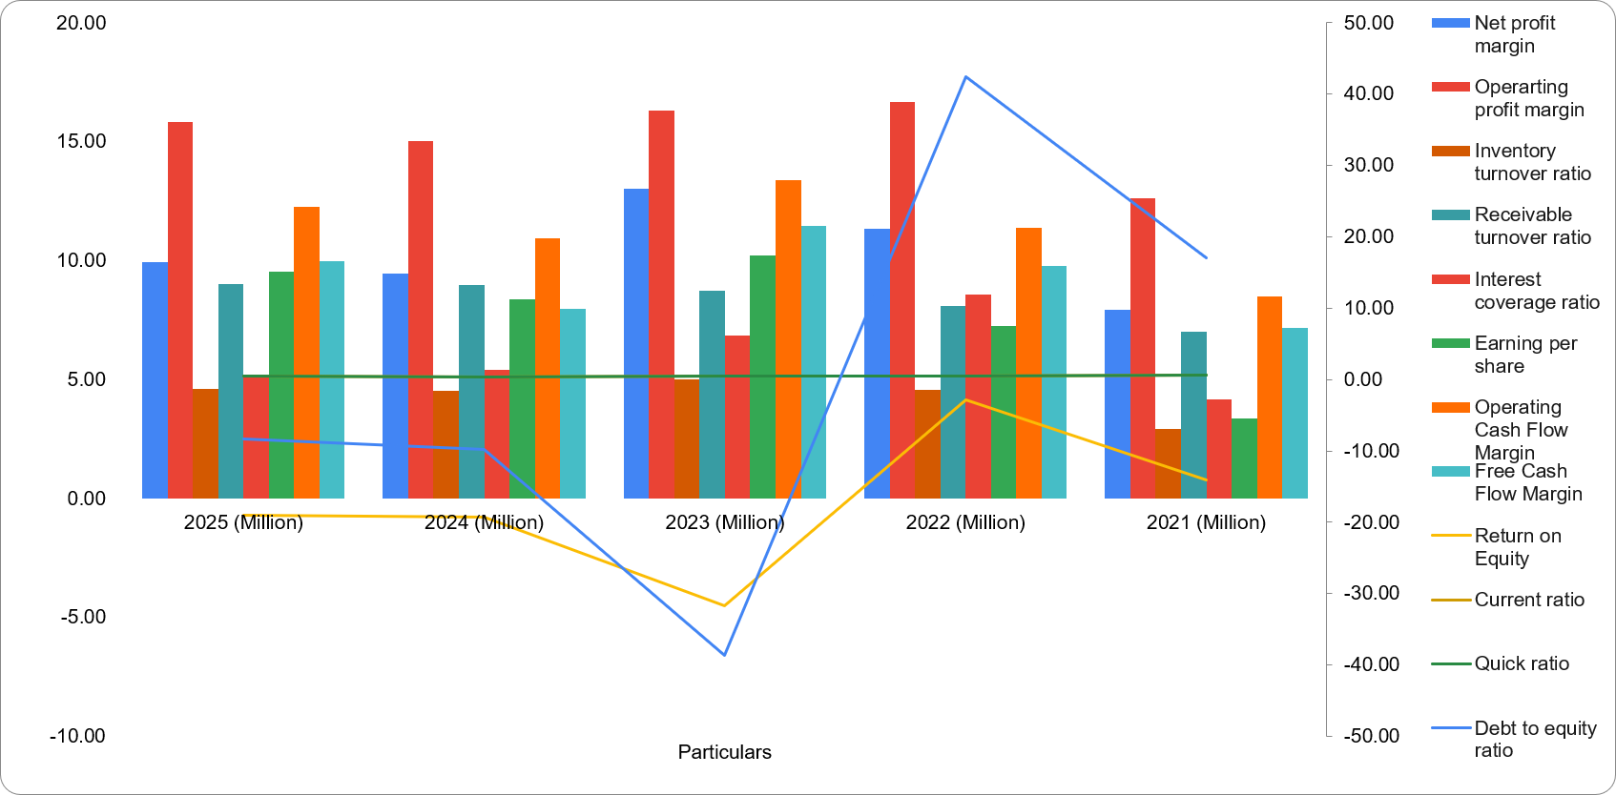
Figure 7: Financial trends
(Source: Marriott International, 2026)

Appendix 4: Liquidity ratio industry comparison
Liquidity Ratio
Company | Current Ratio | Quick Ratio
Marriot International | 1.05 | 1.04
Marriott | 1.18 | 1.16
Hilton | 1.12 | 1.10
IHG | 1.10 | 1.08
Industry Average | 1.13 | 1.11
Table 13: Liquidity ratio industry comparison
(Source: Marriott International, 2026)
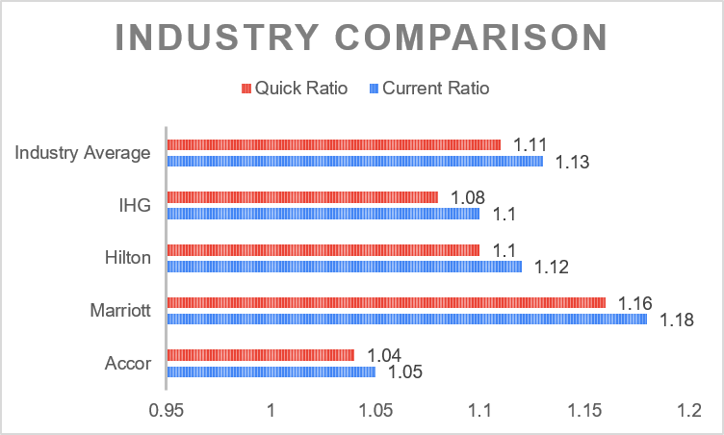
Figure 8: Liquidity ratio industry comparison
(Source: Marriott International, 2026)

Appendix 5: Investment analysis
Net present value
Payback period for Project A
Payback period - Project A
Particulars | Amount
Initial Capital | 50
1 | £10
2 | £12
3 | £14
4 | 10
5 | 8
PBP in year | 4
Unrecovered cash | £4
Recovery period cash flow | £8
Project X's PBP (in months) | 6.00
Project X's PBP | 4 years and 6 months
Table 14: Payback period for Project A
(Source: Self-report 2026)
Payback period for Project B
Payback period - Project B
Particulars | Amount
Initial Capital | 50
1 | £11
2 | £11
3 | £11
4 | £11
5 | £11
PBP in year | 5
Unrecovered cash | -£5
Recovery period cash flow | £0
Project X's PBP (in months) | £0
Project X's PBP | 5 years
Table 15: Net present value for Project B
(Source: Self-report 2026)
Payback period for Project C
Payback period - Project C
Particulars | Amount
Initial Capital | 50
1 | £5
2 | £10
3 | £20
4 | 25
5 | £5
PBP in year | 3
Unrecovered cash | £15
Recovery period cash flow | £25
Project X's PBP (in months) | 7.20
Project X's PBP (in years) | 3 years and 7.20 months
Table 16: Net present value for Project C
(Source: Self-report 2026)
Accounting Rate of Return (ARR)
Accounting Rate of Return Project A
Project A – ARR Calculation
Year | Cash Inflow (£m) | Less: Depreciation (£m) | Accounting Profit (£m)
1 | 10 | 10 | 0
2 | 12 | 10 | 2
3 | 14 | 10 | 4
4 | 10 | 10 | 0
5 | 8 | 10 | -2
Total | 54 | 50 | 4
Average annual profit |  |  | 0.8
Average Investment |  | 25
ARR |  | 3.2%
Table 17: Accounting Rate of Return Project A
(Source: Self-report 2026)
Accounting Rate of Return Project B
Project B – ARR Calculation
Year | Cash Inflow (£m) | Less: Depreciation (£m) | Accounting Profit (£m)
1 | 11 | 10 | 1
2 | 11 | 10 | 1
3 | 11 | 10 | 1
4 | 11 | 10 | 1
5 | 11 | 10 | 1
Total | 55 | 50 | 5
Average Annual Profit (£m) |  |  | 1
Average Investment (£m) |  | 25
ARR |  | 4.00%
Table 18: Accounting Rate of Return Project B
(Source: Self-report 2026)
Accounting Rate of Return Project C
Project C – ARR Calculation
Year | Cash Inflow (£m) | Less: Depreciation (£m) | Accounting Profit (£m)
1 | 5 | 10 | -5
2 | 10 | 10 | 0
3 | 20 | 10 | 10
4 | 25 | 10 | 15
5 | 5 | 10 | -5
Total | 65 | 50 | 15
Average Annual Profit (£m) |  |  | 3
Average Investment (£m) |  | 25
ARR |  | 12.00%
Table 19: Accounting Rate of Return Project C
(Source: Self-report 2026)
Net Present Value (NPV)
Net Present Value Project A
Project A
Year | Net cash flow | 8%. discounting rate | Present Value
1 | £10 | 0.925 | £9
2 | £12 | 0.857 | £10
3 | £14 | 0.793 | £11
4 | £10 | 0.735 | £7
5 | £8 | 0.680 | £5
Owners Capital | £50
Total PV | £43
Net Present Value | -£7
Table 20: Net Present Value (NPV) for project A
(Source: Self-report 2026)
Net Present Value Project B
Project B
Year | Net cash flow | 8%. discounting rate | Present Value
1 | £11 | 0.925 | £10
2 | £11 | 0.857 | £9
3 | £11 | 0.793 | £9
4 | £11 | 0.735 | £8
5 | £11 | 0.680 | £7
Owners Capital (d) | £50
Total PV | £44
Net Present Value (c-d) | -£6
Table 21: Net Present Value (NPV) for project B
(Source: Self-report 2026)
Net Present Value Project C
Project C
Year | Net cash flow | 8%. discounting rate | Present Value
1 | £5 | 0.925 | £5
2 | £10 | 0.857 | £9
3 | £20 | 0.793 | £16
4 | £25 | 0.735 | £18
5 | £5 | 0.680 | £3
Owners Capital (d) | £50
Total PV | £51
Net Present Value (c-d) | £1
Table 22: Net Present Value (NPV) for project C
(Source: Self-report 2026)
Profitability Index (PI)
Profitability Index Project A
Project A
Year | Net cash flow | 8%. discounting rate | Present Value
1 | £10 | 0.925 | £9
2 | £12 | 0.857 | £10
3 | £14 | 0.793 | £11
4 | £10 | 0.735 | £7
5 | £8 | 0.680 | £5
Owners Capital | £50
Initial Investment | £43
Profitability Index | £1
Table 23: Profitability Index Project A
(Source: Self-report 2026)
Profitability Index Project B
Project B
Year | Net cash flow | 8%. discounting rate | Present Value
1 | £11 | 0.925 | £10
2 | £11 | 0.857 | £9
3 | £11 | 0.793 | £9
4 | £11 | 0.735 | £8
5 | £11 | 0.680 | £7
Owners Capital | £50
Initial Investment | £44
Profitability Index | £1
Table 24: Profitability Index Project B
(Source: Self-report 2026)
Profitability Index Project C
Project C
Year | Net cash flow | 8%. discounting rate | Present Value
1 | £5 | 0.925 | £5
2 | £10 | 0.857 | £9
3 | £20 | 0.793 | £16
4 | £25 | 0.735 | £18
5 | £5 | 0.680 | £3
Owners Capital | £50
Initial Investment | £51
Profitability Index | £1
Table 25: Profitability Index Project A
(Source: Self-report 2026)
Internal Rate of Return (IRR)
Internal Rate of Return Project A
Project A
Year | Net cash flow
Owners Capital | -£50
1 | £10
2 | £12
3 | £14
4 | £10
5 | £8
IRR | 3%
Table 26: Internal Rate of Return Project A
(Source: Self-report 2026)
Internal Rate of Return Project B
Project B
Year | Net cash flow
Owners Capital | -£50
1 | £11
2 | £11
3 | £11
4 | £11
5 | £11
IRR | 3%
Table 27: Internal Rate of Return Project B
(Source: Self-report 2026)
Internal Rate of Return Project C
Project C
Year | Net cash flow
Owners Capital | -£50
1 | £5
2 | £10
3 | £20
4 | £25
5 | £5
IRR | 9%
Table 28: Internal Rate of Return Project C
(Source: Self-report 2026)

