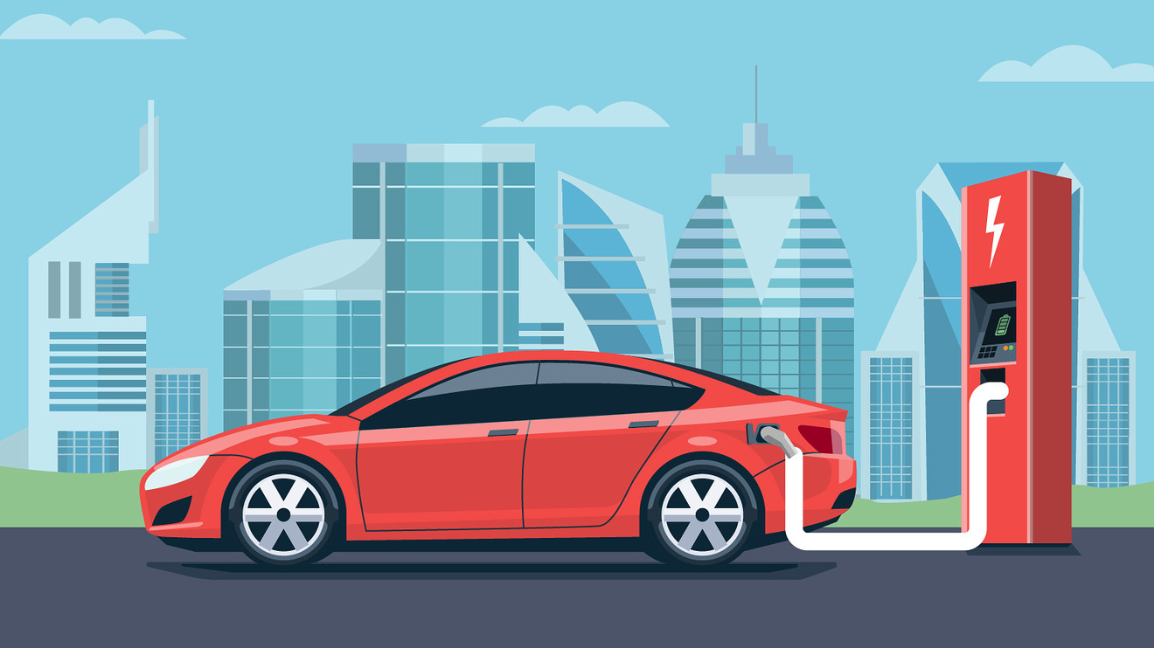

Environmental Analysis of Electric vehicle industry

Assessment 1

  - Global business envioronment
  - tUtor’s name: keany tang

Dimitrina Petrova - 1905516 |BABM Level 4 | 18.05.2020

Contents:

Introduction………………………………………………………………………………………2
Macro-environmental analysis of Electric Vehicle Industry (PESTEL)……………………………………………………………………………………………3
Recognition of the major forces shaping the industry throughout the prism of Porter’s five forces model……………………………………………………8
Conclusion…………………………………………………………………………………………9
References…………………………………………………………………………………………11

Induction:
There is a process where the interaction and integration among the people, organizations and governments impacts different environments, cultures or economics. This process is known as Globalization. However, the globalization is not innovation and it has been renowned by every business-oriented person. (Kopp,2020) This global business environment includes different independent counties worldwide, influenced by dissimilar factors of the home-located organizations of each industry. There are three levels of business environments – Macro, micro and internal environments, that can be analysed by identifying their factors. The external factors that impact the macro business environment are political, economic, social, legal, environmental and technological. Other external factors that directly impact the micro business environment are suppliers, intermediates, customers, stakeholders and competitors. The internal factors include marketing, production, financial, physical, human and technological resources. (Kopp, 2020) To be successful each organisation in particular industry must have effective and efficient functions.
In this report I will emphasise on the external business environmental factors and how they changed throughout the years in the electric vehicle industry.
Electric vehicle industry plays a significant role in our humanity nowadays. The automotive manufacturing is the engine of the industry as it develops one of the big threats of the world, the carbon combustion engine, and turns it into an environmentally friendly vehicle. According to the book ‘’Insane Mode’’ the main purpose of those vehicles is to benefit the nation as well as the planet. However, being successful depends on many factors that can influence the industry positively or negatively. Therefore, the global environment can bring many advantages or disadvantage to the electric vehicle industry. More specifically, the aspects that affect every industry, including the electric cars are macro-environmental factors.

Macro-environmental analysis of Electric Vehicle Industry (Pestel)
The macro-environmental model demonstrates the importance of political, economic, socio-cultural, technological, environmental and legal factors for each industry.

POLITICAL FACTORS
One of the political factors that plays important role for the electric vehicle industry is the emission law. In most of the European countries the emission law has been invented to reduce the air pollution form the combustion engines. For instance, in London City exists Congestion zone that requires one off payments from £12.50 for each visit of non-electric vehicles. (Collinson, 2019) Following this example, from the United Kingdom Government predicts that by the beginning of 2025 will be cheaper to buy an electric car than diesel or petrol car. (Hall, 2019) Therefore, by 2050 the target of zero emissions will be reached (Jericho, 2020). However, in the past the emission standards were not as developed as today because the air pollution was not such a massive issue for the nation. The first country inventing the emission standards was U.S.A. (1963) as a response to the smog problems. (EPA, 2017) This standard was adopted in Europe 20 years later. Though, this law has been improved every year with slight changes for the good to the people and Ozon layer. (Delphi, 2017)
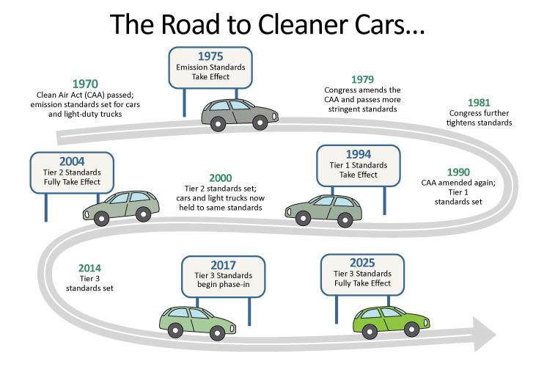

(Fig.1, Source: Internet)
Nowadays, countries such as U.S.A. had established a new law to support and encourage people buying electric vehicles as providing them subsids for the massive purchase. (Bellon, 2020) In Europe before the Coronavirus impact (REF) the number of electric vehicles was increasing rapidly, especially in countries like Norway (6.2), Netherland (4.2), France (0.7), Sweden (0.5) and Denmark (0.3). (McKensey and Company). One of the disadvantages for the electric vehicle owners is the time it takes for charging the battery. This is where the government interfered as inventing a new law for infrastructure and mobility programs, which means that there will be build more spaces for fast-charging station across every country. (Murray, 2019)
Comparing to the actions in the past, nowadays there are many changes in tax law, most of the luxury combustion engine manufacturers face difficulties in most of the countries due to the increased tax they pay for introducing their vehicles on the market. (Murray,2019) This is due to the high emissions those engines produce and how it affects the environment. In this case, we understand the higher government support admire the lower environmental impact. It is beneficial to every electric car manufacturer as the tax cost is lower or does not even exist. The money saved from taxes can be used for improvements the electric car’s batteries or technologies.
Sometimes changes in the government regimes can influence the Electric car’s industry and impact its profitability. Pure example is the Brexit which took place on 31.01.2020 and United Kingdom left the European Union (Murray, 2019). The United Kingdom was concerned that after Brexit the shipping process between UK
and other countries will cost a lot and that could potentially affect the market on this territory. However, the market was not affected as much by Brexits. The main threat for the industry was the Coronavirus (Readfearn, 2020).

ECONOMICAL FACTORS
The economical factor can be divided by many sub-factors that can influence an industry. As mentioned above the current economic factor that negatively affected the electric vehicle industry is the Coronavirus. At the moment most of the countries in Europe are under strict lockdowns or quarantines. (BBC News). Those circumstances influenced the world as leading to closure of a lot of workplaces such as airports, restaurants, banks and shops. This transparently affected every industry worldwide. Even the electric car industry. However, before this virus appeared the global economic rise for sales of electric cars increased the world’s
economy. For example, in one of the European countries Norway the sales of electric cars had positive impact of the county’s economy. (McKensey and Company) Thus, the developed countries have resources for developing the purchasing power of the customer.
Another factor that can directly impact the automotive industry is the price of materials. For example, the battery cost is significant because the quality and length of life can positively increase or decrease the price of the whole effectiveness of the vehicle. (Soon, 2019) Since the first electric vehicle has been introduced on the market (1832), the industry has developed in terms of creating reliable product that can change the whole world.
The recession and inflation could negatively affect the market because this will lead to changing of customer’s purchasing attitude and electric car manufacturers will be forced to drop the price of their vehicles.

SOCIAL FACTORS
The Social aspects are related mainly to the benefit that people can get from the industry. For example, the electric cars are made to be eco-friendly and eliminate the usage of fossil fuel. Therefore, the customer saves money from fuel, which calculated is approximately between £3000-£4000 per annum. (Fig. 2) It is advantageous because that will change customer’s saving attitude.
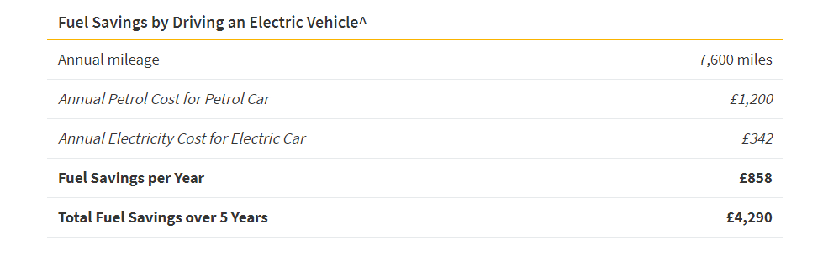

(Fig. 2, Source: Internet, Nimble Fins, Yurday (2020))

Another social factor depends on the countries where the electric vehicles have been invented. For instance, some of the countries in you in European Union prefer different types of vehicles. Countries such as Germany or Scandinavian countries prefer to drive SUV’s, however, Countries such as France, Italy or Spain desire to drive coupes.
Driving and usage benefits are important for either, the customer and the car manufacturer. In most of the big European cities like London, Paris and Oslo the air pollution has become a huge threat for the nation. Consequently, the electric vehicles can be driven in the bus lanes along side with the busses without any additional charges. (Browning, 2019) Another benefit for the European customer is that after every electric vehicle purchase, people can get tax reduction.

TECHNOLOGICAL FACTORS
Technology is the engine of the electric vehicle industry. To make a difference that other automotive makers, Tesla for instance, has invested the most of its capital for improving the life of its battery. The have gone from a small-format battery into a large-format battery. For that reason, Tesla had to buy Panasonic and adopt their powertrain technology for developing the battery. (Watanabe and Hull 2016)
Another technological factor that can directly influence the industry is the adoption of artificial intelligence. There are many examples of how artificial technology can create a strong competitive market. For example, the driverless technology is to be released by Toyota next few years. (Shirouzu and Tajitsu 2019)
Another example is the developed program of Nissan leaf and its E-pedal (Nissan Official), where with one pedal the driver is allowed to accelerate, decelerate, starts and stops the vehicle. On other hand, the electric ultimate pile manufacturer Tesla Motors has also invented many technological options that make their cars more luxury than others. An example for that is the dynamic handling with low centre of gravity of their model Y, which makes the car lightweight and its shape helps accelerate the speed. (Holland, 2020)
To increase the industry’s profitability, the technology helped adopting new fuel-efficient formulas.

ENVIRONMENTAL FACTORS
One of the major environmental factors that impact the electric vehicle industry is the carbon footprint reduction. Many of the countries worldwide started releasing pollution-controlled vehicles to stop the impact of the combustion engine vehicles. According to the case study by McKensey and Company, the issue carbon footprint reduction in Europe has been part of the union’s future goals. The board of Europe have to consider the availability of non-renewable goods, what are the emissions from vehicle production, what are the emissions from vehicle use and finally, they have to consider if the price of fuel will either reduce or increase.
The electric vehicle is environmentally friendly because it uses more electricity than gas. Electric cars have no carbon emission impact and a beneficial of tax subsidies due to fuel consumption.
Another environmental factor could be the brand image and recognition. For example, electric vehicle manufacturers have partnership with big brands like Tesco and Ecotricity. (Roberts, 2019) Them brands work alongside with government and their new goal is to supply the world with electric car charging points. with In European Union a leading trend is deploying their fleet into ‘’green’’ (La Poste And Athlone)

LEGAL FACTORS
Finally is the legal factor that is created to ensure the industry keeps up to date with its patterns. This includes the emission controls, product safety, environmental low's, tax laws and consumer’s lows. For example, VW produced faulty edition of seat belts that had negative impact over the company’s image. For that reason, VW had to call back every single car from that edition and improve the quality of the product. (Atiyeh, 2015).

Recognition of the major forces shaping the industry throughout the prism of Porter’s five forces model:
There is another existing model that can help identifying id Electric automotive industry is attractive for joining or not. This is the model of the five forces. The figure bellow illustrates each step that needs to be considered before entering the industry.

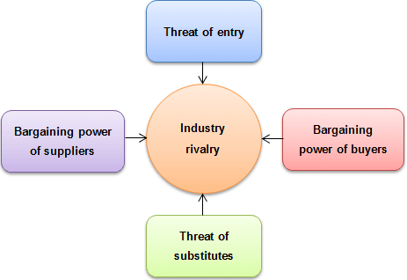

(Fig. 1, Source: Internet)

Competitive rivalry is the stage that helps the industry identify its competitors and analyse its power, strength or weaknesses. For electric vehicle industry the competitive rivalry is low, because at the moment there is no other existing rivalry that can affect this particular industry.
Threat of new entries for the industry can be high because of the requirements of large sum of investments and capability of explicit skills, technologies and machinery. To be successful in entering this industry, the first massive capital will be for inventing a new car brand. Being able to produce new brand the entrant needs manufacturing facilities or distribution centre and set of skilled workforces.
Threat of substitution can be classified as medium Because of the competition between electric cars industry and the traditional automotive industry is intense. The electric vehicles have a variety of mixed models however the industry is not as broad as a traditional car industry. But the benefit having E-car decreases the fuel cost and it is environmentally friendly comparing to the combustion engine cars. Therefore, the threat of substitute still exists but in different form. Another serious threat for electric vehicles could be the different alternatives of transportation for example buses, airplanes and trains.
The Buyers power for the electric vehicle industry is medium to high because the demand for electric cars is increasing either for private customers or for businesses. The pure reason for the high demand of those vehicles is the fact that owning electric car is a long-term saving cost on fuel and this motivates people to easily switch from traditional car to an electric car. There is another aspect that proves that the power is with the buyers. This is the limited cost of changing and switching between models does not cost much for the customer. an option this often this power Can be focusing on the brand loyalty for every company within the industry.
In this case the Supplier power Can be classified as low because the number of companies that supply the ultimate industry is huge. For suppliers there is no difference between electric car industry and conventional car industry. The market for suppliers is the same. However, most of the manufacturers are relying on innovations that suppliers can vendor. Because of all these factors suppliers have comparatively low power on the industry.

Conclusion:
The Electric vehicle industry can be classified as attractive for joining because of the low level of competitive rivalry, low-medium threat of substitution, low buying power and the medium threat of entry. Comparing to the past in today’s world the electric car manufacturers are emphasising on the advantages that this industry brings to the nations. There is a lot of published information that proves the positive impact of the E-cars. Because of the usage of electric vehicles in certain countries of the world the air pollution has decreased its level. The production of oil will not be essential if the electric cars take over the competitive world. Considering the industry as attractive, many of the electric vehicle producers are investing a lot of time and capital in their companies to gain higher competitive advantage amongst each other. Some companies invest in technology and aim to become the top electric car manufacturer as developing the artificial intelligence of the vehicle. Other companies reply on the strategy to supply the Earth will super powerful charging stations that can help people charge their batteries quicker than normal.
As one young future entrepreneur I would consider joining an industry such as electric vehicles because this is the future of the world. Every day people develop the idea of living in a new ‘’green’’ ecosphere for the good of the nation and the nature. Alongside with this idea, people are developing a lot of new business opportunities that can create new competitive advantage.

References:
Atiyeh, C. (2015), Aug. the 14th, Car and driver, ‘’Volkswagen recalls 420,000 cars for potentially faulty airbags’’ Available at: https://www.caranddriver.com/news/a15353432/volkswagen-recalls-420000-cars-for-potentially-faulty-airbags/,
[Accessed on 05.05.2020]
BBC News, (2020), World under lockdown, Available at: https://www.bbc.co.uk/programmes/m000j43t,
[Accessed on 03.05.2020]
Bellon, T., (2020), Jan. 29th, Reuters, Technology news, ‘’Factbox: Electric vehicle subsidies under pressure in some Tesla core markets’’, Available at: https://uk.reuters.com/article/us-tesla-results-subsidies-factbox/factbox-electric-vehicle-subsidies-under-pressure-in-some-tesla-core-markets-idUKKBN1ZS1H9,
[Accessed on 03.05.2020]
Browning, S. (2019), May the 24th, BBC News, ‘’I drive in the bus lane’’, Available at: https://www.bbc.co.uk/news/business-48400271,
[Accessed on 03.04.2020]
Collinson, P. (2019) Jan, 5th, The guardian, Congestion Changing, ‘’London’s ultra-low emission zone: What you need to know’’, Available at: https://www.theguardian.com/politics/2019/jan/05/londons-ultra-low-emission-zone-what-you-need-to-know,
[Accessed on: 03.05.2020]
Delphi, (2016-2017), Innovation for the real world, ‘’Worldwide emission standards – passenger car light duty’’, Available at: https://www.delphi.com/sites/default/files/inline-files/delphi-worldwide-emissions-standards-passenger-cars-light-duty-2016-7.pdf, [Accessed on 03.05.2020]
EPA, (2017), Environmental protection agency of United States, Clean Air Act Overview, ‘’Evolution of clean air act’’, Available at: https://www.epa.gov/clean-air-act-overview/evolution-clean-air-act,
[Accessed on 03.05.202]
Hall, L. (2019), Oct. 29th, Morning star, Equity research and insights, ‘’Will electric vehicles make it mainstream?’’, Available at: https://www.morningstar.co.uk/uk/news/196821/will-electric-vehicles-make-it-mainstream.aspx,
[Accessed on 03.05.2020]
Holland, M., (2020), Mar. The 16th, Clean technica, ‘’Tesla Model Y performance – first dynamic driving review (Video), Available at: https://cleantechnica.com/2020/03/16/tesla-model-y-performance-1st-dynamic-driving-review/,
[Accessed on 05.05.2020]
Jericho, G. (2020), Feb, 22nd, The guardian, Grogonomics graph of the week, Labor Party, ‘’Getting to zero-net emissions in 2050 is going to be tough – but Labor committing to it is a damn good thing’’, Available at: https://www.theguardian.com/commentisfree/2020/feb/23/getting-to-zero-net-emissions-in-2050-is-going-to-be-tough-but-labor-committing-to-it-is-a-damn-good-thing,
[Accessed on 03.05.2020]
Kopp, C. M., (2020), Investopedia, Macroeconomics, ‘’Globalization’’, Available at: https://www.investopedia.com/terms/g/globalization.asp,
[Accessed on 03.05.2020]
McKensey and Company, Case-study, ‘’E-volution - Electric vehicles in Europe: gearing up for a new phase?’’, p. 10, Available at: file:///C:/Users/Admin/Desktop/UWTSD%20assignments/2%20semester/Global%20business%20environment/Case%20Study%20-%20Electric%20vehicles%20in%20Europe%20Gearing%20up%20for%20a%20new%20phase.pdf,
[Accessed om 03.05.2020]
McKenzie, H. (2018), Insane Mode, How Elon Musk’s Tesla sparked an electric revolution to end the age of oil, p. 6-69
Murray, J. (2019) November the 6th, NS Energy Business, Features, ‘’What does the future hold for electric vehicles in UK?’’, Available at: https://www.nsenergybusiness.com/features/future-electric-vehicles-uk-brexit/
[Accessed on 03.05.2020]
Nissan Official web site, Car technology, Nissan Leaf e-Pedal, Available at: https://www.nissan-global.com/EN/TECHNOLOGY/OVERVIEW/e_Pedal.html,
[Accessed on 05.05.2020]
Readfearn, G. (2020), April 28th, The guardian, Coronavirus outbreak, ‘’How did coronavirus start and where did it come from? Was it really Wuhan’s animal market?’’, Available at: https://www.theguardian.com/world/2020/apr/28/how-did-the-coronavirus-start-where-did-it-come-from-how-did-it-spread-humans-was-it-really-bats-pangolins-wuhan-animal-market,
[Accessed on 03.05.2020]
Roberts, J. (2019), Dec, the 4th, Fleet News, ‘’EV drivers can charge for free at Tesco’’, Available at: https://www.fleetnews.co.uk/news/environment/2019/12/04/ev-drivers-can-charge-for-free-at-tesco
[Accessed on 05.05.2020]
Shirouzu, N. and Tajitsu, N. (2019), Oct. the 25th, Reuters, Technology news, Toyota is not alone in the slow late to self-driving cars’’, Available at: https://www.reuters.com/article/us-autoshow-tokyo-toyota-technology/toyotas-not-alone-in-the-slow-lane-to-self-driving-cars-idUSKBN1X41XF,
[Accessed on 04.05.2020]
Soon, S. (2019), Jul. 26th, CNBC, ‘’As electric vehicle production ramps up worldwide, a supply crunch for battery materials is looming’’, Available at: https://www.cnbc.com/2019/07/26/electric-car-production-rises-supply-crunch-for-battery-metals-looms.html,
[Accessed on04.05.2020]
Watanabe, C. and Hull, D. (2016), Dec. th 27th, Bloomberg, Business, Tesla and Panasonic to begin solar panel production in New York.’’ Available at: https://www.bloomberg.com/news/articles/2016-12-27/tesla-panasonic-to-begin-solar-panel-production-in-new-york?utm_source=google&utm_medium=cpc&utm_campaign=dsa&utm_term=&gclid=CjwKCAjwwMn1BRAUEiwAZ_jnEq1QAADh4b9tZ-S4o4iAIbvF5mKfHnnVjNosQqfO5CsUYuJfs3WBZxoC23MQAvD_BwE,
[Accessed on 04.05.2020]
Yurday, E. (2020), Apr. 24th (Fig. 2), Nimble Fins, How much can you save with all electric car?’’, Available at: https://www.nimblefins.co.uk/how-much-save-electric-car,
[Accessed on 04.06.2020]

