Sufia khan
1709300
Submission 20/07/18
Maria heffernen

Contents

Executive summary page 1
Terms of reference 1.0. page 2
Procedure 2.0
Introduction page 3
Finding .3.1/3.2 page 4
3.3/3.4.1 page 5
Appendices page 6/7/8/9
3.4.3
Conclusion page 10
Recommendation page 11
Reference page 12

Executive summary

The report aims to look at and judge modification management at Marks and philosopher, a serious distributer that has undergone appreciable strategic and operational modification over the last eight years following major economic and structure troubles. In presenting this case, the report is split into variety of sections.

.

- TERMS OF REFERENCE

On the 28/11/18 the chief executive of marks and spencer requested a report. The report is to be based on marks and spencer post and current problems, it will also alter recommendations for improvement.

The report is written by the consultant Sufia khan.

2.0. Procedure

2.1. A variety of text books, journals and internet sites have been used to research the report.

INTRODUCTION

The researcher under looks at the history of how marks and spencer started, and how it developed. What impact their had, and what problems and how they overcome it. Marks and spencer went into partnership and opened stores around Europe and introduced to online shopping. M&S is one of the leading retailers of clothing and homeware, with financial services. It became a major national and international force in the retail world.

Finding.

3.1. Marks and spencer was formed in 1884 by Michael marks and opened a market stall in Leeds. The cost of the stall was in pennies and he was a polish refugee, in 1894 went into partnership with Thomas spencer who was a former cashier from the wholesale company. In 1904 Marks & spencer opened their first shop in Leeds, it was limited and then became public company. They introduced food department in 1931, and selling produce and canned goods. The researcher found that they were the first British retailer and had set their own laboratory to pioneer new fabric, and launched its own food knowledge section to bring work closely with suppliers and producers, farmers.

High street favourite Marks and philosopher has more additional edges and rewards to its accounting in a trial to tempt customers aloof from the normal massive banks, however there area unit a couple of catches to look at out for. Those that switch to an M&S accounting can currently receive a £100 gift card, and £10 a month to pay at the complete for a year.

3.2. FASHION, A third of the nation still buys its undies at M&S, but the chain has struggled to maintain its everywoman appeal for everyday clothing amid heavy competition. Middle-aged, and even elderly, women now expect to dress much more fashionably than they did in the past and M&S has struggled to keep pace with their desires. Cutting quality in an attempt to bring prices closer to discounters such as Primark has backfired in the past. The group’s multiple sub-brands, such as Per Una and Limited Edition, also lack authority and consistency and shoppers don’t understand who they are aimed at.

They found that focusing a lot of on the planning and products, merchandise aren’t low cost. they have to be concentrating on nice style and dealing with people that will deliver this, not factories, that square measure way faraway from trends. style team clearly got to get out a lot of, as do the consumers, and work with World Health Organization people that those who concentrate on product style and who have necessary market data. As redoubled competition, product supply and focus firmly on customers satisfaction

If you've got in hand or used one among the product to have a tendency to presently sell on-line, you'll be able to write a review to assist different customers build an enlightened shopping for call. To have a tendency to worth our customers’ views as they assist U.S.A. to boost our product.

3.3. In every organisations have competition, the current position is to look at other organisations and have the ability to compete, looking at the problem and how to make customers happy and not to fall out on investments. Primark & h&m have cheap products, which attract customers and even more designs that customers like. Communicating and changing retailers can help as every retailers has different price and different way of doing business.

Researcher found that looking at the nature of the problem and how big the issue is, which position the business is in and resolving the matter and overcome it, and build the business and stay and compete with other organisations.

3.4.1. Marks & philosopher has suffered its biggest fall in vesture sales since the 2008 banking crisis as new boss Steve Rowe tries to finish its reliance on significant discounting. The 8.9% fall in underlying vesture and residential sales over the last 3 months, was so much larger than analysts expected and turned the clock back to 2008 once the retail merchant had a unfortunate Christmas following the collapse of Lehman Brothers. These aren't the numbers, would like to examine by any stretch however they're the numbers expected to examine, World Health Organization took over as chief government 3 months past.

The dire figures were later combined by embarrassment once M&S was forced to issue a second securities market announcement on admitting it had got a number of its sales figures wrong. Instead of rising one. 3%, cluster sales were really down zero. 4%. The sales range, adjusted for currency fluctuations, was conjointly wrong. the corporate darned the error on a clerical error and same there had been no breach of procedure.

3.4. Swot analysis

STRENGTHS;

Stores have large trading space.
Brand.
Interiors, decorating
Well experienced retailers.
Operation.
It provides recyclable eco.
International coverage.

WEAKNESS

Weak public relation campaigns and expensive shopping.
Changes.
Dependent on suppliers.
Less promotional activity for stores and company.
Clothing

OPPORTUNITIES;

More advertisement and promotion.
keep track of customers' demands.
Online shopping facility
Entering into new market segments.
Understanding competitors for complementary products.
Achieving.

THREATS;

Price competition and expensive.
New competitors.
Changing buyers.
Growing competitive pressures.
Rising sales.
Liability.
Growing customers and suppliers.

3.4.2. Pestle critical

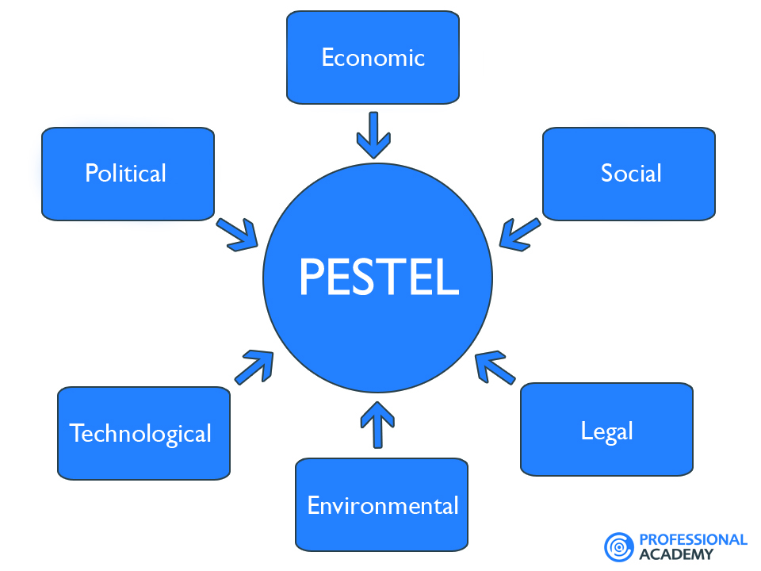

pestleanalysis.com

3.4.3. LISTENING AND TAKING ACTION

Our success depends on the support of stakeholders in our communities. Their engagement is additionally basic to the delivery of arrange A. The additional engaged we tend to are with our stakeholders, the additional prospering arrange is probably going to be.

Our stakeholders embody customers, employees, investors, civil society organisations, and also the media. The table below lists our main neutral teams and provides samples of the ways in which we tend to interact with them. you'll browse additional concerning neutral engagement in our set up Report.

Reactively: responding to info requests, queries and enquiries.
Passively: providing info to confirm our stakeholders square measure higher hip regarding our programme.
Proactively: facilitating dialogue and engagement with key stakeholders actively involve them within the of arrange
delivery

Customers
Employees
Investors
Suppliers
Media
Government and regulators
Society

3.4.4. Stakeholder

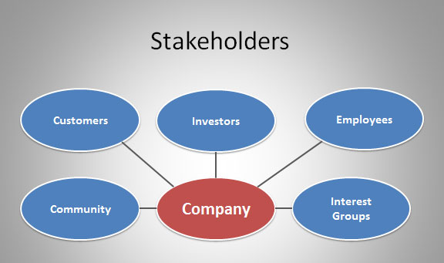

Conclusion

3.4.5. Nearly ten years past they disclosed Marks and spencer’s result. There began to see results and once they begun to travel higher than £1 billion. Sir Stuart’s worked and M&S was back in. Selecting higher merchandiser and victimization skills created them higher in business, having skills they managed to beat they issues. Cutting the value had a control on the expansion, levelling the business towards food appeared the solution. They created some changes they're finance to re-establish the value position by sharpening costs and to reinforce service by putt additional staff into stores. These actions, combined with the troublesome commerce conditions, can have associate adverse impact on profit within the short-run. Its very necessary for Marks and Herbert Spencer to happen a gentle balance between its long permanent singularity of tradition and sterilisation manner business and besides its expected for them to convey in an exceedingly balance in anxiousness they face for shopper, their male person power and also the close and also their ability to accommodate and the most heavy one to regenerate things and in an exceedingly higher mode. throughout this study. It will be able to also cowl the overall schemes employed by Marks and Herbert Spencer. Their had challenges visage by Marks and Herbert Spencer within the emulous atmosphere. The import finding of truth is that M&S holds prospering concern schemes and market programs, the problem is that this price is non maintained by them instead some blessings have clothed to be a drawback for them. Marks and Herbert Spencer developed a brand new concern theme, this was marked as a amount of alteration for the complete organisation. In thought that instructive what area unit operation direction and operations theme is definitely heavy.

Recommendation

As recession is heating the business and financial gain of individuals is decreasing day by day everywhere the planet endlessly, Marks & sociologist is maintaining its position among high ten. Except for creating future safe and secure Marks & sociologist has to improve the business as competitors area unit well maintaining the business within the international situation, by mistreatment varied promotional tools and technologies. Marks & sociologist ought to offer innovative services to the purchasers by mistreatment latest technologies within the business. It has to extend its business everywhere the planet, particularly Asian countries like Asian nation, Republic of India or China.

Reference

https/www.bbc.co.uk
https/corporate.marksandspencer.com
https/www.dailymail.co.uk
https/www.managementtoday.co.uk.
https/www.mindtools.com
pestleanalysis.com
https/www.standard.co.uk
https/www.theguardian.com
https/uk.trustpilot.com

.

