Module Title: Developing Emotional Intelligence Skills
Code: - LCLM 5006

Assignment: Individual written report

Student Name: Andreea-Cristina Balcanu
Student Number: 2329944

Lecturer’s Name: Abdallah Naser

Table of Content

Introduction 3
Critical Evaluation of Emotional Intelligence in the Workplace 4
Research on Generational Characteristic in the Workplace 13
Recommendations 18
Conclusion 18
References 19

- Introduction
Emotional intelligence (EI) has been defined by several scholars as a crucial set of abilities that influence how individuals understand, manage, and express emotions in both personal and professional contexts.
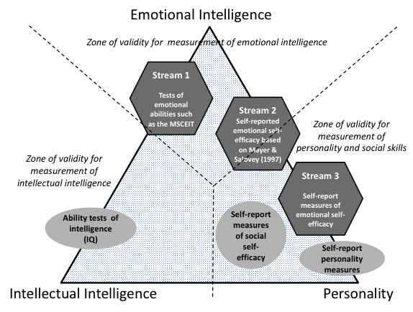Image 1 : Reintroducing Emotional Intelligence: What it Is and Where We Stand Now
- Bar-On (1997), emotional intelligence refers to a range of emotional and social competencies that determine how effectively individuals understand themselves, interact with others, and cope with environmental pressures and daily challenges.
- Salovey and Mayer (1990) describe emotional intelligence as the ability to monitor and recognise one’s own emotions and the emotions of others, separate between different emotional states, and use this information to guide thinking and behaviour.
- Goleman (1998) conceptualises emotional intelligence as a combination of emotional competencies including self-awareness, self-regulation, motivation, empathy, and social skills, which are essential for effective leadership and workplace relationships.
Together, these perspectives demonstrate that emotional intelligence plays a significant role in improving communication, decision-making, teamwork, and overall organisational performance.
Furthermore, organisations increasingly consist of employees from multiple generations with different values, expectations, and communication styles. Understanding the characteristics of Generation X, Generation Y (Millennials), and Generation Z is therefore essential for managers when recruiting and managing diverse teams (Twenge, 2010; Schroth, 2019). This report critically evaluates the application of emotional intelligence models in the workplace and examines generational differences that influence organisational effectiveness.
- Critical Evaluation of Emotional Intelligence in the Workplace
Emotional intelligence (EI) is an important concept in organisational behaviour, influencing communication, leadership, teamwork, and decision-making. According to Goleman (1995), EI involves recognising and managing one’s own emotions while understanding the emotions of others. Similarly, Mayer and Salovey (1997) describe EI as the ability to perceive and regulate emotions. Bar-On (1997) highlights emotional and social competencies that help individuals cope with workplace demands, improving relationships and organisational performance (Cherniss, 2010; Ashkanasy and Daus, 2005).
Cultural sensitivity
Cultural sensitivity in the workplace is important for organisations operating in different environments. It refers to the ability of employees and managers to recognise, respect, and respond appropriately to cultural differences. Emotionally intelligent leaders demonstrate cultural awareness by adapting their communication and leadership styles to support inclusive collaboration.
This approach helps reduce misunderstandings, improve teamwork, and create a respectful organisational culture.
Organisations that promote cultural sensitivity often experience higher employee engagement and better organisational performance (Goleman, 1998; Hofstede, 2011).

Goleman’s Emotional Intelligence Model
Daniel Goleman (1995; 1998) proposed one of the most widely applied emotional intelligence frameworks in organisational contexts. His model identifies five impetant components that influence interpersonal relationships, leadership behaviour, and workplace effectiveness.
Component | Description | Workplace Application
Self-awareness | Understanding one's emotions and their impact | Helps employees recognise emotional triggers
Self-regulation | Managing emotional responses | Enables professional behaviour during conflict
Motivation | Internal drive to achieve goals | Encourages resilience and persistence
Empathy | Understanding others’ emotions | Improves teamwork and leadership
Social Skills | Managing relationships effectively | Supports communication and collaboration
Table 1: Goleman’s Emotional Intelligence Components
Self-Awareness
Self-awareness is considered a fundamental component of emotional intelligence and refers to the ability to recognise and understand one’s own emotions and how they influence behaviour and decision-making (Goleman, 1998). In organisational settings, self-aware employees are better able to reflect on their emotional responses and understand how their actions affect colleagues and workplace relationships.
According to Mayer and Salovey (1997), recognising emotions is the first step in managing them effectively. Research also indicates that self-aware individuals often demonstrate stronger leadership skills, improved decision-making, and greater interpersonal effectiveness (Cherniss, 2010).

Developing self-awareness normally requires reflection, feedback, and continuous personal development.
Question Type | Example
Reflection | “How did I feel during that situation?”
Learning | “What could I do differently next time?”
Perspective | “How might the other person have felt?”
Improvement | “What emotions influenced my decision?”
Table 2: Examples of Open-Ended Questions in Emotional Intelligence Development
These questions encourage individuals to examine emotional experiences more deeply and develop greater emotional understanding.
Self-Regulation
Self-regulation refers to the ability to control and manage emotional responses in challenging situations, allowing individuals to remain calm and respond appropriately rather than react impulsively (Goleman, 1998). In organisational situations employees with strong self-regulation are better able to manage workplace stress and resolve conflicts constructively, contributing to positive team dynamics and effective communication.
According to Mayer and Salovey (1997), regulating emotions is a key component of emotional intelligence that supports rational decision-making. However, some studies argue that excessive focus on emotional control may encourage individuals to control emotions rather than manage them constructively, which may negatively affect wellbeing (Fineman, 2003). Therefore, organisations should promote supportive environments that encourage healthy emotional expression and communication.
Motivation
Motivation within emotional intelligence refers to an individual's fundamental drive to achieve goals and maintain commitment to organisational objectives. Employees with strong emotional intelligence often demonstrate resilience, optimism, and persistence in the face of challenges (Goleman, 1998).
In modern organisations, motivation is closely linked to employee engagement and productivity. Employees who feel emotionally connected to their work are more likely to demonstrate commitment and innovation.
Leadership frameworks such as the GROW coaching model are frequently used to support employee motivation and development.
The GROW model encourages reflective dialogue and supports employees in identifying personal goals and development strategies (Whitmore, 2017).
Stage | Meaning | Workplace Example
Goal | Identify desired outcome | Improving leadership skills
Reality | Assess current situation | Evaluating current performance
Options | Explore possible solutions | Training or mentoring
Will | Commit to action | Implement development plan
Table 3: The GROW Coaching Model
Empathy
Empathy refers to the ability to understand and share the emotional experiences of others. In organisational contexts, empathy plays a crucial role in leadership, teamwork, and customer relationships.
Managers who demonstrate empathy are better able to recognise employee worries and respond with support. This is particularly important during periods of organisational change, where uncertainty and anxiety may affect employee morale.
Empathy also contributes to inclusive workplace cultures. Leaders who understand diverse perspectives are more likely to create environments where employees feel respected and valued.
Social Skills
Social skills represent the ability to build and maintain positive relationships. This includes communication, collaboration, conflict resolution, and influencing others.
Employees with strong social skills contribute to effective teamwork and organisational cohesion. According to Goleman (1998), social competence enables leaders to inspire others, build trust, and manage organisational change effectively.
However, critics suggest that emotional intelligence may overlap with personality features such as extroversion and kindness, making it difficult to measure precisely (Landy, 2005). Despite this debate, many organisations continue to incorporate emotional intelligence training into leadership development programmes.
The Bar-On Model of Emotional Intelligence
Another influential framework is the Bar-On Model, which conceptualises emotional intelligence as a set of emotional and social skills that influence how individuals cope with environmental pressures (Bar-On, 1997).
Dimension | Description
Intrapersonal Skills | Self-awareness and self-expression
Interpersonal Skills | Empathy and social responsibility
Stress Management | Emotional control and resilience
Adaptability | Flexibility and problem-solving
General Mood | Optimism and happiness
Table 4: Bar-On Emotional Intelligence Model
The Bar-On model emphasises emotional wellbeing and adaptability. In workplace contexts, these skills contribute to resilience, collaboration, and effective decision-making.
Employees with strong stress-management skills are better equipped to handle workplace pressures, while adaptability supports innovation and problem-solving in dynamic environments.
The Mayer-Salovey Ability Model
The Mayer and Salovey (1997) model talking about emotional intelligence as a set of cognitive abilities related to emotional processing.
Ability | Description
Perceiving Emotions | Recognising emotional cues
Using Emotions | Applying emotions to thinking
Understanding Emotions | Interpreting emotional patterns
Managing Emotions | Regulating emotional responses
Table 5: Mayer-Salovey Emotional Intelligence Abilities
Employees who can precisely interpret emotional signals such as tone of voice or body language are better able to navigate social interactions and workplace dynamics.
For example, recognising signs of stress in colleagues may prompt supportive behaviour or workload adjustments.
Circles of Influence and Concern
Another important concept related to emotional intelligence is Stephen Covey’s Circles of Influence and Concern. This framework helps individuals focus on areas where they can use control rather than worrying about external factors beyond their influence.
Circle | Description | Example
Circle of Concern | Issues outside personal control | Economic changes
Circle of Influence | Area’s individuals can affect | Communication with colleagues
Table 6: Circles of Influence vs Concern
Employees with strong emotional intelligence focus on actions within their circle of influence, which promotes proactive behaviour and reduces stress.
Mindfulness and Emotional Intelligence
Mindfulness is closely associated with emotional intelligence as it promotes awareness of thoughts and emotions in the present moment. According to Jon Kabat-Zinn (2003), mindfulness involves purposeful attention to present experiences without judgement. Research indicates that mindfulness practices can enhance emotional regulation, concentration, and psychological wellbeing in workplace environments (Good et al., 2016; Brown and Ryan, 2003). Many organisations have introduced mindfulness programmes to support employee resilience and stress management.
However, critics argue that mindfulness should not be used only as a productivity tool, and organisations must also address structural workplace issues such as workload and management practices (Purser, 2019).

Feedback Burger in Supervision
Effective feedback is essential for developing emotional intelligence in the workplace. One widely used method is the Feedback Burger (or Feedback Sandwich) technique.
Stage | Purpose | Example
Positive Feedback | Start with encouragement | “Your presentation was very clear.”
Constructive Feedback | Address improvement areas | “You could engage the audience more.”
Positive Reinforcement | End with support | “Your preparation shows strong commitment.”
Table 7: Feedback Burger Model
This approach encourages constructive dialogue while maintaining employee motivation and confidence.
Benefits of Emotional Intelligence in Organisations
Emotional intelligence provides numerous benefits for both employees and organisations.
Key Organisational Benefits:
- Improved teamwork and collaboration
- More effective leadership
- Better conflict management
- Increased employee engagement
- Reduced workplace stress
- Stronger organisational culture
Leaders who demonstrate emotional intelligence are more likely to create supportive environments where employees feel valued and motivated.
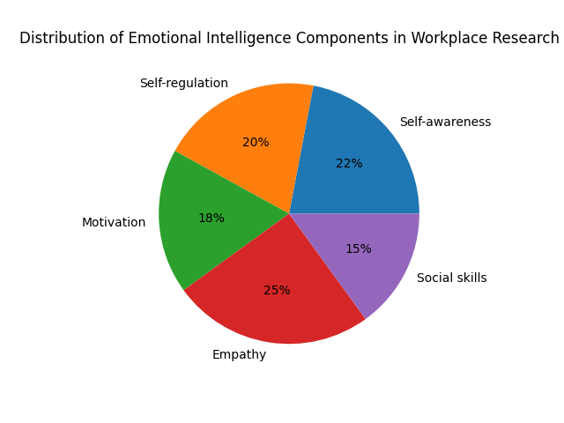
Figure 1: Emotional Intelligence Components
Source: Adapted from Goleman’s Emotional Intelligence model (Goleman, 1995; Goleman, 1998; Mayer, Salovey and Caruso, 2004).
Data Map: Distribution of Emotional Intelligence Components in Workplace Research
Emotional Intelligence Component | Percentage (%) | Description
Self-awareness | 22% | The ability to recognise and understand one’s own emotions and how they affect behaviour and decision-making in the workplace.
Self-regulation | 20% | The ability to control or manage emotional reactions, remain calm under pressure, and behave appropriately in different situations.
Motivation | 18% | Internal drive to achieve goals, maintain commitment, and remain optimistic when facing challenges at work.
Empathy | 25% | The capacity to understand and share the feelings of others, which supports effective leadership, teamwork, and communication.
Social Skills | 15% | The ability to build relationships, influence others, manage conflict, and communicate effectively within teams.

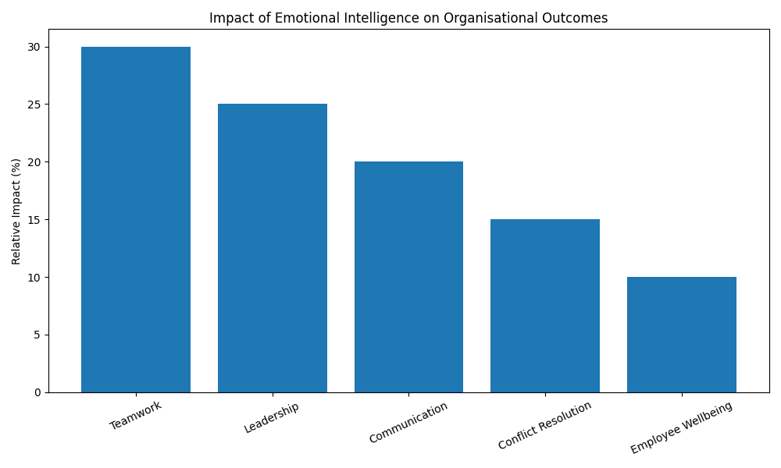
Figure 2: Impact of Emotional Intelligence in Organizations
Source: Adapted from emotional intelligence literature (Goleman, 1998; Mayer, Salovey and Caruso, 2004).
Data Map: Impact of Emotional Intelligence on Organisational Outcomes
Organisational Outcome | Relative Impact (%) | Explanation
Teamwork | 30% | Emotional intelligence improves collaboration, trust, and understanding between team members.
Leadership Effectiveness | 25% | Leaders with high emotional intelligence can motivate employees, manage relationships, and make better decisions.
Communication | 20% | Emotional awareness helps individuals express ideas clearly and understand others’ perspectives.
Conflict Resolution | 15% | Emotional intelligence helps manage disagreements and reduce workplace tension.
Employee Wellbeing | 10% | Emotionally intelligent environments support mental wellbeing and reduce workplace stress.

These figures illustrate how emotional intelligence competencies contribute to organizational outcomes. Empathy and self‑awareness are frequently highlighted in leadership research due to their role in building trust, supporting collaboration and improving workplace culture.

- Research on Generational Characteristics in the Workplace
Modern workplaces consist of employees from different generations, each with unique experiences, expectations, and working styles. Understanding generational differences helps managers create inclusive work environments and develop effective recruitment strategies.
The three main generations currently active in the workforce include:
- Generation X,
- Generation Y (Millennials),
- Generation Z.

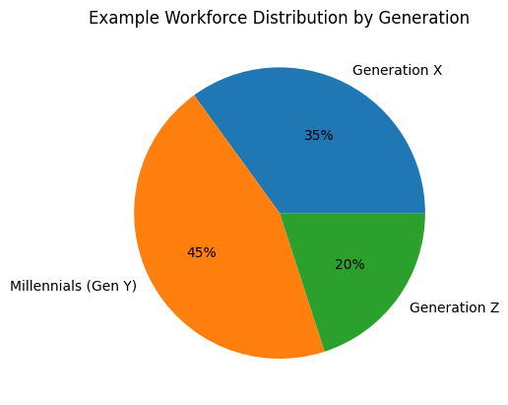
Generation | Percentage | Description
Generation X | 35% | Experienced employees who value independence, stability, and work–life balance.
Millennials (Gen Y) | 45% | The largest group in many organisations, known for collaboration, digital skills, and preference for meaningful work.
Generation Z | 20% | The newest entrants to the workforce, highly technologically skilled and focused on flexibility and innovation.

- Generation X (1965–1980) employees are often described as independent, adaptable, and logical. Many individuals in this generation grew up during periods of economic uncertainty and organisational restructuring, which influenced their attitudes toward job stability and career development. As a result, Generation X employees manage to value autonomy, work–life balance, and flexible working arrangements (Twenge, 2010). They generally prefer managers who trust them to work independently and provide opportunities for professional growth.
- Generation Y - Millennials (1981–1996), represent one of the largest groups in today’s workforce. Having grown up during rapid technological development, Millennials are highly comfortable with digital communication and collaborative working environments. They tend to value meaningful work, continuous feedback, and opportunities for personal and professional development (Hershatter and Epstein, 2010). Organisations that provide mentoring, training, and supportive leadership are more likely to retain Millennial employees.
- Generation Z (1997–2012) is the newest generation entering the workforce. As digital natives, they are highly skilled in technology and online communication. Generation Z employees often prioritise flexibility, diversity, and social responsibility in the workplace (Schroth, 2019). Accordingly, organisations must adopt modern recruitment strategies, including digital platforms and innovative communication methods, to effectively attract and engage this generation.

Characteristic | Generation X (1965–1980) | Millennials / Generation Y (1981–1996) | Generation Z (1997–2012)
Work Values | Independence, stability, work–life balance | Meaningful work, collaboration, development | Flexibility, innovation, diversity
Communication Style | Direct communication, email | Collaborative, digital communication | Instant communication, social media
Technology Skills | Adapted to digital technologies | Highly comfortable with technology | Digital natives
Leadership Expectations | Prefer autonomy and trust  Offer autonomy and flexible working arrangements | Expect mentorship and provide regular feedback and career development regular feedback | Expect coaching and inclusive leadership  Promote diversity, technology and wellbeing initiatives
Career Motivation | Job security and progression | Career growth and purpose | Skill development and flexibility
Workplace Preferences | Flexible work schedules | Collaborative environments | Technological and innovative workplaces
Effective Recruitment Strategy | Professional networks, job stability, leadership roles | Employer branding, development programmes, mentorship | Social media recruitment, digital platforms, innovation
Table 8: Comparison of Generations in the Workplace
Source: Adapted from Twenge (2010); Hershatter and Epstein (2010); Schroth (2019).

Managing Generational Diversity
Generational diversity can provide significant benefits to organisations, including diverse perspectives, knowledge sharing, and innovation. However, differences in communication styles and expectations may also create challenges.
Managers can improve workplace effectiveness by:
- Encouraging intergenerational collaboration
- Providing flexible working arrangements
- Offering training and mentoring programmes
- Adapting leadership styles to different employee needs
By recognising generational differences and promoting inclusivity, organisations can create environments where employees from all age groups feel valued and motivated.
Critical Analysis of Emotional Intelligence in the Workplace
Although emotional intelligence (EI) is widely recognised as an important factor in effective leadership and workplace relationships, some studies claim that the concept lacks clear measurement and consistency across different models. For example, while Goleman (1998) emphasises competencies such as empathy, motivation, and social skills, Mayer and Salovey (1997) conceptualise emotional intelligence as a cognitive ability related to perceiving, understanding, and managing emotions. This difference in theoretical perspectives has directed to debates regarding whether emotional intelligence should be considered a personality feature, a learned skill, or a form of intelligence (Landy, 2005). Despite these criticisms, many studies suggest that emotionally intelligent leaders are better able to manage conflict, motivate employees, and improve team performance, which supports the practical value of emotional intelligence in organisational settings (Cherniss, 2010).

- Recommendations
To maximise the benefits of emotional intelligence (EI) and generational diversity, organisations should implement several strategic practices. First, organisations should provide emotional intelligence training for employees and managers to develop competencies such as self-awareness, emotional regulation, empathy, and interpersonal communication, which support effective leadership and teamwork (Goleman, 1998; Cherniss, 2010). Second, organisations should incorporate mindfulness practices into workplace wellbeing initiatives, as mindfulness can improve emotional regulation, resilience, and employee performance (Kabat-Zinn, 2003; Good et al., 2016). Additionally, emotional intelligence should be integrated into recruitment and leadership development processes, allowing organisations to select individuals with strong interpersonal skills (Mayer, Salovey and Caruso, 2004). Finally, managers should adopt inclusive leadership approaches that recognise generational differences and encourage collaboration between Generation X, Millennials, and Generation Z employees to enhance organisational effectiveness (Twenge, 2010; Schroth, 2019).
- Conclusion
Emotional intelligence (EI) is increasingly recognised as a critical competency in modern organisations because it supports effective communication, leadership, and teamwork. Employees who can recognise and manage their emotions while understanding the emotions of others can improve collaboration, decision-making, and workplace relationships (Goleman, 1998; Mayer and Salovey, 1997). In addition, understanding generational differences within the workforce is essential for effective management. Generation X, Millennials, and Generation Z employees often have different expectations regarding work values, communication styles, and career development (Twenge, 2010; Schroth, 2019). Managers who recognise and adapt to these differences can create more inclusive and supportive work environments. Accordingly, the combination of emotional intelligence and awareness of generational diversity can enhance employee engagement, strengthen organisational culture, and contribute significantly to long-term organisational success (Cherniss, 2010; Ashkanasy and Daus, 2005).

6.References
- Bar-On, R. (1997) The Emotional Quotient Inventory (EQ-i): Technical Manual. Toronto: Multi-Health Systems.
- Boyatzis, R.E. (2018) ‘The behavioural level of emotional intelligence and its measurement’, Frontiers in Psychology.
- Cherniss, C. (2010) ‘Emotional intelligence: Toward clarification of a concept’, Industrial and Organizational Psychology.
- Fineman, S. (2003) Understanding Emotion at Work. London: Sage.
- Goleman, D. (1995) Emotional Intelligence: Why It Can Matter More Than IQ. New York: Bantam Books.
- Goleman, D. (1998) Working with Emotional Intelligence. London: Bloomsbury.
- Good, D. J., Lyddy, C. J., Glomb, T. M., Bono, J. E., Brown, K. W., Duffy, M. K., Baer, R. A., Brewer, J. A., & Lazar, S. W. (2016). Contemplating Mindfulness at Work: An Integrative Review: An Integrative Review. Journal of Management, 42(1), 114-142.
- Hofstede, G., 2011. Dimensionalizing cultures: The Hofstede model in context. Online readings in psychology and culture, 2(1), p.8.
- Kabat-Zinn, J. (2003) ‘Mindfulness-based interventions in context: Past, present, and future’, Clinical Psychology: Science and Practice.
- Mayer, J.D., Salovey, P. and Caruso, D.R. (2004) ‘Emotional intelligence: Theory, findings, and implications’, Psychological Inquiry.
- Purser, R. (2019) McMindfulness. London: Repeater Books.
- Stazyk, E.C. and Davis, R.S. (eds.) (2022) Research Handbook on Motivation in Public Administration. Cheltenham, UK: Edward Elgar Publishing.
- International Labour Organization (2022) Mental Health at Work: Policy Brief. Geneva: International Labour Organization.

