

Name: Rushangkumar Malani
SID: 2430699
Course Name: Master of Business Administration (MBA)
Module Title: International Business Concepts
Module Code: LCMB7034
Topic: “A Critical Analysis of McDonald’s Internationalisation Strategy: OLI Framework Application, Cultural Considerations, and Strategic Recommendations for Operations in India.”
Lecturer: Johnny Wan
Submission Date: 21st November 2025

Word Count:- 5155
Contents
1. Introduction 3
2. Benefits and Challenges of International Operations 4
2.1 Why McDonald’s Can Be Designated as an MNC/TNC 4
2.2 Nature of McDonald’s Global Operations and Value Chain 5
2.3 Entry Modes that McDonalds employs in the international markets 7
2.4 Advantages that are gained by operating internationally 8
3. OLI (Ownership–Location–Internalisation) Advantages and Their Impact on McDonald’s Market Entry Mode into India 9
4. Impact of Cultural Differences Between the United States (Home Country) and India (Emerging Economy) on McDonald’s Market Entry Strategy and Success 16
5. Recommended SOP Adjustments for McDonald’s in India 22
6. Conclusion 28
7. References 29

1. Introduction
One of the largest multinational fast food companies in the world is McDonalds with more than 40,000 stores in more than 100 countries that are supported by integrated supply chain networks and standardized operating procedures (McDonald’s Annual Report, 2023). The global strategy of the company is rooted in the provision of high-quality products with some menu items tailored to local cultural tastes and consumer behaviour (Ghemawat, 2018). As McDonald increases its market presence to different regions like the United States, China, and India, it has to navigate through different political, cultural and economic landscapes that inform its international strategic decisions (Hill and Hult, 2020). India, specifically, is one of the potential markets, as it is characterized by the big population, high income growth rates, and individual culture-based food consumption (World Bank, 2024). The present report critically assesses the advantages and disadvantages of the international activities of McDonald, evaluates its entry approach to the Indian market through the OLI framework, discusses the impact of cultural factors and gives a strategic advice to improve operations in the Indian market.

2. Benefits and Challenges of International Operations

2.1 Why McDonald’s Can Be Designated as an MNC/TNC
The type of McDonalds is that of Multinational Corporation (MNC) since it is based in many countries other than the United States of origin, but it has a great extent of coordination and strategic control within its global system. With the number of its restaurants exceeding 40,000 in more than 100 countries the company has proven its wide geographical spread and capability to conduct the operations across the borders (McDonald’s Annual Report, 2023). McDonalds being an MNC will be globally standardised and locally adapted to ensure the same quality of products and services, but adjust its menus and marketing strategies to fit the cultural, economic, and consumer context of each market (Ghemawat, 2018).
Further, McDonalds has common Transnational Corporation (TNC) features because it has globally integrated supply chains, sharing of learning in countries where one subsidiary operates, and decentralised operational decisions in which partners in the regions are taken as a major strategic consideration (Bartlett and Beamish, 2020). One such example is how McDonalds India has been working with local companies in sourcing of raw materials, distributing and customizing menu products; one can see this as the compromise of global brand control versus local responsiveness. This is the hybrid organisational structure that helps McDonalds to exploit economies of scale and still adapt well to the conditions of the host countries. Based on this, the company can be considered an MNC/TNC because it is global, has integrated its strategic operations across borders, employs multinationalists, has different supply chains, and has a culturally tailored business model (Hill and Hult, 2022).

2.2 Nature of McDonald’s Global Operations and Value Chain
The value chain that McDonalds has in place across the world has contributed to its global business through highly coordinated and efficient value chain that covers research and development, sourcing, production, distribution, marketing, sales and financing. The company follows a three-legged stool operation framework, comprising of the corporate and its franchisees and the suppliers, who collaborate in order to maintain efficiency and brand uniformity in markets (Love, 2019).
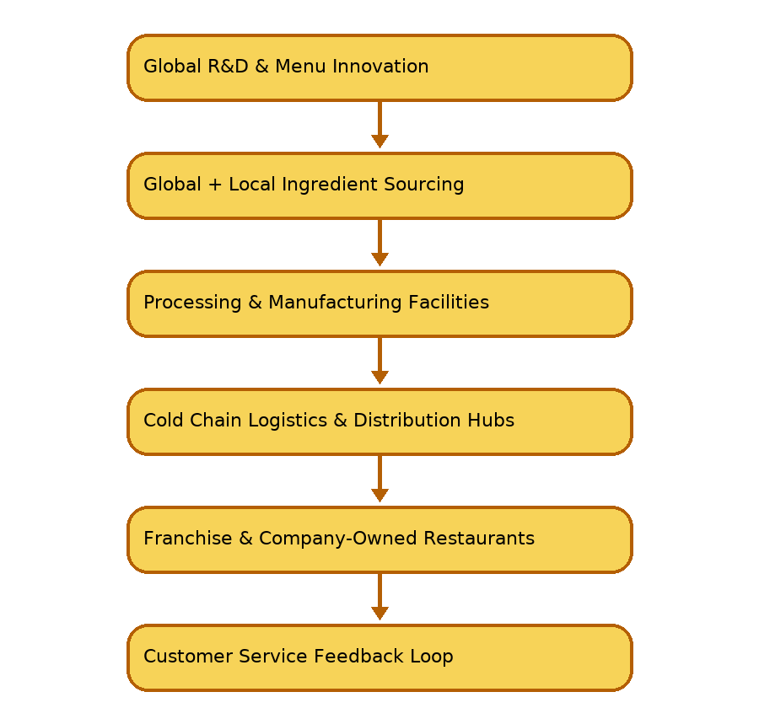
Figure 1: McDonald’s Global Value Chain

- Research and Development (R&D):
McDonald is a company that undertakes a high level of research and development to come up with new product provisions, streamline the processes in the kitchen, improve its menu and also come up with better packaging solutions. Depending on the region, R&D focus can be on convenience and digital ordering additions, or on innovations that are culturally compatible, like the McAloo Tikki or the rice-based Chicken Bowl (Vignali, 2019).
- Sourcing and Procurement:
The McDonald sourcing system is a world sourcing system that provides quality and uniformity of ingredients and utilizes local suppliers wherever feasible. This localization is required in terms of freshness, lowering logistics expenses, and regulatory standards (Ritzer, 2020). McDonalds, in India, also designed a cold-chain logistics infrastructure and deployed it completely with no similar alternatives, whereby it can transport and store perishable commodities at long distances without damaging their quality (Srinivasan and Bandyopadhyay, 2021).
- Production / Supply Chain Manufacturing:
McDonald collaborates tightly with vendors that are affiliated to process meat, dairy, grains, and vegetables to the level of global quality assurance. The supplier relationships of the company are long-term and cooperative which means that the company can shape quality and sustainability practices in its network (Ghemawat, 2018). The reliability of the supply chain is important since product uniformity is the key element of the McDonald brand.
- Distribution and Logistics:
Effective logistics enable the operations of the restaurant in terms of the stable delivery schedules, the temperature-regulated storage and the unified inventory processes. McDonalds heavily invests in logistics facilities, especially in the developing markets where the distribution channel is poorly developed (Kumar and Steenkamp, 2021).
- Sales and Customer Experience:
To ensure a consistent customer experience, McDonalds has been able to use standardised interior design layouts, customer service processes, digital order kiosks, drive-thru, and mobile integration (Johnson, Scholes and Whittington, 2022). Nonetheless, menu and marketing campaigns are localized based on the cultural values and consumer preferences.
- Financing Model:
McDonald's revenue comes mainly from franchise-related payments, rentals, and royalties, not from direct sales at its outlets. This financing model permits the company to have a fast expansion with little capital investment and at the same time to direct its operations strategically (McDonald’s Annual Report, 2023).
To sum up, the world-wide value chain of McDonald's is a mix of standardization of processes for the sake of cost-effectiveness along with localization to the degree of culture being respected. The synergy achieved through this powerful combination makes the brand's competitive edge even stronger in the various scenarios of the world markets.

2.3 Entry Modes that McDonalds employs in the international markets
McDonalds employs franchising, joint venture and wholly owned subsidiary as a way of entering and operating in foreign markets. Franchising is the dominant entry mode of the company that enables to expand quickly with a minimum financial risk and directly with entrepreneurial partners that have a local market understanding (Hill and Hult, 2020). It is also a franchise based model that facilitates adjusting of business practices to host country laws and culture.
McDonalds first ventured in India by collaborating with two local partners Hardcastle Restaurants in the West and South, and in the North and East, Connaught Plaza Restaurants. This strategy has seen McDonalds distribute the risk of investment, local supply chain knowledge, and a deeper appreciation of the cultural food environment (Srinivasan and Bandyopadhyay, 2021). With time, one of these joint ventures evolved into a development licensee model which will depict the strategic change by McDonald to be more operationally controlled although remain responsive to the local market.
Comparatively, the entry of McDonalds in China was a mix of franchising and strategic partnership with state-oriented businesses to help it overcome the bureaucracy of regulations and access prime retail spaces (Liu and McDonald, 2022).
Therefore, the entry modes of McDonald are flexible and strategically chosen depending on the situation in the host country, the global efficiency is combined with the local adaptation.

2.4 Advantages that are gained by operating internationally
International operation offers McDonalds with a number of strategic advantages. To begin with, it enables the company to realize economies of scale in procurement, production, marketing and adoption of technologies, in turn minimizing the overall cost of operations (Ghemawat, 2018). Second, the presence in the international market allows diversification of the markets and eliminates the reliance on a particular country and stabilises the revenues when economic factors change (Hill and Hult, 2022). Third, international expansion helps to build the brand, acquire recognition, and authority in the fast-food market (Johnson et al., 2022).
Besides, interacting with different markets brings about knowledge transfer and innovation, so that the information from one area can be used for the product and process improvement in another place. For instance, the innovations in menus for Indian consumers have affected the availability of vegetarian options in other markets. To sum up, the company's presence in developing countries such as India and China places McDonald’s at a vantage point to reap the benefits of increasing disposable incomes, urbanization, and the rise of the youth population (World Bank, 2024).
After all, McDonald’s multinational operations are a source of business growth, resilience, and competitive advantage, and also the company’s global brand relevance.

3. OLI (Ownership–Location–Internalisation) Advantages and Their Impact on McDonald’s Market Entry Mode into India
John Dunning has created the OLI paradigm (also called the Eclectic Framework) to explain why companies invest in foreign direct investment and how they make a decision regarding the most suitable mode of entry into the international markets (Dunning, 2015). The model suggests that three advantages which are related to each other determine the international expansion decisions of a company, they are Ownership advantages, Location advantages, and Internalisation advantages. With the example of McDonald entry into the Indian market, all these factors were very crucial in determining its strategy and especially the move into the market through joint ventures with a robust system of franchising. The fact that the Indian fast-food market is relatively new, cultural and religious preferences are tricky, and the cold-chain supply chain is not well-developed preconditioned high relevance of the OLI framework in developing the strategy of McDonald market entry and its expansion.

- Ownership Advantages
The ownership benefits describe the company-specific assets McDonalds has and utilizes as a firm in its effort to enter new foreign markets. Such strengths include the reputation of the brand, patented food preparation procedures, administration abilities, and international supply chain policies (Hill and Hult, 2022). McDonalds is worldwide known as one of the major fast-food chains, which are related to speed, uniformity, cleanliness, and comfort. This powerful international brand offers the company a great competitive advantage in case it enters a market such as India, where foreign brands are perceived as something modern and aspirational (Ghemawat, 2018).
Also, McDonalds has proprietary business systems, including quality standards of the control, the architecture of the restaurant layout, and kitchen preparation processes that provide operational efficiency (Love, 2019). These advantages of ownership are cross-border, and they are not very much reliant on local institutional frameworks. Managerial expertise (particularly in large-scale franchising and training of workforce) also brings a competitive advantage to the company since it ensures a consistent performance of stores in the worldwide diversity (Bartlett and Beamish, 2020).
Nonetheless, these high ownership benefits, did not mean that McDonald could use standardisation alone in India. It was not an experienced company in dealing with religious eating habits in India, namely, Hindu vegetarianism and cultural taboos on beef and Muslim restrictions on the consumption of pork. Thus, though the level of ownership gave a platform, McDonald had to incorporate local knowledge to be able to change its menu and business operations.
- Location Advantages
Location benefits to do with the nature of the host country that foreign firms are attracted to. The emerging market of India, such as a large youthful population, fast urbanisation, increasing disposable income, and the increasing acceptance of western-style fast food by the population, has a range of strategic advantages (World Bank, 2024). These variables formed high market potential of McDonald.
But India too posed a lot of problems. The logistics and cold-chain network in India was poorly developed when McDonalds entered the market in the mid-1990s, and it was challenging to keep perishable products safely and distribute them (Srinivasan and Bandyopadhyay, 2021). It would not have been possible to ensure that the global food safety standards of McDonald have been maintained without temperature-controlled supply systems. This is the challenge that directly affected the decision of entry mode as it forced McDonald’s into partnership that could facilitate the development of infrastructure in the long term.
Other essential locations factors were cultural and religious food norms. However, India needed a complete re-modelling of the menu, with vegetarian products and the existence of vegetarian and non-vegetarian zones of cooking, as the West market is characterized by beef burgers as the core product (Vignali, 2019). This required high level of local knowledge and this raised the necessity of partnerships which could offer cultural perspectives.
Besides, the Indian market presented regulatory limitations such as limitations of foreign ownership of multi-brand retail. These rules encouraged McDonalds to embrace joint ventures to abide by the laws and institutional frameworks (Liu and McDonald, 2022). The high growth potential combined with cultural complexity and regulation restrictions made India a favourable and challenging destination that impacted the company decision to select a shared control entry strategy.
- Internalisation Advantages
Internalisation benefits The reason why a company decides to internalise its business instead of licensing its brand or giving the business to local players to run is explained by internalisation benefits. In the case of McDonalds, it was necessary to maintain a quality control and brand consistency, as a slip in one market could affect the global image of the company negatively (Johnson, Scholes and Whittington, 2022).
The situation in the food supply and distribution in India was not reliable to start with the standardized operating model of McDonald. McDonalds could regulate the safety and quality of its products by internalising some of the main elements of the supply chain, especially the procurement and logistics (Ritzer, 2020). Nevertheless, development of such capabilities would have incurred big capital investments and operational risk. Thus, joint ventures with local companies enabled McDonald to internalize core competencies as well as risk sharing and utilise local expertise.
Also needed was internalisation in order to safeguard the proprietary business systems of McDonald, which included cooking techniques, equipment design, staff training systems, and brand management techniques (Hill and Hult, 2022). Assigning licenses to local independent businesses with no ownership and supervision would have jeopardized branding uniformity and consumer trust. Thus, franchising and joint ventures were the best options in terms of control and local responsiveness.

Effects of OLI Factor on the Entry Mode Decision (Joint Ventures + Franchising)
The combination of Ownership, Location, and Internalisation benefits eventually resulted in McDonalds using joint venture entry strategy in entering India. The company entered into an agreement with Hardcastle restaurants in Western India and Connaught Plaza restaurants in Northern India. These local associates offered key cultural, regulatory, and supply chain knowledge that could not be attained by the ownership benefits of McDonald alone (Srinivasan and Bandyopadhyay, 2021).
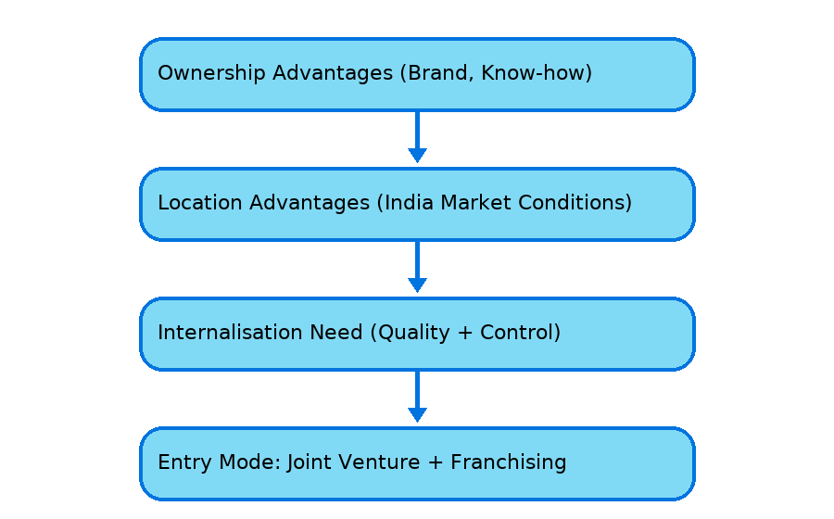
Figure 2: Effects of OLI Factor on the Entry Mode Decision (Joint Ventures + Franchising)
With time, with the regulatory framework in India changing as the McDonald grew in its knowledge on the local market, the joint venture structure started to change gradually to a more internalised control, which ultimately resulted in Hardcastle becoming a master franchisee. This development indicates the dynamic character of the OLI benefits: the local reliance was slowly modified to the global standardisation as the stability in its operations was attained.
The long-term model that prevailed became franchising which enables ease of scale, less capital risk, and the empowered local operator is more sensitive to cultures (Hill and Hult, 2022). In the meantime, brand and quality uniformity is guaranteed by centralized control.
OLI Factor | Key Elements for McDonald’s | Impact on Market Entry into India
Ownership Advantages | Brand reputation, supply chain skill, franchise model expertise | Enabled McDonald’s to transfer successful business systems
Location Advantages | Large youth population, urbanization, stable policy environment | India selected as attractive long-term growth market
Internalization Advantages | Quality control, standardization, IP protection | Led to Joint Ventures + Franchising rather than outsourcing
Table: OLI Framework Applied to McDonald’s India Entry
Hence, the case of McDonald entering India shows that the OLI framework is very effective in explaining the decision on international market strategy. The advantages of ownership like brand strength and knowledge of operations made McDonald create a base in the Indian market. Entry was influenced by location benefits such as market size and consumption potential whereas cultural norms and regulatory impediments influenced the strategic adaptations. The benefits of internalisation made McDonalds not to lose control over major systems in order to preserve the integrity of the brand and the food quality. All these factors combined caused the joint venture entry strategy that was facilitated with franchising to be adopted, which, at the same time, ensures global standardisation and local responsiveness. This strategy helped McDonald to design a sustainable and culturally adaptable business model in India.

4. Impact of Cultural Differences Between the United States (Home Country) and India (Emerging Economy) on McDonald’s Market Entry Strategy and Success
The importance of cultural differences has a big bearing on the strategies and operational approaches of multinationals as they increase their presence in the international markets. The Cultural Dimensions framework created by Hofstede is the most common model used to understand variations in cultural value and behaviours, which can be useful in understanding how organisations can adapt to an international environment (Hofstede, 2011). In the case of McDonalds, cultural differences between the United States, which is the mother firm and India, the selected emerging market, were the key to success in market entry, long-term customer acceptance, and competitive expansion.
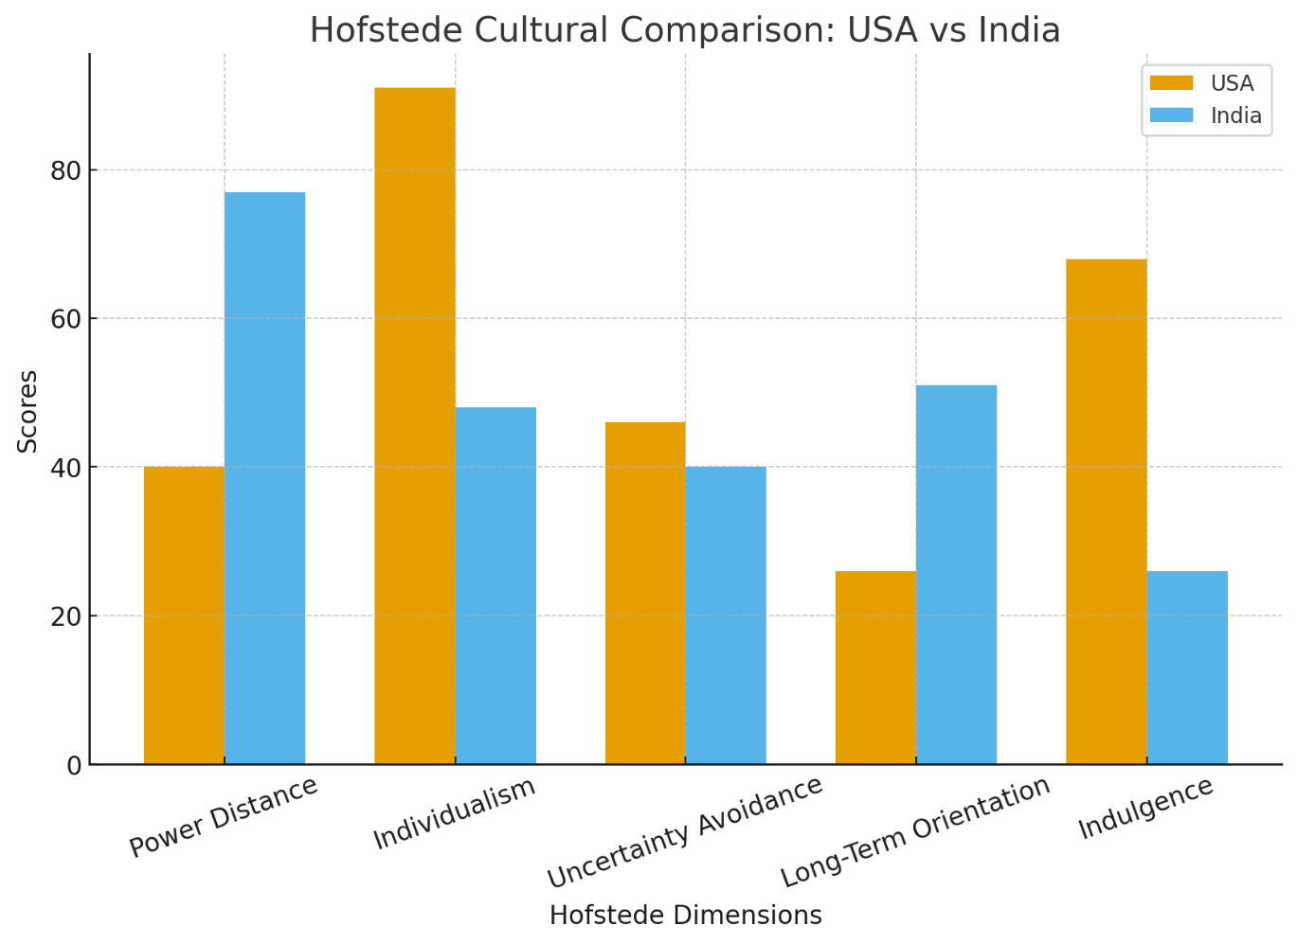
Figure 3: Hofstede Cultural Comparison – USA vs India

- Power Distance
Power Distance is used to quantify how much societies embrace hierarchical structure and unequal allocation of power. In the United States, power distance is low with the focus on equality, autonomy of employees and participative management (Hofstede, 2011). Conversely, India is high and signifies that this country is open to levels of hierarchy, top-down communication, and status-related workplace relations (Vignali, 2019).
In the case of McDonald, the aspect of culture affected the management hierarchy and supervision of employees. The U.S. restaurants McDonalds have adopted an open communication between staff and the managers, but in India operations, the leadership style had to be more formal, the roles were well defined, and there was a solid supervisory presence. The adjustments made in training programs in India focused on the respect and adherence to the hierarchy, the hierarchical communication channels and senior management supervision (Srinivasan and Bandyopadhyay, 2021). This modification assisted McDonald to fit in the expectation of the employees and prevent conflict at work.
- Individualism vs. Collectivism
The United States is among the most individualistic societies in the world and the customers in this country appreciate personal choice, independence, and convenience (Hill and Hult, 2022). India, in its turn, is a country that is inclined to collectivism and values family, social identity, and community membership (Ghemawat, 2018).
Such cultural variations played a great role in determining the marketing and restaurant experience of McDonald. In the USA, McDonald is advertising on the level of personal satisfaction (e.g., I’m Lovin It). The brand in India however concentrated on family oriented content, dining out and eating together as a family and affordability. Indicatively, the McDonalds India market launched family meal packages, shared sitting arrangements and children oriented products as part of attracting the collective social dining habits (McDonalds Annual Report, 2023).
Moreover, collectivists rely on social and parental opinion in their buying decisions. Consequently, McDonalds advertised its restaurants as secure and clean and family-friendly locations, which in comparison to the traditional street food sellers set the company apart and gave Indian families confidence in the company.
- Uncertainty Avoidance
Uncertainty Avoidance is a depiction of how cultures deal with risk and uncertainty. The U.S. is rated averagely low, comfortably flexible and innovative. India is more uncertainty avoidance though it means that it prefers clear expectations, rules, and consistency (Hofstede, 2011).
Such cultural difference demanded that the McDonalds needed to focus more on safety, hygiene and product reliability in India compared to the United States. Indian consumers are extremely sensitive regarding food safety given that there are informal street food markets (Ritzer, 2020). Thus, McDonalds designed one of the pioneering cold-chain logistics in India, which makes it possible to store and transport perishable food products safely (Srinivasan & Bandyopadhyay, 2021). The hygienic and international food safety standards were emphasized during marketing efforts with references to the need to be reliable and trustworthy to the Indian consumers.
On the same note, service training emphasized on uniformity in food preparation and presentation. Although the customization and variation would be tolerated by the U.S. consumers, Indian consumers required predictable quality, and this aspect of the Indian operations would support standardization.

- Masculinity vs. Femininity
Both the United States and India score high on masculinity dimension, which implies that the society values achievement, competition and success (Hofstede, 2011). Nevertheless, this trait is not expressed by consumers alike. Convenience and efficiency are linked to consumption of fast food in the U.S. whereas it is a social and aspirational experience in India (Kumar and Steenkamp, 2021).
This was capitalized by McDonalds who branded itself in India as a British lifestyle of dreams. The design of the restaurants, atmosphere, and brand image communicated a sense of modernity and social status, particularly to the middle-income youth and urban elites (Ghemawat, 2018). Experience and social identity were the key selling points, unlike in the U.S. where the primary selling point is speed.
- Long-Term Orientation
The score of India on Long-Term Orientation is high and it emphasizes patience, slow movement of progress, and continuity of culture. The United States has been ranked lower, meaning that it is more short-term-oriented and fast-result-oriented (Hofstede, 2011).
This had a bearing on the market development schedule of McDonald. McDonalds have experienced fast growth in the U.S. because the culture is accustomed to fast food. Trust in the foreign food brands had to be established gradually in India. McDonalds has been practicing a long term strategic strategy, whereby it has invested in local supply chains, employing people and adapting their cuisines to local culture over many years before the large scale profitability is reaped (Srinivasan and Bandyopadhyay, 2021).
As opposed to forcefully foisting Western food products, McDonalds adopted local cuisine in the long term. Examples include:
- McAloo Tikki (vegetarian)
- Paneer Wrap
- Chicken Maharaja Mac (no beef)
- Spicy seasoning is made according to the preferences of Indian taste.
These product adjustments were critical towards ensuring the success in the long run.
- Influence on Market Entry Performance
A combination of the cultural factors had a direct effect on the choice of entry mode of McDonald, which resulted in joint ventures in India. Cultural knowledge, regulatory navigation and menu development expertise were offered by local partners (Hill and Hult, 2022). In the absence of such cultural understanding, McDonald would have most probably experienced rejection by the customers and failure in its operations.
The cultural adaptation strategy adopted by McDonald in India proved to be successful:
Business Element | Cultural Impact | Result
Menu Offerings | Religious norms and taste preferences | Fully localized menu without beef or pork
Marketing | Collectivist orientation | Family-focused and value-based campaigns
Restaurant Experience | Social dining culture | Comfortable seating and community-oriented layouts
Operations | Hygiene expectations | Strong food safety systems and supply chain investments

The agreement between the culture and the strategy allowed McDonald’s to create a brand in India that was universally accepted, could be expanded, and was trustworthy.
Hence,
The cultural gaps between the US and India had a great impact on the McDonald's entry plan and their later success on the Indian market. When Hofstede’s cultural dimensions are used, it is seen very clearly that McDonald’s had to change its management style, menu offerings, marketing strategies, restaurant experience, and operational procedures to be in sync with Indian cultural norms and consumer expectations. These changes were not only necessary for market acceptance but also for the long term securing of the competitive edge in a culturally complex and price-sensitive market. The mastery of recognizing and strategically responding to the cultural differences enabled McDonald’s to come out with a strong and long-lasting presence in India.

5. Recommended SOP Adjustments for McDonald’s in India
In order to achieve a sustainable success in the Indian market, McDonalds needs to keep synchronizing the Standard Operating Procedures (SOPs) with lessons learned in the OLI Framework and cultural differences as explained earlier. Despite the fact that McDonalds already has undergone a few changes, the changing consumer demands, increased threat posed by the local fast-food corporations and the shifting nature of the regulatory environment demand further strategic adjustment. There are three significant changes that McDonalds would want to make as shown in the next section:
- Improving Localization of Menu Innovation and Research and Development,
- Improving Local Supply Chain Resilience and Sustainability, and
- Strengthening the Cultural Training and Service Personalization.
All of the recommendations are directly related to enhancing the cultural fit, market sensitivity, and operational efficiency in the long term in India.
1) Improve Localization of Menu Innovation and R&D Capacity
Despite the introduction of the McDonalds successful localized products like the McAloo Tikki and Maharaja Mac, the Indian market is still very regionally differentiated in terms of taste preferences, tolerance of spices, use of vegetarianism, and price sensitivity (Ghemawat, 2018). India has to continue with localized menu innovation as opposed to the United States where national menu standardization is more of a possibility with regional R&D departments.
One of the major SOP changes is the set up of regional culinary development centers in India to experiment on new recipes, team up with local chefs, and carry out taste-testing workshops on consumers. The strategy is associated with the Location benefits outlined in the OLI framework according to which the local knowledge is vital to market success (Dunning, 2015). This would enable McDonald to be competitive in terms of relevance in such regional R&D activities, especially in relation to Indian brands such as Bikanervala, Haldiram, and other local QSR chains that are already accessible to cater to local tastes (Kumar and Steenkamp, 2021).
Further, McDonalds ought to increase seasonal and festival menus to conform to the culture and religious consumption patterns. For example:
- Jain friendly versions of the pre-existing vegetarian foods (no onion, no garlic)
- Geographic variations in spice profiles (e.g. South Indian Chettinad spices vs. North Indian Punjabi spices).
- Menus of festival Diwali, Holi, Ramadan, and Navratri.
This SOP change is culturally sensitive and will increase the brand acceptance in a collectivist culture where superstition is closely attached to food (Hofstede, 2011).
2) Empower Local Supply Chain Resiliency and Sustainability
The first entry of McDonald in India on a joint venture basis meant that it had to construct a completely new cold-chain which would keep the food safe (Srinivasan and Bandyopadhyay, 2021). Nevertheless, existing issues in agricultural sector of India including unpredictable prices of commodities, irregular infrastructure of rural areas, and increasing weather variability point to necessity of additional reinforcement of supply chain resilience.
A revised SOP should include:
- Forming more alliances with local and small scale farmers on long-term procurement agreements.
- Investing in cold storage hubs, which are decentralized to minimize the delays in the logistics and temperature variations.
- Enhancing sustainability auditing of suppliers to procure in an ethical manner and environmental responsibility.
Improving supply chain resilience is a fit with internalisation benefits as it allows McDonalds to continue to hold power over the quality and safety standards of the food it serves and minimises dependence on a small number of suppliers (Hill and Hult, 2022). It also favours long-term orientation cultural values of Indians which focus on relationship-building and developing trust gradually with supply partners (Hofstede, 2011).
In addition, a competitive differentiation point can be the improvement of sustainability credentials. Indian customers, particularly young people in cities, are becoming more conscious about the environment and consider the brands in terms of their ethical sourcing and waste minimization (World Bank, 2024). Hence, the incorporation of recyclable packaging, a minimized amount of single-use plastic, and the food waste management systems in the McDonalds SOPs would directly correspond to the changes in consumer values.
3) Enforce the Culture Training and Service Personalization
The effectiveness of the McDonalds service model is not fully based on the standardization of the operational processes but the quality of customer interaction which differs tremendously across cultures. Customer service is not formal and individualistic in the United States and it focuses on fast transactions and efficiency. Customers in India prefer to be engaged warmly, hospitably, and relation-building, which is appropriate in the culture of collectivism (Ghemawat, 2018).
Thus, McDonalds will need to revise its SOPs by improving cultural and interpersonal training courses of frontline workers and managers. These are some of the training improvements that they should have:
- Training on communication etiquette which focuses on social sensitivity and respect.
- Personalization of the service that entails the employees to identify repeat clients and foster relationship.
- High power-distance conflict resolution training that addresses the situation where employees might be reluctant to speak directly.
Moreover, Indian customers usually eat together and going out to the restaurant is a social process and not a productive one. Thus, the SOPs concerning the restaurant layout and seating should be revised to provide communal seating areas, comfortable areas of dine-in experience, and huge family table areas.
Moreover, since India has a high score on uncertainty avoidance (Hofstede, 2011), proper communication about the hygiene standards is necessary. There should be visible food preparation spaces, staff hygiene inspections and showing safety certification to people in SOPs. These are habits that make the Indian consumer foster trust and perceived risk (Ritzer, 2020).

Strategic Benefits of the Three SOP Adjustments
SOP Adjustment | Key Advantage | Strategic Outcome
Localized Menu R&D | Cultural alignment and customer relevance | Increased market acceptance and repeat patronage
Strengthened Supply Chain Resilience | Quality control and risk reduction | Stable long-term operational efficiency
Cultural Service Training & Personalization | Enhanced brand trust and customer loyalty | Strong differentiation in a competitive QSR market
All of these SOP adaptations support a business model that is not entirely global or local, which is typical of the transnational strategy that McDonalds pursues in the world (Bartlett and Beamish, 2020).
Hence, in order to cement its competitive base and guarantee the long term sustainability of its activities in India, McDonalds still needs to fine tune its Standard Operating Procedures as well as localize them. The three suggested changes including regional R&D improvements to customize the menu, local chain of supply chain sustainability, and practices of customer service adapted to culture are responses directly to cultural and operational issues that are revealed by the OLI framework and the cultural dimension’s analysis provided by Hofstede. With these SOP enhancements, McDonald’s will be in better positions to realize greater cultural integration, supply chain stability, consumer trust and market expansion in the dynamism and cultural diversity of the fast-food market in India.

6. Conclusion
Conclusively, the case of McDonald internationalisation shows that multinational corporations need to balance global standardisation and local responsiveness in order to become effective in various markets. The fact that the company has expanded to over 100 countries is an indication of excellent ownership benefits, such as brand image, operational effectiveness, and franchise management skills (Hill and Hult, 2022). Nevertheless, its introduction into India needed thorough consideration of the location-based variables, particularly, food tastes, supply chain constraints, and regulatory restrictions (Srinivasan & Bandyopadhyay, 2021). The introduction of joint ventures backed by franchising helped McDonald to internalise essential functions with the help of local knowledge which is in line with the OLI framework (Dunning, 2015).
There was a significant influence of cultural differences between the United States and India that shaped the market entry strategy and operational strategy of McDonald based on dietary norms, collectivist social behaviour, hygiene and trust expectations (Hofstede, 2011). As a result, the company modified menus, styles of communication, restaurant designs and patterns of customer services to meet the expectations of the Indian culture. The suggested changes to SOP that include the expansion of the local menu R&D, increasing the supply chain resilience, and the cultural service training will contribute to the long-term success of McDonalds. Finally, the development of McDonald in India indicates significance of strategic adaptation in the global business context, which is culturally informed.

7. References
Bartlett, C. and Beamish, P. (2020) Transnational Management: Text, Cases and Readings in Cross-Border Management. 8th edn. New York: McGraw-Hill.
Dunning, J. (2015) The Eclectic Paradigm of International Production: A Restatement and Some Possible Extensions. Journal of International Business Studies, 19(1), pp.1–31.
Ghemawat, P. (2018) Redefining Global Strategy: Crossing Borders in a World Where Differences Still Matter. Boston: Harvard Business School Press.
Hill, C. and Hult, G. (2022) International Business: Competing in the Global Marketplace. 14th edn. New York: McGraw-Hill Education.
Hofstede, G. (2011) Dimensionalizing Cultures: The Hofstede Model in Context. Online Readings in Psychology and Culture, 2(1), pp.1–26.
Johnson, G., Scholes, K. and Whittington, R. (2022) Exploring Corporate Strategy. 12th edn. Harlow: Pearson Education.
Kumar, N. and Steenkamp, J. (2021) Global Brand Strategy: World-wise Marketing in the Age of Local. London: Kogan Page.
Liu, X. and McDonald, F. (2022) Entry strategies of multinational retailers in Asia. Asia Pacific Business Review, 28(3), pp. 365–387.
Love, J. (2019) Behind the Arches: How McDonald’s Built a Global Empire. New York: Bantam.
McDonald’s Corporation (2023) Annual Report 2023. Available at: https://corporate.mcdonalds.com
Ritzer, G. (2020) The McDonaldization of Society. 9th edn. Thousand Oaks: Sage.
Srinivasan, R. and Bandyopadhyay, S. (2021) Building a cold chain in emerging markets: Lessons from McDonald’s India. International Journal of Supply Chain Management, 10(4), pp. 72–85.
Vignali, C. (2019) McDonald’s: “think global, act local” – the marketing mix. British Food Journal, 121(10), pp. 2300–2314.
World Bank (2024) India – Country Economic Overview. Washington DC: World Bank. Available at: https://www.worldbank.org

