

Business Report - Comparison of Two Hospitality Organisations

Module: Financial Management for the Hotel Industry
Module code: BMIH5007
Lecturer name: Tristan Hawkins
Student name: Petre Chiriac
Student ID: 2246594
Word count: 2020

I confirm that I have not used any AI tools in the research and creation of this assignment. I confirm that I have not presented any AI generated materials as my own work. I confirm I have copies of my drafts, notes, and other resources I used, which I may be asked to provide in evidence
Table of Contents
Introduction 3
Analysis along with a comparison of key revenues along with the costs 4
Evaluation of the market positioning of both of the hotel groups by considering factors like market share, customer demographics, along brand perception 5
Analysis of competitive position 6
Evaluation of the growth potential of each organisation involves examining the expansion strategies, market opportunities, and potential barriers to growth 7
Analysis of the financial commitment of each of the hotel groups to CSR initiatives 7
Recommendations 8
Conclusion 9
Reference List 10
Appendices 12
Appendix 1: Profit and Loss Account of Shangri-La Hotels 12
Appendix 2: Profit and Loss Account of Premier Inn Hotels 14

Introduction
The module has the aim of analysing and also evaluating the needs of data of the management which is particularly in relation towards the decisions which include revenues, costs along with the other criteria of finance. Consequently, the comparison of both of the organisations Shangri-La Hotel Group and Premier Inn Hotels will be done on the basis of their costs, revenue growth along revenues. In addition, the module will also make the analysis of the market position of both hotels through the consideration of factors such as the share in the market, demographics of the consumers and brand perception.

Analysis along with a comparison of key revenues along with the costs
The key sources of revenue regarding the firm Shangri-La Hotel Group include revenue through rooms which is the largest contributor to the firm revenue. It drives through the rate of occupancy along with the average daily rates (ADR) (Tran et al., 2024). The organisation is also able to get income through on-site restaurants, and event catering along bars. The firm also provides services such as SPA, spaces for meetings along with hosting events which contributes to its additional revenue. On the other hand, in the case of Premier Inn Hotels the source of revenue of the firm is similar to the Shangri-La in that its primary source is room revenue which is influenced through the level of occupancy along with the strategies of pricing. The organisation is also operating in-house restaurants which makes a contribution to its entire revenue (Chong and Pan, 2020). The firm is also able to get revenue through brand franchising to the other operators.
According to the financial reports of Shangri-La Hotel Group it has been seen that in year 2019, the firm had a strong performance at the pre-COVID stage with an upward trend in its revenue which was £230,236 driven by premium pricing along with high occupancy (Shangri-la.com, 2024). In 2020 and 2021 the revenue of the firm decreased and became £6636 and -£1843 due to the restriction of the pandemic which led towards significant losses in revenue. In the year 2022, the firm is able to make a recovery by having a revue of £109720 since the restrictions regarding travel become used specifically in Asia with the increase in domestic tourism (Wsj, 2024). Lastly in the year 2023, the firm makes continuous recovery by having three revenues of £202044 through living stress on personalisation along with luxury services [Refer to Appendix 1]. On the other hand, in the case of Premier Inn Hotels, the firm was having stable growth through revenue of £ with a strong emphasis on expanding its budget market. In the years 2020 and 2021 the firm was facing a decline in revenue like Shangri-La the revenue was -£1,093,035 and -£402,340 since the COVID-19 restrictions and also less served due to lower costs of operations (Wsj, 2024). In the year 2022, the firm started recovering with revenue of -£171,255 through enhancement in the domestic travellers along with the strong proposition of the value (Cdn.whitbread.co.uk, 2024). In the year 2023, the firm was having revenue of -£121,768 which indicated continued improvement through shifting towards remote working along with enhancement in the demand regarding budget accommodations [Refer to Appendix 2].
Consequently, Shangri-La faced demand decreases, price rises since it has the aim of managing luxury status along with higher pricing aim of decreasing the demand post-pandemic, using the reputation of the brand (Maltese, 2020). Premier Inn makes adjustments in its pricing strategy to remain competitive without making compromises on its value. Additionally, both of the brands faced Demand Decrease, Price Lower, Quantity Supplied Lower during the pick of COVID-19 which led to a decrease in operational efficiency along with aggressive measures of cost-cutting (Zheng, 2024). The firm Premier Inn enhances its capacity with the latest openings in an increasing market which leads towards potential reduction in the price but manages the level of occupancy by value offerings due to which the firm faces Supply Increases, Price Lower, Quantity Supplied Increases. Lastly, Shangri-La faced Supply Decreases, Quantity Supplied Decreased, Price Increased since it gave stress to luxury offerings along with high-end markets which resulted in high prices regarding decreased availability of rooms during the phase of recovery (Gupta et al., 2021). Additionally, in the financial management practices, Shangri-La leverages sophisticated revenue management systems whereas Premier Inn's straightforward pricing strategy.

Evaluation of the market positioning of both of the hotel groups by considering factors like market share, customer demographics, along brand perception
Market share
Shangri-La operates inside the hospitality market luxury segment specifically in Asia and also in Europe along with North America (Giri. and Masanta, 2020). The group holds a strong share in the market inside the luxury sector, specifically in cities like Singapore, London along Hong Kong. On the other hand, Premier Inn Hotels is able to position itself inside the budget along with the segment of mid-market, primarily inside the UK along with expanding inside Europe. The organisation is the largest chain of budgeted hotels in the UK due to which it is a commanding significant position in the market.

Consumer demographics
Shangri-La Hotel Group primarily targets affluent travellers including business executives, individuals with high-net-worth along with vacationers (Giri and Masanta, 2020). The age of target consumers is 30 to 60 years and the consumers who give priority to the personalised services, unique expenses of the culture along premium amenities. On the other hand, Premier Inn Hotels appeals towards travellers of budget-conscious including business travellers, tourists along families. The age of target consumers is between 20 to 50 and the consumers emphasise affordability, basic amenities along with convenience.
Brand perception
Shangri-La Hotel Group is seen as prestigious along with the synonymous high-end brand with luxury along with exceptional services. The firm has high rates regarding personalisation along with attentive services (Yadav et al., 2021). The firm is renowned for the integration of local culture inside its offerings. On the other hand, Premier Inn Hotels is seen as a reliable and affordable choice for budget travellers. The perception includes a strong focus on accessibility along with affordability. The firm is also well known for its consistent quality of services along with the standardisation of all of the locations.

Analysis of competitive position
Shangri-La primarily operates inside the segments of luxury hotels and targets travellers who are affluent and searching for experiences of high-end. The firm also has a strong presence in Asia by having the key characteristics in the primary goal cities (Lorenzen et al., 2020). Using the reputation regarding exceptional services along with popular into amenities helps in developing strong competitive advantages inside the luxury market. Additionally, the firm is giving personalised services along with the experiences of local culture to help the firm differentiate itself from its competitors (Lorenzen et al., 2020). The firm is also making huge investments in facilities of high quality involving fine dining, centres of wellness along with the offering of upscale rooms.
On the other hand, Premier Inn Hotels occupy the budget along with the mid-market segment which appeals to the consumers who are price sensitive (Derudder and Taylor, 2020). The organisation is primarily based in the UK with an increasing footprint inside Europe. The firm stresses affordability, reliability along with convenience which makes the firm a strong player in accommodations which are budgeted. The organisation is giving consistent services along with accommodation quality all over its locations which supports the development of consumer trust. Additionally, the regular promotions along with the strategies of competitive pricing attract travellers who are budget-conscious (Derudder and Taylor, 2020). The firm has the locations of its Hotels in the primary areas such as near to the hubs of transport along with the attractions of tourists catering to the leisure along with business travellers.

Evaluation of the growth potential of each organisation involves examining the expansion strategies, market opportunities, and potential barriers to growth
Shangri-La Group Hotel is one of the largest hotel brands and mainly focuses on implementing a geographic business expansion strategy. Geographical expansion strategy helps a firm diversify risk, gain competitive edges, access new resources and maintain market growth (Zahoor et al., 2023). As per the detailed information it is found that the organisation aims to expand in the Middle East Asian market which will bring them a severe opportunity to increase total revenue and gain competitive advantages. In this case, it also will bring severe market growth opportunities by raising demand for luxury hospitality services in Middle East Asia. Consequently, the organisation enhances their global presence and leverages its brand identity more effectively in the international marketplace (Melewar et al., 2020). On the other hand, the business expansion strategy of Premier Inn focuses on maintaining domestic growth by increasing demand in Ireland and UK marketplaces. In this case, the firm gets many market growth opportunities including it can increase its popularity in the hostel industry and expand its business into a new international market effectively. However, both organisations have potential barriers to maintaining constant business growth that include intense market competition, economic volatility and more (Premierinn, 2024). In this concern, Shangri-La Hotel Group needs to focus on enhancing its digital presence and develop a sustainable plan more effectively. Once Premier Inn focuses on investing in a digital innovation system it will be able to enhance its online presence and get easy access to international expansion effectively and efficiently.

Analysis of the financial commitment of each of the hotel groups to CSR initiatives
The CSR plan of Shangri-La Hotel Group is committed to improving sustainability practices, maintaining employee development and community development. Financial commitments are the crucial drive in organisational sustainability and profitability management systems. Shangri-La took the crisis of the global pandemic situation as an opportunity in terms of affirming its commitment to delivering its signature brand of the best heartfelt hospitality (Shangri-la, 2023). Taking the key context into account the hotel brand focuses on reducing waste, improving the water conservation system and enhancing energy efficiency. The organisation also focused on setting an annual CSR budget which will be 2% of its tidal revenue in a financial year. Along with this, the community development programs will require around 5 million GBP donations to local charities. On the other hand, Premier Inn also focuses on maintaining sustainability practices by requiring an investment of 6 million GBP in energy-efficient systems (Premierinn, 2024,). The entire investment will help to reduce overall carbon emissions, improve its sustainability and gain a high financial return at the end of the financial period.

Recommendations
After all of these, it can be recommended that Shangri-La Hotel Group need to invest in strategic partnerships to improve its future financial management system. The strategic partnership helps a business to grow demand, increase resources, and gain severe competitive advantages (Eldor, 2020). Strategic partnerships with different technologies will help the hotel brand improve its digital transformation system and enhance its cost management efficiency effectively. A further recommendation to Premier Inn would be the firm's need to diversify its revenue streams through digital innovation. In this case, the firm will be able to meet its global expansion plan more efficiently and achieve several market growth opportunities. Consequently, the firm will be able to enhance its customer experience, drive revenue growth and improve overall operations efficiency to gain high profit.

Conclusion
The entire study concluded that Shangri-La Hotel maintained better financial performance compared to Premier Inn Hotel in the last financial period. However, the financial commitments of both organisations strongly support their sustainability profitability plan which is great for leveraging brand awareness in the international hotel industry. Comparing the growth potential of each company it has been recognised that Shangri-La focuses on maintaining a geographical business strategy whereas Premier Inn prioritises digital transformation to maintain business growth. However, intense competition and economic uncertainty are the potential barriers to both organisations which may be constrained to gain high profit and implement strategic plans. Eventually, it is recommended that Shangri-La need to invest in strategic partnerships with tech companies and Premier Inn needs to invest in digital innovation to achieve high business success with better financial returns in the upcoming situation.

Reference List
Cdn.whitbread.co.uk, 2024. Financial information of Premier Inn Hotels. Available at: <https://cdn.whitbread.co.uk/media/2021/02/15095755/whitbread-ar-19-20-1.pdf> [Assessed on: 8th October, 2024]
Cdn.whitbread.co.uk, 2024. Financial information of Premier Inn Hotels. Available at: <https://cdn.whitbread.co.uk/media/2021/02/12122648/pihl-accounts-final-signed.pdf> [Assessed on: 8th October, 2024]
Chong, Z. and Pan, S., 2020. Understanding the structure and determinants of city network through intra-firm service relationships: The case of Guangdong-Hong Kong-Macao Greater Bay Area. Cities, 103, p.102738.
Derudder, B. and Taylor, P.J., 2020. Three globalizations shaping the twenty-first century: understanding the new world geography through its cities. Annals of the American Association of Geographers, 110(6), pp.1831-1854.
Eldor, L., 2020. How collective engagement creates competitive advantage for organizations: A business‐level model of shared vision, competitive intensity, and service performance. Journal of Management Studies, 57(2), pp.177-209.
Giri, B.C. and Masanta, M., 2020. Developing a closed-loop supply chain model with price and quality dependent demand and learning in production in a stochastic environment. International Journal of Systems Science: Operations & Logistics, 7(2), pp.147-163.
Gupta, V., Ivanov, D. and Choi, T.M., 2021. Competitive pricing of substitute products under supply disruption. Omega, 101, p.102279.
Lorenzen, M., Mudambi, R. and Schotter, A., 2020. International connectedness and local disconnectedness: MNE strategy, city-regions and disruption. Journal of International Business Studies, 51(8), p.1199.
Maltese, D., 2020. Ecotourism development in Shangri-La, Yunnan province, China: the case of Tiger Leaping Gorge (Master's thesis, Norwegian University of Life Sciences, Ås).
Melewar, T., Foroudi, P. and Jin, Z., 2020. Corporate branding, identity, image and reputation: Current and future trends, developments and challenges. Journal of business research, 117, pp.672-674.
Premierinn, 2024, ‘About us’ [Online] Available at: <https://www.premierinn.com/gb/en/home.html> [Accessed on: 8th, 2024].
Shangri-la, 2023, ‘Financial commitment’ [Online] Available at: <https://www.shangri-la.com/group/media/media_post?post=Shangri-La%20Group%20Releases%202023%20Full%20Year%20Results> [Accessed on: 8th, 2024].
Shangri-la.com, 2024. Financial information of Shangri-La Hotels (M) Bhd. Available at: <https://www.shangri-la.com/group/media/media_post?post=Aug30_2023InterimResults> [Assessed on: 8th October, 2024]
Tran, X., Carr, D., Owens, D., Bethea, R., Bouressa, H., Kleczkowski, J., Swinehart, J., Phillips, D., Gamble, C., Sexton, M. and Grant, S., 2024. Hotel average daily rate and room standard in game theory. Anatolia, pp.1-13.
Whitbread.co.uk, 2024. Whitbread publishes economic and social impact study of Premier Inn hotels. https://www.whitbread.co.uk/whitbread-publishes-economic-and-social-impact-study-of-premier-inn-hotels/> [Assessed on: 8th October, 2024]
Wild J, 2018. Fundamental Accounting Principles, New York, McGraw Hill
Wsj, 2024. Financial information of Premier Inn Hotels. Available at: <https://www.wsj.com/market-data/quotes/IN/XNSE/PREMIER/financials> [Assessed on: 8th October, 2024].
Yadav, D., Kumari, R., Kumar, N. and Sarkar, B., 2021. Reduction of waste and carbon emission through the selection of items with cross-price elasticity of demand to form a sustainable supply chain with preservation technology. Journal of Cleaner Production, 297, p.126298.
Zahoor, N., Donbesuur, F., Nwoba, A.C. and Khan, H., 2023. Regional expansion of emerging market SMEs: the roles of domestic market environmental uncertainty and international alliance partner diversity. Asia Pacific Journal of Management, pp.1-31.
Zheng, X., 2024. What makes terroir unique? Wine, body techniques, and agricultural modernisation in the Shangri-La region of China. Agriculture and Human Values, pp.1-16.

Appendices

Appendix 1: Profit and Loss Account of Shangri-La Hotels
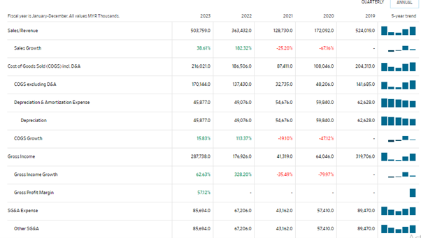
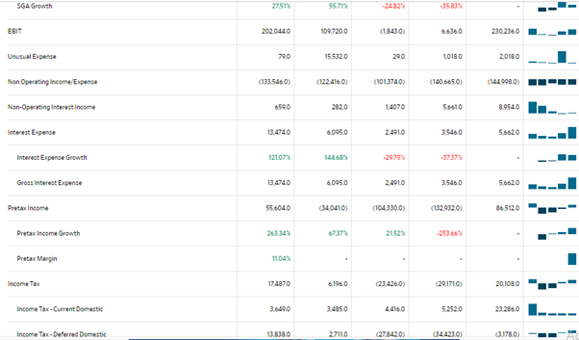
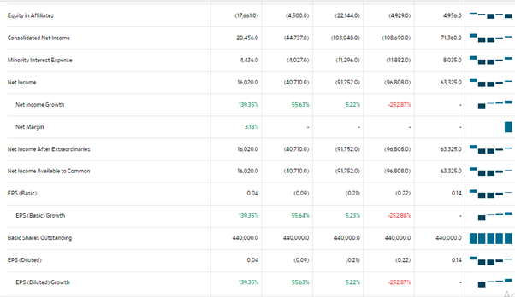
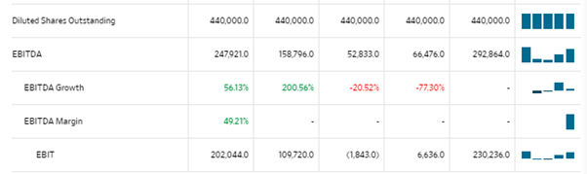
Figure 1: Profit and Loss Account of Shangri-La Hotels
(Source: Wsj.com, 2024)

Appendix 2: Profit and Loss Account of Premier Inn Hotels
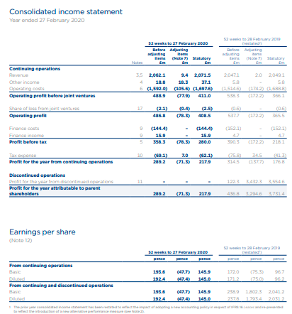
Figure 2: Profit and Loss Account of Premier Inn Hotels
(Source: Whitbread.co.uk, 2024)
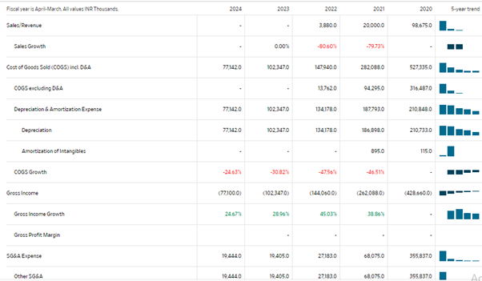
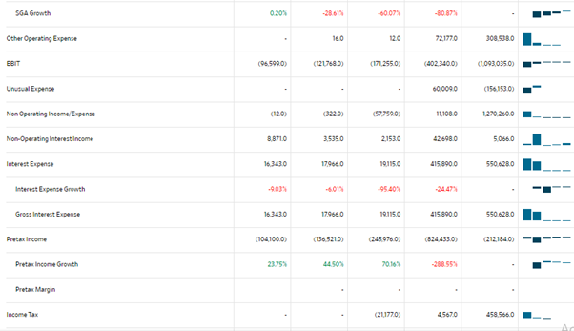
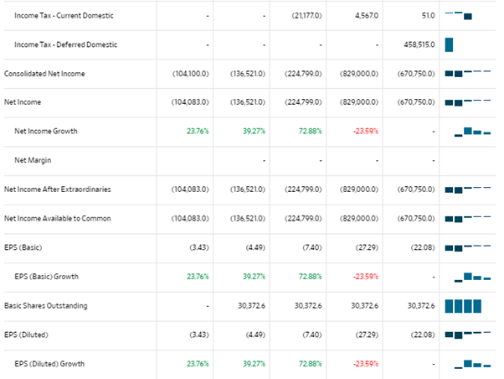
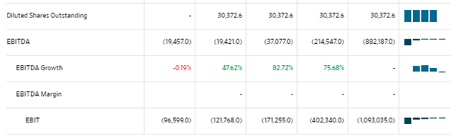
Figure 3: Profit and Loss Account of Premier Inn Hotels
(Source: Wsj.com, 2024)

Appendix 3: Balance Sheet of Shangri-La Hotels for 2019 to 2023
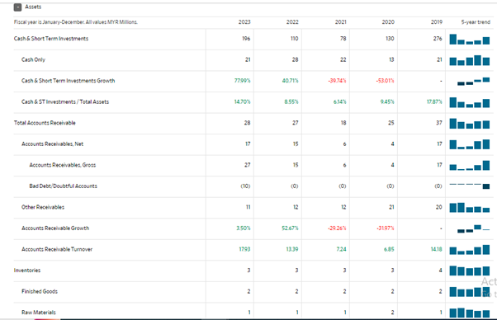
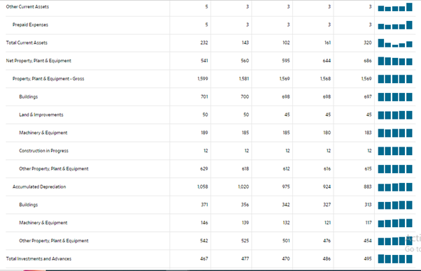
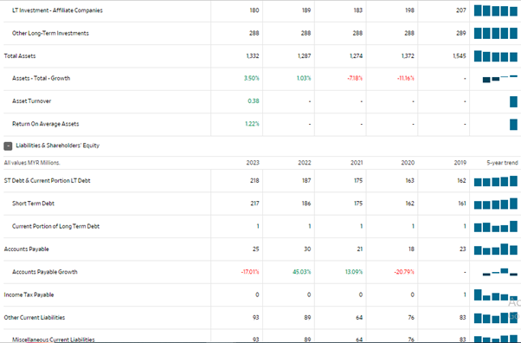
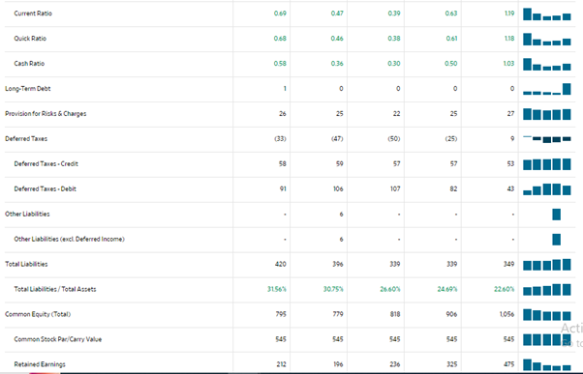
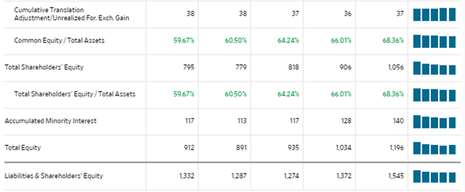
Figure 4: Balance Sheet of Shangri-La Hotels
(Source: Wsj.com, 2024)

Appendix 4: Balance Sheet of Premier Inn Hotel 2019 to 2024
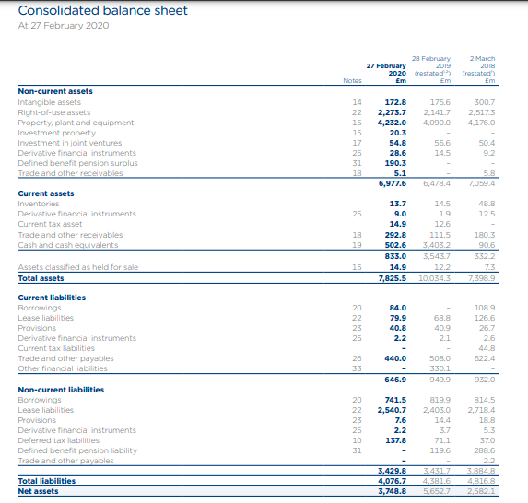
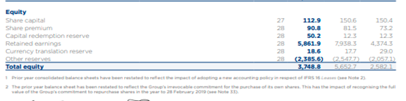
Figure 5: Balance Sheet of Premier Ltd.
(Source: Whitbread.co.uk, 2024)
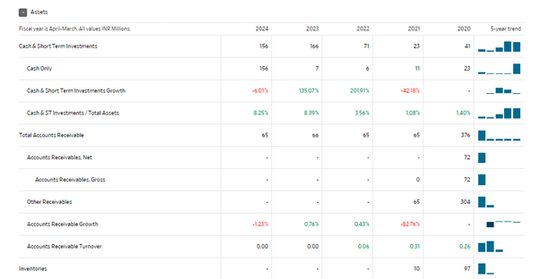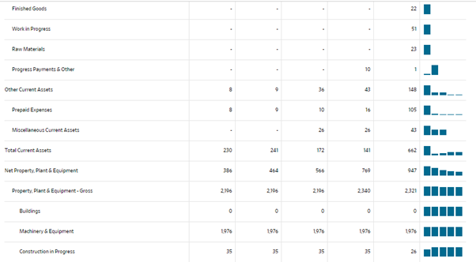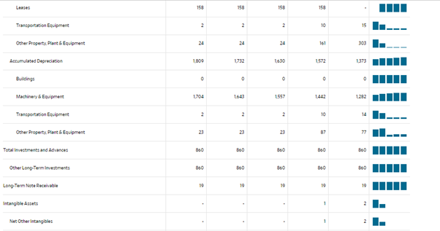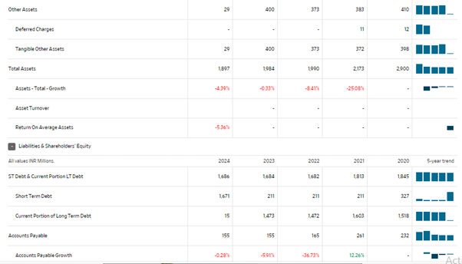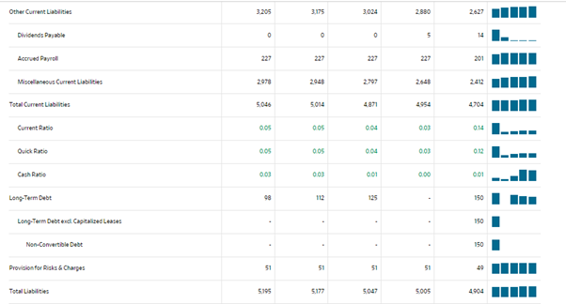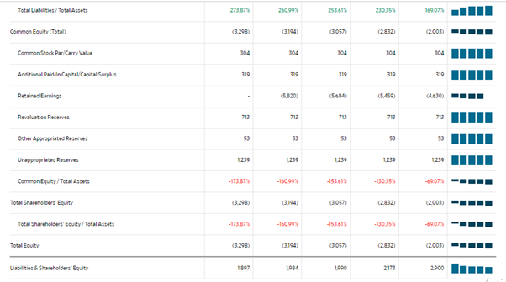
Figure 6: Balance Sheet of Premier Ltd.
(Source: WSJ.com, 2024)

