UWTSD
WISA



Honda NSF250 Group Project Report
Group Project Design ACHA5014

Reuben Pearson-Warder, Charlie Morrish
22/03/2026

Contents
1 Introduction 1
1.1 Project Overview 1
1.2 Project Organisation 1
2 Engine Mapping (Reuben) 2
2.1 Work Content 2
2.2 Research 2
2.3 Ricardo Wave 5
2.4 ECU Remapping 7
2.4.1 Mapping Overview 7
2.4.2 Ignition Advance 7
2.4.3 Injection Timing 9
2.4.4 Ideal Maps 12
2.4.5 Ideal Maps with Race fuel 14
2.5 Further Work 15
3 Gearing Development, Research, and Team Management (Charlie) 16
3.1 Team Management 16
3.2 Analysing Data 17
3.2.1 Track 18
3.3 Honda Gear Setup Research 19
3.4 Enhance Development 22
4 Conclusion 24
5 References 25
5.1 Charlie References 25
6 Reference list 25

No table of figures entries found.
Figure 2-1 - Measurements taken of the Inlet (Top) and Exhaust (Bottom) Valves. 2
Figure 2-2 - Measurement of the Exhaust. 3
Figure 2-3- Clearance Volume verification experiment. 3
Figure 2-4 - The calculated clearance volume in the pipette. 4
Figure 2-5 - The Honda NSF250R Engine Specifications 4
Figure 2-6 - The first Ricardo Wave model. 5
Figure 2-7 - The Power curve simulated from the first version of the NSF250R in Ricardo Wave. 5
Figure 2-8 - The Torque curve simulated from the first Ricardo Wave Model. 5
Figure 2-9- The refined Ricardo Wave model. 6
Figure 2-10 - Refined Ricardo Wave model Power and Torque curves. 6
Figure 2-11- The standard ignition advance. 7
Figure 2-12 - Ignition Advance 2 degrees. 8
Figure 2-13- Ignition Advance 4 degrees. 8
Figure 2-14 - Ignition Advance power curve. 8
Figure 2-15 - Ignition advance torque curve. 9
Figure 2-16 - Ideal ignition advance map. 9
Figure 2-17- Standard Injection Timing. 10
Figure 2-18- 2% increase in Injection time. 10
Figure 2-19 - 5% increase in Injection time. 10
Figure 2-20 - Injection timing power curve. 11
Figure 2-21 - Injection Timing torque curve. 11
Figure 2-22 - Ideal Injection timing map. 12
Figure 2-23- Ideal maps power curve. 12
Figure 2-24 - Ideal maps torque curve. 13
Figure 2-25 - Ideal Maps with Race fuel power curve. 14
Figure 2-26 - Ideal Maps with Race fuel torque curve. 14
Figure 3-1: Team Gantt Chart (old) 16
Figure 3-2: Team Gantt Chart (new) 17
Figure 3-3: RPM vs Drive Speed (Final Lap) 18
Figure 3-4: RPM vs Drive Speed (First Lap) 19
Figure 3-5: Example of motorcycle transmission 20

No table of figures entries found.

Introduction

Project Overview
For this project, Charlie and Reuben will be looking at improving the performance of the UWTSD Honda NSF250. To do this, Charlie will be analysing past data using the MARData software to calculate the ideal gear ratios for the bike. Alongside this, she will use a gear ratio calculator where she can test the ideal ratios for a range of different final drive ratios. She will then research what other gearing options are available from HRC and how they would affect acceleration and top speed. As well as this, she will she what other transmission styles are available, such as a seamless shift style gearbox.
For Reuben’s area of the project, he will be looking at improving performance by altering the bikes Dellorto ECU. To do this, Reuben will first build a Ricardo Wave model to replicate the NSF250 engine and run simulations to see what changes improve the horsepower and torque. From here, Reuben will make changes to the ECU to see where advantages can be gained and from there create an ideal map that can be used across all gears.

Project Organisation
In terms of organisation, Charlie took the role of team leader and focused on organisation whilst Reuben focused on the engine mapping. Every fortnight, both members would meet up on a teams call and discuss what progress they had made with the project and talk about future steps for the project. The team also attempted to follow a planned gannt chart to reach milestone along the projects timeline to make sure progress was made.

Engine Mapping (Reuben)

Work Content
For this area of the project, there were several aspects that needed to be looked at in order to improve the performance of the Honda NSF250 engine by modifying the Dellorto ECU on the bike. The initial plan for this was to look at how injector timing and advancing the ignition could give the Honda more torque and potentially smooth out the power curve towards the top of the RPM range, as on the standard Dellorto maps the power dips slightly around 13,000 RPM. Once the ideal injection and ignition parameters had been calculated, these changes would be made to the ECU and tested on the dyno before heading to Pembrey to see if improvements in lap time could be made over the standard maps.

Research
As to not put too many miles on the NSF250 engine, it was decided that the engine would be replicated inside of Ricardo Wave. This meant that the engine could be simulated with changes made before being implemented onto the bike, and the model could simulate whether the modifications would improve performance of the NSF250. Before the engine could initially be modelled in Ricardo Wave, a few key aspects needed to be measured to make sure the model matched the power output the NSF250 produces as standard.
To start with, the Inlet and Exhaust Valves were measured. This was key in the wave model to make sure the flow was correct, which is highly important for the Ricardo Wave software to give accurate results.
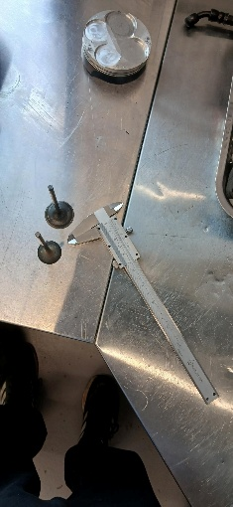
Figure 2-1 - Measurements taken of the Inlet (Top) and Exhaust (Bottom) Valves.
After this, the exhaust length was measured. To do this, wire was taped to the exhaust with dots every 5mm along the wire to get an accurate exhaust length. This again is also crucial for the Ricardo Wave model as the flow of exhaust gases creates pressure within the exhaust as not having it accurate can lead to a fluctuation of around 5% in power. This means that if the exhaust length was incorrect and modifications were applied to the model, it could give false readings which may not see improvement when applied onto the Dellorto ECU (Gajula & Bari, 2017).
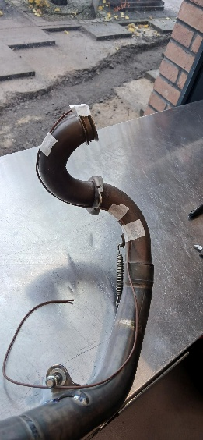
Figure 2-2 - Measurement of the Exhaust.
After this, an experiment to verify the clearance volume was conducted. This was done to get an accurate compression ratio for the wave model. To do this, the crankshaft was turned until the piston was at Top Dead Centre (TDC). From here, engine oil was dripped into the head from a volumetric pipette. Once the head was full of the engine oil, the amount of oil that had dripped from the pipette to see what the clearance volume was.
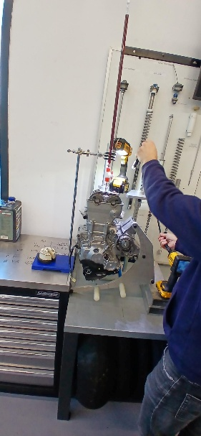
Figure 2-3- Clearance Volume verification experiment.
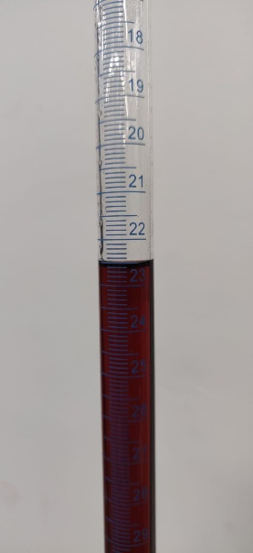
Figure 2-4 - The calculated clearance volume in the pipette.
As seen in figure 2-4, the clearance volume came out as 22.5 cc. In the Honda NSF250R manual as seen in figure 2-5, it states the swept volume is 249.3 cc (Nsf250r 2012 Owners Manual English PDF | PDF | Motor Oil | Transmission (Mechanics), n.d.). The two values were then put in the following equation:
Compression Ratio = (Clearance Volume + Swept Volume)/ Clearance Volume.
This gives a compression ratio of 12.08, slightly lower than in the manual. However, the experiment could be repeated 3 times and give different clearance volumes each time, as it’s based on judgement when the oil reaches the top of the head.
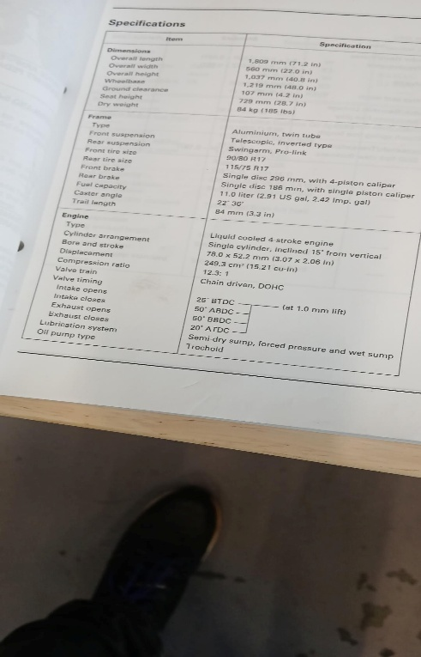
Figure 2-5 - The Honda NSF250R Engine Specifications
After this research had been carried out, it was time to create the first Ricardo Wave model.

Ricardo Wave
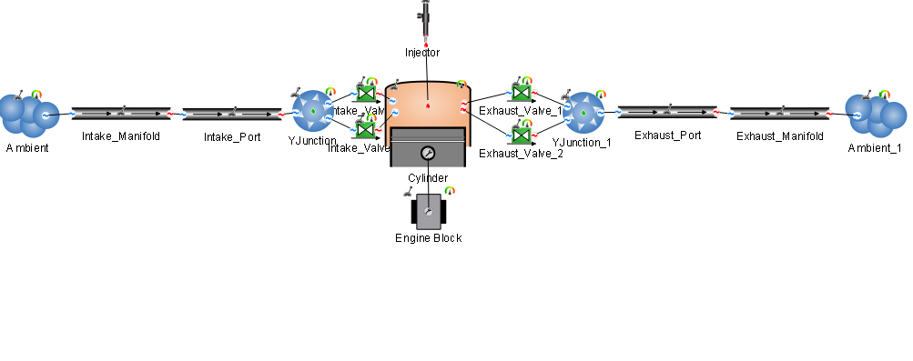
Figure 2-6 - The first Ricardo Wave model.
As seen in figure 2-6, this was the first version of the NSF250R engine inside of Ricardo Wave. This was made from the initial measurements taken from the valves, exhaust and compression ratio. However, the model didn’t simulate and output results similar to the actual bike.
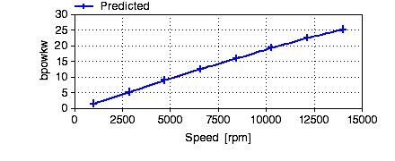
Figure 2-7 - The Power curve simulated from the first version of the NSF250R in Ricardo Wave.
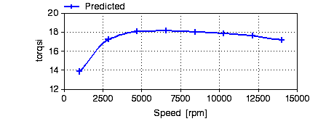
Figure 2-8 - The Torque curve simulated from the first Ricardo Wave Model.
As seen in figure 2-7 and 2-8, the values produced from the Wave Model are a fair way off from what the bike produces as standard on the dyno. For example, the standard Dellorto map produces around 43 Horsepower and around 26 Nm of torque. From this point, the Wave model was refined until it produced a Torque curve which gave results closer to what the NSF250R produces.

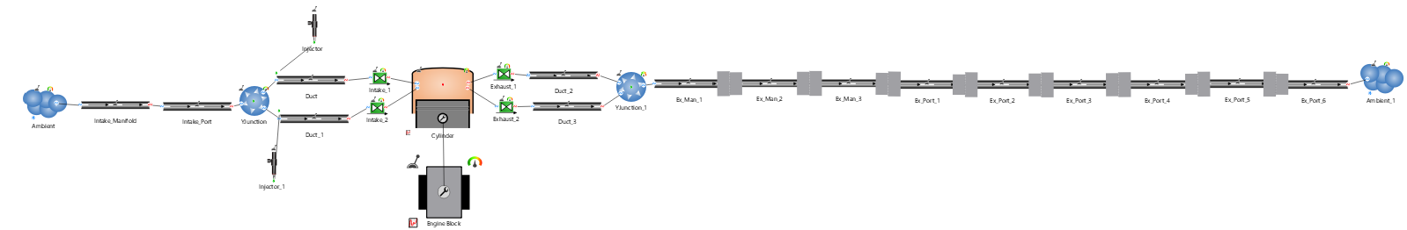
Figure 2-9- The refined Ricardo Wave model.
As seen in figure 2-9, this was the revised Wave model. It included a corrected exhaust length, a corrected compression ratio and the addition of the bottom Injector which replicates what the real bike has. After the model had been refined, it was simulated again to see what Power and Torque outputs it would produce.
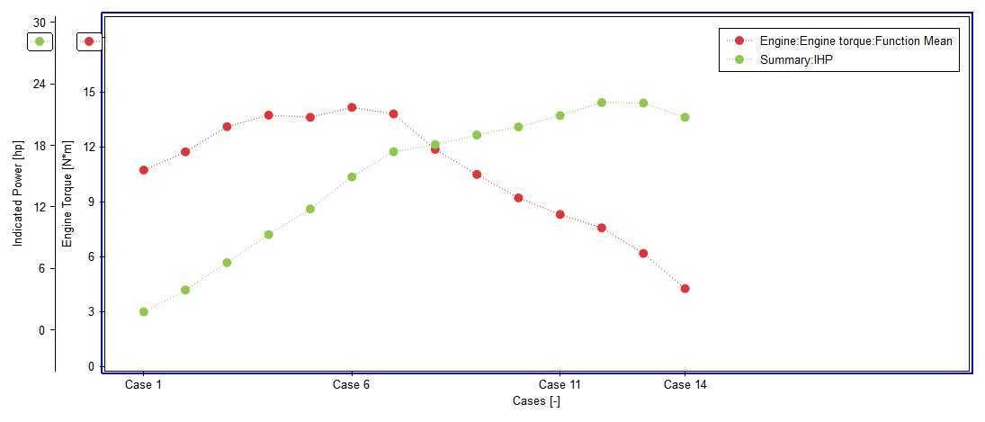
Figure 2-10 - Refined Ricardo Wave model Power and Torque curves.
As seen in figure 2-10, the curves on the graph have significantly improved compared to the initial model. Although the actual values are still not as close to the real bike as they should be, the actual shape of the curves match what the real dyno data show. From research of looking at other Wave models that simulate motorcycle engines, such as a Ducati 1199, getting the correct power output is quite difficult to match, but like the NSF250 model the curves on the graph match the real Ducati 1199 dyno curves.
Now that the model was refined, parameters of the engine could now be modified to see if more power and torque could be produced. One area that made more power when altered was the injection timing. In the model, if the injection timing was increased the power and torque would also slightly increase. This causes the engine to run a little richer, which is quite crucial at low RPMs for a small capacity race bike. This was one area that would then be carried forward when modifying the ECU.
From further research, another area of the engine that modified could produce more power was by advancing the ignition. By doing this, more pressure is created within the cylinder as well as giving the air-fuel mixture more time to burn, which also improves combustion efficiency (Ignition Timing Explained | Understanding the Basics & Importance, n.d.). The benefit of this is more top end power, which will be key for the NSF250 on track. However, the ignition cannot be advanced by too many degrees as this could cause knock, which can lead to overheating and reduced power ultimately damaging the engine.

ECU Remapping

Mapping Overview
After simulations were ran inside of Ricardo Wave, it was time to remap the ECU. It was decided that initially two separate configurations would be created. One would be for ignition advance whilst the other would be for injection time. In the Dellorto ECU, each configuration contains three maps within it, meaning the rider can change between them for whatever he feels is best. It can also be used for doing back-to-back dyno runs and comparing how each map performs.

Ignition Advance
For the ignition advance, Map 1 was left as standard, Map 2 was set to 2 degrees advance, and Map 3 was set to 4 degrees advance. This meant that the ideal amount of ignition advance could be found without the risk of engine knock.
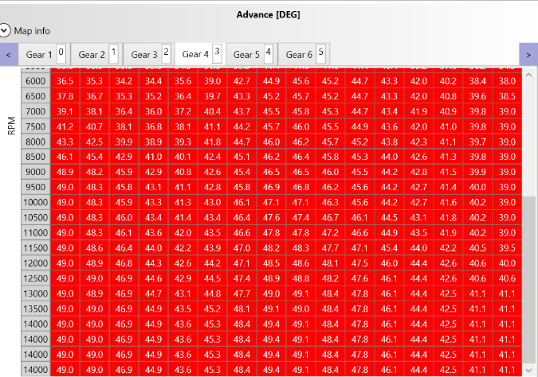
Figure 2-11- The standard ignition advance.
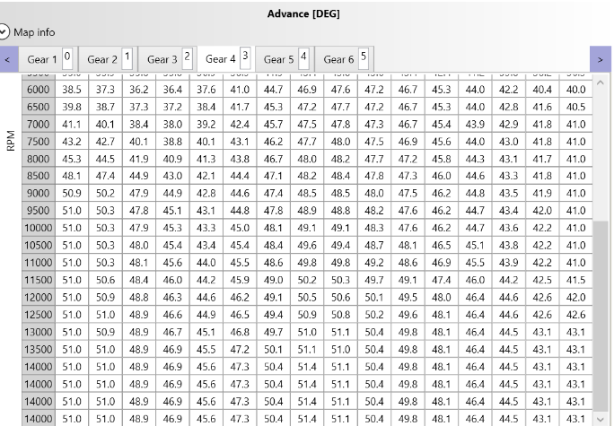
Figure 2-12 - Ignition Advance 2 degrees.
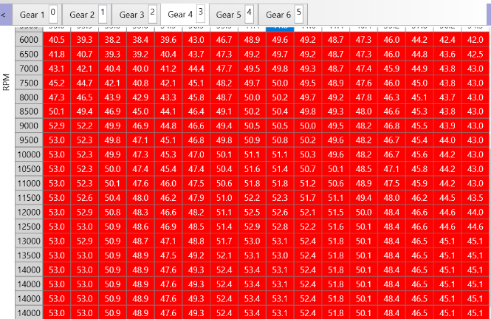
Figure 2-13- Ignition Advance 4 degrees.
These three maps were then tested on the UWSTD dyno to see how they performed.
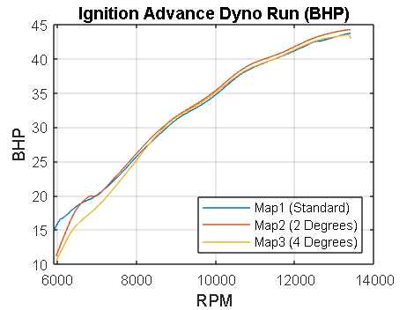
Figure 2-14 - Ignition Advance power curve.
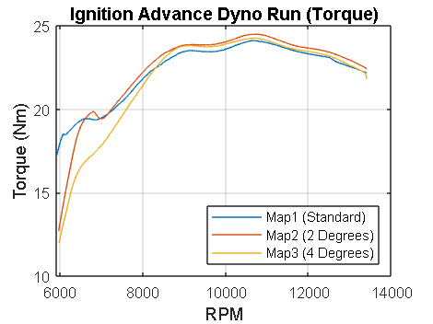
Figure 2-15 - Ignition advance torque curve.
As seen in figure’s 2-14 and 2-15, up to around 7000 RPM, the standard ignition map is best for producing power and torque. However, from 7000 RPM onwards, Map 2 with 2 degrees of advance performs best, providing a decent amount more power than the standard map, and just a little bit more than Map 3. After analysing the dyno curves, it was decided from this point that mostly Map 2 with 2 degrees of advance would be used for the ideal map, as the power delivery was the best and provided quite a bit more torque, key for this little bike. Other areas of the map would include the standard and 4 degrees advance, and an ideal ignition advance map was created.
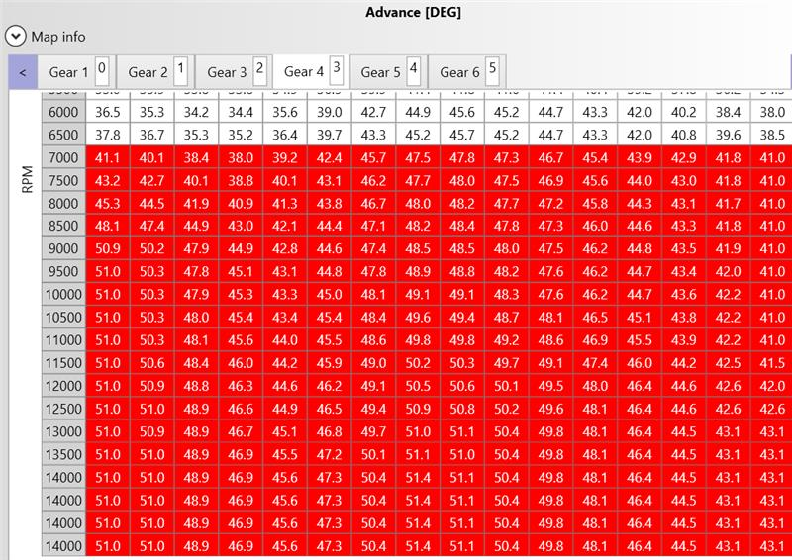
Figure 2-16 - Ideal ignition advance map.

Injection Timing
It was a similar situation when it came to remapping the injection timing. Map 1 was left as standard, Map 2 had a 2% increase in injection time and Map 3 had a 5% increase in injection time.
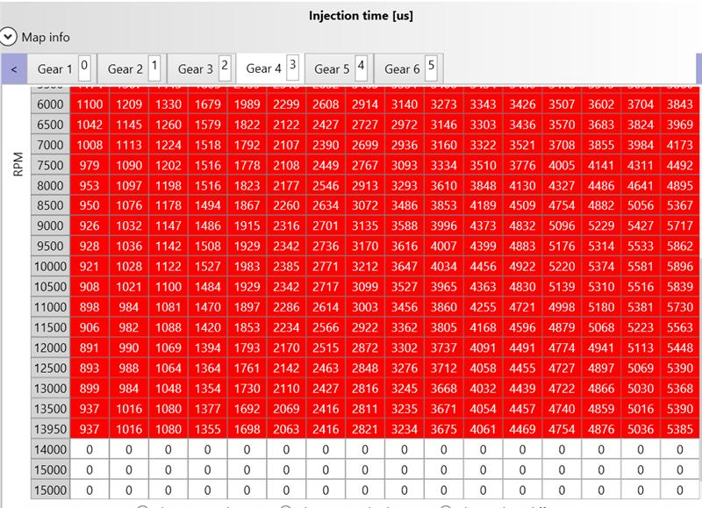
Figure 2-17- Standard Injection Timing.
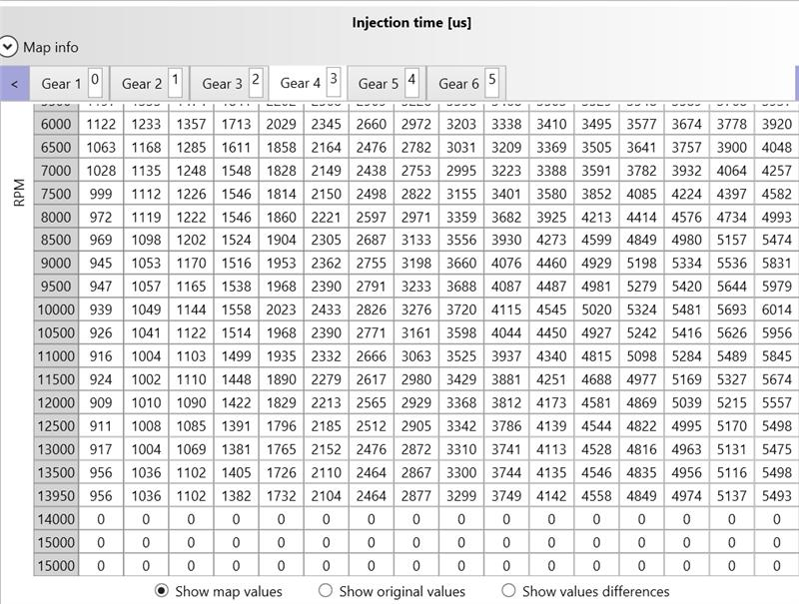
Figure 2-18- 2% increase in Injection time.

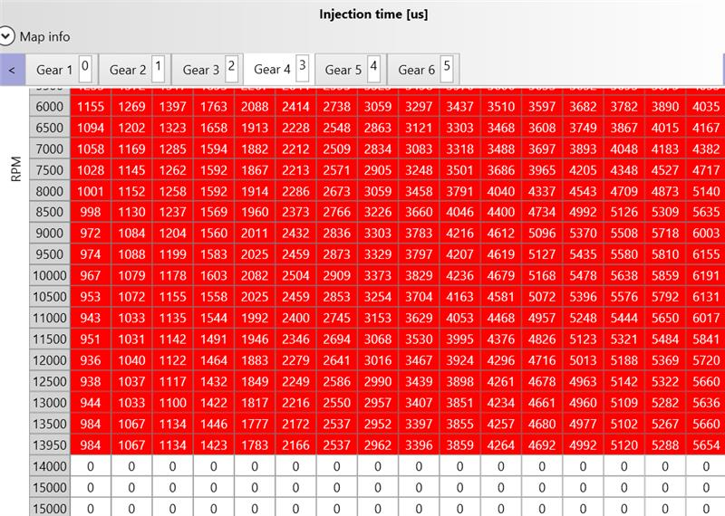
Figure 2-19 - 5% increase in Injection time.
These maps were also run on the UWTSD Dyno. To get the data from the UWTSD dyno, the results were downloaded as a CSV file to then be graphed in MATLAB.
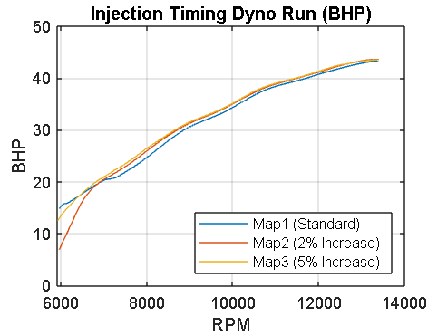
Figure 2-20 - Injection timing power curve.
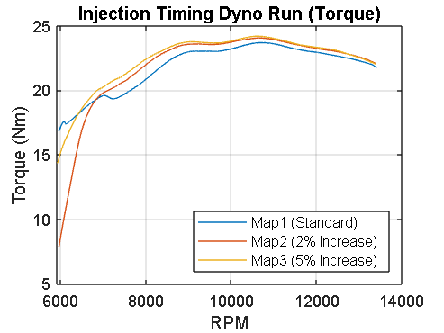
Figure 2-21 - Injection Timing torque curve.
As seen in both figure 2-20 and 2-21, up to around 7000 RPM the standard Dellorto map creates the most power and torque, similar to the ignition advance. However, from that point onwards there is a lot of overlap between the 2% and 5% increase in injection timing, producing a little bit more power and a significant amount more of torque than the standard map. After some analysis of the dyno curves, an ideal injection map was created.
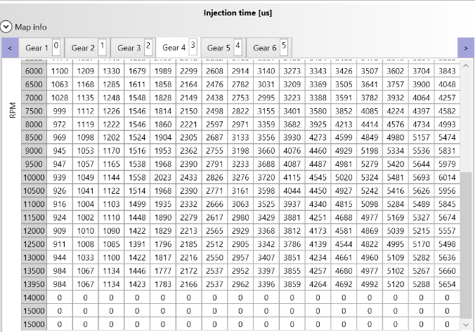
Figure 2-22 - Ideal Injection timing map.

Ideal Maps
For the ideal maps, a new configuration was created. In this configuration, Map 1 was the ideal ignition advance, Map 2 was the ideal injection time and Map 3 was the two ideals combined in the hope they would both work together. This configuration was tested on the UWSTD dyno the day after the previous dyno runs.
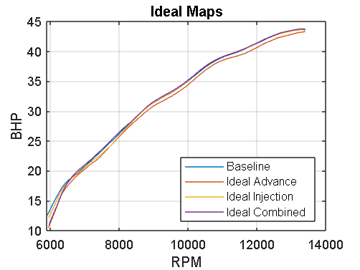
Figure 2-23- Ideal maps power curve.
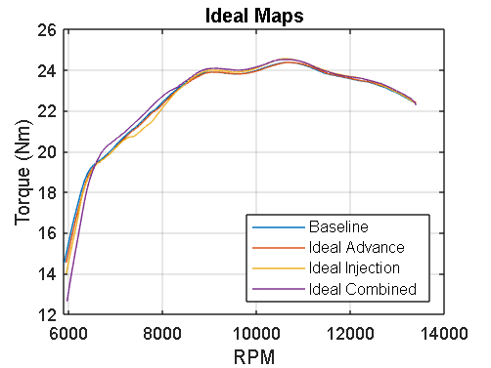
Figure 2-24 - Ideal maps torque curve.
As seen in figure 2-23 and 2-24, the results did not come out as expected compared to the results that had been collected the previous day. For example, the ideal advance was now making less power than the standard map, whereas on the previous run the 2-degree advance made about 5% more horsepower and 10% more torque. This was a similar case with the ideal injection, it made a similar amount of horsepower to the ideal advance but made less torque. For the ideal combined, it only made a slight bit more power and torque when theoretically there could have been a 10% increase in power. After this set of runs the same maps were tried again with race fuel, as the standard Dellorto map makes at least one horsepower more. This run was going to test how much power and torque could be made when combining the ideals and race fuel.

Ideal Maps with Race fuel
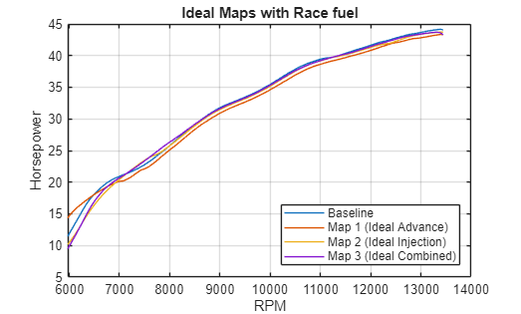
Figure 2-25 - Ideal Maps with Race fuel power curve.
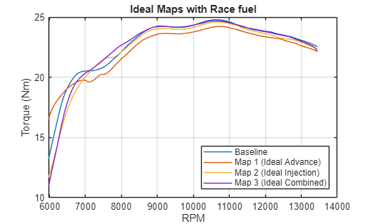
Figure 2-26 - Ideal Maps with Race fuel torque curve.
Again, like the previous set of results they did not come out as predicted. This time with the race fuel, the baseline made more power and torque however the other maps made the same amount of power and torque as with the standard fuel. This is believed to be due to the lambda sensor not reading correctly, as on the dash of the bike the lambda was reading zero. This meant that the ECU was not correcting the air-fuel ratio meaning the added race fuel was not combusting as expected. In conclusion, this meant the ideal maps true potential was not shown on the day of the dyno run.

Further Work
One area of further work that will be undertaken is re-doing the dyno runs for the ideal maps with a new lambda sensor. With a new lambda sensor, the ECU will see the correct lambda reading and alter the air-fuel ratio as the fuel is injected. This should lead to a higher power and torque gain over the standard maps, around 5-10% compared to the 2% seen on the final dyno run. As well as this, the race fuel will be tested again once the ideal maps have been run and it is confirmed the lambda is reading correctly. With the race fuel, this should easily increase the power of the NSF250 by over 10%. Once the maps have been run in 4th gear, all the other gears will have the same modifications so power delivery is similar and should improve performance on track.
Another area of further work will be taking these ideal maps on to track at Pembrey. This will truly tell whether the maps have made improvements to the bike in a dynamic environment. In terms of mapping, the bike can run one of the maps as standard and another one as the ideal modifications. Here, there can be a direct comparison in terms of lap time between the two maps to see how much lap time has been gained.

Gearing Development, Research, and Team Management (Charlie)

Team Management
For this team’s structure, the decision was made to split the roles between the members like so:
Reuben would be focusing solely on engine mapping, and I have the role of team leader and focusing on the gearing development for the proposed set-up for the new engine. This meant that any mapping set-up that Reuben developed I would then have to look at the effect that mapping has on the engine and then understand how a gearing setup would differ for helping to improve the changes made by the new engine mapping.
The professional tools used to aid our team’s workflow was mostly the use of Microsoft Teams and WhatsApp for communication and such. These tools helped me to keep in constant contact with the team and to ensure that everybody kept on track and met their deadlines for specific parts of the project, for example Reuben had to make different maps to test on the dyno and Imaintained consistent communication via Microsoft Teams and an encrypted WhatsApp chat to monitor project milestones and provide support during the ECU calibration phase of the project.
To manage the different deadlines and achievements for the project, the use of Gantt charts proved the best way to keep track of them. These Gantt charts were created using an external application called GanttProject.
Figure 3-1: Team Gantt Chart (old)
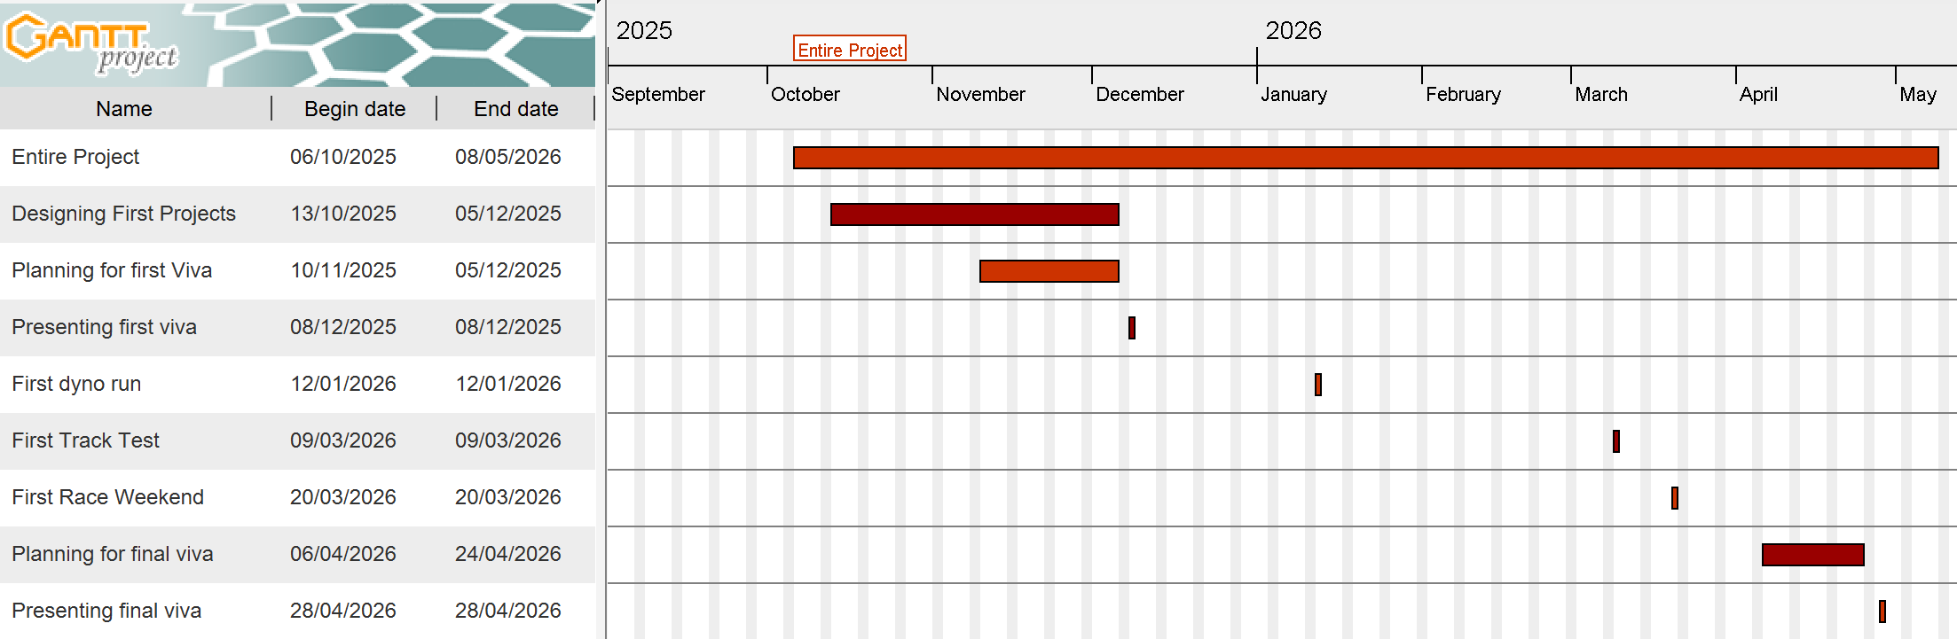
The different points of the project had changed due to different changes in circumstances with both team members and staff aiding the group and this had to be reflected in the gantt charts.

Figure 3-2: Team Gantt Chart (new)
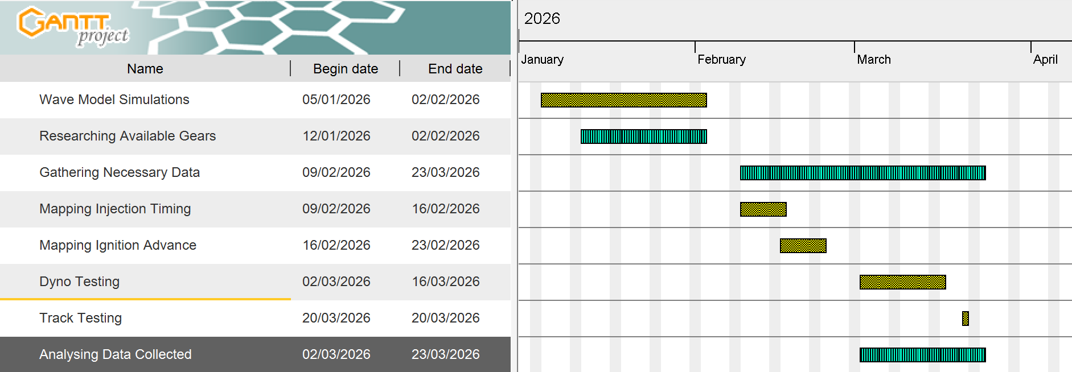
This updated Gantt chart was changed to better reflect the changes in team members and how the workload had to be distributed differently. The previous Gantt chart (Figure 31) shows the original timeline agreed upon by all team members which ran from October to May, including tasks such as scheduling the first dyno run and planning for the first race of the NG Road Racing season. Whereas the updated version (Figure 32) shows a timeline from January to the end of March which is a better and more precise timeline than the previous version.
The way meetings were managed is every other Tuesday our team met either in person or over a Microsoft Teams call and discuss progress made and how every member of the group was handling their workload and if they needed help or parts of their task timelines needed to be changed and such.
Furthermore, expanding on the point made about circumstance changes, the team had to overcome numerous setbacks and delays with the work due to scheduling differences and personal circumstances changing. These were thoroughly communicated to the other members of the group and meetings took place to ensure that everyone was up to speed with the altered timings for the report and the altered tasks as well. Having discussed with the remaining team members, it was decided that the gearing development side of the project would be more research and less practical to accommodate the change in circumstances and the flow optimization section of the project had to be set aside and workload of the Engine Mapping had to be adjusted to accommodate the change in team members.

Analysing Data
This project requires the team to test the engine already in the motorcycle to gather data from both the track and a dyno. This is to ensure that all data gathered is relevant to each part of the project.

Track
To gather the data from the track, the motorcycle is fitted with data loggers that communicate with the ECU and then that data is transferred to a laptop via ethernet cable into the MARdata software. MARdata had the ability to download a session, and MAT lets me see the live data while connected to the bike. It allows me to look at many things, such as suspension travel, rev counter, temperature, etc. Then to analyse this data I used the 2D DataRecording software to analyse the different channels and data displayed in the software.
Using 2D, I was able to analyse the lap consistency from last racing season to the most recent test day and found that the engine is usually used most frequently at around 11,000 and 13,000 RPM but when shifting gears from 2nd to 3rd it seems to be bogging down below 10,000 RPM, which is also known as Shift Sag, and shifting out of the primary power band. There is also the finding of the 6th gear trace ends at approximately 180km/h which means that the motorcycle is hitting the rev limiter before the end of the straight. On faster circuits, such as Brands Hatch and Thruxton, the standard 1.000 internal ratio limits the top speed potential.
Figure 3-3: RPM vs Drive Speed (Final Lap)
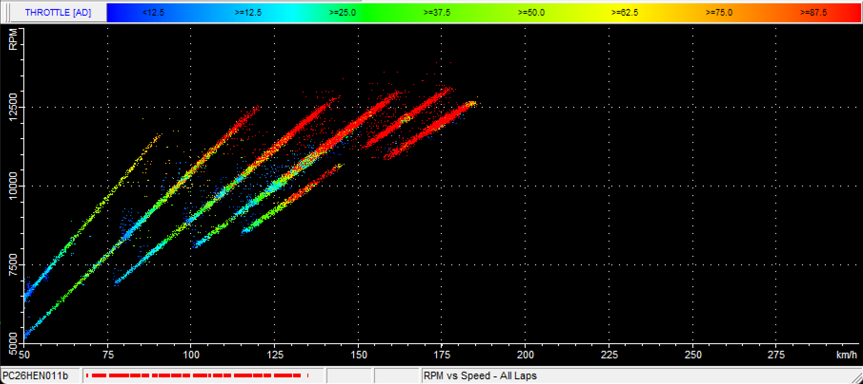
Figure 3-4: RPM vs Drive Speed (First Lap)
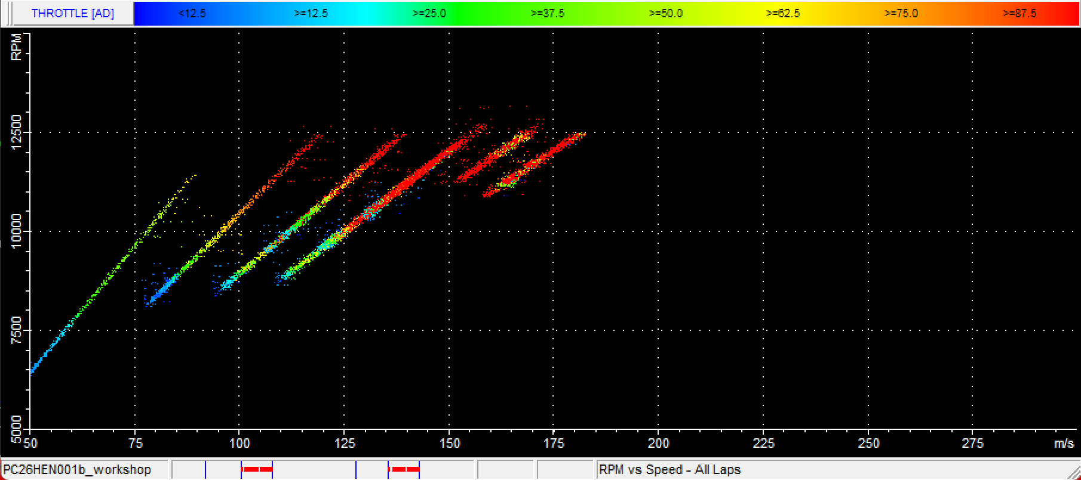
The findings from these graphs help to justify the later choice for a Close-Ratio gearbox, which helps to maintain higher RPMs and to improve lap consistency. The vertical gaps in the data shown in figure 33 and 34 would benefit from the proposed Close-Ratio gearbox setup to keep the acceleration curve more clear.
Having the motorcycle also run on the dyno allows us to see whether different changes to the set-up of the motorcycle. It allows the team to see how the motorcycle performs and how the data may differ depending on what changes have been made to the set-up.
Crank horsepower is the pure power the engine produces before any external components are attached. It represents the maximum potential of the engine mapping developed by Reuben. Wheel horsepower is the power remaining after it has travelled through the primary drive, gearbox, and the chain and sprockets. The gap between both is caused by friction in the bearings, the meshing of gear teeth, and the energy required to move the chain. When racing, a motorcycle typically loses from 10% to 15%. These losses are caused by the friction generated from the chain’s wrap angle around the driving gear.
By optimizing the gear ratios to a close-ratio setup will reduce the frequency of over-revving the engine. This not only increases the longevity of components but also reduces the environmental impact of finding and sourcing replacement parts as well as optimizing fuel consumption during a race which would cut cost down on many things.

Honda Gear Setup Research
Looking at both the Honda NSF250 owner’s manual provided by HRC, there are many available gears to choose from that are compatible with the NSF250 with the standard gearbox.
Gear ratios are the relationship between the number of teeth on two gears that mesh in the gearbox. If the driving gear is smaller than the driven gear, you get more torque but less speed which is a setup known as underdrive. This underdrive is what allows racers to have better drive off the line and out of corners, it also ensures that when the throttle is opened past 40mph the bike has an improved throttle response rather than bogging down. It also has the added benefit of improving engine braking, meaning when the throttle is let off the rear wheel is trying to “drive” the engine. The engine’s internal friction exerts more force onto the rear wheel as a result and helps to shed more speed just before a turn without relying solely on the brakes.
By using a smaller driving gear than the driven gear, the setup creates a unique underdrive setup. This setup acts as a force multiplier which increases the torque at the rear wheel to provide an improved throttle response out of corners.

Figure 3-5: Example of motorcycle transmission
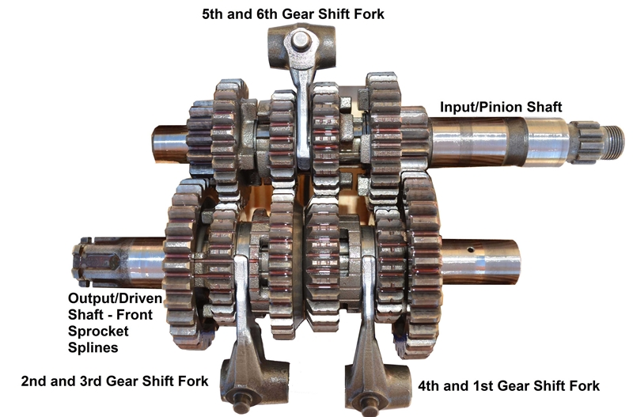
Keeping this in mind when choosing a new setup for the internal gearing of the NSF, the first thing to notice would be the large jump between 1st and 2nd gear. The drop between them is sitting at 18.7% in ratio, meaning if the motorcycle is racing at a track that has a slow hairpin but a fast section after in 2nd it may be bogging down when shifting because the RPMs drop too far.
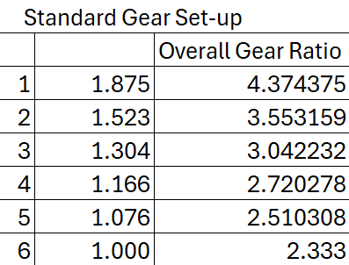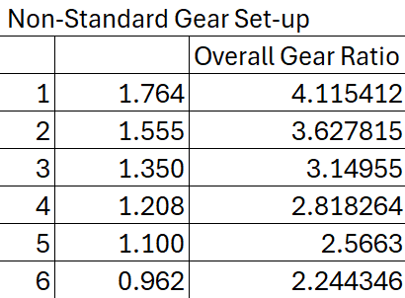
The proposed non-standard setup increases the torque output by keeping the engine in its “sweet spot” while the research conducted into the different materials available will minimize the parasitic losses from the drivetrain, ensuring that the highest percentage of Reuben’s engine mapping reaches the rear tyre. The choice to shift 1st gear from 1.875 to 1.764 prevents the RPM from dropping below the 10,500 RPM power band threshold. The choice from 1.000 to 0.962 in 6th gear means that the bike will be in a higher power threshold which means that there will be less of a chance of hitting the rev limiter.
With the gear ratios all figured out, the next task was looking into the different materials the sprocket can be made from to further support the engine mapping Reuben developed and the proposed gear changes for the transmission.
There are different materials sprockets can be made from, and each one had their own pros and cons. The most common material sprockets are made from are steel as they are favoured for their durability and longevity, but they aren’t very lightweight for racing purposes. Racers usually go for an aluminium sprocket which is more lightweight, but they tend to wear faster than steel sprockets which means they have to be changed and upkept more often.
Less common alternatives include carbon steel, cast iron, and different alloys. A good alternative than the standard steel sprocket is a hard anodized aluminium sprocket as aluminium has a lower density which means the engine can spin up the drivetrain faster. The reduction in weight also helps with the rear shock reacting faster to bumps on the track, helping to keep the tire in contact with the track surface more consistently. An aluminium sprocket also had better heat dissipation as the hard-anodized coatings on the sprocket help to dissipate the heat generated by friction, which also helps to maintain the consistency of the chain lubricant during a longer race.
Hard-anodization is when a thick oxide layer if formed on aluminium surfaces which significantly improves the physical properties of aluminium, making it more suitable for demanding applications in various industries that include racing. This process is commonly used in the aerospace industry due to the high strength and durability the process gives the aluminium, and in the military as the hard-anodized parts can withstand extreme conditions.
The downsides to using aluminium is the service life and the sensitivity to the tension from the chain which could cause a risk of failure. The accelerated wear of the sprocket is due to the fact that aluminium is a softer metal than steel and, even with hard-anodizing, the teeth will eventually start to “hook” or bend forward. This wear will also affect the overall life of the sprocket as we would possibly get only 3-5 race weekends out of one aluminium sprocket compared to a full race season we would get with just one steel sprocket. The chain tension sensitivity is crucial as if the chain tension is too tight or poorly lubricated, the softer nature of the metal cannot withstand the conditions of a dry chain like steel can.
Despite the downsides, the lighter aluminium sprocket would aid with maximizing the power-to-weight ratio and reduce the overall rotation inertia of the motorcycle. The need for more than one and the sensitive upkeep of the aluminium sprocket is worth the upsides that come with it, although a strict maintenance schedule would have to be followed and ensuring the chain is properly lubricated is crucial. An example of a task that would be on the schedule would be:
- Visual inspection of sprocket for tooth “hooking” every 100km
Another change that would need to be made to the maintenance of the motorcycle would be using a high-quality lubricant on the chain to mitigate the downsides listed for the use of an aluminium sprocket instead of a steel one.
The changes made overall to the transmission will ensure that the rider and motorcycle can stay in the newer engine mapping power band for longer. The data gathered from the dyno helped to develop the engine maps and the track data gathered with the altered engine maps helped to aid in the selection for the gears in the transmission and outer gearing to aid in keeping the rider in the higher power band without having the RPMs drop lower then 10,000 RPMs when shifting gears.

Enhance Development
To further enhance the performance and technical performance of this project, future development should prioritize the following four areas for this section of the project:
- Advanced Transmission Systems: Evaluate alternative drivetrain configurations, such as seamless shift technology, to minimize the effect of shift-cut intervals beyond the current capability of the quick-shifter already in use. The idea of using either a quick-shifter or an auto-blipper could be resolved with using a bi-directional system that utilizes both systems and their advantages. By having the automated downshift, it minimizes the risk of the rear wheel locking up and would reduce chatter which is common on Moto3 style motorcycles that have high engine braking. This bi-directional system also benefits the choice of using a hard-anodized aluminium sprocket as there is less load on the shock due to the matched RPMs when shifting up or down gears, extending the life of the sprocket and saving on cost. Having an auto-blipper integrated in the system would also make it easier to read the data gathered from the track and makes it easier to analyse the braking zones on tracks.
- Material Optimization: Investigate the use of high-performance materials for sprocket fabrication, targeting a further reduction in rotational unsprung mass specifically to maximise drivetrain efficiency. The sprocket has a moment of inertia (I=mr^2), by reducing the mass of the sprocket it allows the engine to overcome the inertia faster and that results in a measurable increase in the “Transient Throttle Response”, which is how quickly the motorcycle picks up speed when the throttle is opened up.
- Comprehensive Data Validation: Implement a dual-channel, real-time wheel-speed sensors. This would provide critical feedback loop to validate gear ratio selections against measured rear-wheel slip percentages.
- Testing Diversification: Expand the current testing scope beyond Pembrey Circuit to include diverse track layouts, such as Castle Combe and Donington Park, to ensure a versatile and globally optimized gearing strategy.

Conclusion
Overall, this project hasn’t been the smoothest of which, but the group as a whole has learned many things about how to use different software, such as Ricardo Wave and MARdata, to aid in research and setting up different changes to the motorcycle. Reuben specifically had to learn and adapt to the Ricardo Wave software to build a virtual model of the Honda NSF250 engine to simulate the different mappings before applying them to the actual motorcycle. Charlie had to get familiar with the process of downloading data from the NSF250, saving that file to a safe and accessible folder and then viewing it in the 2D DataRecording software. During this process, the switch from WinARace 2025 Moto3 to WinARace 2026 Moto3 had its own drawbacks of not being able to access the licensing portal which hindered progress from that point onwards.
In future, the group wishes to look at the possibility of re-doing dyno runs with a new lambda sensor to better see how the different maps effect the horsepower output and then taking these maps out onto a track setting, like Pembrey, to see if the maps improve or reduce the power output of the NSF250. Another possibility is looking at both engines in current possession and seeing if a different gearing set-up on both would differ on power output and what tracks each engine works better on with the different maps and gearing ratios.

References

Charlie References

Reference list
Amzar Hazeeq (2025). Motorcycle Quickshifter Explained – Benefits, Types, and How It Works. [online] iMotorbike News. Available at: https://news.imotorbike.com/en/2025/10/motorcycle-quickshifter-explained-benefits-types-and-how-it-works/ [Accessed 29 Mar. 2026].
ManualsLib. (2021). HRC NSF250R 2012 OWNER’S MANUAL & PARTS LIST Pdf Download. [online] Available at: https://www.manualslib.com/manual/2012699/Hrc-Nsf250r-2012.html#manual [Accessed 29 Mar. 2026].
Motorival.com. (2017). รู้หรือไม่? อัตราทดเกียร์แบบ OverDrive, UnderDrive, Direct-Drive มันคืออะไรแตกต่างกันอย่างไร รถคุณเป็นแบบไหน มาชมกันดีกว่าครับ. [online] Available at: https://www.motorival.com/tips-trick-overdrive-underdrive-directdrive/ [Accessed 27 Mar. 2026].
Rodman, J. (2024). Tips for Choosing the Right Sprocket Material. [online] Diversified Specialties. Available at: https://www.div-spec.com/blog/essential-tips-for-choosing-the-right-sprocket-material/ [Accessed 29 Mar. 2026].

