Dissertation

How can graphic design be a force for good in the world?

Name: Ewan Watkins

Student Number: 1703205

Word Count: 5951

Tutor’s name: Donna Williams

Submitted in partial fulfilment of the requirements for the degree of BA (Hons) Graphic Design
University of Wales Trinity Saint David, Swansea (11th December 2019).

Dissertation Plan

Introduction

Chapter One – Design Techniques in Graphic Design

Colour
Social Media, Facebook & Twitter
Suicide Awareness.
Cape Town Pride
Propaganda

Imagery
Kelli Anderson
Peter Grundy
James Montgomery Flagg
Samba Cissa
Imagery to influence

Typography
The Plain Cigarette Packaging
Alan Kitching and The Power of Type
Meth
Nike

Chapter Two - Influential Ethical Companies
Under the Skin
Advocate
Lucienne Roberts+

Chapter Three - Discussion/ Analysis
Is this about making money or are ethics the real concerns’?
Responsibility of the designer?
Conclusion

Bibliography

Contents
Chapter One - Design Techniques in Graphic Design 6
Colour 6
Social Media Facebook and Twitter 6
Suicide Awareness 7
Cape Town Pride 8
Propaganda 9
Imagery 10
Kelli Anderson 10
Peter Grundy 11
James Montgomery Flagg 12
Samba Cissa 13
Imagery to influence 13
Typography 14
The Plain Cigarette Packaging 15
Alan Kitching and The Power of Type 16
Meth 16
Nike 17
Chapter Two - Influential Ethical Companies 18
Under the Skin 19
Advocate 21
Lucienne Roberts+ 22
Chapter Three - Discussion 24
Conclusion 30
Image References 32
Bibliography 33

Introduction
“Visual art has for centuries been used to persuade, educate or control. With greater freedom, artists have deliberated about the appropriate use of their skills” (Roberts, 2007, p. 003)

This shows that artists and designers need to think carefully when designing because they have the powers to persuade, educate and control, they also have the knowledge and skills which allows them to visually communicate their design and solution.

To be a good designer your work does not always have to be positive it can also be a negative solution, it is an essential skill to have the ability to take criticism. “As designers, criticism is part of our job description — even if it is not clearly stated.” (Medium, 2019)

In my first chapter the focus is going to be on examples of design techniques that is used by artist and designers and deconstructing examples and explaining how they have had these. One of the artist/designers that will be spoken about is Alan Kitching, he designed the famous poster protesting against the Iraq War which will be spoken about.

In the second chapter, my focus is going to be on influential ethical companies. My aim is to focus on design companies that have a positive impact on the world and analysing the branding. One of the many companies that will be researched into and analysed is ‘Under The Skin of Endangered Animals’, the reason being after seeing them in my university annual ‘design week’ they had my attention from the minute they began explaining about their brand and ethics, not only this but they also have a significant amount of knowledge in Graphic Design and positively use this by raising awareness which is a powerful tool graphic designers can use.

In the third chapter, the focus will be on discussing the reasoning behind designers, artists and companies and analysing if ethics is a concern. My aim is to find out how they use their skills and how they apply them to their work. Lastly, my focus will be on analysing the jobs they take on and what the responsibility of the designer is.

“graphic design is part of the fabric of society in which we live – even what may seem like small design decisions affect other people and reveal something of a designer’s broader approach to life” (Roberts, 2007, p. 015)

This shows that ethics has a huge role in graphic design and can have an impact on people’s emotions and perspective. Continuing within this chapter my aim is to analyse if money is the reasoning behind it and finding out if it’s the responsibility of the artist/designer and company. Within my dissertation the discussion will include examples of negative impact designers, artists and companies can have within graphic design.

Lastly, within my conclusion, my aim is to find out how this will impact me as a designer and making design decisions in the future. Also finding out what my research has led me to.

Chapter One - Design Techniques in Graphic Design

How Graphic Design has been used to persuade, educate and control.

Colour
Colour is a significant tool within graphic design and society in general. It Is described as
“… perhaps the most powerful tool at the artist’s disposal. It affects our emotions beyond thought and convey any mood, from delight to despair. It can be subtle or dramatic, capture attention or stimulate desirez (Zelanski & Fisher, 2006, p.11)

This shows how much of a significant power colour can have on emotions and mood. Graphic designers need to consider this when designing to portray their message effectively. This is extremely important when choosing colours. According to Burst (2018) evidence shows that colour can have an effect on people’s phycological impact which results in the way people see things, and the decisions they make.

Social Media Facebook and Twitter
Fig.1 – Facebook logo
Fig. 2 – Twitter logo


The colour blue can be used very effectively in design and is described by Wallace (2019) as “a sense of security, curbs appetite, and stimulates productivity.” Blue is a ‘popular’ colour and reflects positivity: “The colour blue has positive effects on the mind and the body” (Bourn, 2019) This illustrates how important the colour can be when deciding on a colour for your logo. This is supported by Dvornechuck, who discusses how effective using the correct colour for your logo can be;

“The implications of colour’s effect on people’s emotions are far reaching, and understanding your customers’ connections to certain colours could increase the effectiveness of your company’s branding methods.” (Dvornechuck, 2019)

These points highlight the importance of giving serious consideration to the choice of colour as it can impact how a company or product is perceived.

Suicide Awareness

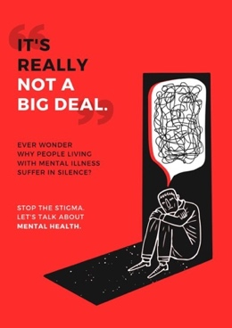
Fig.3 – Suicide Awareness Poster

Red is seen as being a dangerous and extreme colour “…it’s the colour of passionate love, seduction, violence, danger, anger, and adventure” (Morton, 2019). The poster above is representing mental health and uses the colour red as the background colour to identify danger and also representing suicide. “While red signifies danger, it can be used to good effect in marketing campaigns which need to evoke emotion” (NewDesignGroup, 2019). The use of red is effective as it catches the readers’ attention. In poster design, it is important to catch the reader’s attention as otherwise, they will not read it. As awareness campaigns aren’t trying to sell anything, only to make the reader aware of their subject, gaining their attention is the main objective.

Cape Town Pride

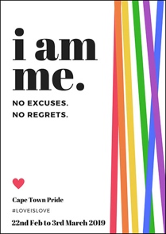
Fig.4 - Cape Town Pride

The colours used above represent pride, according to Place, (Place 2019) these are more than colours they have meanings: “red means life, orange means healing, yellow means sunshine, green means nature, blue means harmony, and purple means spirit” Evidence shows these colours are extremely powerful and have been effectively advertised and are now recognised globally.

“Flags have been created for people who identify as bisexual, pansexual, asexual, polyamorous, intersex, transgender, genderfluid, genderqueer, polysexual, agender, aromantic, non-binary, and more!’ (Moor, A 2019)

This demonstrates how the colours of ‘pride’ are extremely powerful as it promotes the range of diversity within society.

‘Cape Town Pride’ is the event that celebrates “the heritage and diversity of the LGBTQ+ community and its impact on contemporary culture and society” (Igual, 2019). The poster used to advertise this event is colourful and uses a range of colours from the pride flag to represent what pride stands for diversity. It is important to use a diverse spectrum of colours because it supports their individual identities.

Propaganda

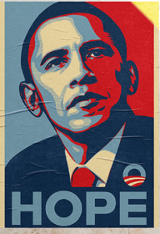
Fig.5 – Propaganda

Propaganda is described as “the statement of facts and beliefs with the intention of influencing a particular audience, trademarked by the omission of any details that might persuade the audience to the other side” (Hoyt, 2019). This demonstrates how propaganda is not always negative. Artist Shepard Fairey designed the poster above, it has been designed to try and persuade people that Barack Obama is the right candidate to become the president of America. Artist Shepard Fairey uses the colours which represent USA to portray a clear message and show the American people what he stands for.

Imagery
Imagery is a powerful tool within graphic design and society in general. It is described as
“An actual object- with nature, as is usually said – I propose the thesis that pictures are created in order to make visible what is not visible. That is true not only of artistic pictures, but also of pictures which are used in religion and science. (Muller-Freienfels, 1948, p.113)

This proves how much of an important role imagery has because it is a visual representation of something and allows the brain to recognise familiar objects and visuals. Stated by Stark (2014) images are the perfect way to use the text details to direct the eye. Without images, it is more difficult to imagine something.

Kelli Anderson
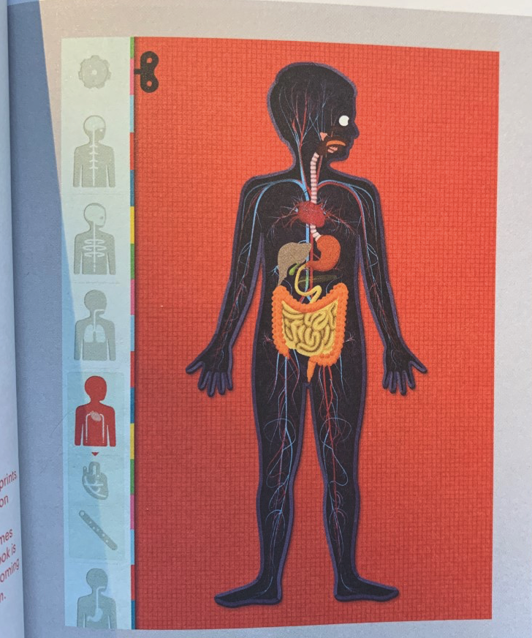
Fig.6 – The human body app

Graphic design can be used in a positive way within digital media, this app was designed by Kelli Anderson, from looking at the images within the human body app you can see the insides of a human body and on the left, it shows the different functions available.

The images used are extremely important as they play a significant role in educating and are described by Kelli Anderson that it’s “Aimed at children aged four to ten” (Schrauwen and Roberts, 2017). This illustrates how important using images can be because it visually communicates in a more enjoyable way and allows the child to understand it easily.

Peter Grundy
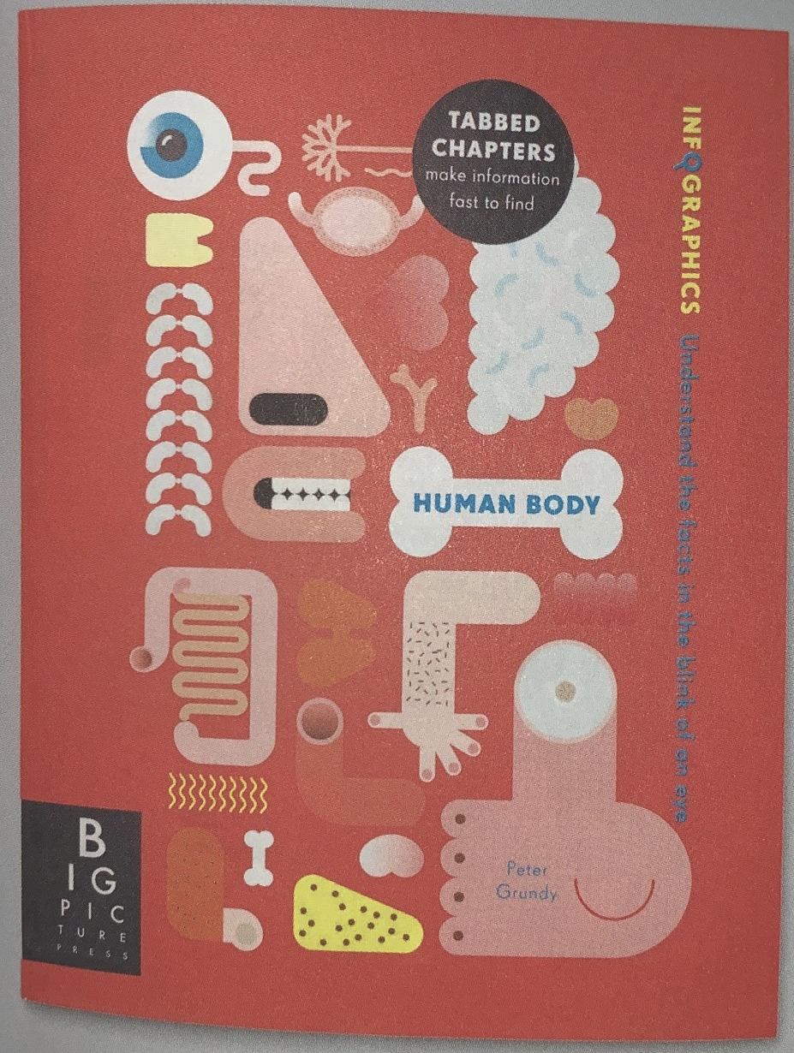
Fig.7 - Human body campaign

The human body infographic campaign above illustrated by Peter Grundy (2014) demonstrates how effective using images can be, the images are used to educate younger children about the human body. “his proposal was to steer away from conventional medical illustration and employ information design as a form of storytelling instead” (Schrauwen and Roberts, 2017, p.62). This demonstrates using images in a fun, exciting and humorous way can change the perspective of the way you look at the campaign and reduce the anxiety of the inside of the human body and the child reading it.

James Montgomery Flagg
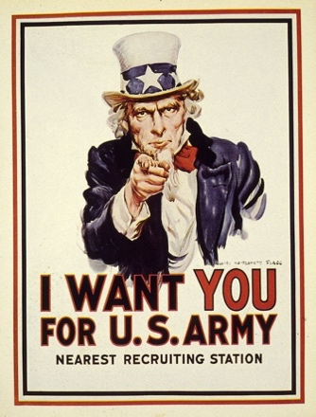
Fig.8 – I WANT YOU

Propaganda is described as
“a systematic scheme created by one person or a group in an effort to persuade people on insufficient grounds to believe what it wants them to believe or to act to it’s advantage”. (Taylor, 1942, p.562)

This shows that propaganda can have a negative effect because it is misleading them with false information. The poster was designed by James Montgomery Flagg, (1916) he has used the image above to try and persuade the people viewing the poster that the country needs them, the pointing of the finger is directly in the centre of the poster to get their attention, “intended to encourage young men to enlist in the Army” (Library et al., 2019). This shows the image of Uncle Sam is used to encourage Americans to join the army.

Samba Cissa
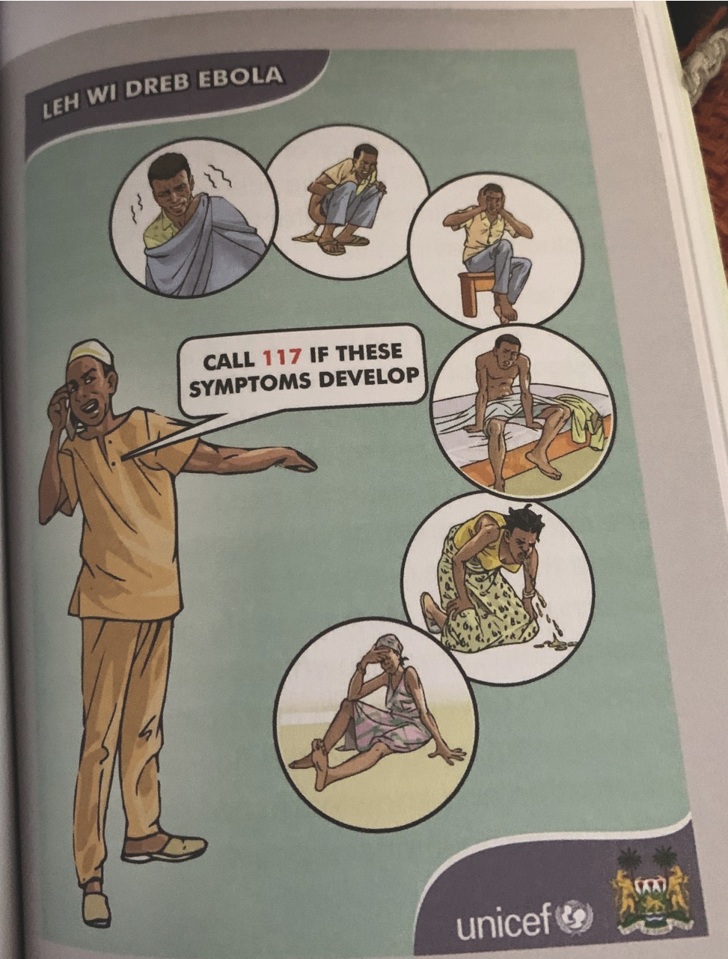
Fig.9 – Ebola Poster

Ebola virus is one of the world’s deadliest diseases and is described as “a filovirus that has caused sporadic outbreaks of dis- ease; the current outbreak is the largest recorded” (Ibrahim and Lee 2014) this demonstrates how deadly and dangerous the disease is and the effects it can have. The poster above shows illustrations from Samba Cissa, she has included images of humans that experienced symptoms of the Ebola virus.

“During the Ebola outbreak in West Affrica, graphic design played an integral role in communicating with a culturally and linguistically diverse population with minimal formal literacy.” (Schrauwen and Roberts, 2017, p.205).

This proves how effective using images can be as it visually communicates the symptoms of the Ebola virus and shows what to do if you encounter these, without these images, it would be hard to understand.

Imagery to influence

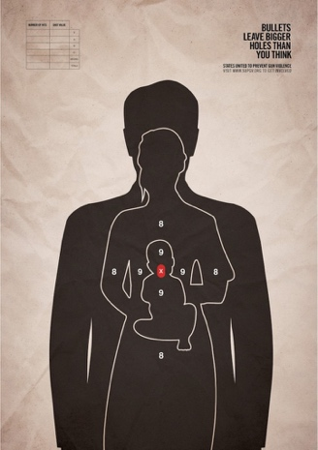
Fig.10 – Gun Violence Campaign

Gun violence in America is a significant problem, “Every day, 100 Americans are killed with guns and hundreds more are shot and injured” (EverytownResearch.org, 2019). This research shows how much horror America are faced with on daily bases, the images included within the print include three human targets, it is an extremely powerful campaign as the images show the damages that can be caused. “Bullets leave bigger holes than you think” It is an advertisement that reaches you’re heart no matter who you are” (Khalil, 2016) this shows the importance of the three different types of images included, as it portrays the message that you don’t only damage the person you shoot but you also damage the family and friends.

Typography
Typography plays a significant role in graphic design and has been used to persuade, educate and control.

“In the context of visual communication, this arrangement of text is known as typography and it's an important part of many different styles of art and communication. Broadly speaking, typography is the way that text is arranged and presented.” (White, 2019)

This states how important typography is because it is used to communicate a message and explain what is happening in literate way. It is important that graphic designers use the correct typography when trying to communicate a message because this allows the reader to understand it more clearly. “Typography is the final result of a design process” (Hausmann and Cullars,1998). Without typography, it can be argued that you may not be able to advertise your product as effectively because it would look less attractive and it would be harder to have a successful brand.

The Plain Cigarette Packaging
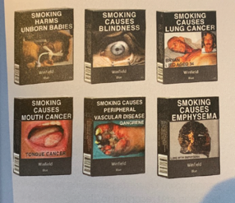
Fig.11 – Australia plain cigarette packaging

The typography above is used on cigarette packaging in Australia,

“in 2012, Australia became the first country to pass a law requiring cigarettes to be sold in ‘umbranded’ packets, with graphic warnings to cover 75% of the front and 90% of the back”. (Schrauwen and Roberts, 2017, p.62).

This states how powerful the typography is on the packaging, it is being used to promote and educate the dangers of smoking. The font that has been used on the all of the packaging is in upper case, and white this is to make the message clear and to persuade people to stop smoking.

“Graphic design, once key in the promotion and proliferation of smoking, has subsequently played an essential role in influencing behaviour change and supporting anti-smoking campaigns across the world”. (Schrauwen and Roberts, 2017, p.15)

This proves how much of a role typography has in persuading, educating and controlling people’s perspective on smoking, (fig.11) shows how the typography doesn’t always have to be positive when branding.

Alan Kitching and The Power of Type

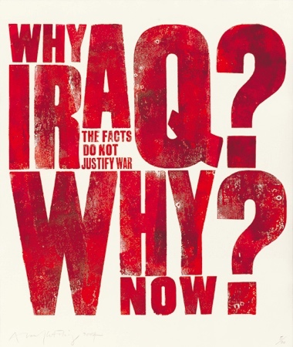
Fig.12 ALAN KITCHING – IRAQ WAR

Alan Kitchen is a typographic designer who experiments with different ways with letterpress design and printmaking. The poster was designed by Alan Kitchen for the Manchester Guardian, he created this poster in anger concerning the start of the Iraq War. “This poster by Alan Kitching gave voice to the anger of millions at the start of the Iraq war in 2003” (de Graaf, 2019). This implies that he has used his emotions within his typography, he has made the typography extremely large in bold and red to show his anger and protesting against the Iraq War.

Meth

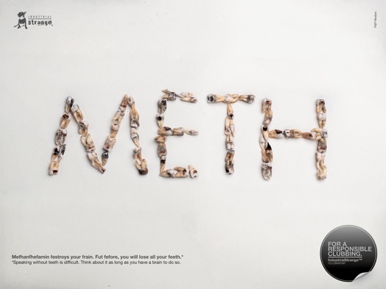
Fig.13 – Meth Advertising Campaign

This advertising campaign has been created by P&P Medien and is used to prevent the use of meth and promote responsible clubbing. The typography included is extremely powerful and stands out as they have included the effects of meth within the main title. The description on the bottom left has been used to describe the effects of using meth “Mefhanfhefamin festroys your frain. Fut fefore, you will lose all your feeth” (Adsoftheworld.com, 2011). The typography interprets the result of taking meth powerfully as it uses scare tactics and explains the consequences of taking the drug and instantly catches your attention.

Nike
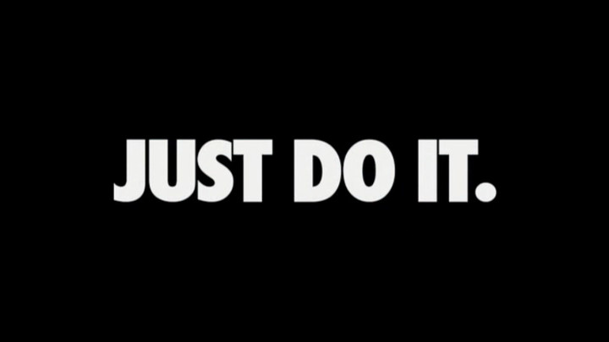
Fig.14 – Nike Advertising Campaign

This advertising campaign was created by Wieden and Kennedy for Nike, but it is credited to “Gary Gilmore, who said “Let’s do it!” (Creative Review, 2019) The typography included is incredibly influential as it portrays a positive message and tries to motivate their customers. “Typography is the art of arranging and designing type. ... Today, typography in advertising often reflects a company's brand” (Evok Advertising, 2019). This states how important the typography used for this advertising campaign is, because it is related to Nike’s main objective, which is “To bring inspiration and innovation to every athlete* in the world” (Nike, 2019) This evidence supports the choice of typography used, you can clearly tell that the kerning has be adjusted to make it stand out and look bold.

Chapter Two - Influential Ethical Companies

In this chapter the focus will be on ethical companies that have a positive impact on the world. It will also include an unethical company and the negative effects this has on the world.

According to Hill (2019), good ethics within a company can have a positive impact on your business as it can create a good relationship with your company and help your company thrive in the marketplace. Hill further explains that an unethical company would have a negative effect as it would stop the chance to secure new customers and create a negative reputation. An example of an unethical company would be Amazon. Hunt (2019) explains that Amazon are one of the lowest ranked companies when it comes to company ethics and the factors behind this are environmental issues, conflict mineral use, tax avoidance and the treatment of the workers in the workplace. This has resulted in a score of 0/20 ethical score.

To be a successful company it is important that you have a strong identity and the branding is good. Branding within a company is extremely important because it creates a relationship with your customers and makes your company memorable and to be recognised.

“Branding can be seen as the devolution of a set of core values to some or all of person, company or thing’s products, assets and attributes, in the form of an identity” (Design, 2004, p.8)

This interprets how branding is important as it can change the way people perceive your company and identify. It also gives you a positive reputation and attractive look, branding can also increase your chances of being successful and getting future work. According to Smithson (2019) by creating an established brand, it will give your company more control in the market, a well-known brand with increase the value of the company.

Companies who brand themselves as ‘ethical’ create a well-established identity. According to a recent study by Balmer (2011), the way companies do this is by underlining the key principles from the beginning, this allows the company to maintain its strategy. In addition, branding yourself as an ethical company allows the organisation to be reminded of its qualities and policies, this is taking into consideration when designing (Balmer et al., 2011).

Under the Skin

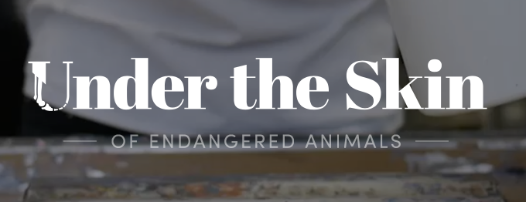
Fig.15 – Logo Under the Skin

Under the Skin are an extremely influential company and use their graphic design knowledge to raise awareness in a positive way.

“Our mission is to raise awareness in fresh, engaging ways whist celebrating the biodiversity of species. Our partner charities work firsthand to prevent endangered animals from falling into the darkness if extinction.” (Under the Skin, 2019)

This evidence shows that they focus on making a difference to the world and use their design knowledge by educating people on the extinctions that are happening. (Fig. 15) shows the logo that has been designed for the company, it was designed by James Harrison and Ed Harrison who are the founders of the company. They describe themselves as “brothers by nature, brothers by design” (Under the Skin, 2019). The ‘U’ included has been designed effectively as it communicates some of the process that is done for them to create a print. The company’s ethics are described by the Harrison brothers to be everyday sustainable and also designing sustainably, they strip back any unnecessary package, and reuse, reduce and recycle materials wherever possible. This suggests that they are not just trying to have an impact on the company but also want to have an impact on other people’s lives.

The company has branded the products to not just make a difference to the people but also to have an impact in saving the species, each product that is bought has a charity that is relevant to the species.
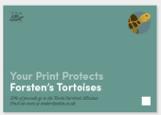
Fig.16 – Print Protects

The company works with charities that have the similar ethics as them and want to make a positive change, as mentioned throughout by Under the skin on their website, the goal is to not just to raise awareness but also to use their graphic design skills to take action, they do this by designing with the goal of educating people.

Advocate

Advocate are an ethical design company who focus on positive change. Advocate (2019) state their goal is to work with purpose-driven organisations and use the power of branding and design to improve the company’s measurable results. This will include improving the company’s sales, attract more supporters, encourage social change or improve the level of engagement. This is done through “a joined-up brand strategy, brand identity, web design and graphic design” (Advocate, 2019).
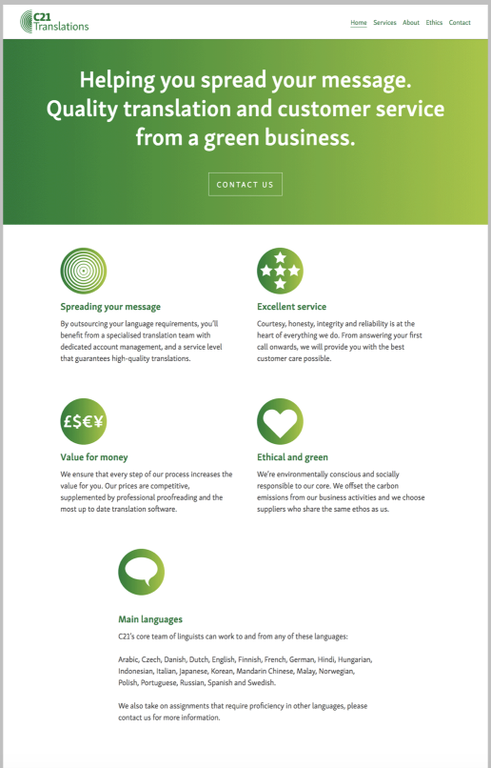

Fig.17 – Brand and Website for Ethical Design

The main objective of Advocate is to work other companies and create an ethical based company. (Fig.17) shows an example of the work carried out by the team, they have designed a brand and website for C21 translations, they have ensured it is ethically designed in order for the company to portray their message, it says “Helping you spread your message. Quality translation and customer service from a green business” (C21 Translations, 2019) this shows they take sustainability seriously.

(Fig.17) shows the brand and website for C21 translations, according to C21 translations (2019) their mission is to limit carbon emissions, work with ethical suppliers, support sustainable business, provide carbon neutral web hosting based entirely in the UK powered by renewable energy and an ethical approach to banking, this evidence shows how seriously they take into consideration all the key factors within a business to have a positive impact on the environment and positive effect on the future.

C21translations (2019) illustrates on the website the company’s goal throughout that they are environmentally conscious and socially responsible, and the main objective is to have a positive impact on the environment and continue to express that the suppliers that they work with share the same ethos as them.

Lucienne Roberts+

Lucienne Roberts and her team are designers who believe in ethical design and have a passion for designing in an ethically correct way.

“We believe that ethical design is defined by its ability to increase quality of life alongside the message it conveys, and place emphasis on clear thinking, visual simplicity and the application of craft skills, we take design seriously and we enjoy design too!” (Roberts, 2019)

This interprets that ethical design is taken seriously by Lucienne Roberts and her design team because they focus on who the message is going to be seen by and making sure it has a positive impact on the world. Lucienne Roberts and her team are located in a London based studio, Roberts (2019) interprets that the process respects the customer ‘goals as well as those who see and use what they do. This shows that Lucienne Roberts and her team want their work to impact not just on the clients they work with but also, they want it to have a positive effect on the people it reaches out to.

Lucienne Roberts is a co-founder of GraphicDesign& which is small publishing venture of hers which includes important information concerning graphic design and why it is important. Lucienne Roberts (2019) states that mutual respect is one of the main factors when working with a client, and also being open, thoughtful and respectful. Lucienne Roberts designed the book ‘Can Graphic Design Save Your Life’ this is a book that includes various different design work and it explains how graphic design is used to educate and entertain.

Chapter Three - Discussion

Artists and designers can have an enormous responsibility in having an influence on the world, the work they produce can be seen by a significant amount of people, the work they design can have positive or negative effects. According to Sasaki (2019), design has a powerful effect on the world because it plays a role in society and the person it reaches out to, it affects cultural identity, social structures, economies, cultural development and environments. Design touches many, as it visually communicates a problem or solution and can educate a variety of disciplines. Sasaki (2019) also explains how design has been used within societies to create a better life. Design is used in everyday life and certain factors are taking into consideration before being carefully produced. For it to be successful, some of the key factors would include sustainability and tolerance and respect. Evidence suggests that design has impacted on countries in a positive way such as India, China, South Africa and Brazil and has been an effective tool for socio-cultural improvement (Sasaki, 2019).

Artists and designers use their skills in imagery, typography and colour to influence the audience and persuade, educate and control. They use colour within design to have an impact on people’s behaviour and decisions. Designers use colour to change the way people perceive the work and often a brand colour is used to offer security and create a relationship. As we are aware in society, things have meanings and within design, different colours have different meanings and signify a message or messages. This is done to make people aware of a situation and also to raise awareness.

According to Sinclair-Ford (2018) colour has a significant effect on people’s mind and decisions, the person viewing the design makes their decisions based on colour alone. Statistics show that about 62-90% do this. These statistics show how important colour is within design and how it can control and influence people’s attitude towards the design.

Graphic designers use their skills in imagery to get the person’s attention and also for designs to be recognised and remembered. Imagery is done to make something look more professional and attractive. It can also be used within branding to sell a product or create an identity. It is an easier way to visually communicate a problem or solution, which can be applied to infographics for it to simplify the process and make it easier for the audience to understand. Graphic designers use graphical images which can set the tone and create a more emotional atmosphere and engage with the audience on a deeper level. Imagery is used to educate, this can be applied to posters, flyers, brochures, infographics, social media or anything design. Graphic designers would use their skills to target the demographic and make sure they know who they are designing for.

Atmosphere of design choices

Good Graphic designers have the skill and knowledge to influence atmosphere, for example, reducing stress and anxiety this has been used for Winnie the Pooh. It is used to influences division and discord with propaganda for example in refuge posters.

Typography is used by graphic designers and can be presented and arranged in different ways, designers use typography in an effective way to get the reader’s attention. It is used in particular to explain what is happening in a literate way, designers can experiment with different ways of applying the text. Designers can use their skills to educate and persuade an audience. This is done by using large fonts, applying colours to fonts, adjusting the kerning and leading, experimenting different ways of applying the text, using capital letters only to get the reader’s attention, as is evident with Kitching’s (Fig.12) example. This is applied within campaigns for example, anti-smoking campaigns to persuade the person to stop smoking and anti- war campaigns. Designers also are also able to position the text in several different ways in order for it to get the audience’s attention, as explained with colour and image, typography is also used for protesting and expressing emotions. Graphic designers use typography to create a relationship with the customer. This can be done within brand identity, for example Tesco uses ‘every little helps’ which promotes the best shopping experience for the customer.

It can be argued that designers use their skills to make money and don’t really care about the outcome, but it is certain some designers use their design skills in an effective way to have more of an impact on people’s behaviour and do care about making a difference to the world. According to Pagan (2016), the best designers that care about the work they produce are designers that engage with the audience on an emotional level and create a connection.

In my opinion, it is important that design companies who have a positive effect on the world and promote ethical design aren’t just doing this for money and jumping on the bandwagon and promoting false advertisement but are actually are actually trying to make a difference.

Under the skin are a company who stands by their word, the goal for them is raise awareness and design sustainable and be everyday sustainable. After researching and looking into this company, evidence shows that the jobs they take on are having a positive impact on the world. In addition, the people they work with are companies and charities that share the same mission. Fig.16 shows how they have donated 20% of the earnings.

The incredible commitment to their craft has enabled Under the Skin, James and Ed Harrison, brothers, to have a powerful voice in ethical design. The skills and knowledge they have gained are applied to their work, not only this but they are a true inspiration as they don’t just do their work for money, but they have also done it for free. They have events running and visit universities which shows they are very passionate about their mission and apply their skills to their designs, these are used in a positive way to raise awareness and educate and also to persuade people to be more aware of the problems of plastic and the environment.

Advocate is a company who use their skills in a positive way, they only work with companies who share the same ethics as them. Fig.17 shows example of an ethical company that they have worked with. In my opinion, this is very important because they are promoting positive change, and this shows the purpose of the company and they are not just promoting it to win over customers and make money.

Fig.17 provides evidence that they have taken into consideration the skills they have used and applied these into their work, as mentioned earlier they take sustainability serious and as shown on C21 translations website, the colour green is used throughout. This demonstrates the correct colour being used and they haven’t just applied any colour to make it look more attractive. The skills are being used in a positive way and are applied to the companies they work with; this is very effective as it creates trust with the companies they work because they do want the company to benefit from their work and make a difference.

Lucienne Roberts has a significant amount of skills and knowledge in graphic design, she has a degree in Graphic Design and English literature and her parents also have creative backgrounds. This has allowed Lucienne to be the designer she is today.

As stated earlier, she is a designer who takes ethics very seriously. The skills she has gained on her journey has been applied to her work and decisions. She is very selective when it comes to the projects she takes on which shows she does actually care about who she is working with and what she is working on. The projects she takes on are normally set against a political agenda.

Lucienne Roberts works with charities, and organisations that make a difference to the world, the work she designs needs to be carefully designed and thought about. Roberts (2017) states that the work can have an emotional impact on herself: it has made her anxious, proud and scared. This shows that the skills she has learnt has a powerful voice in ethical design.

As mentioned earlier, Roberts has published books, for example, in ‘Can Graphic Design Save Your Life’ she only concentrates on designers who use good ethical design and have a positive effect on the world. This shows when applying her skills and designing the book she has taking into consideration the work of the designers and how it has a positive effect on the world.

Conclusion

As I start my career as a visual communicator, my research has made me aware of what makes a good graphic designer.

From my research, it is clear that Graphic design can have a significant impact on someone’s behaviour and decisions and is used in everyday life. When the research began, the main aim was to find out if graphic designers actually cared about what they produced or were they only doing it for money and to be recognised. From my research it is clear that majority of graphic designers do in fact care about the work that is produced and the process behind their design decisions, but a bad designer does not care.

I have learnt that in order to be a good designer, you must be able to take criticism from other people; This can be from industry experts, designers or even someone with no design experience at all, any sort of feedback is good and it’s essential part of the job. This is a major advantage because improves your knowledge because you are communicating and having someone else’s opinion which can result in improving your work and having more of a positive effect on the world.

Graphic designers have an enormous amount of power. They can visually communicate their skills in a positive way. It is clear that this can be done to educate, persuade and control an audience. Many things will be taking into consideration when pursuing these but one of the main factors would be the target audience. As a designer it has made me more aware.

Social media plays a significant role in society today and has advanced over the years. Designers use social media as a platform for advertising and promoting their work, which can have a significant influence on the world. Social media will be an important tool in my career, it will be used to promote any work and for advertisement.

An important finding was that the work that is advertised and designed isn’t always positive, it can be negative. This can lead to conflict and is often used for propaganda and within politics. We can’t always believe everything we see which raises many questions. This can also create diversion but as mentioned earlier graphic design can also be used in a positive way as it brings people together.

This dissertation has illustrated how graphic design can have an impact on people’s perspective and the way they see things. Design choices can also influence on the atmosphere. This is an extremely powerful tool designers use because it allows them to set the tone and fully engage with the audience.

One of the most important factors I have learnt from my research is that graphic design can save lives. This makes me feel proud as designer as you have a lot of responsibly and power. It can be used in awareness campaigns such as suicide prevention and other campaigns that are used in a positive way. This dissertation has highlighted that graphic design is not all about making money as it can be used for free for support and guidance.

This study has highlighted that branding within a company and good ethics can have major advantages as it shows the company care about their work and the environment. It can also give you a more trustworthy reputation and help you be recognised and remembered.

As a visual communicator, this has had an impact on me because it has made me realise that it is important when considering job opportunities to research the company and their ethics and not just take on any jobs. It has made me aware that a good designer will often want to have a positive effect on the world, they would take into consideration everything within the design process. I have learnt that good graphic designers won’t just design for money, but they will do it because they want it to make a difference and have a positive outcome on the world.

Image References

Figure 1
Title
Deisgner/Company
URL

Figure 1
Facebook logo
https://www.facebook.com/images/fb_icon_325x325.png

Figure 6
Human Body App
Designed by Kelli Anderson
Can graphic design save your life (2017) by Schrauwen, S. and Roberts, L.
Page

FINISH THIS SECTION

Bibliography

Adsoftheworld.com. (2011). Industrial Strange Print Advert By P&P Medien: METH | Ads of the World™. [online] Available at: https://www.adsoftheworld.com/media/print/industrial_strange_meth [Accessed 14 Nov. 2019].

Advocate (2019). Advocate ethical design agency – About us. [online] Available at:
https://www.advocatedesign.co.uk/about.html [Accessed 20 Nov. 2019].

Bourn, J. (2019). Meaning of The Color Grey | Bourn Creative. [online] Bourn Creative. Available at: https://www.bourncreative.com/meaning-of-the-color-grey/ [Accessed 7 Nov. 2019].

Brunk, K.H., 2010. Exploring origins of ethical company/brand perceptions—A consumer perspective of corporate ethics. Journal of Business Research, 63(3), pp.255-262.

Burst, D. (2018). How to Use the Psychology of Colors When Marketing. [online] Small Business Trends. Available at: https://smallbiztrends.com/2014/06/psychology-of-colors.html [Accessed 7 Nov. 2019].

C21 Translations (2019). About | C21 Translations. [online] Available at: https://www.c21translations.com/about/ [Accessed 24 Nov. 2019].

Creative Review. (2019). The history of Nike's Just Do It slogan - Creative review. [online] Available at: https://www.creativereview.co.uk/just-do-it-slogan/ [Accessed 14 Nov. 2019].

de Graaf, K. (2019). A voice, of sorts. [online] Design Manchester. Available at: https://designmcr.com/a-voice-of-sorts [Accessed 13 Nov. 2019].

Design, M. (2004). BRANDING From Brief to Finished Solution. 1st ed. Switzerland: RotoVision SA, p.8.
Dvornechuck, A. (2019). What Does Your Logo Color Mean? #branding #logodesign #graphicdesign. [online] Ebaqdesign™. Available at: https://ebaqdesign.com/blog/logo-color/ [Accessed 7 Nov. 2019].

Endenich, C. and TRAPP, R., 2018. Ethical Implications of Management Accounting and Control: A Systematic Review of the Contributions from the 0RW1S34RfeSDcfkexd09rT2Journal of Business Ethics1RW1S34RfeSDcfkexd09rT2: JBE JBE. Journal of Business Ethics, , pp. 1-20.

EverytownResearch.org. (2019). Gun Violence in America - EverytownResearch.org. [online] Available at: https://everytownresearch.org/gun-violence-america/ [Accessed 13 Nov. 2019].

Evok Advertising. (2019). Typography: A Vital Component in the World of Advertising. [online] Available at: https://www.evokad.com/typography-a-vital-component-in-the-world-of-advertising/ [Accessed 14 Nov. 2019].
Front Cover. 1985. Journal of Business Ethics (pre-1986), 4(000006), pp. 427.

Gremillion, A. (2019). How color impacts emotions and behaviors. [online] 99designs. Available at: https://99designs.co.uk/blog/tips/how-color-impacts-emotions-and-behaviors/ [Accessed 28 Oct. 2019].
Hausmann, R. and Cullars, J. (1998). Typography. Design Issues, 14(3), p.71.

Hill, B. (2019). The Advantages of Ethical Behavior in Business. [online] Smallbusiness.chron.com. Available at: https://smallbusiness.chron.com/advantages-ethical-behavior-business-21067.html [Accessed 20 Nov. 2019].

Hoyt, A. (2019). How Propaganda Works. [online] HowStuffWorks. Available at: https://people.howstuffworks.com/propaganda.htm [Accessed 12 Nov. 2019].

Hunt, T. (2019). Five unethical companies | Ethical Consumer. [online] Ethical Consumer. Available at: https://www.ethicalconsumer.org/retailers/five-unethical-companies [Accessed 20 Nov. 2019].

Ibrahim, A. and Lee, T. (2014). Ebola. Canadian Medical Association Journal, 186(15), pp.E589-E589.

Igual, R. (2019). Cape Town Pride announces theme for 2019. [online] MambaOnline - Gay South Africa online. Available at: https://www.mambaonline.com/2018/08/27/%20cape-town-pride-announces-theme-for-2019/ [Accessed 7 Nov. 2019].

Khalil, M. (2019). BULLETS LEAVE BIGGER HOLES THAN YOU THINK. [online] MADELINE KHALIL. Available at: https://madelinekhalil.wordpress.com/2016/12/13/bullets-leave-bigger-holes-than-you-think/ [Accessed 13 Nov. 2019].

Library, W., Flagg, 1., Congress, L. and Congress, L. (2019). I Want You for U.S. Army. [online] Wdl.org. Available at: https://www.wdl.org/en/item/576/ [Accessed 13 Nov. 2019].

Medium. (2019). How to Criticize and Accept Criticism as a Product Designer. [online] Available at: https://uxplanet.org/how-to-criticize-and-accept-criticism-as-a-product-designer-10bd09da57b2 [Accessed 14 Nov. 2019].

Moor, A. (2019). These Are the Secret Meanings of the Pride Flag's Colors | Best Life. [online] Best Life. Available at: https://bestlifeonline.com/pride-flags-colors-meaning/ [Accessed 7 Nov. 2019].

Morton, J. (2019). Red. [online] Colormatters.com. Available at: https://www.colormatters.com/the-meanings-of-colors/red [Accessed 7 Nov. 2019].
Muller-Freienfels, R. (1948). On Visual Representation: The Meaning of Pictures and Symbols. The Journal of Aesthetics and Art Criticism, 7(2), p.113.

Nike. (2019). What is Nike's Mission?. [online] Available at: https://www.nike.com/help/a/nikeinc-mission [Accessed 14 Nov. 2019].

Pagán, B. (2019). Four Things Great Designers Care About | UX Magazine. [online] Uxmag.com. Available at: https://uxmag.com/articles/four-things-great-designers-care-about [Accessed 23 Nov. 2019].

Place, M. (2019). LGBTQ Symbols. [online] Medium. Available at: https://medium.com/matthews-place/lgbtq-symbols-7d925b396ebe [Accessed 7 Nov. 2019].

Poor Company Ethics May Cause Turnover. 2010. OfficePro, 70(5), pp. 6.

Roberts, L. (2007). Good: An Introduction to ethics in graphic design. 1st ed. London: AVA Publishing.

Roberts, L. (2019). LucienneRoberts+. [online] Luciennerobertsplus.com. Available at: http://www.luciennerobertsplus.com/about.html [Accessed 15 Nov. 2019].

Sasaki, S. (2019). The role of graphic design in international development | ico-D. [online] Ico-d.org. Available at: https://www.ico-d.org/connect/features/post/363.php [Accessed 23 Nov. 2019].

Schrauwen, S. and Roberts, L. (2017). Can graphic design save your life?. 1st ed. London: GraphicDesign&.

Sharifah FarIdah, S.A., SULAIMAN, M.A. and NGUYEN, B., 2017. The Importance of Ethics in Branding: Mediating Effects of Ethical Branding on Company Reputation and Brand Loyalty. Business Ethics Quarterly, 27(3), pp. 393-422.

Sinclair-Ford, C. (2019). The psychology and relationship of colour and design - Clicky Media™. [online] Clicky Media™. Available at: https://www.clicky.co.uk/blog/the-psychology-and-relationship-of-colour-and-design/ [Accessed 24 Nov. 2019].

Smithson, E. (2019). What Is Branding And Why Is It Important For Your Business? | Brandingmag. [online] Brandingmag.
Available at: https://www.brandingmag.com/2015/10/14/what-is-branding-and-why-is-it-important-for-your-business/ [Accessed 15 Nov. 2019].

Stark, H. (2014). Which is More Important in Design: Images or Text? — SitePoint. [online] SitePoint. Available at: https://www.sitepoint.com/images-text-important/ [Accessed 12 Nov. 2019].

Taylor, W. (1942). What Is Propaganda?. College English, 3(6), p.562.

Undertheskin.co.uk. (2019). Mission • Under the Skin of Endangered Animals. [online] Available at: https://undertheskin.co.uk/mission/ [Accessed 15 Nov. 2019].

unknown, u. (2019). Psychology of Colour in Advertising | New Design Group. [online] New Design Group Inc. Available at: https://www.newdesigngroup.ca/graphic-design/psychology-colour-advertising/ [Accessed 7 Nov. 2019].

Wallace, D. (2019). Psychology of Color in Marketing Infographic. [online] Small Business Trends. Available at: https://smallbiztrends.com/2013/04/psychology-of-color-infographic.html [Accessed 7 Nov. 2019].

White, D. (2019). What is Typography? - Definition, Terms & Examples | Study.com. [online] Study.com. Available at: https://study.com/academy/lesson/what-is-typography-definition-terms-examples.html [Accessed 13 Nov. 2019].

Zelanski, P. and Fisher, M. (n.d.). Color. 5th ed. London: Pearson Education LTD, p.11.

