
Master of Business Administration
Module name and code: Human Capital Management - LCMB7023
Assessment component 1: Individual Report

Lecturer’s name: Gladius Kulothungan (London)
Name: Rifatun Nabi Chowdhury Rian
Student ID: 2510637
Word count: 2671

Contents
Introduction 3
Question 1: Labour market disruption and Technological Advancements 4
Question 2: Demographic and Geopolitical Factors and the labour market issues 7
Question 3: Strategic HRM Reactions to Skills Gaps and Talent Shortages 9
Question 4: Self-Reflection on International Workplace Capabilities 12
Conclusion 16
References 17

Introduction
The labor market has shown transformation due to high use of technology, changes in demography and instability in political situation are crucial for Human Resources Management both national and international. Managing human capital with strategic movement is necessary since organizations engages in ecosystems which is based on technology based on cross-border. Constant increase in HRM market globally annually 14.4 percent indicates focus should be on workforce issues to get immediate relief (Grand View Research, 2024). Changes in demand of labor due to technological advancement. how changes in global and geopolitical factors effects labor market are discussed in this report. Improvement is organizational development with competency in professional level determine the success of strategic HRM.

Question 1: Labour market disruption and Technological Advancements
Strategies to re-evaluate HRM which transforms labor markets with the help of automation and intelligence can make changes in the scenario. The Future of Jobs Report 2025 by the World Economic Forum shows the extent of this change: by the year 2030, 170 million jobs will be created at the same time as 92 million jobs will be displaced, meaning that the total number of jobs will increase by 78 million but with massive disruption in the sector and occupation categories. More importantly, this shift is not uniform, as wider employment expands, 63% of employers see skills gaps as the main obstacle to business transformation, which reflects the systematic incompatibility between technological capability development and workforce preparedness (World Economic Forum, 2025).​
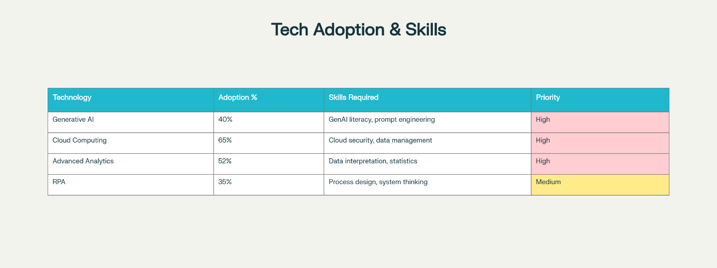
Figure 1: Technological Adoption and HRM Development Priority (WEF,2025)
The ways that AI and automation are transforming the dynamics of the labor market are interrelated. To begin with, they invent occupational classes as they subjugate others. Some specific jobs like data entry, automated manufacturing is in the risk obsolescence (Microsoft, 2024). Second, they increase skill obsolescence speed, by almost 40 percent of the skills employees need will be obsolete by 2030, shrinking the timeframes to adapt to the labour market (International Labour Organisation, 2025). Third, they democratize expertise: with the help of generative AI, less skilled employees are able to work on the tasks that used to presuppose specialized knowledge, which fundamentally changes the stratification of workforce. The HRM and IHRM strategies implications are far-reaching. Proactive Talent Management structures should be applied in organizations that focus on ongoing upskilling as opposed to conventional recruitment structures. The strategic organizational responses can be seen in the Microsoft case of preparing 2 million people in India by 2025 and in Amazon with its Upskilling 2025 Initiative that produced an average salary increase of 8.6% among the participating employees and career growth in three-quarters of participants (Amazon, 2024). These efforts focus on the shortages of skills in the short term and also on the retention of talent since employees who are provided with development opportunities are more committed to the organization.​
It is also important that organizations re-think the concept of workforce planning using dynamic capability models. According to the analysis provided by the International Labour Organization, AI is bound to complement rather than substitute jobs and therefore organizations must invest in complementary skill acquisition or development - combining technical knowledge with resilience, innovative thinking and skills through leadership. Eight of ten employers around the world intend to introduce AI training to their current workforces and two out of every three intend to recruit AI talent which indicates that the technological change needs an internal development policy and external hiring policy at the same time.​
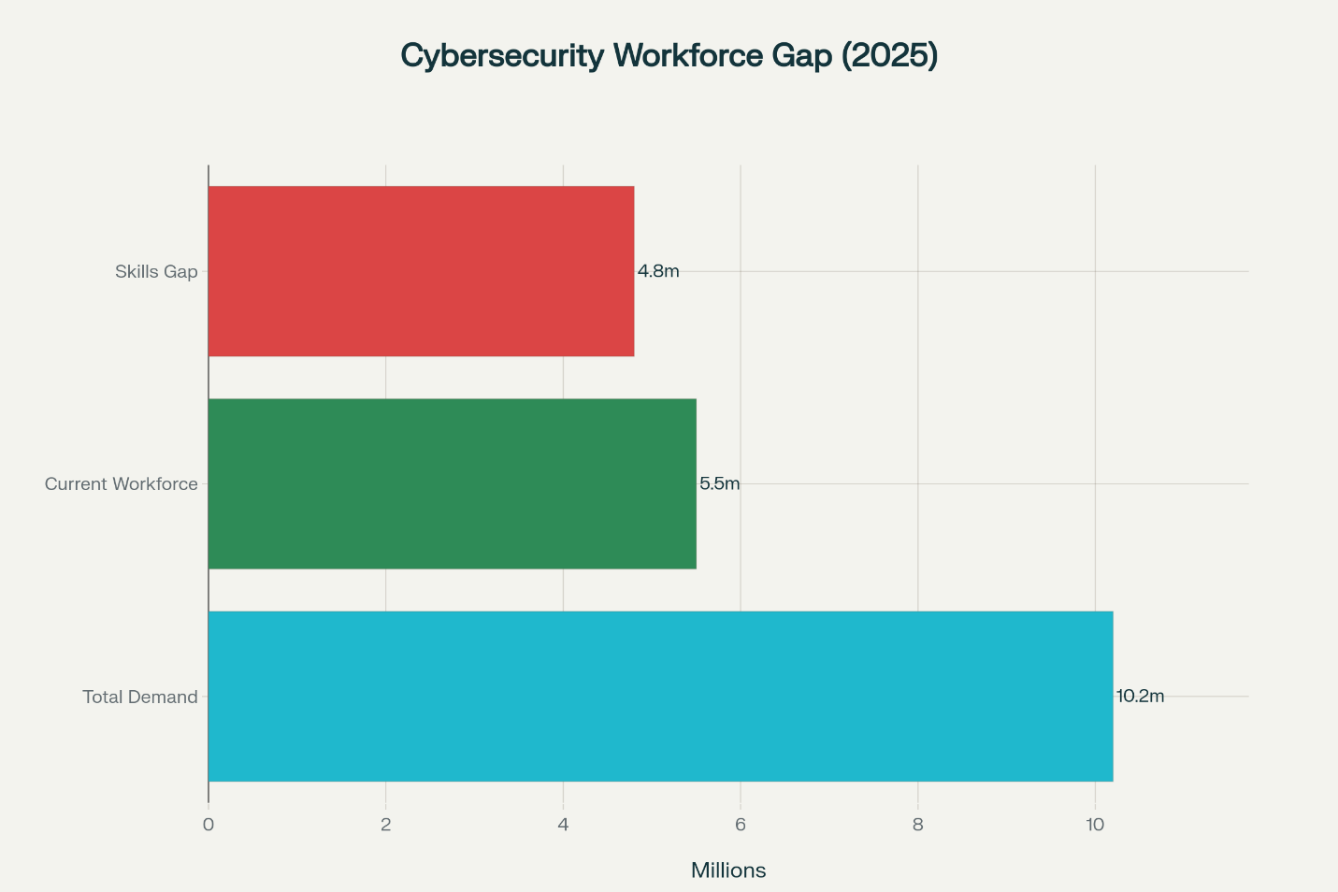
Figure 2: Workforce cybersecurity skills gap of the world (WEF, 2025)
Nevertheless, there are still critical tensions that are not resolved. Although 77 percent of employers intend to upskill their workforce, 41 percent also intend to down skill their employees with automation, which has ethical implications of fair transition assistance. This paradox needs to be mitigated in strategies of IHRM by integrating social responsibility in talent management, especially in geographically dispersed labour forces who encounter different exposure levels to technology. Therefore, strategic HRM should strike the right balance between efficiency gains to the organization and the stakeholder concern in terms of employment security and equal opportunity access in technology-driven labour markets.

Question 2: Demographic and Geopolitical Factors and the labour market issues
In the modern labour markets, the demographic changes and geopolitical fragmentation exert compounded pressure, and the resulting multifaceted HR issues demand the strategic response of the organization. The nearest challenge, demographic, is getting older: OECD populations are ageing at a very high rate, with the ratio between old age and working-age almost doubling (33 to 59) by the year 2064, though especially in Japan (79% by 2050) and Korea (96% by 2050). At the same time, fertility is still below the replacement in the OECD countries, declining working-age populations (OECD, 2024a). An example is Japan: as working-age people are expected to fall by 8 percent in 2035 and 15 percent in 2045, the government has increased specified skilled worker visas to 820,000 over five years, but is experiencing political opposition against extensive immigration even though 340,000 foreign workers are coming in every year (OECD, 2024b). This demographic-policy paradox results in organizational ambiguity: companies can no longer count on the growth of the labour market and have to spend a lot of money on automation and productivity improvement as well as retention strategies.​
These issues are added by geopolitical fragmentation disrupting trade and realigning the supply chain. According to the World Economic Forum, in 34 percent of employers there are geopolitical divisions that will drive business transformation, and 23 percent of employers underline trade restrictions as important disruptors. The U.S.-China conflict and Brexit are some of the examples of how trade disputes redefine labour markets: Apple and Tesla diversifying supply chains to India and Mexico; nearshoring projects establishing manufacturing jobs in the North American and European markets at the cost of Asian jobs. The International Labour Organisation reduced its forecast of employment growth to 1.5 in 2025 with reference to geopolitical tension coupled with structural vulnerabilities and impacting 84 million jobs in 19 countries which relied on US consumer demand.​
The UK NHS is an example of how geopolitical and demographic factors overlap to generate acute HR crises. Having a forecasted gap of between 260,000-360,000 employees in the coming 2036/37, the NHS is at the same time struggling with 106,432 vacancies (March 2025), with more than 25,000 of these roles unfilled being nurses (International Bar Association Global Employment Institute, 2025). Brexit decreased inflows of workers to the EU and demographic pressures raised the demand; by 2030 one in three people will be aged 65 and above. Ironically, the brain drain issues are comorbid with labour shortages: although 18 per cent of bachelor’s degree graduates in low-income countries live in OECD countries, 91 per cent of Ethiopian PhD graduates work overseas, but emerging evidence indicates that education investments by countries of destination of migration create brain gain by sending remittances and diaspora networks, especially where countries of origin have sufficient training infrastructure (Oxford Economics, 2025).​
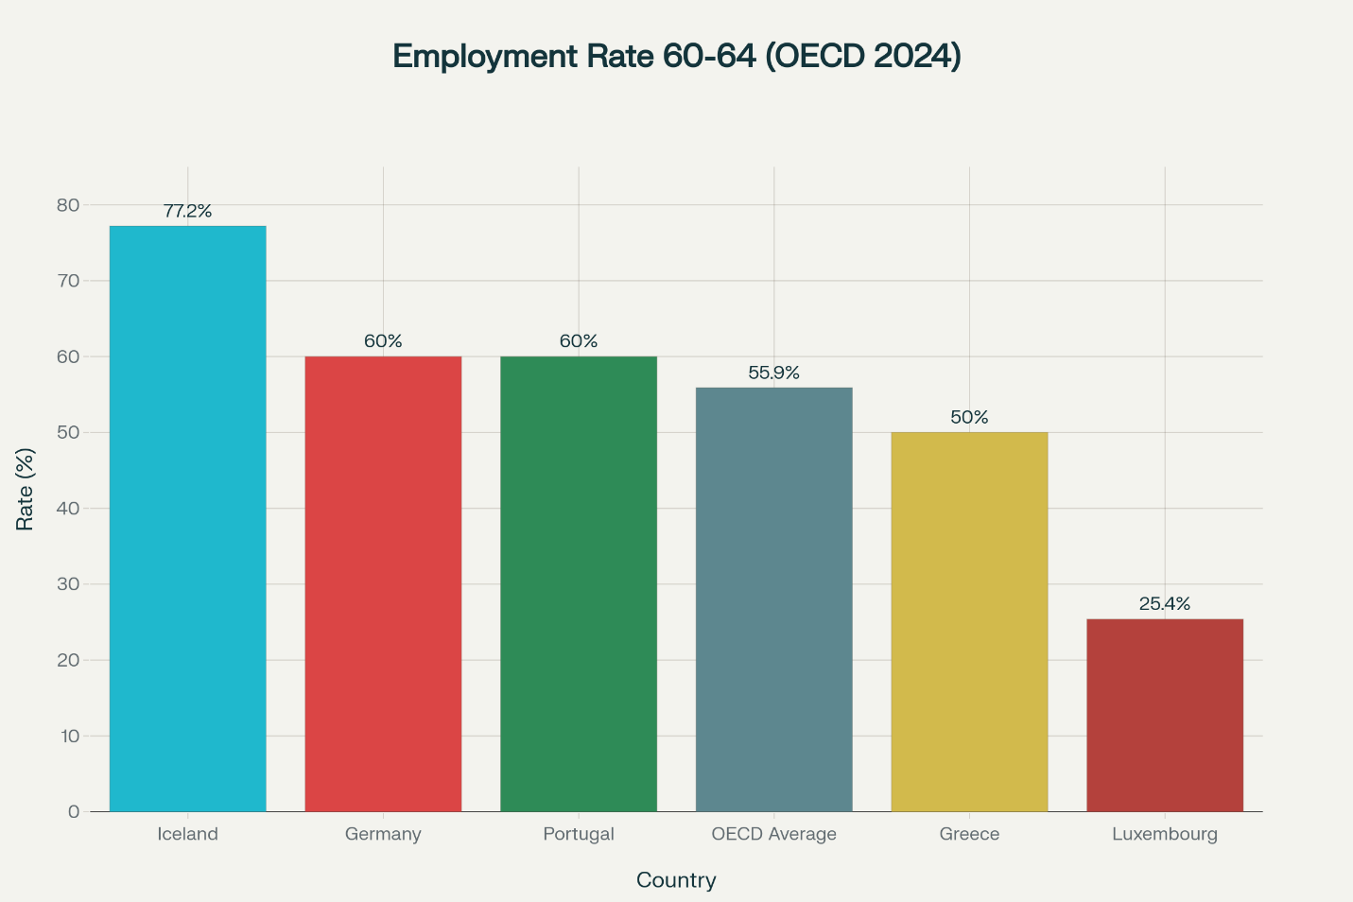
Figure 3: Workers Age 60-64 employed in the selected OECD Countries (OECD, 2024)
HR professionals have conflicting demands: recruitment strategies need to address geopolitical supply chain changes, visa limits; retention strategies need to address cost pressures due to ageing and the lack of labour supply; and workforce planning has to deal with both labour displacement as a result of nearshoring and long-term sectoral shortages (UK Health and Social Care Policy and Network, 2025). PESTLE analysis indicates the interplay of such aspects as political protectionism, economic fragmentation, and social ageing, making the resilience of organizations based on geographic diversification, localized talent development, and flexible employment forms going beyond geographic limits a necessity.

Question 3: Strategic HRM Reactions to Skills Gaps and Talent Shortages
The endemic skills deficit in key industries, such as technology, healthcare and hospitality require strategic HRM intervention that goes beyond conventional recruitment. Demand is high the world has a severe talent shortage issues 3.5 million cybersecurity vacancies are still unfilled; 900,000 registered nurses are projected to be short in healthcare systems by 2027; 66% of respondents inorganizations report moderate-to-critical cybersecurity skills gaps (National Staffing Institute, 2025). They are not impoverished imbalances in the labour markets but structural malpractices in the development of the workforce capability as compared to the technological/sectoral rapidity.​
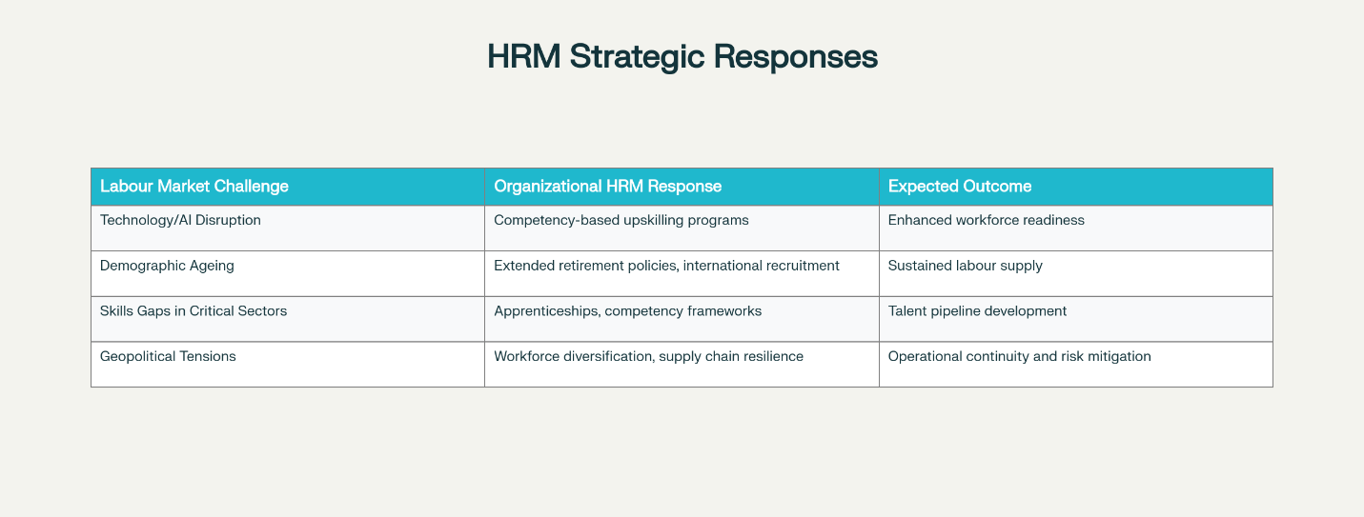
Figure 4: HRM Strategic Responses to the Modern Labour Market Challenges (WEF, 2025)
Strategic HRM needs to use integrated Talent Management models that have utilized acquisition, development, and retention processes. An example of this model is Google Software Application Development Apprenticeship, which is a 12-month, competency-based initiative, 20% of structured training, and 80% real-world on-the-job experience of a project within a defined set of technical areas. By 30-40% of the time compared to conventional training, this model hastens the acquisition of skills because, in the process, the apprentices are able to gain contextual knowledge, and they are productive at the same time. Likewise, the U.S. healthcare systems with issues of nursing shortages (reaching 124,000 vacancies over the next 33 years) implement multi-faceted approaches to retention: high salaries, flexible working hours, nurse residency programmes with 3.8/5 success levels, and float pools that allow flexibility in careers (All Med Search, 2024). Of paramount importance to the healthcare approach is that one must recognize that 34 percent of the current RNs will have retired by 2030, thus knowledge transfer and succession planning are the critical competency frames.
The apprenticeships in the hospitality sector show fair capacity-building: participation in registered apprenticeships grew by 76% in five-years to 9942 participants in 2024 decreased turnover in the sector with a structured career pathway including classroom training with the mastery of on-the-job training. Competency-based systems are especially effective: in a case of organized competency tests, organizations achieve 30 percent productivity growth and 21 percent employee turnover decrease in 12 months.​
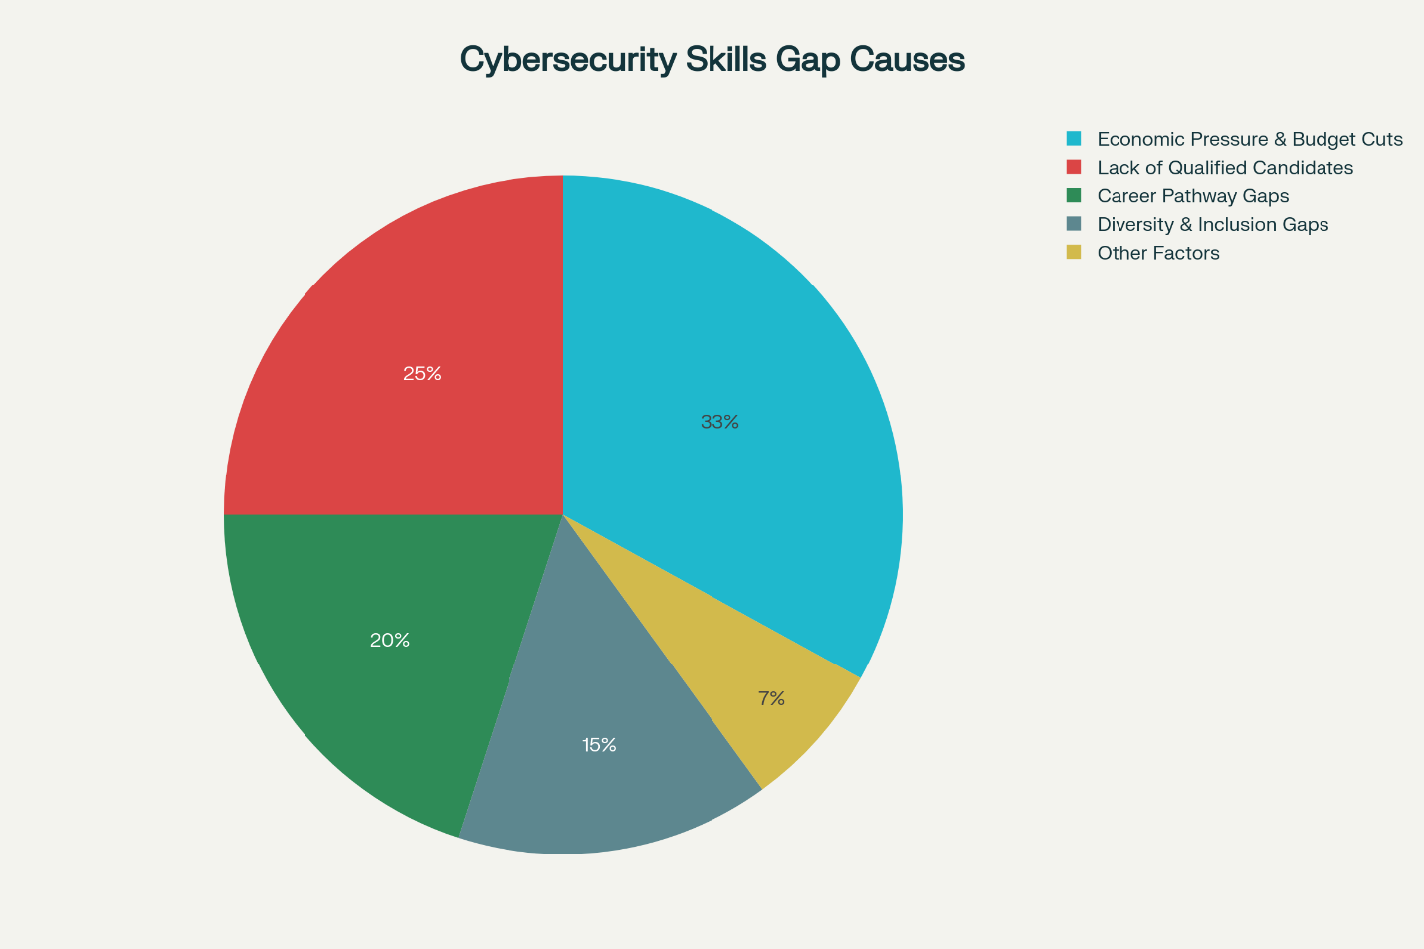
Figure 5: Root Causes of Global Cybersecurity Skills Gap (WEF, 2025)
Nevertheless, there are critical tensions that impair HRM effectiveness. Sector-based solutions are not sufficient as long as systemic education pipeline failures such as 18% of UK adults are lacking in the most basic digital skills limiting the talent pools in technological sectors irrespective of organizational investment. Also, 55 percent of organizations do not know how to define measurable competencies, which form uneven developmental lines. The concentration of geographic talent is also another limitation: international recruitment solves the problem of skills shortage in the country, but introduces ethical dilemmas of brain drain and limitations on visa regimes, especially concerning emerging economies.​
Strategic HRM should consequently involve workforce foresight with macro-policy involvement: promulgation of education programs, financing types of apprenticeship, and global mobility systems. Systemic skills gaps cannot be self-resolvable by organizations; the competitive advantage can be achieved by engaging in active talent ecosystems, building internal capacity, and communicating with stakeholders on an open basis about the sectoral challenges. Apprenticeship models and competency-based frameworks are effective, but to be sustainable, the collaboration of cross-organizational efforts and responsiveness of the educational system to the needs of the labour market must take place. International Workplace Capabilities Self-Reflection.

Question 4: Self-Reflection on International Workplace Capabilities
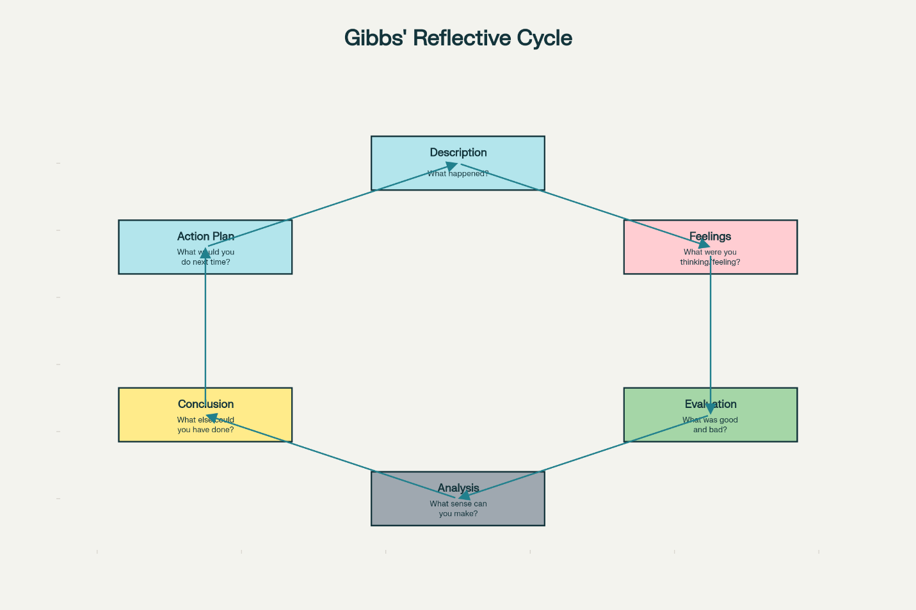
Figure 6: The Reflective Cycle Framework of Professional Development by Gibbs (Gibbs G, 1988)
Reflective International Practice Competency Examination
Reflective International Practice Competency Examination. The course of MBA that I completed during this term (the Human Capital Management module, cross-cultural group projects, etc.) has been a good source of evidence about my existing skills and areas of development to focus on in my future professional practice on a global level. Three sequential reflections on technology, communication, teamwork, leadership, and self-directed learning give an impression of an emergent level of readiness with certain areas needing particular development.
Digital Competence and Technology
My technological ability is in good use of collaborative digital platforms. In my Global HRM Strategy project, I organized asynchronous work of international team members through Microsoft Teams, Asana, and shared analytical dashboards, which allowed keeping five-hour time zone differences on par and synchronized in real-time. This technical skill indicates that I am self-directed in learning as the module of digital transformation. Nevertheless, I understand that I am highly restricted: the new AI-driven HR analytics tools have a capability gap. My reluctance to use ChatGPT-4 to predictively model the workforce in the context of my assigned task in Talent Management showed that my technical background, though strong in traditional platforms, is not as deep into modern AI applications that are becoming a more significant expectation in global human resource management.
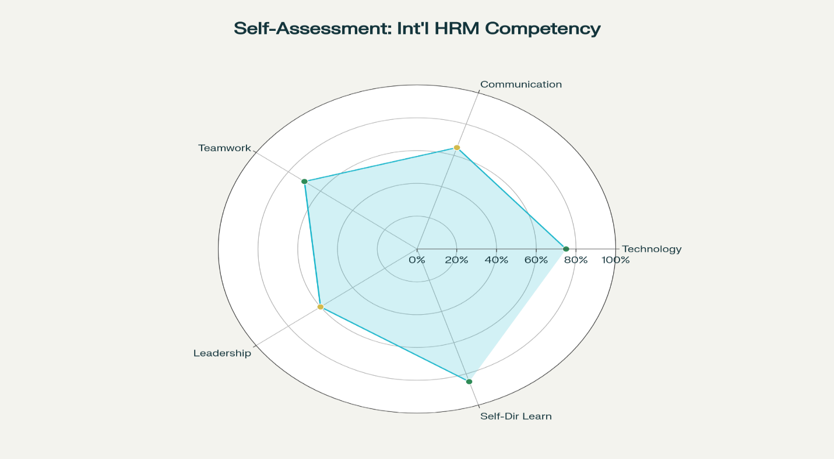
Figure 7: Self-Assessment Dashboard: International HRM Competency Profile

Communication in Cultural Situations
I use English language in a way that is professionally clear in formal occasions. My module presentation received some feedback on the issue of clear structure and evidence-based argumentation. Nonetheless, cross-cultural communication needs to be perfected. My direct approach to communication, which works in the business environment of Indian, caused a conflict in group discussions as the Western colleagues viewed my directness with confrontation instead of a focus on effectiveness. This experience helped to realize that the art of international communication requires cultural code switching - changing assertive behavior based on the situation (Torrington et al., 2020). I will be able to build this skill by consciously noting how colleagues with a varied background handle sensitive conversation, as well as, actively seeking direct feedback when the communication effect does not seem to match the intent.
Teamwork and Teamwork Effectiveness
My teamwork contribution is characterized by reliability and conscientiousness. I fulfilled the given parts on time and changed the working styles to suit the preferences of teammates, especially by changing the individual work orientation to the methodology of consensus building when I worked with my Malaysian colleague. On the other hand, the area of weakness appeared in conflict navigation: in the case of the disagreement with an offered analytical strategy, I retreated instead of interacting socially, and I worked alone (Salas, 2020). This reaction was an uneasiness of the possibility of interpersonal friction in foreign settings as opposed to a failure to cooperate. Going forward, I will be engaged in conflict management by starting clear communication on differences in methodologies as I realize that the varied ways are what enhance the work of the team.
Leadership and Professional Initiative
My leadership potential manifests in situations that require a problem when solving. When coordination in the team went bad, I offered coordination rules and offered coordination duties, which were embraced by the team. This portrays initiative and systems thinking. Yet, I am reluctant in the assumption of formal leadership visibility, especially among Western workers, as it is indicative of being unsure about cross-cultural expectations of leadership and not incompetence. I will cope with it by taking visible leadership positions actively, volunteering to serve in committees or project leadership positions, to gain confidence and obtain bona fide international leadership identity.
Self-Managed Learning Orientation
Self-directed learning commitment is my best strength. I will go to all optional seminars, actively use tutoring assistance when I have technical deficits, and do additional reading that is not compulsory.
Developmental Strategy
To be prepared to practice internationally, I need to be consciously developed in the communication and leadership aspects. By December 2025, I will have a cross-cultural communication certification, and in June 2026, I will have the visible project leadership responsibility. These high-performance investments, which are in addition to my technical learning strengths, will give me overall potential of working effectively in multinational organizations after 18 months.

Conclusion
Modern labour markets are confronted with an unparalleled technological upheaval, population fragmentation and political unpredictability that require strategic HRM realignment involving constant up-skilling, international mobility models, and competency-based talent management. These organizational needs are directly parallel to the needs of the individual readiness: successful international HRM professionals are needy in technological skills, cross-cultural communication, team-based flexibility, genuine presence of leadership, and commitment to self-directed learning. With predicted effort I can show enough competence to facilitate mobility by June 2026. Finally, the organizational and personal preparedness to international, technology-based HRM are processes which are interdependent and must be considered with strategic approach and individual professional dedication at the same time.

References
- All Med Search (2024) Addressing the nursing shortage in 2024: recruitment and retention strategies. Available at: https://www.allmedsearch.com (Accessed: 11 November 2025).
- Amazon (2024) Upskilling 2025: impact report. Amazon Corporate Responsibility. Available at: https://www.aboutamazon.com (Accessed: 11 November 2025).
- Gibbs, G. (1988) Learning by Doing: A Guide to Teaching and Learning Methods. Further Education Unit, Oxford Polytechnicgan.
- Grand View Research (2024) Human resource management market size report, 2030. Report. Available at: https://www.grandviewresearch.com (Accessed: 11 November 2025).
- International Bar Association Global Employment Institute (2025) Global war, global trade: a global employment institute perspective. Available at: https://www.iclg.com (Accessed: 11 November 2025).
- International Labour Organisation (2025) AI impact on employment: trends and outlook. World Employment and Social Outlook. Available at: https://www.ilo.org (Accessed: 11 November 2025).
- Microsoft (2024) AI reskilling initiative India: training 2 million people. Microsoft Official Blog. Available at: https://news.microsoft.com (Accessed: 11 November 2025).
- National Staffing Institute (2025) 2025 national healthcare retention & RN staffing report. Available at: https://www.nsinursingsolutions.com (Accessed: 11 November 2025).
- OECD (2024) Enhancing productivity and growth in an ageing society. Available at: https://www.oecd.org (Accessed: 11 November 2025).
- OECD (2024) Society at a glance 2024: demographic trends. Available at: https://www.oecd.org (Accessed: 11 November 2025).
- Oxford Economics (2025) Ageing Japan needs a drastic shift in migration policy. Available at: https://www.oxfordeconomics.com (Accessed: 11 November 2025).
- Salas, E. (2020) Wiley Blackwell handbook of the psychology of team working and collaborative processes. S.l.: Wiley-Blackwell.
- Torrington, D., Hall, L., Taylor, S. and Atkinson, C. (2020) Human resource management. 11th edn. Harlow, U.K.: Pearson Education Limited.
- UK Health and Social Care Policy and Network (2025) Workforce challenges and solutions in UK health and social care sector. Available at: https://www.hscpn.org (Accessed: 11 November 2025).
- World Economic Forum (2025) Future of jobs report 2025. World Economic Forum. Available at: https://www.weforum.org (Accessed: 11 November 2025).

