

Major Proposal

Design and Implementation of a Contactless Digital Tachometer

by
Gareth Davies
Requested Supervisor: Jenifer Prince Devarja

Project submitted as part of the requirements for the award of

BEng (Hons) Electrical and Electronics Engineering

April 2025
DECLARATION FORM AND FORM OF CONSENT

DECLARATION

I Gareth Davies declare that I am the sole author of this Project; that all references cited have been consulted; that I have conducted all work of which this is a record, and that the finished work lies within the prescribed word limits.

This work has not previously been accepted as part of any other degree submission.

FORM OF CONSENT

I Gareth Davies hereby consent that my Project, submitted in candidature for the B.Eng. (Hons) Electrical and Electronics Engineering degree, if successful, may be made available for inter-library loan or photocopying (subject to the law of copyright), and that the title and abstract may be made available to outside organisations.

Abstract

This project presents the design and implementation of a contactless digital tachometer that utilises microcontroller technology to deliver highly accurate rotational speed measurements. Its primary aim is to improve measurement accuracy and precision at ERIKS Cardiff, whilst also eliminating contact measurements for health and safety concerns.
The report details a comprehensive engineering approach, from literature reviews of contactless measurement techniques through to the design and testing of software and prototypes. The resulting tachometer achieves an impressive 99.43% accuracy across a range of over 10000 revolutions per minute.
This tachometer represents a significant advancement in rotational speed measurement at ERIKS by combining high accuracy, range and precision with improved safety features. The successful integration of this contactless tachometer results in a reliable, efficient, and user-friendly device suitable for a wide range of industrial applications.

Table of Contents
Abstract 2
1.0 Introduction 7
2.0 Aim and Objectives 8
2.1. Project Aim 8
2.2. Project Objectives 8
Research and Analysis 8
Define Specifications 8
Select Components 8
Design Circuitry 8
Develop Software 8
Prototype Development 8
Testing and Calibration 8
PCB Design and Testing 9
Tachometer Evaluation 9
3.0 Project Research 10
3.1. Product Design Specifications 10
Physical Specifications 10
Technical Specifications 10
3.2. Increased Demand for Safety 10
3.3. Literature Review of Contactless Measurement Techniques 11
Optical Tachometers 11
Magnetic Tachometers 14
Chosen Contactless Method 16
3.4. Major Component Research 16
Battery Options 16
Display Options 18
Microcontroller 19
4.0 Development Methodology 22
4.1. Hardware Acquisition 22
4.2. Software Selection 22
4.3. Experimental & Evaluation Method 23
Software Evaluation Method 23
Hardware Evaluation Method 23
5.0 Design & Implementation 24
5.1. Component Selection 24
Battery Selection 24
Charing Module 25
Display Selection 25
Infrared Module 26
Microcontroller 27
Wire to Board Connectors 28
5.2. Circuit Design 29
Overvoltage Protection 29
LPF Circuit 30
Tachometer Circuit Design 31
5.3. Software Design 33
CCS C Compiler – Microcontroller Setup 33
CCP & Interrupts 34
Proteus – Software Design & Simulation 34
5.4. PCB Design 37
5.5. Design Implementation 38
PCB Assembly 38
LCD Assembly 39
IR Module Assembly 39
Battery and Charging Module Assembly 40
Tachometer Housing 40
Microcontroller Programming 42
5.6. Test Implementation 42
LCD Fault Finding 42
6.0 Project Evaluation 45
6.1. Software Evaluation 45
Accuracy 45
Precision 47
Resolution 47
Range 47
Software Structure 48
Software Conclusion 49
6.2. Hardware Evaluation 49
Battery and Charging Module 49
IR Module 50
PCB 51
Tachometer Case 52
6.3. Future Work Recommendations 52
Update LCD Driver File 52
Optical Lens 52
Complete Circuit PCB 52
Enhanced Microcontroller Specifications 53
7.0 Conclusion 54
8.0 Project Reflection 55
8.1. Key Learnings and Insights 55
Focus on Health and Safety 55
Tackling Complex Tasks 55
Challenges in Hardware Implementation 55
Project Review 56
9.0 Bibliography 57
10.0 Appendices 60
10.1. Appendix 1 - Project Budget Breakdown 60
10.2. Appendix 2 - Project Gantt Chart 61
10.3. Appendix 3 - Complete Tachometer Software 62
10.4. Appendix 4 - Software Evaluation Results 63

Table of Figures

Figure 1 - Infrared Wavelength [18] 12
Figure 2 - Coherent vs Incoherent Light [21] 13
Figure 3 - Hall Effect Physics [22] 15
Figure 4 - Hall Effect Sensor 16
Figure 5 - Operational Block Diagram for a CCP [51] 21
Figure 6 - LP883048 Li-Ion Battery [17] 25
Figure 7 - AZ-Delivery TP4056 Charging Module [18] 26
Figure 8 - AZ-Delivery 16x2 LCD [19] 27
Figure 9 - AZ-Delivery IR Proximity Sensor [20] 27
Figure 10 - IR Module Schematic 27
Figure 11 - PIC16F87 Microcontroller [6] 29
Figure 12 - Overvoltage Protection Circuit 31
Figure 13 – Designed 300Hz Low Pass Filter 32
Figure 14 - Complete Tachometer Schematic 33
Figure 15 - Tachometer Test Simulation 35
Figure 16 - Software Setup 36
Figure 17 - Software Variable Definition 36
Figure 18 - Software CCP ISR 37
Figure 19 - Software Main Function 37
Figure 20 - Software Main Loop 37
Figure 21 - Tachometer PCB Design 38
Figure 22 - 3D Simulated Image of Designed PCB 39
Figure 23 - Assembled PCB 39
Figure 24 - LCD Assembly 40
Figure 25 - IR Module Assembly 40
Figure 26 - Battery & Charging Module Assembly 41
Figure 27 - Battery & Charging Module Connections 41
Figure 28 - PVC Junction Box 42
Figure 29 - Tachometer Case 42
Figure 30 - Manually Setting Microcontroller Output Pins 44
Figure 31 - Operation of Software Simulation 46
Figure 32 – Ideal vs Simulated Software Results 47
Figure 33 – Software Precision Results 48
Figure 34 - USB Charging of Li-Ion Battery 50
Figure 35 - Operational Distance Measurement 51
Figure 36 - Device Operation in High Ambient Light 52
Figure 37 – PCB Close Trace Spacing 52
Figure 38 - Project Gantt Chart 62
Figure 39 - Complete Software Program 63

Table of Tables
Table 1 - Advantages and Disadvantages of Battery Types 18
Table 2 - LCD Pin Requirements for a Microcontroller 19
Table 3 - OLED Pin Requirements for a Microcontroller 19
Table 4 - Prescaler Effect on Timers 22
Table 5 - Project Software Requirements 23
Table 6 - Microcontroller Pin Count Requirement 28
Table 7 - Chosen Molex Connectors 30
Table 8 – Microcontroller Parameter Setup 34
Table 9 – Signal Frequency to RPM Conversion 36
Table 10 – Initial Simulation Software Results 46
Table 11 - Low Range Boundary of Software 49
Table 12 - High Range Boundary of Software 49
Table 13 - Project Budget Breakdown 61
Table 14 - Software Evaluation Results 64

Introduction

In various industrial applications, accurate measurement of rotational speed is critical for ensuring optimal performance and safety of machinery. Traditional contact tachometers, which rely on physical contact with the rotating object, can pose significant health and safety risks. These devices require direct interaction with moving parts, increasing the likelihood of accidents, injuries, and equipment damage. Additionally, contact methods can lead to wear on both the tachometer and the machinery being measured, resulting in maintenance challenges and potential inaccuracies over time.
In contrast, contactless tachometers offer a safer and more efficient alternative. By utilising contactless measurement techniques, such as optical or magnetic sensors, these devices eliminate the need for physical contact, thereby reducing the risk of injury to operators. This technology not only enhances workplace safety but also improves measurement accuracy and reliability, as it is less susceptible to the mechanical wear over time.
This project aims to design and implement a contactless digital tachometer using a microcontroller, leveraging the advantages of contactless technology to provide a safer, more efficient solution for measuring rotational speed. By focusing on health and safety benefits, this project seeks to contribute to a safer working environment while delivering precise and reliable performance in various applications.

Aim and Objectives

Project Aim
The primary aim of this project is to design and implement a contactless digital tachometer using a microcontroller that accurately measures rotational speed while enhancing health and safety in industrial environments.

Project Objectives

Research and Analysis
Conduct a thorough literature review of existing tachometer technologies using Google Scholar and the UWTSD library. Emphasis shall be placed on information regarding contactless measurement techniques and identifying industry best practices.

Define Specifications
Establish clear technical specifications for the digital tachometer, including measurement range, accuracy, response time, and display requirements.

Select Components
Choose an appropriate microcontroller and electronic components that meet the project specifications, ensuring compatibility and reliability. The Product Selection Tool [1] by Microchip shall be used for microcontroller selection.

Design Circuitry
Create a schematic diagram for the tachometer circuit, integrating the microcontroller, sensors, and display components. Proteus [2] and Easy PC [3] software will be used to simulate the circuits for both the prototype and printed circuit board (PCB) designs.

Develop Software
Write and test the software for the microcontroller using CCS C Compiler [4] and Proteus, that will process sensor data, calculate RPM, and manage user interface elements.

Prototype Development
Build a prototype of the contactless digital tachometer, incorporating all hardware and software components. The initial prototype shall be built using the chosen electronic components on a breadboard set-up for proof of concept.

Testing and Calibration
Conduct rigorous testing of the prototype to ensure accuracy and reliability, followed by calibration to fine-tune measurements. For this, a small motor with a variable speed drive shall be used along with a calibrated market brand tachometer, ensuring accuracy of prototype readings.

PCB Design and Testing
A printed circuit board (PCB) shall be designed using Easy-PC software in order to reduce the products overall size and allow for easier integration into some form of protective casing. The PCB shall be purchased, made to specification, through JLC-PCB [5].

Tachometer Evaluation
The final tachometer design shall be placed into an extended testing period at ERIKS Cardiff motor repair workshop. Throughout this time, data shall be gathered and compared to known calibrated results. The tachometers performance shall then be evaluated to determine design accuracy, sustainability, and areas in which it can be improved through future work.

Project Research

Product Design Specifications
After discussing this project’s aims and objectives with ERIKS, the following product design specification (PDS) was created to ensure the designed tachometer would meet their required testing standards.

Physical Specifications
- Handheld device weighing no more than 250g.
- Clear readout capable of displaying a minimum of five digits.
- Electrically insulated casing.
- Must be user intuitive.
- Project budget of £100.

Technical Specifications
- Contactless device
- Rechargeable battery to conform with ISO 14001 sustainability standards [6].
- Measurement range of 0-12000 RPM.
- Resolution of one RPM
- Accuracy of +/- 1%.

Increased Demand for Safety
Since the creation of the Health and Safety at Work Act in 1974 [7], companies across the United Kingdom have had to adhere to strict health and safety regulations. These regulations are continuously reviewed to ensure the safety of all people operating in and around modern working environments. To ensure compliance with these regulations, many companies have adopted safety first initiatives. A large part of these initiatives involve updating company equipment to utilise modern, safer technologies.
As this project looks to eliminate the risks associated with contact RPM measurement, it is already working toward meeting these compliance requirements. It will be important however, to ensure that no design features introduce a new hazard to the workplace. A basic risk assessment of the new tachometer device will therefore be required prior to its integration into ERIKS testing procedures.

Literature Review of Contactless Measurement Techniques

Optical Tachometers
Optical tachometers operate by using a light source and receiver to measure the speed of a rotating object. A light beam is emitted onto a reflective element placed on the rotating object, which then reflects the light back towards the receiver. This in turn will generate an input signal to the device. If a single reflective element is used, then each signal generated will equate to a single revolution. By timing the intervals between these signals, a simple calculation can be used to determine RPM.

$$RPM= \frac{One Minuite (µs)}{ Period Between Each Signals (µs)}$$

Optical tachometers utilise two primary forms of technology:

Infrared
The simplest form of optical tachometers utilises infrared (IR) technology. Inferred light has a wavelength of 700nm to 1mm, which cannot be seen by the human eye [8]. It is commonly used as a means of wireless communication between devices over relatively short distances. The distance of data transfer is limited due to its wavelength which makes it susceptible to interference and absorption [9].
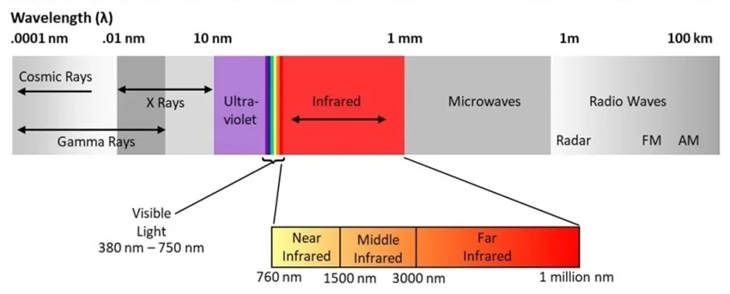
Figure 1 - Infrared Wavelength [18]

For IR data transfer to occur, a transmitter and receiver is required. The IR transmitter is used to convert electrical signals into modulated IR pulses, which can be used to transmit data or information. The receiver captures these signals and converts them back into an electrical signal completing the contactless data transfer [10]. Typically, an IR light emitting diode (LED) will be used for transmitting, whilst a photodiode or phototransistor is used as the receiver.
Within an IR tachometer, the transmitter and receiver are placed parallel to each other. The transmitter emits the signal towards the rotating components which in turn reflects the signal back to the receiver. Subsequently, the receiver produces the required output signal. By timing the periods between these signals, the RPM can be calculated.

IR Tachometer Advantages
When operating in optimal conditions, IR tachometers can be highly accurate, responsive and sustainable devices. They are able to provide the required contactless measurement, which not only reduces health and safety risks, but also eliminates factors such as slip and wear associated with traditional tachometers. They can be designed using simple electronic components and thus, can be manufactured and sold at relatively cheap prices.

IR Tachometer Disadvantages
The primary disadvantage to using IR technology is that it is highly sensitive to environmental interference and absorption. Factors such as sunlight, dust or water vapor will significantly reduce the operating capabilities of IR devices. Due to this, these tachometers have a relatively short-range and can be inaccurate should environmental conditions not be assessed before each measurement.
IR tachometers are optimally designed for applications within controlled testing environments. For this project, the designated motor testing facility remains clean and covered from direct sunlight. All equipment can easily be cleaned and stored correctly between uses. An IR design may therefore be suitable for this project.

Laser
Much like IR, lasers can be used to transmit data through light modulation. Lasers however emit coherent light which means it is produced in phase and travels in a straight line [11]. They also exist within the optical spectrum which means they are emitted at high frequencies and are therefore, less susceptible to interference. Because of these characteristics, lasers are produced at high intensity allowing them to transmit data over much longer distances.
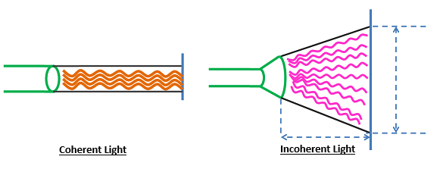
Figure 2 - Coherent vs Incoherent Light [21]

The physical construction of a laser tachometer and its operating principles are nearly identical to that of IR devices; the only difference being the light source used. Despite this seemingly small change, it has a significant effect on the operating characteristics of laser devices.

Laser Tachometer Advantages
As already discussed, the use of coherent light allows laser tachometers to operate over much greater distances compared to IR devices. The characteristics of coherent light allows lasers to travel across these extended distances without significant diminishing effects from environmental interference. The high frequency and precision of laser beams ensures that an accurate and reliable signal can still be transmitted in challenging environments where other optical technologies may struggle. As a result, in uncontrolled environments, lasers provide a significant advantage in terms of versatility and accuracy when compares to other optical tachometers.

Laser Tachometer Disadvantages
Despite their resilience, laser tachometers, as with all optical devices, can have their performance significantly reduced by environmental interference. In direct sunlight or particularly unkept workspaces, laser tachometers may still struggle to match the accuracy and reliability of mechanical alternatives.
Another disadvantage is the inherent health and safety risks associated with laser technologies. Without proper safety precautions, the high intensity of laser beams can cause serious and permanent visual impairment. This may require users to create risk assessments, provide additional personal protective equipment (PPE), and train their staff in the safe handling of lasers. These devices also tend to be relatively expensive compared to other technologies, primarily due to the increased costs of laser transmitters and their power consumption. They also require regular calibration, particularly positional, if operating at extended distances, which can lead to increased maintenance and process downtime. All of this may necessitate significant time and financial investment from a company just to integrate their use.
Overall, despite the advantages of laser technology, the inherit health and safety risks and financial considerations have been deemed too great for this project. Discussions with ERIKS determined that laser technology, combined with the design engineer’s relative inexperience of working with them, would pose too great a risk to the workshop from a health and safety prospective. The additional financial consideration would also push the project over the £100 budget specified in the PDS. For these reasons, laser technology will not be used.

Magnetic Tachometers
Magnetic tachometers use magnets and a sensor to measure the rotational speed of an object. Typically, a magnetic trigger is attached the rotating object that, with each rotation, causes a change in magnetic field around the sensor. This in turn generates the output signal used to calculate RPM. The most common form of magnetic tachometers, utilise Hall effect sensors [1].

Hall Effect Explained
The physics of the Hall effect can easily be conceptualised using Figure 3 shown below.
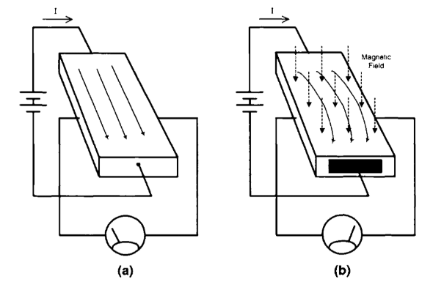
Figure 3 - Hall Effect Physics [22]

The left-hand image shows a thin conductive material connected across its length to the terminals of a battery. A voltmeter is then connected across its width. When a voltage is applied, current flows in a straight line from one side of the material to the other. Subsequently, the voltmeter shows zero volts [12].
However, if a magnetic field is applied perpendicular to the flow of current as shown in the right-hand image, charged particles, such as electrons, move to one side of the conductive plate due to Lorentz force. Lorentz force is defined as “the force which is exerted by a magnetic field on a moving electric charge” [13]. As the charge particles move to one side of the plate, a potential difference is created across its width. This in turn produces a small voltage known as Hall voltage [12].
The Hall voltage is directly proportional to the strength of the magnetic field applied, the amount of current flowing and the properties of the conductor being used. This entire phenomenon is known as the Hall effect.

Hall Effect Tachometer
Using these principles, tachometers can be designed using Hall effect sensors. Within these sensors, a permanent magnet is used to create the Hall effect across a semiconductor material. The Hall voltage induced is then calibrated as the default reading from the sensors under normal conditions.
When a metallic object interacts with this permanent magnet, the magnetic field changes and thus the output Hall voltage fluctuates. The rotating component can therefore act as a trigger to generate an output signal. A microcontroller can be programmed to count these fluctuations in Hall voltage to determine the RPM. Figure 4 highlights this operation using a sprocket.
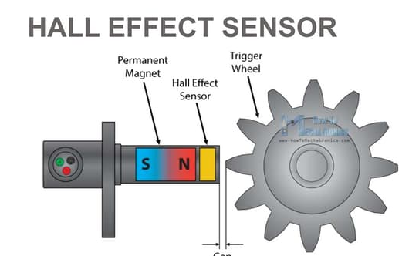
Figure 4 - Hall Effect Sensor

Hall Effect Tachometer Advantages
Much like optical tachometers, Hall effect devices provide the contactless measurement desired for this project. They are also highly accurate and eliminate slippage or mechanical inaccuracies associated with traditional devices. Hall effect tachometers can also be relatively compact and require minimal maintenance once in operation.
Arguably the greatest benefit to using Hall effect tachometers is the versatility and durability that they can provide. They are optimally designed to work in adverse conditions and do not suffer the environmental interference issues linked to optical devices. Because of these characteristics, Hall effect tachometers are commonly found within car engines to measure the rise and fall of pistons to determine vehicle speed.

Hall Effect Tachometer Disadvantages
Whilst Hall effect tachometers are incredibly resistant to environmental interference, they are greatly affected by magnetic interference. As this project requires a tachometer to be used in the proximity of large motors and variable frequency drives, it is highly likely that accuracy and reliability of any Hall effect device would be significantly diminished.
Additionally, given that motor shafts are cylindrical, a Hall effect tachometer would necessitate the attachment of a magnetic trigger to the rotating shaft for proper operation. Considering that this project outlines a measurement range of up to 12000 RPM, it is evident that any component fixed to the shaft could pose a significant safety risk, potentially becoming a dangerous projectile if it were to detach. For these reasons, it has been determined that a Hall effect tachometer will not be suitable for this project.

Chosen Contactless Method
Among the three researched contactless measurement techniques, both the laser and Hall effect options have been excluded from consideration due to unsuitability and safety concerns. Consequently, an infrared tachometer shall be designed for this project.

Literature Review of Major Components
With the method of contactless measurement selected, research can now be conducted into the key components necessary to supplement infrared technologies to create a complete tachometer device.

Battery Options

Lithium-Ion (Li-Ion)
Li-Ion batteries are rechargeable batteries that store energy through the movement of lithium ions between electrodes. This movement positively charges the anode of the battery through the creation of free electrons allowing a current to flow [2].
Li-Ion batteries provide a high energy density and low discharge rate which ensures a single charge can be maintained for an extended period. This high energy density also allows Li-Ion batteries to be relatively compact compared to other battery types making them ideal for use in small handheld devices.
These batteries are however sensitive to overcharging and overheating and required some form of control to operate safely and optimally [3].
Nickel-Metal Hydride (NiMH)
NiMH batteries are rechargeable components that store energy by utilising the electrochemical reaction between nickel oxide and a hydrogen absorbing alloy. During charging, hydrogen ions are release and absorbed by the alloy, storing energy within the battery [2]. Generally, the internal structure, rechargeability and absence of toxic materials from NiMH batteries provide an eco-friendly alternative to other battery types.
These batteries have good energy density although, have a higher discharge rate compared to Li-Ion equivalents. This makes them ideally suited to high-drain applications where high energy output is prioritised over battery charge longevity [2].
NiMH batteries also require special charging modules due to their internal chemistry meaning that NiMH batteries tend to be specific to application and cannot be interchanged between devices. Additional costs may therefore need to be considered.
Alkaline
Alkaline batteries are non-rechargeable components that generate power through the electrochemical reaction between zinc and a type of metal oxide. These batteries are commonly used across the world due to their widespread availability and affordability.
Unlike their rechargeable equivalents, alkaline batteries have relatively poor energy densities, which means they need to be replaced more frequently and are unsuitable for high-drain applications. Additionally, the continuous replacement of these batteries can lead to significant electronic waste being created through their use. Due to their electrical characteristics, alkaline batteries should be used in low-powered devices that are infrequently used or that are only used for brief durations.

Advantages and Disadvantages of Battery Types
Table 1 - Advantages and Disadvantages of Battery Types

Battery Type | Advantages | Disadvantages
Li-Ion | - Rechargeable  - High energy density  - Low discharge rate  - Compact | - Expensive  - Charging control required
NiMH | - Rechargeable  - Good energy density  - Eco-friendly | - Poor discharge characteristics  - Requires special charging module
Alkaline | - Widley available  - Cheap  - Long shelf life | - Poor discharge characteristics  - Non-rechargeable  - Unsustainable

Display Options

16 x 2 Liquid Crystal Display (LCD)
An LCD uses liquid crystals to either block or allow light to pass through a backlit screen to create characters or symbols. These liquid crystals are polarised and positioned by electrical signals sent via the data and control pins. A 16x2 LCD will allow for 16 characters to be displayed on each of its 2 available rows. This means that 32 total characters will be able to be displayed. LCDs are incredibly energy efficient and easy to control using a microcontroller. The pin requirements for a 16x2 LCD are shown in Table 2.

Table 2 - LCD Pin Requirements for a Microcontroller

LCD Pin Requirements for a Microcontroller
Data Pins | 4 - Data1, Data2, Data3 & Data4
Control Pins | 3 – RS, RW & E
Power Pins | 2 – VCC & GND

Organic Light Emitting Diode (OLED)
Each pixel in an OLED display is made up of three elements corresponding to each of the primary colours. These elements are individually controlled by electrical currents to create a specific colour within the pixel. Through correct interfacing, OLEDs cannot only be used to display characters and symbols, but also coloured images.
A typical 128x64 OLED display contains a total of 8192 pixels which can be controlled individually. Because of this flexibility, OLED displays provide a significant advantage over LCDs in terms general picture quality and resolution. Whilst OLEDs can be used for simplistic tasks, their energy efficiency and power consumption are higher than that of an LCD.
To connect an OLED display to a microcontroller, I²C or SPI protocols must be used. This necessitates the development of more complex software, which in turn can increase the microcontroller's requirements regarding clock frequency and protocol capabilities.
Table 3 - OLED Pin Requirements for a Microcontroller
OLED Pin Requirements for a Microcontroller
Data Pins | 2 – SDA & SCL (I²C) or MOSI & SCK (SPI)
Control Pins | 1 – Reset (I²C) or Chip Select (SPI)
Power Pins | 2 – VCC & GND

Microcontroller
The microcontroller within this tachometer will act as the central processing unit (CPU) of the device. It will centralise all component communications, interpret and modify data through internal software and provide output signals to the chosen display for projection.
As the required pin count and software size is as yet unknown, a specific microcontroller cannot be selected at this point of the design. Despite this, there are two key microcontroller features that will need to be researched for this project.

Capture/Compare/Pulse Width Modulation (CCP)
The CCP module is an integrated feature found in certain microcontrollers. The capture function specifically will be useful for the timing and measurement requirements of this project.
The capture function can be programmed to record the time at which a specific event occurs. This is particularly useful for measuring signal frequencies or timing intervals between a specified sequence of signals. The fundamental operation of the capture function for this project is detailed below [14]:
- Event Triggering
The capture function will be programmed to trigger on the rising edge (RE) of an input signal. This signal will be fed directly into the CCPx pin specified for the chosen microcontroller.
- Timer Control
For RPM to be calculated, the time periods between the RE of consecutive signals shall be measured. Each CCP module will have a designated timer assigned to its operation which will be configured during program initialisation.
- Data Storage
When an event occurs, the CCP module captures the current value of the assigned timer and stores it in a register. This data can be recalled for processing that will allow the microcontroller to calculate RPM.
- Interrupt Generation
During program initialisation, CCP interrupts will be enabled which will allow the microcontroller to respond immediately to an event trigger using an interrupt service routine (ISR). This feature will improve system responsiveness and will minimise timing delays in real-time applications.
- Timer Reset
Once CCP data has been processed, the program should be written to reset the associated timer. This will allow the CCP routine to restart accurately and to continuously monitor the input signals.
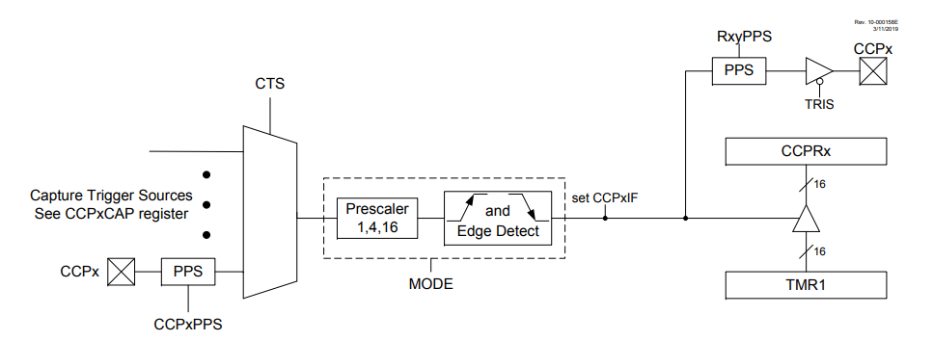
By utilising the CCP, this project will calculate RPM based on the intervals between two detected signals. Since microcontrollers can measure extremely small time intervals, this method of RPM measurement will offer excellent resolution. A block diagram highlighting the flow of operations within a CCP module is shown below in Figure 5.
Figure 5 - Operational Block Diagram for a CCP [52]

Timer Prescaler
Microcontrollers operate at high clock frequencies, which can make it challenging to generate longer time delays or to measure extended time intervals accurately due to timer overflow.
Overflow refers to the rate at which a timer counts from zero to its maximum bit rate value before resetting [4]. For example, an 8-bit timer can count from 0-255 before it overflows and resets to zero. Depending on the clock frequency of the microcontroller, overflow will occur at different rates. The following example highlights how the overflow is calculated for a 16-bit timer using a 4MHz clock frequency.

$$Timer Increment= \frac{1}{Clock Frequency}= \frac{1}{4000000}=250ns$$

In this example, the timer will increment by a value of 1 every 250ns. As a 16-bit timer has a range of 65536 values, the overflow can be calculated.

$$Overflow=Timer Increment ×Timer Bit Range=250ns ×65536=16.38ms$$

Using this data, the minimum frequency at which the timer could accurately measure a signal can be determined.

$$Minimum Singal Frequency= \frac{1}{Overflow}= \frac{1}{16.38ms}=61Hz$$

In this instance, if a signal was being measured that had an input frequency less than 61Hz, the timer would overflow between pulses resulting in timing errors in the final calculations. To overcome this problem, timer prescalers can be used.
A prescaler divides the input clock frequency before it reaches the timer, effectively slowing down the timer's counting rate [4]. Common prescaler values include 2, 4, 8 and 16 although higher specification microcontrollers can have significantly higher values. If these prescalers where assigned to the above example, the following results would be observed.
Table 4 - Prescaler Effect on Timers
Prescaler | 2 | 4 | 8 | 16
Timer Increment | 500ns | 1000ns | 2µs | 4µs
Overflow | 32.76ms | 65.52ms | 131.04ms | 262.14ms
Minimum Signal Frequency | 61Hz | 30.5Hz | 7.63Hz | 3.81Hz

It can be seen that timer prescalers will have a significant impact on the measurement range and accuracy capabilities of a microcontroller. This research has highlighted the importance of using prescalers within this design and that a minimum 16-bit CCP timer will be required to provide accurate readings. It has also shown that a lower clock frequency for the microcontroller will be beneficial to reduce errors caused by overflow.

Development Methodology

Hardware Acquisition
To meet the sustainability objectives of this project, all hardware will be sourced from reputable vendors located within the UK where available. This approach not only minimises transportation needs, thereby reducing carbon emissions, but also ensures that high-quality components are received that meet project standards for durability and performance.

Software Selection
Throughout this project, several software packages will be used for various applications. Table 5 below details which software will be used and for which purpose.

Table 5 - Project Software Requirements
Software Package | Application
Proteus | Proteus will be utilised for schematic design and to assist in the software development of the device. It will also simulate the device's operation, ensuring that it functions correctly prior to implementation.
CCS C Compiler | CCS C Complier will be use for the initial setup of the chosen microcontroller prior to its software being developed.
MPLab IPE | MPLab IPE will be used to program the microcontroller with the designed device software.
Easy-PC | Easy-PC will be used to design a compact PCB for this device, interconnecting all major components.

Experimental & Evaluation Method

Software Evaluation Method
To assess the software developed for the tachometer, a simulation will be created using Proteus. This simulation will integrate the programmed microcontroller with the selected display and will vary the input to the CCP pin according to a known frequency. These inputs will correspond to ideal RPM values, allowing for a comparison of the displayed results against known values.
Using Microsoft Excel, analysis into the tachometer accuracy, range and resolution will be conducted at multiple frequencies, highlighting overall operational trends of the device.

Hardware Evaluation Method
Once a prototype tachometer is constructed, the ERIKS motor testing facility will be used for device evaluation. Over the course of a week, the prototype will be tested alongside a calibrated tachometer to measure the speeds of various motors. Data will be collected on the rated motor speed, the calibrated RPM readings, and the RPM detected by the prototype.
Similarly to the software analysis, these results will be entered into Microsoft Excel to assess the accuracy of the prototype in comparison to the calibrated tachometer. Additionally, feedback will be requested from the ERIKS test engineers regarding the device's ease of use, any issues encountered, and potential areas for future improvement.

Design & Implementation

Component Selection

Battery Selection
To fulfil the sustainability requirements of this project, it has been determined that a re-chargeable Li-ion battery shall be used. This will reduce electrical waste created through disposable battery usage and provide the user with a highly efficient means of powering the device.
Li-ion batteries are desired for their high energy density properties which allow them to store relatively large amounts of energy in a compact and light weight housing. They are also extremely energy efficient providing a low discharge rate compared to other battery types [14]. As a result of these qualities Li-ion batteries have become a staple component of modern handheld devices.
For this project, it has been determined that a LP883048 from LiPol Battery LTD [15] shall be used to power the tachometer.

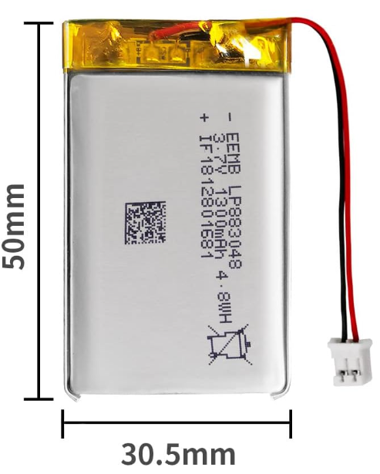
Figure 6 - LP883048 Li-Ion Battery [18]

In addition to providing the desirable characteristics described for a Li-ion battery, the LB883028 has been selected due to its 3.7V supply and extended 1300mAH charge capacity. The 3.7V supply will ensure that this battery is compatible with a wide range of electronic components including microcontrollers, display devices and external modules that may be required for this build.
The 1300mAH capacity has been selected as a quality-of-life benefit for users of this device. This will allow the tachometer to be operational for extended periods without the need for frequent re-charging.

Charing Module
To facilitate the charging of the Li-ion battery, a USB-C charging module shall be used. These modules allow Li-ion batteries to be charged via any USB power source including computer ports, wall adapters and power banks making them a versatile solution for modern devices.
In December of 2024, a new European directive was introduced to standardise the use of USB-C charging ports across all new electronic devices. Its primary aim is to standardise the design of all charging ports, reducing the need for multiple charging devices to ultimately contribute to a more sustainable electronic ecosystem [16].
To maintain the sustainability targets of this project, this new USB-C directive shall be adhered to. For this project, the 3.7V TP4056 charging module from AZ-Delivery will be used [17].
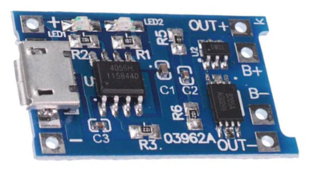
Figure 7 - AZ-Delivery TP4056 Charging Module [19]

This module utilises a 4056 integrated circuit (IC) for charging operations. The 4056 IC was specifically designed to control the charging function of Li-ion batteries. It is powered via a standard 5V USB-C connection and regulates the voltage to either a 5V or 3.7V output [17]. In conjunction with the rest of the module, it provides over-voltage, over-charge and thermal protection to the battery.
As shown in Figure 7, the module provides easy connections for both the battery during charging and for external circuitry during devices operation. This small design feature will simplify the connection requirements for this device.

Display Selection
The sole purpose of the display for this device will be to show the real time RPM of a motor. There will be no interfacing or additional requirements for this display. Due to this simplicity, a 16x2 LCD will be used for this project.
As most LCDs require a 5V supply, research was conducted to find an LCD that would be compatible with the 3.7V supplied by the chosen Li-Ion battery. Through this research, the HD44780 16x2 LCD from AZ-Delivery was identified [18].This LCD has an operating range of 3.3 to 5V, has a compact 80 x 36 x 12.5mm model and provides the standard I/O pins required for operation and C-programming.
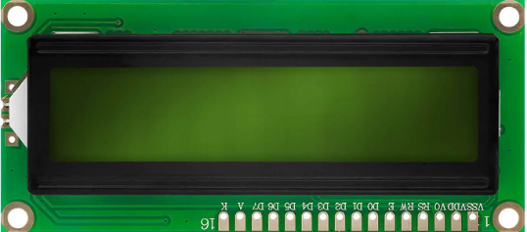
Figure 8 - AZ-Delivery 16x2 LCD [20]

Infrared Module
Whilst researching IR components for the sensing function of this project, several prebuilt modules were found. These modules were all compact in design, had proven operation and were relatively cheap compared to purchasing all require components. By utilising one of these modules, project build time could be reduced, PCB design simplified, and overall project cost minimised. For these reasons, a 3.3V IR module from AZ-Delivery [5] was selected.
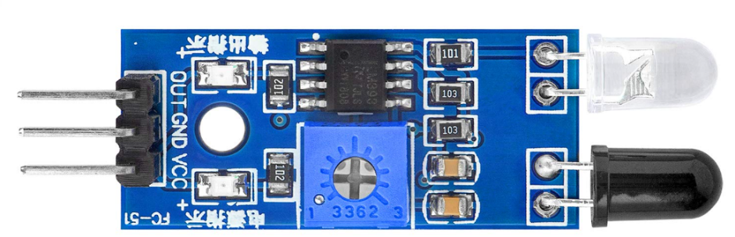
Figure 9 - AZ-Delivery IR Proximity Sensor [21]

This module contains an IR LED and photodiode pair, a comparator and a potentiometer as its primary components. To better understanding its operation, the circuitry of the module was reverse engineered to create the circuit shown below.
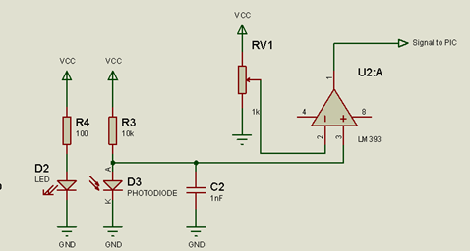
Figure 10 - IR Module Schematic

AZ-Delivery IR Module Operation
The IR LED transmits a signal directed towards a rotating object which is reflected back to the IR photodiode. The photodiode is connected to the non-inverting input of a comparator, whilst the inverting input is linked to a potentiometer, allowing for voltage adjustment proportional to the desired sensing distance.
When the photodiode does not detect any IR light, it remains non-conductive, causing the supply voltage to appear at the non-inverting input. As a result, the output of the comparator remains high. However, when the photodiode detects a signal, it becomes conductive, decreasing the voltage at the non-inverting input. This creates a voltage difference between the inputs of the comparator, leading to a change in output signal.

Microcontroller
With the major components selected, specifications for the microcontroller can now be defined. It is known from the research that a CCP module with a 16-bit timer will be required for processing input signals. Research into timer overflow also suggested that a lower microcontroller clock frequency may be beneficial for this application.
From the selected major components, a minimum pin count requirement can also be determined as shown below in Table 6.
Table 6 - Microcontroller Pin Count Requirement
Required Microcontroller Pin Count
Power | VCC, VDD, Mclear | 3
LCD | RS, RW, E, Data 4-7 | 7
IR Module | Signal Output | 1
Total Pins - 11

The selected microcontroller needs to have adequate flash memory and static random-access memory (SRAM) to support this project. The flash memory will serve as permanent storage for the operational software, while the SRAM will be used for temporary storage of CCP and calculation data. Given that the project code is expected to remain under two thousand characters, a flash memory capacity of 2kB should be adequate. Due to the relatively simple calculation requirements, a minimum 256 bytes of SRAM should also be looked for.
Using these specifications and the Microchip advanced selection tool [6], microcontrollers can be found that meet design requirements. Of the filtered microcontrollers, the PIC16F87 [7] emerged as the most suitable choice for this project.

PIC16F87 Microcontroller [7]
The PIC16F87 is an 18pin, 8-bit microcontroller with a 20MHz internal clock, CCP module and two 16-bit internal timers. It has 7kB of flash memory and 368bytes of SRAM that will be more than sufficient for this project.
Whilst the clock frequency is much higher than wanted, the software can be written to reduce clock rate during operation. For this project, an initial clock frequency of 4MHz will be programmed for simulation and testing. In addition, the plastic duel in-line package (PDIP) shall be used for easier assembly to the designed PCB.
This microcontroller was selected over other suitable choices for several reasons.
- It is readily available in the UK and is more affordable than other options.
- This is one of only 23 available 18-pin packages that meet the required specifications, which will help minimise the PCB size.
- It offers scalability for future upgrades due to its enhanced specifications.
- The PIC16F87 is also compatible with the simulation and software programs specified for this project.
- Its wide operating voltage range of 2 to 5.5V ensures compatibility with the selected power supply and other components
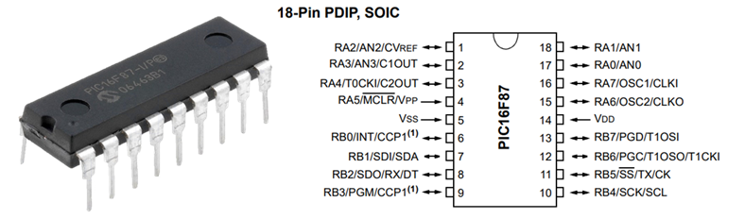
Figure 11 - PIC16F87 Microcontroller [7]

Wire to Board Connectors
For wire-to-board connections to the PCB, Molex connectors will be used. Molex connectors use male and female connectors to securely hold wire-to-board connections via a mechanical clip. This provides a durable connection designed to withstand mechanical and vibration stresses common with handheld devices. These are also available in many different configurations depending on the required application. The ability to remove these connectors easily will also allow for easier maintenance and fault finding of the device.

The Molex connectors to be used for this design are outline below in Table 7.
Table 7 - Chosen Molex Connectors

Molex Product ID | Pin Count | Application
0022232101 [8] | 10 | LCD
0022013107 [9] | 10 | LCD
0022272031 [10] | 3 | IR module
0022013037 [11] | 3 | IR module
0022272021 [12] | 2 | Power
0022013027 [13] | 2 | Power
0008500113 [14] | Per wire connection | Wire crimp connection

Circuit Design
Before the final circuit can be finalised there are two critical elements that will need designing in the form of overvoltage protection and a low pass filter (LPF).

Overvoltage Protection
Overvoltage protection is crucial for microcontroller circuits as it safeguards sensitive components from damage caused by spiking voltage levels. To ensure the reliability and proper functionality of an electronic circuit, some form of overvoltage protection will be required. As a 3.7V battery has been selected for this project, overvoltage protection will be provided using a 3.7V Zener diode connected across the load.
A Zener diode is designed to allow current to flow in reverse bias only when a designate breakdown voltage has been exceeded. If a Zener diode is connected across the load, the load voltage will be clamped to that designated breakdown voltage. When conducting, any excess voltage is diverted through the Zener diode, protecting the load. Operating under normal voltage conditions, the breakdown voltage is not exceeded, and the diode will not conduct [14].
To create this protection circuit, a Zener diode and low impedance resistor configuration has been designed as shown in Figure 12. Excess voltage will be dropped across this resistor in overvoltage situations.

Figure 12 - Overvoltage Protection Circuit

LPF Circuit
A LPF will be used to prevent tested motors and connected variable frequency drives from introducing electrical interference into the signal line of the tachometer. To achieve this, a simple passive LPF can be designed using a capacitor and resistor.
To determine the cut off frequency required, the below calculation was used to convert the maximum RPM value of 12000 to signals per second.

$$Maximum Signal Frequency=\frac{12000}{60}=200Hz$$

Whilst initially it would seem correct to therefore use 200Hz as the cut off frequency, attenuation of the output signal needs to be considered. Attenuation in a LPF refers to the reduction in amplitude of a signal as it approaches the designated cut-off frequency [14]. This can result in a very weak output signal that may not be detectable by the microcontroller.
To eliminate this concern, the cut-of frequency can be raised to a level where the signal attenuation at 200Hz is minimal. As the primary purpose of this LPF is to eliminate high frequency noise from the motor drive, i.e.,>1kHz, the LPF can confidently be redesigned with a cut-off frequency of 300Hz without significantly diminishing its primary objective.
If a 10Ω resistor is assumed to prevent significant voltage drop across the LPF, the required value of the capacitor can be calculated as shown.

$$Capacitance =\frac{1}{2π×Fc ×R}= \frac{1}{2π×300 ×10}=53µF$$

Using this value, the closest standard sized capacitor to this was found at 47µF which will be used for this design. The 300Hz LPF created using these components can be seen in Figure 13 below.

Figure 13 – Designed 300Hz Low Pass Filter

Tachometer Circuit Design
With the individual sections of this project designed, using Proteus software, the complete circuit schematic was created. For the signal input to the microcontroller, the datasheet was referenced [7] to find the correct CCP1 pin assigned to RB0. The final schematic design for this project is shown in Figure 14 found on the following page.

Complete Tachometer Schematic

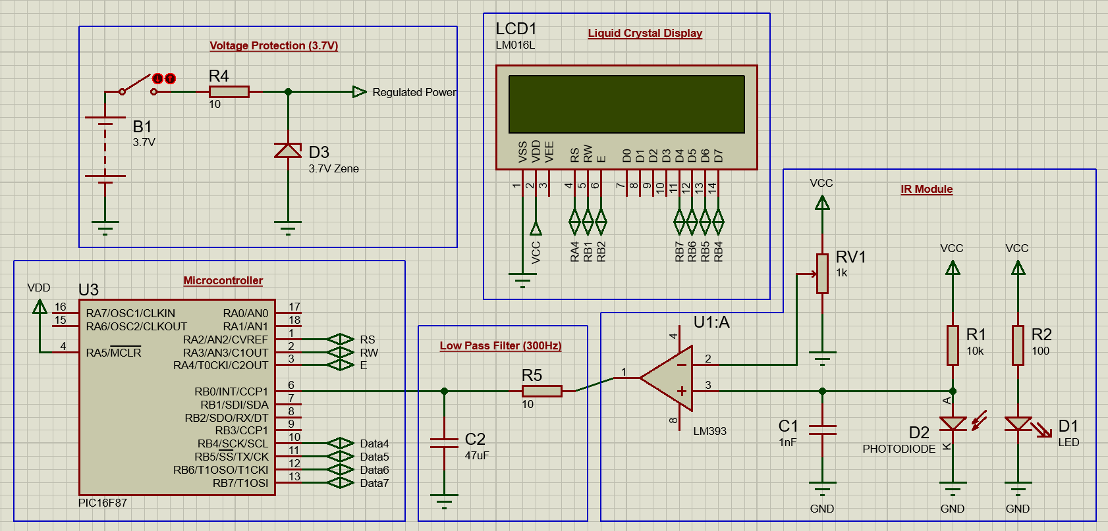
Figure 14 - Complete Tachometer Schematic

Software Design
Before designing the PCB or building the prototype for this project, it is important to firstly prove the function of the designed circuit. To achieve this, the software required for the microcontroller needs to be written. This was done using CCS C Complier and Proteus.

CCS C Compiler – Microcontroller Setup
CCS C Compiler allows the user to set the parameters for the chosen microcontroller and provides example codes for initialisation. Once complete, the header and driver files created can be transferred to Proteus to write the program and run simulations.
Using the Project Wizard of CCS C Compiler, the PIC16F87 was setup using the parameters outlined in Table 8.
Table 8 – Microcontroller Parameter Setup
PIC16F87 Parameter Setup
Clock Frequency | 4MHz
CCP | CCP1 enabled
CCP Trigger | Rising edge
CCP Timer 1 Prescaler | Prescaler of 4 – 262ms overflow
Interrupts | Global and CCP interrupts enabled
External LCD | Enabled
LCD Pin Assignment | RS to RA2
LCD Pin Assignment | RW to RA3
LCD Pin Assignment | E to RA4
LCD Pin Assignment | D4 to RB7
LCD Pin Assignment | D5 to RB6
LCD Pin Assignment | D6 to RB5
LCD Pin Assignment | D7 to RB4
Advanced Options | Fuses included
Advanced Options | Master Clear pin enabled
Advanced Options | Reset on brownout enabled

Clock Frequency & Prescaler:
To minimise timer overflow issues, the clock frequency for the PIC16F87 was reduced from 20MHz to 4MHz. This increased the base overflow of Timer 1 from 13.1ms to 65.5ms. By setting a prescaler of 4, this was further increased to 262ms providing a minimum RPM measurement of 229 as shown in the following calculations.

$$Minimum Singal Frequency= \frac{1}{Overflow}= \frac{1}{262ms}=3.82Hz$$

$$Minimum Measurable RPM= Singla Frequency ×60 seconds=229.2 RPM$$

Whilst this minimum RPM value does not meet the initial design specifications, it does meet the requirements for the slowest speed motor typically tested at the ERIKS facility. These motors are 50Hz, 16-pole machines that have a synchronous speed of 375RPM. By communicating this information to the company, it was deemed acceptable to continue this project with a modified RPM range of 300 to 12000 RPM.

CCP & Interrupts
CCP1 was enabled and set up to trigger on the rising edge of each signal input. This will allow the period between signals to be calculated for RPM measurements. CCP and global interrupts were also enabled to facilitate immediate response to CCP events. This is critical for real time applications such as for this project.

LCD
The PIC16F87 was programmed to operate with an external LCD. All connections were then defined to allow for correct operation. Control pins where set to port A whilst data pins set to port B. This pin arrangement was selected for easier tracking of the connections during the PCB design.

Proteus – Software Design & Simulation
Once the setup of the microcontroller was complete, the CCS C Compiler files were transferred over to a Proteus simulation built around a PIC16F87. This allowed the project software to be written.
Before starting the software, a simple simulation was created in order to test the function of the written program as seen below in Figure 15.
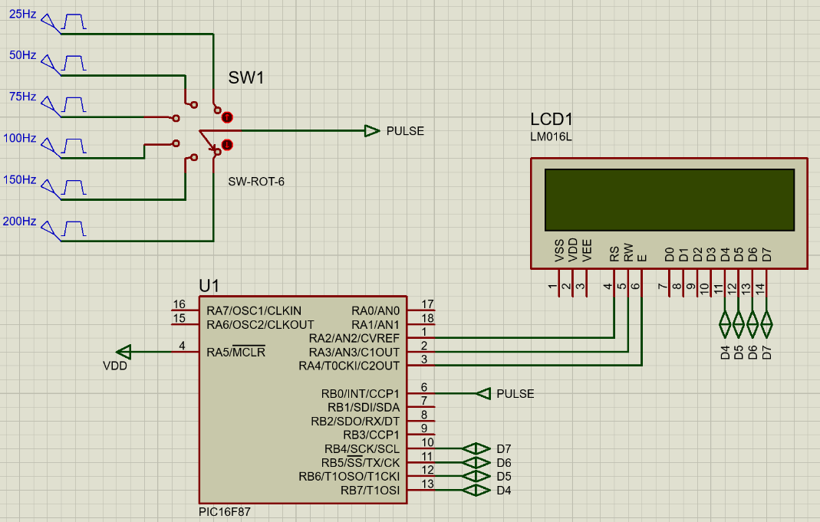
Figure 15 - Tachometer Test Simulation

This simulation utilises a 6-pole switch connected to known frequency pulse generators. By adjusting the signal frequency, the program will be able to be tested against a range of known RPM values. The known RPM values are shown in Table 9.
Table 9 – Signal Frequency to RPM Conversion

Signal Frequency | Conversion | Equivalent Project RPM
25 | x60 Seconds | 1500
50 | x60 Seconds | 3000
75 | x60 Seconds | 4500
100 | x60 Seconds | 6000
150 | x60 Seconds | 9000
200 | x60 Seconds | 12000

Tachometer Software
With the microcontroller setup and a simulation created for testing, the tachometer software was then written. The completed program can be seen in appendix 3 of this report. The designed software can be broken down into five sections:
- Software Setup
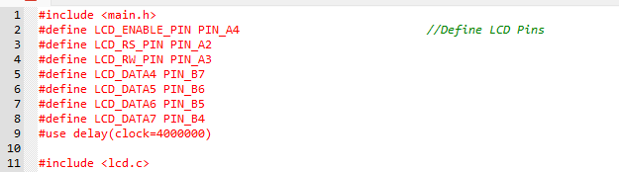
Figure 16 - Software Setup

This section introduces all of the parameters outlined in CCS C Complier for the microcontroller setup. The header file ‘main.h’ contains most of this information with the driver file ‘lcd.c’ used for LCD operation. The LCD to microcontroller connections are also defined for correct interfacing.
- Variable Definition
The two variables used within this program are defined here with their initial values set to 0. ‘Signal_Interval’ is used to call data from the CCP for calculations whilst ‘RPM’ is used to store the calculated RPM value for writing to the LCD.
Figure 17 - Software Variable Definition

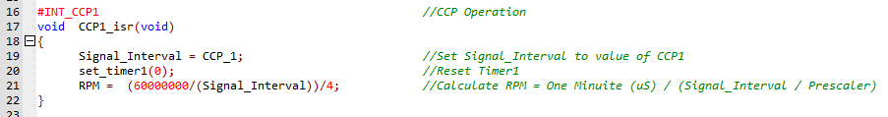
- CCP1 Interrupt Service Routine (ISR)
Figure 18 - Software CCP ISR

The CCP ISR defines how the software should act once the rising edge of a signal is detected. Initially, the value of CCP1 is stored to the variable ‘Signal_Interval’ before Timer 1 is immediately reset. This prevents timing errors within the next measurement. The calculation required for RPM conversion is then performed using the below calculation.

$$RPM=\left(\frac{One Minutie \left(µS\right)}{Period Between Signals}\right)÷Prescaler Value$$

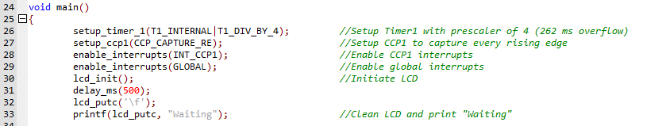
- Main Function
Figure 19 - Software Main Function

The main function initialises the necessary parameters for this program. Timer 1 is configured with a prescaler of 4, and CCP1 is set to capture mode, triggering on the rising edge of each signal. Both global and CCP interrupts are enabled prior to initialising the LCD, which is then set to display ‘Waiting’ until an RPM value is detected.
- Main Loop
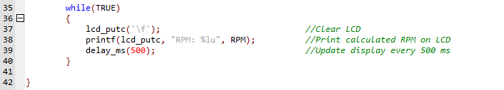
Figure 20 - Software Main Loop

The main loop is simply used to display the RPM value on the LCD. The LCD is firstly cleared before the integer value of RPM is printed to the display. A 500ms delay is placed at the end of this loop ensuring the LCD only updates every 0.5 seconds.
After completing the software, simulation testing was conducted to verify the program’s functionality before implementing the design. A comprehensive evaluation of this testing can be found in Section 6.1: Software Evaluation.

PCB Design
With a functional circuit simulation and software, prototyping of the device could now be considered. A key component of this prototype will be the PCB which will be used connected the components of this device.
To design the PCB, Easy-PC was used. From the initial Proteus schematic previously shown in Figure 14, only the voltage protection, LPF and microcontroller will need to be directly integrated into the PCB. The LCD, IR module and power pins will be connected to the PCB via Molex connectors.
0.1µF decoupling capacitors will be placed close to the power pins of the microcontroller, LCD and IR module. These capacitors will provide a low impedance path for any high frequency noise to be filtered through, producing a stable supply voltage.
Once the device schematic had been recreated in Easy-PC, the PCB design shown below in Figure 21 was created for the tachometer.
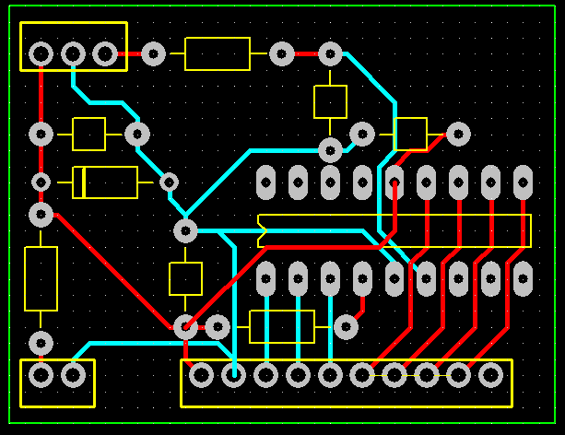
Figure 21 - Tachometer PCB Design

This PCB was compactly designed utilising both the top and bottom layers for efficient tracking of connections. After all connections were verified, the Gerber files were extracted and uploaded to JLCPCB [15] for production. 3D imaging of the designed PCB can be seen in Figure 22.

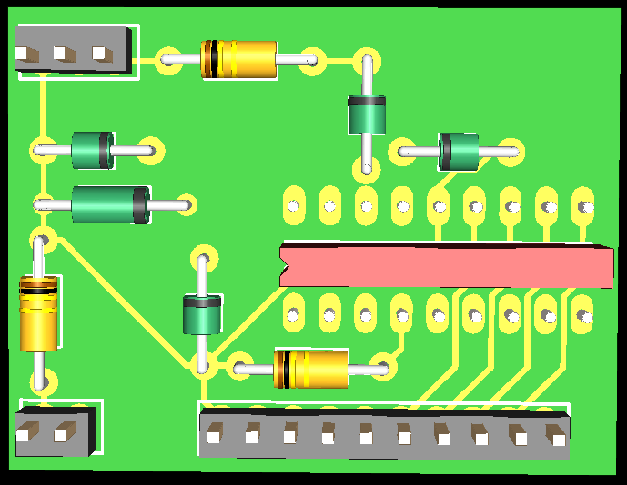
Figure 22 - 3D Simulated Image of Designed PCB

Design Implementation
With components selected, circuitry designed, and proof of concept provided by successful simulation, all components were ordered ready for assembly. A full budgetary breakdown of these costs can be found in appendix 1 of this report.

PCB Assembly
The PCB was the first module to be assembled as it contained all the interconnections between major components. Following the PCB design shown in Figure 21, each component was added to the blank PCB and soldered into place. The assembled PCB is shown in Figure 23 below.
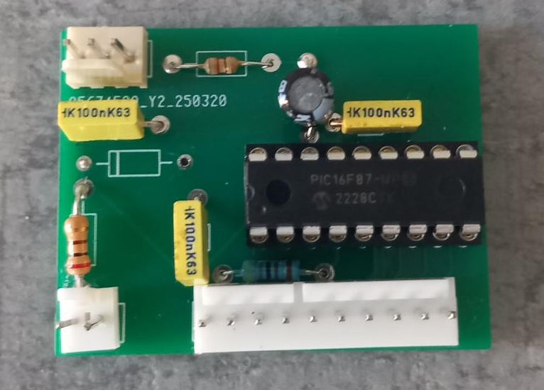
Figure 23 - Assembled PCB

LCD Assembly
The LCD simply required leads to be fitted with the 10 pin Molex connector crimped to the other end. Each pin on the LCD corresponds to a given microcontroller pin specified in the designed software. Before soldering, these connections were confirmed via the program and PCB design.
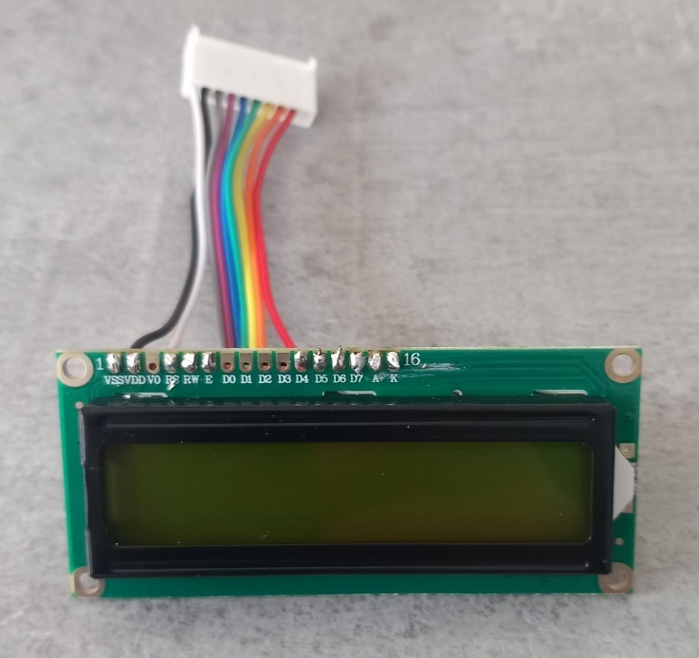
Figure 24 - LCD Assembly

IR Module Assembly
Similarly to the LCD, the IR module only needed leads and a Molex connector fitted ensuring correct connectivity to the PCB.
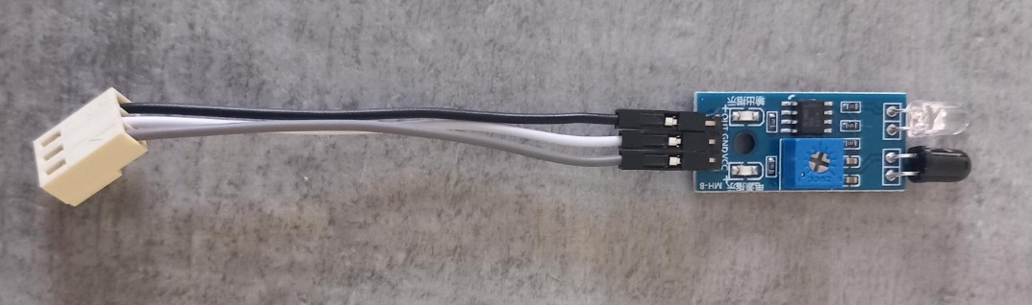
Figure 25 - IR Module Assembly

Battery and Charging Module Assembly
The TP4056 charging module offered straightforward connection instructions for the battery and device supply cables. The battery was directly connected to the charging module, with the positive output supply crimped to spade connectors for the switch. The opposite side of the switch was linked to a Molex connector for the positive supply, while the negative lead from the charging module was connected to the other side of the Molex connector.
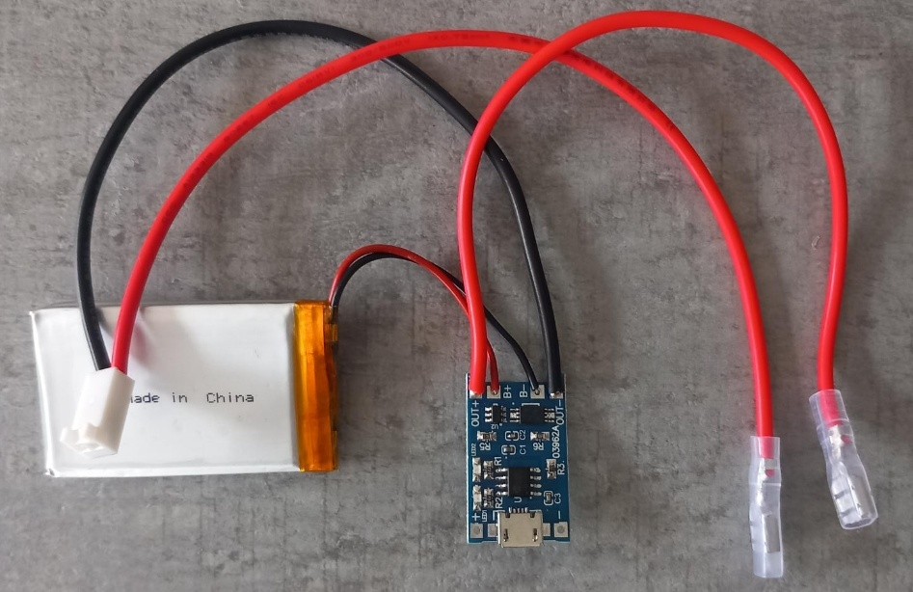
Figure 26 - Battery & Charging Module Assembly
Figure 27 - Battery & Charging Module Connections

Tachometer Housing
Once all module assemblies were complete, a tachometer case was required to securely house all components. For this, a 100 x 68 x 50mm, IP65 PVC junction box was used. This will provide water and dust ingress protection, sufficient space to securely house all components, and a robust case for applications within a workshop environment.

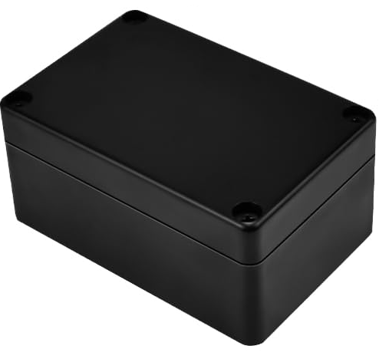
Figure 28 - PVC Junction Box

To ensure the LCD was visible and the IR module could operate, multiple entries were cut into the junction box. An additional entry was also created to accommodate the tachometer power switch as shown below in Figure 29.

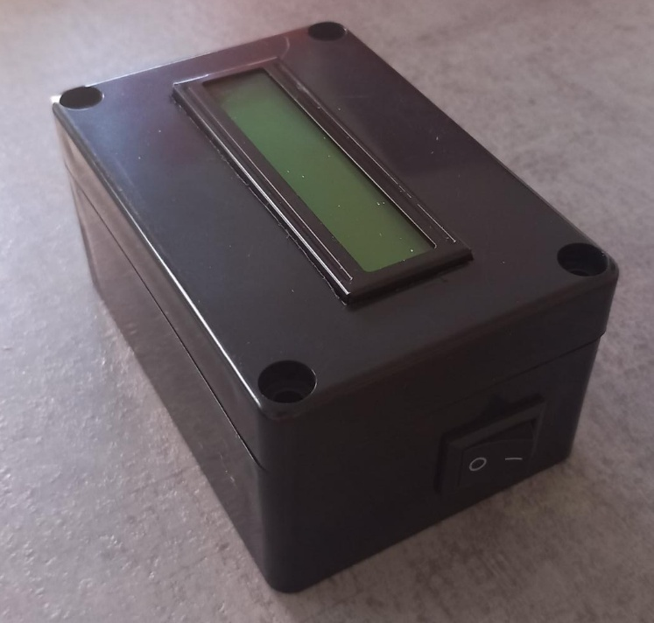
Figure 29 - Tachometer Case

Microcontroller Programming
The final task in the design implementation was to program the microcontroller with the developed tachometer software. This was accomplished using MPLab IPE and a PICKIT3 adapter [16].
Following the datasheets for both the microcontroller and the PICKIT3 adapter, the PIC16F87 was connected to a PC. The program hex file generated from Proteus was transferred to MPLab IPE and subsequently uploaded to the microcontroller. After inserting the microcontroller onto the PCB, the prototype tachometer was ready for testing.

Test Implementation
Before sending the prototype to ERIKS for testing, a simple test using the rotation of a drill was to be conducted as proof of function. Unfortunately, when turning on the device, it was noticed that the LCD was not displaying the ‘Waiting’ message programmed within the code. This indicated either a software problem with the LCD initialisation, or a hardware issue from connections or components. In an attempt to fault find this problem, the following steps were taken.

LCD Fault Finding
- Connection Verification
The first step was to thoroughly inspect all connections between the microcontroller and LCD. This involved verifying the component wiring, PCB tracking and connector continuity. After several inspections, no problems were identified, eliminating the possibility of connection error.

- Power Supply Check
Another obvious inspection was to ensure the LCD was supplied with the correct voltage of 3.3 to 5V specified in the LCD datasheet. Using a multimeter, voltage to the LCD was measured at 3.57V showing no supply issue.

- Contrast Adjustment
The contrast of the LCD was also adjusted using a potentiometer to determine if the message was being written to the display but was simply not visible. The potentiometer was connected to V0 on the LCD and varied throughout its full range. However, this adjustment did not resolve the issue.

- RW Pin Grounding
The Read/Write (RW) pin of the LCD was grounded as the software did not need to read from the LCD. This is a common practice to prevent any unintended read operations that could interfere with initialisation. However, this again did not resolve the issue.

- Basic "Hello World" Program
To isolate the problem further, a basic ‘Hello World’ program was implemented. This simple test is often used to verify that the LCD is initialising and can display output correctly. Unfortunately, the LCD remained unresponsive.

- Multiple Microcontrollers and LCDs
To rule out a basic hardware issue, multiple PIC16F87 microcontrollers and different LCDs where integrated into the prototype. The problem persisted across all components.

- Microcontroller Communication
In order to confirm a software issue, the device was turned on with an oscilloscope connected to the data pins for the LCD. The oscilloscope highlighted no activity across any of the output pins indicating that the LCD has not been properly initialised for operation.

- Initialisation Delay
To ensure the LCD was able to initialise correctly, a small delay was added to the software after initialisation. This delay is often necessary to allow the LCD to power up and become ready for communication. However, even with various delays (10ms up to 500ms), the LCD still was not functioning.

- Pin Configuration Changes
In certain microcontrollers, specific pins or ports require configuration within the software to be used as outputs. To ensure this wasn’t the case, the data and control pins to the LCD were manually set as outputs using the code shown in Figure 30. Even with this inclusion, the LCD still failed to display the required text.

Figure 30 - Manually Setting Microcontroller Output Pins

Despite all these efforts, the design engineer was unable to resolve the LCD issue within the project's designated timeframe. From this fault finding, it is believed that the LCD driver file generated from the CCS C Compiler may not be correctly configured for this practical application. Due to limited prior experience with modifying these files and the project's time constraints, the engineer will proceed with the project based on the existing simulation and software. A physical prototype will still be built, however it is unlikely to be fully operational for testing purposes.

Project Evaluation

Software Evaluation
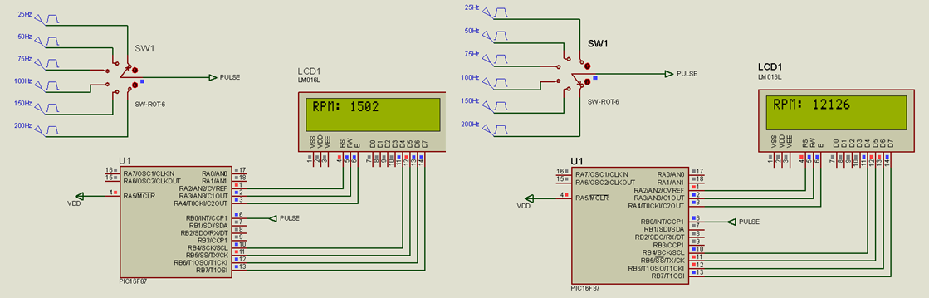
To evaluate the software, the Proteus simulation initially shown in Figure 15 was used. Whilst this setup is excellent for demonstrating the software operation, the 6-pole switch does not provide sufficient data for a comprehensive evaluation of the results.
Figure 31 - Operation of Software Simulation
Table 10 – Initial Simulation Software Results
Signal Frequency (Hz) | Ideal RPM | Simulated RPM | Accuracy (%)
25 | 1500 | 1502 | 99.87
50 | 3000 | 3008 | 99.73
75 | 4500 | 4519 | 99.58
100 | 6000 | 6033 | 99.45
150 | 9000 | 9079 | 99.13
200 | 12000 | 12133 | 98.90

To expand this dataset, the switch was held in a fixed position with the signal frequency manually adjusted in increments of 5Hz from 300 to 12000 RPM, covering the range requirements of this project. A comprehensive table of these results is included in appendix 4 of this report and should be referenced for the subsequent evaluation.

Accuracy
This software demonstrates an impressive accuracy, averaging 99.43% across the range scope of this project. The data shows that for lower frequencies (5 Hz to 15 Hz), the tachometer achieves perfect accuracy of 100%, demonstrating its capability to accurately measure low-speed applications.
An impressive accuracy above 99.50% is achieved for measurements up to 5400RPM, significantly above the nominal maximum RPM for 2-pole, 50Hz motors tested at ERIKS. This indicates that for the vast majority of motors tested, this software will be able to deliver high accuracy results.
As frequency increases, these results do show a slow decline in accuracy reducing from 100% at 300 RPM to 98.90% at 12000 RPM. Whilst still achieving a relatively high accuracy, this does indicate potential software inaccuracies as signal frequency increases. This may be improved by increasing the clock frequency of the microcontroller and therefore its processing speed, although this would run the risk of re-introducing overflow issues into timer operations. If this were implemented, it would be recommended that the prescaler for Timer 1 be increased from 4 to 8.
Another reason for this decline may be the absence of delays within the software. Introducing a brief delay (25ms) at the end of the ISR for CCP1 could reduce the processing demands on the software and provide better results at higher frequencies while still utilising the existing 4 MHz clock frequency.
Overall, the software demonstrates linear and high accuracy results that aligns with the design specifications of this project. Although there is a minor decrease in accuracy at higher frequencies, the software continues to perform very well across the range requirements for this tachometer.

Figure 32 – Ideal vs Simulated Software Results

Precision
To gauge the precision of this software, each signal frequency was measured three separate times. From the results highlighted in Figure 33, it can be seen that there is no deviation of any result across all tests indicating perfect software precision within simulation.

Figure 33 – Software Precision Results

Resolution
To evaluate the resolution capabilities of this software, the methodology used for the RPM calculation needs to be examined. The device utilises a CCP module within the microcontroller, which facilitates highly accurate measurement of very short signal intervals. Even at the maximum rotational speed of 12000 RPM, the combination of the chosen 4 MHz clock frequency and timer prescaler, provides sufficient temporal resolution [17] to measure time intervals down to the microsecond scale. Given this configuration, the software can reliably achieve a resolution of 1 RPM, aligning with the project’s specified requirements.

Range
For the purpose of this evaluation, the range of this device will be defined as the range within which the software is able to maintain the ±1% accuracy stated in the project specification.
From the initial dataset, it can be seen that at the lower tested limit of 300 RPM, this software provides 100% accurate results. Conversely, the higher limit within this range definition can be found at 10800 RPM where a 99% accuracy is achieved. To refine these findings, secondary testing was performed at 1Hz intervals near these boundaries to precisely determine the software's effective operational range shown below in Tables 11 and 12.

Table 11 - Low Range Boundary of Software
Signal Frequency (Hz) | Ideal RPM | Simulated RPM | Accuracy (%)
1 | 60 | 280 | 21.43%
2 | 120 | 252 | 47.62%
3 | 180 | 843 | 21.35%
4 | 240 | 240 | 100.00%
5 | 300 | 300 | 100.00%

Table 12 - High Range Boundary of Software
Signal Frequency (Hz) | Ideal RPM | Simulated RPM | Accuracy (%)
177 | 10620 | 10721 | 99.06%
178 | 10680 | 10783 | 99.04%
179 | 10740 | 10845 | 99.03%
180 | 10800 | 10909 | 99.00%
181 | 10860 | 10972 | 98.98%

From these secondary results, an operational range of 240 to 10800 RPM can be defined for this software. Although the lower limit of 240 RPM exceeds the product design specifications, the upper limit of 10800 RPM falls short of the requested maximum of 12000 RPM. Upon reviewing the accuracy analysis, it is evident that the software narrowly misses the 99% accuracy target at 12000 RPM, falling short by just 0.1%.

Software Structure
The software is clearly presented, concise, and easy to follow. Despite its simplicity, it functions as intended within Proteus, without simulation errors. By utilising the CCP1 ISR, the software responds immediately to signals, demonstrating excellent responsiveness. The overflow of Timer 1 was correctly calculated using an appropriate prescaler of 4, ensuring accurate measurements at lower RPMs. During the simulation, the software correctly initialises the LCD and displays the calculated RPM value without issues.
To improve this software, two ‘if’ statements could be incorporated within the main loop to prevent writing to the LCD when there is no change in RPM. Currently, the software repeatedly executes the main loop regardless of whether the RPM value has changed, which is inefficient and increases processing requirements. By implementing simple ‘if’ statement, the program could bypass the main loop when the RPM remains unchanged. This could be achieved by using a ‘flag’ variable to store the previous RPM value and comparing it with the current RPM before entering the main loop.

Software Conclusion
The evaluated software demonstrates a high level of accuracy, precision, and resolution, effectively meeting the project’s design specifications within its operational range. The simulation results indicate that the software can reliably measure RPM from approximately 240 to 10800, with an accuracy above 99% across this range. While a slight decline in accuracy occurs at higher speeds, potential improvements such as increasing the microcontroller’s clock frequency or incorporating software delays, could improve performance at the upper limits. The software’s clear structure and responsiveness further highlights its suitability for real-time RPM measurement. Overall, the software performs effectively within the specified parameters, with minor adjustments required to optimise its accuracy at the upper RPM limit.

Hardware Evaluation
Despite not being able to test a fully functional prototype, several aspects of the device’s hardware were still able to be evaluated.

Battery and Charging Module
The selected Li-Ion battery performs as expected providing a stable voltage of 3.7V to all connected components. During a five-hour testing period, it maintained an average voltage of 3.62V across the entire system, including the LCD, IR module, and microcontroller, demonstrating the efficiency of its 1300mAh capacity.
The charging module was straightforward to integrate, thanks to its simple setup, and successfully recharged the battery via its USB-C adapter. Overall, the combination of the chosen battery and charging module proved to be highly effective, making them an optimal selection for this project.
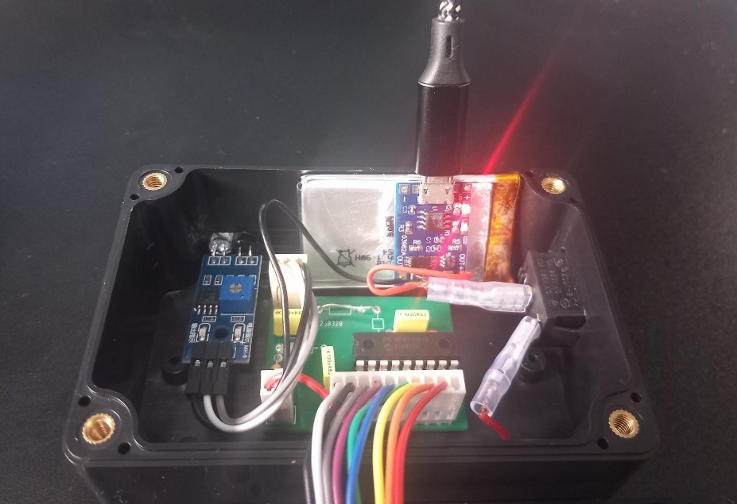
Figure 34 - USB Charging of Li-Ion Battery

IR Module
Although the measurement capability of the IR module could not be directly tested, several of its operational characteristics were observed, starting with its measurement distance. Using the basic setup shown in Figure 35 below and by varying the IR module’s potentiometer, the maximum operational distance of the device was established.
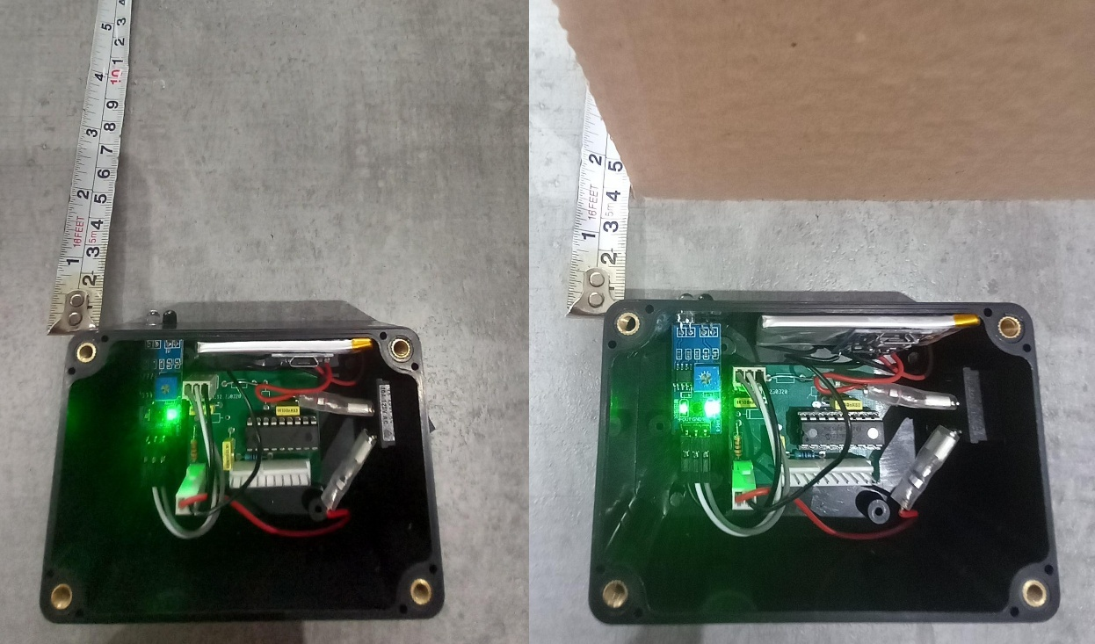
The IR module features two indicator LEDs: the right LED indicates power status, while the left LED activates when an object is detected. By slowly moving a piece of card toward the prototype, it was determined that the IR module functions effectively at a maximum distance of 45mm.
Figure 35 - Operational Distance Measurement

To evaluate how the IR module operates in high ambient light, the device was placed in direct sunlight and turned on. Consistent with previous research on optical devices, it was observed that strong ambient light completely inhibits the IR module’s functionality. The sunlight immediately activated the photodiode, placing the module into a continuously conductive state.
Although the ERIKS test facility is situated within a shaded area, the flexibility of the device would still benefit from future development of filtering or shielding solutions. Potential improvements may include implementing an optical bandpass filter or optical lens to mitigate light interference.

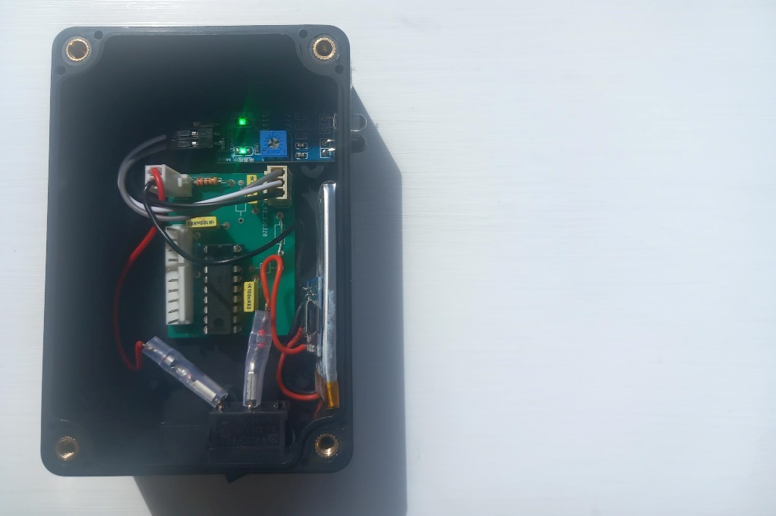
Figure 36 - Device Operation in High Ambient Light

Although unable to assess the module's performance via RPM measurement testing, the datasheet indicates that the module can operate at an output frequency of 400kHz [5]. This specification strongly suggests that the module would easily have been capable of meeting the requirements for this project, even at the higher end of 12000 RPM (200Hz).

PCB
The project PCB is compactly designed and easy to house within the selected enclosure. Prior to assembly, all traces were thoroughly checked for continuity, confirming that the circuitry was correctly positioned and properly connected across the board. The Molex connectors proved essential for troubleshooting, enabling easy removal and inspection of larger modules.
During assembly, some PCB traces were found to be positioned very close to each other, raising concerns about potential short circuits. However, no such issues were encountered. If the PCB were to be redesigned, increasing the spacing between traces would help eliminate these concerns.
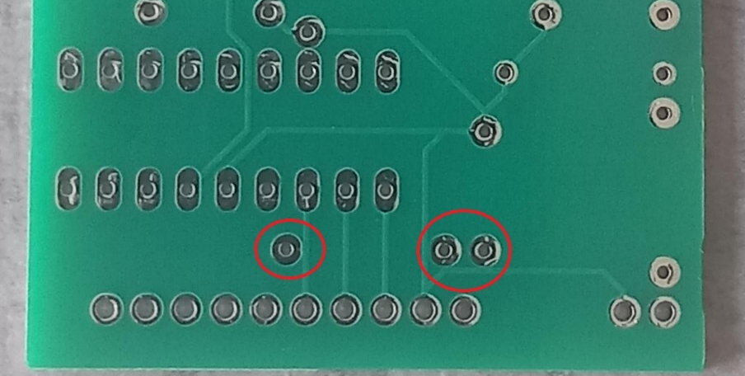
Figure 37 – PCB Close Trace Spacing

Tachometer Case
The chosen enclosure for the tachometer is capable of housing all components and circuitry within a compact case, making it a good choice for a handheld device. Its IP65 rating ensures protection against water and dust ingress. The cutouts for the LCD, power switch, and IR module have been sealed with silicone to maintain this level of protection.
However, there are some concerns regarding the stability of components inside the enclosure. Without dedicated mounting points, certain modules and components have been secured to the case using silicone. While this approach works in the short term, it is not a sustainable long-term solution.
A potential next step for this project would be to design a custom 3D-printed enclosure. This new case could incorporate mounting features such as pins or screws to securely hold each module. Additionally, it could be designed with improved ergonomics to enhance ease of use with one hand.

Future Work Recommendations

Update LCD Driver File
The obvious first step for future work would be to get the LCD to function with the prototype tachometer. Since it is suspected that the LCD driver file is responsible for the current issues, the first approach would be to investigate and modify this file to better suit the application. If modifications to the existing driver do not resolve the problem, alternative compiler software, such as MPLAB X Compiler, will be employed along with its corresponding LCD driver files to determine if different configurations rectify the issue.

Optical Lens
During the hardware evaluation, the significant impact of ambient light interference was identified. While this is an inherent challenge for all optical devices, components such as optical lenses can help mitigate these effects by focusing and directing light more precisely, thereby enhancing performance in environments with high interference. These lenses can also help to improve the measurement distance of the device. The design engineer would therefore look to modify the tachometer casing to incorporate an optical lens around the IR module output.

Complete Circuit PCB
A further improvement that could be made to this tachometer would be to integrate the IR module into the circuit PCB. The housing of the current PCB and IR module proved more difficult than initially anticipated once the battery, power switch, and LCD were also integrated. This resulted in a larger product case having to be used. By integrating the module onto the PCB, the space requirements of the device would be reduced and a smaller case utilised. The positioning of the IR module would also be fixed to the PCB, providing greater stability once mounted in the case.

Enhanced Microcontroller Specifications
To improve the accuracy of the tachometer at higher frequencies, an increased clock frequency could be implemented for the microcontroller. Currently, the clock frequency has been reduced to 4 MHz to mitigate overflow issues with the CCP timer. However, if only the clock frequency were increased, the overflow rate would increase and reduce the device's high-accuracy, lower-range measurements. Therefore, to maintain the current lower-range accuracy whilst also supporting higher-end measurements, adjustments should be made not only to the clock frequency but also to the CCP timer bit rate. The prescaler would then be adjusted accordingly. The design engineer would therefore look to use a microcontroller with a minimum 8MHz clock frequency and a 32-bit CCP timer.

Conclusion

This project successfully demonstrated the design and development of a contactless digital tachometer utilising infrared measurement technology, a microcontroller, and supporting electronic components. Through comprehensive research, careful component selection, and meticulous circuit and software development, a tachometer was designed that aligns with the initial project aims of providing a safer, more efficient means of measuring rotational speed in industrial environments.
The contactless infrared technology was chosen for its balance of accuracy, safety, and practicality within controlled testing environments. Despite challenges encountered with LCD initialisation, extensive troubleshooting confirmed the robustness of the software and hardware design. The PIC16F87 microcontroller proved suitable for real-time RPM measurement with a high resolution, precision, and an operational range of approximately 240 to 10800 RPM at above 99% accuracy, comfortably covering the typical motor speeds encountered at ERIKS.
Software simulations validated the effectiveness of the RPM calculation algorithm, demonstrating high accuracy and responsiveness. Although the prototype hardware could not be fully tested in operational conditions, the overall system architecture and component evaluations suggest that, with minor adjustments and troubleshooting, the device could reliably perform as intended.
The project also emphasised sustainability, selecting rechargeable Li-ion batteries and environmentally conscious components, aligning with industry trends towards safer, greener workplace equipment. The design’s compact PCB, modular wiring connections, and protective casing support ease of use and maintenance.
In summary, this contactless tachometer represents a significant advancement over traditional contact-based methods currently utilised at ERIKS, enhancing safety, accuracy, and operational efficiency. Future work should focus on resolving hardware issues such as LCD initialisation, refining software to improve accuracy at higher RPMs, and conducting extensive real-world testing to validate performance and durability. With these enhancements, the device has the potential to be a valuable tool for industrial applications, contributing to safer workplaces and more reliable machinery performance monitoring.

Project Reflection

This project has offered an in-depth examination of the steps necessary for an engineering project, with a specific focus on the research, resources, and evaluation required. Throughout the course of this project, the design engineer encountered several key learning experiences that will provide valuable insights for future projects.

Key Learnings and Insights

Focus on Health and Safety
From the establishment of project aims and objectives to the selection of components and the implementation of testing procedures, this project has highlighted the importance of health and safety in modern engineering environments. Companies and project leaders conduct critical evaluations at each stage to ensure adherence to health and safety standards. Moving forward, greater emphasis will be placed on allocating adequate time and resources to address health and safety considerations throughout the course of all projects.

Tackling Complex Tasks
What initially appeared to be a complex undertaking transformed into the development of a relatively simple and effective solution. Through comprehensive research, careful planning, and a clear understanding of individual tasks, many challenging aspects of this project were effectively addressed. A key example of this is the utilisation of the CCP module for time-based signal measurements.
Initially, the design engineer faced difficulties in developing the software for this device due to a lack of prior experience with the CCP module. However, by breaking the project down into smaller, manageable sections, the engineer was able to navigate this learning curve. This process began with researching the fundamental functions of the CCP module, then specifically focusing on Capture mode, and ultimately learning how to configure the CCP software for Capture mode within the CCS C Compiler.
By methodically approaching each aspect of the CCP, the design engineer gained the confidence and knowledge needed to implement the software, as demonstrated by the high-accuracy simulation that was created. This structured approach to each task underlines the effectiveness of proper project planning. While initial project plans are always established, the engineer intends to continue developing individual task plans for future projects to facilitate a smoother and more straightforward completion process.

Challenges in Hardware Implementation
Troubleshooting the LCD highlighted the complexities often encountered in interfacing between software and hardware. Despite extensive fault-finding efforts, the LCD remained unresponsive within the project's timeframe. This experience underlined the importance of conducting early testing and having a contingency plan in place for unforeseen issues.
For future projects, the design engineer plans to allocate a more substantial contingency period toward the scheduled completion date. This approach will ensure that sufficient time is available to address any delays or complications that may arise. Additionally, early proof-of-concept testing will be prioritised before other aspects of the project are complete. In this instance, testing a breadboard prototype of the tachometer prior to designing and assembling the final device could have facilitated quicker fault identification and potentially led to a solution being implemented before the project's conclusion.

Project Review
Overall, this project has successfully fulfilled its primary objective of demonstrating the design and implementation of a contactless digital tachometer. Despite setbacks experienced with the prototype LCD, it is believed that by adhering to the outlined future work recommendations, a fully functional tachometer can be developed. Additionally, this project has provided the design engineer with valuable insights and strategies that will enhance future engineering endeavours, promoting continuous improvement in safety, efficiency, and project planning.

Bibliography

[1] | Microchip, “MICROCONTROLLER AND PROCESSORS Products,” Microchip, [Online]. Available: https://www.microchip.com/en-us/parametric-search.html/980?filters=JTdCJTIyY2F0ZWdvcnlkcm9wZG93biUyMiUzQSU1QiUyMk1pY3JvY29udHJvbGxlcnMlMjBhbmQlMjBNaWNyb3Byb2Nlc3NvcnMlMjIlMkMlMjJBbGwlMjBNaWNyb2NvbnRyb2xsZXJzJTIwYW5kJTIwTWljcm9wcm9jZXNzb3JzJTIyJTJDJTIyJTIy. [Accessed 20 10 2024].
[2] | LabCentre, “PCB Design & Simulation Made Easy,” LabCentre, [Online]. Available: https://www.labcenter.com/. [Accessed 20 10 2024].
[3] | easypcltd, “Easy PC - Making it work for you,” easypcltd, [Online]. Available: https://www.easypcltd.co.uk/. [Accessed 20 10 2024].
[4] | Custom Comrputer Services, “C Compiler Solution Suite,” Custom Comrputer Services, [Online]. Available: https://www.ccsinfo.com/compilers.php. [Accessed 20 10 2024].
[5] | JLC-PCB, “Easier One-Stop Solutions for PCB & PCBA Services,” JLC-PCB, [Online]. Available: https://jlcpcb.com/. [Accessed 20 10 2024].
[6] | ISO, “ISO 14001:2015,” 2015. [Online]. Available: https://www.iso.org/standard/60857.html. [Accessed 22 10 2024].
[7] | Health and Safety Executive, “Health and Safety at Work etc Act 1974,” Health and Safety Executive, 1974. [Online]. Available: https://www.hse.gov.uk/legislation/hswa.htm. [Accessed 02 12 2024].
[8] | Electricity Magnetism, “Infrared Waves – en,” 2025. [Online]. Available: https://www.electricity-magnetism.org/infrared-waves-en/#:~:text=Infrared%20%28IR%29%20waves%20are%20a%20type%20of%20electromagnetic,microwaves%20and%20visible%20light%20in%20the%20electromagnetic%20spectrum.. [Accessed 01 02 2025].
[9] | Konsyse, “Advantages of Infrared Communication,” 2017. [Online]. Available: https://www.konsyse.com/articles/infrared-communication-advantages-and-disadvantages/#:~:text=IR%20communication%20technology%20only%20works%20at%20a%20short,of%20wireless%20communication%20via%20infrared%20is%20considerably%20limited.. [Accessed 01 02 2025].
[10] | MicroDigisoft, “IR Communication: A Comprehensive Guide,” 2021. [Online]. Available: https://microdigisoft.com/ir-infrared-communication-system/. [Accessed 01 02 2025].
[11] | T. Philipp, “What is coherent light?,” 26 07 2022. [Online]. Available: https://www.mr-beam.org/en-gb/blogs/news/kohaerentes-licht?srsltid=AfmBOop9l1tMQFroHeeMSOeSr2Td-5Zfljf_FzKP-ax7diRtfmyXaSX0. [Accessed 01 02 2025].
[12] | E. Ramsden, Hall-Effect Sensors: Theory and Application, Burlington, MA: Newnes Publications, 2006.
[13] | E. V. B. K. a. O. Z. André Thess, Theory of the Lorentz force flowmeter, New Jersey: IOP Publishing Ltd, 2007.
[14] | P. H. &. W. Hill, “The Art of Electronics,” in Third Edition, Cambridge, TAS, Australia, Cambridge University Press, 2015, pp. 1211, 1142.
[15] | LiPol, “FD_6145_10 Datasheet,” 2021. [Online]. Available: https://www.lithium-polymer-akkus.de/wp-content/uploads/2022/03/LP883048-3.7V-1300mAh-datasheet.pdf. [Accessed 20 02 2025].
[16] | Yordan, “USB-C charging is now mandatory in EU, here's what you need to know,” 30 12 2024. [Online]. Available: https://www.gsmarena.com/usbc_law_in_eu_is_now_in_order_heres_what_you_need_to_know-news-65894.php. [Accessed 05 01 2025].
[17] | AZ-Delivery, “TP4056 Micro-USB Datasheet,” [Online]. Available: https://cdn.shopify.com/s/files/1/1509/1638/files/Laderegler_TP4056_Micro-USB_Datenblatt_AZ-Delivery_Vertriebs_GmbH.pdf?16218315642872936401. [Accessed 06 02 2025].
[18] | AZ-Delivery, “HD44780 16x2 Display Datasheet,” [Online]. Available: https://cdn.shopify.com/s/files/1/1509/1638/files/HD44780_1602_Grunes_LCD_Display_Datenblatt_AZ-Delivery_Vertriebs_GmbH_79330942-e867-4c0c-8442-67f7e999e046.pdf?v=1606236375. [Accessed 08 02 2025].
[19] | Mouser Electronics, “The Newest Products for Your Newest Designs,” Mouser Electronics, [Online]. Available: https://www.mouser.co.uk/?utm_id=217016849&gad_source=1&gclid=EAIaIQobChMIjqiu-5yuiQMVp5-DBx2dVBpQEAAYASAAEgLy5_D_BwE. [Accessed 21 10 2024].
[20] | Farnell, “Welcome to Farnell Global,” Farnell, [Online]. Available: https://www.farnell.com/. [Accessed 21 10 2024].
[21] | Mircochip, “MPLAB® X Integrated Development Environment (IDE),” Mircochip, [Online]. Available: https://www.microchip.com/en-us/tools-resources/develop/mplab-x-ide. [Accessed 21 10 2024].
[22] | Microsoft, “Welcome to Microsoft 365,” Microsoft, [Online]. Available: https://www.office.com/. [Accessed 21 10 2024].
[23] | U. Goverment, “Global Resource Initative,” March 2020. [Online]. Available: https://assets.publishing.service.gov.uk/government/uploads/system/uploads/attachment_data/file/881395/global-resource-initiative.pdf. [Accessed 22 10 2024].
[24] | sensaweb, “What is Infrared Radiation and How Is It Used?,” 2023. [Online]. Available: https://www.sensaweb.com.au/2023/01/20/infrared-radiation/. [Accessed 01 02 2025].
[25] | Physics and Radio Electronics, “LASER,” 2020. [Online]. Available: https://www.physics-and-radio-electronics.com/physics/laser/characteristics-of-laser.html. [Accessed 02 02 2025].

Appendices

Appendix 1 - Project Budget Breakdown

Table 13 - Project Budget Breakdown
Component | Vendor | Cost
LP883048 Li-Ion Battery | Amazon [18] | £6.99
TP2046 Charging Module | Amazon [19] | £1.66
16x2 LCD | Amazon [20] | £6.49
IR Proximity Sensor | Amazon [21] | £2.33
PIC16F87 | DigiKey [22] | £3.17
Molex 0022232101 | DigiKey [8] | £0.43
Molex 0022013107 | DigiKey [9] | £0.35
Molex 0022272031 | DigiKey [10] | £0.16
Molex 0022013037 | DigiKey [11] | £0.32
Molex 0022272021 | DigiKey [12] | £0.08
Molex 0022013027 | DigiKey [13] | £0.19
Molex 0008500113 | DigiKey [14] | £0.19
3.7V Zener Diode | DigiKey [23] | £0.15
10Ω Resistor (x2) | Digi Key [24] | £0.08
Power Switch | Amazon [25] | £0.99
Junction Box | Amazon [26] | £2.99
Total Cost - £26.47

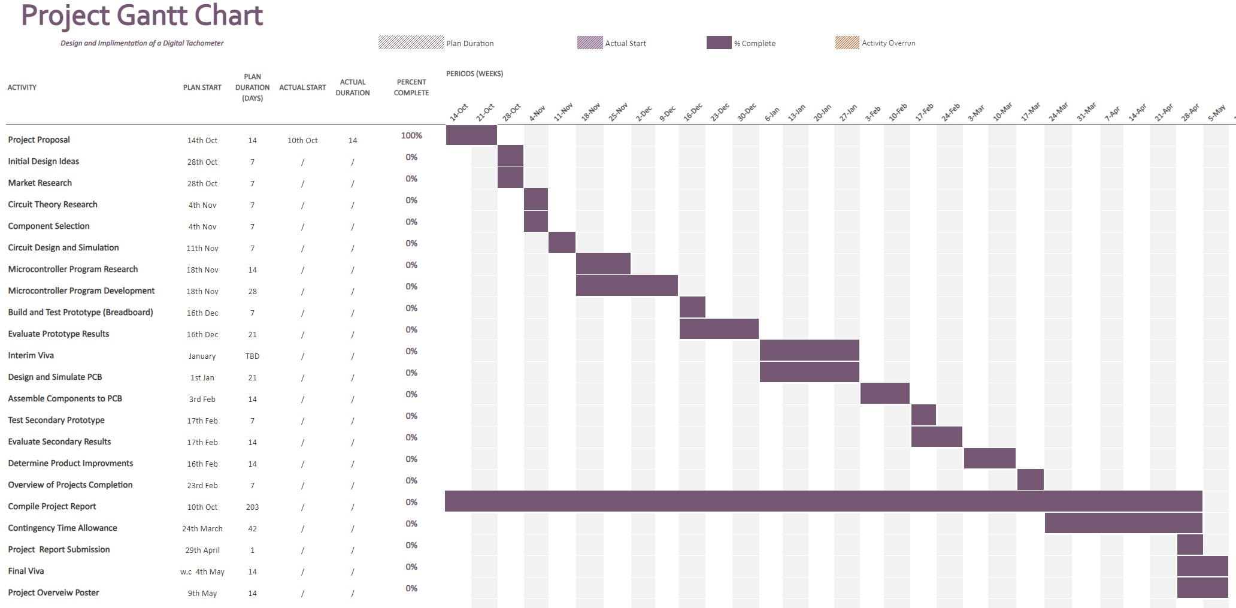
Appendix 2 - Project Gantt Chart
Figure 38 - Project Gantt Chart

Appendix 3 - Complete Tachometer Software
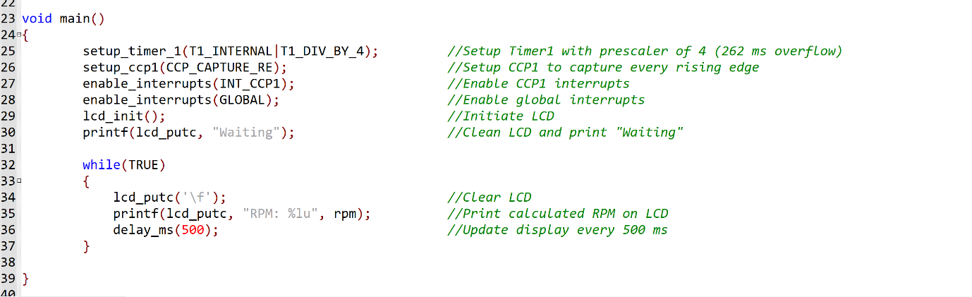
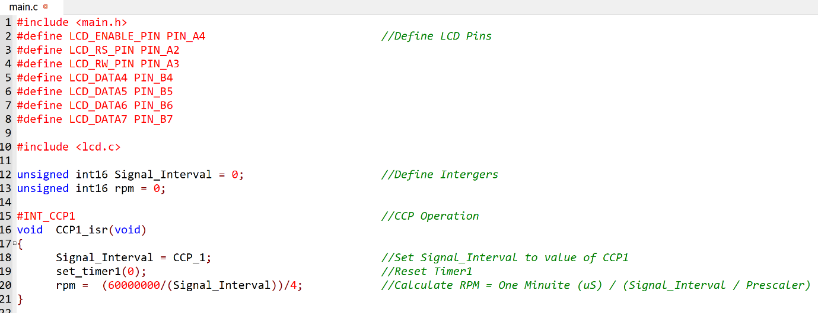
Figure 39 - Complete Software Program

Appendix 4 - Software Evaluation Results
Table 14 - Software Evaluation Results
Frequency | Ideal | Simulation 1 | Simulation 2 | Simulation 3 | Accuracy
5 | 300 | 300 | 300 | 300 | 100.00%
10 | 600 | 600 | 600 | 600 | 100.00%
15 | 900 | 900 | 900 | 900 | 100.00%
20 | 1200 | 1201 | 1201 | 1201 | 99.92%
25 | 1500 | 1502 | 1502 | 1502 | 99.87%
30 | 1800 | 1803 | 1803 | 1803 | 99.83%
35 | 2100 | 2104 | 2104 | 2104 | 99.81%
40 | 2400 | 2405 | 2405 | 2405 | 99.79%
45 | 2700 | 2707 | 2707 | 2707 | 99.74%
50 | 3000 | 3008 | 3008 | 3008 | 99.73%
55 | 3300 | 3310 | 3310 | 3310 | 99.70%
60 | 3600 | 3612 | 3612 | 3612 | 99.67%
65 | 3900 | 3915 | 3915 | 3915 | 99.62%
70 | 4200 | 4217 | 4217 | 4217 | 99.60%
75 | 4500 | 4519 | 4519 | 4519 | 99.58%
80 | 4800 | 4823 | 4823 | 4823 | 99.52%
85 | 5100 | 5124 | 5124 | 5124 | 99.53%
90 | 5400 | 5426 | 5426 | 5426 | 99.52%
95 | 5700 | 5730 | 5730 | 5730 | 99.48%
100 | 6000 | 6033 | 6033 | 6033 | 99.45%
105 | 6300 | 6337 | 6337 | 6337 | 99.42%
110 | 6600 | 6640 | 6640 | 6640 | 99.40%
115 | 6900 | 6944 | 6944 | 6944 | 99.37%
120 | 7200 | 7249 | 7249 | 7249 | 99.32%
125 | 7500 | 7552 | 7552 | 7552 | 99.31%
130 | 7800 | 7857 | 7857 | 7857 | 99.27%
135 | 8100 | 8161 | 8161 | 8161 | 99.25%
140 | 8400 | 8465 | 8465 | 8465 | 99.23%
145 | 8700 | 8771 | 8771 | 8771 | 99.19%
150 | 9000 | 9079 | 9079 | 9079 | 99.13%
155 | 9300 | 9380 | 9380 | 9380 | 99.15%
160 | 9600 | 9683 | 9683 | 9683 | 99.14%
165 | 9900 | 9993 | 9993 | 9993 | 99.07%
170 | 10200 | 10302 | 10302 | 10302 | 99.01%
175 | 10500 | 10608 | 10608 | 10608 | 98.98%
180 | 10800 | 10909 | 10909 | 10909 | 99.00%
185 | 11100 | 11219 | 11219 | 11219 | 98.94%
190 | 11400 | 11520 | 11520 | 11520 | 98.96%
195 | 11700 | 11829 | 11829 | 11829 | 98.91%
200 | 12000 | 12133 | 12133 | 12133 | 98.90%

