DS 1 Template

My Screenshots/Photos
- Please add 4–6 screenshots or photos of your digital life.
- You can use your phone or laptop.
- For each screenshot, write one or two sentences explaining what it shows.

Screenshot/Photo 1

[Insert Photo/Screenshot below]
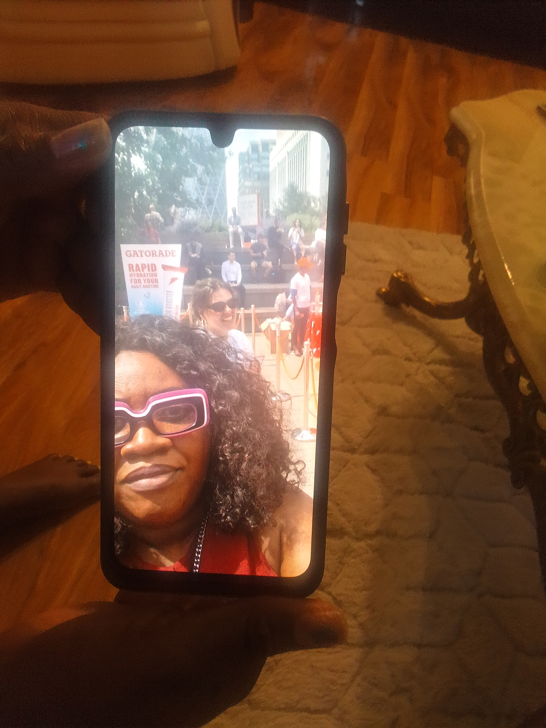

There is an event in Canary Wharf, I used my device to take a picture of the event

Screenshot/Photo 2
[Insert Photo/Screenshot below]
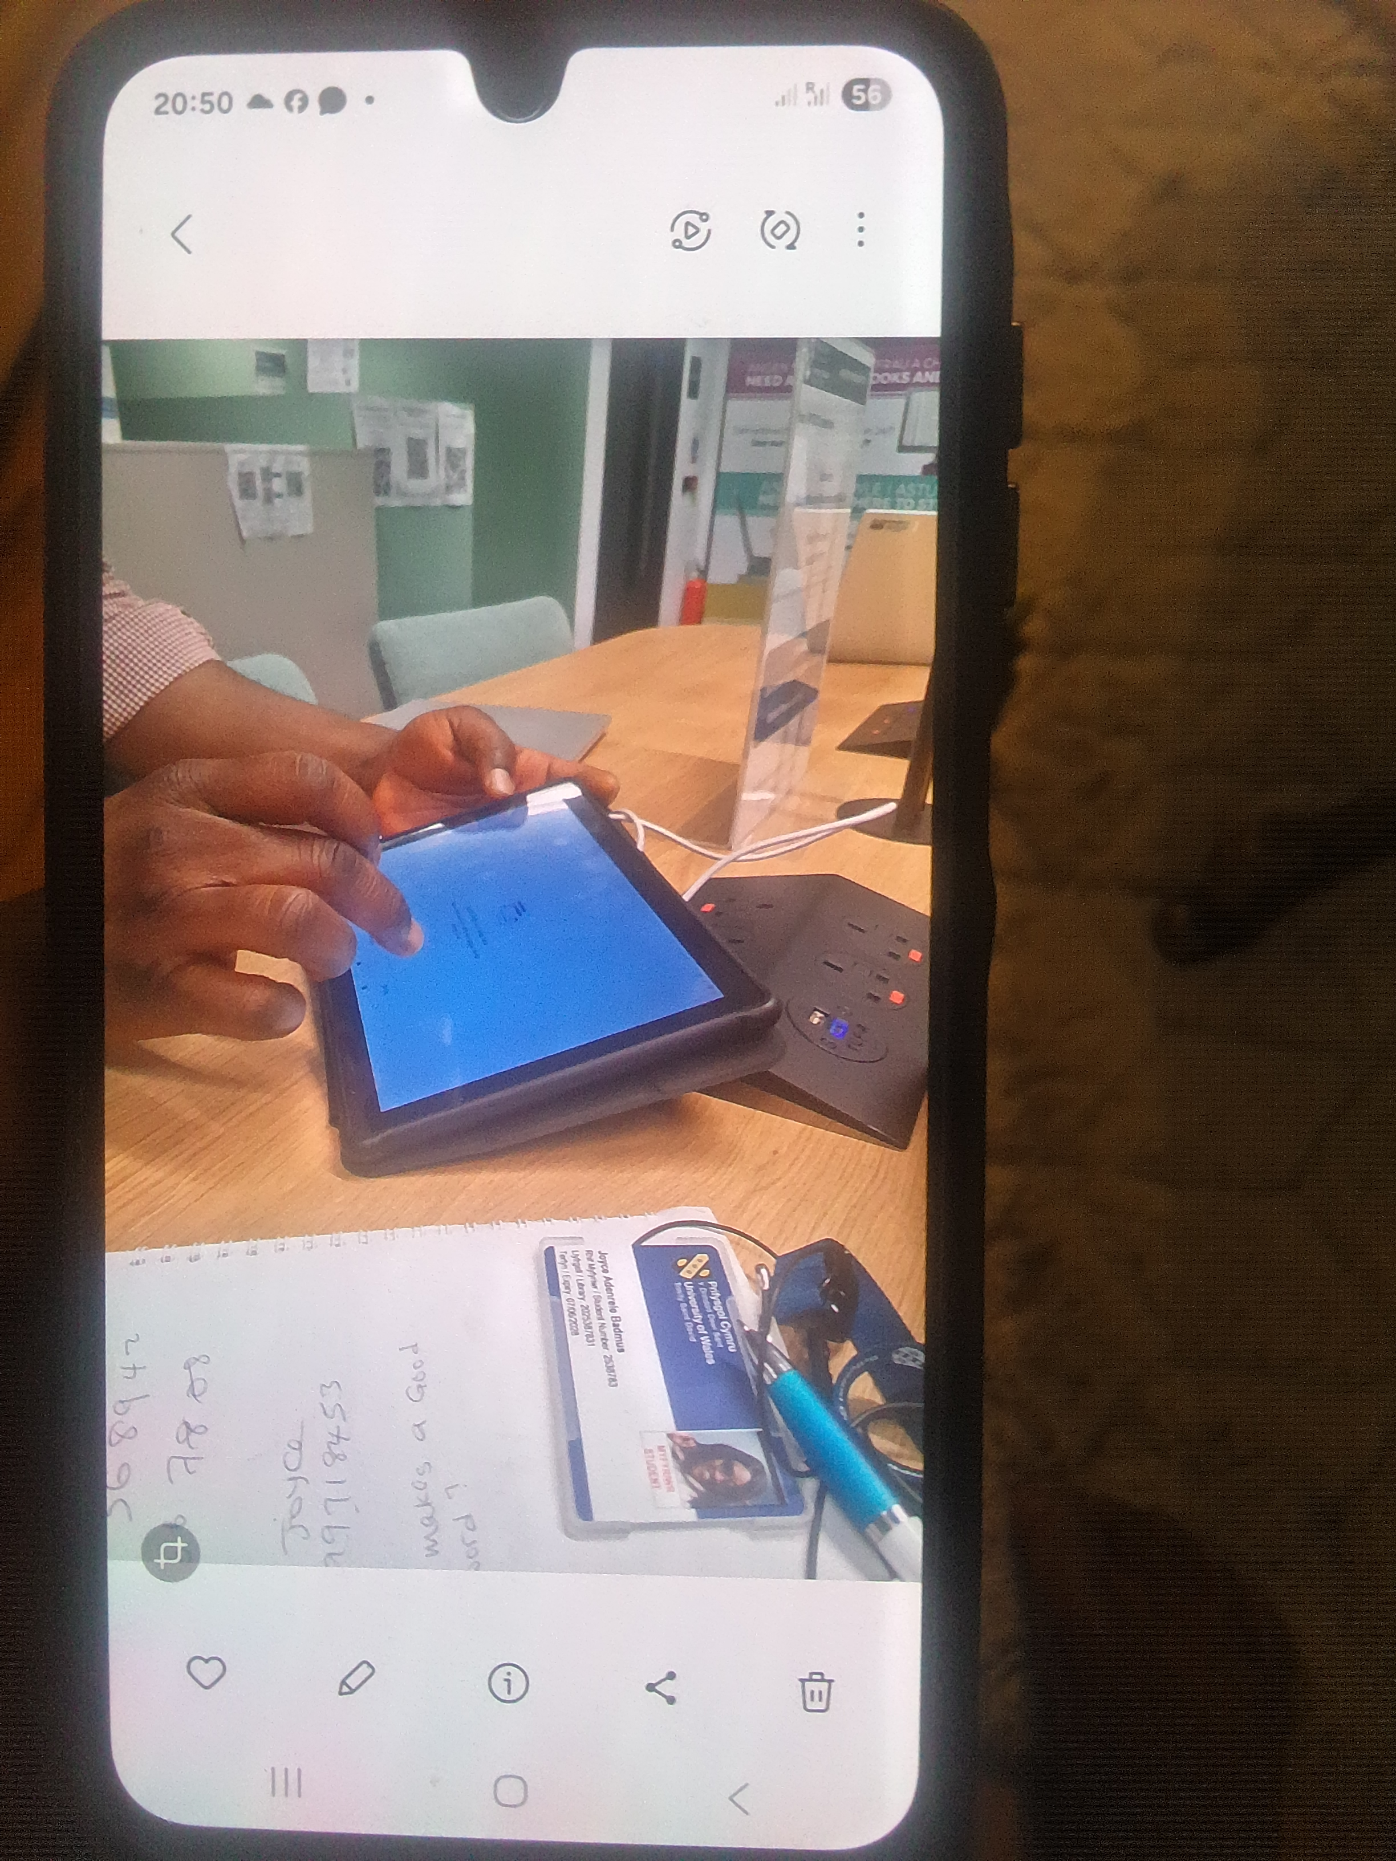
[Write what this shows of your digital life]
I went into the library in order to sort out my iPad for me to be able to do my assignment, I used my phone to take a picture whilst the IT technician fixed it

Screenshot/Photo 3
[Insert Photo/Screenshot below]
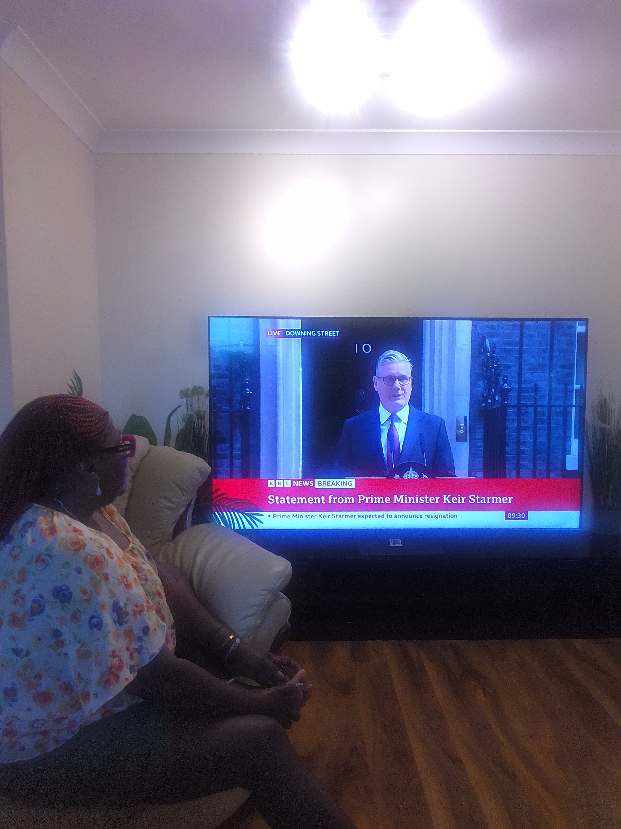
[Write what this shows of your digital life]
I used my device to take a picture of me watching the news on the resignation of the Prime Minister. I used my TV device to watch the this.

Screenshot/Photo 4
[Insert Photo/Screenshot below]
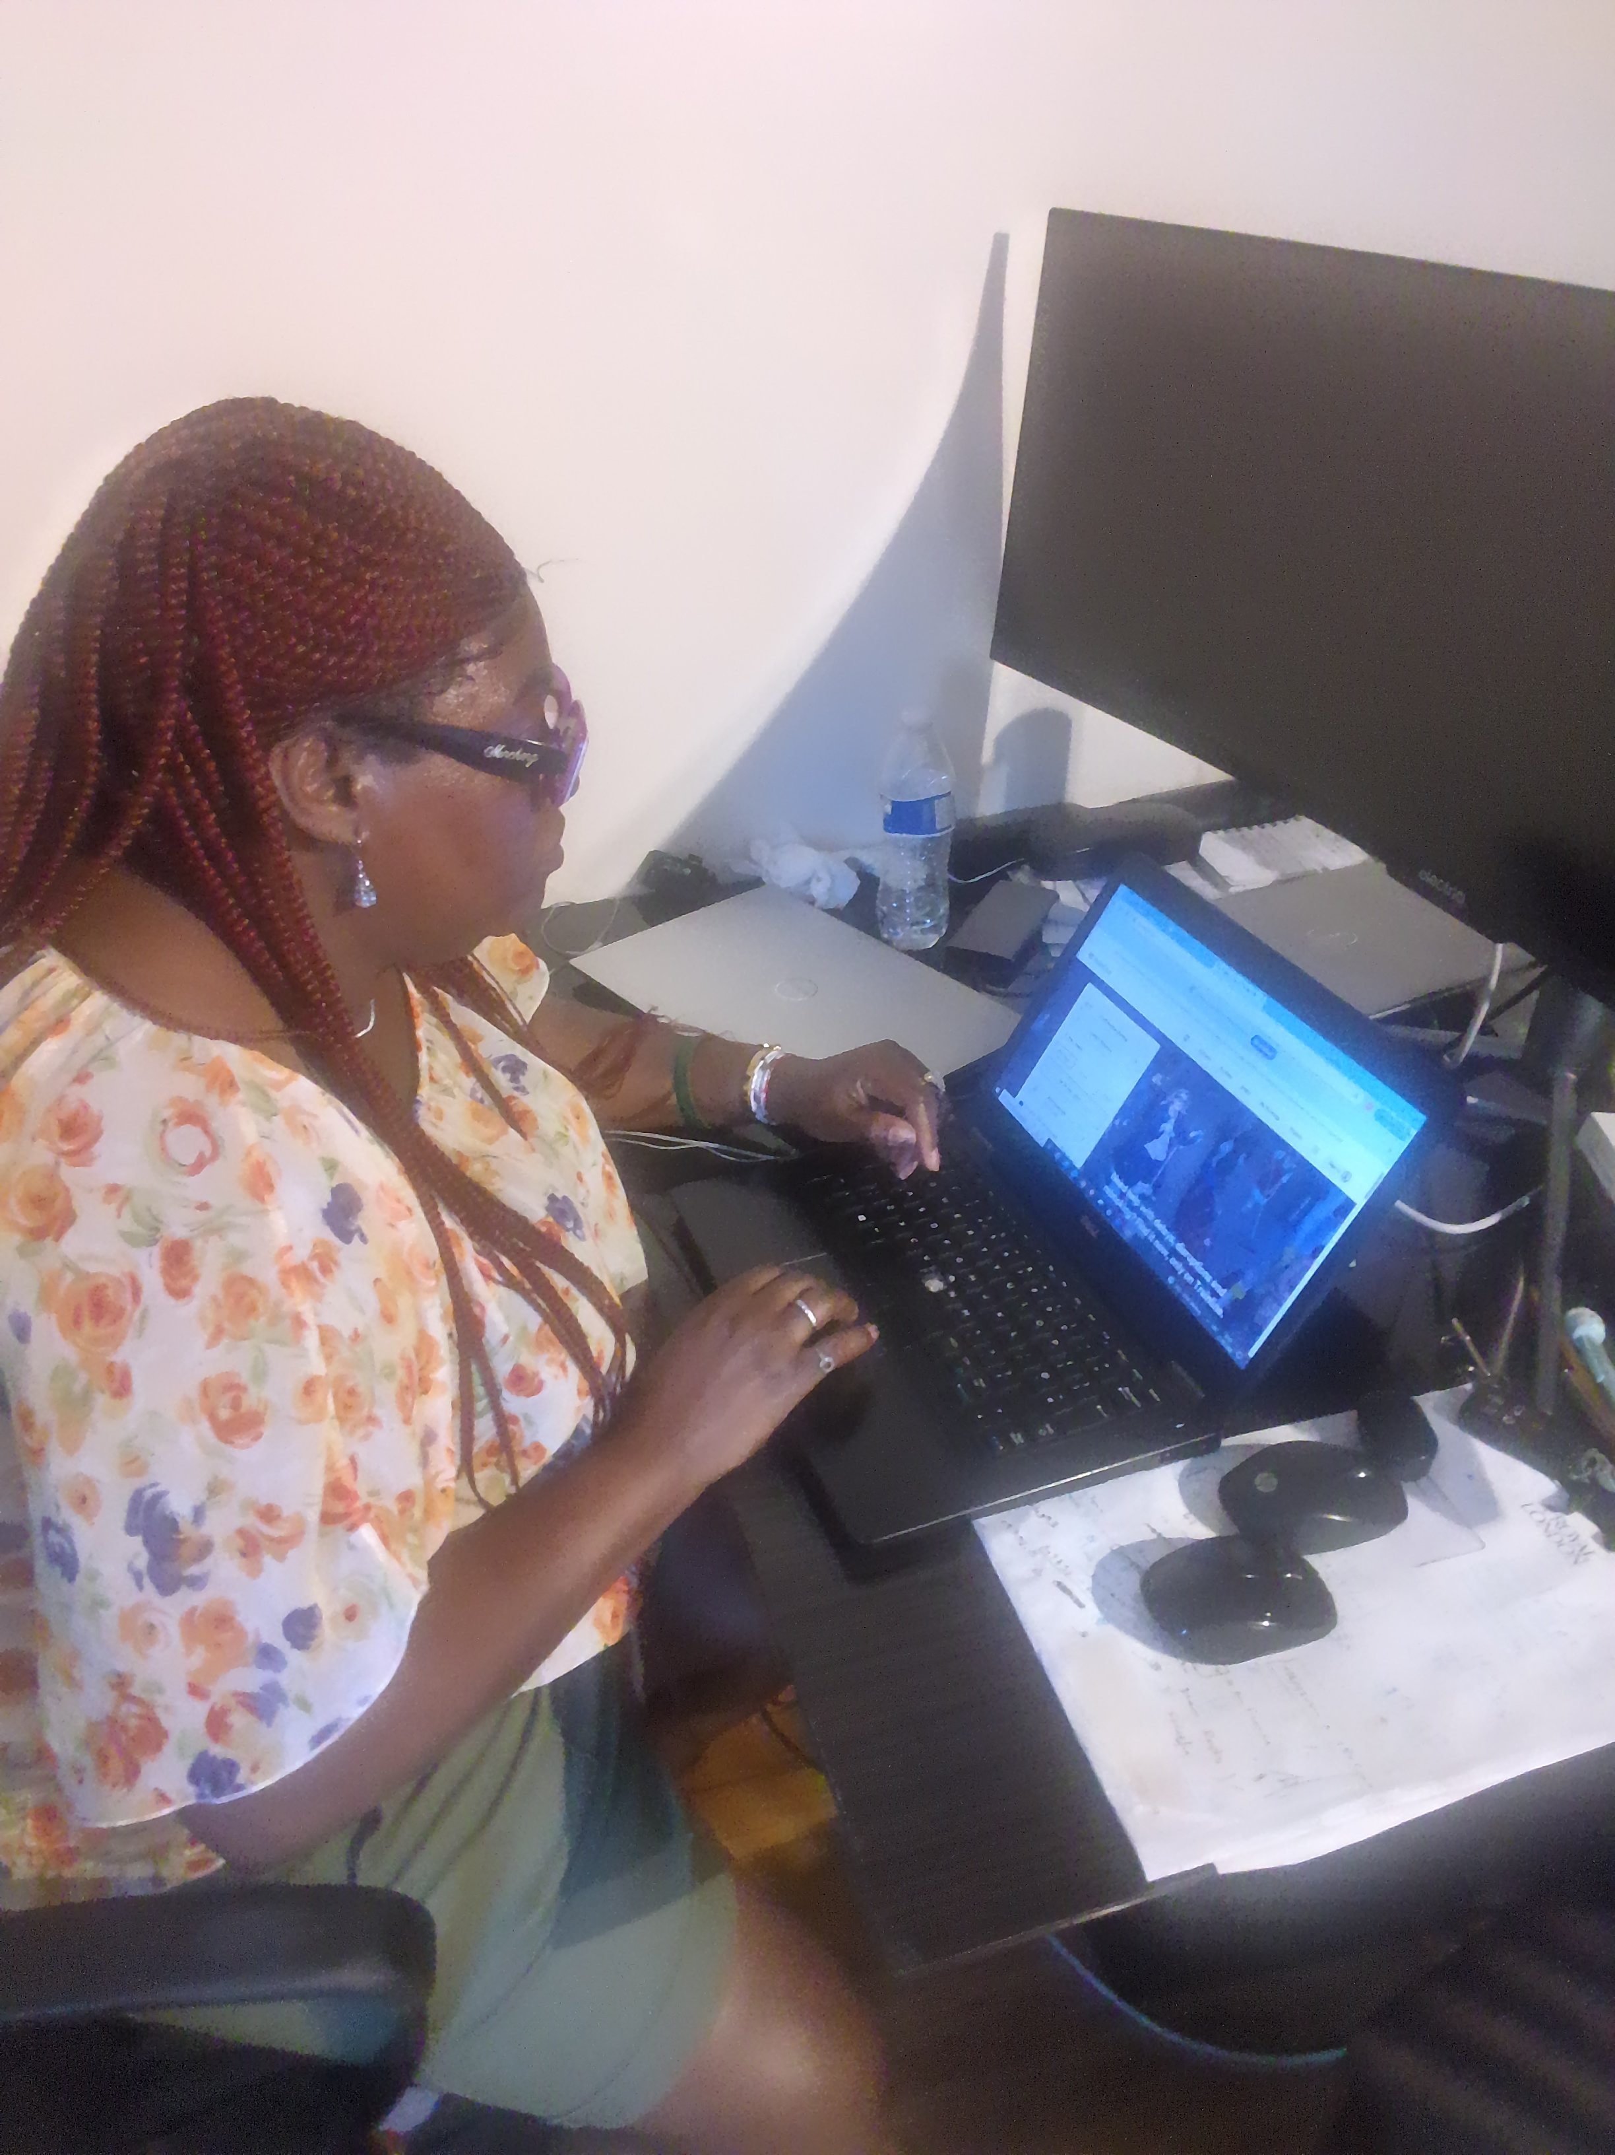
[Write what this shows of your digital life]
On my laptop I booked tickets to go to London comparing prices and checking times online

Screenshot/Photo 5
[Insert Photo/Screenshot below]
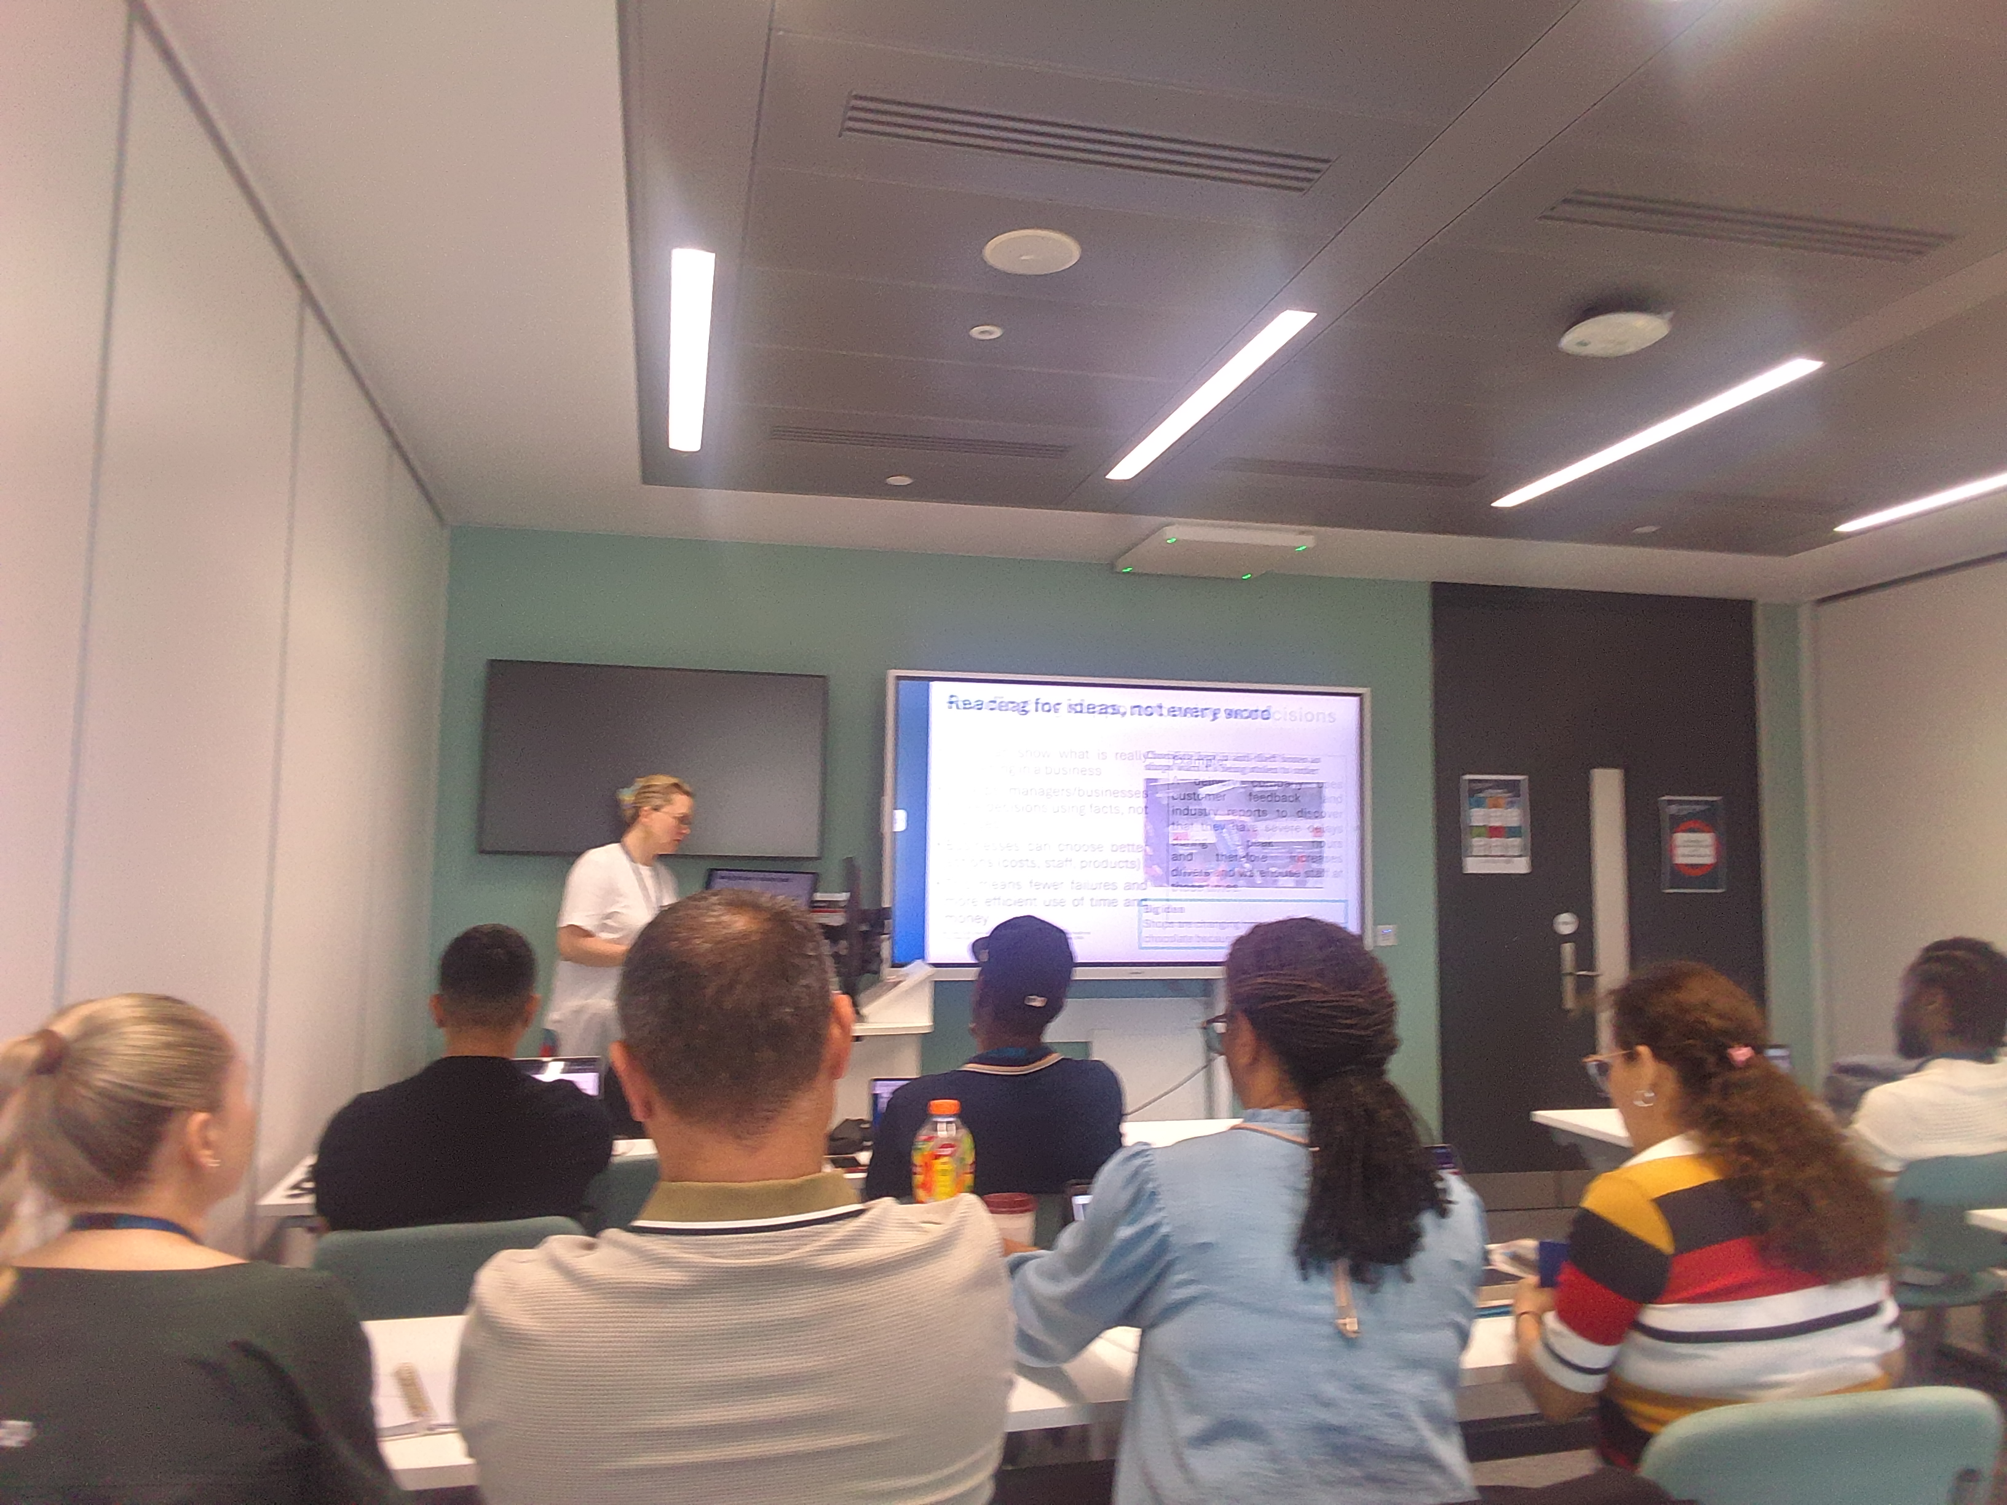
[Write what this shows of your digital life]
While the lecture was taking place in study academics, I took a picture using device of the group. I also used my phone to access a QR CODE.

Screenshot/Photo 6
[Insert Photo/Screenshot below]
[Write what this shows of your digital life]
I used my phone to take a picture of myself ,making use of my device to remember this moment on a sunny day.

My Short Reflection
- Write 5–8 simple sentences about your digital life.
- You can use the sentence starters below if helpful.
I used my digital device to take picture of event in my life. I feel confident when I used my device to navigate and find information . I want to improve in typing an spelling when using my digital device. I often use these tools when I need information about everything in general. I sometimes feel nervous about operating my digital device. I hope and believe this module will help me improve my digital life skills. Digital skills are important o me, especially when I started this course, because I used digital skills in my day-to-day life, for example, checking the time and checking social media. I do not think my life can be complete without not using digital skills. I am finding it very interesting and I am learning new things every Tuesday.

Sentence starters
- I use digital tools to …
- I feel confident when I …
- I want to improve …
- I often use these tools: …
- I sometimes feel nervous about …
- I hope this module will help me …
- Digital skills are important for me because …
You can write more if you want.

Submission Checklist
Before you submit, please check:
​​​ ☐ I added 4–6 screenshots
☐ I wrote short sentences for each screenshot
☐ I wrote my short reflection
☐ My work is my own
☐ My file opens correctly
​​☐ My file opens correctly

