 |  | RESULT:

ASSIGNMENT SPECIFICATION

Student name: | Assignments will not be accepted without a name here |  |  | Student P number: |  | Assignments will not be accepted without P number
Programme: | MArts(Hons) Creative Computer Games Design |  |  | Faculty/School: |  | FAD/SGDA
Module: | Game Design & Critical Analysis |  |  | Module Level (4, 5, 6, 7): |  | 6
Module code: | M6X02045 |  |  | Contribution to Overall  Module Assessment (%): |  | 100%
Lecturer: | J. Carroll |  |  | Internal Verifier: |  | D. Bainton
Assignment Title: | Written Analysis |  |  | Assignment No (x of x): |  | 1 of 1
Hand Out Date: | October 2017 | Submission Date: | 15/12/2017 |  | Feedback Date: |  | By 02.02.18

Referencing: | Written coursework submissions: In the main body of your submission you must give credit to authors on whose research your work is based. Append to your submission a reference list that indicates the books, articles, etc. that you have read or quoted in order to complete this assignment (e.g. for books: surname of author and initials, year of publication, title of book, edition, publisher: place of publication). Harvard or APA referencing systems is accepted.  Practical coursework submissions: You must give credit to designers or artists whose work you have used to inspire your own. Where specific designs or images have been used in your development work you must indicate the name of the ‘author’ and details of the source of the work (e.g. book, journal, website etc.).
Disclosure: | I declare that this assignment is all my own work and that I have acknowledged all materials used from the published or unpublished works of other people. All references have been duly cited.
Student’s Signature: |   Assignments will not be accepted without a signature here and date > | Date of submission: | 15/12/2017
Turnitin: Lecturer to tick to indicate if an electronic version of the assignment must be submitted to Turnitin.  If both electronic and hard copy submissions are required then both versions MUST be submitted by the same deadline. No marks will be released until both submissions are received.  Note: the Turnitin version is the primary submission and acts as a proof of receipt for the student.  A paper receipt must be completed for hard copy submissions, including portfolios and other design work. |  |  | YES
 |  |  | NO
Penalties for late submission: Up to one week late, maximum mark of 40% for first attempt.
Work cannot be accepted after 1 week and will be recorded as a non-submission, 0%.

- The Assignment Specification Form MUST be at the front of all assignment submission. Assignments will not be accepted without this form, as it is a requirement that you sign the disclosure regarding referencing conventions.
- DO NOT include this form in your Turnitin submission or it will match many similarities with other students’ submissions.

ASSIGNMENT DESCRIPTION

Learning Outcomes
Module Learning Outcomes being Assessed:
- Demonstrate a critical insight and aesthetic understanding of the strengths and weaknesses of available game engines and game mechanics, and use these to inform their design decisions on future game proposals.
- Practically apply the theoretical content of the module to develop an analysis document on existing games engines.

Task
Students will normally work individually on this module.

You will be required to research and evaluate, in detail, a selection of game engines and game mechanics. The research and evaluation will be focused on an examination of effectiveness and environment within each of the game engines analysed. Students will then implement their research that they have conducted over the semester and develop an in-depth written 5000 word analysis of existing games engines and evaluate the benefits of their chosen engine in relation to their related field of expertise on the final major project.

- Advanced idea generation, development and evaluation; production of concept, art, and design documents necessary for game production.
- Workflow and pipeline issues towards an efficient games development process, including those for a variety of platforms including PCs, consoles, web, or mobile applications.
- Evaluate and analyse existing games engines.
- Analysis of interface design and gameplay spaces including representational and abstract.
- Game mechanics refinement through play testing and player analysis.

Guidance for Students in the Completion of Tasks
The students will implement their research that they have conducted over the semester and develop an in-depth written 5000 word analysis of existing games engines and evaluate the benefits of their chosen engine in relation to their related field of expertise on the final major project.

Each student should include a detailed production diary outlining the stages of analysis and experimentation within their appendices. All data, times and dates should be accurately recorded and represented within the main body of the overall analysis.

Assessment & Feedback
Game Engine Analysis Document (5000 words) (100%)
Marking and weighting:
1. Research & Analysis - 40%
- The project must show evidence of independent research (experimentation, case studies, comparative research etc.)
- These sources must be referenced wherever appropriate using the Harvard method.
- A solution to the problem has been derived from a sound conceptual base.
- An effective and informative experiment and/or case study has been conducted and recorded.
- A realistic, honest, and critical self-evaluation is provided that highlights both the strengths and weaknesses of the project and suggest ways in which these lessons may be carried forward.

2. Development - 20%
- The student must show an understanding of the game engine(s) being evaluated in terms of their overall design role within the Major Project

4. Subject Knowledge - 20%
- A solution is provided that meets the required quality criteria.
- There is some evidence of creativity or innovation.
- Results of research undertaken implemented within practical work.

7. Professional Practice - 20%
- Documentation and presentations are delivered in a manner commensurate with professional practice.


UG STUDENT SELF EVALUATION FORM

Student Name: |  | Student P Number:
Programme: | MArts(Hons) Creative Computer Games Design
Module: | Game Design & Critical Analysis | Module Level (4, 5, 6): | 6
Module Code: | M6X02045 | Contribution to Module: | 100%
Assignment Title: | Written Analysis

Common Assessment Criteria Applied | Level of Achievement
Common Assessment Criteria Applied | Outright Fail |  |  | MF | 3  Satisfactory |  |  | 2:2  Good |  |  | 2:1  Very Good |  |  | 1st  Exceptional
Common Assessment Criteria Applied | F |  |  | E | D |  |  | C |  |  | B |  |  | A
Common Assessment Criteria Applied | 1 | 2 | 3 | 4 | 5 | 6 | 7 | 8 | 9 | 10 | 11 | 12 | 13 | 14 | 15 | 16
Common Assessment Criteria Applied | 0-15% | 16-30% | 31-34% | 35-39% | 40-43% | 44-46% | 47-49% | 50-53% | 54-56% | 57-59% | 60-63% | 64-66% | 67-69% | 70-79% | 80-89% | 90-100
1. Research & Analysis
2. Development
3. Technical Skill
4. Subject Knowledge
5. Presentation & Communication
6. Personal Learning & Development
7. Professional Practice

Please comment on areas in which you feel that you have performed well:
Please comment on areas that you feel you need to develop:
Student Signature: |  | Date:

MODULE LEARNING OUTCOMES
Upon the successful completion of this module, students should be able to demonstrate the ability to:
- Demonstrate a critical insight and aesthetic understanding of the strengths and weaknesses of available game engines and game mechanics, and use these to inform their design decisions on future game proposals.
- Practically apply the theoretical content of the module to develop an analysis document on existing games engines.

COMMON ASSESSMENT AND MARKING CRITERIA
ASSESSMENT CRITERIA | OUTRIGHT FAIL | MARGINAL FAIL | SATISFACTORY | GOOD | VERY GOOD | EXCEPTIONAL
ASSESSMENT CRITERIA | 0-34% | 35-39% | 40-49% | 50-59% | 60-69% | 70-79% | 80-100%
1. Research & Analysis  Systematic exploration and selection of sources; effective interpretation and evaluation of findings. | Limited or no material presented with limited or no evidence of critical enquiry. | Material presented indicates a basic degree of insight and is of limited relevance to the task. | Material presented is adequate and relevant demonstrating the application of standard research techniques. | Material presented shows a good range of sources, is well organised and interpreted in a manner relevant to the task. | Connections have been made between sources and qualitative judgements have been made in the interpretation of these findings. | Research is extensive, well documented and critically evaluated with new personal judgements made and applied. | Research and exploration is impressive both in extent and depth and the level of interpretation and critical insight is highly advanced.
2. Development  Formulation of innovative and effective concepts through appropriate application of problem solving, creative experimentation and testing methods. | Limited or no engagement with the practical and creative processes of ideation. | Basic proposals have been made but limited in scope and lacking in considered and focused development processes. | Proposals are adequate and are delivered within a familiar and well established framework of methods. | Proposed concepts are formulated with a good degree of detail through the use of a variety of systematic and exploratory methods. | Concepts display innovative ideas within established territories, which are well resolved through sound practical and creative processes. | Proposals respond effectively to unfamiliar or new conceptual territories and expand perceptions of process and/or product. | Proposals both challenge and extend the conceptual territory and set new benchmarks for innovation and effectiveness within the field.
3. Technical Skill  Effective utilisation of appropriate materials, tools and techniques and the level of skill demonstrated in their application to the realisation process. | Limited or no awareness and utilisation of tools and techniques are demonstrated. | Rudimentary processes may have been applied but without consideration and competence. | Skills demonstrated display adequate awareness and appropriate application of standard materials and methods. | Controlled application of a range of materials and methods with good standards of finishing evident. | Communication of intent is fully executed demonstrating diversity of process and effective technique. | Extensive and highly advanced technical skills in established processes demonstrating sensitivity and excellence in idea realisation. | Outstanding levels of technical skill in all aspects of the realisation process demonstrating the assimilation and development of cutting edge processes and techniques.
4. Subject Knowledge  Understanding and application of concepts and underlying principles associated with the discipline and the specific context of study. | Unable to grasp or communicate key principles or knowledge. | Limited understanding and communication of key principles or knowledge. | Evidence of basic understanding of the relevant concepts and underlying principles. | Knowledge is accurate and effectively applied in relation to the specific context. | Knowledge is extensive and the understanding of the context exhibits awareness of the breadth and depth of established views. | Knowledge has been assimilated and individual and personal perspectives have been formulated and debated with effectiveness. | Discipline and context specific knowledge are substantive and a highly advanced synthesis of these elements creates new or expanded perspectives.
5. Presentation & Communication  Clarity and effectiveness in the deployment of appropriate media to communicate a message relevant to specialist and non-specialist audiences. | Appropriate media for communication have not been identified or applied effectively. | Limited awareness of the audience and a lack of clarity and organisation are demonstrated. | Basic awareness of the audience and clarity of message is demonstrated in deployment of standard communication forms. | Selection and application of media and conventions show good understanding of the audience and context. | Communication media have been selected and deployed to maximise impact for the selected audience and context. | Individual stylistic approaches have been implemented to communicate to a diverse range of audiences in a highly compelling and effective way. | Presentation and communication methods employed are not only highly individual, compelling and effective but also combine media in an innovative way.
6. Personal Learning & Development Personal responsibility demonstrated in managing own learning through programme engagement, self-directed study and reflective practice. | Little or no responsibility taken for own learning demonstrated by poor attendance, engagement and reflection. | Inconsistency in programme engagement and poor awareness of personal learning and development needs. | Evidence of some reflective practice contributing to appropriate effort and engagement to further personal development. | Evidence of regular reflective practice and awareness of individual strengths and weaknesses demonstrable in core learning and self-directed study. | Reflective practice and individual development is extended beyond core learning, is well managed and documented. | Full responsibility for own learning and development is evidenced in detail demonstrating critical appraisal of purpose, progress and future direction. | Outstanding level of engagement with all elements of the programme enhanced by the personal drive and passion to extend learning beyond established parameters and into new domains.
7. Professional Practice Demonstrates those attributes expected in professional practice including individual initiative, project management, collaborative working and inter-personal skills. | No demonstrable understanding of professional expectations and does not work effectively as an individual or with others. | Poor level of productivity as an individual or in a collaborative context, ineffective management and little understanding of professional life. | Demonstrates awareness of the relevant attributes for professional practice and delivers work to the minimum requirements as an individual and/or in collaboration. | Works to the relevant standards and meets most requirements as stipulated in both individual and team working scenarios. | Meets most or all of the relevant standards and in some areas exceeds the requirements as stipulated, taking control of some aspects of project management. | Often works above the relevant standards and exceeds the requirements as a team member, leader or individual in a variety of working scenarios | Always works well above the relevant standards and demonstrates outstanding individual and collaborative professional attributes in every working scenario encountered.

Level 6
CORY RICHARDS - P145235 BA CREATIVE COMPUTER GAMES DESIGN
GAME DESIGN AND CRITICAL ANALYSIS WORDCOUNT: 4506 WORDS SUPERVISED BY MR JULIAN HAINSWORTH AND JOHN CARROLL
A Comparison between Animation Pipelines in MotionBuilder and Maya
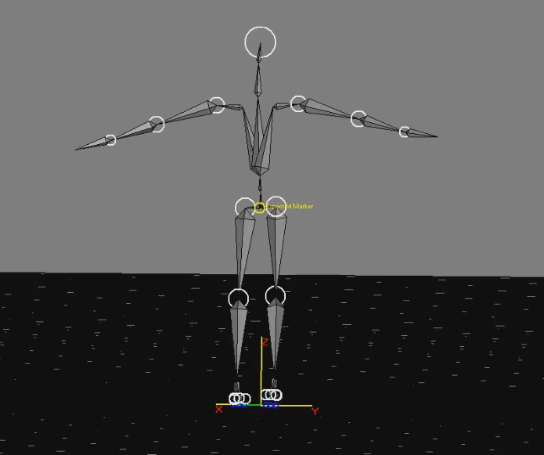

Declaration
I hereby declare that I carried out the work reported in this critical analysis report in the department of Creative Computer Games Design, University of Trinity Saint Davids, under the supervision of Mr. Julian Hainsworth and Mr. John Carroll. I solemnly declare that to the best of my knowledge; no part of this report has been submitted here or elsewhere in a previous application for award of a degree. All sources of knowledge used have been referenced with the Harvard system.

Student Signature: _________________

P Number: 145235

Date: 08/12/17

Abstract
The focus of this analysis is to measure ease of use of the animation pipelines in creating a walk cycle in Maya by keying frames and using video references, versus recording motion capture data of a walk and creating the animation in MotionBuilder. Motion capture data was captured using an electromechanical suit (Animazoo). The Maya walk cycle uses captured footage of the actor walking as a reference (see appendix B). Motion data from each test are applied to a pre-made rigged 3d model. Ease of use is measured by comparing the time taken to create the walk animation in each software, and animation tools within each software are compared and analysed.
The results indicate that Maya’s toolset is greater than MotionBuilder’s, however which tools were easier to use was not found. The further works section suggests ways that ease of use can be more accurately measured. The results indicate that MotionBuilder completes animation tasks faster than Maya, however, Maya produced animations at a higher quality. In conclusion, using time to measure ease of use is not an accurate way of measuring on its own. Biases leading to this conclusion are reviewed in the analysis.

Contents

Declaration 1
Abstract 2
Introduction 6
Literature Review 7
Methodology 9
Results 11
Analysis 17
Future work 20
Conclusion 22
References 23
Bibliography 24
Appendix 25
Appendix A - Diary 1 - 24/10/17 25
Test / Research Undertaken 25
Testing Notes 25
Personal Notes 25
Conclusion 25
Relevant Files 25
Appendix B - Diary 2 - 29/10/17 25
Test / Research Undertaken 25
Testing Notes 25
Personal Notes 25
Conclusion 25
Relevant Files 26
Appendix C - Diary 3 - 31/10/17 26
Test / Research Undertaken 26
Testing Notes 26
Personal Notes 26
Conclusion 26
Relevant Files 26
Appendix D - Diary 4 – 31/10/17 26
Test / Research Undertaken 26
Testing Notes 26
Personal Notes 26
Conclusion 26
Relevant Files 27
Appendix E - Diary 5 – 7/11/17 27
Test / Research Undertaken 27
Testing Notes 27
Personal Notes 27
Conclusion 27
Appendix F 28
28
Appendix G 29
29

Introduction
Creating animations in games and movies is done predominately using two methods; manually doing so by hand-keying frames, or using motion capture. The literature review introduces relevant terminologies and processes regarding 3D animation and motion capture. The literature review contains sufficient information on what is measured in the methodology. The methodology covers the tests taken place, how they are conducted, and what kind of data is recorded for the results. The tests measures the time taken in two softwares; Maya and MotionBuilder, to establish a measurement of ease of use. The software that produces the animation in the shortest time will be considered easier to use. The results section contains all the relevant data from the tests ready for a self-review analysis. The analysis breaks down the validity of each test, what happened during the animation processes and acknowledges any possible biases. Diary entries of each test and other relevant processes with video links are found in the appendices. Further works covers what could be done to strengthen the tests were they to be done again. The conclusion determines whether the tests successfully portray which animation pipeline is more effective.

Literature Review
Maya is a 3D animation, modelling, simulation and rendering software. This software is commonly used to produce computer generated graphics (CGI) in films and videogames (Autodesk.co.uk, 2017). Animation is accomplished in Maya using a range of techniques; Inverse Kinematics (IKs), Animating with keyframes, and use of the graph editor (Palamar, 2013, p.237).
To understand keyframes in 3D animation, it is important to understand some aspects of 2D animation. Traditional 2D animation is ‘a series of drawings shot one after another and played back to give the illusion of movement’ (Roberts, 2002, p. 2). Key to Key (aka pose to pose) are used to create animation sequences. Key drawings, aka keys, are important drawings that ‘sum up the essence of the action during a scene’ (Roberts, 2002, p.11).
Maya animates 3D character models and objects using keyframes. A 3D character model is digitally created through modelling software, and is comprised of polygons. A polygon is ‘a portion of a plane bounded by three or more lines or segments’ (Ratner, 2000, p.4). A keyframe ‘records the value of an attribute at the point in time on the timeline... When two keyframes are set for an attribute at different points in time, Maya interpolates the value between two keyframes’ (Palamar, 2013, p. 249). Interpolation is what moves an object from one place to another, creating an animation in 3D space.
Kinematics is the study of the motion of objects. There are two types of kinematics: forward kinematics (FKs) and inverse kinematics (IKs) (Palamar, 2013, pp.242 - 243). FKs refer to ‘how a basic hierarchy or chain of objects is animated… each joint in a chain is rotated individually’ (Jones & Oliff, 2007, p. 308). IKs is ‘a way to animate a hierarchy, or chain of objects, such that each link in the chain is automatically rotated so that the lower segment is at a specific position or orientation’ (Jones & Oliff, 2007, p. 309).
Motionbuilder is another software created by AutoDesk but focuses primarily on 3D animation. Unlike Maya, MotionBuilder can play and manipulate motion capture data. Motion capture is ‘the process of recording a live motion event and translating it into usable mathematical terms by tracking the number of key points in space over time and combining them to obtain a single three-dimensional (3D) representation of the performance’ (Menache, 2011, p. 2). This means that a person’s motions can be recorded, and that data is used to create animations.
Motion capture systems are classified as outside-in (optical Motion capture systems), inside-out (Electromagnetic motion capture systems), and inside-in (inertial human tracking motion capture systems). These names are ‘indicative of where the capture sources and sensors are placed’ (Menanche, 2011, p. 16).
Rigging is a character setup process where a controllable skeleton is applied to a character model for the animator to use. A skeleton is a ‘structure for animating a character’s actions’ (Ratner, 2000, p.52). Characters are often rigged before animation because a character without a rig cannot be moved around. In a production pipeline, Rig artists may work in parallel with modellers and animators. MotionBuilder generates a rig after its skeleton has been characterised. Characterisation is when the character model’s joints have been mapped out, taking the model’s current pose as ‘the base for all future movements’ (Knowledge.autodesk.com, 2016). Rigging is dependent on marker setup when dealing with motion capture. Marker setup meaning ‘the locations of markers, sensors, or tags used to collect data’. (Menanche, 2011, p. 88).
Both Maya and MotionBuilder make use of animation curves. Animation curves are used to ‘visually describe how the values between two keyframes interpolated over time’ (Palamar, 2013, p. 257). These curves can be manipulated to change the behaviour of the animation. This can also clean up the animation. The animation curves are viewed through the graph editor, which offers ‘basic controls for creating and editing keyframes’ (Palamar, 2013, p. 256). MotionBuilder uses FCurves to display animation curves, which works similarly to Maya’s graph editor.
Methods of setting up motion capture data in MotionBuilder will come from a series of tutorial videos on YouTube (Twycross, 2012). Methods of setting up a walk cycle in Maya will be done by eye following a video reference of the actor, as well as a wider reference to walk cycles from Richard William’s The Animator’s Survival Kit.

Methodology
Maya and Motionbuilder share a range of tools that handle animation. The following tools will be compared and analysed:
- Maya’s Graph Editor vs MotionBuilder’s FCurves
- Maya’s Animation Layers vs MotionBuilder’s Animation Layers
- How both software’s use keyframes
- Import/Export Options
Each step in creating the walk animation will be recorded. Time spent within MotionBuilder, the motion capture recording software (AnimDemo), and Maya will be recorded via OBS screen capture software.
The time taken to create animations in Maya software will take a series of steps. Each step will be recorded individually. These steps are;
- Creating the walk cycle animation by adding key to key poses as keyframes.
A Walk cycle will be created based on video references of an actor. Key poses will be broken down into - Contact (right foot), Down, Passing Position, Up, Contact (left foot), Down, Passing Position, Up, Contact (right foot). This will create a looping animation. In-between keyframes will be added for further adjustments.

- Cleaning the animation by adjusting animation curves.
Animation curves will be manipulated through the graph editor. The animation will also be stretched so that it matches the pace of a walk cycle.
Time taken to create the animation in MotionBuilder will take a series of steps. Each step will be recorded. These steps are;
- Recording the walk cycle.
- The recording software AnimDemo will be used to record the walk cycle. 5 takes will be recorded. Each take would vary in quality, which is why multiple takes are taken. The take with the highest quality will be used in MotionBuilder.

- Using motion captured data to create a walk cycle animation.
- Mapping the motion captured data to a digital actor.
- Merging the pre-made model (Appendix F) into the scene (must be in T-pose).
- Characterising the model and using the digital actor to move the pre-made model.

- Cleaning the animation by adjusting animation curves and adding animation layers.
- A rig will be generated to adjust the skeleton.
- The animation will be layered with animation layers.
- Animation curves will be manipulated through FCurves.
The time taken in Maya will be visualised using a pie chart. The chart will show how much time each process has taken, along with the overall time spent. The time taken to record each walk cycle in AnimDemo and the animation creation process in Motionbuilder will be visualised using a pie chart. The chart will show how much time each process had taken, along with the overall time spent. The pie charts will be used for analysis of the animation pipelines.

Results
Animating a Walk Cycle in Maya
 | Time (Hours, Minutes, Seconds)
Keyframes | 0 h 33 m 33 s
In-Betweens | 0 h 8 m 24 s
Cleanup Animation | 0 h 39 m 2 s
Total Time | 1 h 21 m 0 s

Animating a Walk Cycle in MotionBuilder
 | Time (Hours, Minutes, Seconds)
Recording 1 (Test_Walk02.bvh) | 0 h 0 m 32 s
Recording 2 (Test_Walk03.bvh) | 0 h 0 m 26 s
Recording 3 (Test_Walk04.bvh) | 0 h 0 m 14 s
Recording 4 (Test_Walk05.bvh) | 0 h 0 m 16 s
Recording 5 (Test_Walk06_no jump.bvh) | 0 h 0 m 16 s
Mapping Data to Digital Actor | 0 h 31 m 36 s
Cleanup Animation | 0 h 36 m 43 s
Total Time | 1 h 10 m 3 s

 | MotionBuilder vs Maya Tools
Tool Comparison | Similarities | Differences
Maya’s Graph Editor vs MotionBuilder’s FCurves | Lists translation and rotation information of each joint/ curve.  Each has these same tangent controls;  - Auto  - Spline  - Spline Clamp  - Linear  - Step, Unify  - Break  - Smooth  Each have the same framing tools in the hot bar – frame all keys, frame playback range, centre the view about the current time.  Both software’s have an insert key tool in their hot bar.  Each animation curves can be manipulated by using handles.  Both have a TimeWarp setting.  Both Maya and MotionBuilder can apply namespaces to imported/ exported files. | MotionBuilder has scaling information of each joint/ curve.  Maya has additional tangent controls;  - stepped next  - flat  - plateau  MotionBuilder has the additional hot bar tool ‘Isolate Curve’. The same tool is available in Maya under ‘Select’ < ‘Only Curve’.  FCurves hot bar can key via ‘key’ button, snap to the ‘previous’ and ‘next’ keys, and delete keys.  Maya has different key tools; move nearest picked key  - Lattice  - Region  - Retime  Additional key tools can be found in the ‘keys’ dropdown menu.  Maya has curve tools, such as;  - Enable Normalise Curve tools  - Disable Normalise Curve Tools  - Renormalise Curve Tools  - Enable Stacked Curve Display  - Disable Stacked Curve Display  Maya has cycle tools;  - pre-infinity  - pre-infinity offset  - post-infinity  Additional curve settings can be found in the curve menu.  ‘TimeWarp Display’ is a checkbox that can be ticked on FCurves sidebar.  Maya’s Timewarp settings are located under ‘Edit < Scene TimeWarp < Enable Scene Timewarp’.  Tangent values in FCurves are broken down into ‘value’, ‘time’, ‘angle’, and ‘weight’.  Tangent values such as these are not represented in Maya.
Maya vs MotionBuilder Import/Export Options | Both software’s can import and export FBX files. Scenes from MotionBuilder can be transferred to Maya (given that the data is readable), and Maya can send scenes to MotionBuilder. | MotionBuilder has a range of import/ export features. Motion builder can break down ‘Scene’ and ‘Settings’ data into ‘elements’ and ‘animations’. Each element has a ‘floppy disk’ symbol, meaning that element will be imported in (if it exists). These floppy disks can be clicked to negate that elements import. These are the following ‘Scene’ Data Elements;  - Actors  - Actors Faces  - Audio  - Bones  - Cameras  - Characters  - Characters Faces  - Character Extensions  - Constraints  - Devices  - File references  - Groups  - HUDs  - Keying Groups  - Lights  - Materials  - Models  - Notes  - Optical Data  - Poses  - Physical Properties  - Scripts  - Sets  - Shaders  - Solvers  - Story  - Textures  - Video  These are the following ‘Settings’ data elements;  - Base Cameras  - Camera Switcher  - Current Camera  - Global Lighting  - Transport  Maya can import a range of file types, but does not break down Import Export settings in the same way. Each file type comes with ‘File Type specific Options’.  Maya cannot use motion data in its raw form.
Animation Layers | Both animation layering tools allow the user to add layers, duplicate layers, delete layers, and move layers up or down the listed layers. Both software’s have a lock, solo, and mute function for each layer. Both software’s have a weight slider that can range from 0% - 100% weight influence.  Animation layers can be manipulated in FCurves and Maya’s Graph Editor. | Maya has extra features added to the animation layers hot bar, such as;  - Zero key Layer  - zero weight key layer  - Set weight to 1 and key layer  Animation layers are displayed as a tangent in Maya’s graph editor, and can be manipulated like any curve.  Maya also has extra features under ‘Layers’ and ‘Options’.

Analysis
Data gathering for MotionBuilder was problematic because the space used to record a walk cycle was limited. The actor’s movement was recorded outside the AnimDemo recording room. The further the actor was from the computer, the more interference occurred in the recorded data. When the actor reached a certain distance away from the recording room, the recording would result in a crash. To resolve this issue, a marked space was defined showing where the actor could walk to. Two locations were defined, indicating where the actor could walk without a recording crash. Interference reduced the data accuracy of each recorded take. If the actor was closer to the computer, such interference may have been reduced.
Posing issues occurred during the recording process. The Animazoo suit records best when the actor starts in I pose (Figure 2), however the actor must be in T pose for the digital actor in MotionBuilder. This means that the actor would have to stand in I pose, then T pose, and then the walk motion data would be recorded with the actor ending in T pose. This was the best process to ensure that the BVH data would be usable in Motion Builder.
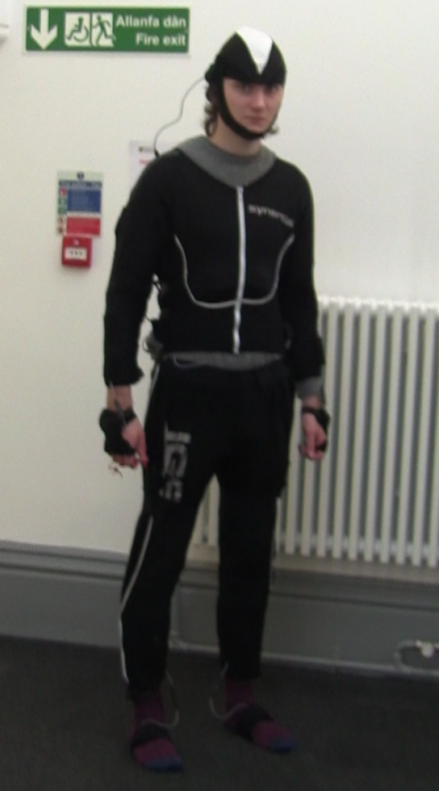
Figure 2: Gray 2017. I pose Animazoo suit.
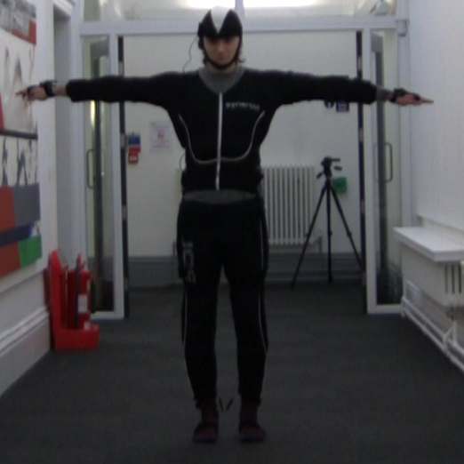
Figure 3: Gray 2017. T pose in Animazoo suit.

The AnimDemo software confuses north and south directions. The actor would have to face south for AnimDemo to orient correctly. However, the orientation tool within the software states that the actor should be facing north. Attaining the correct world orientation was an awkward process because of this.
An extra walk cycle was recorded with the aim of attaining a data with less interference. All recordings, except for the 6th take, were recorded with AnimDemo’s ‘jumping’ option on. The jumping option allows for the actor to perform actions that would potentially lift them from the ground i.e. a jump. This option was ticked off for the 6th recording. The resulting animation had no significant increase nor decrease in quality over the previously recorded walk cycles.
The recorded motion captured data was poor. Recordings suffered from crashes and interference, making the BVH data look jittery. The 3rd BVH file was chosen for MotionBuilder as it appeared to be the most accurate and did not suffer any crashes.
Assigning the BVH data to the digital actor was a straightforward process following the YouTube tutorial videos. By aligning the actor to the BVH data (the point to which the actor begins in T Pose), data could be dragged and dropped from the BVH to the actor. This was an interesting process, as BVH data could be added to multiple key points in the actor. This was imperative to the actor’s setup as the hip area required BVH data from the hips, thighs, and spine. After correctly assigning BVH data to the digital actor, the ‘active’ checkbox must be checked (located in Navigator < Actors < Actor). This allowed the digital actor to move following the BVH data.
It was difficult to undo any mistakes when mapping BVH data to the digital actor as an undo button seemed to be absent. Any mistakenly placed BVH data on the actor could not be amended. Some data required trial and error to understand where it should and shouldn’t be placed. Trial and error problem solving can be difficult when there are no options to undo, asides from reloading the file at an earlier stage.
An issue cropped up when assigning the BVH data to the digital actor because the BVH data does not begin in a perfect T Pose. The digital actor’s arms had to be bent unnaturally to match the BVH data, which may have affected the animation quality later. Were it that the BVH data began in a better T-pose, the resulting animation may have looked more natural.
The BVH data controlling the digital actor was very messy. Each body part shook uncontrollably, yet at the same time the range of motion for the arms seemed stiff. The arms clipped through the body when swinging back and forth. This explains why 53% of time in MotionBuilder was spent cleaning up the animation.
Generating a control rig via characterisation was easy because the model used matched with motionbuilder’s naming conventions. This was not the same model used for the walk cycle in Maya, but a model from Mixamo (Appendix G). The model was mistakenly used over the Maya model because both model shared similar file names. The skeletons of both models are similar, however one difference that would impact the test was the joints naming conventions. If the Maya model was used the naming conventions would have to be changed. This would impact the time spent in the ‘mapping data to the digital actor’ section of the results.
Animation layers were added to fix the arm clipping issue. The joints were selected using the generated control rig. Unlike Maya’s graph editor, MotionBuilder does not show all the tangent curves in FCurves right away. The tangents must be individually selected by clicking the translation or rotation on the x, y, z axis. This prevents the editor from being cluttered with curves, but it appears to be unintuitive when wanting to see anomalies in a series of curves. The clipping issue did not appear as an anomaly in FCurves and could not be fixed. The animation layer made little difference to the clipping issue. The cleaning process in MotionBuilder was pre-emptively stopped because these efforts to fix clipping and clean FCurves made little to no difference.
The difference between the control rig generated in MotionBuilder and the pre-made rig in Maya may have affected the overall time spent in each software. The shape of the controls and additional features in Maya’s rig such as IK/FK switching, may have sped up the animation process. The tests could have lessened the chance of bias if the rig in Maya identically matched the rig in MotionBuilder.
A walk cycle in videogames often requires the animation to begin and end from the same root position. MotionBuilder has a solution for this by locking the model’s positioning to one place. This tool is found within navigator < Characters < Character < modifier < In place. The tool can lock positions in each axis individually. The tool is very useful and such a tool does not exist in Maya. The Maya model would require the forward translation of the animation to be zeroed out in the graph editor so that it would not move. MotionBuilder’s method of locking a model in one axis is easier to do in than in Maya, but both software’s can achieve the same results.
Looping an animation in Maya can be done easily selecting and copying the keys at the beginning of the animation, and pasting those keys to the end of the animation. The problem with Motion captured data is that the data is keyed to each frame, meaning blending and looping is difficult unless certain tools are used. MotionBuilder does have tools that can loop animations (Story and Motion Blend) however the quality of those loops is unclear without further testing. Given that the time spent of cleaning the animation was so long, no time was dedicated to looping the animation in MotionBuilder.
The walk cycle was created strictly following the motion capture actor’s footage. This walk cycle was created with the attempt of discarding previous known animation techniques and solely using the recorded reference. Unfortunately, there is no evidence that this eliminates personal experience bias. Accuracy is difficult to achieve when trying to mimic a recorded walk cycle. The animation is similar but not identical to the reference. With more time spent the resulting animation may be more accurate, however, how much time it would take is uncertain.
Achieving a quality reference for Maya was a difficult process. Two cameras were used to attain a front and side shot. These were intended for use for the Maya animation process. It was intended that the actor would be recorded during the mocap recording session, so that the motion capture data would match the references used in Maya. Due to space limitations, a side and front reference could not be attained at the same time. The space was found outdoors, and the walk cycle reference could successfully be recorded. This recording is found in the relevant files section of Appendix B.
The recordings were not conducted using individuals without acting nor directing experience. This lack of experience may have affected the quality of the motion capture. It is difficult to tell if this is the case because AnimDemo recorded data poorly anyway. Hiring a motion capture director could significantly improve the overall quality of the animations through guiding the actor’s performance.
This kind of test would be difficult to conduct with random participants as the methodologies for creating 3d animations or setting up motion capture data appears quite dense. Therefore, an analysis of an animator would be preferable. However, using an animator brings the risk of having experience bias in one software over the other, and thus affecting the test results. No attempts were made to account for such biases.
Using the time taken to measure the ease of use of each software does not appear be a valid on its own. There were many things to account for, such as the usability of tools used during the animation process, which time in itself does not account for. A list of the tools used with a numerical ranking system suggesting which tools were easier to use would be a more effective way of measuring ease of use.
By looking at both software’s animation tools, Maya has the widest range of functions by having additional curve animation layer options. Almost all tools in MotionBuilder are available in Maya in some form. However, MotionBuilder handles data that specifically pertains to motion capture, such as ‘Actors’ and ‘Characters’. Also, MotionBuilder can read motion capture data whereas Maya cannot.
It may have been more effective to compare tools in Maya and MotionBuilder before conducting the time tests. Despite the wide range of tools Maya has at its disposal, very few of those tools were used during the test. With more knowledge of the animation tools in both software, the time spent in each test may have been reduced and/ or the quality of the animations may have increased.

Future work
The analysis points to several issues of the tests conducted such as bias and data accuracy. There are numerous resolutions to these problems that could be implemented in future works;
- Achieve more accurate data from motion capture technology
The data gathered using the Animazoo gyroscopic suit was very poor and impacted MotionBuilder’s effectiveness in creating animations from that data. The animation produced from the motion captured data was of poor quality, even after undergoing a clean-up process. If an optical system (for example, a Vicon system) was used instead, far greater data accuracy could be achieved.
The poor motion captured data had a significant impact on the time taken to clean-up animations in MotionBuilder. The clean-up process may have been reduced significantly with more accurately captured data. The clean-up time in Maya and MotionBuilder were roughly the same, however Maya’s clean-up process was much more effective.
- Use the same character model and control rig in both tests
The different control rig and character model used in MotionBuilder and Maya could affect the overall time spent in each software. The control Rig used in Maya is similar, but not identical, to the control in MotionBuilder. This could give a time advantage/disadvantage to the animation creation process in Maya. This same issue applies to the separated character model. To prevent such issues in future work, the character model and control rig should be identical in both tests.
- Conduct tool analysis before the test
Many of the tools available in Maya and MotionBuilder were not used during the animation creation process. This is because of a lack of awareness of certain tools. An awareness of the tools available would provide a greater knowledge of how to develop animations in both software’s. This could impact the overall time spent creating animations.
- Tools ranked by their usefulness
With knowledge of each of the tools, a numerical system between 1 (very low) to 5 (very high) ranking each tools usefulness could be established and used as part of the test. This could outline how tools are used more effectively in one software over another. The same numerical system could be used to measure the test participant’s experience in each software, accounting for experience bias.

Conclusion
An ease of use measurement could not be achieved by measuring time spent in MotionBuilder due to poorly captured motion data. Mistakes such as using the wrong 3D model in MotionBuilder would create a bias affecting the overall time spent in each test. Measurements of time spent in each software does not appear to be a valid measurement of ease of use alone. Comparing the time spent in Maya and MotionBuilder has no practical relevance because of this.
Tool analysis suggests that Maya has the wider toolset, however, it is ineffective in reading motion captured data without MotionBuilder. A conclusion on which tools in each toolset was more/ less effective than the other was not reached.

References
Autodesk.co.uk. (2017). Maya | Computer Animation & Modelling Software | Autodesk. [online] Available at: https://www.autodesk.co.uk/products/maya/overview [Accessed 10 Oct. 2017].
Figure 1: Richards, C. (2017). UE4 Mannequin Rig. [image] Available at: http://coryrichards327.wixsite.com/portfolio/copy-of-flying-snake-prototype-2017 [Accessed 3 Dec. 2017].
Figure 2: Gray, J. (2017). I pose Animazoo suit.
Figure 3: Gray, J. (2017). T pose Animazoo suit.
Figure 4: Mixamo. (2017). X Bot. [image] Available at: https://www.mixamo.com/#/?page=2&type=Character [Accessed 3 Dec. 2017].
Jones, A. and Oliff, J. (2007). Thinking animation. Boston, MA: Thomson Course Technology.
Knowledge.autodesk.com. (2016). Characterize the character model | MotionBuilder | Autodesk Knowledge Network. [online] Available at: https://knowledge.autodesk.com/support/motionbuilder/learn-explore/caas/CloudHelp/cloudhelp/2017/ENU/MotionBuilder/files/GUID-4C33E322-D32F-43B1-AA19-0AC5262E4EAB-htm.html [Accessed 10 Oct. 2017].
Menache, A. (2011). Understanding motion capture for computer animation. Burlington, MA: Morgan Kaufmann.
Palamar, T. (2013). Mastering Autodesk Maya 2014. Sybex.
Ratner, P. (2000). Mastering 3D animation. New York: Allworth Press.
Roberts, S. (2002). Character animation in 3D. Oxford: Focal.
Twycross, J. (2012). MotionBuilder part 1 - Using actors & motion capture data. [online] YouTube. Available at: https://www.youtube.com/watch?v=6k1ul5SGIUE [Accessed 3 Oct. 2017].
Williams, R. (2012). The Animator's Survival Kit: A Manual of Methods, Principles and Formulas for Classical, Computer, Games, Stop Motion and Internet Animators (Expanded). Faber & Faber.

Bibliography
Lowe, D. (2013). Motionbuilder Mocap Clean-Up for Games. [online] YouTube. Available at: https://www.youtube.com/watch?v=XxHi7_pXN-k [Accessed 3 Oct. 2017].
O'Hailey, T. (2013). Rig it right! Maya animation rigging concepts. Burlington MA: Focal Press.
Pluralsight. (2014). Key 3D Rigging Terms to Get You Moving. [online] Available at: https://www.pluralsight.com/blog/film-games/key-rigging-terms-get-moving [Accessed 10 Oct. 2017].
Twycross, J. (2012). MotionBuilder part 2 - Use an actor to drive a character. [online] YouTube. Available at: https://www.youtube.com/watch?v=3Fvd9-sqx4Y [Accessed 3 Oct. 2017].
Vicon. (2009). Motion Capture and MotionBuilder demo. [online] YouTube. Available at: https://www.youtube.com/watch?v=2uDnW4AtFiE [Accessed 3 Oct. 2017].
3d, E. (2014). Motion Builder - MoCap Cleanup and Re-targeting. [online] YouTube. Available at: https://www.youtube.com/watch?v=wOzChtcqBRk [Accessed 3 Oct. 2017].

Appendix

Appendix A - Diary 1 - 24/10/17
Game Design and Critical Analysis
P145235 – Cory David Richards

Test / Research Undertaken
Motion capture recording sessions for walk cycles.

Testing Notes
- Recording walk animations.
- Recording walk cycle 1 to 5 with jump setting on.
- Recording walk cycle 6 with jump setting off.
- Interference when actor is too far from the computer, causing the software to crash.

Personal Notes
- Test being conducted in a hall. Some interruptions by people walking in the hall.
- Cannot record front and side reference for Maya.
- AnimDemo video contains all mocap recordings of that day, it is unedited.

Conclusion
6 walk cycles are recorded and are ready for use in MotionBuilder.

Relevant Files
AnimDemo screen capture, with BVH data for MotionBuilder: https://drive.google.com/open?id=1tMQzX03W7GGbryJqXZMwFf3PrTTbt3HV .

Appendix B - Diary 2 - 29/10/17
Game Design and Critical Analysis
P145235 – Cory David Richards

Test / Research Undertaken
References for Maya walk cycle.

Testing Notes
- Side and front references recorded using cameras on tripods.

Personal Notes
- Recordings may need to be edited later to match for a more accurate reference.

Conclusion
Front and side references successfully recorded

Relevant Files
Recorded video reference of front and side of the actor: https://drive.google.com/open?id=1tchpvC2uAcyv5iYxk4qsC12tvgD3OfLC .

Appendix C - Diary 3 - 31/10/17
Game Design and Critical Analysis
P145235 – Cory David Richards

Test / Research Undertaken
Creating the walk cycle in Maya.

Testing Notes
- Creating the animation keyframes.
- Creating inbetween keys and adjusting curves.
- Adjusting and cleaning up curves up curves.

Personal Notes
- Watching the walking reference on a separate screen whilst animating.
- Will have to edit out or not use the time when not animating in results.

Conclusion
Walk cycle was successfully animated.

Relevant Files
The recorded screen capture of making the walk cycle in Maya:
https://drive.google.com/open?id=1MKbpRG64ZN2g1CU8kQRa3kUrnWr6AlzC .

Appendix D - Diary 4 – 31/10/17
Game Design and Critical Analysis
P145235 – Cory David Richards

Test / Research Undertaken
Creating the walk cycle in MotionBuilder.

Testing Notes
- Importing BVH files, finding the file with the most accuracy.
- Assigning BVH data to digital actor. Requires trial and error.
- Using digital actor to drive character model.
- Cleanup consisting of manipulating FCurves and adding animation layers.
- Centre animation using modifier.

Personal Notes
- FCurves difficult to use – can’t access curves easily.
- Animation layers aren’t very effective.

Conclusion
A poor-quality walk cycle was created.

Relevant Files
Recorded Screen Captures of animating in MotionBuilder: https://drive.google.com/open?id=1u1YnXMMcNh_iXKsS7dkRBbmSCR3NXe38

Appendix E - Diary 5 – 7/11/17
Game Design and Critical Analysis
P145235 – Cory David Richards

Test / Research Undertaken
Breakdown of Maya and MotionBuilder’s tools regarding animation

Testing Notes
- Differences in hot bars between Maya’s graph editor and MotionBuilder’s FCurves.
- Differences with import / export settings.
- Few differences in animation layers, however Maya has more features.

Personal Notes
- Should have analysed tools sooner and applied them to the test.

Conclusion
Comparison of animation layers, FCurves, graph editor, and import / export settings between software’s are established.

Appendix F

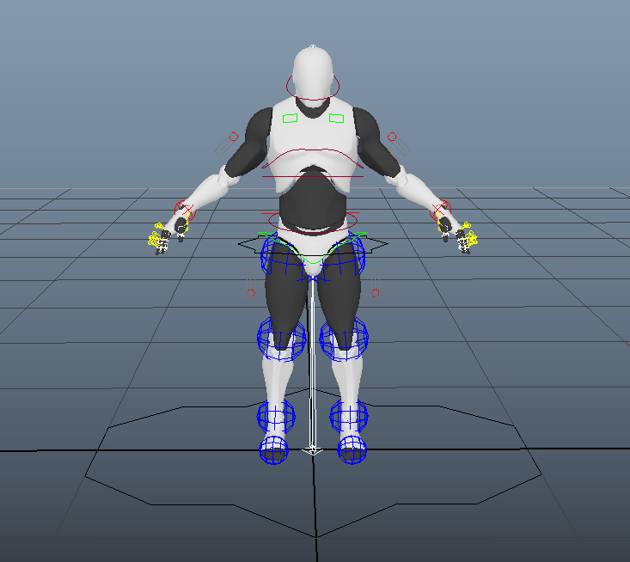

Figure 1: Richards 2017. UE4 Mannequin rig.

Appendix G

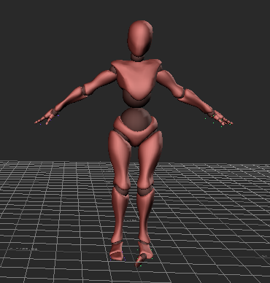
Figure 4: Mixamo 2017. X Bot.

