Explore and analyse the Corporate Strategy of BMW and explain how this influence the company’s ability to gain a competitive advantage

The business strategy of BMW is based on having a powerful brand image, this strategy bring success to BMW Group.
BMW Group believes in maintain core values as technology, innovation , performance , quality, reliability, exclusivity and customer satisfaction. This values make them gain a
competitive advantage on market.
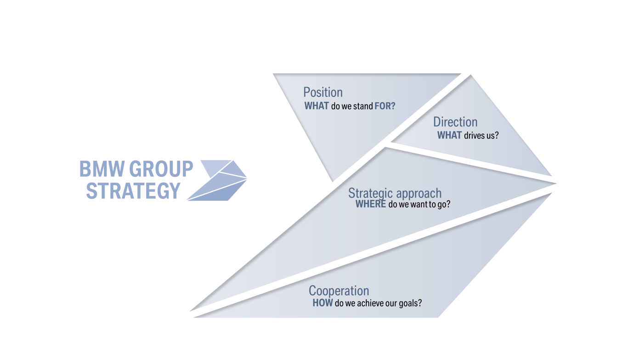

If we will have a look on them official site www.bmwgroup.com they explain very nice and clear them strategy. That strategy is based on 4 main points like: Position which is what they stand for, Direction is what is driving them, Strategic approach which shows here they want to go and Cooperation where they explain how they achieve them goals.

There is strong evidence that our implementation of the BMW Group Strategy is having a very concrete effect. It sets clear guidelines and provides the company with a roadmap for shaping the individual premium mobility of tomorrow. We will continue to chart our own course and develop the BMW Group in a sustainable way that will secure its future. In doing so, we are guided by our goal of long-term, profitable growth for the company.

