BMSW5101
Developing Workplace Critical Thinking

How Individual’s Beliefs,

Attitudes and Values impact on

workplace behaviour
Yen Yen Lai
1710668

13th December 2019

Executive Summary

The author was requested to critically analyse how individual’s behavior in the workplace has originated from their own beliefs, attitudes and values, and the impact of such behavior on the organisation they work for. The author examined classical and modern management theories to critically assess their relevance to the organisation’s culture and values. Following this, the author’s own beliefs, attitudes and values about the author’s job role were assessed, which led to a conclusion that if possible, individuals should always choose to work for an organisation that has similar values with themselves.

Table of Content

Executive Summary 2

Table of Content 3

Introduction 4
- Findings 5
1.1 Analysis of Management Theories 5

1.2 Impact of Systems Theory on Swansea University’s employees 7
1.3 Additional theory to enhance Swansea University performance 7

- Individual’s beliefs, attitudes and values 8

2.1 Impact on customer base 8
2.2 Impact on employees 9
2.3 Review on Swansea University values 9
2.4 Comparison and The author own beliefs, attitudes and values 10

Conclusion 11

Appendices 13

References and Bibliography 15

Introduction

The author was working in a group project to critically analyse Admiral Group organisational culture and values impact on its employees. The author and group have used Toulmin model to construct the argument whether Admiral Group live up to its values. From this project experience, the author also started to evaluate her own beliefs, attitudes and values, and whether she is aligned with the organisation she works for and exhibiting her behaviour in the workplace matching to the organisation’s values.

This report was requested to answer the question raised from the project. The author carried out a critical analysis of the impact of beliefs, attitudes and values on workplace behaviour. The Toulmin model was used to generate arguments between classical and modern management theories in a critical manner, and to evaluate how the manager in a workplace engages with its employees to foster the organizational culture and values. At this point, the author will compare Admiral Group with Swansea University to back up and explore different arguments to reflect the management of the organization, and its success or failure to deliver what it claims.

The author will use Toulmin model to construct the argument of management theories to evaluate and analyse to those of individual’s values, beliefs and attitudes.

- Findings

For an award winning and growing organisation Admiral Group must have a strong core culture and values that work to elevate it to succeed in becoming the number one company in the 25 Best Big Companies to Work for this year (Best Companies, 2019). The author will be exploring her own workplace: Swansea University, to find out how the organisation implements its culture and values in her workplace. By way of contrast, the author also will assess another organisation: Forever 21, that has recently closed down a number of retail shops.

  - Analysis of Management Theories

The management team and individual managers in an organisation need to consistently use a management theory to shape and control the employees in the workplace to perform to enable them to achieve the organisation’s desired outcomes.

Business Dictionary explains this as “A collection of ideas which set forth general rules on how to manage a business or organisation. Management theory addresses how managers and supervisors relate to their organisations in the knowledge of its goals, the implementation of effective means to get the goals accomplished and how to motivate employees to perform to the highest standard.” (Business Dictionary, 2019).

There are four main categories of management theories, the first three are historical theories, and the last one is more contemporary, having been adjusted and developed to include the latest technological advancements, globalisation and the communication revolution. Although the author would say that some parts of the historical theories are still applicable in the 21st century, management theory has evolved, encompassing changes such as diversity, and internationalisation of the workplace. Consequently, the author finds that there is a mixture of historical and modern theories being used in organisations.

- Scientific Management (Frederick Taylor) – This is a scientific approach to improve operations processes by breaking down the task into micro levels, and reducing production times (Elkins, 2019). This theory was developed during the industrial revolution. The most high-performing workers get selected to do the jobs best suited to the organisation’s needs. The downside for workers is that if a worker didn’t achieve targets, he would be paid less than those that achieved target.

- Classical Management – focuses on structured operations, and standardised production to maximizing total output (Elkins, 2019).

Administrative (Henri Fayol) – Fayol came from an engineering background and progressed to managing his own factory. He developed an administrative theory that structured a series of processes of principles, rules, and procedures to accomplish work. The authority and hierarchy in this theory is a limitation for bottom line employee to cross over (Elkins, 2019).

Bureaucracy (Max Webber) – A legal central controlled system similar to government agencies, designed to eliminate favouritism, and incorporating organisational hierarchies given authority to control specific areas. Each area of control is tied to a specific job position, and the power of control will rest with any new person that comes into that particular job role. However, the lack of flexibility of this theory can caused long delays, and lead to corruption (Elkins, 2019).

- Behavioral Management – A people-oriented method designed to satisfy interpersonal needs. Also called the Human-Relation theory, it emphasizes the alignment between worker’s needs and organisation’s needs.

Maslow’s hierarchy of needs and McGregors’s Theory X/Y were both developed to motivate workers to perform well in work (Sasan and Almasifard, 2017). Maslow’ s hierarchy of needs will not be appropriate for people who are content with what they already have, as they do not desire to progress to the next level.

- Modern Management –For the constantly changing globalised business world, elements such as work environment and technology assimilate with human and traditional theories. A mixture of ideas has developed for this management style (McNamara, 2019).

Quantitative theory was essentially developed for military decision-making during World War II for managerial efficiency needs. Problems are solved through statistical and mathematical analysis, collected from different areas, to ensure resources are deployed more effectively and efficiently. However, the unpredictability of human response was not fully thought of, and some unrealistic assumptions can be considered drawbacks of this theory (McNamara, 2019).

Systems theory is a collective of interrelated (internal and external) components to accomplish the organisation goals. The whole system framework only works when original planned inputs and outputs come together. If any one of the planned inputs is removed, outcomes will not be the same as expected (McNamara, 2019). The drawback is the bigger an organisation the more complex the system become, and it involve social system, numerous subsystems, clusters of communications could cause confused messages within main system and subsystem.

Contingency theory (Joan Woodward) The idea is for decision making managers to solve issues depending on key aspects of each situation and circumstance. Nonetheless, the effectiveness for solving problem relies heavily on manager’s merits and experiences of handling crisis (McNamara, 2019).

1.2 Impact of Systems Theory on Swansea University’s employees

Due to the complexity of local and international students demands and external suppliers’ involvement, Swansea University management have applied Systems theory to manage the organisation.

For example, to hold a successful graduation event, there are a string of departments working together: these include Estates for planning and organising the venue, and booking photographers and music, Student Unions for volunteers and social apps and website; The Student Hub for distribution of news, marketing emails, accommodation bookings and welcome packages, ISS for wifi queries, customer enquiries and photo orders, the Graduation Committee for food catering, attendance name list, clothing orders, certificates, and dealing with external suppliers. With planning, motivation, consistent communications, and good situation management, it is possible to ensure everything meets the customer expectations and they have a good experience. Swansea University employees take pride in receiving high praise from graduates and family members, because the whole event was so well organised and exceeded their expectations.

Exchanging feedback among its various internal and external components after an event is a vital tool for improvement. All participating departments meet for an internal feedback meeting. External suppliers meetings are also held by the Estates and Graduation Committees to follow up on any issues highlighted by these external participants.

The problem is that an academic college could, for example have a wonderful central administration and wonderful set of lecturers, but if the department didn’t synchronize with other areas of the business at all the event could be a disaster (McNamara, 2019). The system is formed by the density of communications of information within and between internal and external actors. The college should separate communication into two sections: within-system communications and between-system communications. The manager needs to have constant and consistent communication with employees, ensuring employees fully understand their tasks for the college administrative team within, and clearly defined goals to deliver excellent lectures for students.

System management theory has created a wave of internal and external engagement opportunities for employees. The energy it generates motivates employees’ willingness to work hard together as a team, which boosts the whole management team spirit. For every different event or project, internal and external components started to form together, the combination of internal and external components could be different; that means employees from different colleges, different level get to work together, socialised for a same goal, engaged with the wider communities, with different supplier, from different countries, due to the different demands of the project. This impact on the perspective of employees, motivates them to work outside from their comfort zone, and be more adaptable to changes in the workplace, more aware of their effect on a particular project. This new theory also allows the management and individual manager break the traditional model of top-down, hierarchical structure of managing their employees.

System theory is relatively new, and not many managers understand the full functionality of it. The external components could be environment effects or logistical factors. Inexperience managers will struggle to comprehend the situation, the increasing complexity in the system means increases in cost, and more resources are needed to process this increased complexity and cost, along with more internal paper works trails.

1.3 Additional theory to enhance Swansea University performance.

Another new modern management theory Contingency theory could enhance manager’s ability to make fast decisions depending on different situations during crisis times. Managers should not expect to still be able to keep the modern-day workplace fully controlled using an old-style management system. Today world events have spiralled into chaotic situations, and even some basic task could go out of control in the workplace. Managers need to use all the key aspects available on hand to approach and deal with the out of control situation. The approach basically ‘depends on’ what happened, what key aspects are available, and which priority come first.

This theory also requires experience, practice, and quick thinking, not all managers have these qualities. The organisation needs to offer extensive specialist conference courses to develop such skills, which again means extra cost.

- Individual’s beliefs, attitudes and values

The definition of beliefs has been separated from values by Barrett Values Centre, because they are regarded as two different issues. Barrett Values Centre claim “Beliefs are assumptions we hold to be true. When we use our beliefs to make decisions, we are assuming the causal relationships of the past, which led to the beliefs, will also apply in the future.”(Barrett Values Centre, 2019).

Values are defined as “important and lasting beliefs or ideals shared by the members of a culture about what is good or bad and desirable or undesirable. Values have major influence on a person’s behaviour and attitudes and serve as broad guidelines in all situations.” (Business Dictionary, 2019).

Every individual has their own set of beliefs, attitudes and values in life. These beliefs, attitudes and values are reflected in every action and reaction when people come to in contact with one another. Genuine individuals behave and function naturally showing others their own beliefs, attitudes and values through communication and socialising.

When these individuals go to work, the way they treat colleagues, customers, and suppliers unconsciously reflect their own beliefs, attitudes and values, whether such behaviour is approved by the organisation they work for or not. Traditional organisations tend to try to instil their history, beliefs and values in employees during their orientation period, including desirable behaviour patterns. Such a controlling enforcement is no longer practical in a modern workplace, as it could affect employees job satisfaction and retention.

Individuals can change what they believe and redefine their own attitudes and values. To evolve and transform into a better individual. According to Barrett, there are seven levels of growth and development stages for an individual person’s consciousness (Table A), which are rooted deeply in that person’s beliefs, attitudes and values (Barrett Values Centre, 2019).

2.1 Impact on customer base.

Instead of trying to change and control the behaviour of employees in the workplace, it would be better to employ a group of people that already have the desired behaviours. While organisations require employees to commit themselves when working, the employees also ask the organisation do the same thing in return. Both sides require reciprocal commitment for the work contract to be successful (Arnold and Randall, 2010).

Once the individual feels that they have total trust from the organisation, they can embed the organisation’s values in their actions, being a valued member in a big family, willing to input effort in everything they do. This positive commitment from both sides helps motivate individuals to be willing to go the extra mile when dealing with difficult or distressed customers, this increases customer satisfaction, improves work performance, and increases business profit and growth.

If the individual feels their own beliefs and values are disconnected from the organisation’s values, the façade put up in workplace cannot last long. Soon the individual will start feeling frustrated, and angry. This negative energy could reflect when dealing with colleagues or customers, unintentionally causing customer dissatisfaction, and an increase in complaints.

2.2 Impact on employees.

“It is important to align personal values and the values of your organisation so that you can be who you are really at work.” (Barrett Values Centre, 2010)

Further explained by the Barrett Values Centre “The alignment is important because it release commitment, enthusiasm, creativity, motivation to go to work just be yourself.” (Barrett Values Centre, 2010). Individuals cannot continue to perform in a fake façade for long period of time, very soon conflict will be created, and friction with inner self due to being unable to regulate one’s own behaviour.

2.3 Review and on Swansea University values.

Public consciousness has become much more sensitive, leading to demands that Swansea University be more socially responsible. Swansea University has created a wider arena for sales and services gains within the global marketplace, and therefore has become responsible to a wider community of “stakeholders.”

Swansea University core values are: We are Professional, We Work Together and We Care.

Between organisational values and business growth, the university is engaging and reinforcing these values in the workplace. Swansea University needs to employ likeminded new starters, because their behaviour in the workplace and response to customers determines the future success of the university.

2.4 Comparison and The author own beliefs, attitudes and values.

The author has completed a personal values assessment (Table B) online using Barrett Values Centre tool to make sense of her life, having a blueprint of personal values, align with her own beliefs, attitudes and values, with the university she works for.

The author further analyse the university values by checking the company reviews on Glassdoor.co.uk website. A comparison chart (Table C) and Glassdoor company reviews screen (Table D) showed that achieved 4.3 satisfaction from employees (Glassdoor.co.uk., 2019).

According to criticism on high peaks of workload; the author will class this as a personal time management issue, not related to the total function of a department, on low season is bored, which indicated there is motivation issue, and poor admin staff, mostly related to individuals conflict case. There are strong evidence show the university value is compatible with the author’s own values, such as accountability, commitment, creativity, equality and community involvement.

The author is encouraged and motivated by section manager to make decision and design own development plan in workplace. Judging on supports from colleagues and flexible hours to suit personal family life, the author is enjoying go to work in the university. Finally, the author will continue to work for the university and continuously development ownself to progress to next level.

2.5 Values-led organisations more successful?

Yes. Employees that have or share the same belief, attitudes and values are motivate in their work, they understand their own behaviour could affect colleagues and customers in the workplace. Employees willingness to collaborate with the organisation strategy, engage with the activities happen in the workplace, contribute effort to meet target that encourage business growth. Employees feel that they are “living” with the organisation values. Organisation need to be embedding the values starting from recruiting process, internal awards, internal communications, training and development, appraisals, and performance management (Sales, 2017). Organisation no longer need to use bureaucracy style of management theory to manage their employees how to behave and perform in the workplace, instead the employees are enjoying go to work, conscious how their own behaviour impacts the performance regulate themselves in the workplace. This is competitive advantage for an organisation to be more successful than others.

Conclusion

The author has used the Toulmin model framework to construct the report in an analysis and evaluation format. The analysis on management theories, following by impact of these theories on an organisation. Then, the author critically analyse the individual’s beliefs, attitudes and values impact on organisation’s customer base and employees. The in-depth comparison with the author own beliefs, attitudes and values to confirm that alignment with the organisation values is best way for an employee.

Appendices

Table A: Seven Levels of Personal Consciousness

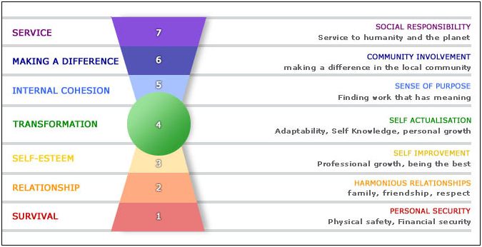
Copy Right: Barrett Values Centre

Table B: The author’s Personal Values Assessment report

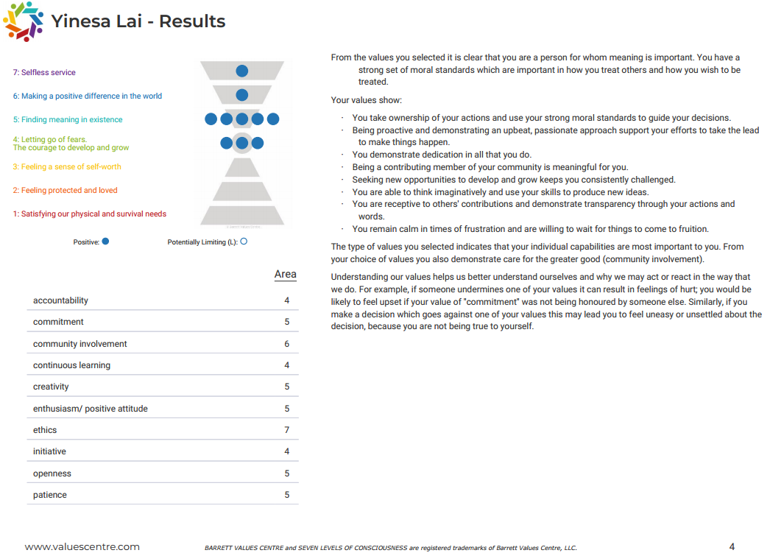
Table C: Comparison chart between Critics on Swansea University, Swansea University values and The author personal values

Critics on Swansea University practice | Swansea University Values | The author Personal Values
- High peaks of workload.  - Low season is bored.  - Poor admin staff.  - Poor communications.  - Not enough shift hours. | - Communication  - Accountability  - Commitment  - Transparency  - Creativity  - Equality  - Teamwork  - Care  - Environmental awareness  - Community involvement | - Accountability  - Commitment  - Community involvement  - Continuous learning  - Creativity  - Ethics  - Equality

Table D: Glassdoor Company Review on Swansea University

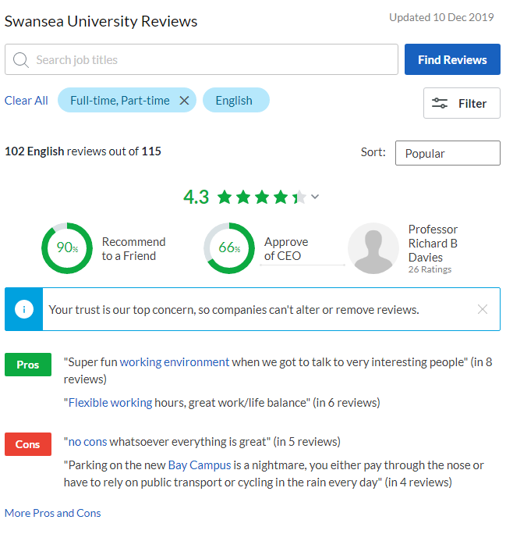
Copy right: Glassdoor.co.uk

References and Bibliography

Admiral Group plc. (2019) Available at: https://admiralgroup.co.uk/our-culture (Accessed: 10 November 2019).

Admiral Group plc. (2018) Annual Report 2018. Available at: https://admiralgroup.co.uk/sites/default/files_public/annual-report/2019/03/2018-full-year-results-annual-report.pdf (Accessed: 10 November 2019).

Arnold, J., Randall, R. et al. (2016) Work psychology: understanding human behavior in the workplace. 6th edn. New York : Pearson Education.

Barrett, R. (2013) Changing Culture in the workplace – Empathy and Compassion in Society 2013 [video]. Available at: https://www.youtube.com/watch?v=jb4gPoZ5Imk
(Accessed: 4 December 2019).

Best Companies (2019) Available at: https://www.b.co.uk/ (Accessed: 10 November 2019).

Business Dictionary.com (2019). Management theory. Available at: 2019, Available at: http://www.businessdictionary.com/definition/management-theory.html (Accessed: 1 December 2019).

Business Dictionary.com (2019). Values. Available at: 2019, Available at: http://www.businessdictionary.com/definition/values.html (Accessed: 4 December 2019).

Conlin, B (2019) Popular Management Theories Decoded. Available at: https://www.business.com/articles/popular-management-theories-decoded/ (Accessed: 3 December 2019).

Cottrell, S. (2017) Critical thinking skills : Effective analysis, argument and reflection. 3th edn. London: Palgrave study skills.

Covey, S.R. (1989) The 7Habits of Highly Effective People. USA: Free Press Available at: https://theedge.solutions/wp-content/uploads/2018/08/Covey-The-7-habits-of-highly-effective-people.pdf (Accessed: 11 November 2019).

Elkins, H. (2019) Management Theories & Concepts at the Workplace. Small Business - Chron.com. Available at: http://smallbusiness.chron.com/management-theories-concepts-workplace-17693.html (Accessed: 3 December 2019).

Jackson, E. (24 July 2012) The Only Thing You Need To Remember About The Seven Habits of Highly Effective People. Available at: https://www.forbes.com/sites/ericjackson/2012/07/24/the-only-thing-you-need-to-remember-about-the-seven-habits-of-highly-effective-people/#5b36ece367f7 (Accessed: 11 November 2019).

Khah, S. 2019, Week 6: Management Theories lecture slides, BA Leadership and Management Skills in the Workplace BMSW5101, University of Wales Trinity Saint David, delivered 24 October 2019.

Lederman, G. (2017) Employees bring company values to life. Recognition and Engagement Excellence Essentials. Available at: https://search.proquest.com/docview/2043535527?accountid=14680 (Accessed: 3 December 2019).

Ludwig, V. B. (1972) The history and status of general systems theory. Academy of Management Journal (Pre-1986), 15(4), 407. Available at: https://search.proquest.com/docview/229596723?accountid=14680 (Accessed: 3 December 2019).

McNamara, C. (unknown) What is organizational and business management? How do I manage? Available at: https://managementhelp.org/management/index.htm
(Accessed: 1 December 2019).

Organizational Communication Channel (2017) Classical Management Theory [video]. Available at: https://www.youtube.com/watch?v=d1jOwD-CTLI (Accessed: 1 December 2019).

Rhoades, A. and Shepherdson, N. (2011) Built on values creating an enviable culture that outperforms the competition. 1st edn. San Francisco: Jossey-Bass.

Sales, S. (2017) Fixer: How can we inspire staff to live our values? Available at: https://www.peoplemanagement.co.uk/experts/advice/fixer-inspire-staff-live-values (Accessed: 4 December 2019).

Sasan, T. K. and Almasifard, M. (2017). Evolution of management theory within 20 century: A systemic overview of paradigm shifts in management. International Review of Management and Marketing, vol. 7(3) Available at: https://search.proquest.com/docview/1984677472?accountid=14680 (Accessed: 1 December 2019).

Shealy, C. and Acheson, K. (2016). Making sense of beliefs and values : Theory, research, and practice. New York: Springer Publishing Company.

Woods, S.A., and West, M.A. (2010) The Psychology of Work and Organisations Andover: South-Western Cengage Learning.

Valuescentre (2010) Bringing Personal Values to Work [video]. Available at: https://www.youtube.com/watch?v=7j66AyiRhSI (Accessed: 1 December 2019).

Valuescentre (2019) Values vs. Beliefs. Available at: https://www.valuescentre.com/values-vs-beliefs/ (Accessed: 4 December 2019).

