Organizational Audit of Intercontinental Hotels Group (IHG)

Name: Mohammed Mamunur Rashid
ID: 2012546

Module Title: Management and Organizational Behaviour

Module Code : BMIH5004

Tutor: Robyn Griffiths

Table of Contents
1.0 Introduction 4
2.0 Analysis and Findings 5
2.1 Structure, culture and goals 5
2.2 Recent changes, initiatives, their impacts and their management 7
2.3 Strategic direction and current business performance 9
3.0 Conclusion 13
4.0 Recommendations 14
5.0 References 15

Executive Summary
The Intercontinental Hotels Group (IHG) is among the most well-known and successful hotel conglomerates in the world. In this report, the organizational structure, culture, values, goals, recent changes and strategies have been analyzed. It does so under the auspices of a variety of institutions located in various parts of the world. Because of this, the group needs a hybrid organizational structure to function well. The company upholds moral standards and has a strong culture. The provision of true hospitality services to customers is the organization's primary objective. The corporation develops a variety of tactics and puts them into action in order to guarantee this outcome. The organization seems to make use of cognitive strategies in the performance of its duties. The COVID-19 and the Russia-Ukraine conflict were the ones that had an influence on the firm, despite the fact that the Brexit problem didn't have as big of an effect on the organization as it did on adopting successful plans. In particular, the business has seen a great deal of hardship as a result of the pandemic scenario. With the exception of the COVID-19 impact in 2020, it seems as if the overall financial performance of the firm has been excellent.

1.0 Introduction
Organizational structure, culture, and values fluctuate from one company to the next due to the various strategies, objectives, and visions of the various organizations. However, a successful structure may alter the company's viewpoint by making the organization successful. It is equally important for a company's success to have good strategy creation and execution. Effective decision-making and leadership are critical to a company's financial success. A major player in the hotel industry, Intercontinental Hotels Group (IHG) is one of the world's largest hotel chains (Groysberg et al., 2018). It successfully develops and executes its plans in order to achieve its aims. The firm seems to be stable in its performance, and it is predicted by the corporation that it will continue to grow in the years to come.

2.0 Analysis and Findings

2.1 Structure, culture and goals
Structure
An organization's structure is defined by the way it distributes and coordinates work. An organisation should have an effective structure so that it can operate its functions effortlessly and in an efficient way. The Intercontinental Hotels Group (IHG) uses a hybrid organisational structure combining both functional and divisional structures. This is also called a matrix structure. Businesses that have branches or other units located in a variety of regions or geographical areas benefit from adopting a geographical organisational structure. This kind of structure gives companies the ability to build a system that is both functional and capable of reporting across many places. On the other hand, a functional organisational structure is a kind of corporate structure that categorises individuals into groups based on their areas of expertise, related jobs, or other relevant factors (Waruwu et al., 2020). It is set up like a hierarchy, with different departments working under the direction of leaders who have been chosen, and each level of the hierarchy building on the one below it. IHG is structured under both the structure as it operates its activities through different institutions and in different places. It has expanded its services to the more than 100 countries. It has divided its work by location and its different functions and services.
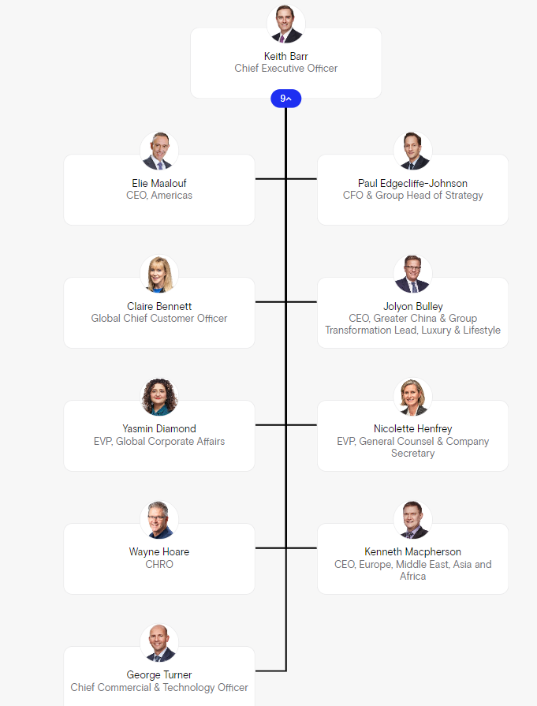
Chart-01: Organizational Chart of IHG (IHG, 2022)
The IHG follows chain of command in its activities as there is clear line of authority and responsibility of every employees of the group. There is less scope of Home-Working or Telecommuting in the organization.
Culture
A company's culture influences how employees should behave. Leaders create a set of similar perspectives and values, which are subsequently communicated to workers and reinforced in various ways. This culture shapes workers' views, behaviors, and understanding.

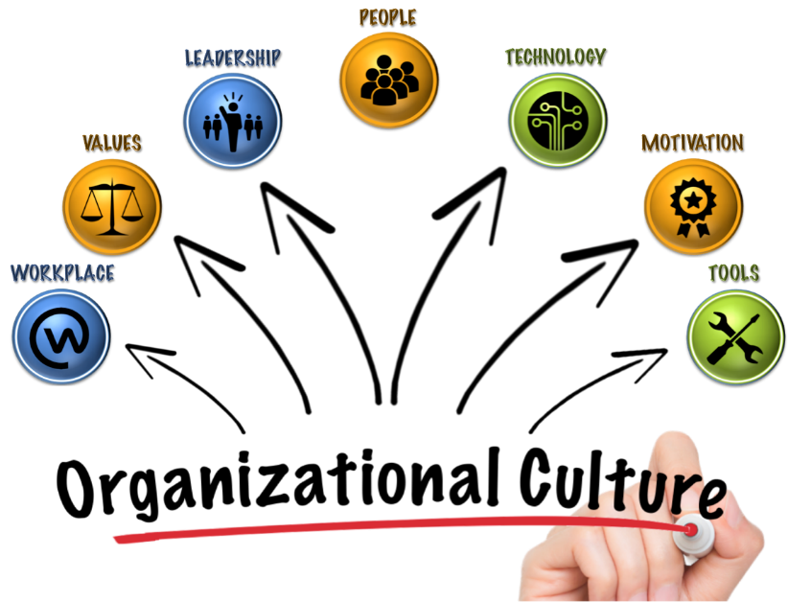
Chart-02: Organizational Culture (Simpson, 2022)
IHG is committed to giving everyone true hospitality (Harsch and Festing, 2020). This includes guests, shareholders, stakeholders, and individuals. This is their main organizational culture. Out of Handy’s 4 types of culture, IHG practices role and task culture in which emphasis is given both on the roles and responsibilities and on teamwork, flexibility, and speed. The organization also practices a work-hard culture, which means there is low risk and quick feedback. The organization mostly values the wants and demands of both the customers and employees.
IHG's business and culture revolve around operating ethically and sustainably. In recent years, they've had success tackling operational, people-led, and environmental concerns vital to the organization and its stakeholders, broadening their emphasis and effect as part of their pledge to deliver True Hospitality for Good.
The staff are guided by IHG and guest values. These collective values give a common sense of purpose that guides all they do, from how they support and recognize their employees to how they build the company and interact with its owners and communities (Okmumus et al., 2017).
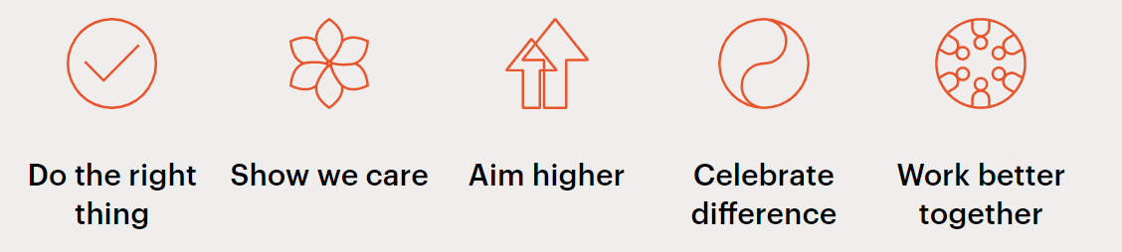
Chart-03: Values of the IHG (IHG, 2022)
Goals
The goal of True Hospitality for Good is to create a positive impact on all guests, workers, owners, communities, and the environment by influencing the culture, bringing the brands to life, and representing a devotion to making a difference in these areas.
By carrying out its actions with intent, it may be able to seize opportunities to bring about positive change and disseminate true hospitality for good. It might be establishing relationships that bring loved ones closer together, cultivating a feeling of belonging for all staff members as they advance their careers at IHG, or assisting hotels in developing environmentally responsible practices that preserve the natural beauty of their locations (Hajizadeh et al., 2022).

2.2 Recent changes, initiatives, their impacts and their management
The Brexit issue has been a hot topic for all sorts of businesses in the UK. But the IHG was not impacted so much regarding the issue. Because it was just 5% of the company's overall business around the world, but it was where they were situated, and there were greater opportunities for them to expand all of the brands in that market.
Following the acquisition of Kimpton Hotels & Restaurants in 2014, the organization shifted its attention to the development of the company's premium products in an effort to increase its share of the market. In 2017, the luxury segment of InterContinental's business generated $4 billion in sales and included around 80,000 guest rooms, with a further 20,000 rooms now in the planning stages (Fitria, 2018).
The demand for hotels in the middle price range was growing, particularly in nations like Saudi Arabia, where the government was trying to diversify its economy away from reliance on oil by putting more emphasis on the development of tourism.

COVID-19 has affected the tourism sector all around the world as people could not move to have a tour. The pandemic also affected the Intercontinental Hotels Group (IHG). Hotels have shuttered and worldwide tourism has halted, upsetting the hotel business. Even though just 15% of IHG's estate was shuttered at the end of April, financial figures reflected the effect. Global RevPAR fell 24.9% in Quarter1, with March being the weakest month (-55%). April's RevPAR fell 80% (Lee et al., 2021).
IHG is more exposed to China than Hilton and felt the contagion sooner. The hotel company said it could survive 18 months without capacity. Only 12 of IHG's 470 hotels are shuttered in China, an improvement.
IHG's new financial arrangements include a relaxation of current covenants until December 31, 2021. IHG has issued £600m (US $745.2m) in commercial paper under the UK government's CCFF, which was confirmed by the Bank of England. IHG has taken different steps in response to COVID-19. such as-

- The group has provided the guests with safety and flexibility during the pandemic situation. Different strategies and tasks were developed to respond to COVID-19 in the best way so that the guests are ensured of the safest and best quality services (Gurbaxani and Dunkle, 2019).
- COVID-19's weak demand and financial problems have hurt several of the group's small, individually operated hotels. The group is working closely to provide advice, support, and adaptability for rehabilitation and growth.
- Everybody is well aware of the extreme hardships that the hotel staff and business colleagues have had to endure recently. Even though the world's recovery is complicated and different in each market and even each city, it stands with them all and is committed to helping them as a single team (Shayo and Lin, 2019).
- It's a priority for everyone at IHG to have a positive effect on all the areas where our hotels and offices are located. Once again, this has been a pressing issue since COVID-19, and the organization has responded in a variety of ways, including organizing donation drives and deliveries, giving hotel rooms for frontline staff and the homeless, and backing the essential work of the charity partners.

As part of its global climate change monitoring efforts, IHG has pledged its support. Efforts have been made to reduce their carbon emissions and save energy in order to do their part for the environment. The following are the company's commitments on the subject (Chan et al., 2021):
- To achieve a 46 percent reduction in greenhouse gas emissions from the energy consumed in our owned, managed, leased, and franchised estate by 2030 via a science-based aim.
- By 2030, all new hotel rooms should be operating at a very low or zero carbon footprint.
- In order to maximize/optimize renewable energy's function.

The Ukraine-Russia war had an impact on IHG as there were hotels in Russia for the company. The company announced that it will no longer make new investments, undertake new development projects, or construct new hotels in Russia. Investment and development activities will not be resumed in the near future. It also shut down its Moscow headquarters, although it continued to provide assistance to its employees (IHG, 2022)

2.3 Strategic direction and current business performance
IHG's successful approach includes a strong brand portfolio and loyalty programme, effective channel management, a better owner proposition, and employee-preferred brands.
The company undertakes cognitive strategies to manage its daily activities and to achieve its targeted goals. Important parts of the company's strategy were tweaked in 2020 to improve its ability to drive future growth. Continued investment in our guest and owner offerings and brand development at scale in high-value regions will continue to fuel our net room growth ambitions. To achieve a sustainable increase in cash flows and earnings, this strategy requires rigorous execution, which may be reinvested and repaid to shareholders (Zaitseva et al., 2018)). In terms of how it carries out our plan, it has developed in terms of the priorities it sets, the behaviors it promotes, and the reason why it serves as our guide. Listening to stakeholders has helped IHG establish what's most important for the company's future and how it develops, taking into account the lessons learnt from dealing with COVID-19 and planning for a long-term recovery.
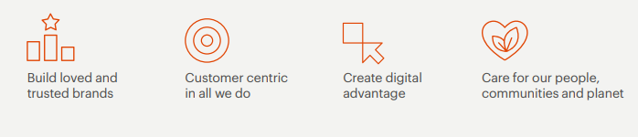
Chart-04: Strategies of IHG (Gyódi, 2021)

Rethinking the company's goals, it shifted to a more customer-centric approach, with owners and visitors at the center of its thinking. For them, a smart, well-resourced digital strategy is critical. They want to make sure that it satisfies their expanding obligation to care for people and have a beneficial impact on their communities as well as on the world itself.

Because of COVID-19, IHG has faced difficulties in 2020 like other hotel companies in the world. Except for 2020 and 2021, the revenue of the company seems to have an increasing trend, which is a good indicator of sound financial performance. The figure in the following section expresses the increasing trend of revenue of the company (Sharma et al., 2021).
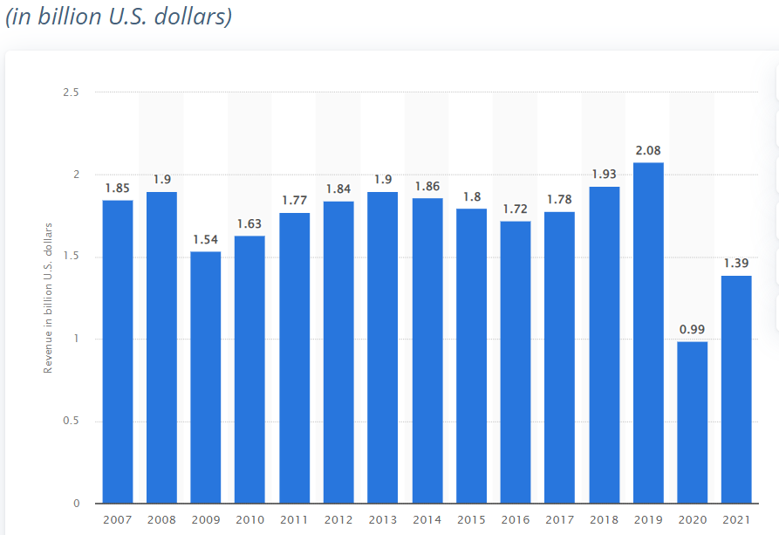

Chart-05: Revenue of the InterContinental Hotels Group (2007-2021) (Statista, 2022)

The same instance may be noted in the gross revenue of the corporation, where gross revenue drops in 2020 due to the influence of COVID-19. Otherwise, it was a growing tendency.
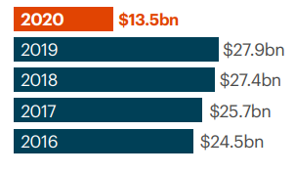
Chart-06: Gross revenue of IHG (2016-2020) (IHG, 2022)
In the event that the organization has had free cash flow in recent years, a mixture modification has been observable. However, the difference is not quite as big. The year 2020 serves as an exception to this rule since the effect of COVID-19 resulted in a free cash flow of just $29 million during that year (Sharma and Kaushik, 2021).

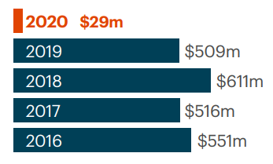
Chart-07: Free cash flow of IHG (2016-2020) (IHG, 2022)

So, in general, IHG's financial performance seems to be strong and stable, other from the COVID-19 case in 2020.

3.0 Conclusion
Intercontinental Hotels Group (IHG) is one of the biggest groups of hotels in the hotel industry. It operates its functions under different institutions in different locations. This is why the group needs to have a hybrid organizational hierarchy. The organization has good values and culture. Its main goal is to provide customers with true hospitality services. To ensure this, the company formulates different strategies and implements them. The company seems to have cognitive strategies to conduct its tasks. Though the Brexit issue didn’t impact the group so much in taking effective strategies, COVID-19 and Russia-Ukraine have affected the company. During the pandemic, the company suffered greatly. The overall financial performance of the company seems to be satisfactory with the exception of the COVID-19 effect in 2020. The company should be more strategic so that it can attain its upcoming targeted goals (Wang, 2020).

4.0 Recommendations
There are not many areas in which the Intercontinental Hotel Group can make improvements. As a result, IHG has to implement a plan that is more efficient for increasing its position in the market and, as a result, its capability to compete if it wants to maintain its current level of growth. The corporation might improve its performance if it included its employees in a greater proportion of its sustainable activities. IHG cannot achieve its sustainable goals for 2030 on its own; the company needs the cooperation of its employees (Kucharska and Kowalczyk, 2019).

5.0 References
Chan, J., Gao, Y.L. and McGinley, S., 2021. Updates in service standards in hotels: how COVID-19 changed operations. International Journal of Contemporary Hospitality Management.
Ettinger, A., Grabner-Kräuter, S. and Terlutter, R., 2018. Online CSR communication in the hotel industry: Evidence from small hotels. International Journal of Hospitality Management, 68, pp.94-104.
Fitria, H., 2018. The influence of organizational culture and trust through the teacher performance in the private secondary school in Palembang. International Journal of Scientific & Technology Research, 7(7), pp.82-86.
Groysberg, B., Lee, J., Price, J. and Cheng, J., 2018. The leader’s guide to corporate culture. Harvard business review, 96(1), pp.44-52.
Gurbaxani, V. and Dunkle, D., 2019. Gearing up for successful digital transformation. MIS Quarterly Executive, 18(3).
Gyódi, K., 2021. Airbnb and hotels during COVID-19: different strategies to survive. International Journal of Culture, Tourism and Hospitality Research.
Hajizadeh, H., Makvandi, F. and Amirnejad, G., 2022. The effective coaching factors in operational managers of Persian gulf petrochemical company in motivation of human resources. International Journal of Engineering Business Management, 14, p.18479790211037222.
Harsch, K. and Festing, M., 2020. Dynamic talent management capabilities and organizational agility—A qualitative exploration. Human Resource Management, 59(1), pp.43-61.
InterContinental Hotels Group PLC. 2022. [online] Available at: <https://www.ihgplc.com/en> [Accessed 19 June 2022].
Kucharska, W. and Kowalczyk, R., 2019. How to achieve sustainability?—Employee's point of view on company's culture and CSR practice. Corporate Social Responsibility and Environmental Management, 26(2), pp.453-467.
Lee, G.C., Restrepo, M.I., Harper, N., Manoharan, M.S., Smith, A.M., Meunier, J.A., Sanchez-Reilly, S., Ehsan, A., Branum, A.P., Winter, C. and Winter, L., 2021. Immunologic resilience and COVID-19 survival advantage. Journal of Allergy and Clinical Immunology, 148(5), pp.1176-1191.
Okumus, F., Bilgihan, A., Ozturk, A.B. and Zhao, X.R., 2017. Identifying and overcoming barriers to deployment of information technology projects in hotels. Journal of Organizational Change Management.
Sharma, A., Shin, H., Santa-María, M.J. and Nicolau, J.L., 2021. Hotels' COVID-19 innovation and performance. Annals of Tourism Research, 88, p.103180.
Sharma, S. and Kaushik, T., 2021. Aesthetically clean to clinically clean–A study on new housekeeping practices in Delhi hotels beyond COVID-19 pandemic. Worldwide Hospitality and Tourism Themes, 13(5), pp.646-659.
Shayo, C. and Lin, F., 2019. An exploration of the evolving reporting organizational structure for the chief information security officer (CISO) function. Journal of Computer Science, 7(1), pp.1-20.
Simpson, K.L., 2022. A Case Study on Creating and Sustaining Organizational Culture in a Startup Company (Doctoral dissertation, Charleston Southern University).
Starčević, K. and Peleš, B., IMPACT OF ORGANIZATIONAL STRUCTURE ON FINANCIAL RESULT OF THE COMPANY. In BOOK OF PROCEEDINGS (p. 83).
Statista. 2022. IHG revenue 2021 | Statista. [online] Available at: <https://www.statista.com/statistics/273254/revenue-of-the-intercontinental-hotels-group/> [Accessed 20 June 2022].
Wang, T., 2020. The impact of organizational culture on the success of the company: The case of Alibaba company.
Waruwu, H., Asbari, M., Purwanto, A., Nugroho, Y.A., Fikri, M.A.A., Fauji, A., Shobihi, A.W.I., Hulu, P., Sudiyono, R.N., Agistiawati, E. and Dewi, W.R., 2020. The role of transformational leadership, organizational learning and structure on innovation capacity: Evidence from Indonesia private schools. EduPsyCouns: Journal of Education, Psychology and Counseling, 2(1), pp.378-397.
Zaitseva, N.A., Larionova, A.A., Eliseeva, O.V., Katerynich, O.A., Vikhrova, N.O., Takhumova, O.V. and Zhukova, M.A., 2018. The features of the marketing strategies formulation and their application in hotels (by the example of business-hotels). Modern Journal of Language Teaching Methods, 8(10), pp.642-651.

